Okeanos Explorer ROV Dive Summary
Site Name | Mytilus Seamount North |  |  |  | 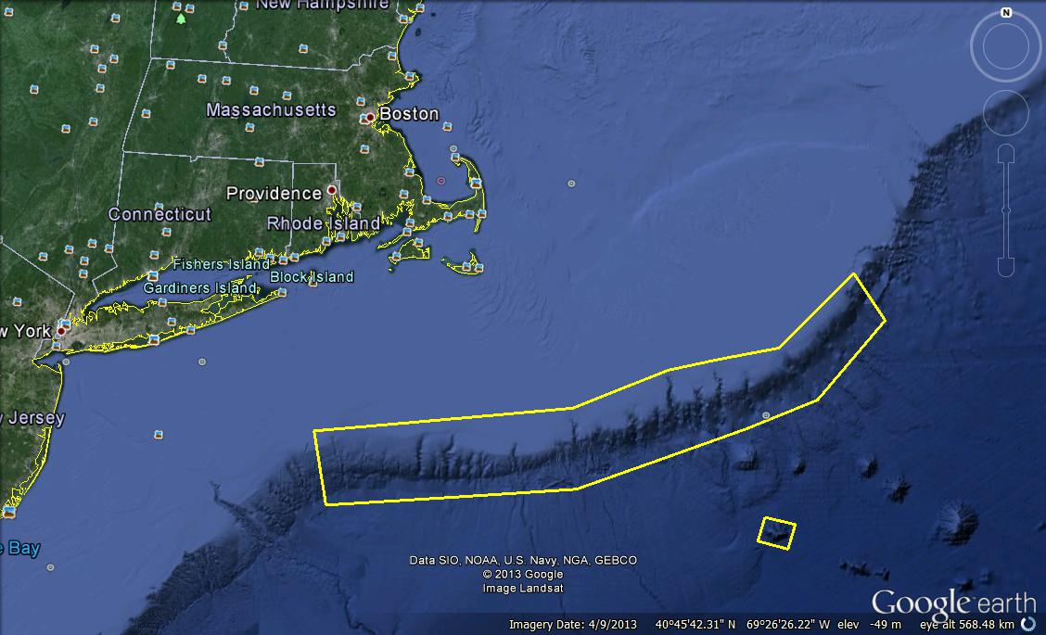
ROV Lead/Expedition Coordinator | David Lovalvo/  Brian Kennedy
Science Team Leads | Amanda Demopoulos  Martha Nizinski
General Area Descriptor | Northwest Atlantic Ocean;  Northeast U.S. Canyons
ROV Dive Name | Cruise Season |  | Leg |  |  | Dive Number
 | EX1304 |  | 2 |  |  | DIVE04
Equipment Deployed | ROV: |  | Deep Discoverer
 | Camera Platform: |  | Seirios
ROV Measurements | CTD |  | Depth |  |  | Altitude
 | Scanning Sonar |  | USBL Position |  |  | Heading
 | Pitch |  | Roll |  |  | HD Camera 1
 | HD Camera 2 |  | Low Res Cam 1 |  |  | Low Res Cam 2
 | Low Res Cam 3 |  | Low Res Cam 4 |  |  | Low Res Cam 2
Equipment Malfunctions
ROV Dive Summary  (From processed ROV data) | In Water at: 2013-08-04T14:08:51.436000  39°, 23.494' N ; 067°, 08.061' W  Out Water at: 2013-08-05T00:15:41.120000  39°, 23.073' N ; 067°, 08.635' W  Off Bottom at: 2013-08-04T22:28:50.137000  39°, 23.097' N ; 067°, 08.278' W  On Bottom at: 2013-08-04T16:02:54.004000  39°, 23.230' N ; 067°, 08.039' W  Dive duration: 10:6:49  Bottom Time: 6:25:56  Max. depth: 3271.4 m
Special Notes
Scientists Involved  (please provide name / location / affiliation / email) | Primary  Amanda Demopoulos(Science lead), USGS, ademopoulos@usgs.gov  Andrea Quattrini, Temple, andrea.quattrini@temple.edu  Christopher Mah, Smithsonian, brisinga@gmail.com  Jason Chaytor, USGS, jchaytor@usgs.gov  Les Watling, UH, watling@hawaii.edu  Martha Nizinski (Science Lead). NOAA NMFS, nizinski@si.edu  Michael Vecchione, NOAA NMFS, VecchioneM@si.edu  Morgan Kilgour, UCONN, morgan.kilgour@uconn.edu  Peter Auster, UCONN, peter.auster@uconn.edu  Peter Etnoyer, NOAA, Peter.Etnoyer@noaa.gov  Rhian Waller, U of Maine, rhian.waller@maine.edu  Robert Carney, LSU, rcarne1@lsu.edu  Santiago Herrera, WHOI, sherrera@whoi.edu  Scott France, UL Lafayette, france@louisiana.edu  Tim Shank, WHOI, tshank@whoi.edu  Passive  Brian Kennedy, NOAA OER, Brian.Kennedy@noaa.gov  Brendan Roark, Texas A&M, broark@geos.tamu.edu  Brian Kinlan, NOAA NOS, brian.kinlan@noaa.gov  Erick Geiger, URI ISC, egeiger@udel.edu  Nicola Morgan, FSU, nbmorgan11@yahoo.com  Thomas Ritter, MSU, thomas.ritter@msu.montana.edu
Purpose of the Dive
Despite a significant level of past effort, the New England seamounts, a major chain of undersea mountains, remains largely unexplored. Building on previous work, we will conduct the first ecological explorations of the New England seamounts. Of those seamounts within the US EEZ, Mytilus Seamount has yet to be visited in this regard. This dive will explore steep terrain along the north side of the seamount to characterize deep sea coral and sponge communities.
Description of the Dive:
Dive # 4 took us to Mytilus Seamount, one of the least explored of the New England Seamount chain inside the US EEZ. The dive started late after an issue with the traction winch that required maintenance. While the ROV descended to the seafloor, there were very few planktonic organisms observed. The ROV was on bottom at 1602 UTC at a depth of 3271 m. The dive track ascended a steep portion of the wall along the north side of the seamount, from ~3270 m to 2750. The geology was characterized by a combination of gentle and steeply sloping basalt pillars that were smooth in texture, interspersed with ledges or steps covered with sediment drape. Periodically, piles of small, dark rocks were observed. All the rocks had a manganese coating. At the start of the dive, various sponges, mostly hexactinellids of different forms, populated the rock walls. These included long stalked forms with a “tulip”shaped head, vases, “witches” hat, globular, and “rose” shaped. Various species of ophiuroids, stalked and non-stalked crinoids, and holothurians were abundant along the rock walls and on the sediment ledges throughout the dive. At around 3250 m, the first corals, stoloniferous octocorals, were observed. As the ROV continued up slope, additional corals, including a few different species of bamboo corals as well as Chrysogorgia, Paragorgia, Paranarella, Anthomastus, Corallium, Convexella, and two black coral species were noted. No scleractinian corals were documented on the dive. Other fauna observed included hermit crabs, squat lobsters (Galacantha, Munidopsis), seastars (Hymenaster, Pythonaster), the coral-eating seastar (Evoplosoma), several bryozoans, two featherduster polychaete worms, and barnacles. At 2806 m, a large bamboo colony with associated crinoids was imaged. Several large bamboos (Jasonisis?) were documented throughout the remainder of the dive. At the end of the dive, a pillow lava was observed. Very few fish, including a toadfish, cusk eel, and synaphobranchid eel were documented. The science operations for the dive ended at 2204 UTC. Our dive at Mytilus Seamount represents the most comprehensive investigation of benthic communities at this seamount to date.

Overall Map of ROV Dive Area |  |  |  | Close-up Map of Main Dive Site
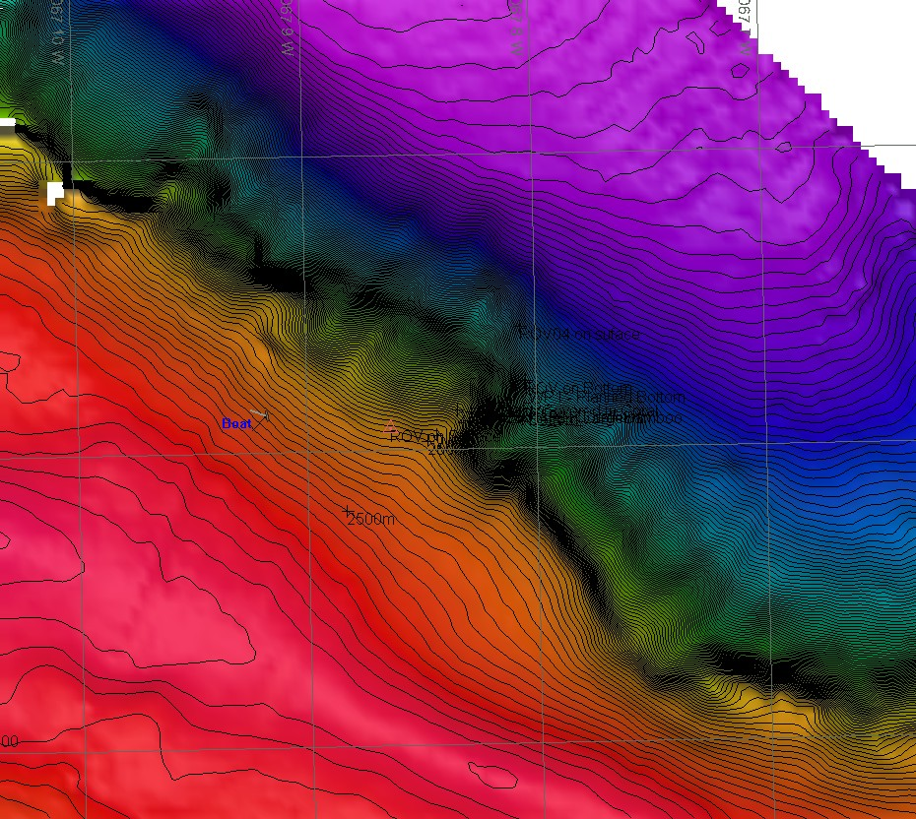 |  |  |  | 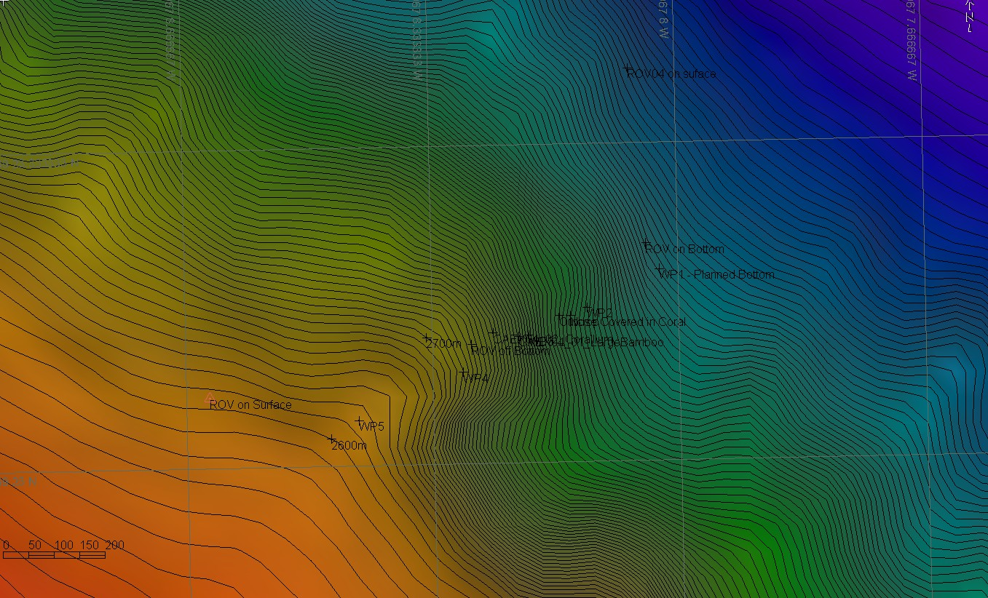
Representative Photos of the Dive
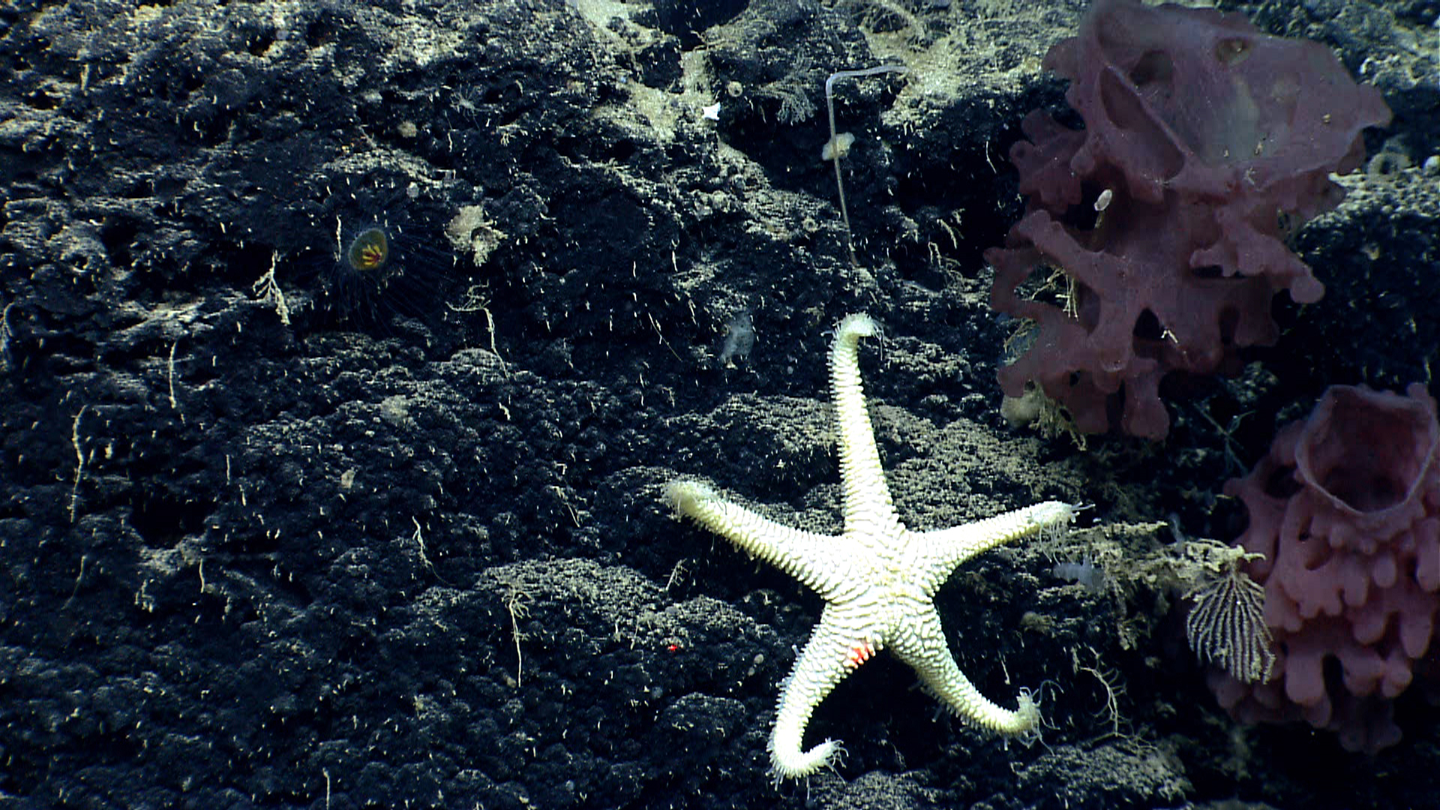 |  |  |  | 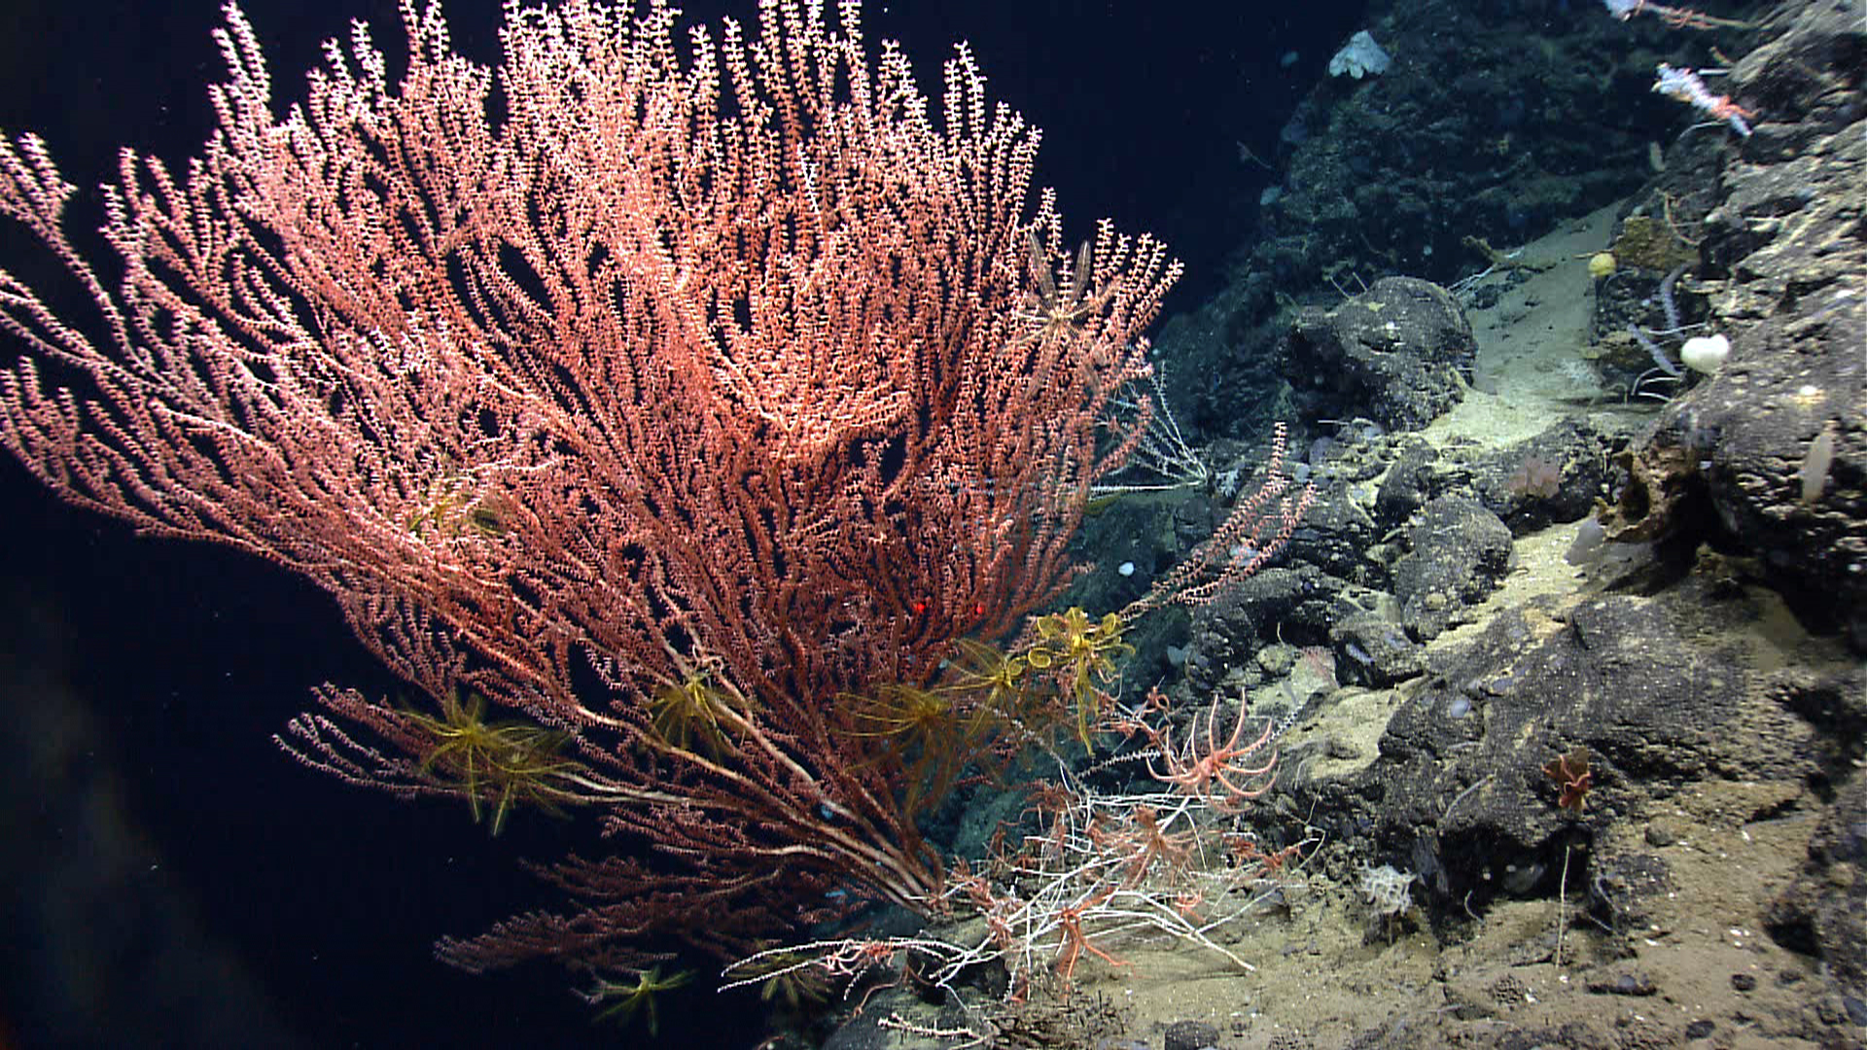
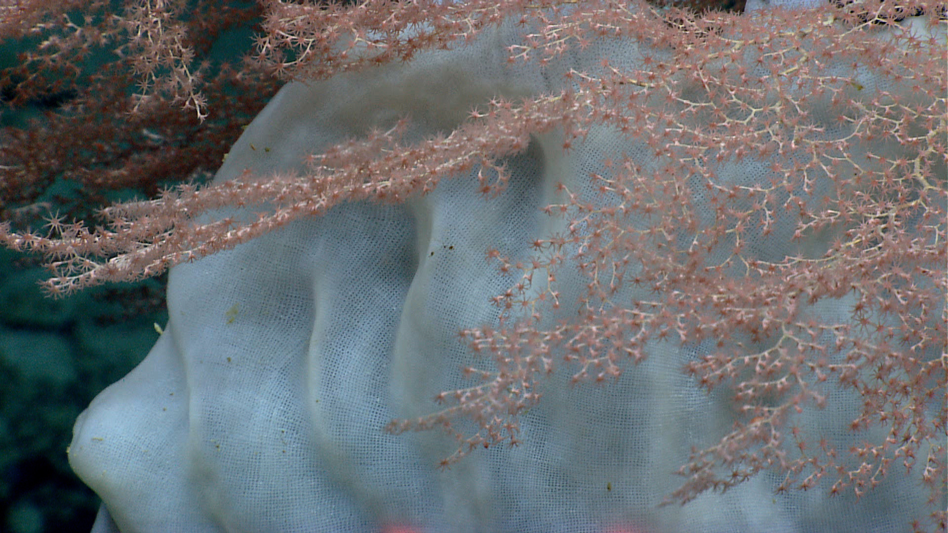 |  |  |  | 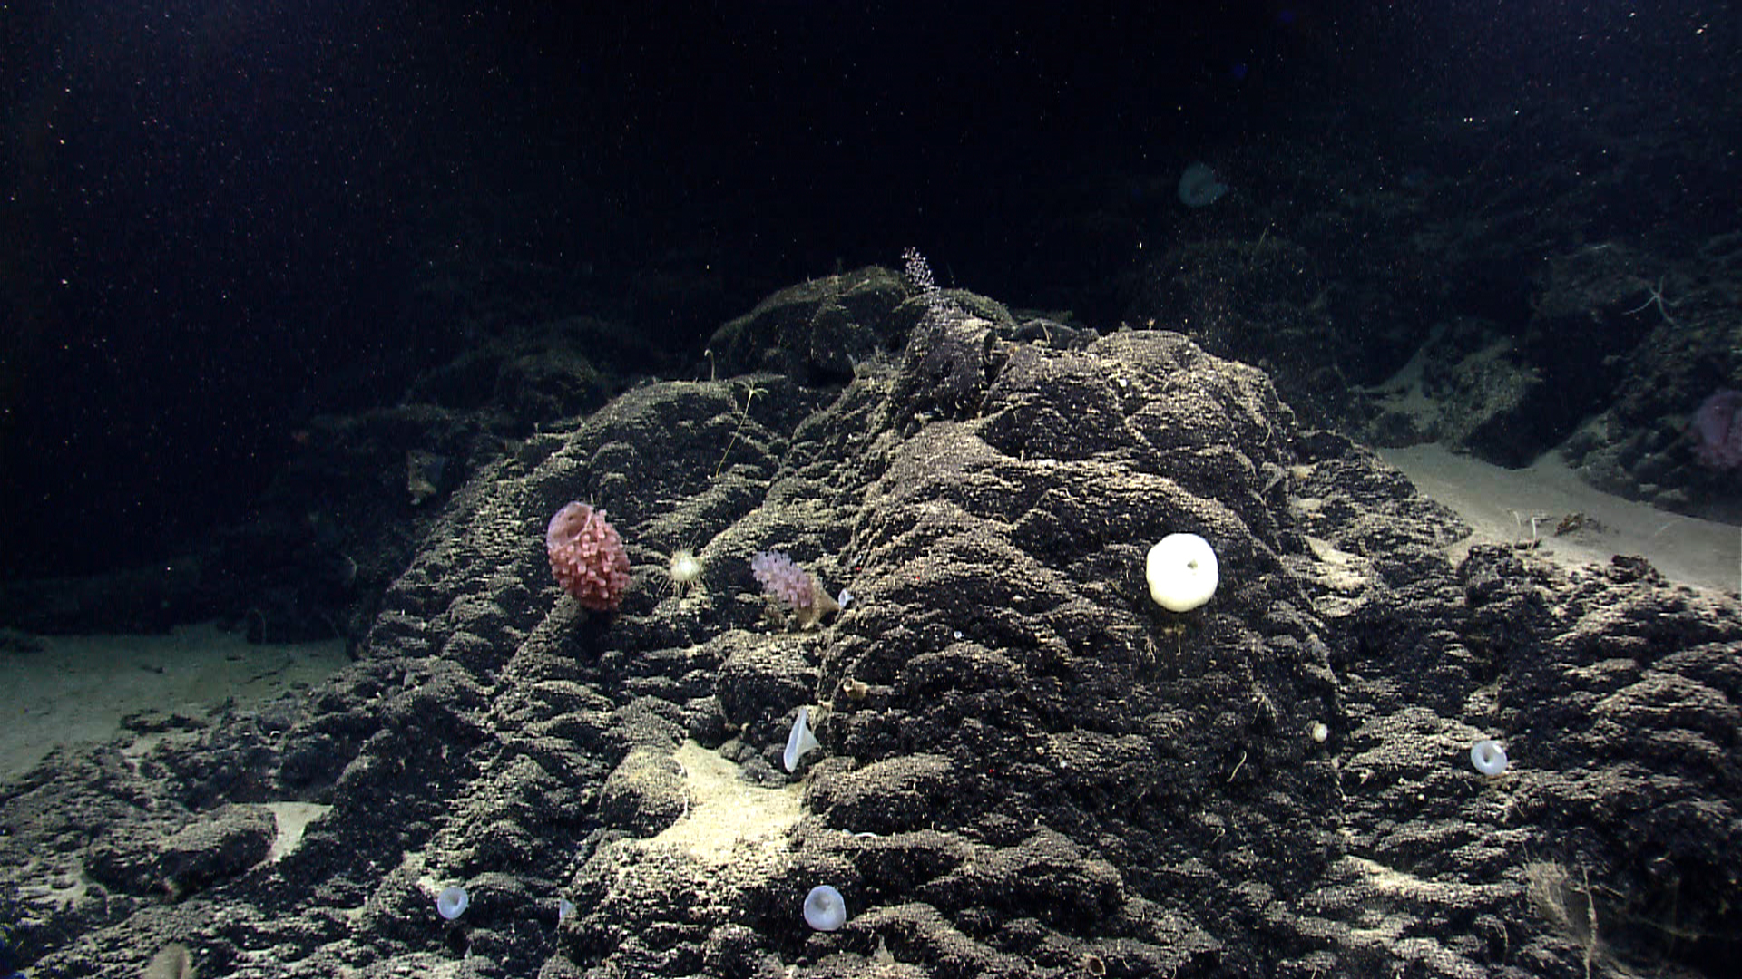
Please direct inquiries to: |  | NOAA Office of Ocean Exploration & Research  1315 East-West Highway (SSMC3 10th Floor)  Silver Spring, MD 20910  (301) 734-1014

