Okeanos Explorer ROV Dive Summary
Site Name | Oceanographer 1 |  |  |  | 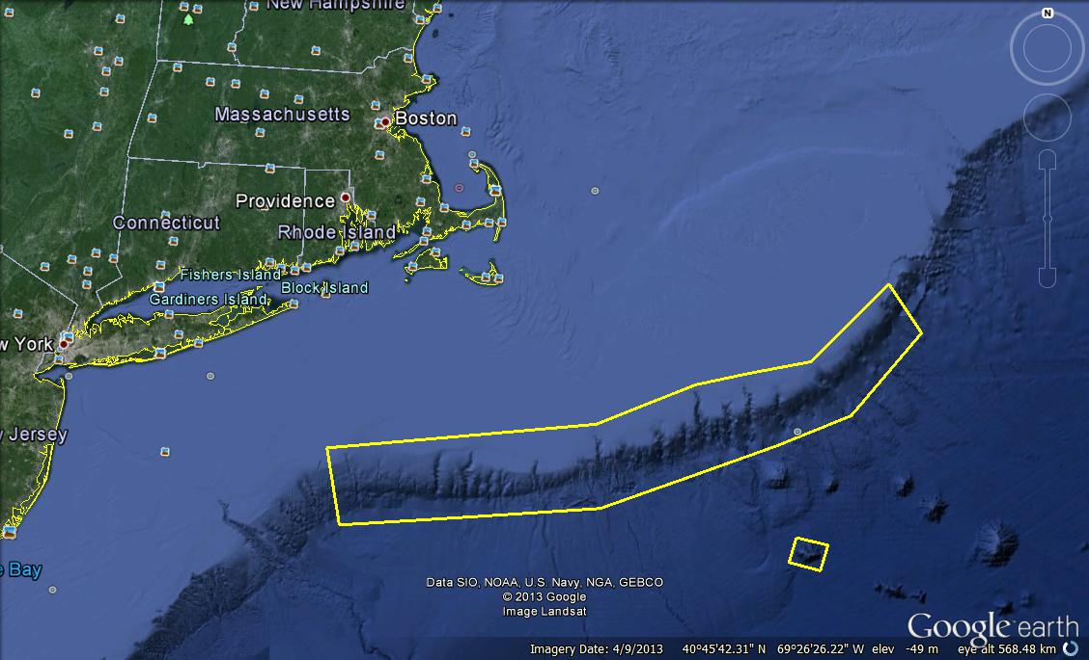
ROV Lead/Expedition Coordinator | David Lovalvo/  Brian Kennedy
Science Team Leads | Amanda Demopoulos  Martha Nizinski
General Area Descriptor | Northwest Atlantic Ocean;  Northeast U.S. Canyons
ROV Dive Name | Cruise Season |  | Leg |  |  | Dive Number
 | EX1304 |  | 2 |  |  | DIVE03
Equipment Deployed | ROV: |  | Deep Discoverer
 | Camera Platform: |  | Seirios
ROV Measurements | CTD |  | Depth |  |  | Altitude
 | Scanning Sonar |  | USBL Position |  |  | Heading
 | Pitch |  | Roll |  |  | HD Camera 1
 | HD Camera 2 |  | Low Res Cam 1 |  |  | Low Res Cam 2
 | Low Res Cam 3 |  | Low Res Cam 4 |  |  | Low Res Cam 2
Equipment Malfunctions
ROV Dive Summary  (From processed ROV data) | In Water at: 2013-08-03T12:27:04.748000  40°, 15.207' N ; 068°, 06.896' W  Out Water at: 2013-08-03T20:34:12.461000  40°, 15.048' N ; 068°, 07.600' W  Off Bottom at: 2013-08-03T19:58:44.809000  40°, 15.116' N ; 068°, 07.512' W  On Bottom at: 2013-08-03T13:23:45.640000  40°, 15.101' N ; 068°, 07.232' W  Dive duration: 8:7:7  Bottom Time: 6:34:59  Max. depth: 1239.3 m
Special Notes
Scientists Involved  (please provide name / location / affiliation / email) | Primary  Amanda Demopoulos (Science Lead), USGS, ademopoulos@usgs.gov  Amy Baco-Taylor, FSU, abacotaylor@fsu.edu  Andrea Quattrini, Temple, andrea.quattrini@temple.edu  Brian Kennedy, NOAA OER, Brian.Kennedy@noaa.gov  Brian Kinlan, NOAA, Brian.Kinlan@noaa.gov  Christina Kellogg, USGS, ckellogg@usgs.gov  Clara Smart, URI, clarajsmart@gmail.com  Ellie Orbors ,WHOI, ekbors@gmail.com  Jason Chaytor, USGS, jchaytor@usgs.gov  Les Watling, UH, watling@hawaii.edu  Martha Nizinski (Science Lead), NOAA NMFS, nizinski@si.edu  Michael Vecchione, NOAA, VecchioneM@si.edu  Morgan Kilgour, UCONN, morgan.kilgour@uconn.edu  Peter Auster, UCONN, peter.auster@uconn.edu  Rhian Waller, U of Maine, rhian.waller@maine.edu  Robert Carney, LSU, rcarne1@lsu.edu  Santiago Herrera, WHOI, sherrera@whoi.edu  Scott France, UL Lafayette, france@louisiana.edu  Taylor Heyl, WHOI, theyl@whoi.edu  Tim Shank, WHOI, tshank@whoi.edu  Passive  Matt Rittinghouse, NOAA, matthew.rittinghouse@noaa.gov  Nicole Morgan ,FSU, nbmorgan11@yahoo.com  Thomas Ritter, MSU, thomas.ritter@msu.montana.edu
Purpose of the Dive
The purpose of the dive was to characterize 1) the submarine canyon geomorphology and benthic habitats, including possible coral and sponge communities at a depth of ~1200 m in Oceanographer Canyon and 2) groundtruth a model of predicted deep-sea coral occurrence.
Description of the Dive:
The third dive of the cruise was on the western wall of Oceanographer Canyon was characterized by high diversity and abundances of corals. While descending to the bottom, several salps were observed suspended in the water column. The ROV reached the seafloor at a depth of 1236 m at 1325 UTC. Here rocks of various sizes, all with some level of sediment drape, were observed. These rocks had very angular faces, with no obvious signs of erosion. Several coral colonies and other invertebrates populated the rocks, including octocorals (Paramuricea, Swiftia) and bamboo corals (Acanella). Roots from an Acanella extended down a rock face, much like tree roots, which had not been observed by the scientists before. Other invertebrates encrusting the rocks included stoliniferan corals, anemones (Actinerus nobilis), and hexactinellid sponges. Many quill worms were present on the soft sediment. At ~1408 UTC, after completing observations of the animals on the rocks, a ship move was commenced, following a heading of 280º. Between 1217-1233 m, the seafloor was composed of rocks interspersed with large patches of soft sediment. Imaging rock associates was the primary focus of most of the dive. Specifically, Paragorgia, Paramuricea, white stoliniferan corals, and anemones were imaged extensively. At 1217 m, a squid was documented eating a midwater fish. Several large rocks with steep faces were the primary features examined for the remainder of the dive. Hard substrates were populated by several large Anthothela, Paramuricea with ophiuroid associates, and various sponges, including yellow sponges and other hexactinellids. Around 1205-1210 m, coral abundance increased dramatically and time was spent imaging corals, their associates, and rock associated fauna. Two black corals, Parantipathes and cf. Bathypathes were imaged with their associates, chirostylid squat lobsters and scaleworms. At 1204 m, a different type of shrimp, grey/purple in color, was resting on the rock surface near an Acanella bamboo coral and cup corals. A t-shaped echiuran proboscis was imaged retracting into the sediment nearby; this animal has not been observed on any of the dives thus far, including CANEX leg 1. At ~ 1150m, there was a distinctive change in the geology to eroded and heavily sculpted mudstone. These sedimented rock outcrops contained many coral colonies. Paragorgia was first observed at 1091 m and the colony contained several ophiuroids and a large pycnogonid. As the ROV continued along the track, at ~ 1078 m, red crabs and the corals Thourella, other bamboo corals, and Taxipathes (?) black coral with 3 Uroptychus squat lobsters were documented. As the ROV moved upslope, the seafloor was composed of several rock layers that alternated between exposed and sediment draped. At 1818 UTC, a bacterial mat was documented coating the seafloor in an area of collapsed soft sediment. There was no seafloor seepage throughout the dive, so the underlying source for bacterial production was not obvious but possibilities are numerous. At 997m, the stony corals, Lophelia and Solenosmilia, were observed apparently growing together next to bivalves (Family Limidae) attached to the underside of one of the rock ledges. Continuing upslope along the dive track, large Paramuricea, white Paragorgia, and several cupcorals had populated a large rock face at ~ 990 m. Other hard substrates included several small, heavily encrusted, rocks that were on top of a larger boulder. At the end of the dive, the ROV came upon a steep rock wall with many colonies of large corals, plus sea urchins and asteroid sea stars. Throughout the dive, very few fish were noted, including fathead, witch flounder, grenadiers (Coryphaenoides sp.), black dogfish (Centroscyllium fabricii), a Lepidion with copepod parasite attached to its tail, and cutthroat eels. The primary highlights from the dive were the high abundances of Paramuricea and bamboo corals, and the range of sizes observed along the dive track, with the largest colonies appearing at the end of the dive. Overall, there was a north to south trend in current flow, and many of the corals extended from the walls perpendicular to the southward flow, possibly to take advantage of the flow and associated food flux. The ROV was off bottom at 1601EST at ~990 m.

Overall Map of ROV Dive Area |  |  |  | Close-up Map of Main Dive Site
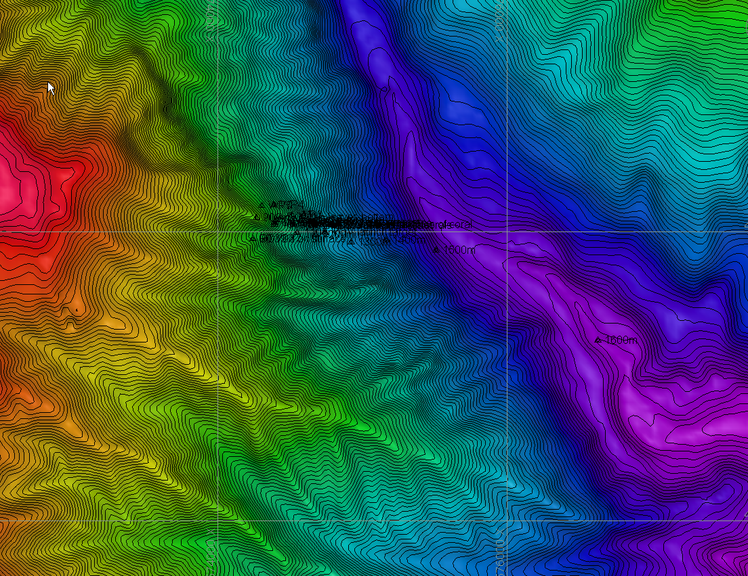 |  |  |  | 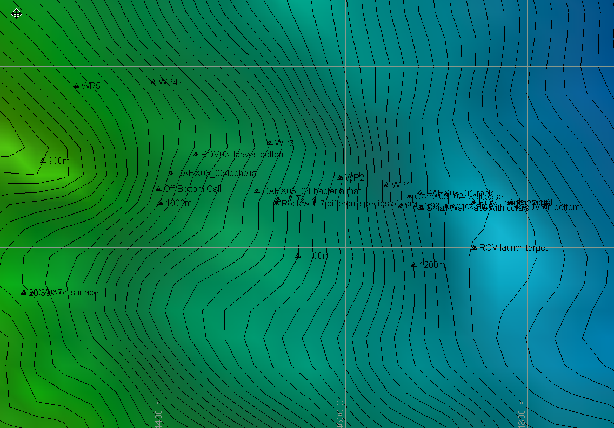
Representative Photos of the Dive
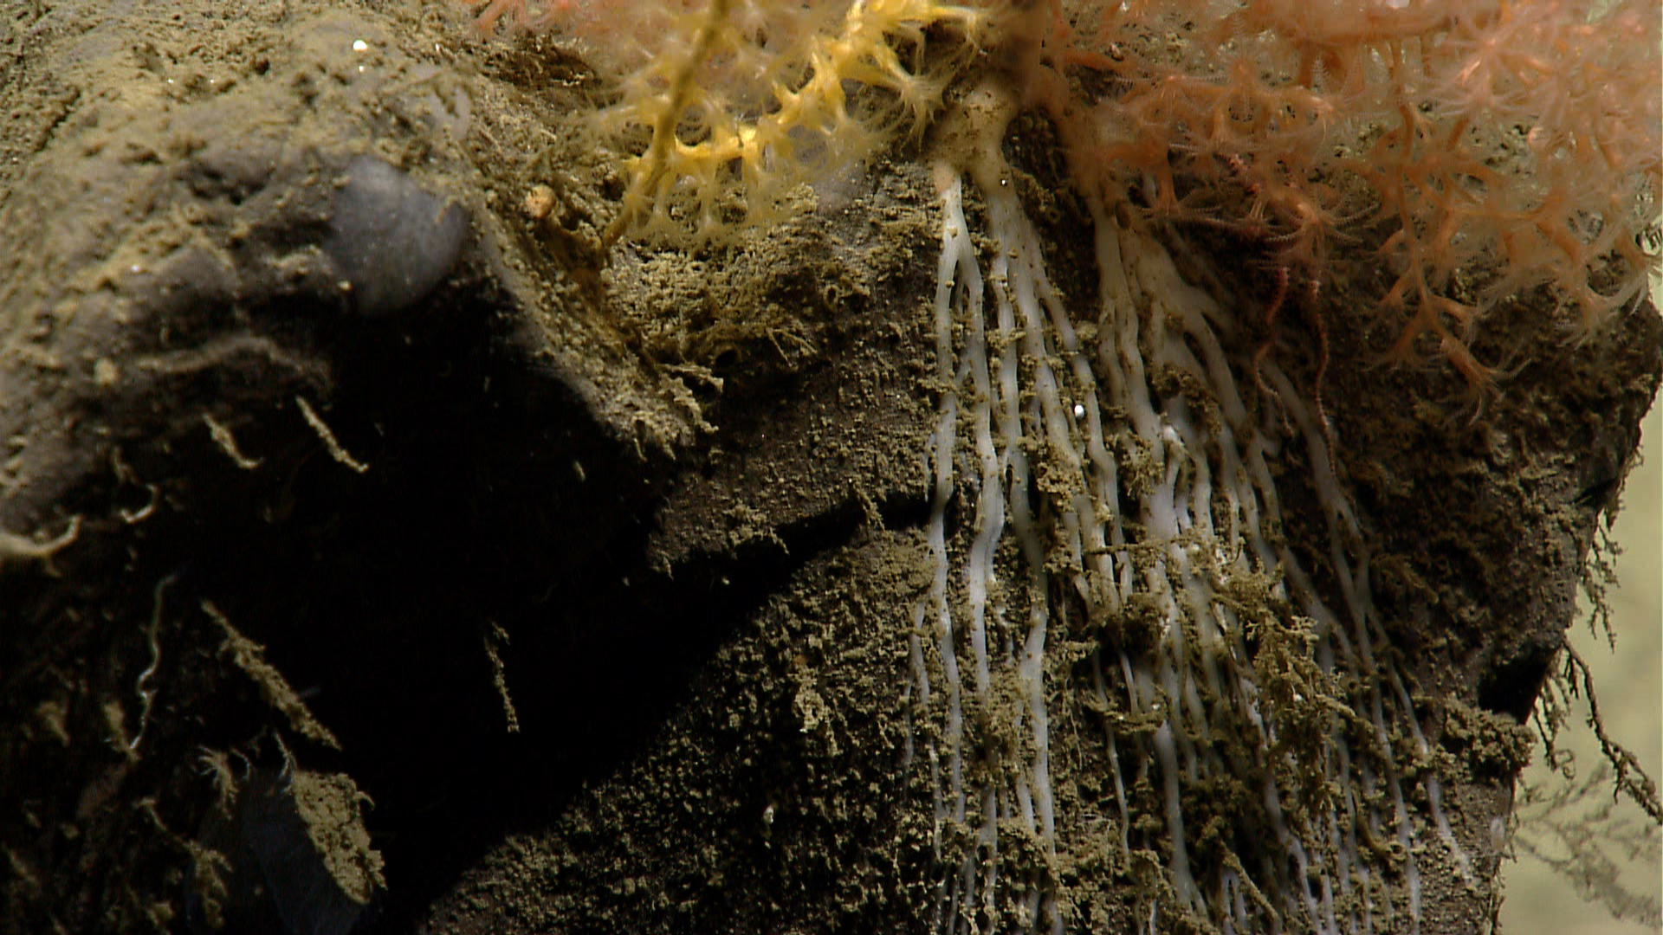 |  |  |  | 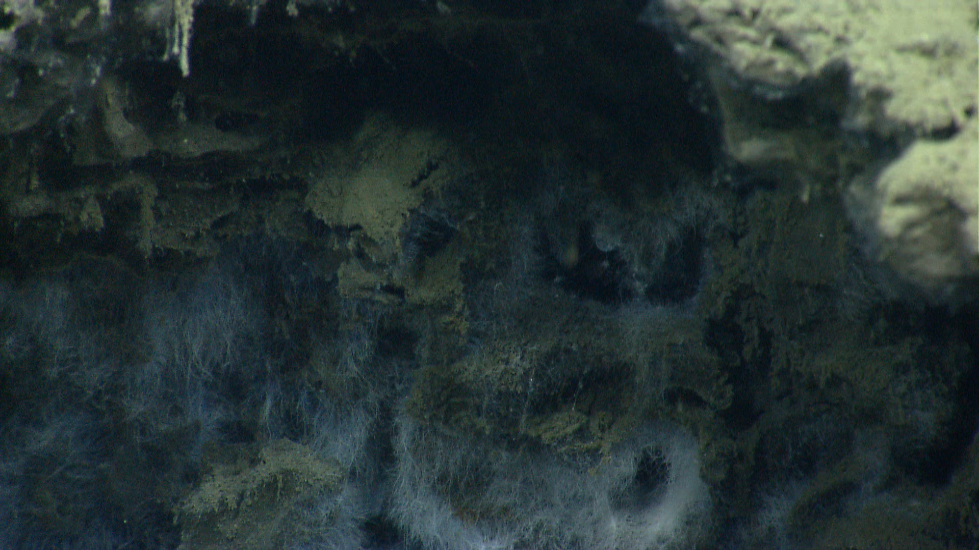
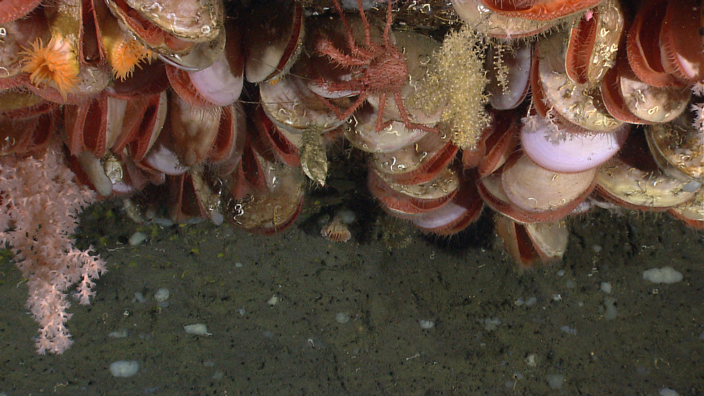 |  |  |  | 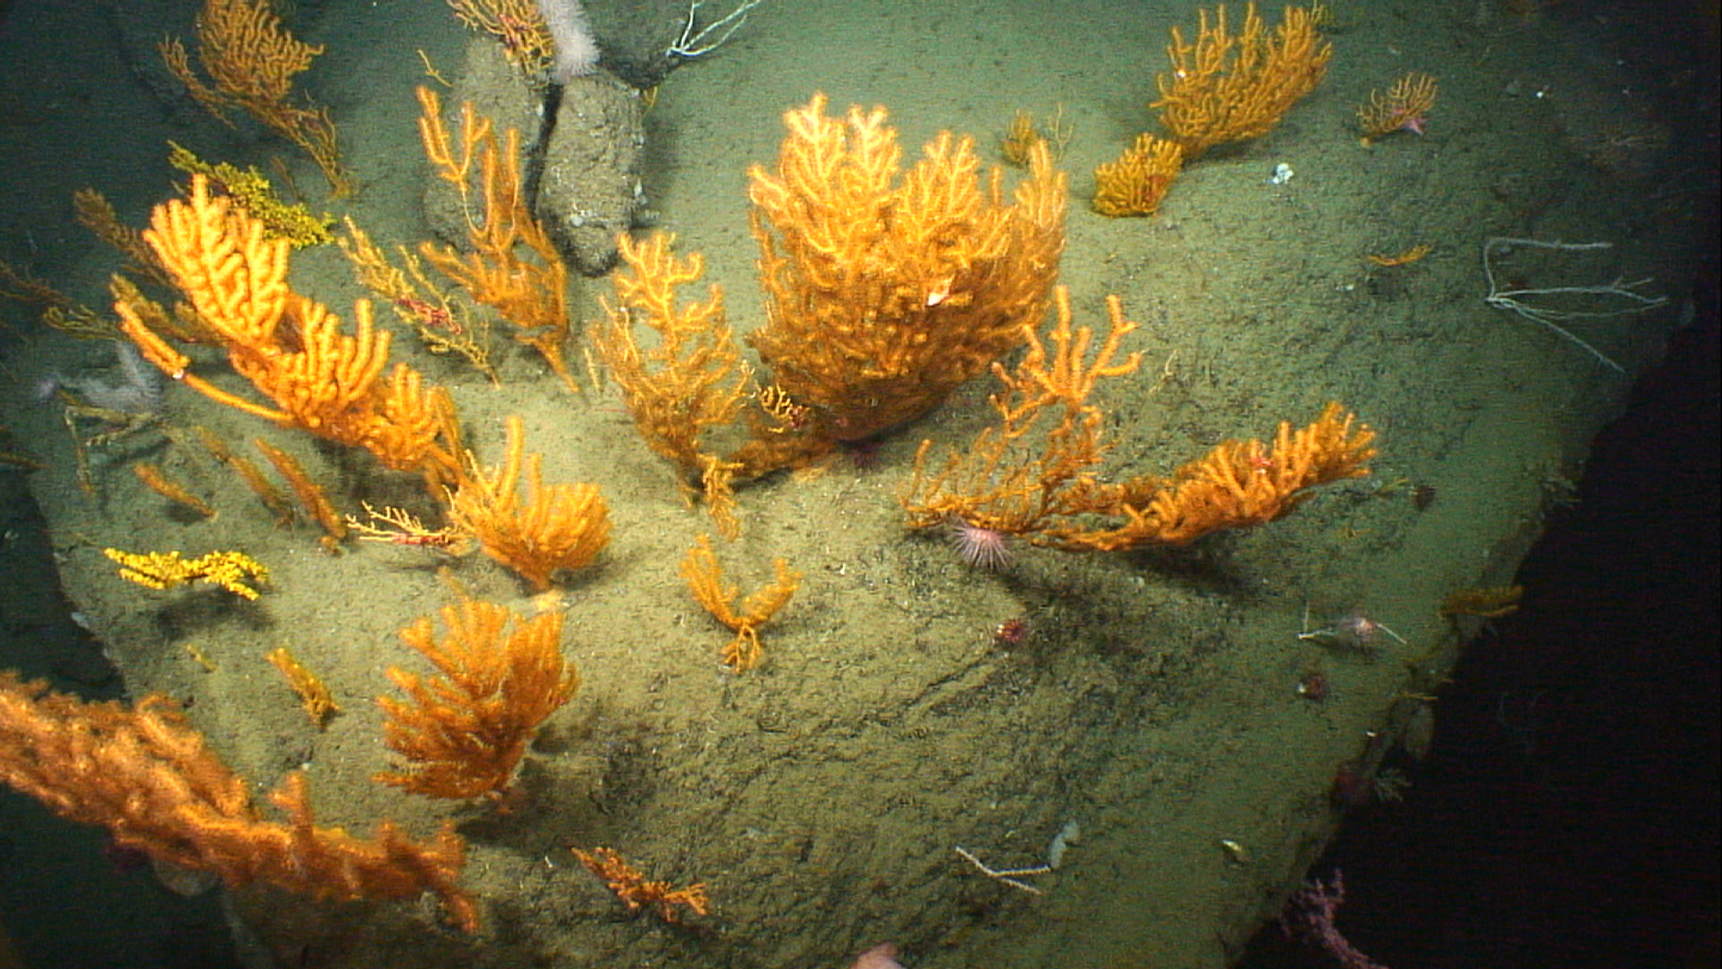
Please direct inquiries to: |  | NOAA Office of Ocean Exploration & Research  1315 East-West Highway (SSMC3 10th Floor)  Silver Spring, MD 20910  (301) 734-1014

