NOAA OFFICE OF OCEAN EXPLORATION AND RESEARCH
DRAFT Project Instructions

Date Submitted: July 2, 2012
Platform: NOAA Ship Okeanos Explorer
Cruise Number: EX-13-04 Leg I and Leg II
Project Title: Northeast U.S. Canyons Exploration
Cruise Dates: Leg I (ROV, mapping, CTD ops) July 8 – 25, 2013
Leg II (ROV, mapping, CTD ops) July 31 – August 17, 2013

Prepared by: Kelley Elliott, Expedition Manager
Brian Kennedy, Leg II Expedition Coordinator
Office of Ocean Exploration & Research

Approved by: ________________________ Dated: __________________
Craig W. Russell, NOAA
Program Manager
Office of Ocean Exploration & Research

Approved by: ________________________ Dated: __________________
CAPT Anita L. Lopez, NOAA
Commanding Officer
Marine Operations Center – Atlantic

- OVERVIEW
- Cruise Period
This document contains project instructions for EX-13-04 Legs I and II of NOAA Ship Okeanos Explorer’s exploration of the Northeast U.S. Canyons. EX-13-04 Leg I operations will commence on July 8, 2013 in North Kingstown, RI and conclude on July 25, 2013 in New York, NY. EX-13-04 Leg II operations commence on July 31, 2013 in New York, NY and conclude on August 17, 2013. Combined, 24-hour multibeam mapping, remotely operated vehicle (ROV) and CTD/rosette operations will be conducted during both cruise legs, and will include telepresence and shore-side participation.

B. Service Level Agreements

Of the 36 DAS scheduled for this project, 36 DAS are funded by the program and 0 DAS are funded by OMAO. This project is estimated to exhibit a high operational tempo.
- Operating Area
The 2013 Northeast U.S. Canyons Expedition operations will focus primarily on Northeast Canyons and inter-canyon areas, and include some exploration of Mytilus seamount. Leg I operations will focus on the western portion of the Northeast U.S. Canyons operating area, and Leg II operations will focus on the eastern portion of the Northeast U.S. Canyons operating area. The daily schedule for both cruises will usually be split between daytime ROV operations and evening/night CTD rosette and mapping operations. ROV operations will focus in depths >500m and will include high-resolution visual surveys; no biological or geological samples will be collected. All operations including transit will be conducted entirely within the 200nm exclusive economic zone (EEZ) maritime boundary of the United States of America. Mapping operations will include subbottom data collection over key features, multibeam data collection over canyon heads requiring coverage development, and holiday lines completing previous multibeam data.

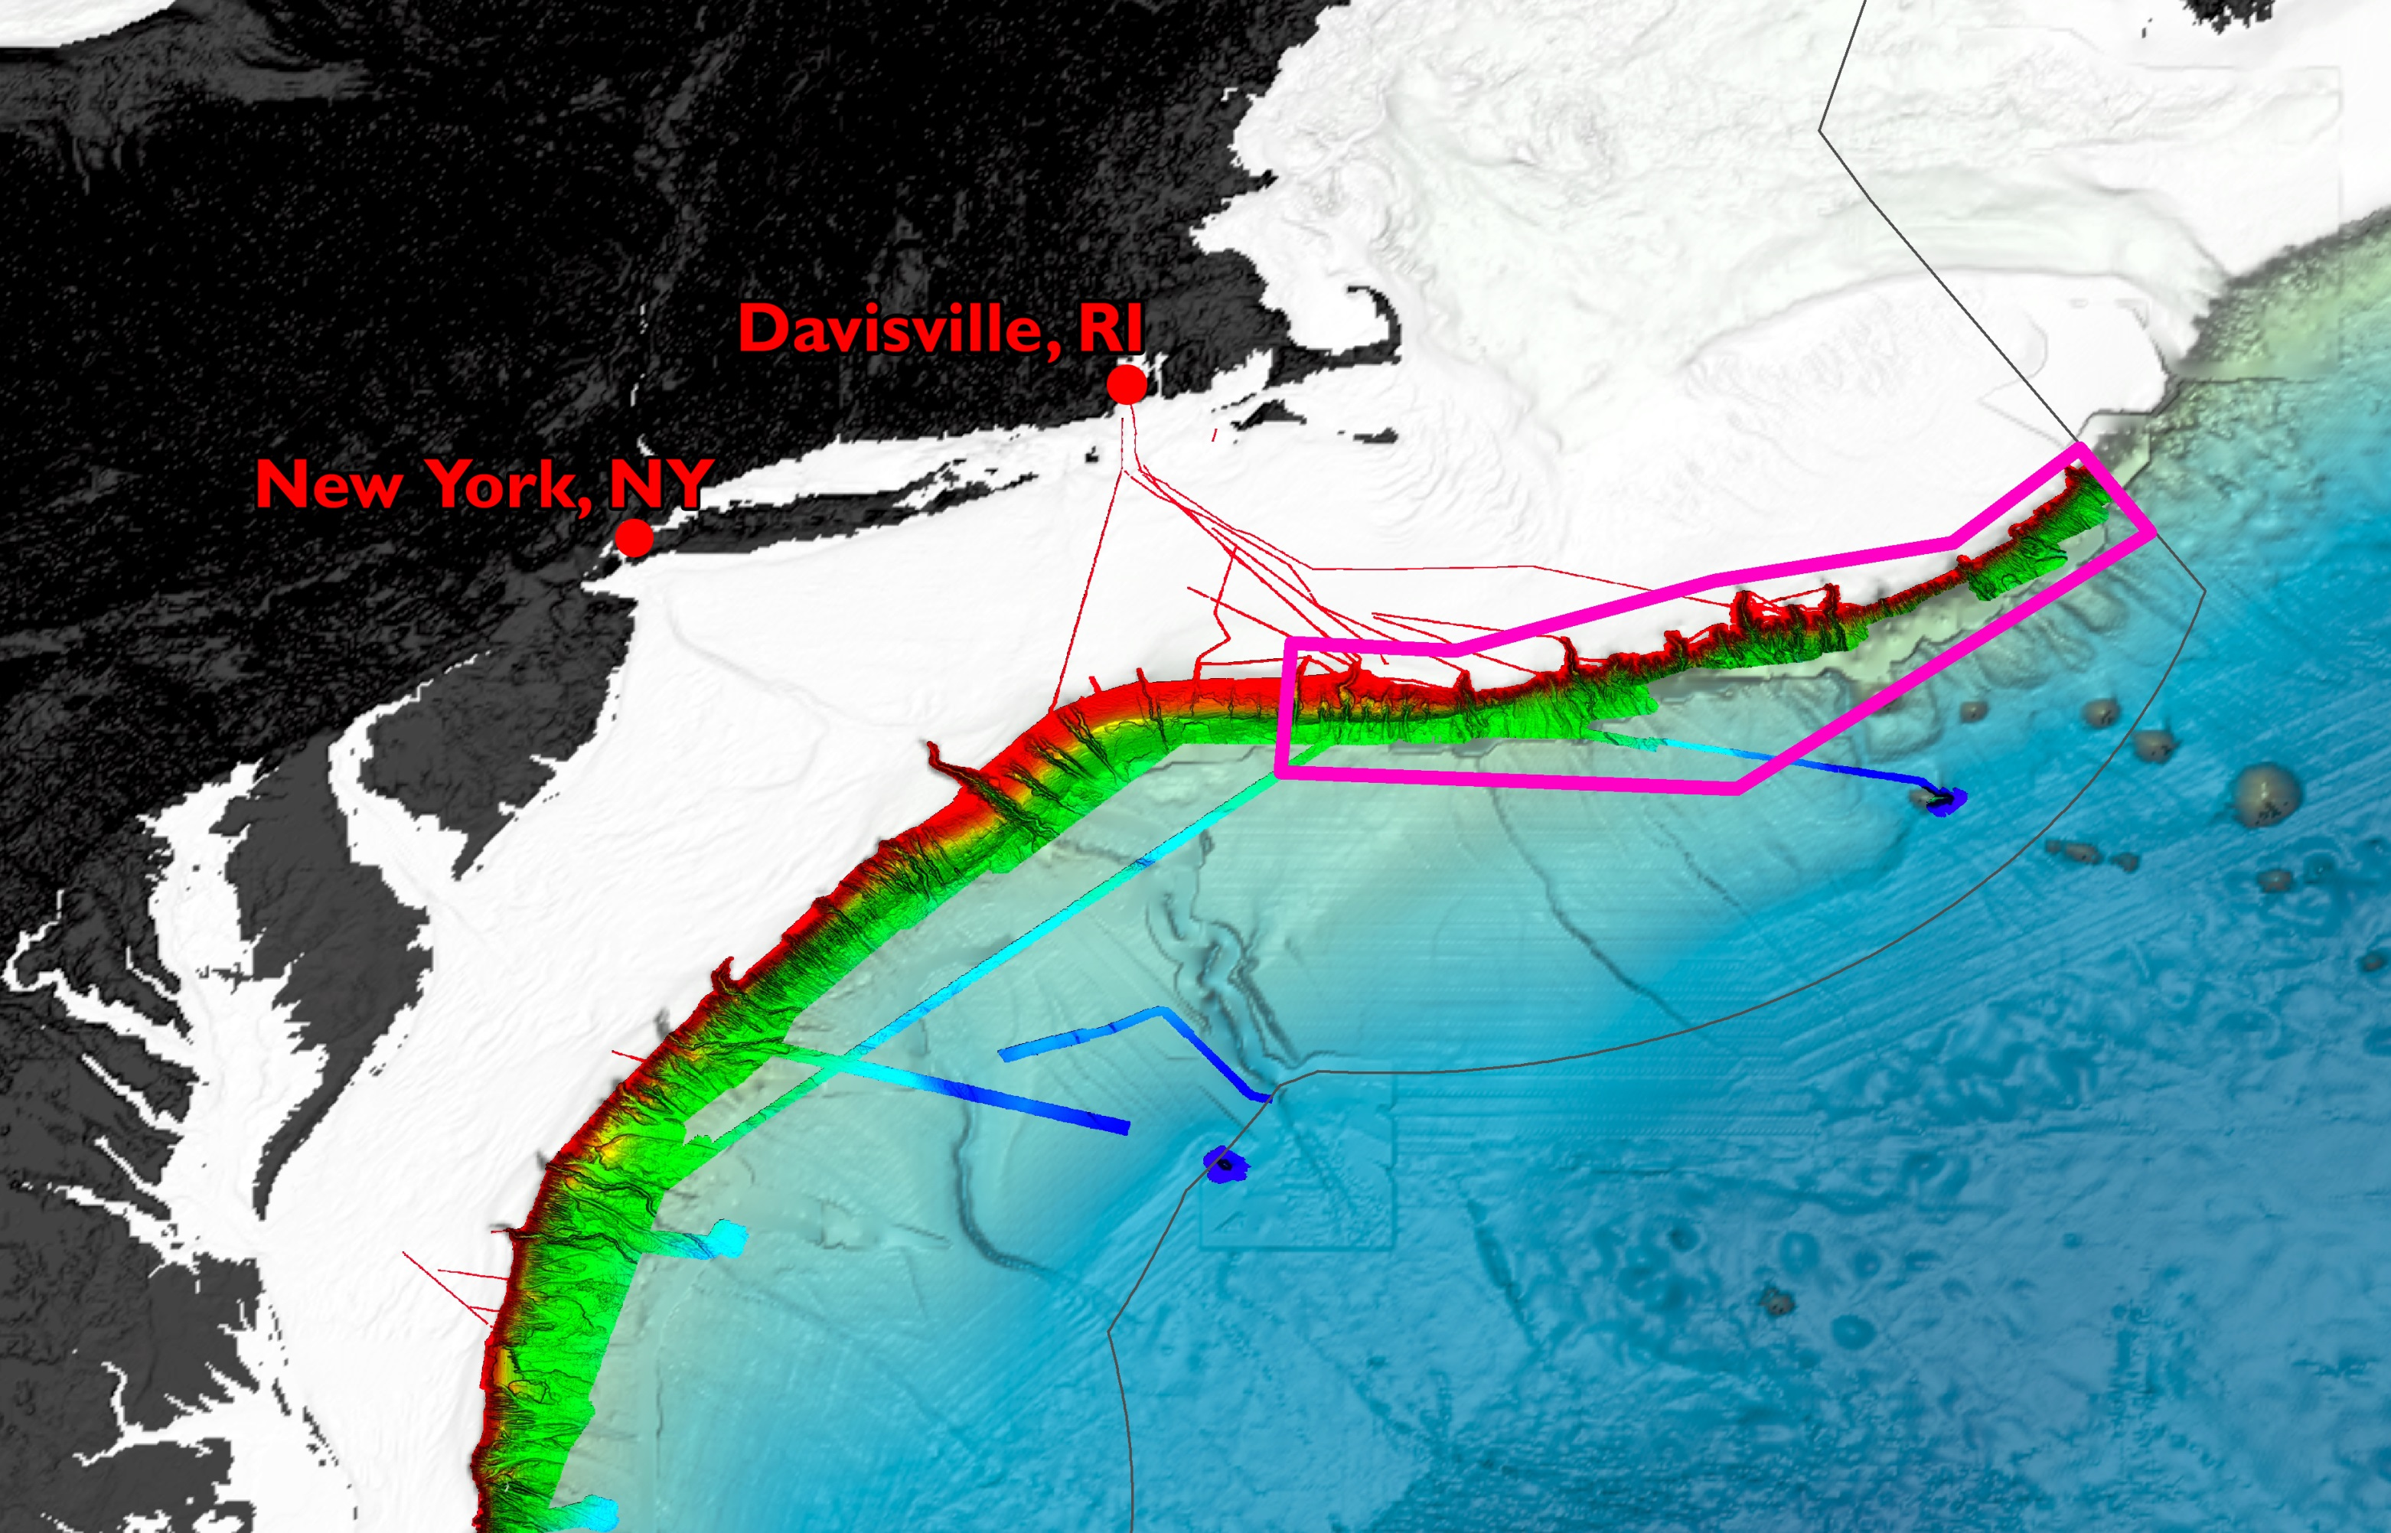
Figure 1: Map showing general operating areas for the 2013 Northeast U.S. Canyons Expedition outlined in black. Operations will focus on the Northeast U.S. Canyons and inter-canyon areas, generally from Block canyon northeast to the U.S./Canada EEZ, and include limited work at Mytilus Seamount. National 200nm EEZ boundaries are shown in grey to the east and southeast of the operating area in the image.

EX-13-04 OPERATIONS AREA COORDINATES
Northeast U.S. Canyons
Longitude | Latitude
-67.43208125793754 | 40.11646028506308
-66.74002166236402, | 40.31526751029698
-66.06497594448516 | 40.87806674760311
-66.35798214218225 | 41.2280258066647
-67.10452867979147 | 40.69818848442243
-68.16909767626105 | 40.54923280198276
-67.68020335719008 | 40.62432891985224
-69.07292741947616 | 40.27796000782733
71.51454116579484 | 40.07982728053273
71.38377341000627 | 39.54465047554448
-69.03357858440836 | 39.69188042058642
Mytilus Seamount
Longitude | Latitude
-67.26001674203761 | 39.29863934946352
-67.32765452934017 | 39.2348092869464
-67.04463929575896 | 39.4133880101565
-66.97100479592673 | 39.47148143405244
Table 1: Exploration area coordinates. Refer to Figure 1. Boundaries are approximate;
exploration activities can occur outside these boxes.

EX-13-04 efforts complement and continue the 2012 Atlantic Canyons Undersea Mapping Expeditions (ACUMEN). The 2012 series of five ACUMEN cruises (NOAA Ships Okeanos Explorer, Ferdinand Hassler and Henry B. Bigelow), and two Okeanos Explorer cruises since then gathered baseline information on deep water canyons off the northeastern U.S. seaboard, mapping along the continental shelf and slope from Virginia to the northeastern boundary of the U.S. Exclusive Economic Zone (EEZ) (see fig. 1). These mapping operations provide the basis for preliminary target selection, and enable EX-13-04 Legs I and II to commence the next steps in systematic ocean exploration, investigating deep water areas in and along the northeast canyons off the U.S. East Coast.

The May 2011 NOAA Workshop on Systematic Telepresence-Enabled Exploration in the Atlantic Basin (Summary Report available at http://explore.noaa.gov) identified canyons and seamounts as priority areas for systematic ocean exploration. Operating areas were further refined based on priority area input from other NOAA programs and the management community.

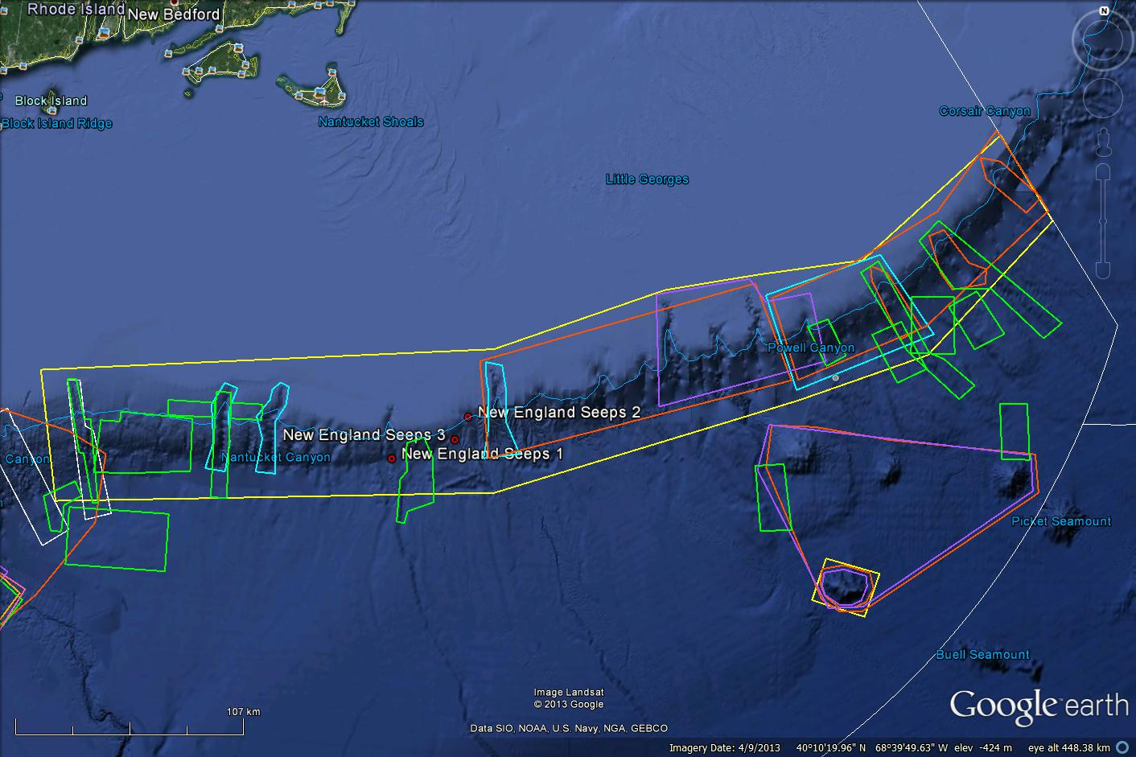
Figure 2: Google Earth map showing general priority areas for 2013 operations. The yellow boxes represent the general expedition operating areas shown in figure 1. Light blue boxes represent NOAA Deep Sea Coral Research and Technology Program priority areas. Purple boxes represent NOAA Office of National Marine Sanctuaries interests. The orange boxes represent Northeast Fisheries Management Council interests. Green boxes represent U.S. Geological Survey areas of interest. The red dots are the location of gas seeps detected by Okeanos Explorer’s EM302 multibeam sonar in 2012. White boxes represent planned work by NOAA Ship Bigelow. The white line is the U.S. EEZ. Image created in Google Earth.

- Summary of Objectives
There will be two mapping, ROV and telepresence-enabled cruises in July and August. Leg 1 will depart from North Kingstown, RI on July 8 and conduct operations focused on the western portion of the Northeast U.S. Canyons, pulling into New York, NY on July 25. Leg 2 will depart from New York, NY on July 31 and conduct operations focused on the eastern portion of the Northeast U.S. Canyons, pulling into North Kingstown, RI on August 17. The daily schedule for both cruises will usually be split between daytime ROV operations (>500m) and evening/night CTD rosette and mapping operations.

Leg I: JULY 8-25 (North Kingstown, RI to New York, NY) Mapping, ROV, and Telepresence
EX-13-04 Leg I operations will focus on the western portion of the operating area shown in figure 1. Priority exploration areas identified by the management community in this area (see figure 2) include: Block, Alvin, Atlantis and Hydrographer canyons, USGS landslide features southwest and southeast of Veatch canyon, unconfirmed New England seep sites, and inter-canyon areas.

Leg II: JULY 31–AUG 17 (New York, NY to North Kingstown, RI) Mapping, ROV, and Telepresence
EX-13-04 Leg II operations will focus on the northeastern portion of the operating area shown in figure 1. Priority exploration areas identified by the management community in this area (see figure 2) include: Oceanographer, Lydonia, Powell, Munson, Nygren and Heezen canyon and inter-canyon areas, and Mytilus Seamount. Limited work is expected at Oceanographer, Lydonia, Powell and Munson. Previous work has been conducted at Oceanographer and Lydonia canyons in the 1970’s and 80’s, and there is interest in dives here to conduct exploration in the time domain. A June 2013 cruise on NOAA Ship Henry B. Bigelow plans to explore for deep-sea corals at Powell and Munson, and EX-13-04 Leg II operations may augment that work.
Mission objectives for EX-13-04 Legs I and II include a combination of operational, science, education, outreach and data management objectives. They are:
- Science
  - Identify and explore the diversity of benthic habitats and features in the region (e.g. canyons, seamounts, landslide features, deep sea corals, seeps);
  - Locate and characterize underwater cultural heritage (possible for Leg II), e.g. shipwrecks (data will be used to assess their eligibility for the National Register of Historic Places); and
  - Ground-truth acoustic seep data and characterize associated habitat

- ROV
  - Test and use the ROV for telepresence-enabled exploration
  - Daytime ROV dives on exploration targets; and
  - Ongoing training of pilots; and
  - Ongoing system familiarization, documentation and training.
  - Refine communications protocols
  - Put 6000m ROV and Seirios camera platform through rigorous engineering tests.
  - Calibrate 6000m ROV navigational systems
  - Train pilots to take high quality images and navigate the new ROV
  - Continue to apply, develop and/or refine system checklists, SOPs, spares lists, etc.
  - Continue training in ROV launch and recovery operations
  - Continue to train bridge crew on ROV operations and use of dynamic positioning system (DP)

- Telepresence (VSAT 20 mb/sec ship-to-shore; T1 shore-to-ship)
  - Turn on and test terrestrial and high-speed satellite links; and
  - Test and refine ship-to-shore communications and operations procedures that engage multiple ECCs during the course of each cruise; and
  - Test and refine operating procedures and products; and
  - Engage a broad spectrum of the scientific community and public in telepresence-based exploration; and
  - Evaluate new video encoder models
  - Test/implement new protocols for accessing the ship’s wireless internet
  - Work with NOAA NOC to harden the video network path

- ECCs
  - Host a core team of scientists focused on ROV operations at the Inner Space Center and OSEC 115 classroom for the duration of at least one cruise; and
  - Prepare for and assess expectation of distributed participation from science community at multiple shore-side locations through telepresence; and
  - Train scientists on how to use online collaboration tools and technologies to conduct remote science; and
  - Refine/update SOPs; and
  - Ongoing system familiarization and training.

- Mapping Operations
- Complete ACUMEN mapping coverage of the northeast U.S. canyons , including multibeam holiday fill lines, canyon head development of Welker, Oceanographer, Chebacco, Lydonia, Powell, and Munson canyons; and
- Acquire water-column data with EK 60 and EM 302; and
- Acquire sub-bottom data as appropriate/required; and
- Conduct mapping operations during transit, with possible further development of exploration targets; and
- Conduct training of new mapping watchstanders.

- Collect data from ancillary sonar systems as permitted by staffing / operational paradigm
- EK60 single beam; and
- Knudsen sub-bottom profiler

- CTD operations
- Conduct CTD/rosette casts or tow-yo operations as needed to guide science operations; and
- Collect and freeze water samples opportunistically for inorganic nutrient samples (see appendix A). This does not require HAZMAT.

- XBT operations
  - During mapping operations, XBT casts will be collected at regular intervals of 2-4 hours or more often as data quality requires.

- Data Management
  - Provide a foundation of publicly accessible data and information products to spur further exploration, research, and management activities, as detailed in the 2013 post-cruise product list; and
  - Provide daily cumulative multibeam products to shore for operational decision making purposes, as detailed in the 2013 field products list; and
  - Test the ability to record all high definition video footage of a dive onboard the ship

- Participating Institutions
National Oceanic and Atmospheric Administration (NOAA) - Office of Ocean Exploration and Research (OER) - 1315 East-West Hwy, Silver Spring, MD 20910 USA

National Oceanic and Atmospheric Administration (NOAA) – Office of Habitat Conservation, Deep-Sea Coral Research and Technology Program – 1315 East-West Hwy, Silver Spring, MD 20910 USA

NOAA National Marine Fisheries Service Systematics Laboratory, Smithsonian Institution, Washington, DC 20013-7012

University of New Hampshire (UNH) - Center for Coastal and Ocean Mapping (CCOM) –
Jere A. Chase Ocean Engineering Lab, 24 Colovos Road, Durham, NH 03824 USA

University of Rhode Island, Graduate School of Oceanography, Inner Space Center, Narragansett, Rhode Island, 02882

NOAA, National Oceanographic Data Center, National Coastal Data Development Center, Stennis Space Center MS, 39529

University Corporation for Atmospheric Research (UCAR), Joint Office for Science Support (JOSS) PO Box 3000 Boulder, CO 80307

Woods Hole Oceanographic Institution MS24 Clark Laboratory, Woods Hole, MA 02543-1049

NOAA Pacific Marine Environmental Lab 7600 Sand Point Way NE, Seattle, WA 98115

U.S. Geological Survey, Woods Hole Science Center, 384 Woods Hole Road, Quissett Campus, Woods Hole, MA 02543-1598

U.S. Geological Survey, Southeast Ecological Science Center, 7920 NW 71st St., Gainesville, FL 32653

Temple University, Biology Life Sciences Building, Room 315, 1900 North 12th Street, Philadelphia, PA 19122

Texas A&M University, Department of Geography, College Station, TX 77843

- Personnel (Science Party)
Leg I: July 8-25 (North Kingstown, RI to New York, NY) Mapping, ROV, and Telepresence
 | NAME | AFFILIATION | ROLE | M/F | NATIONALITY
1 | Kelley Elliott | OER | Expedition Coordinator | F | US Citizen
2 | Andrea Quattrini | Temple/ UCAR | Science Team Lead | F | US Citizen
3 | Brendan Roark | TAMU | Scientist | M | US Citizen
4 | Brian Bingham | OER/UCAR | ROV Ops Manager | M | US Citizen
5 | Meme Lobecker | OER | Mapping Team Lead | F | US Citizen
6 | Webb Pinner | OER | Telepresence Lead | M | US Citizen
7 | Dave Wright | UCAR | ROV Team | M | US Citizen
8 | Jeff Williams | UCAR | ROV Team | M | US Citizen
9 | Bobby Mohr | UCAR | ROV Team | M | US Citizen
10 | Karl McLetchie | UCAR | ROV Team | M | US Citizen
11 | Tom Kok | UCAR | ROV Team | M | US Citizen
12 | Joshua Carlson | UCAR | ROV Team | M | US Citizen
13 | Roland Brian | UCAR | ROV Video Engineer | M | US Citizen
14 | Art Howard | UCAR | ROV Video Engineer | M | US Citizen
15 | Jeff Lanning | UCAR | ROV Team | M | US Citizen
16 | Anthony Sylvester | UCAR | ROV Team | M | US Citizen
17 | Jared Drewniak | UCAR | Telepresence/ Video/Data Engineer | M | US Citizen
18 | Brendan Reser | OER | Data Manager | M | US Citizen
19 | Annie Raymond | OCS | Mapping Watch Stander | F | US Citizen
20 | Kasey Cantwell | OER | Web Coordinator | F | US Citizen
Table 2: Full list of the science party and their affiliation

Leg I: Shore-side Participants (Location and duration of participation will vary)
REMOTE | NAME | INSTITUTION | ROLE | INTEREST | PARTICIPATION LEVEL
URI | Catalina Martinez | OER | RI Regional Manager | N/A | Core
URI | LTJG Brian Kennedy | OER | Operations Support | N/A | Core
URI | Dwight Coleman | URI/ISC | Technical support | N/A | Core
URI | Bob Sand | URI/ISC | Technical support | N/A | As needed
WHOI | Tim Shank | WHOI | Co-Science Team Lead | Ecology | Core
WHOI | Taylor Heyl | WHOI | Core Scientist | Biology | Core
WHOI | Santiago Herrera | WHOI | Biologists/Grad Students | Biology | Core - Daily
WHOI | Ellie Bors | WHOI | Biologists/Grad Students | Biology | Core - Daily
WHOI | Kelly Williams | Allegheny College | Biologists/Grad Students | Biology | Core - Daily
WHOI | Kerry McCulloch | U. Oregon | Biologists/Grad Students | Biology | Core - Daily
UNCW | Steve Ross | UNCW | Core Scientist | Ichthyology | Core
FSU | Sandra Brooke | FSU | Core Scientist | Deep-Sea Coral & chemosynthetic ecosystems | Core
Duke | Cindy Van Dover | Duke | Scientist | Seep Biology | Partial;  July 8-15
Woods Hole | Jason Chaytor | USGS | Marine Geology | All | Partial
Woods Hole | Uri Ten Brink | USGS | Marine Geology | All |  | Partial
Woods Hole | Carolyn Ruppel | USGS | Marine Geology | All | Background
Temple | Cordes Lab | Temple | Scientist (biology) | All | Partial
France | Lenaick Menot | IFREMER | Scientist | Canyons | Core – Daily
France | Inge van den Beld | IFREMER | Scientist | Canyons | Core – Daily
Etnoyer Lab | Peter Etnoyer | NOAA Charleston | Scientist (biology) | DDeep Sea Coral Habitat | Core – Daily
Etnoyer Lab | Stephen Roth | NOAA | Scientist (biology) | Deep Sea Coral Habitat | Core – Daily
Etnoyer Lab | Matthew Rittinghouse | NOAA | Scientist (biology) | Deep Sea Coral Habitat | Core – Daily
Etnoyer Lab | AJ Turner | College of Charleston | Scientist (biology) | Deep Sea Coral Habitat | Core – Daily
Etnoyer Lab | Holly Fowle | Temple University | Scientist (biology) | Deep Sea Coral Habitat | Core – Daily
Etnoyer Lab | Neah Baechler | College of Charleston | Scientist (geology) | Deep Sea Coral Habitat | Core – Daily
Etnoyer Lab | Enrique Salgado | JHT, Inc. | Scientist (biology) | Deep Sea Coral Habitat | Core – Daily
Washington, DC | Mike Vecchione | NMFS National Systematics Lab/ Smithsonian | Scientist (biology) | Cephalopods; Nekton; Pelagic Exploration | Core for Pelagic Exploration
LSU | Bob Carney | LSU | Scientist (biology) | Mud bottom fauna; sediment | Core
FAU | Shirley Pomponi | FAU/HBOI | Scientist (biology) | Sponges | Partial; On call
Gainesville, FL | Amanda Demopolous | USGS | Scientist (biology) | Benthic Ecologist | Partial
Richmond, VA | Jay Odell | TNC | Scientist (corals) | Management; Data Distribution | Doctor on Call
Gloucester, MA | David Stevenson | NOAA/NMFS/ Habitat Conservation Division | Scientist (oceanography; fisheries science) | Management; Deep-Sea Corals; Fisheries | Partial
URI | Rod Mather | URI | Scientist (marine archaeology) | Marine Archaeology | Doctor on Call
Herndon, VA | Brian Jordan | BOEM | Scientist (marine archaeology) | Marine Archaeology | Doctor on Call
Herndon, VA | James Moore | BOEM | Scientist (marine archaeology) | Marine Archaeology | Doctor on Call

Table 3: List of expected shore-side program and science participants during Leg I.
An individual’s location and level of participation is likely to change during the expedition. Not all will participate for the entire duration of the cruise. ‘Remote’ refers to non-ECC shore-side locations where we expect some robust participation.

Leg II: July 31-August 17 (New York, NY to North Kingstown, RI) Mapping, ROV, and Telepresence
 | Name | Affiliation | Position | M/F | Status
1 | LTJG Brian Kennedy | OER | Expedition Coordinator | M | US Citizen
2 | Amanda Demopolous | USGS | Science Team Lead | F | US Citizen
3 | Martha Nzinski | NMFS/SI | Scientist | F | US Citizen
4 | Adam Skarke | OER | Mapping Team Lead | M | US Citizen
5 | TBD | UCAR | Mapping Watchstander | M | US Citizen
6 | Dave Lovalvo | OER | ROV Team Lead | M | US Citizen
7 | Webb Pinner | OER | Telepresence Lead | M | US Citizen
8 | Dave Wright | UCAR | ROV Team | M | US Citizen
9 | Jeff Williams | UCAR | ROV Team | M | US Citizen
10 | Bobby Mohr | UCAR | ROV Team | M | US Citizen
11 | Karl McLetchie | UCAR | ROV Team | M | US Citizen
12 | Tom Kok | UCAR | ROV Team | M | US Citizen
13 | Josh Carlson | UCAR | ROV Team | M | US Citizen
14 | Brian Bingham? | UCAR | ROV Team | M | US Citizen
15 | TBD | UCAR | ROV Team | M | US Citizen
16 | Roland Brian | UCAR | ROV Video Engineer | M | US Citizen
17 | Joe Biscotti? | UCAR | ROV Video Engineer | M | US Citizen
18 | Art Howard? | UCAR | ROV Video Engineer | M | US Citizen
19 | TBD | UCAR | Video/Data Engineer | M | US Citizen
20 | TBD |  |  | M | US Citizen
Table 4: Full list of the science party and their affiliation

Leg II: Shore-side Participants (Location and duration of participation will vary)
ECC | NAME | INSTITUTION | ROLE | INTEREST | LEVEL PARTICIPATION
URI | Catalina Martinez | OER | RI Regional Manager | N/A | Core
URI | Kelley Elliott | OER | ECC Coordinator / Operations Support | N/A | Core
URI | Dwight Coleman | URI/ISC | Technical support | N/A | Core
URI | Steve Damas | UCAR | Video Broadcast Engineer | Focused on video for OER | Core
URI | Eric Geiger? | URI | Mapping/GIS Specialist | N/A | Core
URI | Emily Crum | OER | Web Coordinator/ ArcGIS | N/A | Core
URI | Brendan Reser | NGDDC | Data Manager | US | N/A
URI | Jared Drewniak | OER | Video broadcast engineer | US | N/A
URI | Nicola VerPlanck | OER | EX Operations Manager | US | N/A
URI | Adam Boyette | NGDDC | Data Manager | US | N/A
URI | Jamie Austin | UT, Austin | Core Scientist | Marine Geology | Core
URI | Peter Auster | UCONN | Core Scientist | Marine Biology | Partial
URI | Morgan Kilgour | UCONN Postdoc | Core Scientist | Marine Biology | Core
URI | Rod Mather | URI | Scientist | Marine Archaeology | Doctor-on-Call.
SS | Frank Cantelas | NOAA OER | Scientist | Marine Archaeology |  | Doctor-on-Call
REMOTE | NAME | INSTITUTION | ROLE | REGION OF INTEREST | PARTICIPATION LEVEL
WHOI | Tim Shank | WHOI | Co-Science Team Lead | Ecology | Core/Partial
WHOI | Taylor Heyl | WHOI | Core Scientist | Biology | Core
WHOI | Santiago Herrera | WHOI | Biologists/Grad Students | Biology | Core
WHOI | Ellie Bors | WHOI | Biologists/Grad Students | Biology | Core
WHOI | Kelly Williams | Allegheny College | Biologists/Grad Students | Biology | Core
WHOI | Kerry McCulloch | U. Oregon | Biologists/Grad Students | Biology | Core
Woods Hole | Daniel Brothers | USGS | Core Scientist | Marine Geology | Core/Partial
USGS | Uri Ten Brink | USGS | Core Scientist | Marine Geology | Partial
UNCW | Steve Ross | UNCW | Core Scientist | Ichthyology | Core
FAU | Sandra Brooke | FSU | Core Scientist | Deep-Sea Coral & chemosynthetic ecosystems | Core/Partial
Temple | Cordes Lab | Temple | Scientist (biology) | All | Core/Partial
Etnoyer Lab | Peter Etnoyer | NOAA Charleston | Scientist (biology) | DDeep Sea Coral Habitat | Core
Etnoyer Lab | Stephen Roth | NOAA | Scientist (biology) | Deep Sea Coral Habitat | Core
Etnoyer Lab | Matthew Rittinghouse | NOAA | Scientist (biology) | Deep Sea Coral Habitat | Core
Etnoyer Lab | AJ Turner | College of Charleston | Scientist (biology) | Deep Sea Coral Habitat | Core
Etnoyer Lab | Holly Fowle | Temple University | Scientist (biology) | Deep Sea Coral Habitat | Core
Etnoyer Lab | Neah Baechler | College of Charleston | Scientist (geology) | Deep Sea Coral Habitat | Core
Etnoyer Lab | Enrique Salgado | JHT, Inc. | Scientist (biology) | Deep Sea Coral Habitat | Core
Washington, DC | Mike Vecchione | NMFS National Systematics Lab/ Smithsonian | Scientist (biology) | Cephalopods; Nekton; Pelagic Exploration | Core for Pelagic Exploration
LSU | Bob Carney | LSU | Scientist (biology) | Mud bottom fauna; sediment | Core
Ft. Lauderdale, FL | Charles Messing | NOVA Southeastern University | Scientist (biology) | Crinoids | Partial
FAU | Shirley Pomponi | FAU/HBOI | Scientist (biology) | Sponges | Partial; On call
Richmond, VA | Jay Odell | TNC | Scientist (corals) | Management; Data Distribution | Doctor on Call
Gloucester, MA | David Stevenson | NOAA/NMFS/ Habitat Conservation Division | Scientist (oceanography; fisheries science) | Management; Deep-Sea Corals; Fisheries | Partial
Highlands, NJ | Dave Packer | NOAA/NMFS/ NEFSC Deep-Sea Coral Research & Technology Team | Scientist (oceanography; fisheries science) | Management; Deep-Sea Corals; Fisheries | Partial;  Aug. 13-16.  Location TBD.  Possibly ECC.
URI | Rod Mather | URI | Scientist (marine archaeology) | Marine Archaeology | Doctor on Call
Herndon, VA | Brian Jordan | BOEM | Scientist (marine archaeology) | Marine Archaeology | Doctor on Call
Herndon, VA | James Moore | BOEM | Scientist (marine archaeology) | Marine Archaeology | Doctor on Call

Table 5: An individual’s location and level of participation is likely to change during the expedition. Not all will participate for the entire duration of the cruise. ‘Remote’ refers to locations non-ECC shore-side locations where we expect some robust participation.

- Administrative

Key Points of Contact:

Ship Operations

Marine Operations Center, Atlantic (MOA)  439 West York Street  Norfolk, VA 23510-1145  Telephone: (757) 441-6776  Fax: (757) 441-6495 | Acting Chief, Operations Division, Atlantic (MOA)  LTJG Laura Gibson, NOAA  Telephone: (757) 441-6842  E-mail: ChiefOps.MOA@noaa.gov

Mission Operations

Kelley Elliott  Expedition Manager/Leg I Expedition Coordinator  NOAA Office of Ocean Exploration  Phone: (301) 734-1024/ (703) 927-5449  Email: Kelley.Elliott@noaa.gov  LTJG Brian Kennedy, NOAA  Leg II Expedition Coordinator  NOAA Ocean Exploration and Research  Phone: (401) 874-6150/ (706) 540-2664  Email: Brian.Kennedy@noaa.gov | CDR Ricardo Ramos, NOAA  Commanding Officer  NOAA Ship Okeanos Explorer  Phone: (401) 378-8284  Email: CO.Explorer@noaa.gov  LT Laura Gallant, NOAA  Operations Officer  NOAA Ship Okeanos Explorer  Phone: (207) 240-0957 (c)  E-mail: Ops.Explorer@noaa.gov

Other Mission Contacts
Craig Russell, EX Program Manager  NOAA Ocean Exploration & Research  Phone: 206-526-4803 / 206-518-1068  E-mail: Craig.Russell@noaa.gov  Dave Lovalvo, ROV Program Manager  Eastern Oceanics  Phone: 203-246-5531  Email: David.Lovalvo@noaa.gov | John McDonough, Deputy Director  NOAA Ocean Exploration & Research  Phone: 301-734-1023 / 240-676-5206  E-mail: John.McDonough@noaa.gov  LCDR Nicola VerPlanck, NOAA  NOAA Ocean Exploration & Research  Phone: 206-526-4801 / 401-603-6017  E-mail: Nicola.Verplanck@noaa.gov
Meme Lobecker, Mapping Lead  NOAA Ocean Exploration & Research (ERT, Inc.)  Phone: 603-862-1475/ 401-662-9297  E-mail: elizabeth.lobecker@noaa.gov  Adam Skarke, Mapping Lead  NOAA Ocean Exploration & Research (ERT, Inc.)  Phone: 603-862-0369/ 302-981-9908  E-mail: Adam.Skarke@noaa.gov | Webb Pinner, Telepresence Lead  NOAA Office of Ocean Exploration & Research  Phone: (401) 874-6250 (o) / (401) 330-9662 (c)  Email: Webb.Pinner@noaa.gov  Catalina Martinez, Regional Manager  NOAA Office of Ocean Exploration & Research  Phone: (401) 874-6250 (o) / (401) 330-9662 (c)  Email: Catalina.Martinez@noaa.gov

Shipments

Be sure to send an email to Okeanos Explorer Operations Officer, LT Laura Gallant at OPS.Explorer@noaa.gov indicating the size and number of items being shipped and the name of the person it is being shipped to. All items should arrive at North Kingstown, RI prior to COB July 05, 2013.

Vessel shipping address:

ATTN: Operations Officer
NOAA Ship Okeanos Explorer
2578 Davisville Rd.
North Kingstown, RI 02852

Shipping information for the inport period in New York, NY is pending.
- Diplomatic Clearances
NOT APPLICABLE TO THIS CRUISE
- Licenses and Permits
See appendix B for categorical exclusion documentation

- OPERATIONS
- Cruise Plan Itinerary (All times and dates are subject to prevailing conditions and the discretion of the commanding officer)
Leg I: JULY 8-25 (North Kingstown, RI to New York, NY) Mapping, ROV, and Telepresence
Primary operations are expected to focus on the western area of the EX-13-04 operating area box shown in figure 1. Daily schedule will usually be split between daytime ROV operations (>500m) and nightly multibeam surveys and opportunistic daytime subbottom profiler surveys. Night operations may include occasional CTD casts.

Date | Operations | Remarks
7/05 | Telepresence/VSAT Turn up and Test Operations Begin | Pending VSAT bandwidth and terrestrial link established.
07/05-07/07 | Mission party arrives on the ship
07/08 | Ship transits from North Kingstown, RI to working grounds | Acquire data during transit
07/09-07/24 | Conduct operations in vicinity of western operating area | First ROV dive expected on 07/09.
07/19-07/21 | Ocean Exploration 2020: A National Forum | First ever national forum on ocean exploration, hosted at the Aquarium of the Pacific in Long Beach, CA and facilitated by OER. Telepresence interaction detailed on specific dates.
07/20, 1:30 PM EDT | National Forum Telepresence Event: Introduction of NOAA Ship Okeanos Explorer and EX-13-04 Expedition to participants. | ~10 min telepresence event with the National Forum on Ocean Exploration at the Aquarium of the Pacific in Long Beach, CA. I-2 connection at conference venue unlikely. 3-hr time difference with ship.
07/21, 12 – 8 PM EDT | National Forum Telepresence Event: Interactions with the public throughout the day.  Dive at interesting location. | A series of ~15-30 minute interactions with the public located at the Aquarium of the Pacific in Long Beach, CA. I-2 connection at conference venue unlikely. 3-hr time difference with ship.
07/24 | Following ROV dive, depart working grounds and transit toward New York, NY | Acquire data during transit
07/25 | Arrive New York, NY
07/26 | Possible VIP Ship Tours | (Pending Port determination)
07/27 | Possible limited public ship tours | (Pending Port determination)
Table 6: Approximate schedule of Leg I operations.

Leg II: JULY 31–AUG 17 (New York, NY to North Kingstown, RI) Mapping, ROV, and Telepresence
Primary operations are expected to focus on the eastern area of the EX-13-04 operating area box shown in figure 1. Daily schedule will usually be split between daytime ROV operations (>500m) and nightly multibeam surveys. Night operations may include occasional CTD casts.

Date | Operations | Remarks
07/29-07/30 | Mission party arrives on the ship
07/31 | Ship transits from New York, NY to working grounds | Acquire data during transit
08/01 | Conduct ROV dive in western operating area | First ROV dive expected on 08/01.Continue transit west post-dive; acquire data during transit
08/02-08/16 | Conduct operations in vicinity of eastern operating area | First ROV dive expected on 08/01.
TBD | Conduct operations at Mytilus seamount
08/16 | Following ROV dive, depart working grounds and transit toward North Kingstown, RI | Acquire data during transit
08/17 | Arrive North Kingstown, RI
08/18-08/20 | De-staging | De-terminate and remove the ROV. Remove the ROV A-frame block and secure the .68 cable. Remove all OER electronics and counter coverings from the wet lab.
Table 7: Approximate schedule of Leg II operations.
- Telepresence Events
In addition to the National Forum Telepresence Event, several additional telepresence events with the Exploratorium and for the explorationnow.org website may be conducted. Live feeds would be streamed to shore, and someone on the ship would speak to shore-side participants from the control room.
- In-Port Events
A VIP in port event in New York, NY is anticipated, along with limited public ship tours, however OER is waiting for a port to be identified to flesh out the goals of the event.
- Staging and Destaging
Staging

Minimal staging will be required prior to leg I. The majority of the ROV components are still stored aboard from the ROV shakedown cruise in May. Some crane and forklift assistance will be required to move the overhauled thrusters and other moderate sized items from the port office to the ship.

Destaging
At the conclusion of leg II the camera sled will be de-terminated and removed from the ship. The ROV will also be removed during the in port. The .68 cable block will be removed from the A-Frame and the .68 cable secured. OER electronics and wooden counter tops will be removed from the wet lab to accommodate NMFS equipment for the following leg. Due to the quick turnaround before the NMFS ECOMON cruise full support maybe required from the ship force during the inport including weekends to allow OER to de mobilize while leaving NMFS enough time to mobilize their equipment unencumbered by OER operations.
- Sonar Operations
Mapping Operations
Continuous EM 302 and EK 60 data acquisition is planned for this cruise. All data acquisition will be conducted in accordance with established standard operating procedures under the direction of the mapping team lead.
- Dive Plan
NOT APPLICABLE TO THIS CRUISE
- Applicable Restrictions
Conditions that preclude normal operations:

Weather will be the biggest potential hindrance to operations during this cruise. ROV launch and recovery can be limited by even moderate weather and current conditions.

Knudsen sub-bottom profiler night operations are not possible due to audible noise within the vessels living quarters. When possible, Knudsen sub-bottom profiler will be operated during daytime hours (0800-2000) to minimize impact of excessive noise on the crew. The final decision to operate and collect sub-bottom profiler data will be at the discretion of the Commanding Officer.

- EQUIPMENT
- Equipment and capabilities provided by the ship
- Kongsberg Simrad EM302 Multibeam Echosounder (MBES)
- Kongsberg Simrad EK60 Deepwater Echosounder
- Knudsen Chirp 3260 Sub-bottom profiler (SBP)
- LHM Sippican XBT (various probes)
- Seabird SBE 911Plus CTD
- Seabird SBE 32 Carousel and 24 2.5 L Niskin Bottles
- Light Scattering Sensor (LSS)
- Oxidation – Reduction Potential (ORP)
- Dissolved Oxygen (DO) sensor
- Altimeter Sensor and battery pack
- CNAV GPS
- POS/MV
- Seabird SBE-45 (Micro TSG)
- Kongsberg Dynamic Positioning-1 System
- NetApps mapping storage system
- CARIS HIPS Software
- IVS Fledermaus Software
- SIS Software
- Hypack Software
- Scientific Computing System (SCS)
- ECDIS
- Met/Wx Sensor Package
- Telepresence System
- Cruise Information Management System (CIMS)
- VSAT High-Speed link (20mbps ship to shore; T1 shore to ship)
- NOAA OER 6000m ROV
- NOAA Seirios Camera Platform

- Equipment and capabilities provided by the scientists
Solar Light Company Microtops II Sun Photometer. Provided by NASA Maritime Aerosol Network Program (See section V subsection A “Supplementary Projects” for details)
- HAZARDOUS MATERIALS
- Policy and Compliance
The Expedition Coordinator is responsible for complying with MOCDOC 15, Fleet Environmental Compliance #07, Hazardous Material and Hazardous Waste Management Requirements for Visiting Scientists, released July 2002. Documentation regarding those requirements will be provided by the Chief of Operations, Marine Operations Center, upon request.
By Federal regulations and NOAA Marine and Aviation Operations policy, the ship may not sail without a complete inventory of all hazardous materials by name and the anticipated quantity brought aboard, MSDS and appropriate neutralizing agents, buffers, and/or absorbents in amounts adequate to address spills of a size equal to the amount of chemical brought aboard. The amount of hazardous material arriving and leaving the vessel shall be accounted for by the Expedition Coordinator.
- Radioactive Isotopes
NOT APPLICABLE TO THIS CRUISE
- Inventory
NOT APPLICABLE TO THIS CRUISE

- ADDITIONAL PROJECTS
- Supplementary Projects
NASA Maritime Aerosol Network

During the cruise the marine aerosol layer observations will be collected for the NASA Maritime Aerosol Network (MAN). Observations will be made by mission (mapping interns) or bridge watch standers with a sun photometer instrument provided by the NASA MAN program. Resulting data will be delivered to the NASA MAN primary investigator Alexander Smirnov by the expedition coordinator. All collected data will be archived and publically available at: http://aeronet.gsfc.nasa.gov/new_web/maritime_aerosol_network.html
- NOAA Fleet Ancillary Projects
NOT APPLICABLE TO THIS CRUISE

- DISPOSITION OF DATA AND REPORTS
- Data Responsibilities
All data acquired on Okeanos Explorer will be provided to the public archives without proprietary rights. All data management activities shall be executed in accordance with NAO 212-15, Management of Environmental and Geospatial Data and Information [http://www.corporateservices.noaa.gov/ames/administrative_orders/chapter_212/212-15.html].

Ship Responsibilities
The Commanding Officer is responsible for all data collected for missions until those data have been transferred to mission party designees. Data transfers will be documented on NOAA Form 61-29. Reporting and sending copies of project data to NESDIS (ROSCOP form) is the responsibility of OER.

NOAA OER Responsibilities
The Expedition Coordinator will work with the Okeanos Explorer Operations Officer to ensure data pipeline protocols are followed for final archive of all data acquired on Okeanos Explorer without proprietary rights.

Deliverables
  - At sea
      - Daily plans of the Day (POD)
      - Daily situation reports (SITREPS)
      - Daily summary bathymetry data files
      - On an extremely limited, as appropriate/required for operational decision making purposes: daily draped bottom backscatter products, EK 60 and EM 302 water column data products, sub-bottom vertical curtains.
      - ROV dive track providing ROV position and depth
      - Raw video clips from ROV dives, onboard cameras
      - Still image frame grabs from underwater video; topside still images
      - Daily “eventlog” files, including hourly updates detailing ongoing ship operations
      - Regular cruise logs providing the context of a given day at sea or at an ECC
  - Post cruise
      - Refined SOPs for all pertinent operational activities
      - Assessments of all activities
  - Science
- Multibeam and XBT raw and processed data (see appendix C for the formal cruise data management plan)
- ROV dive site maps
- ROV dive summaries
- CTD/rosette operation summaries
- HD footage archived at the NOAA Central Library
- Video products
- Highlight images with descriptive captions
- Raw CTD data
- Quick Look Report
- Mapping data report
- Cruise Report

Archive
- The Program and ship will work together to ensure documentation and
stewardship of acquired data sets in accordance with NAO 212-15. The Cruise Information Management System is the primary tool used to accomplish this activity.
- Pre and Post Cruise Meeting
Pre-Cruise Meeting
Prior to departure, the Operation’s Officer will conduct a meeting of the scientific party to inform them of cruise objectives and vessel protocols, e.g., meals, watches, etiquette, etc.
Post-Cruise Meeting
Upon completion of the cruise, a meeting will be held by the Operation’s Officer and attended by the ship’s Survey Technicians, the Expedition Coordinator and members of the scientific party to review the cruise. Concerns regarding safety, efficiency, and suggestions for improvements for future cruises should be discussed.
Shipboard Meetings
Daily Operations Briefing meetings will be held at 1500 in the forward lounge to review the current day, and define operations, associated requirements and staffing needs for the following day. A Plan of the Day (POD) will be posted each evening for the next day in specified locations throughout the ship. A safety brief and overview of POD will occur on the Bridge each morning at 0800. Daily Situation Reports (SITREPS) will be posted as well and shared daily through e-mail and/or the EX PLONE site ( http://tethys.gso.uri.edu/OkeanosExplorerPortal ).
- Ship Operation Evaluation Report
Within seven days of the completion of the cruise, a Ship Operation Evaluation form is to be completed by the Expedition Coordinator and lead scientist. The preferred method of transmittal of this form is via email to OMAO.Customer.Satisfaction@noaa.gov. If email is not an option, a hard copy may be forwarded to:
Director, NOAA Marine and Aviation Operations
NOAA Office of Marine and Aviation Operations
8403 Colesville Road, Suite 500
Silver Spring, MD 20910

- MISCELLANEOUS
- Meals and Berthing
Meals and berthing are required for up to 20 mission personnel. Meals will be served 3 times daily beginning one hour before scheduled departure, extending throughout the cruise, and ending two hours after the termination of the cruise. Since the watch schedule is split between day and night, the night watch may often miss daytime meals and will require adequate food and beverages (for example a variety of sandwich items, cheeses, fruit, milk, juices) during what are not typically meal hours. Special dietary requirements for scientific participants will be made available to the ship’s command at least twenty-one days prior to the survey (e.g., Expedition Coordinator is allergic to fin fish). Berthing requirements, including number and gender of the scientific party, will be provided to the ship by the Expedition Coordinator. The Expedition Coordinator and Operations Officer will work together on a detailed berthing plan to accommodate the gender mix of the scientific party taking into consideration the current make-up of the ship’s complement. The Expedition Coordinator is responsible for ensuring the scientific berthing spaces are left in the condition in which they were received; for stripping bedding and linen return; and for the return of any room keys which were issued. The Expedition Coordinator is also responsible for the cleanliness of the laboratory spaces and the storage areas utilized by the scientific party, both during the cruise and at its conclusion prior to departing the ship.
All NOAA scientists will have proper travel orders when assigned to any NOAA ship. The Expedition Coordinator will ensure that all non NOAA or non Federal scientists aboard also have proper orders. It is the responsibility of the Expedition Coordinator to ensure that the entire scientific party has a mechanism in place to provide lodging and food and to be reimbursed for these costs in the event that the ship becomes uninhabitable and/or the galley is closed during any part of the scheduled project.
All persons boarding NOAA vessels give implied consent to comply with all safety and security policies and regulations which are administered by the Commanding Officer. All spaces and equipment on the vessel are subject to inspection or search at any time. All personnel must comply with OMAO's Drug and Alcohol Policy dated May 7, 1999 which forbids the possession and/or use of illegal drugs and alcohol aboard NOAA Vessels.
- Medical Forms and Emergency Contacts
The NOAA Health Services Questionnaire (NHSQ, Revised: 12/11) must be completed in advance by each participating scientist. The NHSQ can be obtained from the Expedition Coordinator or the NOAA website at NOAA HEALTH SERVICES QUESTIONNAIRE. The completed form should be sent to the Regional Director of Health Services at Marine Operations Center. The participant can mail, fax, or scan the form into an email using the contact information below. The NHSQ should reach the Health Services Office no later than 4 weeks prior to the cruise to allow time for the participant to obtain and submit additional information that health services might require before clearance to sail can be granted. Please contact MOC Health Services with any questions regarding eligibility or completion of the NHSQ. Be sure to include proof of tuberculosis (TB) testing, sign and date the form, and indicate the ship or ships the participant will be sailing on. Clearances are valid for 2 years for personnel under age 50 and 1 year for age 50 and over. All PPD’s expire after one year from the date of administration. The participant will receive an email notice when medically cleared to sail if a legible email address is provided on the NHSQ.
Contact information:
Regional Director of Health Services
Marine Operations Center – Atlantic
439 W. York Street
Norfolk, VA 23510
Telephone 757.441.6320
Fax 757.441.3760
E-mail: MOA.Health.Services@noaa.gov
Please make sure the medical.explorer@noaa.gov email address is cc’d on all medical correspondence.
Prior to departure, the Expedition Coordinator must provide a listing of emergency contacts to the Operations Officer for all members of the scientific party, with the following information: name, address, relationship to member, and telephone number.
Emergency contact form is included as Appendix D.
- Shipboard Safety
Wearing open-toed footwear or shoes that do not completely enclose the foot (such as sandals or clogs) outside of private berthing areas is not permitted. Steel-toed shoes are required to participate in any work dealing with suspended loads, including CTD deployments and recovery. The ship does not provide steel-toed boots. Hard hats are also required when working with suspended loads. Work vests are required when working near open railings and during small boat launch and recovery operations. Hard hats and work vests will be provided by the ship when required.
Operational Risk Management: For every operation to be conducted aboard the ship (NOAA-wide initiative), risk management procedures will be followed. For each operation, risks will be identified and assessed for probability and severity. Risk mitigation strategies / measures will be investigated and implemented where possible. After mitigation, the residual risk will have to be assessed to make Go-No Go decisions for the operations. Particularly with new operations, risk assessment will be ongoing and updated as necessary. This does not only apply to over-the-side operations, but to everyday tasks aboard the vessel that pose risk to personnel and property.
- CTD, ROV (and other pertinent) ORM documents will be followed by all personnel working on board Okeanos Explorer.
- All personnel on board are in the position of calling a halt to operations/activities in the event of a safety concern.
- Communications
A daily situation report (SITREP) on operations prepared by the Expedition Coordinator will be relayed to the program office. Sometimes it is necessary for the Expedition Coordinator to communicate with another vessel, aircraft, or shore facility. Through various modes of communication, the ship is able to maintain contact with the Marine Operations Center on an as needed basis. These methods will be made available to the Expedition Coordinator upon request, in order to conduct official business. The ship’s primary means of communication with the Marine Operations Center is via e-mail and the Very Small Aperture Terminal (VSAT) link. Standard VSAT bandwidth at 128kbs is shared by all vessels staff and the science team at no charge. Increased bandwidth in 30 day increments is available on the VSAT systems at increased cost to the scientific party. If increased bandwidth is being considered, program accounting is required it must be arranged at least 30 days in advance.
Specific information on how to contact Okeanos Explorer and all other fleet vessels can be found at: http://www.moc.noaa.gov/phone.htm

Important Telephone and Facsimile Numbers and E-mail Addresses

Ocean Exploration and Research (OER):
OER Program Administration:
Phone: (301) 734-1010
Fax: (301) 713-4252
E-mail: Firstname.Lastname@noaa.gov

University of New Hampshire, Center for Coastal and Ocean Mapping
Phone: (603) 862-3438
Fax: (603) 862-0839

NOAA Ship Okeanos Explorer - Telephone methods listed in order of increasing expense:

EX Cellular: (401) 378-7947
EX Iridium: (808) 659-9179
OER Mission Iridium (dry lab): (808) 851-3827

EX INMARSAT B
Line 1: 011-872-764-852-328
Line 2: 011-872-764-852-329

Voice Over IP (VoIP) Phone:
301-713-7772 (expect a delay once picked up by directory)

E-Mail: Ops.Explorer@noaa.gov - (mention the person’s name in SUBJECT field)

expeditioncoordinator.explorer@noaa.gov - For dissemination of all hands emails by Expedition Coordinator while on board. See ET for password.
- IT Security
Any computer that will be hooked into the ship's network must comply with the NMAO Fleet IT Security Policy prior to establishing a direct connection to the NOAA WAN. Requirements include, but are not limited to:
- Installation of the latest virus definition (.DAT) file on all systems and performance of a virus scan on each system.
- Installation of the latest critical operating system security patches.
- No external public Internet Service Provider (ISP) connections.
Completion of these requirements prior to boarding the ship is required.
Non-NOAA personnel using the ship's computers or connecting their own computers to the ship's network must complete NOAA’s IT Security Awareness Course within 3 days of embarking.

- Foreign National Guests Access to OMAO Facilities and Platforms
NOT APPLICABLE TO THIS CRUISE

Appendix A – Hydrographic Observations
NOAA Northeast Fisheries Science Center
Primary Contact: Jon Hare (jon.hare@noaa.gov)

The Oceanography Branch is interested in supporting cruise participants to obtain hydrographic data from the study region. This information will assist also us to assess broad-scale ecosystem properties and implications for fisheries. The Okeanos Explorer has a SeaBird CTD and rosette. We request that:
- A NEMA string be provided to the CTD computer so that location is captured in the CTD data file;
- The CTD be outfitted with the following additional sensors: Dissolved Oxygen (DO), Oxygen Reduction Potential (ORP) and Altimeter;
- Water samples be taken at the following depths: surface, 20m, 50m, 100m, 200m, 300m, 400m, 500m and near the bottom. (A protocol, log sheets, and supplies for collecting the nutrients samples from the water bottles will be provided.
- All CTD data (hex files, bottle files), SCS position and time data, calibration records for the instruments be provided.

Protocol for Inorganic Nutrient Sampling

- Record the following information on the Station Log sheet:

1. Station Number
2. Cast Number
3. Latitude
4. Longitude
5. Time of CTD cast
6. Bottom Depth (m)
7. Depth of Niskin bottle water sample (m)
8. Nutrient vial number that corresponds to Niskin bottle

Standard depths to be sampled are:
near bottom
500 m
250m
200
150
100
50
30
20
10
surface

- Start sampling with the deepest Niskin bottle

- Rinse the syringe and plunger three times -Open cock and rinse the 60ml syringe and plunger three times.

- Rinse the sample vial three times - Fill the plunger with the sample seawater, attach filter head (0.45micron disc), and dispense a small volume into the acid washed 20ml scintillation vial, replace the cap, shake and then discard water from vial. Repeat this rinse two more times.

- Take nutrient sample - After the vial and cap have been rinsed, slowly dispense the filtered seawater sample into the vial. DO NOT over fill vial. The total volume needed is only 10ml (the vial should not exceed ¾ full). If possible keep nutrient vial numbers in sequential order. Place the vial in an ice bath until all the samples have been collected from the remaining Niskin bottles.

- Freeze samples - Once all the samples have been collected from a station, place them in a freezer and keep frozen until analysis.

Notes
The filter does not need to be changed in between depths only between stations.

It is best to keep samples in a separate freezer than the one used for fish samples.

Appendix B – Categorical Exclusion
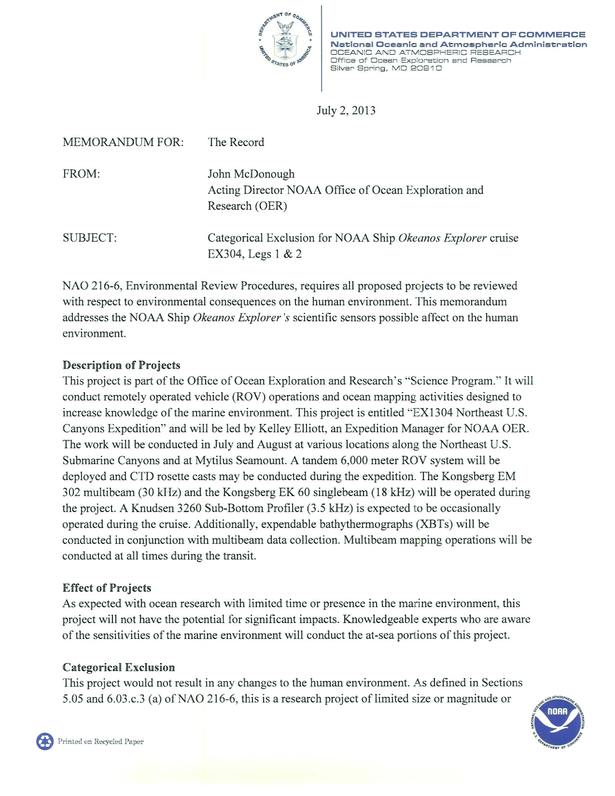

Appendix C – Data Management Plan

Appendix D

EMERGENCY DATA SHEET
NOAA OKEANOS EXPLORER

PRINT CLEARLY

NAME: __________________________________________________________
(Last, First, Middle)

Mailing Address ____________________________________________________

_____________________________________________________

_____________________________________________________
(Other than the ship address)

Phone (Home) _________________________________________________________

(Cell) ___________________________________________________________

Date of Birth ___________________________________________________________

Emergency Contact: _____________________________________________________
(Name and Relationship)

Address: ______________________________________________________________

______________________________________________________________

_______________________________________________________________

Phone (Home) ____________________________________________________

(Work) ____________________________________________________

(Cell) _____________________________________________________

Email: ________________________________________________________________

Signature __________________________________ Date _______________________

