Okeanos Explorer ROV Dive Summary
Site Name | Gauntlet Minor |  |  |  | 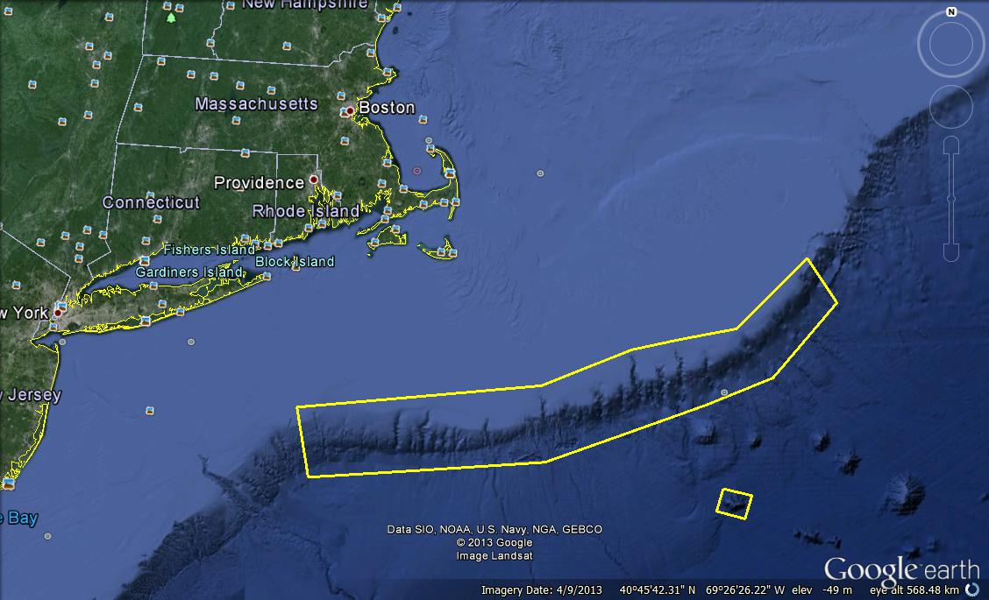
ROV Lead/Expedition Coordinator | Brian Bingham/  Kelley Elliott
Science Team Leads | Tim Shank (Shore)  Andrea Quattrini (Ship)
General Area Descriptor | Northwest Atlantic Ocean;  Northeast U.S. Canyons
ROV Dive Name | Cruise Season |  | Leg |  |  | Dive Number
 | EX1304 |  | 1 |  |  | DIVE16
Equipment Deployed | ROV: |  | Deepwater Discoverer
 | Camera Platform: |  | Seirios
ROV Measurements | CTD |  | Depth |  |  | Altitude
 | Scanning Sonar |  | USBL Position |  |  | Heading
 | Pitch |  | Roll |  |  | HD Camera 1
 | HD Camera 2 |  | Low Res Cam 1 |  |  | Low Res Cam 2
 | Low Res Cam 3 |  | Low Res Cam 4 |  |  | Low Res Cam 2
Equipment Malfunctions
ROV Dive Summary  (From processed ROV data) | In Water at: 2013-07-24T12:36:34.040000  39°, 49.180' N ; 071°, 07.273' W  Out Water at: 2013-07-24T19:56:16.235000  39°, 48.914' N ; 071°, 07.585' W  Off Bottom at: 2013-07-24T17:34:15.963000  39°, 49.018' N ; 071°, 07.444' W  On Bottom at: 2013-07-24T13:13:38.361000  39°, 49.024' N ; 071°, 07.413' W  Dive duration: 7:19:42  Bottom Time: 4:20:37  Max. depth: 1121.1 m
Special Notes
Scientists Involved  (please provide name / location / affiliation / email) | Primary  Tim Shank, Woods Hole (shore-based science team lead), WHOI, tshank@whoi.edu  Andrea Quattrini, EX (onboard science team lead), Temple, Andrea.Quattrini@temple.edu  Brendan Roark, EX, TAMU, broark@geos.tamu.edu  Taylor Heyl, Woods Hole, MA; WHOI, theyl@whoi.edu  Santiago Herrera Woods Hole, MA; WHOI, sherrera@whoi.edu  Scott France, Lafayette, LA, U. Louisiana at Lafayette, france@louisiana.edu  Jason Chaytor, Inner Space Center, USGS at Woods Hole, jchaytor@usgs.gov  AJ Turner, Charleston, NOAA, aj.turner@noaa.gov  Les Watling, Darling Marine Center, Maine; U. Hawaii, watling@hawaii.edu  Mike Vecchione, Washington, DC; SI/NOAA, vecchionem@si.edu  Passive  Cheryl Morrison, Kearneysville, WV; USGS; cmorrison@usgs.gov  Inge Van Den Beld, Brest, France; IFREMER, inge.van.den.beld@ifremer.fr  Amanda Demopoulos, Gainesville, FL; USGS SE Ecological Science Center, ademopoulos@usgs.gov  Brian Kinlan, Silver Spring, MD; NOAA NCCOS, brian.kinlan@noaa.gov
Purpose of the Dive
The purpose of this dive was to describe the geomorphology and benthic communities of both east and west walls in a minor canyon, site named Gauntlet Minor, to a depth of ~1100-1000 m.
Description of the Dive:
The ROV D2 reached the bottom at a 13:10 UTC at a depth of 1110 m (temperature 4.5 deg C). The bottom target was a slightly sloped area in the northern region of this minor canyon, between the east and west walls. Fishes were prevalent here, including cutthroat eels, witch flounder (Glyptocephalus cynoglossus) and several rattail species in the family Macrouridae. Several shrimps were also observed in the area. The bottom consisted of soft sediment of silt mixed with rock boulders, blocks, and rubble. Rubble included both rock and coral rubble. Coral rubble included dead, broken attached pieces of cup corals and a branching stony coral that appeared to be ?Solenosmilia. Dead bivalve shells (?Acesta sp.) were also apparent. Several Thouarella grasshoffi colonies occurred on the rock blocks. At 14:18 UTC, the ROV began to move up more of a steep slope, and reached a vertical wall face ~14:20 UTC. Moving up the wall, the ROV approached an area of higher abundance of sessile fauna at a depth of ~1078 m. Species included ?Solenosmilia variabilis, Desmophyllum, Javania, Acanthogorgia, Clavularia, Anthothela and ?Acesta. This wall of colonization continued to a depth of ~1030 m. No corals were observed at the top of the wall as the ROV continued up slope over a thicker sediment cover ~1020 m. The ROV then moved northward and came back down slope, picking up the abundant line of colonization at ~1030 m, with the same dominant fauna. At a time of ~17:10, the ROV continued west at a depth of ~1115m, over mostly a soft sediment bottom with scattered rubble. A debris field of coral and rock rubble was observed up to the base of the vertical wall. As the ROV moved up slope, the same faunal assemblages were evident as seen on the east wall, with abundance of fauna at ~1070 m depth. Near the end of the dive, a few additional corals were observed that were not observed on the east wall, including an unidentified black coral, Swiftia sp., and a few bamboo corals. The ROV left the bottom at the top of the wall at 19:15 at a depth of 1030 m. Several octopus (G. verrucosa) were seen throughout the dive. In general, a lot of trash and debris, including monofilament line, was observed in this area. A weak to moderate current from the south was noted.
Overall Map of ROV Dive Area |  |  |  | Close-up Map of Main Dive Site
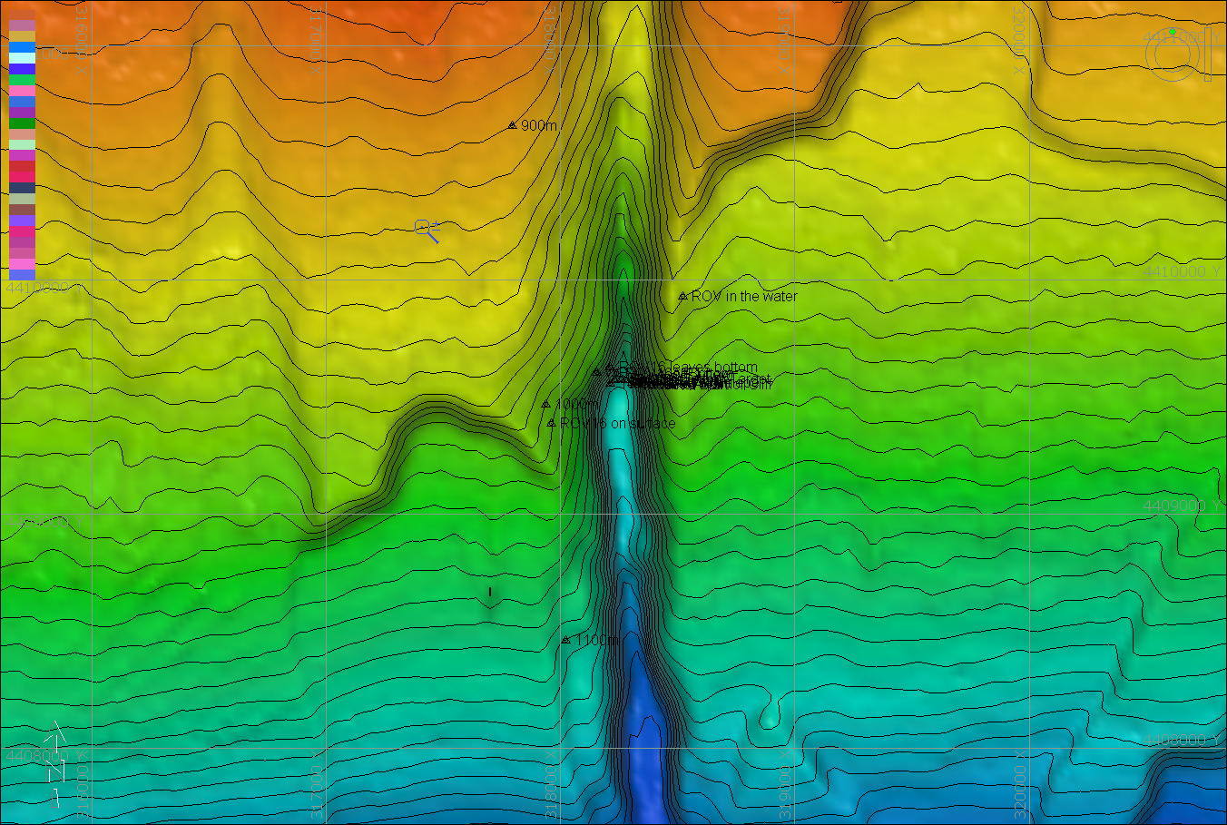 |  |  |  | 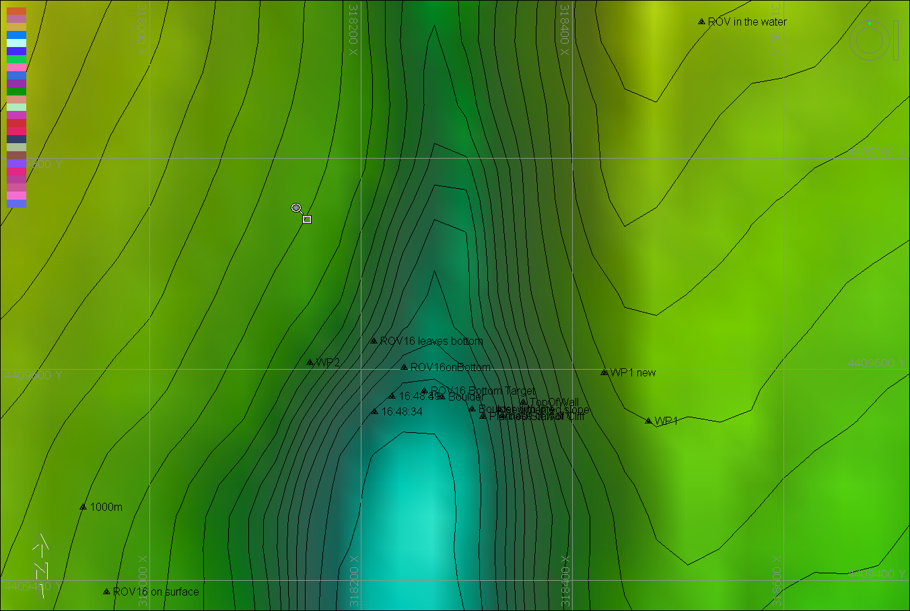
Representative Photos of the Dive
Please direct inquiries to: |  | NOAA Office of Ocean Exploration & Research  1315 East-West Highway (SSMC3 10th Floor)  Silver Spring, MD 20910  (301) 734-1014

