Okeanos Explorer ROV Dive Summary
Site Name | Block Shallow 1 |  |  |  | 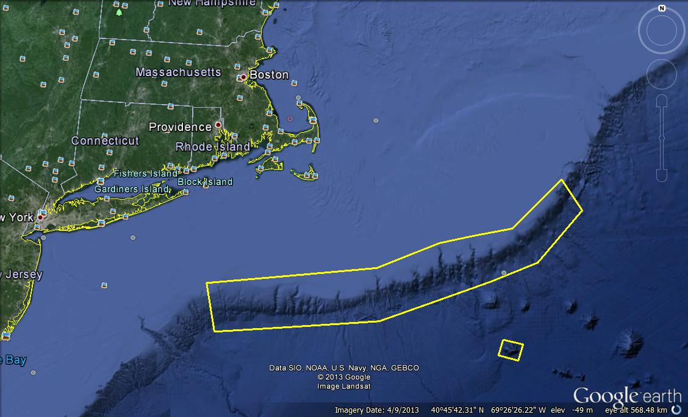
ROV Lead/Expedition Coordinator | Brian Bingham/  Kelley Elliott
Science Team Leads | Tim Shank (Shore)  Andrea Quattrini (Ship)
General Area Descriptor | Northwest Atlantic Ocean;  Northeast U.S. Canyons
ROV Dive Name | Cruise Season |  | Leg |  |  | Dive Number
 | EX1304 |  | 1 |  |  | DIVE15
Equipment Deployed | ROV: |  | Deepwater Discoverer
 | Camera Platform: |  | Seirios
ROV Measurements | CTD |  | Depth |  |  | Altitude
 | Scanning Sonar |  | USBL Position |  |  | Heading
 | Pitch |  | Roll |  |  | HD Camera 1
 | HD Camera 2 |  | Low Res Cam 1 |  |  | Low Res Cam 2
 | Low Res Cam 3 |  | Low Res Cam 4 |  |  | Low Res Cam 2
Equipment Malfunctions
ROV Dive Summary  (From processed ROV data) | In Water at: 2013-07-23T12:30:33.454000  39°, 48.627' N ; 071°, 16.069' W  Out Water at: 2013-07-23T20:16:14.723000  39°, 48.601' N ; 071°, 16.299' W  Off Bottom at: 2013-07-23T19:56:08.793000  39°, 48.594' N ; 071°, 16.275' W  On Bottom at: 2013-07-23T13:10:29.968000  39°, 48.458' N ; 071°, 16.183' W  Dive duration: 7:45:41  Bottom Time: 6:45:38  Max. depth: 1137.7 m
Special Notes
Scientists Involved  (please provide name / location / affiliation / email) | Primary  Tim Shank, Woods Hole (shore-based science team lead), WHOI, tshank@whoi.edu  Andrea Quattrini, EX (onboard science team lead), Temple, Andrea.Quattrini@temple.edu  Brendan Roark, EX, TAMU, broark@geos.tamu.edu  Taylor Heyl, Woods Hole, MA; WHOI, theyl@whoi.edu  Santiago Herrera Woods Hole, MA; WHOI, sherrera@whoi.edu  Scott France, Lafayette, LA, U. Louisiana at Lafayette, france@louisiana.edu  Jason Chaytor, Inner Space Center, USGS at Woods Hole, jchaytor@usgs.gov  AJ Turner, Charleston, NOAA, aj.turner@noaa.gov  Les Watling, Darling Marine Center, Maine; U. Hawaii, watling@hawaii.edu  Passive  Cheryl Morrison, Kearneysville, WV; USGS; cmorrison@usgs.gov  Mike Vecchione, Washington, DC; SI/NOAA, vecchionem@si.edu  Inge Van Den Beld, Brest, France; IFREMER, inge.van.den.beld@ifremer.fr  Lenaick Menot, Brest, France; IFREMER, lenaick.menot@ifremer.fr  Brian Kinlan, Silver Spring, MD; NOAA NCCOS, brian.kinlan@noaa.gov
Purpose of the Dive
The purpose of the dive was to explore a shallow area of Block Canyon and describe the geomorphology and biological communities along the east wall at a depth of ~1100-1000 m. Another objective was to groundtruth a model that predicted coral occurrence base on slopes of >36 degrees.

Description of the Dive:
The ROV D2 reached a depth of 1134 m over a soft sediment seafloor composed of silty and silty clay mixed with scattered rocks and boulders of various sizes at 13:11 UTC (temperature 4.7 deg C). The rock type appeared to be carbonate cemented mudstone or siltstone, similar to other Block Canyon dives. Numerous fishes were evident, consisting of what appear to be the typical fauna observed at this depth near the base of the canyon walls, including cutthroat eels (Synaphobranchidae), red crabs (Chaceon quinquedens), blue cod (Antimora rostrata), witch flounder (G. cynoglossus) and grenadier (Coryphaenoides rupestris). Rocks were colonized sparsely with small bamboo corals, and several mysid shrimp were often observed hovering around the colonies. At 13:32 UTC, the ROV began moving upslope towards waypoint 1. One Paramuricea colony with a ring anemone and an ophiuroid and an octopus (Graneledone verrucosa) were observed at 13:34 UTC. At 13:39 UTC, additional coral colonies were observed, including several Thouarella grasshoffi. At 13:52, more soft sediment was apparent as the ROV moved up a steep slope. At ~14:15 and a depth of 111 m, the ROV reached the base of the vertical rock wall, which was horizontally stratified with interbedded layers of carbonate and porcellinite. The porcellinite layers were stronger and less bio-eroded compared with the carbonate cemented mudstone layers. Acanella was observed at ~14:20. As the ROV continued to move upslope to waypoint 2, it reached a depth of ~1080 m and began traversing over areas with higher colonization of limid bivalves (?Acesta sp.), ?Solenosmillia variabilis, and cup corals (Desmophyllum, Javania). As the ROV continued to move up slope, it became clear that the most extensive area of colonization was around 1030 m. Also, as the ROV moved laterally, mid-way up slope, it was noted that sessile fauna were concentrated on promontory features. The most abundant sessile fauna was the bivalve, occurring in “lines” along the wall, and these bivalves were all of the same size class; no small individuals were noted. For octocorals, bamboo corals, Anthomastus and Clavularia were common, and a few black coral colonies were observed. Of note, associates that were common on/with coral colonies included brittle stars, polychaetes (black corals), and mysiid shimp. At 17:02, the ROV moved downslope to waypoint 3 at a depth of 1116 m. After reaching the base, the ROV moved upslope, noting the same patterns in faunal colonization. A white and red morphotype of Paragorgia sp. were observed near the base, each with red brittle stars (17:13UTC, 17:49 UTC, ~115 m). Towards the end of the dive, at 18:14 UTC and a depth of 1044 m ( DVL 02 midwall) a few Acanthogorgia colonies were noted. During the last 30 min of the dive, the ROV traversed up slope approaching a flat sedimented area and then a second wall, which appeared to be of a different origin, maybe sandstone (with white and black flecks). This second wall was relatively barren with a few bivalves and sponges. Of note, great video of a Gadiropsaurus ensis was obtained. The ROV left bottom at a depth of 995 and a time of 19:53 UTC. In general, lack of fishes occurred on the wall face, however, 2 Neocyttus helgae oreos were noted. Twice during this dive, at 14:37 and 17:36 UTC, hermit crabs with commensal colonial anemones Epizonathus sp. were observed. A few skates were noted during this dive. A weak current was noted and there was a lot of particulate matter in the water column.
Overall Map of ROV Dive Area |  |  |  | Close-up Map of Main Dive Site
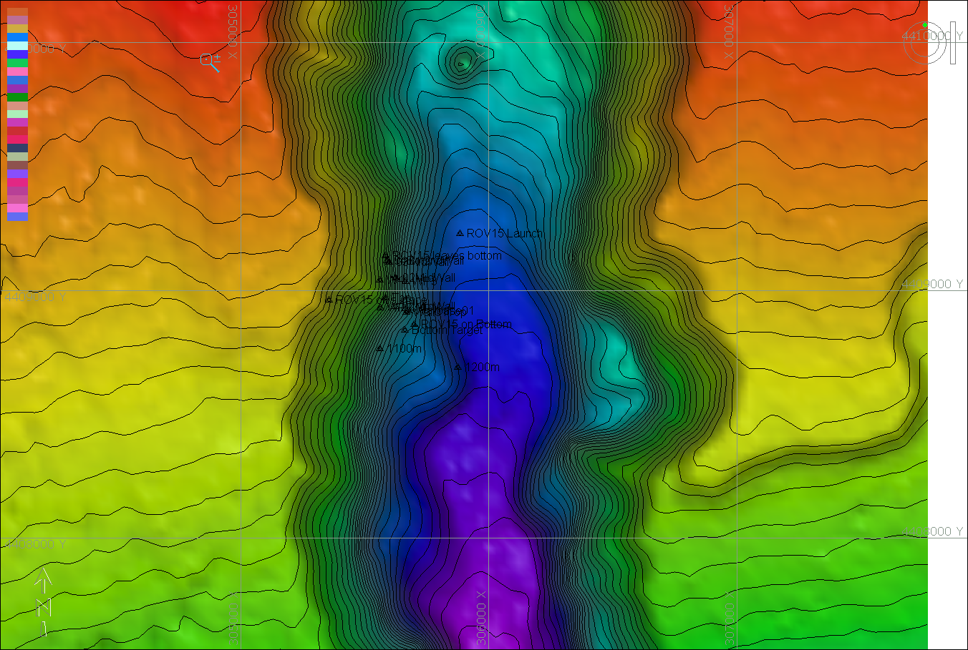 |  |  |  | 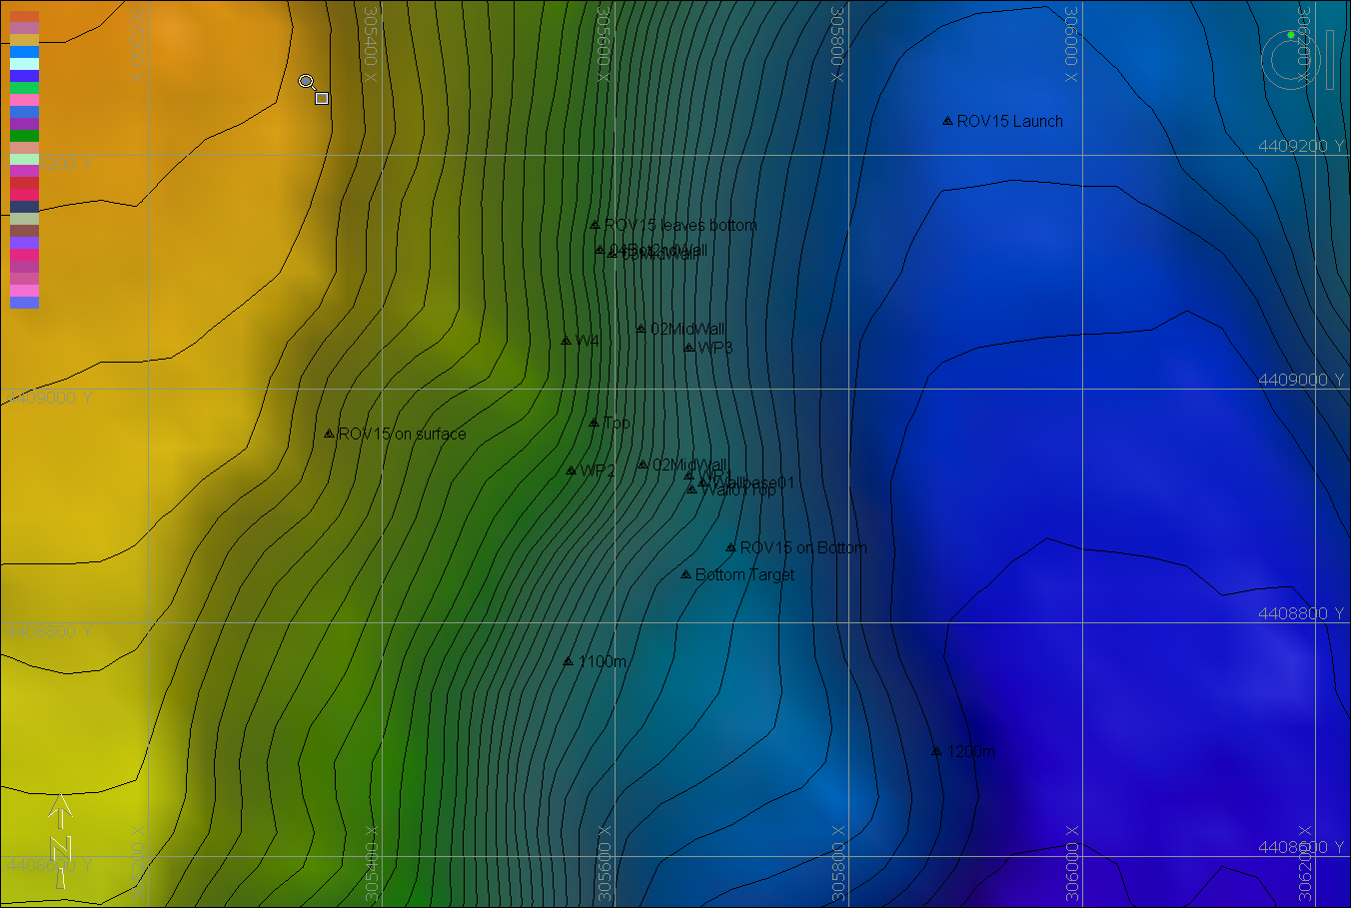
Representative Photos of the Dive
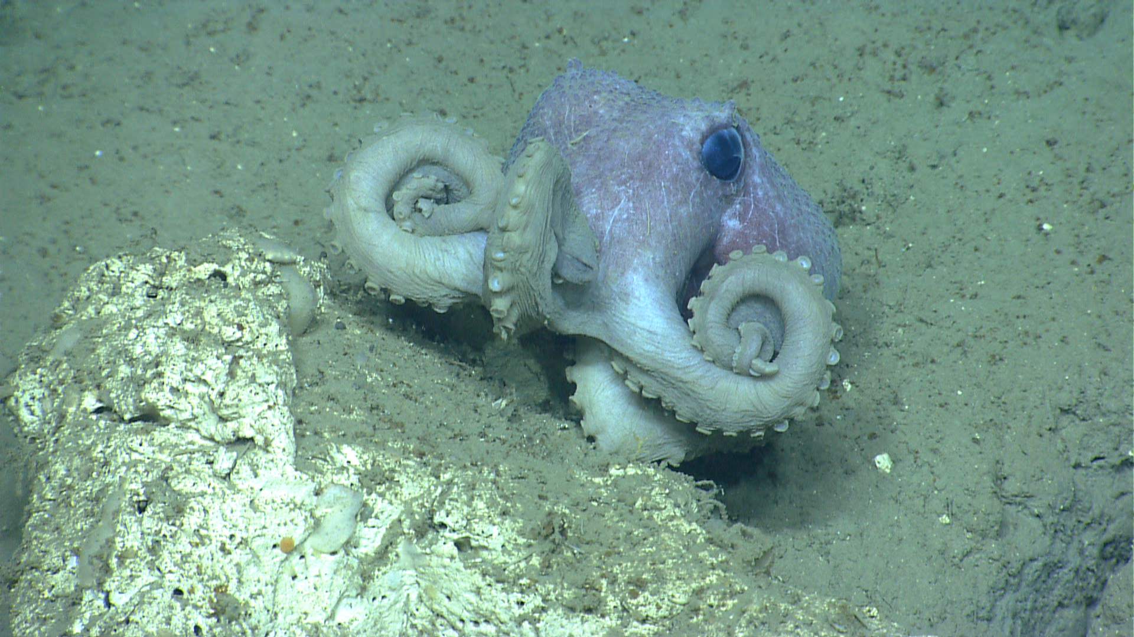 |  |  |  | 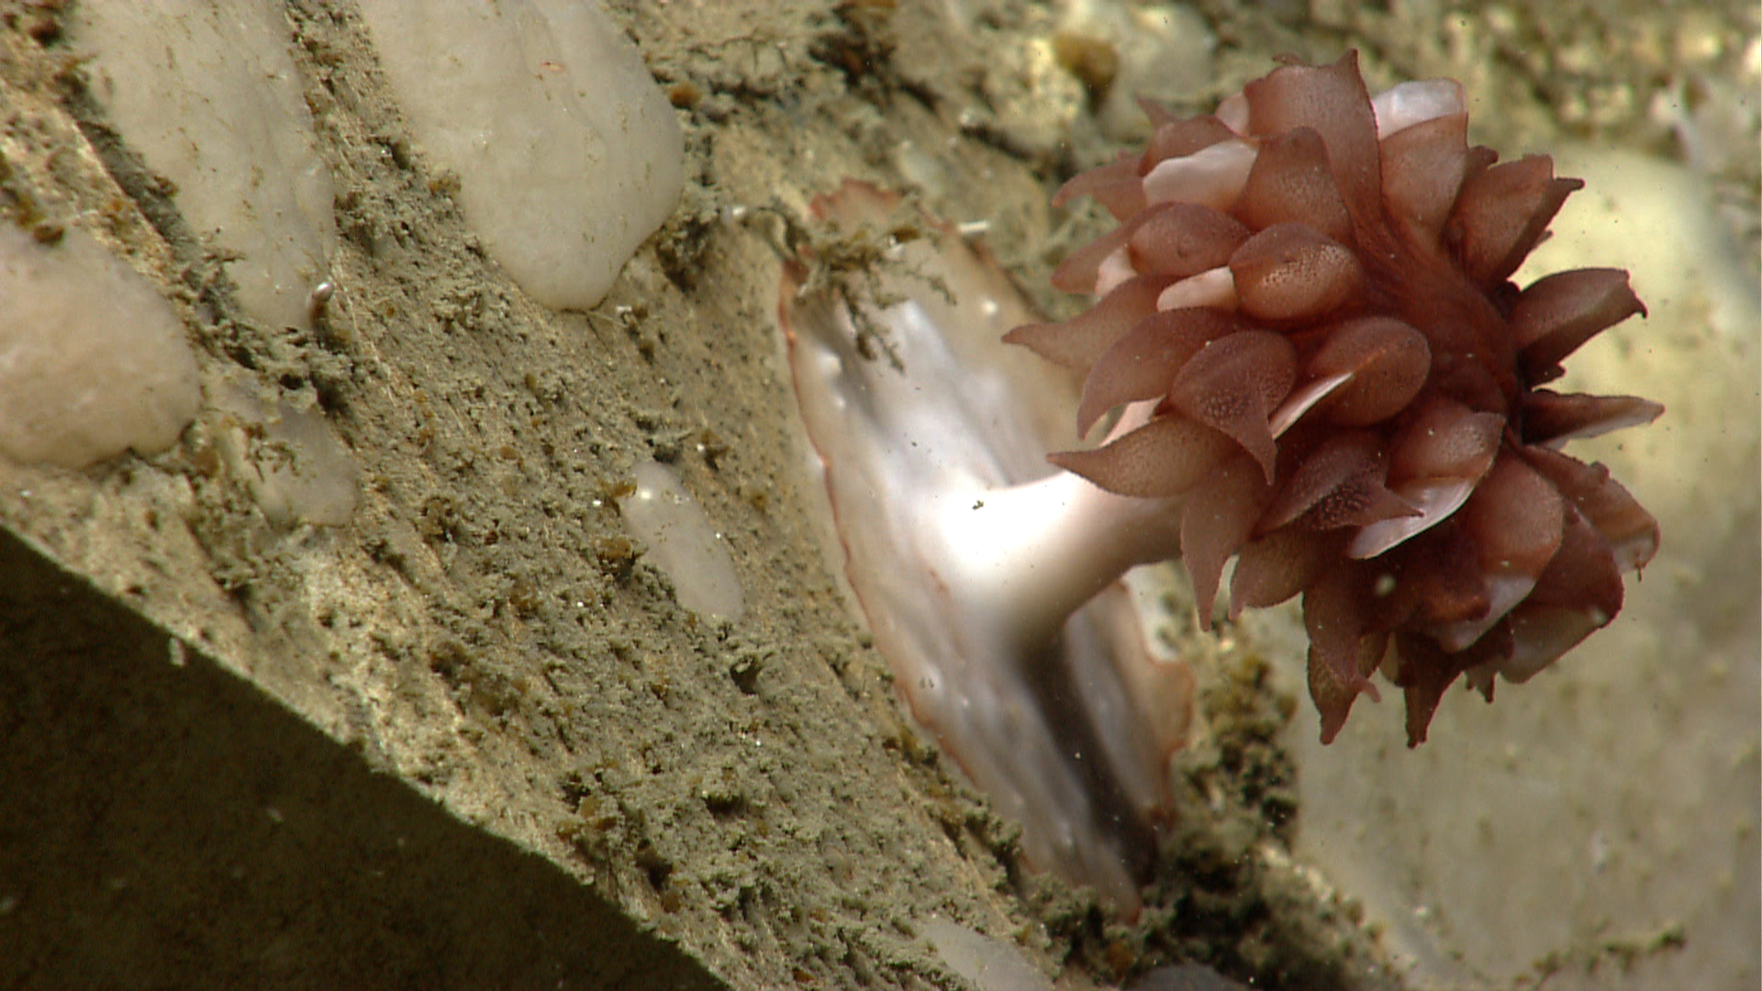
Graneledone verrucosa, a common octopus observed in Block Canyon. Time 13:37 Depth ~1120 m. |  |  |  | One of the common cup corals (Javania sp.) observed in Block Canyon. Time: 13:48 Depth ~1120 m.
Please direct inquiries to: |  | NOAA Office of Ocean Exploration & Research  1315 East-West Highway (SSMC3 10th Floor)  Silver Spring, MD 20910  (301) 734-1014

