Okeanos Explorer ROV Dive Summary
Site Name | New England Seep 1 |  |  |  | 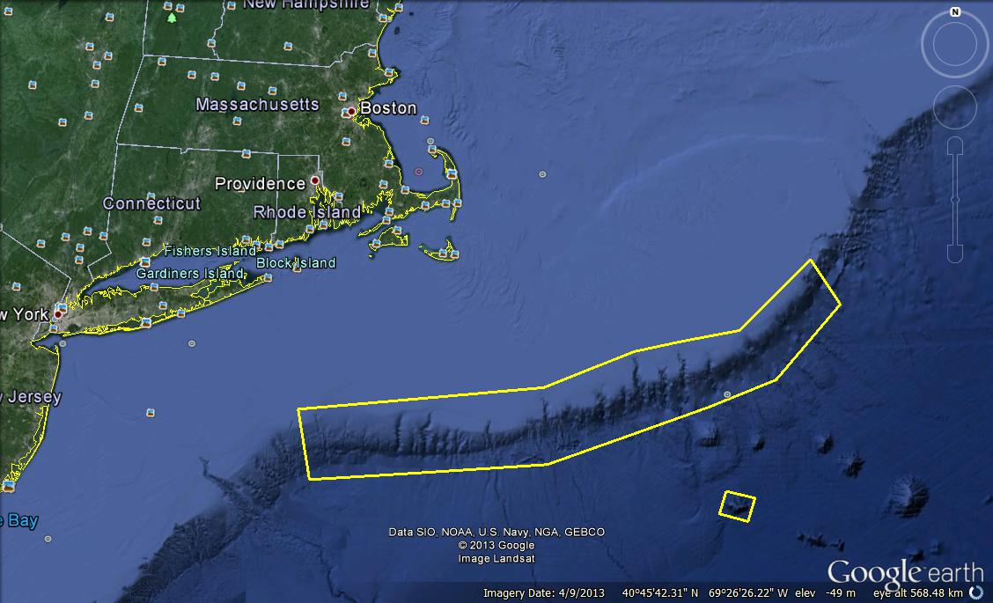
ROV Lead/Expedition Coordinator | Brian Bingham/  Kelley Elliott
Science Team Leads | Tim Shank (Shore)  Andrea Quattrini (Ship)
General Area Descriptor | Northwest Atlantic Ocean;  Northeast U.S. Canyons
ROV Dive Name | Cruise Season |  | Leg |  |  | Dive Number
 | EX1304 |  | 1 |  |  | DIVE13
Equipment Deployed | ROV: |  | Deepwater Discoverer
 | Camera Platform: |  | Seirios
ROV Measurements | CTD |  | Depth |  |  | Altitude
 | Scanning Sonar |  | USBL Position |  |  | Heading
 | Pitch |  | Roll |  |  | HD Camera 1
 | HD Camera 2 |  | Low Res Cam 1 |  |  | Low Res Cam 2
 | Low Res Cam 3 |  | Low Res Cam 4 |  |  | Low Res Cam 2
Equipment Malfunctions
ROV Dive Summary  (From processed ROV data) | In Water at: 2013-07-21T14:50:30.139000  39°, 48.473' N ; 069°, 35.552' W  Out Water at: 2013-07-21T23:33:18.116000  39°, 48.114' N ; 069°, 35.780' W  Off Bottom at: 2013-07-21T22:30:22.761000  39°, 48.362' N ; 069°, 35.541' W  On Bottom at: 2013-07-21T15:36:51.947000  39°, 48.301' N ; 069°, 35.654' W  Dive duration: 8:42:47  Bottom Time: 6:53:30  Max. depth: 1423.2 m
Special Notes
Scientists Involved  (please provide name / location / affiliation / email) | Primary  Tim Shank, Woods Hole (shore-based science team lead), WHOI, tshank@whoi.edu  Andrea Quattrini, EX (onboard science team lead), Temple, Andrea.Quattrini@temple.edu  Brendan Roark, EX, TAMU, broark@geos.tamu.edu  Taylor Heyl, Woods Hole, MA; WHOI, theyl@whoi.edu  Scott France, Lafayette, LA, U. Louisiana at Lafayette, france@louisiana.edu  Jason Chaytor, Inner Space Center, USGS at Woods Hole, jchaytor@usgs.gov  Mike Vecchione, Washington, DC; SI/NOAA, vecchionem@si.edu  Carolyn Ruppel, ISC, USGS Woods Hole, cruppel@usgs.gov  Bernie Ball, Beaufort, NC; Duke, bernieb@duke.edu  Les Watling, Darling Marine Center, Maine; U. Hawaii, watling@hawaii.edu  Passive  Inge Van Den Beld, Brest, France; IFREMER, inge.van.den.beld@ifremer.fr  Amanda Demopoulos, Gainesville, FL; USGS SE Ecological Science Center, ademopoulos@usgs.gov  Sandra Brooke, St. Theresa, FL, FSU, sbrooke@fsu.edu  Shirley Pomponi, Inner Space Center, FAU/CIOERT, spomponi@hboi.fau.edu  Sophie Plouviez, Beaufort, NC; Duke, sophie.plouviez@duke.edu  Megumi Shimizu, Beaufort, NC; Duke, megumi.shimizu@duke.edu
Purpose of the Dive
The engineering dive discovered live mussel beds (some with juveniles), extensive dead mussel debris (with methane bubbling), bacterial mats, carbonates, and other indicators of chemosynthetic activity. Our 21 Jul 2013 dive purpose was to resurvey this area, particularly the southern portion that was only documented for moments before recovery of the ROV during the engineering dive. Dive objectives included imaging with lasers, to get estimates of the sizes of the mussels, associated fauna, and rate of bubble ascent from seafloor for at least 1 min. Another objective included groundtruthing a new water column anomaly that was detected by multibeam sonar on the 20th of July.

Description of the Dive:
The ROV D2 reached the bottom at a depth of 1409 m at 15:37 UTC. The seafloor in the beginning of the dive was covered in soft sediment, composed of silt and clay, with some small pebbles. A few coral colonies were observed in this area, attached to pebbles (although attachments were not visible). These included Parantipathes black coral, Paramuricea, and Swiftia. No ophiuroid associates were observed on the corals. Also common soft-sediment species included red crabs, rattails, cutthroat eels, and urchins. Black dogfish (Centroscyllium fabricii) were also seen and mesopelagic fishes (Myctophidae, Gonostomatidae, Phosichthydae) were abundant near the bottom. Of note, a synaphobranchid eel was observed ingesting a large shrimp. The ROV continued over soft sediment westward toward the first waypoint following a sonar target. At 16:30 UTC, the western edge of a large mussel bed was discovered (DVL west edge) at a depth of 1420 m. This bed was mixed with live and dead mussels, with most of the dead mussels on the peripheries of the bed. The ROV transited both directions to get an estimate of the size. Mussel bed was very large, and extended ~50 m to the south, and at least 80 m to the north; although the mussel bed likely continued farter to the north in which the ROV did not transit. The bed appeared to be ~10 m wide. On the east side of the mussel bed, there was a line of carbonate blocks extending along the entire edge of the mussel bed. Bathymodiolus mussels in this area were of several size classes, and 1000s over very small (~2-3 cm) mussels were noted. Numerous (~25) Paragorgia colonies were attached to the carbonates on the east side, but notably were not observed on the carbonates that were in the southern portion of the mussel bed. Desmophyllum cup corals were also common on the carbonates. Close up images in several places revealed caprellid amphipods, amphipods, scale worms, ?Alvinocaris shrimp, and abundant gastropods. Numerous DVL targets were dropped along the bed. At 17:12 UTC, the ROV began looking for bubble plumes emanating from the seafloor using both Seirios view and the sonar. Although the ROV passed through waypoint 1 (where a water column anomaly was observed) no bubbles were found; however, bubbles were found and imaged in the soft sediments to the east of the carbonate “wall” at 18:44 at a depth of ~1421. Seepy sediments with bacterial mats and white “marshmallow” material were seen in patches in and around the mussel bed. This mussel bed and corals were surveyed for the majority of the dive, as throughout the afternoon numerous live interactions with the Aquarium of the Pacific occurred. Imaging the white and red morphotypes of Paragorgia revealed numerous ophiuroids associated with the colonies. Also, octopods were common in the area, and likely they were guarding eggs under ledges, Gadiropsaurus ensis and Chaceon ?quinquedens crabs were observed, the latter had a more “golden” color then usually seen. The ROV left bottom at 22:29 UTC at a depth of 1422 m. There was a moderate current from the south –southeast throughout the dive.

Overall Map of ROV Dive Area |  |  |  | Close-up Map of Main Dive Site
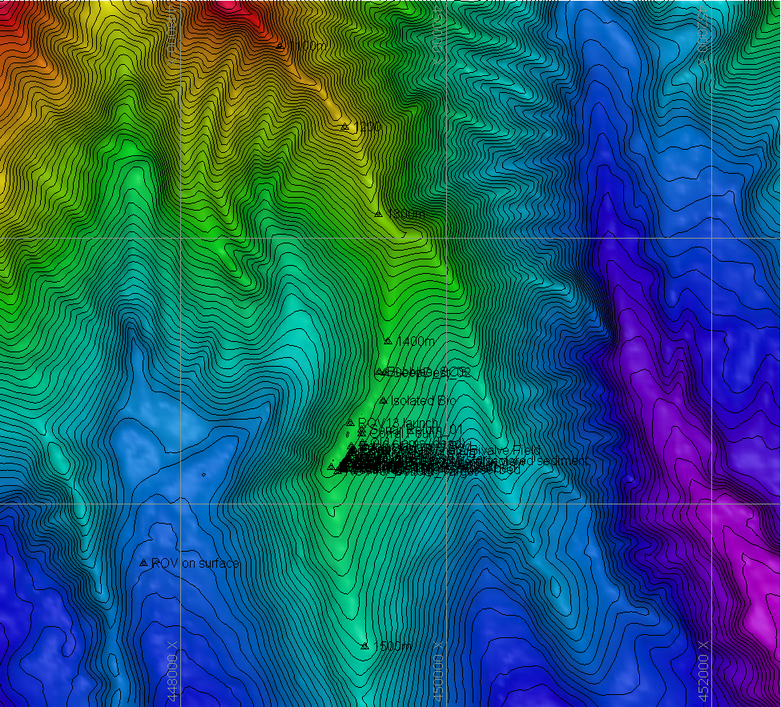 |  |  |  | 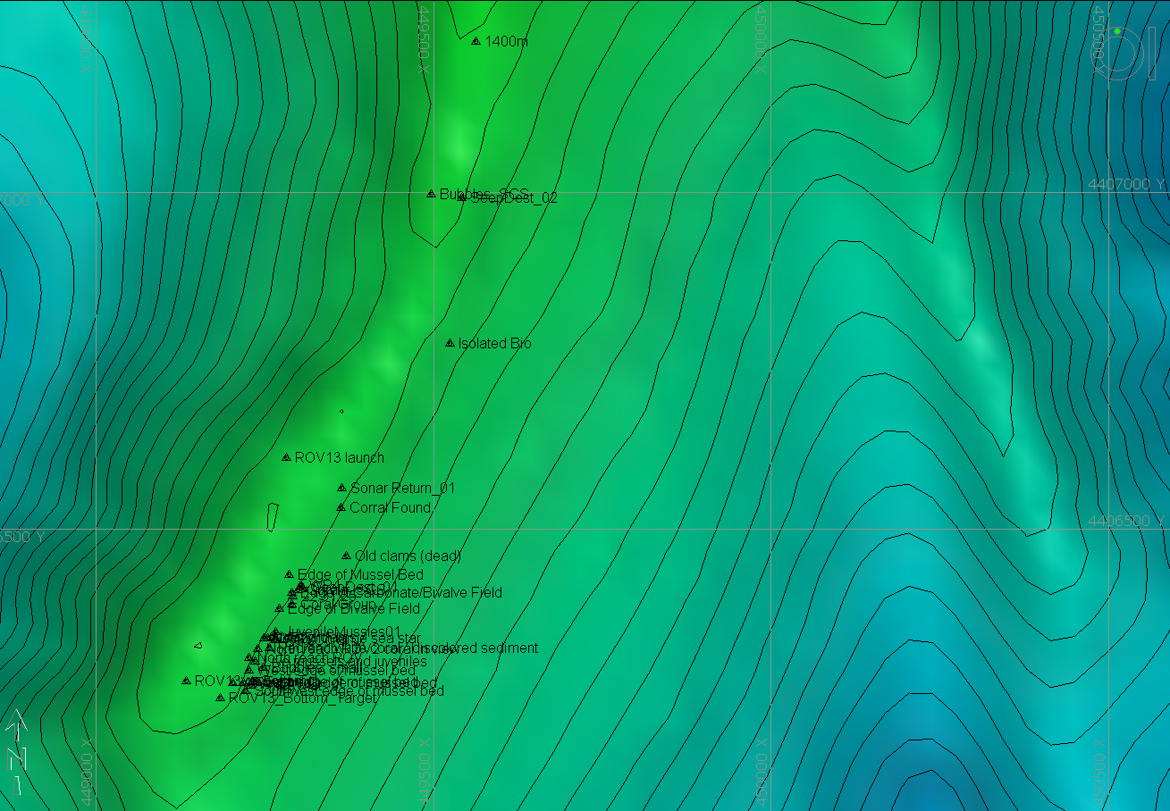
Representative Photos of the Dive
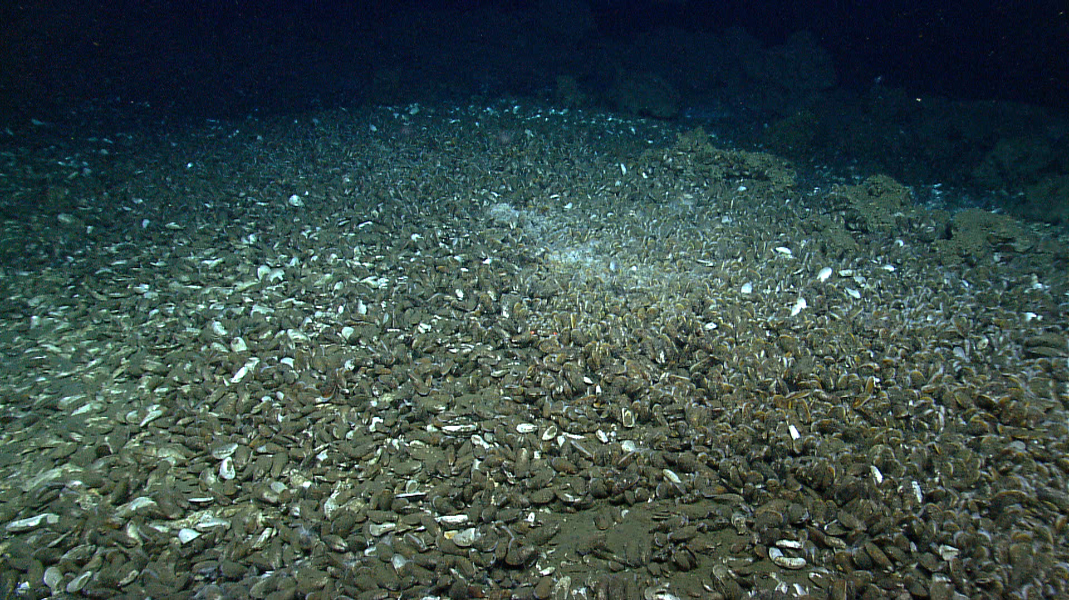 |  |  |  | 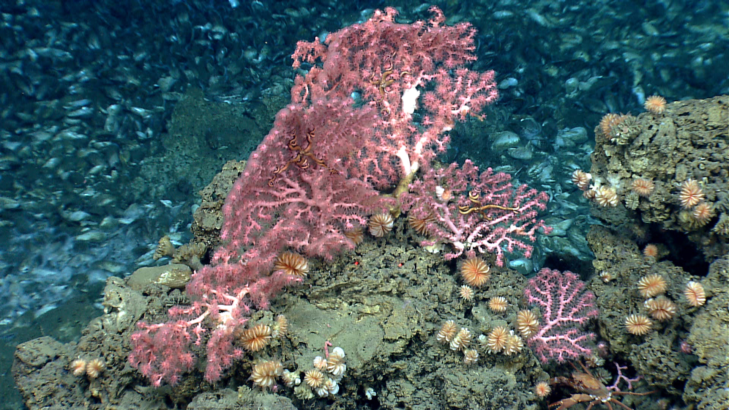
A large Bathymodiolus mussel bed with live and dead mussels. Live mussels consisted of numerous size classes. Time 16:38. Depth 1420 m. |  |  |  | Three Paragorgia colonies attached to carbonates on the east side of the mussel bed. Numerous Desmophyllum cup corals also in view. Time 18:35. Depth 1421 m.
Please direct inquiries to: |  | NOAA Office of Ocean Exploration & Research  1315 East-West Highway (SSMC3 10th Floor)  Silver Spring, MD 20910  (301) 734-1014

