Okeanos Explorer ROV Dive Summary
Site Name | USGS Hazards 2 |  |  |  | 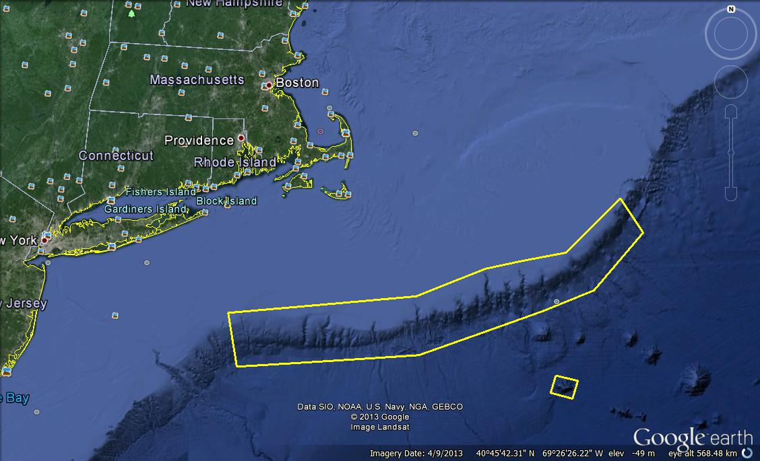
ROV Lead/Expedition Coordinator | Brian Bingham/  Kelley Elliott
Science Team Leads | Tim Shank (Shore)  Andrea Quattrini (Ship)
General Area Descriptor | Northwest Atlantic Ocean;  Northeast U.S. Canyons
ROV Dive Name | Cruise Season |  | Leg |  |  | Dive Number
 | EX1304 |  | 1 |  |  | DIVE12
Equipment Deployed | ROV: |  | Deepwater Discoverer
 | Camera Platform: |  | Seirios
ROV Measurements | CTD |  | Depth |  |  | Altitude
 | Scanning Sonar |  | USBL Position |  |  | Heading
 | Pitch |  | Roll |  |  | HD Camera 1
 | HD Camera 2 |  | Low Res Cam 1 |  |  | Low Res Cam 2
 | Low Res Cam 3 |  | Low Res Cam 4 |  |  | Low Res Cam 2
Equipment Malfunctions
ROV Dive Summary  (From processed ROV data) | In Water at: 2013-07-20T12:34:52.431000  39°, 43.797' N ; 069°, 30.465' W  Out Water at: 2013-07-20T20:15:13.678000  N/A ; N/A  Off Bottom at: 2013-07-20T19:31:12.265000  39°, 43.949' N ; 069°, 30.971' W  On Bottom at: 2013-07-20T13:45:01.253000  39°, 43.720' N ; 069°, 30.698' W  Dive duration: 7:40:21  Bottom Time: 5:46:11  Max. depth: 2026.9 m
Special Notes
Scientists Involved  (please provide name / location / affiliation / email) | Primary  Tim Shank, Woods Hole (shore-based science team lead), WHOI, tshank@whoi.edu  Andrea Quattrini, EX (onboard science team lead), Temple, Andrea.Quattrini@temple.edu  Brendan Roark, EX, TAMU, broark@geos.tamu.edu  Taylor Heyl, Woods Hole, MA; WHOI, theyl@whoi.edu  Scott France, Lafayette, LA, U. Louisiana at Lafayette, france@louisiana.edu  Jason Chaytor, Inner Space Center, USGS at Woods Hole, jchaytor@usgs.gov  Mike Vecchione, Washington, DC; SI/NOAA, vecchionem@si.edu  Les Watling, Darling Marine Center, Maine, watling@maine.edu  Passive  Amanda Demopoulos, Gainesville, FL; USGS SE Ecological Science Center, ademopoulos@usgs.gov  Jay Lunden, Philadelphia, PA; Temple, jlunden@temple.edu  Walter Cho, San Diego, CA; Point Loma Nazarene, waltercho@pointloma.edu
Purpose of the Dive
The purpose of this proposed dive is to investigate the transition (marked by the red dashed line on the map) from canyon processes to landslide deposition within Veatch Canyon to establish relative timing of the landslide event. The Veatch Canyon landslide breaches the eastern levee of Veatch Canyon and deposits debris within the canyon, blocking the normal sediment transport pathway. If Veatch Canyon is still active, the landslide may be relatively young (Recent), but if Veatch Canyon has been inactive since the LGM, the landslide may be late Pleistocene in age.
Description of the Dive:
The ROV D2 reached the bottom at 13:43 UTC at a depth of 2108 m (3.4 deg C). Soft sediment comprised of silt and clay with larger components was evident, with some biotrubation including feeding traces, hummocks, and burrows. Burrows often appeared round, like a hole had been “punched out”. Throughout the entire dive, ?Ophomusium brittle stars blanket the seafloor; 10’s of thousands were apparent. Cerianthid anemones, sea pens, and polychaetes tubeworms were also abundant throughout the dive. Few fishes were observed overall, but included the deep-sea lizardfish (Bathysuarus ferox), tripod fish (Bathypterois sp.), halosaurs (Notacanthidae), rattails (Macrouridae) and blue cod (Antimora rostrata). At least four species of sea urchins were common, including Hygrosoma petersi (often with purple polychaetes) and green heart urchins. Two species of holothurians were abundant as well (Paleopatides sp. and ?Mesothuria sp.) A piece of wood that was heavily bored was observed at 14:13 UTC, and a crinoid and pink Ophioplinthacid brittle stars occurred on the wood. At 14:32 UTC, a helium balloon was spotted on the seafloor. The overall dive track of the ROV D2 consisted of moving due north through a transition area, before heading south-west up a gradual slope on the west side of the canyon wall at ~16:38. As the ROV continued to move up this gradual slope, new fauna appeared. This included at least three different species of sea pens, lithodid king crabs (possibly juveniles), an Acanella bamboo coral, and a Lepidisis bamboo coral. On the sea pens, different ophiuroid brittle star associates were noted, including one that had a rounded purple disc. It was noted that the brittle stars on the sediment were never seen on the corals. Anemones were also noted growing on one type of sea pen. The ROV was able to just make it to the top of the slope, before leaving bottom at a depth of 1969 m and a time of 19:30 UTC. A weak current was evident at this site.

Overall Map of ROV Dive Area |  |  |  | Close-up Map of Main Dive Site
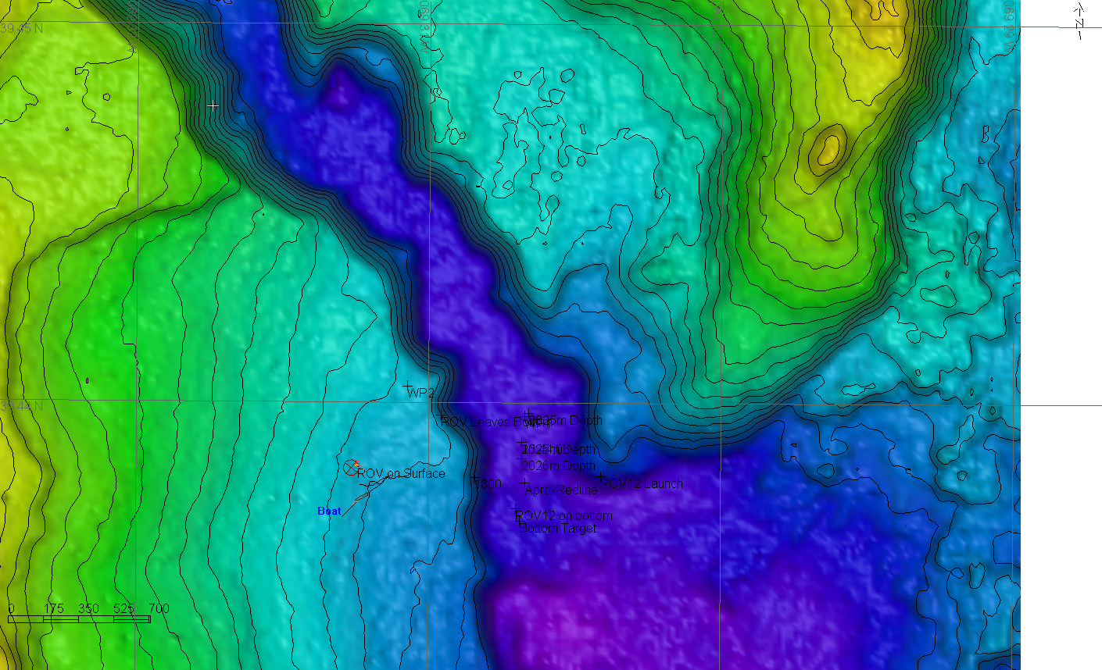 |  |  |  | 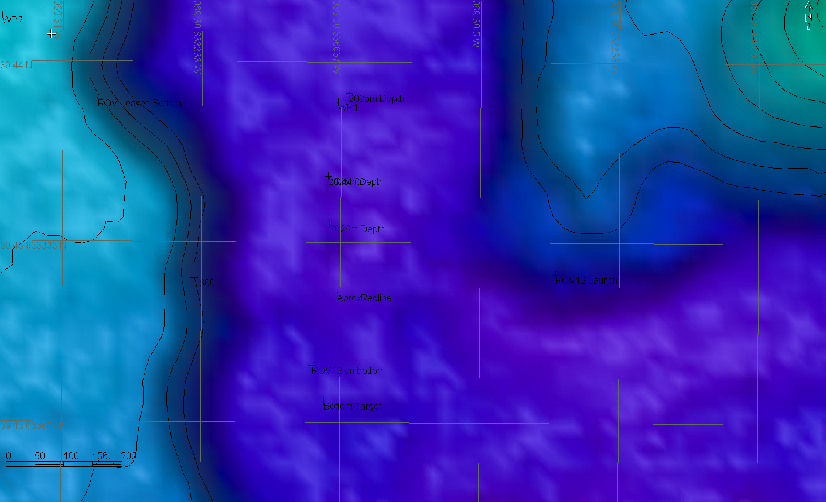
Representative Photos of the Dive
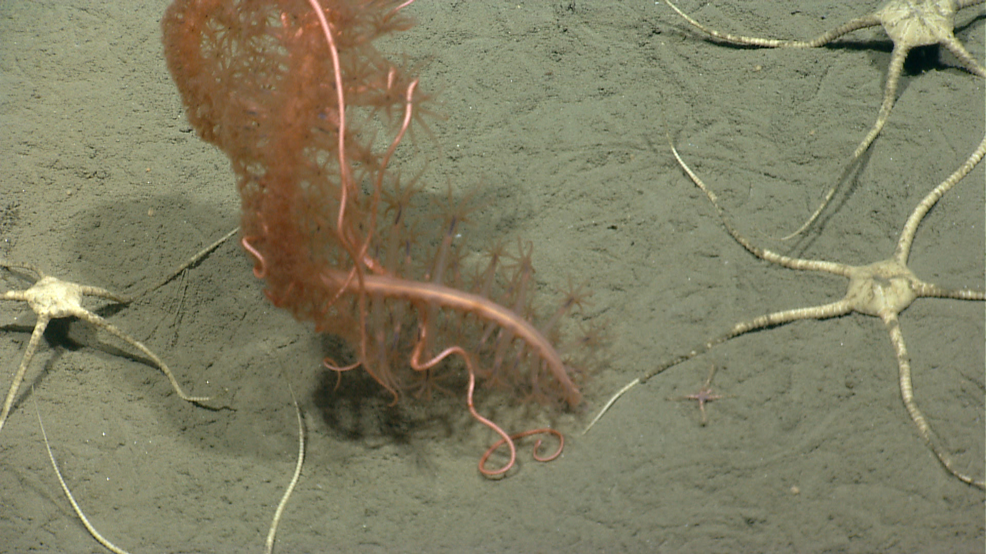 |  |  |  | 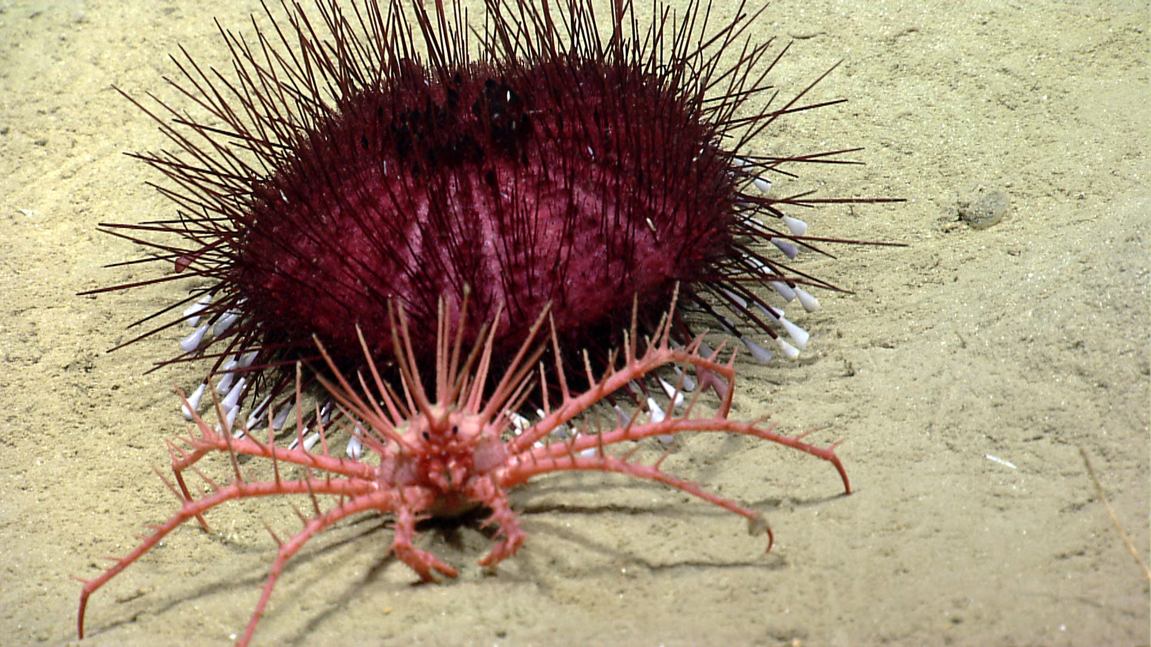
Abundant white brittle stars on the sediment (?Ophiomusium sp.). In the center, a “curly-cue” Anthoptilum sea pen anchored in the soft sediment. Note the different ophiuroid species inhabiting the coral. Time 17:34. Depth 2021 m. |  |  |  | Hygrosoma petersi sea urchin with tube feet extended. In front is a juvenile, lithodid king crab. Time 18:04. Depth 1977 m.
Please direct inquiries to: |  | NOAA Office of Ocean Exploration & Research  1315 East-West Highway (SSMC3 10th Floor)  Silver Spring, MD 20910  (301) 734-1014

