Okeanos Explorer ROV Dive Summary
Site Name | Atlantis Deep |  |  |  | 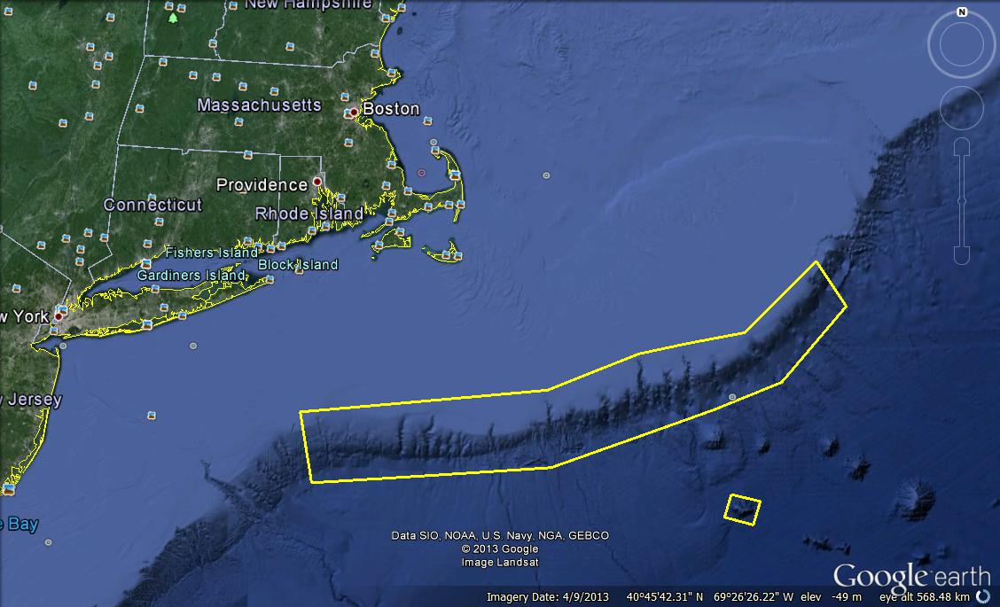
ROV Lead/Expedition Coordinator | Brian Bingham/  Kelley Elliott
Science Team Leads | Tim Shank (Shore)  Andrea Quattrini (Ship)
General Area Descriptor | Northwest Atlantic Ocean;  Northeast U.S. Canyons
ROV Dive Name | Cruise Season |  | Leg |  |  | Dive Number
 | EX1304 |  | 1 |  |  | DIVE08
Equipment Deployed | ROV: |  | Deepwater Discoverer
 | Camera Platform: |  | Seirios
ROV Measurements | CTD |  | Depth |  |  | Altitude
 | Scanning Sonar |  | USBL Position |  |  | Heading
 | Pitch |  | Roll |  |  | HD Camera 1
 | HD Camera 2 |  | Low Res Cam 1 |  |  | Low Res Cam 2
 | Low Res Cam 3 |  | Low Res Cam 4 |  |  | Low Res Cam 2
Equipment Malfunctions
ROV Dive Summary  (From processed ROV data) | In Water at: 2013-07-16T12:30:17.119000  39°, 47.301' N ; 070°, 13.092' W  Out Water at: 2013-07-16T20:32:05.942000  39°, 47.174' N ; 070°, 13.382' W  Off Bottom at: 2013-07-16T19:17:40.190000  39°, 47.181' N ; 070°, 13.007' W  On Bottom at: 2013-07-16T13:29:57.234000  39°, 47.184' N ; 070°, 13.228' W  Dive duration: 8:1:48  Bottom Time: 5:47:42  Max. depth: 1793.9 m
Special Notes
Scientists Involved  (please provide name / location / affiliation / email) | Tim Shank, Woods Hole (shore-based science team lead), WHOI, tshank@whoi.edu  Andrea Quattrini, EX (onboard science team lead), Temple, Andrea.Quattrini@temple.edu  Brendan Roark, EX, TAMU, broark@geos.tamu.edu  Taylor Heyl, Woods Hole, MA; WHOI, theyl@whoi.edu  Santiago Herrera Woods Hole, MA; WHOI, sherrera@whoi.edu  Scott France, Lafayette, LA, U. Louisiana at Lafayette, france@louisiana.edu  Jason Chaytor, Inner Space Center, USGS at Woods Hole, jchaytor@usgs.gov  AJ Turner, Charleston, NOAA, aj.turner@noaa.gov  Amanda Demopoulos, Gainesville, FL; USGS SE Ecological Science Center, ademopoulos@usgs.gov  Les Watling, Darling Marine Center, Maine, watling@maine.edu  Kerry McCulloch, Woods Hole, MA; WHOI, williamsk@allegheny.edu  Kelly Williams, Woods Hole, MA; WHOI, mcculloc@uoregon.edu  Shirley Pomponi, Inner Space Center, RI; CIOERT, SPomponi@hboi.fau.edu  Passive  Inge Van Den Beld, Brest, France; IFREMER, inge.van.den.beld@ifremer.fr  Brian Kinlan, Silver Spring, MD; NOAA NCCOS, brian.kinlan@noaa.gov  Walter Cho, San Diego, CA; Point Loma Nazarene, waltercho@pointloma.edu  Cheryl Morrison, Kearneysville, WV, USGS, cmorrison@usgs.gov  Sandra Brooke, Tallahassee, FL; FSU, sbrooke@fsu.edu  Mike Vecchione, Washington, DC; SI/NOAA, vecchionem@si.edu
Purpose of the Dive
The purpose of the dive was to characterize 1) the submarine canyon geomorphology and benthic habitats, including possible coral and sponge communities at a depth of ~1800 m on the east wall of Atlantis Canyon and 2) groundtruth a model of predicted deep-sea coral occurrence.
Description of the Dive:
At 13:30 UTC, the ROV reached the bottom at a depth of 1795 m (3.7 deg C), where the seafloor was covered in soft sediment with scattered rock rubble and rock outcrops. Halosaurs and cutthroat eels were prevalent in this area, four species of sea urchins were noted, and white ophiuroids (Ophiomusium sp.) were abundant on the seafloor. Sea pens (morphology of a whip coral) were noted in this area, each with an ophiuroid wrapped tightly around the central rachis. At 13:54, the ROV moved up slope to our first waypoint from the launch target area, noting more sea pens along the way on the sediments between the scattered rock outcrops. At 14:02 UTC the ROV approached the base of a rock wall, that appeared to be calcareous mudstone/siltstone and chalky in appearance. Few conspicuous sessile fauna were evident on this wall. A DVL target was dropped at 14:37 (DVL TRAN 1) for the transition between soft sediment and the vertical rock face. Staining was noted here on the rock, and a few corals (Swiftia sp., Paramuricea sp., Bathypathes sp.) and hexactinellid sponges were attached. An ophiuroid brittle star was noted on Swiftia; one association not previously known. The ROV continued to move up slope over sediment covered (think layer) rock. Sponges were among the most abundant attached fauna, and included Aphrocallistes beatrix. Numerous shrimps were often associated with the sponge structure. Although corals were not abundantly attached to the rocks, they were diverse, as we noted a few sea pens (Calibelemnon sp.), cup corals (Javania sp., Desmophylum sp.) and other octocorals including Chyrsogorgia sp., Metallogorgia melanotrichos, and large colonies of Keratoisis sp. at a depth of ~1750 m. The multiple observations of M. melanotrichos with the brittle star Ophicocreas oedipus are noteworthy, as this species had been previously only known from the seamounts in this region. The ROV continued towards waypoint 2, and at a depth 1710 m(DVL DSC 2 target), a large aggregation of Desmophyllum cup corals and demosponges (Geodiidae) were seen growing on a ledge. On the sediments below the ledge, numerous dead cup coral rubble was accumulated. At 17:48 UTC, the ROV came across an octopus (Muusoctopus johnsonianus) guarding eggs at a depth of 1643 and a debris chute was noted. At 18:15 UTC at a depth of 1663 m, the ROV began moving along the wall to waypoint 3, noting extensive fracturing along parts of the wall. The afternoon portion of the dive was interrupted with fire and abandon ship drills on the ship. This took up about 50 min of time total. However, in the mean time, we were able to capture amazing footage of a benthic ctenophore at ~18:37. As the end of the dive approached, the ROV turned upslope to cover a broader depth range. One large vertical wall (DVL DSC3) at 19:20 and a depth of 1637 had numerous sponges, Desmophyllum and a clump of live Solenosimila variabilis. Also, the first colonies of Acanthogorgia and Acanella were seen. The ROV left bottom at 19:33 UTC and a depth of 1622 m. In general, the currents at this site were not very strong. Few fishes were noted at this depth range.

Overall Map of ROV Dive Area |  |  |  | Close-up Map of Main Dive Site
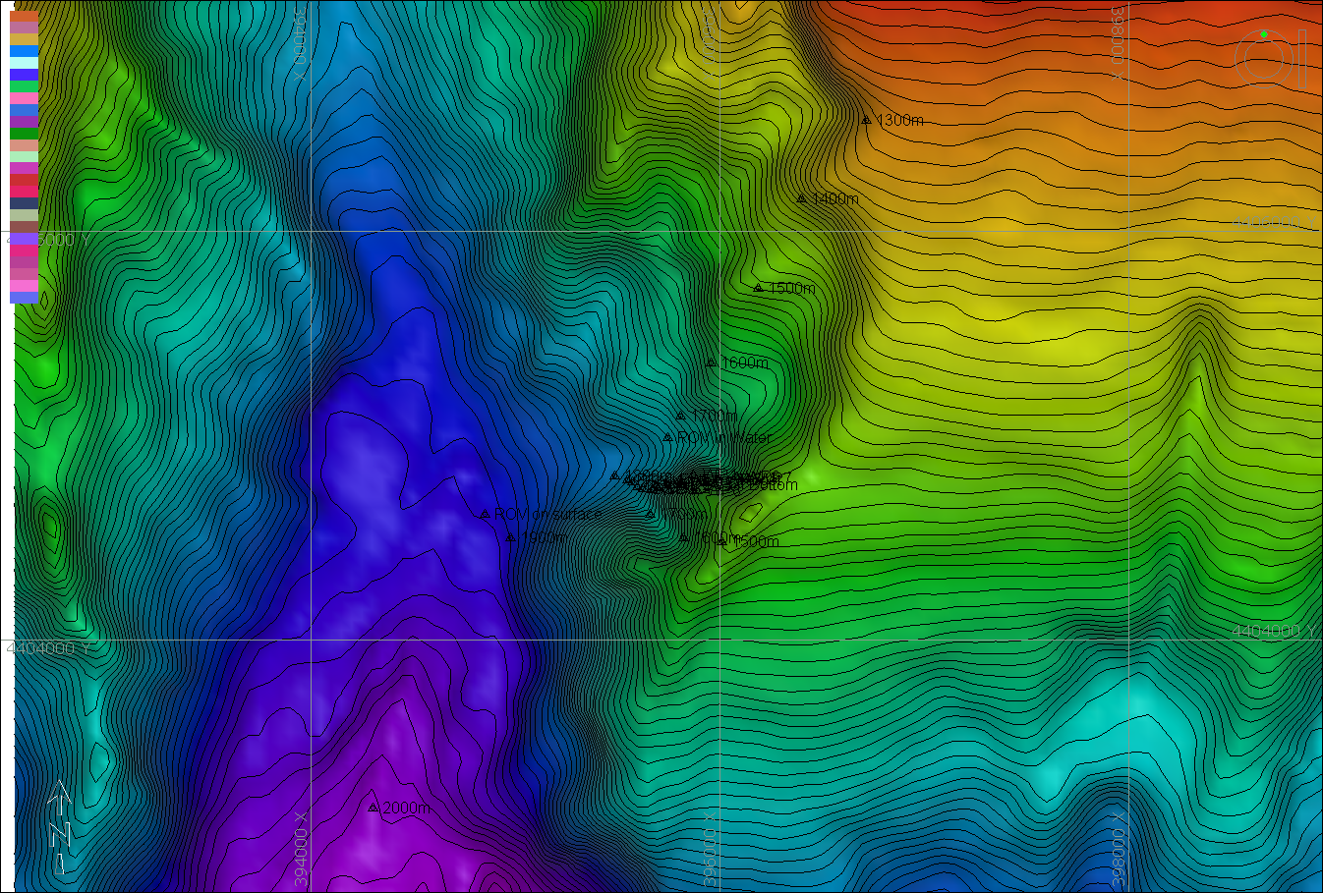 |  |  |  | 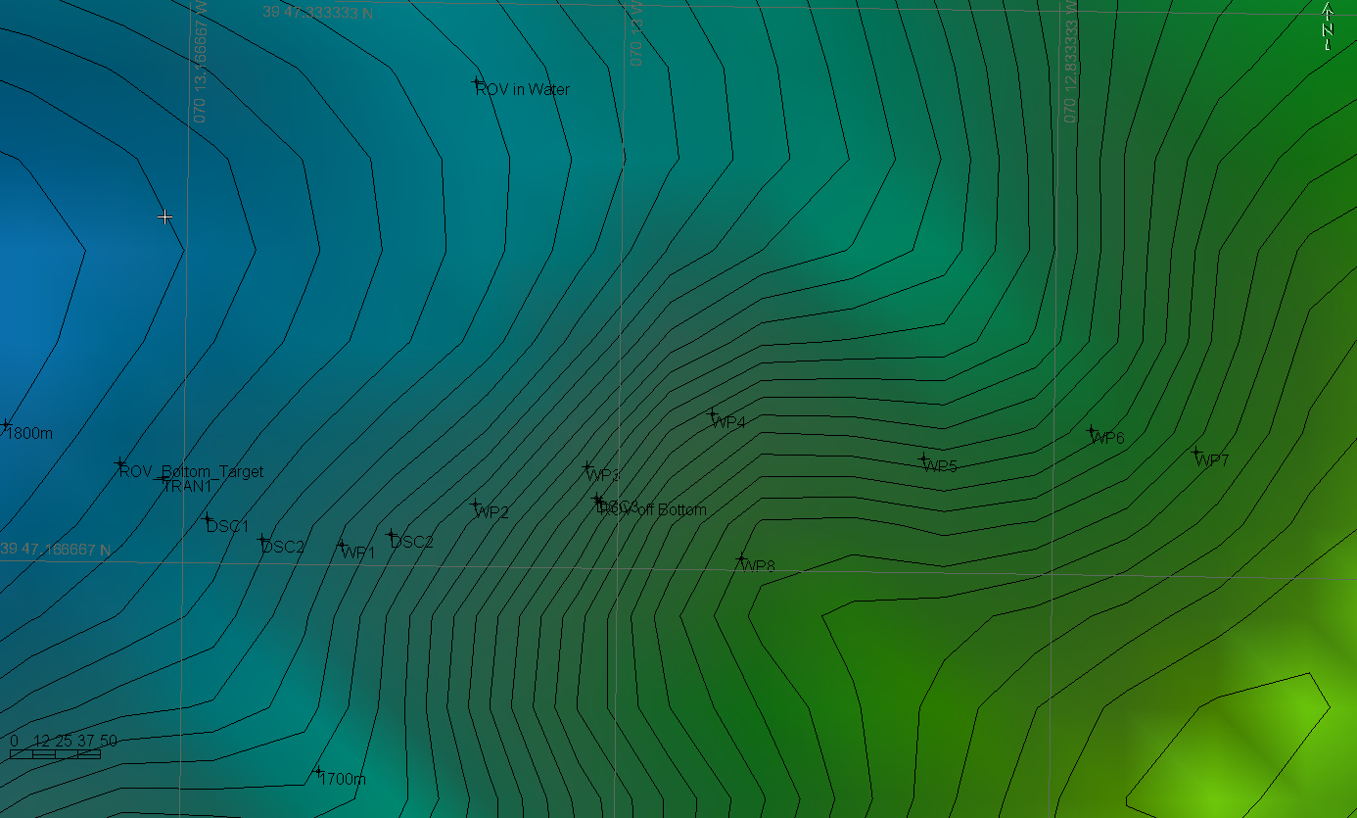
Representative Photos of the Dive
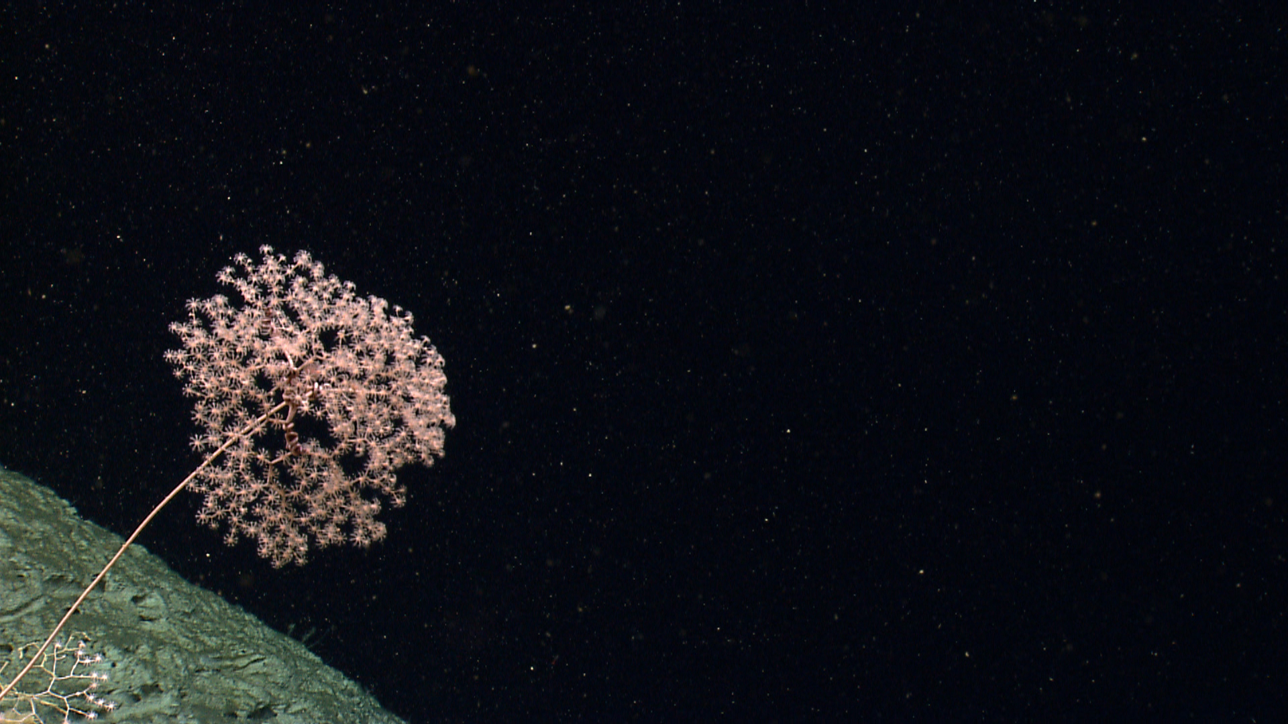 |  |  |  | 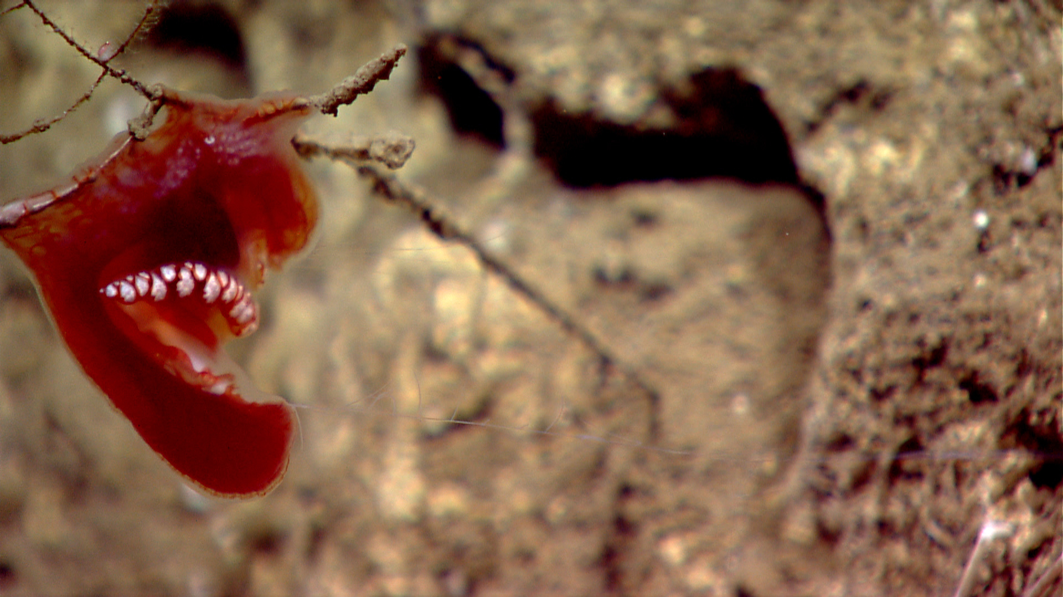
Metallogorgia melanotrichos with an Ophiocreas oedipus, an obligate coral-associate relationship. Time 15:34. Depth 1760 m. |  |  |  | A rare siting of a benthic Ctenophore wrapped around a likely hydroid stalk. Time 18:38. Depth 1675 m.
Please direct inquiries to: |  | NOAA Office of Ocean Exploration & Research  1315 East-West Highway (SSMC3 10th Floor)  Silver Spring, MD 20910  (301) 734-1014

