Okeanos Explorer ROV Dive Summary
Site Name | Hydrographer Canyon – Shallow 2 |  |  |  | 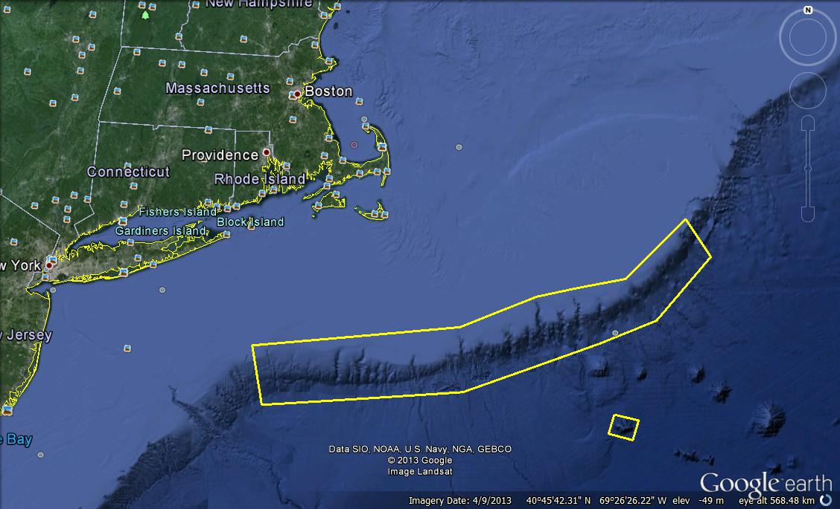
ROV Lead/Expedition Coordinator | Brian Bingham/  Kelley Elliott
Science Team Leads | Tim Shank (Shore)  Andrea Quattrini (Ship)
General Area Descriptor | Northwest Atlantic Ocean;  Northeast U.S. Canyons
ROV Dive Name | Cruise Season |  | Leg |  |  | Dive Number
 | EX1304 |  | 1 |  |  | DIVE06
Equipment Deployed | ROV: |  | Deepwater Discoverer
 | Camera Platform: |  | Seirios
ROV Measurements | CTD |  | Depth |  |  | Altitude
 | Scanning Sonar |  | USBL Position |  |  | Heading
 | Pitch |  | Roll |  |  | HD Camera 1
 | HD Camera 2 |  | Low Res Cam 1 |  |  | Low Res Cam 2
 | Low Res Cam 3 |  | Low Res Cam 4 |  |  | Low Res Cam 2
Equipment Malfunctions
ROV Dive Summary  (From processed ROV data) | In Water at: 2013-07-14T12:42:28.619000  40°, 03.197' N ; 069°, 02.130' W  Out Water at: 2013-07-14T20:15:12.749000  40°, 03.149' N ; 069°, 01.987' W  Off Bottom at: 2013-07-14T20:06:50.279000  40°, 03.157' N ; 069°, 01.990' W  On Bottom at: 2013-07-14T13:15:22.433000  40°, 03.012' N ; 069°, 02.244' W  Dive duration: 7:32:44  Bottom Time: 6:51:27  Max. depth: 908.3 m
Special Notes
Scientists Involved  (please provide name / location / affiliation / email) | Primary  Tim Shank, Woods Hole (shore-based science team lead), WHOI, tshank@whoi.edu  Andrea Quattrini, EX (onboard science team lead), Temple, Andrea.Quattrini@temple.edu  Brendan Roark, EX, TAMU, broark@geos.tamu.edu  Taylor Heyl, Woods Hole, MA; WHOI, theyl@whoi.edu  Santiago Herrera Woods Hole, MA; WHOI, sherrera@whoi.edu  Scott France, Lafayette, LA, U. Louisiana at Lafayette, france@louisiana.edu  AJ Turner, Charleston, NOAA, aj.turner@noaa.gov  Amanda Demopoulos, Gainesville, FL; USGS SE Ecological Science Center, ademopoulos@usgs.gov  Kerry McCulloch, Woods Hole, MA; WHOI, williamsk@allegheny.edu  Les Watling, Darling Marine Center, Maine, watling@maine.edu  Kelly Williams, Woods Hole, MA; WHOI, mcculloc@uoregon.edu  Passive  Jason Chaytor, Inner Space Center, USGS at Woods Hole, jchaytor@usgs.gov  Brian Kinlan, Silver Spring, MD; NOAA NCCOS, brian.kinlan@noaa.gov  Inge Van Den Beld, Brest, France; IFREMER, inge.van.den.beld@ifremer.fr  Walter Cho, San Diego, CA; Point Loma Nazarene, waltercho@pointloma.edu  Sandra Brooke, Tallahassee, FL; FSU, sbrooke@fsu.edu  Mike Vecchione, Washington, DC; SI/NOAA, vecchionem@si.edu
Purpose of the Dive
The purpose of the dive was to explore for deep-sea corals (DSC), DSC associates, and other deep-water benthic and mobile fauna such as sponges, fishes and crabs. This was considered a shallow-depth dive (~900-600 m). An additional goal of this dive was to groundtruth a model that predicted the occurrence of DSC associated with slopes >36 degrees.
Description of the Dive:
ROV D2 reached a seafloor covered in soft sediment at 13:15 UTC at a depth of 907 m (temperature 5.0 C). The ROV settled over this soft sediment area of fine silt with scattered rock boulders that were scoured out at the bases. A strong current was coming from the south, and a lot of particulate matter was in the water column. Numerous cutthroat eels (Synaphobranchus sp.), blue cod (Antimora rostrata), witch flounder (Glyptocephlaus cynoglossus), and red crab (Chaceon quinquedens) were observed. Notably, a fishing line draped the bottom. There were a few dead octocoral colonies observed in the area. The ROV began to move over this patchy, scattered rock habitat towards waypoint 1 at 13:41. A few black dogfish (Centroscyllium. fabricii) were observed. At 13:47 UTC, a very angular, detached rock block and several small Paramuricea recruits were noted. Another large boulder at 13:58 UTC was noted, colonized with several corals, including Desmophyllum, Paragorgia arborea, Anthothela sp., and glass sponges. Aplacophorans (molluscs) and shrimps were notable associates with coral colonies. In between areas of large rock blocks/boulders, dislodged coral colonies were observed. Video footage of a Mastogoteuthis squid was captured. At 14:08 UTC, the ROV reached the base of a steep cliff. The cliff was covered with a dense assemblage of sessile invertebrates (octocorals and sponges), particularly near top of the cliff face. Larger coral colonies appeared to grow under ledges. At 14:45, Lophelia pertusa (DPL wall3 target) was noted growing under a ledge. Cladorhized sponges blanketed the walls, particularly the tops of the overhangs. The sediment composition differed between that under the overhangs and away from the cliff, with dislodged coral colonies frequent. A large, vertical wall, ~4-5 m tall, (DPL wall 4 target) with wide variety of corals and other invertebrates was observed, including orange morphotypes of what appeared to be L. pertusa. Of note, a sponge containing cephalopod eggs (potentially bobtail squid) was observed at 15:27 UTC. The ROV began moving up a steep scarp at 15:55 UTC, and the substrate appeared to be in a stepping stone pattern, with large vertical faces, and the tops covered with additional debris and sediment. Near the tops of many of these wall faces, both white and red morphotypes of the bubblegum coral, Paragorgia arborea occurred. In some cases, individuals had unusually large, wide bases and on the seafloor below the ledges, dislodged Paragorgia colonies (partially dead) were seen. Of note, a catshark eggcase on a bamboo coral was seen at 830 m depth, at a time of 16:16 UTC. As the ROV approached the top of the vertical scarp at a depth of 808 m, numerous large bubblegum corals (both color morphs) were observed. Shrimps were common associates of the bubblegum corals. Many of the large colonies also had an overgrowth of Anthothela at the base. At the end of the dive, the ROV continued upslope, crossing more of a soft sediment bottom with scattered rock boulders. The strong current, high particulate matter, and detachments of corals, rock blocks and debris fields are notable in this region of Hydrographer canyon. The ROV left bottom at 20:03 UTC at a depth of 610 m.
Overall Map of ROV Dive Area |  |  |  | Close-up Map of Main Dive Site
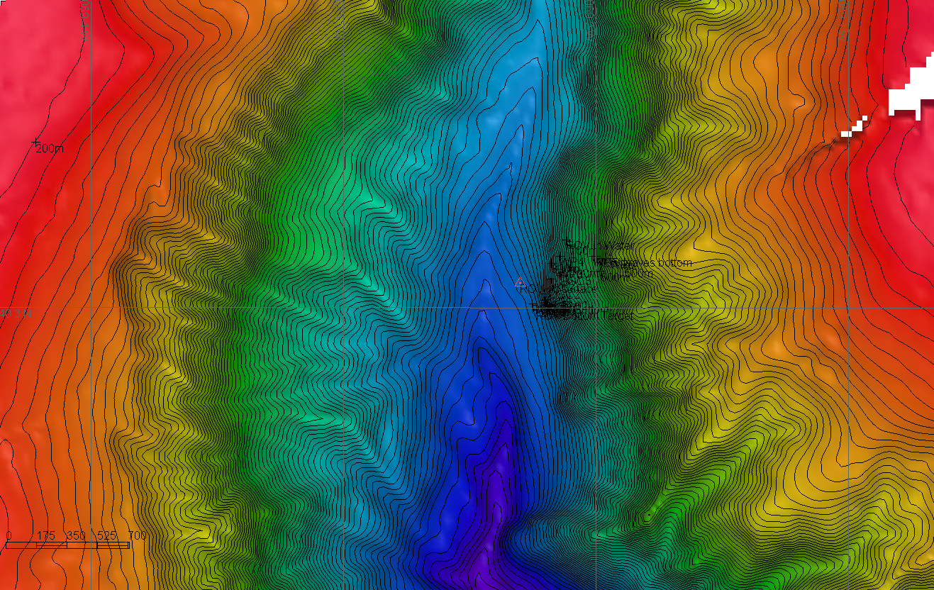 |  |  |  | 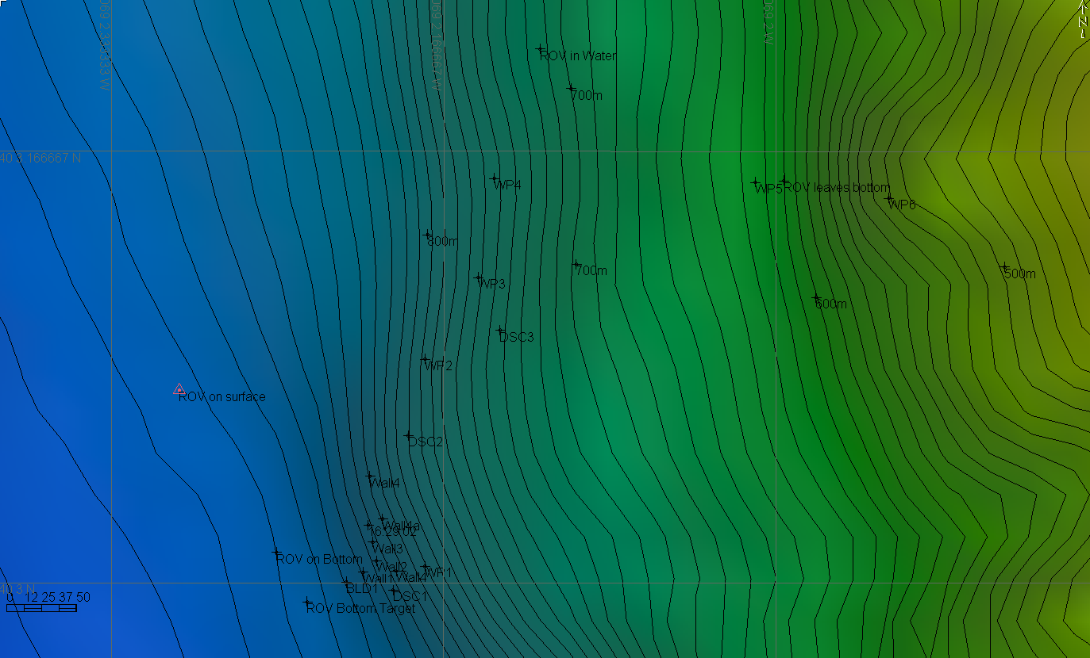
Representative Photos of the Dive
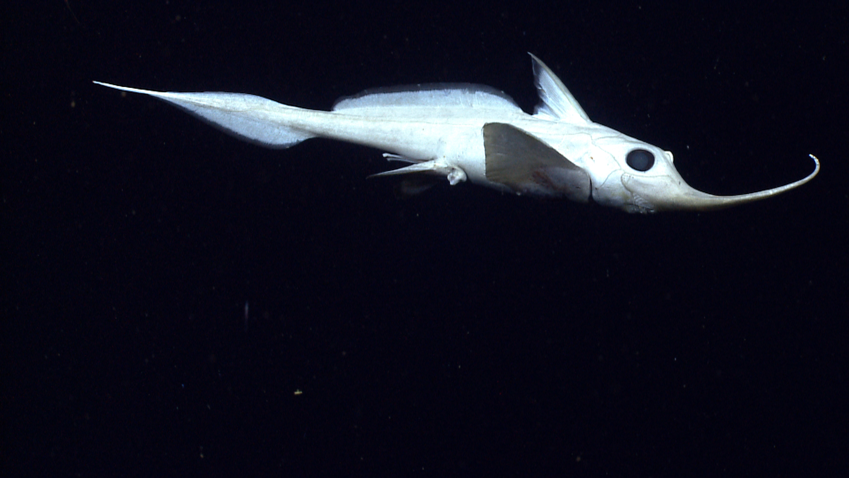 |  |  |  | 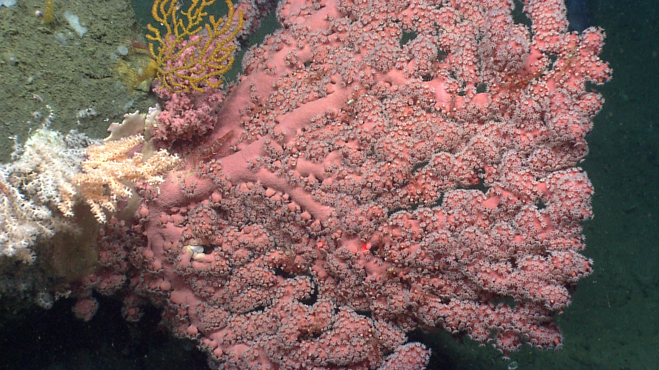
A rhinochimerid (Harriotta raleighana) swims above the seafloor. Time 18:41. Depth ~745 m. |  |  |  | A large bubblegum coral I(Paragorgia arborea) with a shrimp associate. Also pictured include Anthothela (white colony in lower left) and Paramuricea (yellow colony upper left). Time 18:14. Depth 779 m.
Please direct inquiries to: |  | NOAA Office of Ocean Exploration & Research  1315 East-West Highway (SSMC3 10th Floor)  Silver Spring, MD 20910  (301) 734-1014

