Okeanos Explorer ROV Dive Summary
Site Name | New England Seep 2 |  |  |  | 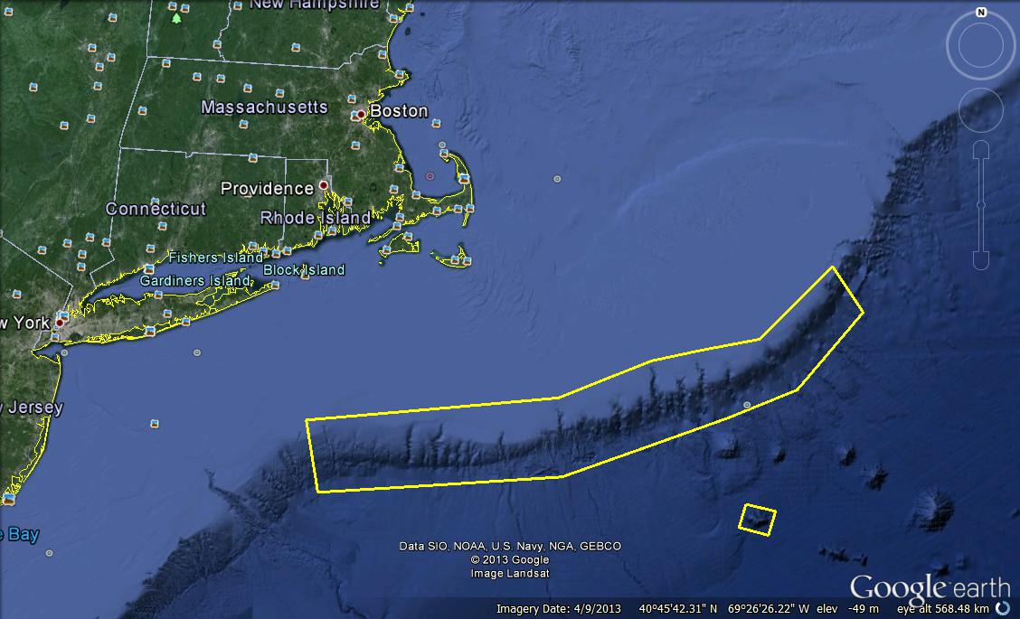
ROV Lead/Expedition Coordinator | Brian Bingham/  Kelley Elliott
Science Team Leads | Tim Shank (shore)  Andrea Quattrini (ship)
General Area Descriptor | Northwest Atlantic Ocean;  Northeast U.S. Canyons
ROV Dive Name | Cruise Season |  | Leg |  |  | Dive Number
 | EX1304 |  | 1 |  |  | DIVE04
Equipment Deployed | ROV: |  | Deepwater Discoverer
 | Camera Platform: |  | Seirios
ROV Measurements | CTD |  | Depth |  |  | Altitude
 | Scanning Sonar |  | USBL Position |  |  | Heading
 | Pitch |  | Roll |  |  | HD Camera 1
 | HD Camera 2 |  | Low Res Cam 1 |  |  | Low Res Cam 2
 | Low Res Cam 3 |  | Low Res Cam 4 |  |  | Low Res Cam 2
Equipment Malfunctions
ROV Dive Summary  (From processed ROV data) | In Water at: 2013-07-12T12:45:25.615000  39°, 52.087' N ; 069°, 17.133' W  Out Water at: 2013-07-12T20:35:49.122000  39°, 52.042' N ; 069°, 17.042' W  Off Bottom at: 2013-07-12T19:38:02.214000  39°, 52.312' N ; 069°, 17.158' W  On Bottom at: 2013-07-12T13:33:40.567000  39°, 52.087' N ; 069°, 17.248' W  Dive duration: 7:50:23  Bottom Time: 6:4:21  Max. depth: 1476.1 m
Special Notes
Scientists Involved  (please provide name / location / affiliation / email) | Primary  Tim Shank, Woods Hole (shore-based science team lead), WHOI, tshank@whoi.edu  Andrea Quattrini, EX (onboard science team lead), Temple, Andrea.Quattrini@temple.edu  Brendan Roark, EX, TAMU, broark@geos.tamu.edu  Taylor Heyl, Woods Hole, MA; WHOI, theyl@whoi.edu  Santiago Herrera Woods Hole, MA; WHOI, sherrera@whoi.edu  Scott France, Lafayette, LA, U. Louisiana at Lafayette, france@louisiana.edu  Bob Carney, Baton Rouge, LA; LSU, rcarne1@lsu.edu  Jason Chaytor, Inner Space Center, USGS at Woods Hole, jchaytor@usgs.gov  AJ Turner, Charleston, NOAA, aj.turner@noaa.gov  Amanda Demopoulos, Gainsville, FL; USGS SE Ecological Science Center, ademopoulos@usgs.gov  Carolyn Ruppel, ISC, USGS Woods Hole, cruppel@usgs.gov  Bernie Ball, Beaufort, NC; Duke, bernieb@duke.edu  Mike Vecchione, Washington, DC; SI/NOAA, vecchionem@si.edu  Sandra Brooke, St. Theresa, FL, FSU, sbrooke@fsu.edu  Passive  Cindy Van Dover; Beaufort, NC; Duke, clv3@duke.edu  Brian Kinlan, Silver Spring, MD; NOAA NCCOS, brian.kinlan@noaa.gov  Enrique Salgado; Charleston, SC; Temple, enrique.salgado@noaa.gov  Holly Fowle, Philadelphia, PA; holly.a.fowle@noaa.gov  Matt Rittinghouse; Charleston, SC; Temple, matthew.rittinghouse@noaa.gov  Kerry McCulloch, Woods Hole, MA; WHOI, williamsk@allegheny.edu  Kelly Williams, Woods Hole, MA; WHOI, mcculloc@uoregon.edu  Walter Cho, Boston, MA; Gordon College, waltercho@pointloma.edu  Stephen Roth; Charleston, SC; NOAA; stephen.roth@noaa.gov  Danny Brothers, Woods Hole, MA; USGS at Woods Hole, dbrothers@usgs.gov  Jason Chaytor, Inner Space Center, USGS at Woods Hole, jchaytor@usgs.gov  Sophie Plouviez, Beaufort, NC; Duke, sophie.plouviez@duke.edu  Peter Girguis, Boston, MA; Harvard, pgirguis@oeb.harvard.edu  Jay Lunden, Philadelphia, PA; Temple, jlunden@temple.edu  Mike Vecchione, Washington, DC; NOAA/SI, vecchiom@si.edu  Cheryl Morrison, Kearneysville, WV, USGS, cmorrison@usgs.gov  Jon Moore, Jupiter, FL; FAU; jmoore@fau.edu  Megumi Shimizu, Beaufort, NC; Duke, megumi.shimizu@duke.edu  Peter Etnoyer, Charleston, SC; NOAA, Peter.Etnoyer@noaa.gov  Chris Kellog, St. Petersburg, FL; USGS, ckellogg@usgs.gov
Purpose of the Dive
The purpose of the dive was to investigate 4 potential seep sites that were identified based on bubble plumes seen during recent multibeam mapping by the Okeanos Explorer including 3 targets that were identified the night before. The primary purpose of the dive was to determine if there are methane seeps within the region and to describe both their geology (vigor and extent of seepage, distribution of authigenic carbonates, relationship of seeps to seafloor geology and their ecology (community structure, distribution of live and dead animals).
Description of the Dive:
The ROV Deep Discoverer was launched at 12:31 UTC and reached bottom at 13:34 UTC at a depth of 1475 m, where the surrounding sediment was mostly fine silt. We started transiting upslope to our first seep target. At 14:30 UTC at a depth of ~1453 m the first mussel was seen quickly followed by more live and dead mussels in clumps and patches spaced in some cases in linear lines. ~5 to >40 individuals were present in each clump and the clumps of mussels were present throughout the rest of the dive when present. At 14:44 UTC at a depth 1450 m the first methane hydrate (small angular chunk) of the dive was identified along with bacterial mats and more live mussels in clumps. Sediments with a dark or black stained appearance were common. At 15:37 UTC at a depth 1447 m the first couple of methane bubbles were identified in association with escape holes but were very sparse. At 16:15 UTC at a depth of 1426 m the largest mussel bed seen in any of seep dives to date was discovered. One individual of an Alvinocaris shrimp was observed embedded in the mussels. Estimation of its size was on the order of ~5x8 m with patchy to dense coverage in certain areas. At 17:00 UTC a transect was done across the mussel bed, with the camera on wide angle and the lasers in view. At 17:12 UTC at a depth of 1419 m the first sighting of active and streaming bubbles was observed from multiple locations in the area. At this point the ship lost DP and we were pulled of the site. Once DP was reacquired, the ROV was then able to descend back to the bottom at 18:19 UTC. The ROV then started to a transit up slope to the 3rd plume target. Again white stained sediments were seen as was carbonate material and some clumpy mussels. At 18:46 UTM at a depth 1420 m an area of rapid and active bubbling was found in an area of dark sediments. Methane hydrates on the sea floor were also identified, and it was questioned whether some of the large patches of white material were hydrates and not bacterial mats. Common fauna for this depth range were observed throughout the dive, including cutthroat eels (synaphobranchids), red crabs (Chaceon quinquedens), cod (Antimora sp.), and halosaurs. Of note, two species of chimera (Hydrolagus and Harriotta) were observed as well as one catshark (Apristurus manis) and an octopus (Graneledone verrucosa). A few flytrap anemones were also observed in the area as well. ROV D2 left the sea floor at 19:38 UTM from a depth 1410 m.

Overall Map of ROV Dive Area |  |  |  | Close-up Map of Main Dive Site
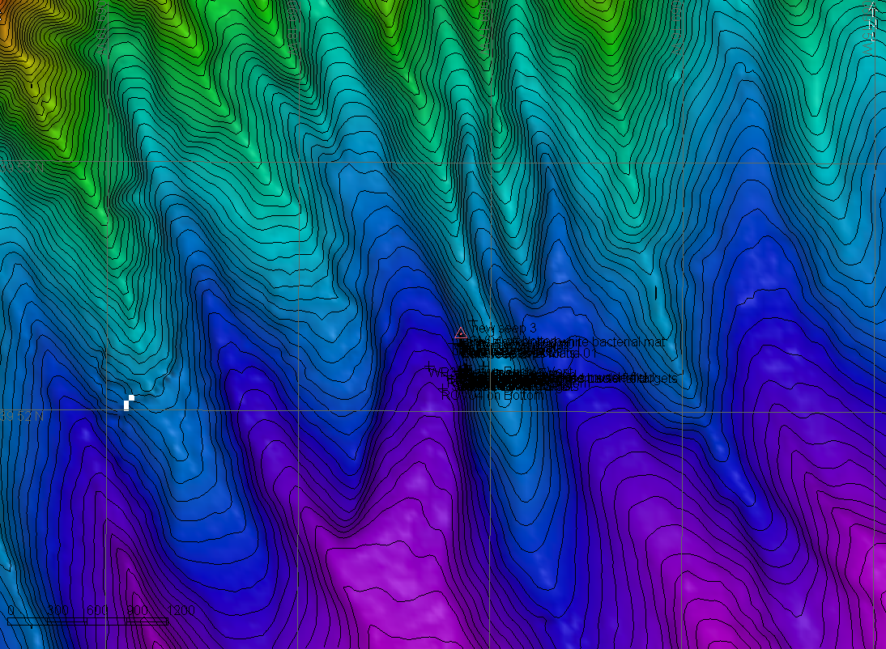 |  |  |  | 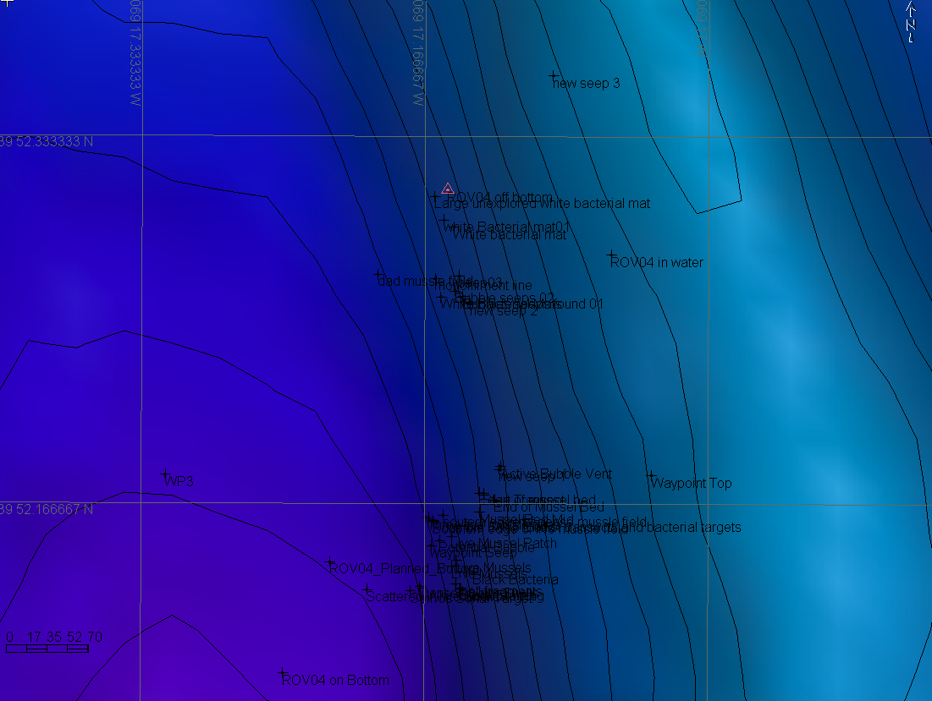
Representative Photos of the Dive
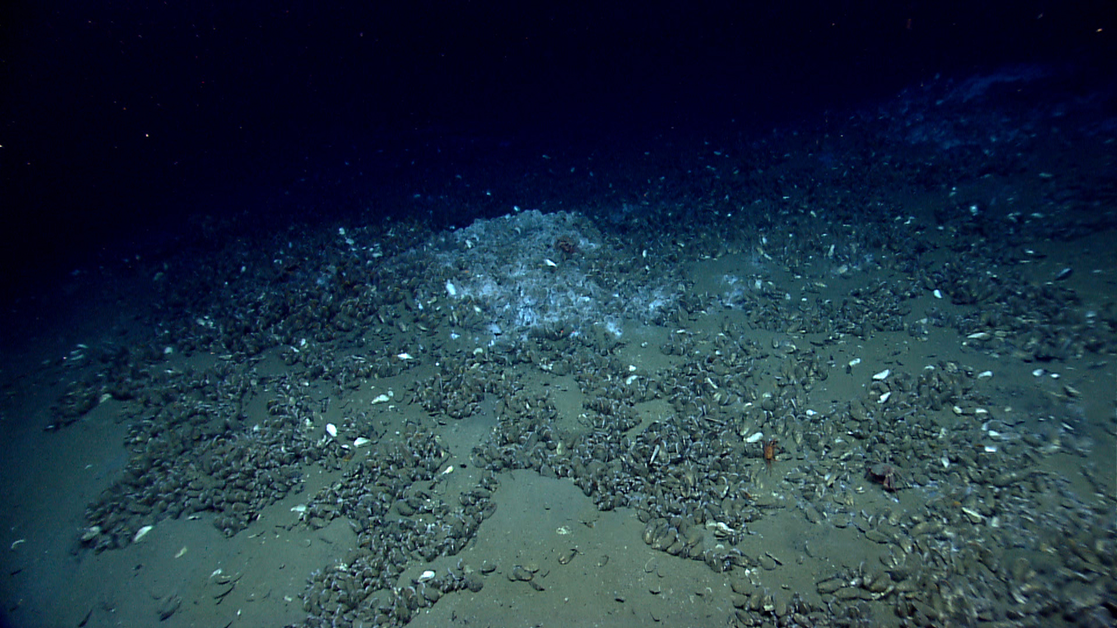 |  |  |  | 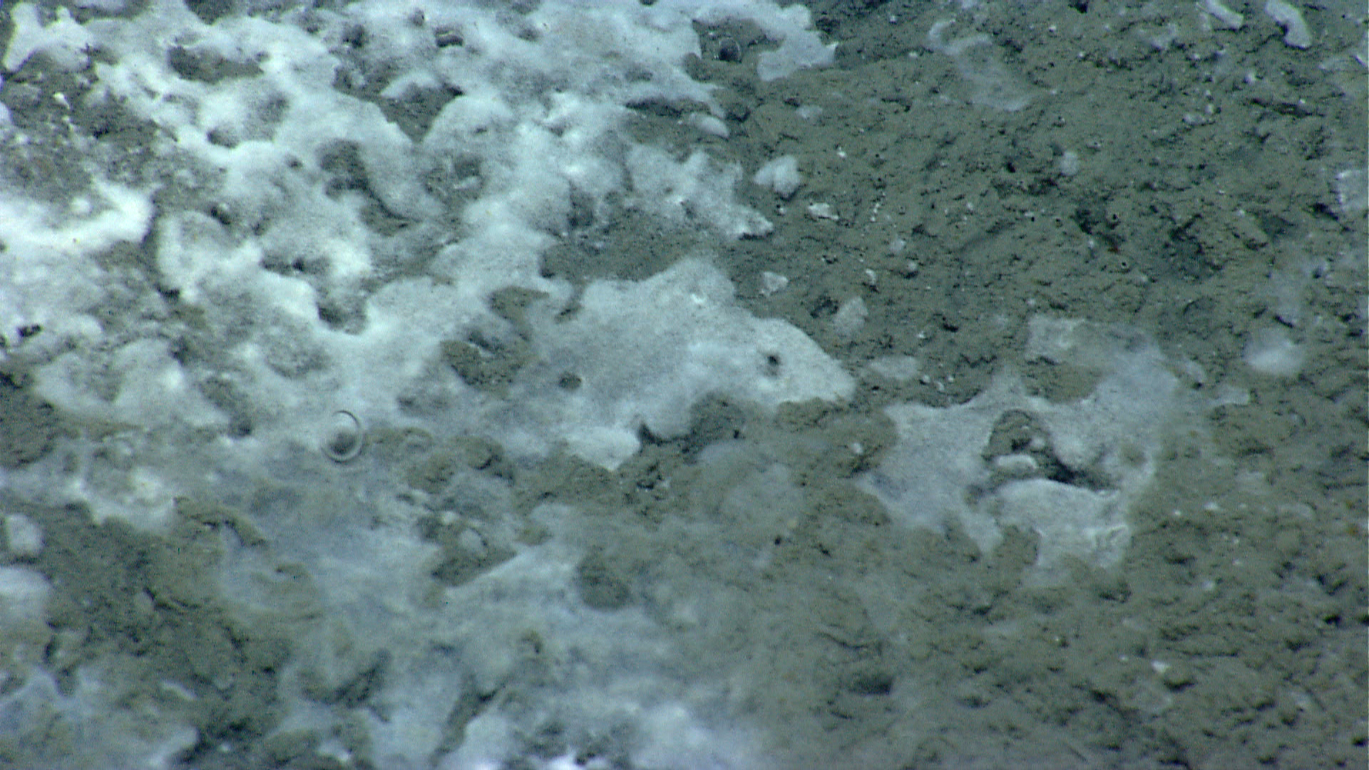
A live bed of Bathymodiolus mussels capped with what appears to be a bacterial mat at a depth of 1427 m. Time 16:26 UTC. |  |  |  | Observations of methane bubbles arising from the seafloor at 1415 m from holes in mud as well as through the white crust on top of the mud, which potentially is methane hydrate. Time 18:48 UTC.
Please direct inquiries to: |  | NOAA Office of Ocean Exploration & Research  1315 East-West Highway (SSMC3 10th Floor)  Silver Spring, MD 20910  (301) 734-1014

