Okeanos Explorer ROV Dive Summary
Site Name | USGS Hazard 3 |  |  |  | 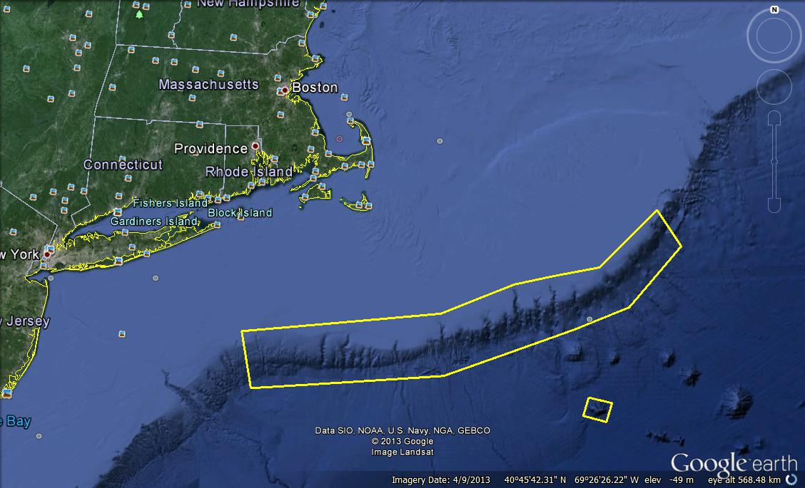
ROV Lead/Expedition Coordinator | Brian Bingham/  Kelley Elliott
Science Team Leads | Tim Shank (shore)  Andrea Quattrini (ship)
General Area Descriptor | Northwest Atlantic Ocean;  Northeast U.S. Canyons
ROV Dive Name | Cruise Season |  | Leg |  |  | Dive Number
 | EX1304 |  | 1 |  |  | DIVE01
Equipment Deployed | ROV: |  | Deepwater Discoverer
 | Camera Platform: |  | Seirios
ROV Measurements | CTD |  | Depth |  |  | Altitude
 | Scanning Sonar |  | USBL Position |  |  | Heading
 | Pitch |  | Roll |  |  | HD Camera 1
 | HD Camera 2 |  | Low Res Cam 1 |  |  | Low Res Cam 2
 | Low Res Cam 3 |  | Low Res Cam 4 |  |  | Low Res Cam 2
Equipment Malfunctions | Occasional Port Vertical Motor Failure
ROV Dive Summary  (From processed ROV data) | In Water at: 2013-07-09 T12:34:27  39°, 45.086' N ; 071°, 04.297' W  Out Water at: 2013-07-09 T20:50:30  39°, 45.328' N ; 071°, 04.672' W  Off Bottom at: 2013-07-09 T19:29:58  39°, 45.328' N ; 071°, 04.672' W  On Bottom at: 2013-07-09 T14:14:48  39°, 44.912' N ; 071°, 04.521' W  Dive duration: 8:16:3  Bottom Time: 5:14:50  Max. depth: 1880 m
Special Notes
Scientists Involved  (please provide name / location / affiliation / email) | Primary  Tim Shank, Woods Hole (shore-based science team lead), WHOI, tshank@whoi.edu  Andrea Quattrini, EX (onboard science team lead), Temple, Andrea.Quattrini@temple.edu  Brendan Roark, EX, TAMU, broark@geos.tamu.edu  Neah Baechler, NOAA Charleston, baechlernv@g.cofc.edu  Peter Etnoyer, Charleston, NOAA, Peter.Etnoyer@noaa.gov  Taylor Heyl, Woods Hole, MA; WHOI, theyl@whoi.edu  Santiago Herrera Woods Hole, MA; WHOI, sherrera@whoi.edu  Scott France, Lafayette, LA, U. Louisiana at Lafayette, france@louisiana.edu  Bob Carney, Baton Rouge, LA; LSU, rcarne1@lsu.edu  Jason Chaytor, Inner Space Center, USGS at Woods Hole, jchaytor@usgs.gov  Amanda Demopoulos, Gainsville, FL; USGS SE Ecological Science Center, ademopoulos@usgs.gov  Passive  Uri Ten Brink, Inner Space Center; USGS, utenbrink@usgs.gov  Shannon Hoy, Inner Space Center; USGS , hoy.shannon@gmail.com  Cindy Van Dover; Beaufort, NC; Duke, clv3@duke.edu  Brian Kinlan, Silver Spring, MD; NOAA NCCOS, brian.kinlan@noaa.gov  Enrique Salgado; Charleston, SC; Temple, enrique.salgado@noaa.gov  Holly Fowle, Philadelphia, PA; holly.a.fowle@noaa.gov  Matt Rittinghouse; Charleston, SC; Temple, matthew.rittinghouse@noaa.gov  Kerry McCulloch, Woods Hole, MA; WHOI, williamsk@allegheny.edu  Kelly Williams, Woods Hole, MA; WHOI, mcculloc@uoregon.edu  Walter Cho, Boston, MA; Gordon College, waltercho@pointloma.edu  Stephen Roth; Charleston, SC; NOAA; stephen.roth@noaa.gov  Danny Brothers, Woods Hole, MA; USGS at Woods Hole, dbrothers@usgs.gov  Carolyn Ruppel, Inner Space Center, USGS at Woods Hole, cruppel@usgs.gov
Purpose of the Dive
The purpose of this proposed dive is to investigate headwall scarps of a large landslide scar on the lower continental slope. The scientific rationale for this site is: 1) to determine if these scarps are relatively young and if they pose a hazard in terms of tsunami generation; 2) evaluate the long term stability of landslide scars and test hypotheses about their evolution, 3) attempt to develop a means of using biologic activity on the scarps and deposits as a means of determining relative ages of the features and the response of bottom communities to catastrophic events (Bob Carney, LSU has an interest in this also).
Description of the Dive:
The ROV Deep Discoverer (D2) was launched at 12:33 UTC. During the lowering through the water column, several mesopelagic organisms were observed, including at least one species of squid and numerous species of midwater fishes. The ROV reached the bottom at 14:15 UTC at a depth of 1870 m, where the surrounding sediment was mostly silt and silty clays, most likely dominated by foraminiferal ooze. The ROV then transited over this fairly flat, soft sediment bottom toward the base of the slope feature, or headwall scarp of a landslide scar. A number of large angular boulders, most likely mudstones ornamented with varying levels of bioturbation and other erosion, detached from the adjacent vertical walls were encountered Several species of fishes were observed over this soft sedimented area, including halosaurs, cutthroat eels, chimaera, rajiid skates, and macrourid rattails. The invertebrate megafauna was dominated by one holothurian (Paelopatides sp.) and at least one sea urchin (Echinus sp.); however, pycnogonid sea spiders and at least 3 species of sea pens were observed during the transit to the hard bottom features. At ~15:15 UTC the ROV approached the first hard substrates during this dive, and continued to survey hardbottom habitats until ~18:53 UTC. The overall slope was ~20-30 deg; however, there were two large vertical rock wall with relief of more than 15 m. separated by a steeply sloped ledge. Several other smaller walls and rock/boulder outcrops (>2-3 m) were encountered during the dive. Several smaller rocks appeared to have ferromanganese coatings during the deeper part of the dive. Numerous corals colonized the faces and tops of the large hard features, including Paramuricea cf. grandis, Anthomastus sp., Chrysogorgia sp., and Radicepes sp. Stony corals including Desmophylum were observed attached to the underside of ledges and a solitary hydrozoa, Corymorpha sp. was observed. Brown staining was observed on the walls, and in many areas the hard substrates were heavily eroded, with numerous burrows and crevices, and some columnar structures were also observed. The top of this feature (~1621 m depth) was covered with soft sediment composed of silt and silty clays. Of note, few fauna were observed on top of the feature, with the exception of halosaurs and cutthroat eels. The sessile fauna was dominated by Acanella sp., a type of bamboo coral that commonly occurs on both soft and hard substrates. One notable behavior observed was potential predation event, of what appeared to be an Echinus sea urchin preying upon an Acanella colony. The dive was ended 5 min prior to scheduled recovery time, as we lost complete control and communication with the vehicles due to someone accidentally hitting the emergency stop in the ROV hangar. The successful first dive of the cruise ended at 19:26 UTC at 1610 m.
Overall Map of ROV Dive Area |  |  |  | Close-up Map of Main Dive Site
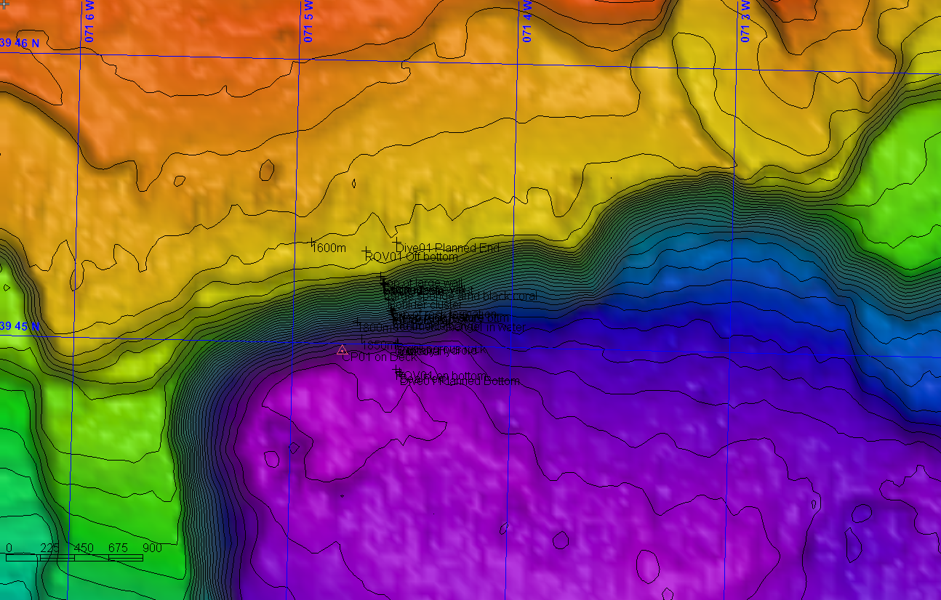 |  |  |  | 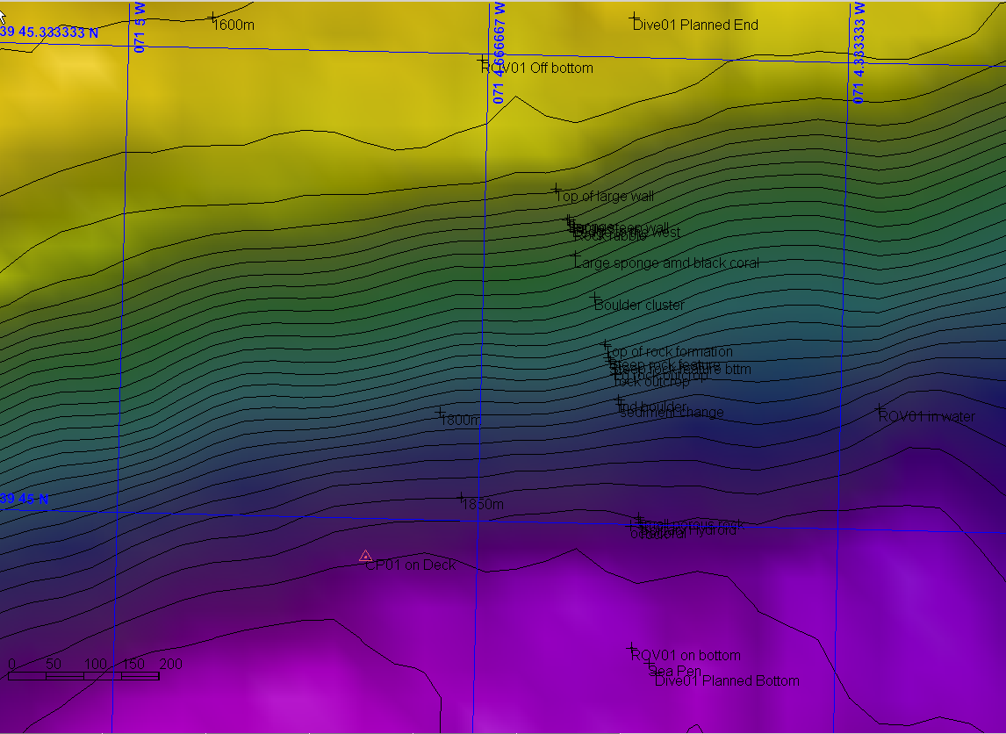
Representative Photos of the Dive
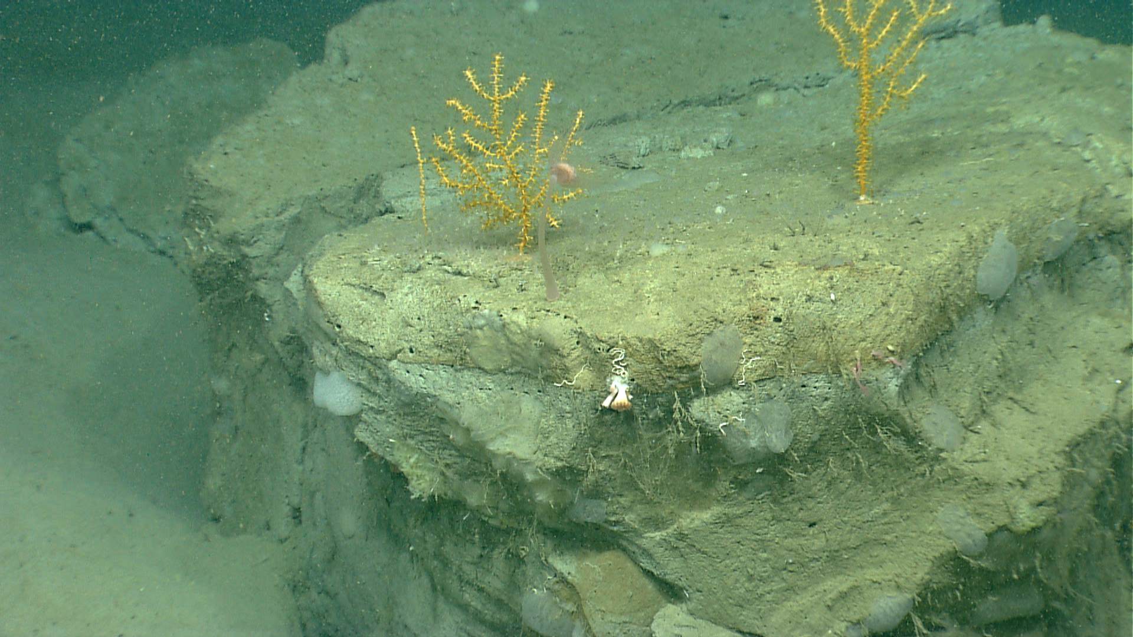 |  |  |  | 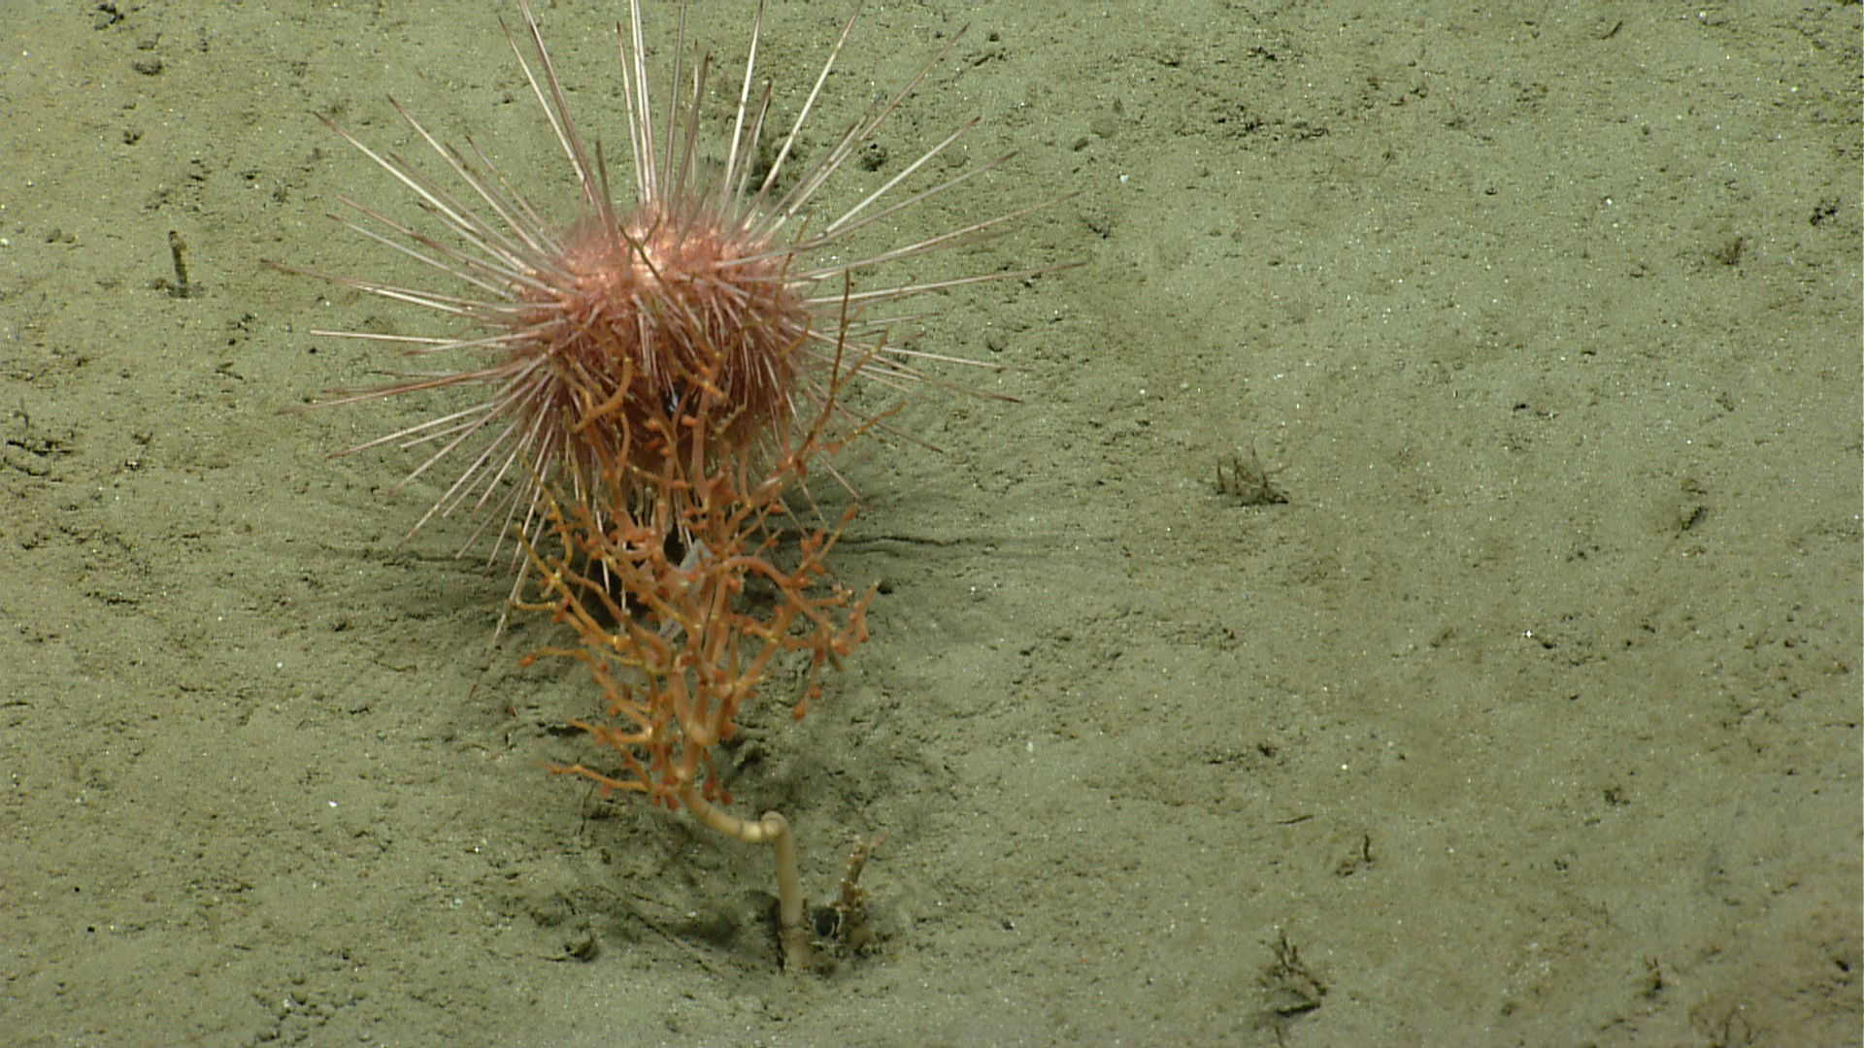
Two Paramuricea colonies on top of a rock block with a cup coral on the ledge. This image was captured at 15:24 UTC at a depth of 1855 m. |  |  |  | An urchin on top of a bamboo coral Acanella sp. in what appears to be a predation event. Image captured at 18:56 at a depth of ~1619 m.
Please direct inquiries to: |  | NOAA Office of Ocean Exploration & Research  1315 East-West Highway (SSMC3 10th Floor)  Silver Spring, MD 20910  (301) 734-1014

