***Carolyn Ruppel, USGS Gas Hydrates Project, Woods Hole, cruppel@usgs.gov***

**Site Name:** Outreach Dive 21 July, NE Canyons

**Approximate Location:** 39.81 N; 69.59 W

**Dive Date (local):** DATE (2013/07/21)

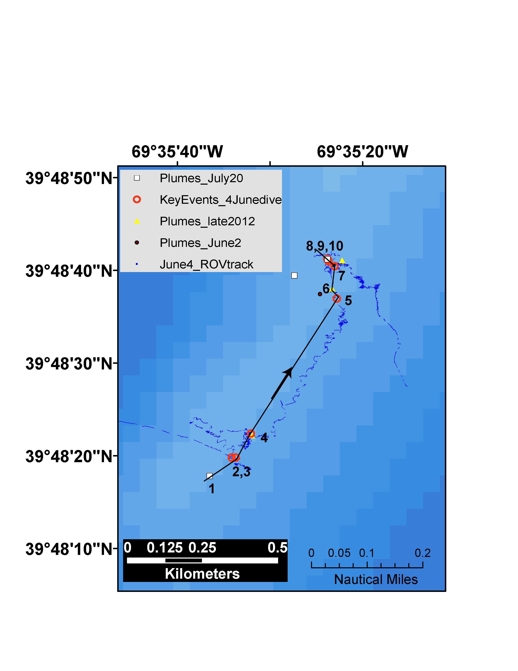

1: July 21 methane plume; **2, 3: MOST PHOTOGENIC KNOWN LOCATION: carbonates, live mussels, bac. mats**; **4: QUITE PHOTOGENIC: live mussels with juveniles;** 5: mussel bed; 6: near methane plume imaged in late 2012 and on June 2; 7, 8, 9: active bubbling; 10: mussels

**Brief Explanation of Exploration Objectives and Rational for the Desired Dive Track:**

This multi-seep area was surveyed relatively rapidly during the June 4 engineering dive, which progressed from north to south (downhill). Repeated multibeam surveys (late 2012, June 2, and July 20) have revealed two to three methane plumes, but these are not always originating at the same locations in the different surveys. The locations of these plumes move too much to be explained merely by spatial resolution issues with the multibeam data. Thus, the “movement” of plumes between surveys may indicate that at least some of the seeps are ephemeral. This has important implications for the colonization of the seeps by chemosynthetic organisms, the duration of these communities, and their demise.

The engineering dive discovered live mussel beds (some with juveniles), extensive dead mussel debris (with methane bubbling), bacterial mats, carbonates, xenophyophores, and other indicators of chemosynthetic activity. The return dive on 21 July is designed to go from south to north in a generally uphill direction. All but 2 of the waypoints correspond to features discovered during the 4 July engineering dive. The “new” waypoints cross the inferred bases of methane plumes, where seep features are expected at the seafloor.

The dive will first encounter one of the “new” waypoints (methane plume), in the spirit of true discovery. About 85 m away at Waypoints 2 and 3, the ROV will come across a picturesque chemosynthetic community where live mussels and bacterial mats are nestled among carbonates. Waypoint 4 is another nice scene, with a live mussel bed, juvenile mussels, and a white “marshmallow” material (mat?) that it would be good to see again at close range with the lasers on. After waypoint 4, if the outreach goals of the dive make it possible to continue for a few more hours, the ROV should proceed on a relatively straight line path to waypoint 5 (but on a track parallel to and uphill of the original ROV track), where another clump of live mussels was observed on June 4. Waypoint 6 coincides with the general area of a methane plume imaged on multiple occasions. Waypoints 7 through 9 have active bubbling, although the area is within a mussel debris field (not very photogenic). Waypoint 10 again encounters live mussels. Waypoints 7 through 10 can be dropped if time does not permit. Achieving Waypoint 6 would probably be optimistic with a late start for the dive and ample time to explore various features.

**Has previous work been conducted here? Are there potential hazards in the area?**

No hazards. Previous work includes repeated MBES surveys (June 2, 2013; July 20, 2013; late 2012); engineering dive on June 4.

**ROV Track Waypoints Table:**

|  |  |  |  |  |  |  |  |
| --- | --- | --- | --- | --- | --- | --- | --- |
| *DESIRED WAYPOINTS TO EXPLORE -*  *(COMPLETED BY SHORE-SIDE LEAD SCIENTIST)*  *(not including launch)* | | | | *ACTUAL WAYPOINTS TO EXPLORE-*  *(COMPLETED BY SHIPBOARD EXPEDITION LEADER)* | | | |
| **WAYPOINT NAME/SEQUENCE** | **LATITUDE** | **LONGITUDE** | **APPROX DEPTH** | **WAYPOINT NAME/SEQUENCE** | **LATITUDE** | **LONGITUDE** | **APPROX**  **DEPTH** |
| Launch | 39.805 | -69.594 |  |  |  |  |  |
| 1 | 39.80495 | -69.5935 | 1417.8 |  |  |  |  |
| 2 | 39.8055 | -69.5927 | 1421.5 |  |  |  |  |
| 3 | 39.8055 | -69.5928 | 1420.2 |  |  |  |  |
| 4 | 39.80622 | -69.5922 | 1418.9 |  |  |  |  |
| 5 | 39.81026 | -69.5897 | 1410.1 |  |  |  |  |
| 6 | 39.81056 | -69.5898 | 1415(?) |  |  |  |  |
| 7 | 39.81138 | -69.5899 | 1406 |  |  |  |  |
| 8 | 39.81141 | -69.5899 | 1406.1 |  |  |  |  |
| 9 | 39.81145 | -69.5899 | 1406 |  |  |  |  |
| 10 | 39.81123 | -69.5897 | 1398.6 |  |  |  |  |
| Recovery | 39.812 | -69.59 | 1408 |  |  |  |  |

**ANCILLARY INFORMATION:**

**Recommended operations in the target area prior to or after ROV dive**

*Please include requests for in situ sensors (LSS, DO, ORP) to be added to the CTD cast here, and specifics on the type of mapping operation requested (multibeam, subbottom, single beam).*

|  |  |  |  |
| --- | --- | --- | --- |
|  | **LATITUDE** | **LONGITUDE** | **APPROX DEPTH** |
|  | | | |
| 1 |  |  |  |
| 2 |  |  |  |
| 3 |  |  |  |
| 4 |  |  |  |
| **MAPPING AREA BOUNDING COORDINATES** | | | |
| North |  | |  |
| East |  |
| South |  |
| West |  |