***Proposed by Carolyn Ruppel, USGS Gas Hydrates Project, Woods Hole***

**Site Name:** “Okeanos New England seeps/SEEP3” (between Veatch and Hydrographer Canyons)

**Approximate Location:** 39.902 N; 69.257 W

**Dive Date (local):** DATE (2013/07/11)

**General map showing relationship to area seeps Focus map showing target seeps for dive**

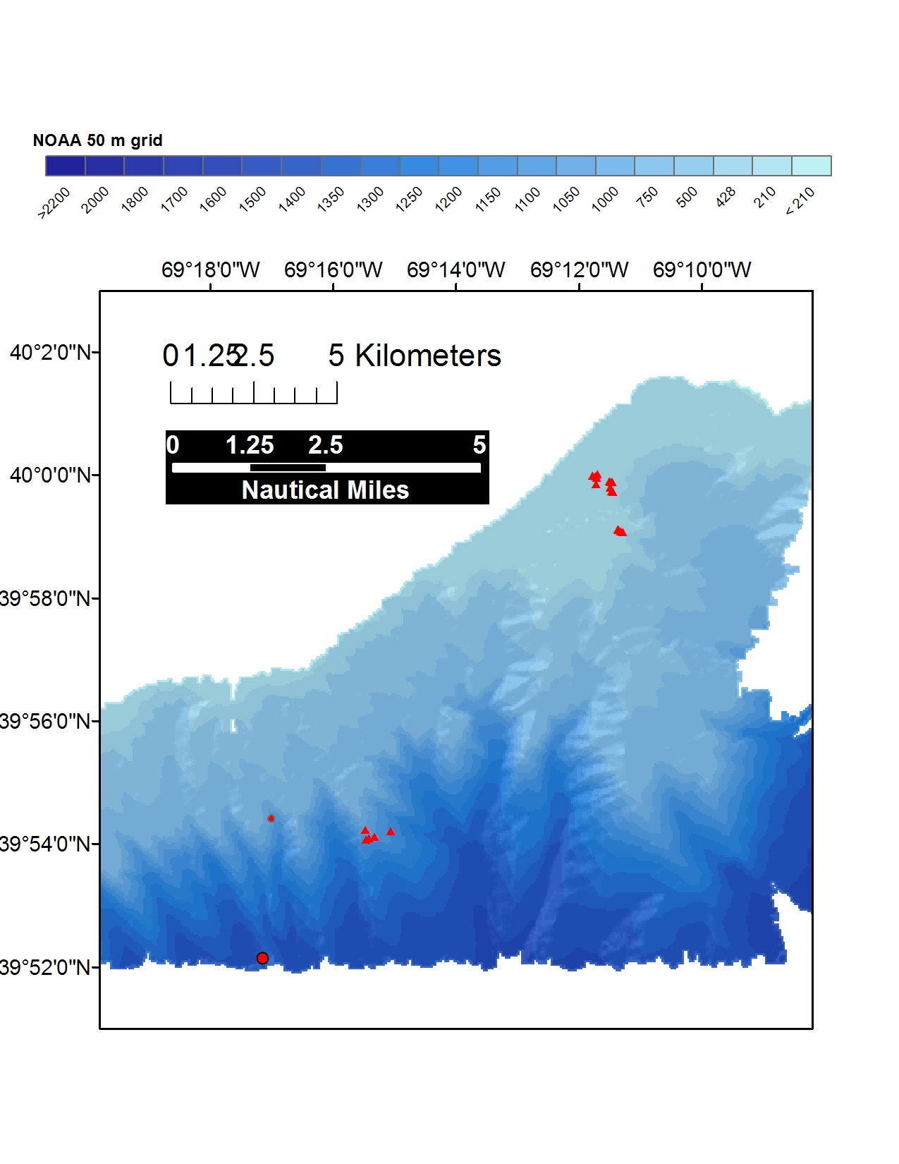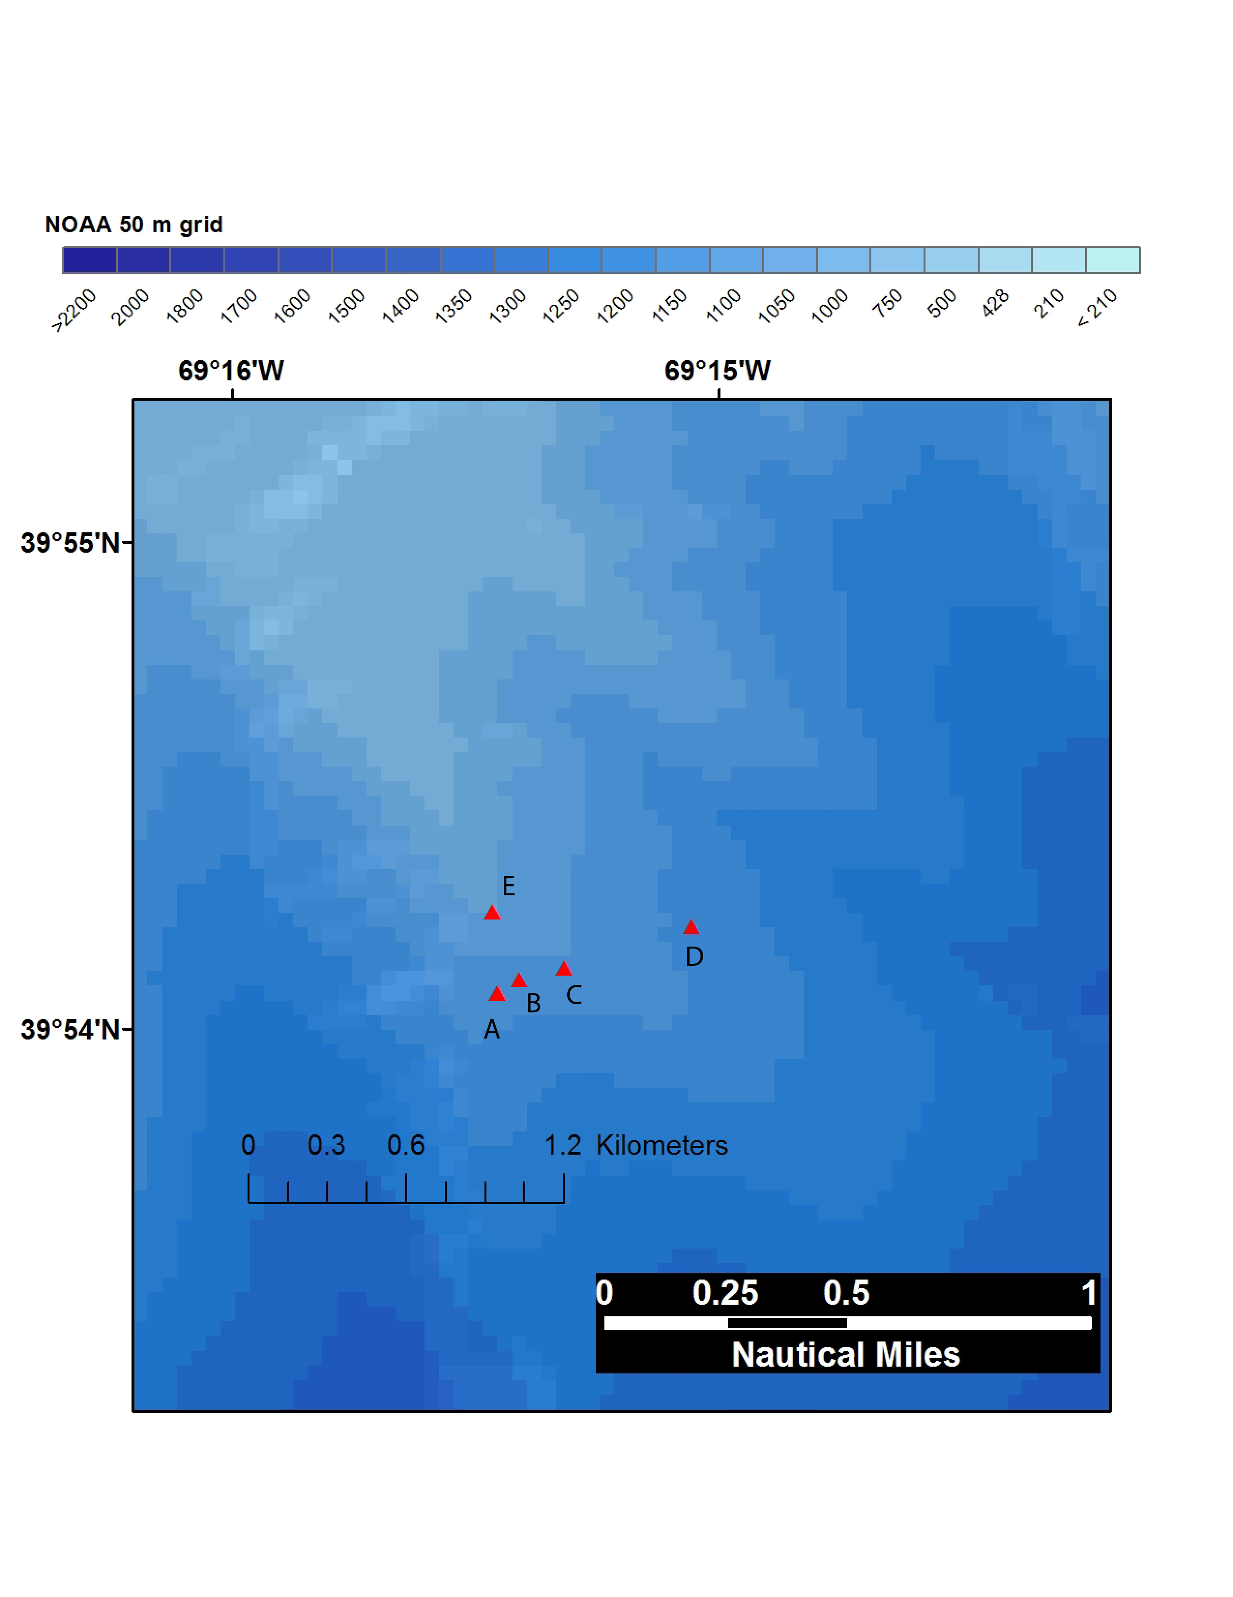

**This set of seeps, which was discovered based on NOAA OE’s analysis of water column anomalies (plumes) in MB data in late 2012, lies mostly on a ridge (not within or at the head of a canyon) in ~1100 of water. There are several potential dive strategies: (1) Start west of A and visit A-B-C then move up the ridge to E at end of dive. (2) Start east of C and visit C-B-A and move up ridge toward E. (3) (Worse strategy) Start at D and visit C-B-A. This is risky due to the distance to be traversed between D and C.**

**Brief Explanation of Exploration Objectives and Rational for the Desired Dive Track:**

These seeps, unknown only 7 months ago, lie within the gas hydrate stability field on the Nantucket margin. This means that seeps should in theory not exist, since free gas should be forming gas hydrate. On the southern US margin, such cold seeps are underlain by diapirs that heat the sediment and the gas hydrate, leading to the release of gas. The origin of the newly discovered deepwater seeps (> 600 m) on the northern part of the US Atlantic margin remains poorly understood. This part of the margin is highly eroded and strongly affected by Pleistocene processes, and the nature of seepage here may be inherently different than on the heavily sedimented southern part of the Atlantic margin.

The relative proximity of these 5 seeps, which cover less than a kilometer along-track, renders them potentially rich dive targets to address both geological (vigor and extent of seepage, distribution of authigenic carbonates, relationship of seeps to seafloor geology) and ecological (community structure, distribution of live and dead animals, similarity to faunal assemblages at Veatch seep) questions. Several possible dive strategies are described in the red caption under the detailed map on previous page. The best strategy starts just downslope of seep A and visits A-B-C before starting up the spine of the ridge towards seep E. The total bathymetric range is less than 100 m and the total distance to go past seep C before turning uphill through seep E is ~775 m.

For the sake of geologic issues, it is important that the ROV operators film bubble streams where they are emitted from the seafloor for a period of about a minute with the laser scale on. This will assist in assessing the size of bubbles, which contributes to estimates of methane flux (both at individual seeps and integrated across seeps). Video of multiple bubble streams, as done so well on the dive at 450 m offshore Virginia on May 25, is also important to get a sense of the distribution of seepage (e.g., one discrete location or many). Carbonate edifices on the seafloor may seem boring, but they are meaningful in terms of methane seepage since they are a product of anaerobic methane oxidation. Where they are visible in cross-section, their thickness is noteworthy as it indicates sustained methane seepage, not recently triggered seep initiation.

**Has previous work been conducted here? Are there potential hazards in the area?**

No hazards. Previous work includes EX1206 multibeam; Regional XBTs; water column plumes and seafloor seeps identified based on analysis of prior OE multibeam data

**ROV Track Waypoints Table:**

|  |  |  |  |  |  |  |  |
| --- | --- | --- | --- | --- | --- | --- | --- |
| *DESIRED WAYPOINTS TO EXPLORE -*  *(COMPLETED BY SHORE-SIDE LEAD SCIENTIST)*  *(not including launch)* | | | | *ACTUAL WAYPOINTS TO EXPLORE-*  *(COMPLETED BY SHIPBOARD EXPEDITION LEADER)* | | | |
| **WAYPOINT NAME/SEQUENCE** | **LATITUDE** | **LONGITUDE** | **APPROX DEPTH** | **WAYPOINT NAME/SEQUENCE** | **LATITUDE** | **LONGITUDE** | **APPROX**  **DEPTH** |
| Launch—**OPTION 1 from red** **caption on previous page** | 39.901 | -69.258 | 1123 | Launch |  |  |  |
| WP1 | 39.901211 | -69.257582 | 1126 | WP1 | 39.901211 | -69.257582 | 1126 |
| WP2 | 39.901682 | -69.256826 | 1122 | WP2 | 39.901682 | -69.256826 | 1122 |
| WP3 | 39.902066 | -69.255284 | 1110 | WP3 | 39.902066 | -69.255284 | 1110 |
| WP4 | 39.904001 | -69.257741 | 1055 | WP4 | 39.904001 | -69.257741 | 1055 |
| Recovery | 39.904 | -69.258 | 1048 | Recovery |  |  |  |

**ANCILLARY INFORMATION:**

A CTD cast will be made post-dive and water samples will be collected to depths of 500 m.

**DIVE PLAN OVERVIEW**

The general dive plan is to launch downslope of point A and transit up through point C before moving up slope to point E to finish the dive.

**IMAGE: SLOPE TOPOGRAPHY WITH WAYPOINTS**

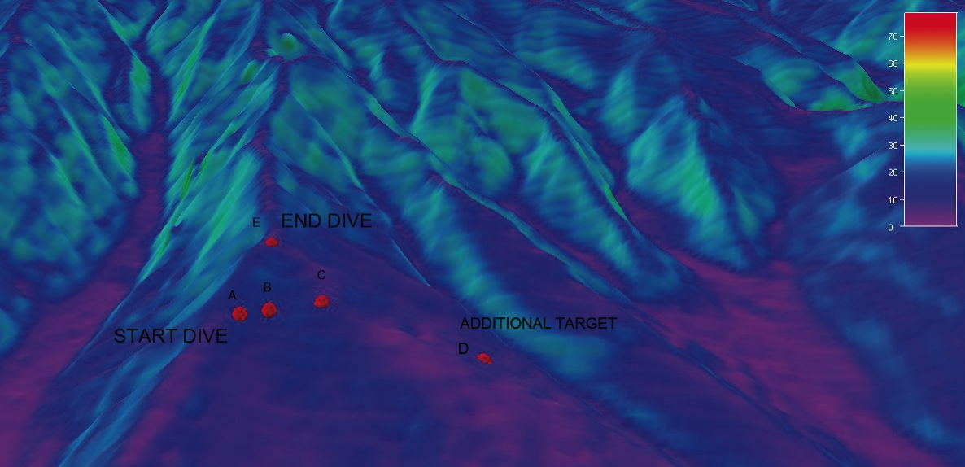

**Recommended operations in the target area prior to or after ROV dive**

*Please include requests for in situ sensors (LSS, DO, ORP) to be added to the CTD cast here, and specifics on the type of mapping operation requested (multibeam, subbottom, single beam).*

|  |  |  |  |
| --- | --- | --- | --- |
|  | **LATITUDE** | **LONGITUDE** | **APPROX DEPTH** |
| **CTD CASTS (OPTIONAL—The greatest scientific need on this part of the US margin is casts to collect temperature/salinity data to the seafloor at 500 and 600 m water depths, but this is rather distant from the proposed operations area.** | | | |
| 1 | 39.906 | -69.259 | 1000 |
| 2 | 39.9 | -69.255 | 1150 |
| 3 |  |  |  |
| 4 |  |  |  |
| **MAPPING AREA BOUNDING COORDINATES** | | | |
| North | Will send potential Chirp (Knudsen 3260) tracklines for this area in separate email. Because they are on a ridge, not the side of a canyon, these seeps have among the best locations (relative to canyons) on this margin for acquisition of subbottom data to potentially image subseafloor plumbing. The data will have to be acquired with some care to increase the chances that they will be useful. Meme Lobecker has some experience with this in the past month or so. | |  |
| East |  |
| South |  |
| West |  |