*Please use this as a template for documenting your recommendations for high-priority dive targets. Be sure to include a rationale for the dive as well as specific protocols (if applicable), and any known previous work or potential hazards at the site. Please include only generalized location information for any marine archaeology sites.*

*The form also includes fields for mapping targets and CTD cast locations as well.*

*Please send the completed form to* [*Kelley.Elliott@noaa.gov*](mailto:Kelley.Elliott@noaa.gov) *and* [*Brian.Kennedy@noaa.gov*](mailto:Brian.Kennedy@noaa.gov)*.*

**Site Name:** USGS-Hazards 4

**Approximate Location:** 39.87152, -69.76779

**Dive Date (local):** July 10, 2013

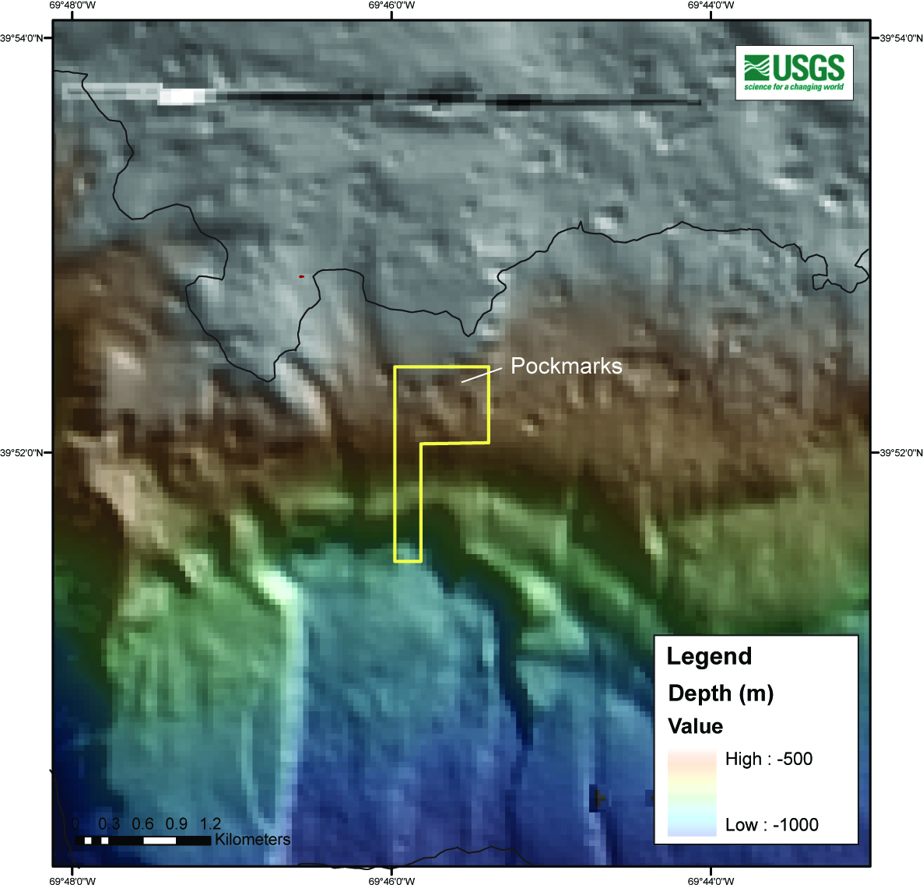

**Brief Explanation of Exploration Objectives and Rational for the Desired Dive Track:** The purpose of this proposed dive is toinvestigate pockmarks on the upper continental slope between 500 and 650 m water depth directly above the headwall scarp of a landslide. The scientific rationale for this site is to: 1) investigate the potential for these feature to be created by ephemeral or long-lived fluid flow (gas, water, etc.); 2) characterize the pockmark morphology, sediment infilling, and linkages to nearby landslides; 3) evaluate the long term stability of landslide scars and test hypotheses about their evolution, 3) attempt to develop a means of using biologic activity on the scarps and deposits as a means of determining relative ages of the features and the response of bottom communities to catastrophic events (Bob Carney, LSU has an interest in this also).

The proposed dive track is an upslope transect across the landslide headwall, followed by investigation of the numerous pockmark features in the area above the headwall.

**Has previous work been conducted here? Are there potential hazards in the area?** The proposed dive area has been investigated by the USGS using multibeam bathymetry and sub-bottom. No known hazards.

**ROV Track Waypoints Table:**

|  |  |  |  |  |  |  |  |
| --- | --- | --- | --- | --- | --- | --- | --- |
| *DESIRED WAYPOINTS TO EXPLORE -*  *(COMPLETED BY SHORE-SIDE LEAD SCIENTIST)*  *(not including launch)* | | | | *ACTUAL WAYPOINTS TO EXPLORE-*  *(COMPLETED BY SHIPBOARD EXPEDITION LEADER)* | | | |
| **WAYPOINT NAME/SEQUENCE** | **LATITUDE** | **LONGITUDE** | **APPROX DEPTH** | **WAYPOINT NAME/SEQUENCE** | **LATITUDE** | **LONGITUDE** | **APPROX**  **DEPTH** |
| Launch |  |  |  | Launch |  |  |  |
| WP1 | 39.87187418 | -69.73276518 | -568.33 | WP1 | 39.87187418 | -69.73276518 | -568.33 |
| WP2 | 39.8739922 | -69.74024491 | -575.34 | WP2 | 39.8739922 | -69.74024491 | -575.34 |
| WP3 | 39.87265331 | -69.74454768 | -577.94 | WP3 | 39.87265331 | -69.74454768 | -577.94 |
| WP4 | 39.87179574 | -69.7472546 | -592.97 | WP4 | 39.87179574 | -69.7472546 | -592.97 |
| WP5 |  |  |  | WP5 |  |  |  |
| Recovery |  |  |  | Recovery |  |  |  |

**ANCILLARY INFORMATION:**

We will conduct a CTD cast after the dive.

**DIVE PLAN OVERVIEW**

The general dive plan is to start east and move west targeting various pockmarks.

