CTD Cast Name |  |   Cruise |  |  |  |  |  | CTD Number |  |  | Date
 |  | EX1304L1 |  |  |  |  |  | CTD007 |  |  | 07/16/2013
Expedition Coordinator/  Science Team Lead |  | Kelley Elliott/Andrea Quattrini  /Tim Shank (on shore) |  |  |  |  |  |  | 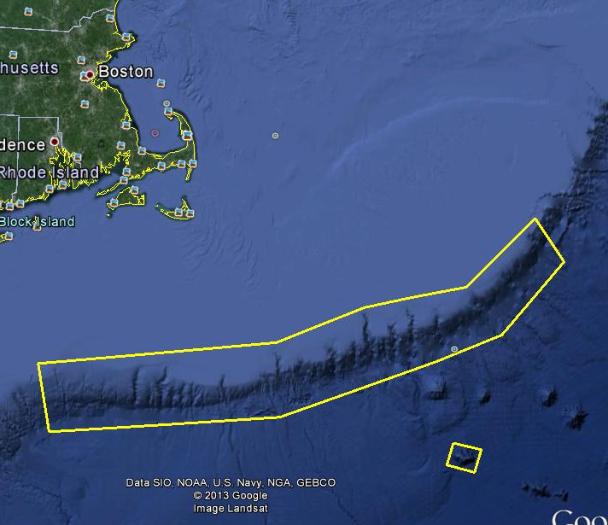
General Area Descriptor |  | Northeast U.S. Canyons/  Northwest Atlantic Ocean
Site Name |  | Atlantis Canyon Deep
Type of CTD Operation |  | Vertical Cast Po-Go
 |  | Tow-Yo Combination
Target Position |  | 39 |  | 47.1957872N
 |  | 70 |  | 13.1910642W
Deployment  Time & Location |  | UTC Time | 22:30
 |  | Latitude | 39 |  | º | 47.203 |  |  |  |  |  |  | ‘ |  |  | N
 |  | Longitude | 70 |  | º | 13.199 |  |  |  |  |  |  | ‘ |  |  | W
Time & Location  At Depth |  | UTC Time | 22:40 |  | Target Depth/Range |  |  |  |  | 500m
 |  | Latitude | 39 |  | º |  | 47.203 |  |  |  |  |  |  | ‘ |  |  | N
 |  | Longitude | 70 |  | º |  | 13.199 |  |  |  |  |  |  | ‘ |  |  | W
Recovery  Time & Location |  | UTC Time | 23:08 |  | Maximum Depth (m) |  |  |  |  | 1800m
 |  | Latitude | 39 |  | º | 47.204 |  |  |  |  |  | ‘ |  |  | N
 |  | Longitude | 70 |  | º | 13.199 |  |  |  |  |  | ‘ |  |  | W
CTD Sensor  Data Acquired |  | CTD P 107068 T1 5023 T2 5026 C1 3455 C2 3456
 |  | ORP 07 Votage Channel 07
 |  | LSS 12791 Voltage Channel 02 LSS 12791 Voltage Channel 06
 |  | Dissolved Oxygen 2097 Voltage Channel _04_ Altimeter Voltage Channel 00
 |  | Other (specify) ____________ Voltage Channel __ ____________ Voltage Channel __
Water Samples Collected? |  | Yes No If Yes, Number of Bottles Tripped: _____________
Sample  Processing |  | Sample Type(s): ___ ________________________________
 |  | Processed on board Preserved Chemicals _______________________
 |  | None Room Temp Storage -80 Freezer -20 Freezer Refrigerator
Data Archival |  | Tethys FTP site
Equipment Malfunctions | n/a
Special Notes
Scientists Involved  (name / location / affiliation / email) |  | Brendan Roark (TAMU), broark@geos.tamu.edu  Andrea Quattrini (Temple), andrea.quattrini@temple.edu  Jon Hare (NEFSC), Jon.Hare@noaa.gov

Purpose of the CTD operation: Collect data overtop of dive location. Collect water samples for future nutrient analysis by NEFSC.
Description of the Data/Results:
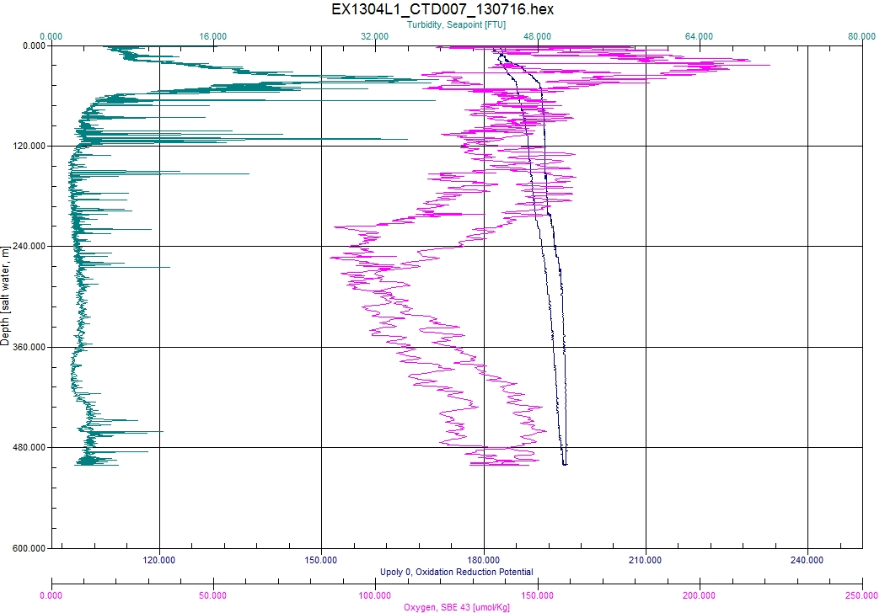
Overall Map of CTD Cast Area | Screen Grab of Data
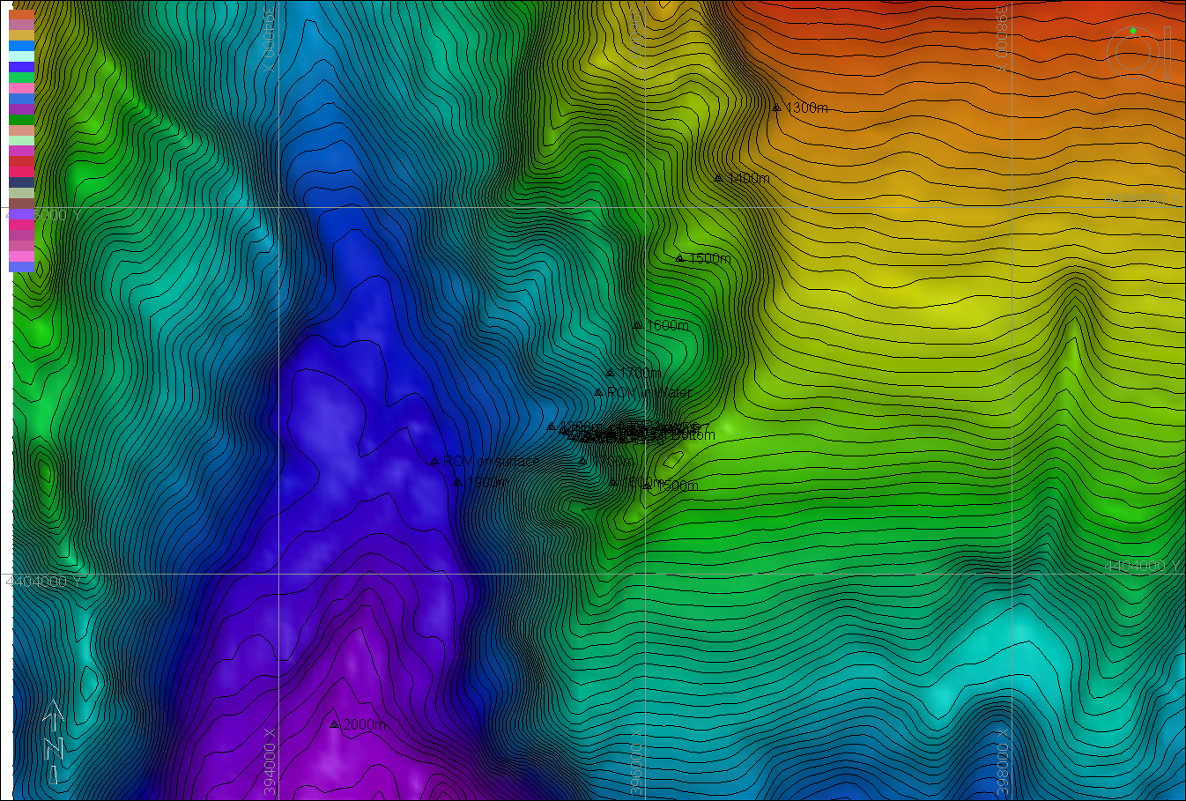 | 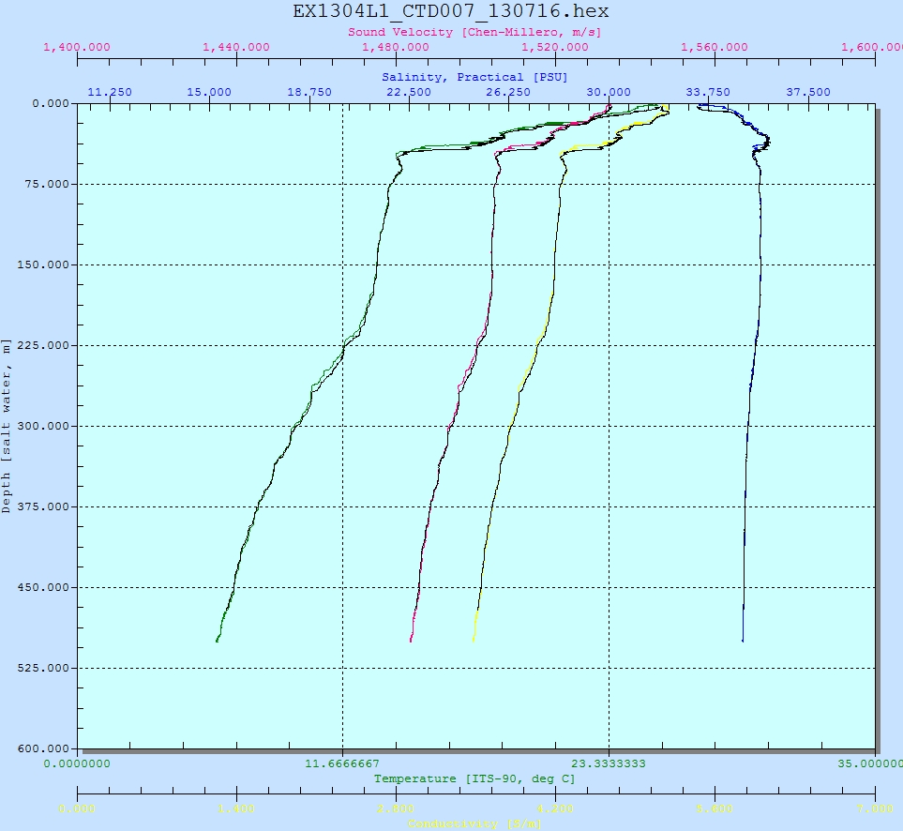
Overview of Cast site (southern end of box 1) | SeaSave Data Acquisition Screen
Please direct inquiries to: | NOAA Office of Ocean Exploration & Research  1315 East-West Highway (SSMC3 10th Floor)  Silver Spring, MD 20910  (301) 734-1014

