CTD Cast Name |  |   Cruise |  |  |  |  |  | CTD Number |  |  | Date
 |  | EX1304L1 |  |  |  |  |  | CTD003 |  |  | 07/12/13
Expedition Coordinator/  Science Team Lead |  | Kelley Elliott/Andrea Quattrini  /Tim Shank (on shore) |  |  |  |  |  |  | 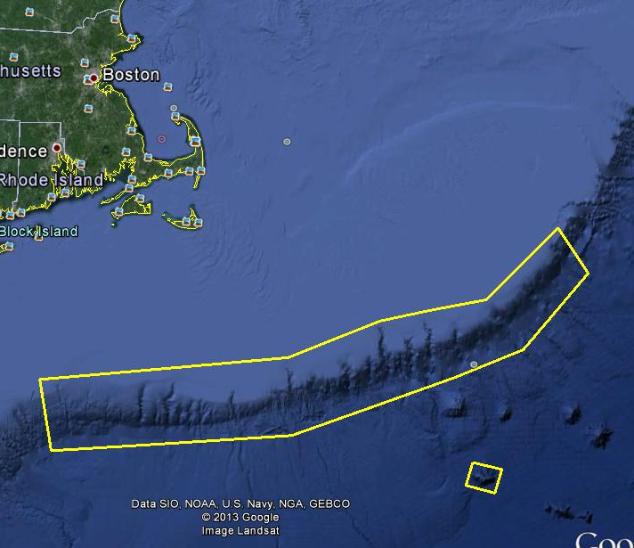
General Area Descriptor |  | Northeast U.S. Canyons/  Northwest Atlantic Ocean
Site Name |  | New England Seep 2
Type of CTD Operation |  | Vertical Cast Po-Go
 |  | Tow-Yo Combination
Target Position |  | 39° |  | 52.90N
 |  | 69° |  | 14.98W
Deployment  Time & Location |  | UTC Time | 00:24
 |  | Latitude | 39 |  | º | 52.90 |  |  |  |  |  |  | ‘ |  |  | N
 |  | Longitude | 69 |  | º | 14.98 |  |  |  |  |  |  | ‘ |  |  | W
Time & Location  At Depth |  | UTC Time |  |  | Target Depth/Range |  |  |  |  | 1300m/13 mob
 |  | Latitude | 39 |  | º |  | 52.90 |  |  |  |  |  |  | ‘ |  |  | N
 |  | Longitude | 69 |  | º |  | 14.98 |  |  |  |  |  |  | ‘ |  |  | W
Recovery  Time & Location |  | UTC Time |  |  | Maximum Depth (m) |  |  |  |  | 1313m
 |  | Latitude | 39 |  | º | 52.90 |  |  |  |  |  | ‘ |  |  | N
 |  | Longitude | 69 |  | º | 14.98 |  |  |  |  |  | ‘ |  |  | W
CTD Sensor  Data Acquired |  | CTD P 0905 T1 5001 T2 5017 C1 3449 C2 3451
 |  | ORP 08 Votage Channel 05
 |  | LSS 12790 Voltage Channel 02 LSS 12791 Voltage Channel 06
 |  | Dissolved Oxygen Voltage Channel __ Altimeter Voltage Channel 00
 |  | Other (specify) ____________ Voltage Channel __ ____________ Voltage Channel __
Water Samples Collected? |  | Yes No If Yes, Number of Bottles Tripped: ____
Sample  Processing |  | Sample Type(s): ___
 |  | Processed on board Preserved Chemicals _
 |  | None Room Temp Storage -80 Freezer -20 Freezer Refrigerator
Data Archival |  | Tethys FTP site
Equipment Malfunctions
Special Notes
Scientists Involved
(name / location / affiliation / email)

Purpose of the CTD operation: Collect data overtop of dive site.
Description of the Data/Results:
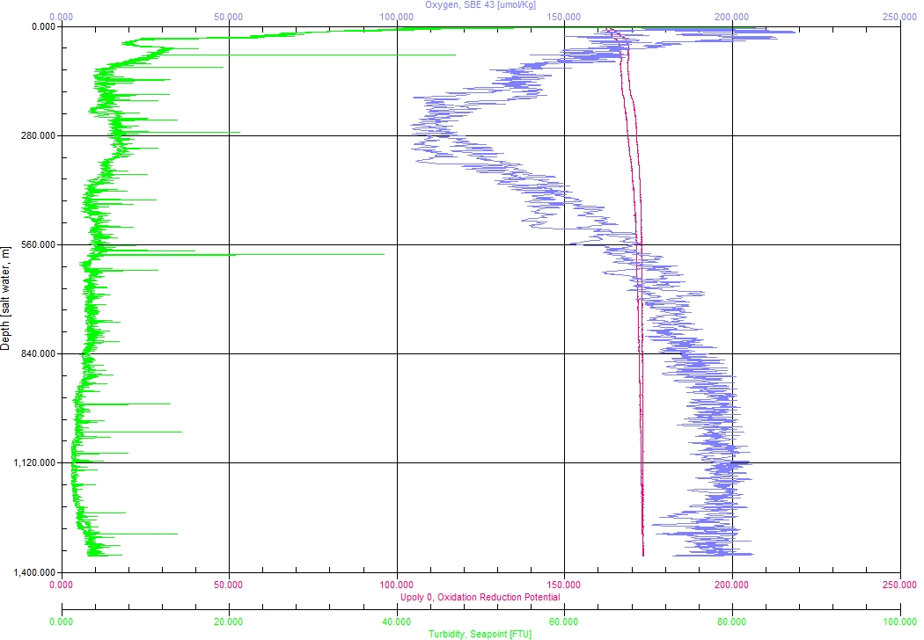
Overall Map of CTD Cast Area | Screen Grab of Data
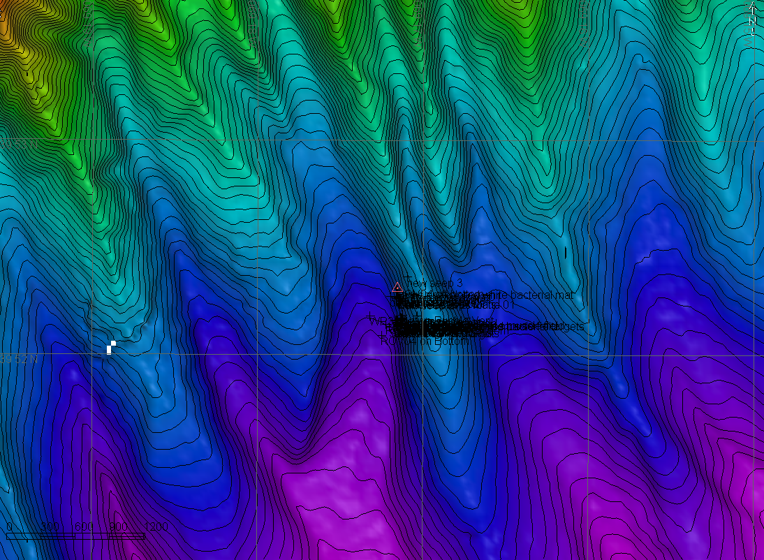 | 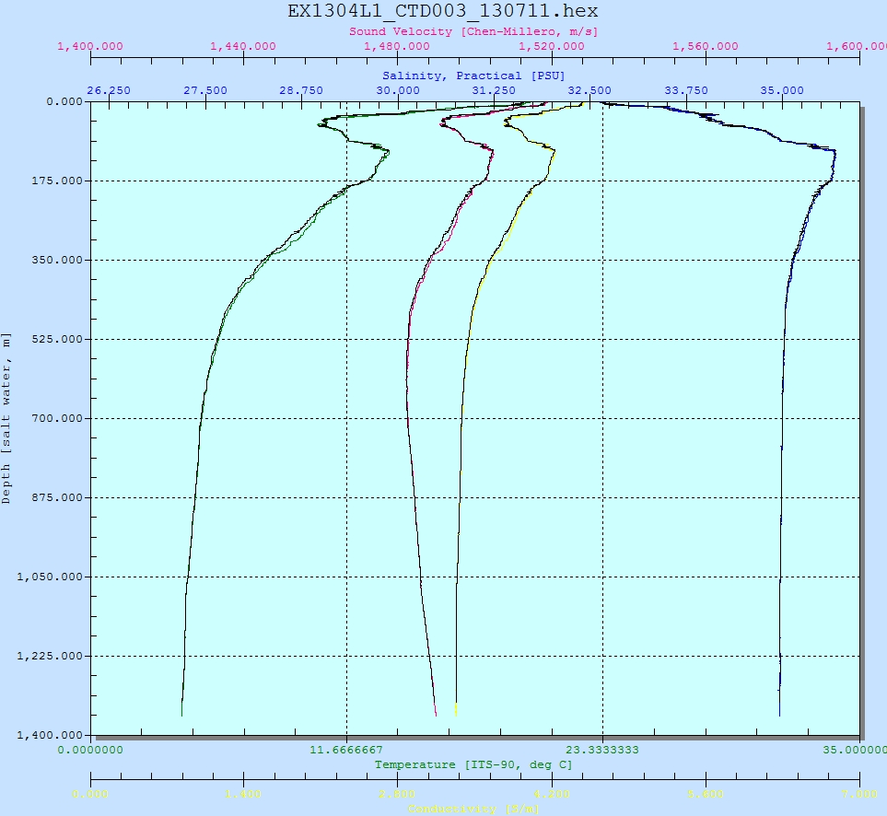
Overview of Cast site | SeaSave Data Acquisition Screen
Please direct inquiries to: | NOAA Office of Ocean Exploration & Research  1315 East-West Highway (SSMC3 10th Floor)  Silver Spring, MD 20910  (301) 734-1014

