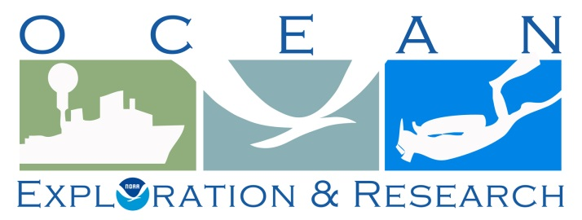

FINAL Project Instructions

Date Submitted: May 2, 2013

Platform: NOAA Ship Okeanos Explorer

Project Number: EX 13-02

Project Title: Ship Shakedown & Patch Test & Exploration, NE Canyons

Project Dates: May 13 - June 6, 2013

Prepared by: LTJG Brian RC Kennedy, NOAA
Expedition Coordinator
Office of Ocean Exploration & Research

Approved by: ________________________ Dated: __________________
Craig W. Russell
Program Manager
Office of Ocean Exploration & Research

Approved by: ________________________ Dated: __________________
Captain Anita Lopez, NOAA
Commanding Officer
Marine Operations Center - Atlantic

I. Overview
A. Brief Summary and Project Period
This cruise plan encompasses sonar shakedown and patch test as well as the field trials and shakedown of the new Office of Ocean Exploration and Research (OER) 6000m ROV. The cruise will depart from Charleston, South Carolina on May 13, 2013 then conduct an alongside personnel transfer on or near May 17 in Norfolk, VA. The cruise will end June 6, 2013 in North Kingstown, RI.

B. Service Level Agreements

Of the 25 DAS scheduled for this project, 19 DAS are funded by the program and 6 DAS are funded by OMAO. This project is estimated to exhibit a high operational tempo.

C. Operating Area

The primary operating area will be off the East coast of the United States in water deeper than 1000m. The sonar shakedown portion of the cruise will be conducted between Charleston, SC and Norfolk, VA. The ROV shakedown portion weather permitting will focus area for the cruise will be the Atlantic Canyons from North Carolina to the Canadian maritime border; however, dives may be conducted as far south as the northern edge of the Blake Spur if weather conditions are unfavorable for ROV operations further north. This cruise is engineering focused so the geographical location of the dives is not as important as finding specific seafloor types and good weather. As possible, dives will be planned in areas of high scientific interest and/or limited previous submersible work. The map below shows the general operating area as well as the priority areas.

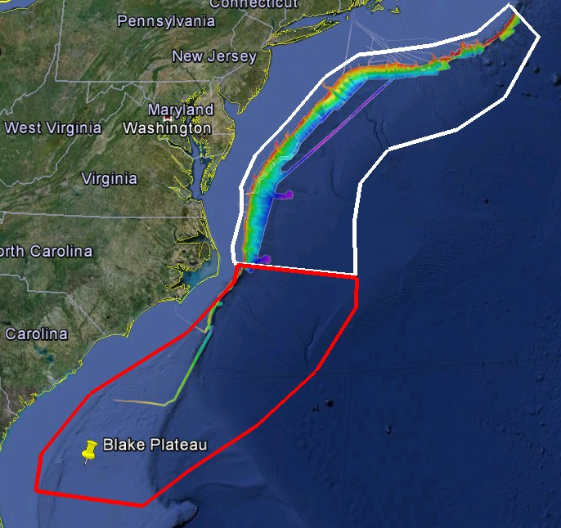
Figure 1. The primary operations area is shown in white. The southern contingency area is shown in red. Both polygons lay completely within the US EEZ. Multibeam bathymetry shown was collected as part of the ACUMEN project. Image created in Google Earth.
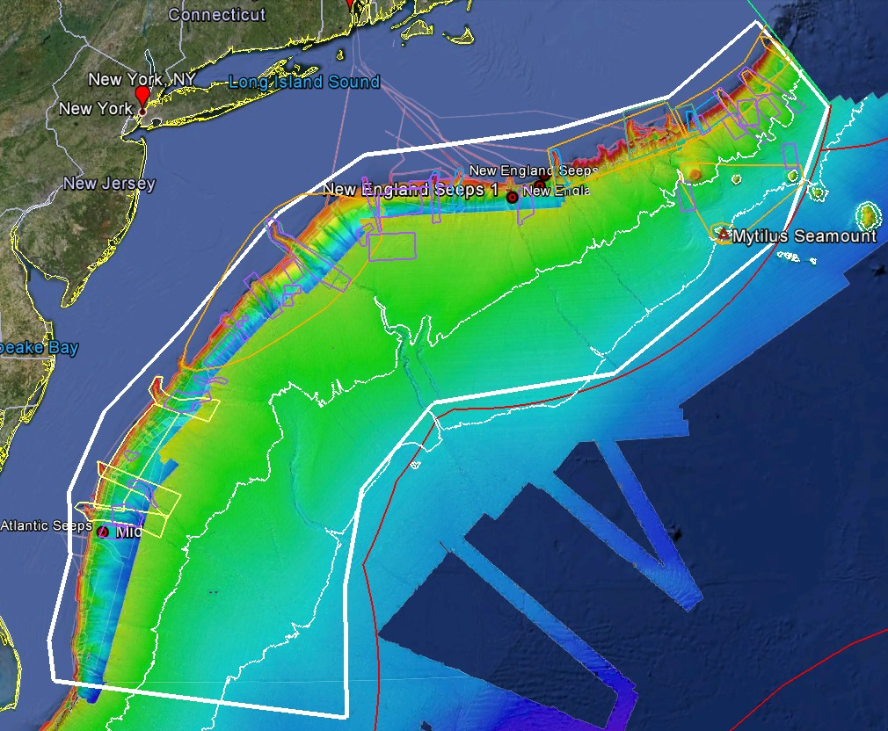
Figure 2. The primary operations area is shown along with the canyons priority areas. Blue polygons are from the NOAA Deep Water Cora Group. Yellow boxes are from BOEM, Orange are from the NortheastFisheries Management Council, green from NOAA Sanctuaries, and purple are from USGS . The locations of the seeps discovered on EX1206 are also displayed. Image created in Google Earth.

D. Summary of Objectives
  - Sonar Shakedown and Patch test

Ensure all scientific sonars are in good working order after dry dock

Assess noise reduction modifications for the Knudsen Chirp 3260 Sub-bottom profiler (SBP)

Kongsberg technical representative update software and install the new multibeam acquisition computer

Conduct EM 302 multibeam patch test including a CTD

    - Calibrate the EK60 single beam sonar with assistance from the Kongsberg technical representative.

    - Conduct annual maintenance on EM 302 and EK 60 units in the sonar closet (Kongsberg technician)

    - Test newly-installed Reson SVP70 spare probe

ROV shakedown

Test stern thrusters after dry dock

Put 6000m ROV and Seirios camera platform through rigorous engineering tests.

    - Calibrate 6000m ROV navigational systems

Train pilots to take high quality images and navigate the new ROV

Continue to apply, develop and/or refine system checklists, SOPs, spares lists, etc.

Continue training in ROV launch and recovery operations

Continue to train bridge crew on ROV operations and use of dynamic posistioning system (DP)

Ongoing system familiarization and training

Refine communications protocols

Test 24 hour ROV operations

Telepresence (VSAT 10 mb/sec ship to shore; 512 kb/sec shore to ship)

Observe and test VSAT

Refine data management protocols relating to the automated system

Test terrestrial links between ship and shore

Continue to apply, develop and/or refine system checklists, SOPs, spares lists, etc.

Ongoing system familiarization and training

Refine and test information sharing protocols between ship and shore

Test supporting 24 hour ROV operations

    - Test new website really simple syndication (RSS) update system

    - Troubleshot EX video feed with NOAA net

    - Test full dive video recording on the ship

Data management

See the Data Management Plan in Appendix B.

  - Education/outreach

    - Complete live telepresence media events with the Aquarium of the Pacific Long Beach, California on May 23

7. Science

- Gather reconnaissance information about possible dive locations for future ROV cruises

- Collect value-added scientific data as engineering objectives allow

E. Participating Institutions

National Oceanic and Atmospheric Administration – Office of Ocean Exploration and Research (OER) 1315 East-West Hwy, Silver Spring, Maryland 20910

University of New Hampshire (UNH), Center for Coastal and Ocean Mapping (CCOM)
Jere A. Chase Ocean Engineering Lab, 24 Colovos Road, Durham, NH 03824 USA

University Corporation for Atmospheric Research (UCAR), Joint Office for Science Support (JOSS) PO Box 3000 Boulder, CO 80307

University of Rhode Island, Graduate School of Oceanography, 215 South Ferry Rd. Narragansett, RI 02882

Aquarium of the Pacific, 100 Aquarium Way, Long Beach, CA 90802

F. Personnel/Science Party:

Sonar Shakedown and Patch Test (May 12 ~ May 17, 2013)
Name (Last, First) | Title | Date Aboard | Date Disembark | Gender | Affiliation | Nationality
LTJG Brian Kennedy | Expedition Coordinator | 5/10/13 | 6/7/13 | M | OER(NOAA Corps) | US
Webb Pinner | Telepresence Team Lead | 5/11/13 | 6/7/13 | M | OER (2020) | US
Elizabeth “Meme” Lobecker | Mapping Co- Lead | 5/11/13 | 6/7/13 | F | OER (ERT) | US
Ash Harris | Mapping Team | 5/11/13 | ~ 5/17/13 | M | OER (UCAR) | US
Vanessa Self-Miller | Mapping Team | 5/11/13 | ~ 5/17/13 | F | NOAA (NOS) | US
Jennifer Kist | Mapping Team | 5/11/13 | ~ 5/17/13 | F | NOAA (NOS) | US
Tony Dalheim | Kongsberg Representative | 5/11/13 | ~ 5/17/13 | M | Kongsberg | US
Jared Drewniak | Telepresence Engineer | 5/11/13 | 6/7/13 | M | OER (ERT) | US

ROV Shakedown (~May 17- June 6, 2013)
Name (Last, First) | Title | Date Aboard | Date Disembark | Gender | Affiliation | Nationality
LTJG Brian Kennedy | Expedition Coordinator | 5/10/13 | 6/7/13 | M | OER(NOAA Corps) | US
Dave Lovalvo | ROV Team Lead | 5/11/13 | 6/7/13 | M | OER (20/20) | US
Webb Pinner | Telepresence Team Lead | 5/11/13 | 6/7/13 | M | OER (20/20) | US
Elizabeth “Meme” Lobecker | Mapping Lead | 5/11/13 | 6/7/13 | F | OER (ERT) | US
Dave Wright | ROV Engineer | ~ 5/17/13 | 6/7/13 | M | OER (UCAR) | US
Chris Ritter | ROV Engineer | ~ 5/17/13 | 6/7/13 | M | NavSea | US
Todd Gregory | ROV Engineer | ~ 5/17/13 | 6/7/13 | M | OER (UCAR) | US
Brian Bingham | ROV Engineer | ~ 5/17/13 | 6/7/13 | M | OER (UCAR) | US
Karl McLetchie | ROV Engineer | ~ 5/17/13 | 6/7/13 | M | OER (UCAR) | US
Bobby Mohr | ROV Engineer | ~ 5/17/13 | 6/7/13 | M | OER (UCAR) | US
Josh Carlson | ROV Engineer | ~ 5/17/13 | 6/7/13 | M | OER (UCAR) | US
Tom Kok | ROV Engineer | ~ 5/17/13 | 6/7/13 | M | OER (UCAR) | US
Colin Riggs | ROV Engineer | ~ 5/17/13 | 6/7/13 | M | GreenSea Systems | US
Andy O'Niel | ROV Engineer | ~ 5/17/13 | 6/7/13 | M | GreenSea Systems | US
Jim Newman | ROV Engineer | ~ 5/17/13 | 6/7/13 | M | OER (UCAR) | US
Roland Brian | Telepresence Engineer | ~ 5/17/13 | 6/7/13 | M | OER (UCAR) | US
Joe Biscotti | Telepresence Engineer | ~ 5/17/13 | 6/7/13 | M | OER (UCAR) | US
Brian Brinkman | Telepresence Engineer | ~ 5/17/13 | 6/7/13 | M | OER (UCAR) | US
Jared Drewniak | Telepresence Engineer | ~ 5/11/13 | 6/7/13 | M | OER (UCAR) | US
Tara Smithee | Documentary filmmaker | ~ 5/17/13 | 6/7/13 | F | OER (UCAR) | US

G. Administrative

Points of Contacts

Dave Lovalvo,  ROV Program Manager for NOAA  Eastern Oceanics  Phone: 203-246-5531  Email: David.Lovalvo@noaa.gov  LTJG Brian Kennedy, NOAA  Expedition Coordinator  NOAA Ocean Exploration & Research  Phone: 706-540-2664  Email: Brian.Kennedy@noaa.gov  Webb Pinner,  Telepresence Lead  NOAA Ocean Exploration & Research (2020, Inc.)  Phone: 401-749-9322  Email: webb.pinner@noaa.gov | CDR Ricardo Ramos, NOAA  Commanding Officer  NOAA Ship Okeanos Explorer  Phone: (401) 378-8284  Email: CO.Explorer@noaa.gov  LT Laura Gallant, NOAA  Operations Officer  NOAA Ship Okeanos Explorer  Phone: 321-960-3726  E-mail: OPS.Explorer@noaa.gov  Elizabeth “Meme” Lobecker,  Mapping Lead  NOAA Ocean Exploration & Research (ERT, Inc.)  Phone: 603-862-1475/ 301-938-8460  E-mail: elizabeth.lobecker@noaa.gov

Other Mission Contacts

Craig Russell  EX Program Manager  NOAA Ocean Exploration & Research  Phone: 206-526-4803 / 206-518-1068  E-mail: Craig.Russell@noaa.gov | John McDonough  Deputy Director  NOAA Ocean Exploration & Research  Phone: 301-734-1023 / 240-676-5206  E-mail: John.McDonough@noaa.gov
LCDR Nicky Verplanck, NOAA  Deputy EX Program Manager  NOAA Ocean Exploration & Research  Phone: 206-526-4803  Email: Nicola.Verplanck@noaa.gov | Catalina Martinez  RI Regional Program Manager  NOAA Ocean Exploration & Research  Phone: 401-874-6250 (o)/ 401-330-9662 (c)  Email: Catalina.martinez@noaa.gov

3. Diplomatic Clearances
NOT APPLICABLE TO THIS CRUISE

4. Licenses and Permits
NOT APPLICABLE TO THIS CRUISE

II. Operations

- Project Itinerary

Sonar Shakedown and Patch Test (May 13 ~18, 2013):
Dates | Location | ROV ops | Telepresence | Mapping | Ship
5/10 | Charleston, SC | NA | High Bandwidth Connection established. Testing with the Inner Space Center | NA | Dry Dock
5/11, 5/12 | Charleston, Sc | NA | Personnel arrives to ship | Personnel arrives to ship | Alongside
5/13 | Depart Charleston, SC | Preparation for ROV portion of the cruise | Test equipment and software; test VSAT and RTS connection | Test sonars and install new acquisition computer | Transit to patch test site
5/14-5/15 | patch test and EK60 calibration location | Preparation for ROV portion of the cruise | Preparations for ROV portions of the Cruise Support mapping operations | Conduct patch test and sonar shakedown. EK60 calibration | Mapping operations
5/16 | Transit to port for personnel transfer | Preparation for ROV portion of the cruise | Preparations for ROV portions of the Cruise | Transit mapping and sonar testing | Transit to port
5/17 AM | Arrive Norfolk, VA | ROV team arrival set up equipment | Preparations for ROV portions of the Cruise | Mapping personnel disembark | Assist ROV preparations
Table3: Draft table of activities for Sonar Shakedown and Patch Test

ROV Shakedown (~ May 18- June 6, 2013):

Dates | Location | ROV ops | Telepresence | Mapping | Ship
5/17 PM or 5/18 AM | Depart Norfolk, VA | ROV prep; familiarization and training | Preparations for ROV operations | Transit mapping | Transit
5/18 | TBD | USBL calibration | Preparations for ROV operations | Support ROV operations | USBL Calibration
5/19-5/24 | Dive sites TBD | Continue ROV system tests; ROV dives; ongoing familiarization and training | Support ROV OPS and training; control room familiarization and training; test clearinghouse protocols | Support ROV operations | Support ROV OPS and testing
5/23 | Dive Site TBD | ROV shakedown | Live media events with the Aquarium of the Pacific and possibly national media | Support ROV operations | Support operations
Approx 5/25-6/3 | Dive Sites TBD | Start 24hr ROV operations. Continue ROV system tests; ROV dives; ongoing familiarization and training | Start 24hr ROV operations. Support ROV OPS and training | Support ROV operations | Support 24hr ROV OPS and testing
6/4 | Depart Dive Site | Prepare vehicles and support systems for future cruise | Prepare all systems for future cruises | Transit mapping | Transit
6/6 | Arrive port North Kingstown, RI | Prepare vehicles and support systems for future cruise | Prepare all systems for future cruise | Cruise wrap-up | Cruise wrap-up

- Staging and De-staging
The majority of the staging will be conducted during ROV integration period prior to the dry dock while the ship is alongside in North Kingstown, RI. Only small items are expected to be loaded on the ship after the dry dock is complete. Mission personnel will arrive at the conclusion of the dry dock. The ROV engineers will utilize the personnel transfer alongside time in Norfolk, to position the ROV on deck and conduct any operations requiring the ship’s cranes and load any last minute items
De-staging will be minimal. The majority of equipment will remain onboard for the remainder of the OER field season. The ROVs will be secured onboard in preparation for the following mapping cruise. The 20ft container will remain on board for the remainder of the field season.

D. Operations to be conducted
Sonar Shakedown and Patch Test (May 13 ~ 17, 2013):
All scientific sonar systems will be tested to ensure that they are in proper working order following the emergency dry dock and sub bottom profiler noise mitigation work. This will include testing the newly installed SVP probe and a multibeam patch test. Ken Nadeau from EEB will be sailing to assess the sub bottom profiler noise mitigation work completed in dry dock. Calibration of the EK60 will be completed during this period.
The patch test will require 12-24 hours to complete and the deepest water possible given the time constraints of the cruise. The ship will be required to run several survey lines repeatedly at different speeds and directions. One or two CTD casts may be required during the multibeam patch test. They will be conducted according the Okeanos Explorer standard operating procedure for CTDs.
An EK60 calibration requires the ship to be as quiet as possible in the water. Ideally, the ship will drift or anchor in calm water deeper than 10 m with no propulsion online during the calibrations. Calibration operations can take up to 12 hours. During that time calibration efforts can be suspended to allow the ship to reposition if necessary. The calibration process requires hanging metal or glass spheres overboard and under the ship at varying depths to serve as a reference for the calibration. Detailed instruction regarding calibration can be found in appendix D.

ROV Shakedown (~ May 18- June 6, 2013):
Upon completion of the work required during the alongside personnel transfer, the ship will transit to an area with water 500-1000 meters deep with a relatively flat bottom to conduct a USBL calibration. The ROV team will deploy a USBL transponder attached to an acoustic release. The ship will be required to conduct several passes by the USBL transducers passing it on different sides. Once the calibration is complete the acoustic release signal will be transmitted and the USBL and the transponder will be recovered when it floats to the surface. Detailed instruction on the USBL calibration can be found in appendix F.
Following a successful USBL calibration the ship will commence operational system tests of the vehicles. The initial ROV dives will be conducted in 1000m to 2000m water depth for comprehensive operational system checks of all systems and support equipment. Deck and Bridge personnel will practice underway launch and recovery procedures, and training will be ongoing for ROV positions in the control room. Training will begin for ROV pilots, co-pilots and video engineers on capturing the highest possible image quality during dives.
Once the new ROV system has been demonstrated to be operational, the ship and mission personnel will commence 24hrs ROV operations. There are two goals associated with 24 hour ROV operations. The first is to get the ROV as much bottom time as possible. The second is the determine the outer limits of the ship and ROV team capabilities with regards to around-the-clock ROV operations to better inform future cruise planning. Vehicle launch and recovery will not be purposely be scheduled between 2200 and 0800, however it is likely the vehicle will require recovery during this time occasionally.
Some ROV dives will be conducted in the deepest water feasible given the cruise time frame and location. Due to the nature of a vehicle shakedown, dive locations may need to be selected with minimal lead time (12-24 hour notice of location) in order to use the ship time as efficiently as possible.
There is no plan for systemic mapping while the ROV is on deck, however, some opportunistic mapping data may be collected during transits and overnight as time and staffing allows. The only planned mapping activity during the ROV shakedown will be small area mapping to cover a proposed dive site. Currently there are no plans for CTD operations during the ROV shakedown portion of the cruise, however, CTD operations may be requested if the ROV requires extended down time.
During this cruise the Expedition Coordinator and OER web team will be testing a new method of near real-time updates from the ship. The Expedition Coordinator will be able to generate a RSS feed from the ship that will automatically generate a post with the live video page on the Ocean Explorer website; thus allowing for better situational awareness for internet 1 (I1) viewers who do not have access to the eventlog.
There will be one day of telepresence events coordinated by the Aquarium of the Pacific which will include several separate events throughout the day on May 23. The events may include interviews from the ship with national media outlets and a live press conference. More detail will follow as they become available.

D. Dive Plan
No dives are planned however SCUBA dive operations may be required if there are problems with the SVP probe or the USBL sonar after the emergency drydock or a problem during EK60 calibration.

E. Applicable Restrictions

Conditions which preclude normal operations:

Weather will be the biggest potential hindrance to operations during this cruise. ROV launch and recovery can be limited by even moderate weather and current. Given that this cruise is engineering focused the location of the dives are less important, therefore if an area is forecast to experience conditions outside of the ROV’s weather envelope, dive sites in another area will be chosen.

Equipment

      - Equipment and Capabilities provided by the ship and OER

Kongsberg EM302 Multibeam Echosounder (MBES)
Kongsberg EK60 Deepwater Echosounder (SBES)
Knudsen Chirp 3260 Sub-bottom profiler (SBP)
TrackLink 10000
Reson SVP 70
LHM Sippican XBT (various probes)
Seabird SBE 911Plus CTD
Seabird SBE 32 Carousel and 24 2.5 L Niskin Bottles
Light Scattering Sensor (LSS)
Oxidation – Reduction Potential (ORP)
Dissolved Oxygen (DO) sensor
Altimeter Sensor and battery pack
CNAV GPS
POS/MV
Seabird SBE-45 (Micro TSG)
Kongsberg Dynamic Positioning 1 System
NetApp mapping storage system
CARIS HIPS Software
IVS Fledermaus Software
SIS Software
Hypack Software
Scientific Computing System (SCS)
ECDIS
Met/Wx Sensor Package
Telepresence System
VSAT High-Speed link (Comtech 10 Mbps ship to shore; 1.54 Mbps shore to ship)
Cruise Information Management System (CIMS)
6000m ROV and various cameras and sensors
Seirios Camera Platform and various cameras and sensors
Acoustic release system
      - Equipment and Capabilities provided by scientist and external programs

Sun photometer instrument provided by the NASA MAN program

Hazardous Materials

Policy and Compliance

The Expedition Coordinator is responsible for complying with FEC 07 Hazardous Materials and Hazardous Waste Management Requirements for Visiting Scientific Parties (or the OMAO procedure that supersedes it). By Federal regulations and NOAA Marine and Aviation Operations policy, the ship may not sail without a complete inventory of all hazardous materials by name and the anticipated quantity brought aboard, MSDS and appropriate neutralizing agents, buffers, or absorbents in amounts adequate to address spills of a size equal to the amount of chemical brought aboard, and a chemical hygiene plan. Documentation regarding those requirements will be provided by the Chief of Operations, Marine Operations Center, upon request.
Per FEC 07, the scientific party will include with their project instructions and provide to the CO of the respective ship 60 to 90 days before departure:
- A list of hazardous materials by name and anticipated quantity
- Include a chemical spill plan the addresses all of the chemicals the program is bringing aboard. This shall include:
    - Procedures on how the spilled chemicals will be contained and cleaned up.
    - A complete inventory (including volumes/amounts) of the chemical spill supplies and equipment brought aboard by the program. This must be sufficient to clean and neutralize all of the chemicals brought aboard by the program.
    - A list of the trained personnel that will be accompanying the project and the training they’ve completed.
Upon embarkation and prior to loading hazardous materials aboard the vessel, the scientific party will provide to the CO or their designee:
- An inventory list showing actual amount of hazardous material brought aboard
- An MSDS for each material
- Confirmation that neutralizing agents and spill equipment were brought aboard sufficient to contain and cleanup all of the hazardous material brought aboard by the program.
Upon departure from the ship, scientific parties will provide the CO or their designee an inventory of hazardous material indicating all materials have been used or removed from the vessel. The CO’s designee will maintain a log to track scientific party hazardous materials. MSDS will be made available to the ship’s complement, in compliance with Hazard Communication Laws.

Scientific parties are expected to manage and respond to spills of scientific hazardous materials. Overboard discharge of scientific chemicals is not permitted during projects aboard NOAA ships.

B. Radioactive Isotopes
NOT APPLICABLE TO THIS CRUISE

V. Additional Projects

A. Supplementary (“Piggyback”) Projects
During the cruise the marine aerosol layer observations will be collected for the NASA Maritime Aerosol Network (MAN). Observations will be made by ENS Keith with a sun photometer instrument provided by the NASA MAN program. Delivery of resulting data to the NASA MAN primary investigator Alexander Smirnov will be organized by ENS Keith. All collected data will be archived and publically available at: http://aeronet.gsfc.nasa.gov/new_web/maritime_aerosol_network.html. The equipment is already onboard.See Appendix E for full Survey of Opportunity Form.

NOAA Fleet Ancillary Projects
NOT APPLICABLE TO THIS CRUISE

VI. Disposition of Data and Reports

      - Data Responsibilities
All data acquired on Okeanos Explorer will be provided to the public archives without proprietary rights. All data management activities shall be executed in accordance with NAO 212-15, Management of Environmental and Geospatial Data and Information [http://www.corporateservices.noaa.gov/ames/NAOs/Chap_212/naos_212_15.html].

Ship Responsibilities
The Commanding Officer is responsible for all data collected for missions until those data have been transferred to mission party designees. Data transfers will be documented on NOAA Form 61-29. Reporting and sending copies of project data to NESDIS (ROSCOP form) is the responsibility of OER.

NOAA OER Responsibilities
The Expedition Coordinator will work with the Okeanos Explorer Operations Officer to ensure data pipeline protocols are followed for final archive of all data acquired on the EX without proprietary rights.

Deliverables
  - At sea
      - Daily Plans of the Day (POD)
      - Daily situation reports (SITREPS)
      - Summary bathymetry data files
  - Post cruise
      - Refined SOPs for all pertinent operational activities
      - Assessments of all activities
  - Science
- Multibeam and XBT raw and processed data
- Mapping report
- ROV dive summary forms
- Dive tracks
- Still Images
- HD footage

Archive
- The Program and ship will work together to ensure documentation and
stewardship of acquired data sets in accordance with NAO 212-15. The Cruise Information Management System is the primary tool used to accomplish this activity.

Pre and Post Project Meeting

Prior to departure, the Expedition Coordinator will conduct a meeting of the scientific party to inform them of project objectives. Some vessel protocols, e.g., meals, watches, etiquette, etc. will be presented by the ship’s Operations Officer.

Post-Project Meeting: Upon completion of the project, a meeting will normally be held at 0830 (unless prior alternate arrangements are made) and attended by the ship’s officers, the Expedition Coordinator and members of the scientific party to review the project. Concerns regarding safety, efficiency, and suggestions for improvements for future projects should be discussed. Minutes of the post-project meeting will be distributed to all participants by email, and to the Commanding Officer and Chief of Operations, Marine Operations Center.

C. Ship Operation Evaluation Report

Within seven days of the completion of the project, a Ship Operation Evaluation form is to be completed by the Expedition Coordinator. The preferred method of transmittal of this form is via email to omao.customer.satisfaction@noaa.gov. If email is not an option, a hard copy may be forwarded to:
Director, NOAA Marine and Aviation Operations
NOAA Office of Marine and Aviation Operations
8403 Colesville Road, Suite 500
Silver Spring, MD 20910

VII. Miscellaneous

      - Meals and Berthing

The ship will provide meals for the scientists listed above. Meals will be served 3 times daily beginning one hour before scheduled departure, extending throughout the project, and ending two hours after the termination of the project. Since the watch schedule is split between day and night, the night watch may often miss daytime meals and will require adequate food and beverages (for example a variety of sandwich items, cheeses, fruit, milk, juices) during what are not typically meal hours. Special dietary requirements for scientific participants will be made available to the ship’s command at least seven days prior to the survey.
Berthing requirements, including number and gender of the scientific party, will be provided to the ship by the Expedition Coordinator. The Expedition Coordinator and Commanding Officer will work together on a detailed berthing plan to accommodate the gender mix of the scientific party taking into consideration the current make-up of the ship’s complement. The Expedition Coordinator is responsible for ensuring the scientific berthing spaces are left in the condition in which they were received; for stripping bedding and linen return; and for the return of any room keys which were issued. The Expedition Coordinator is also responsible for the cleanliness of the laboratory spaces and the storage areas utilized by the scientific party, both during the project and at its conclusion prior to departing the ship.
All NOAA scientists will have proper travel orders when assigned to any NOAA ship. The Expedition Coordinator will ensure that all non NOAA or non Federal scientists aboard also have proper orders. It is the responsibility of the Expedition Coordinator to ensure that the entire scientific party has a mechanism in place to provide lodging and food and to be reimbursed for these costs in the event that the ship becomes uninhabitable and/or the galley is closed during any part of the scheduled project.
All persons boarding NOAA vessels give implied consent to comply with all safety and security policies and regulations which are administered by the Commanding Officer. All spaces and equipment on the vessel are subject to inspection or search at any time. All personnel must comply with OMAO's Drug and Alcohol Policy dated May 7, 1999 which forbids the possession and/or use of illegal drugs and alcohol aboard NOAA Vessels.

Medical Forms and Emergency Contacts

The NOAA Health Services Questionnaire (NHSQ, Revised: 02 JAN 2012) must be completed in advance by each participating scientist. The NHSQ can be obtained from the Expedition Coordinator or the NOAA website http://www.corporateservices.noaa.gov/~noaaforms/eforms/nf57-10-01.pdf. The completed form should be sent to the Regional Director of Health Services at Marine Operations Center. The participant can mail, fax, or scan the form into an email using the contact information below. The NHSQ should reach the Health Services Office no later than 4 weeks prior to the project to allow time for the participant to obtain and submit additional information that health services might require before clearance to sail can be granted. Please contact MOC Health Services with any questions regarding eligibility or completion of the NHSQ. Be sure to include proof of tuberculosis (TB) testing, sign and date the form, and indicate the ship or ships the participant will be sailing on. The participant will receive an email notice when medically cleared to sail if a legible email address is provided on the NHSQ.

Contact information:
Regional Director of Health Services
Marine Operations Center – Atlantic
439 W. York Street
Norfolk, VA 23510
Telephone 757-441-6320
Fax 757-441-3760
E-mail MOA.Health.Services@noaa.gov

Prior to departure, the Expedition Coordinator must provide an electronic listing of emergency contacts to the Executive Officer for all members of the scientific party, with the following information: contact name, address, relationship to member, and telephone number.

      - Shipboard Safety

Wearing open-toed footwear or shoes that do not completely enclose the foot (such as sandals or clogs) outside of private berthing areas is not permitted. Steel-toed shoes are required to participate in any work dealing with suspended loads, including CTD deployments and recovery. The ship does not provide steel-toed boots. Hard hats are also required when working with suspended loads. Work vests are required when working near open railings and during small boat launch and recovery operations. Hard hats and work vests will be provided by the ship when required.

      - Communications

A daily situation report (SITREP) on operations prepared by the Expedition Coordinator will be relayed to the program office. Sometimes it is necessary for the Expedition Coordinator to communicate with another vessel, aircraft, or shore facility. Through various modes of communication, the ship is able to maintain contact with the Marine Operations Center on an as needed basis. These methods will be made available to the Expedition Coordinator upon request, in order to conduct official business. The ship’s primary means of communication with the Marine Operations Center is via e-mail and the Very Small Aperture Terminal (VSAT) link.

Specific information on how to contact the NOAA Ship Okeanos Explorer and all other fleet vessels can be found at: http://www.moc.noaa.gov/phone.htm

NOAA Ship Okeanos Explorer –

OOD Cell Phone: 401-378-7414
Iridium: 808-659-9179
Cell Phone: 401-932-4114
VoIP: 301-713-7772
INMARSAT: 011 870 764 852 328
Quonset Point Land Lines: 401-294-4760 VOICE
401-294-4591 VOICE
401-294-4686 FAX
401-294-4902 VOICE

E-Mail: Ops.Explorer@noaa.gov(mention the person’s name in SUBJECT field) expeditioncoordinator.explorer@noaa.gov - For dissemination of all hands emails by Expedition Coordinator while on board. See ET for password.

- IT Security

Any computer that will be hooked into the ship's network must comply with the NMAO Fleet IT Security Policy 1.1 (November 4, 2005) prior to establishing a direct connection to the NOAA WAN. Requirements include, but are not limited to:
(1) Installation of the latest virus definition (.DAT) file on all systems and performance of a virus scan on each system.
(2) Installation of the latest critical operating system security patches.
(3) No external public Internet Service Provider (ISP) connections.
Completion of these requirements prior to boarding the ship is required.
Non-NOAA personnel using the ship's computers or connecting their own computers to the ship's network must complete NOAA’s IT Security Awareness Course within 3 days of embarking.

- Foreign National Guests Access to OMAO Facilities and Platforms

NOT APPLICABLE TO THIS CRUISE

Appendix A: Emergency Contact Sheet

EMERGENCY DATA SHEET
NOAA OKEANOS EXPLORER

PRINT CLEARLY

NAME: __________________________________________________________
(Last, First, Middle)

Mailing Address ____________________________________________________

_____________________________________________________

_____________________________________________________
(Other than the ship address)

Phone (Home) _________________________________________________________

(Cell) ___________________________________________________________

Date of Birth ___________________________________________________________

Emergency Contact: _____________________________________________________
(Name and Relationship)

Address: ______________________________________________________________

_______________________________________________________________

Phone (Home) ____________________________________________________

(Work) ____________________________________________________

(Cell) _____________________________________________________

Email: ________________________________________________________________

Signature __________________________________ Date _______________________
Appendix B: Data Management Plan (Will be included in final plan)

Appendix C: Categorical Exclusion letter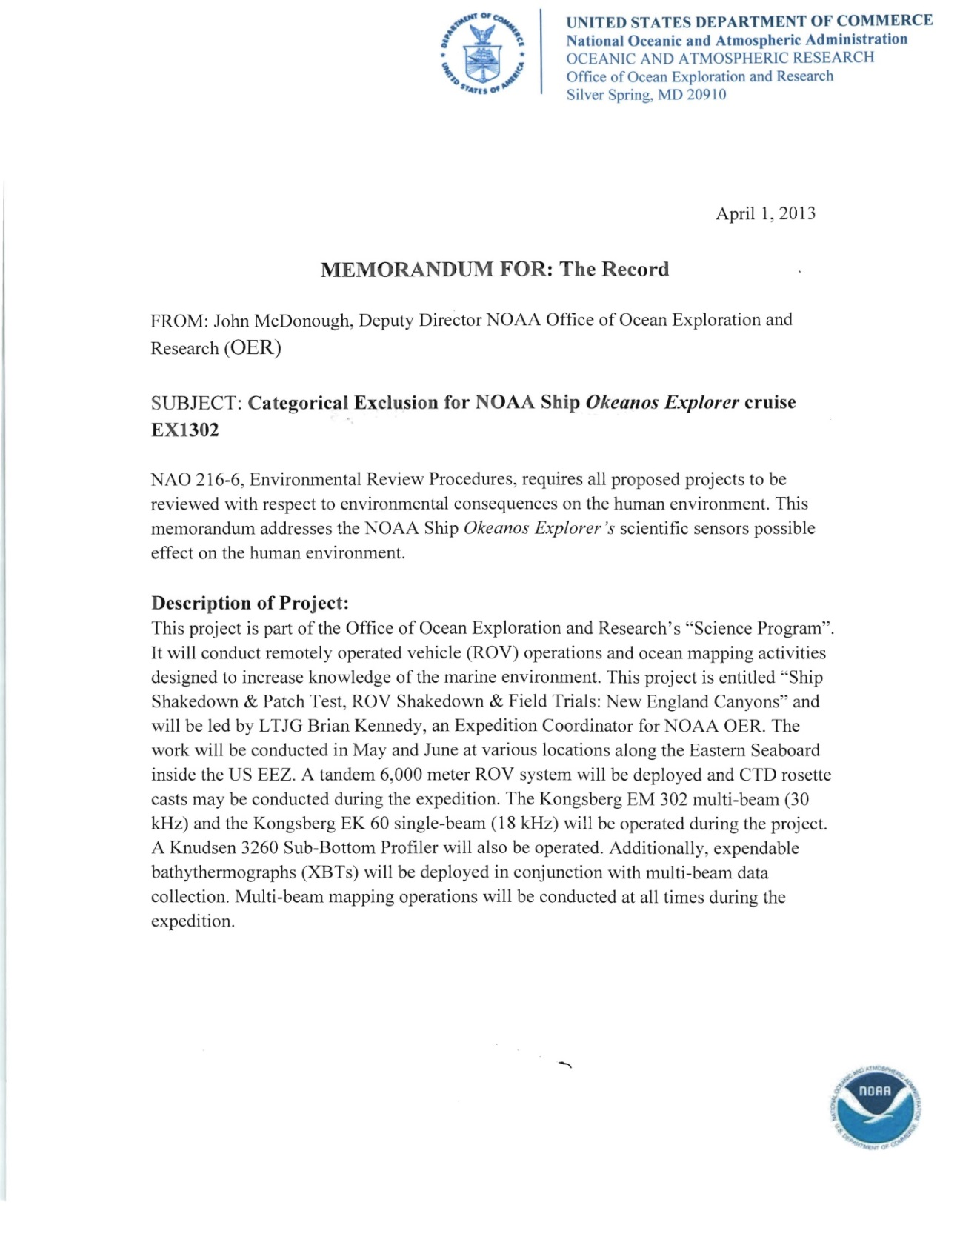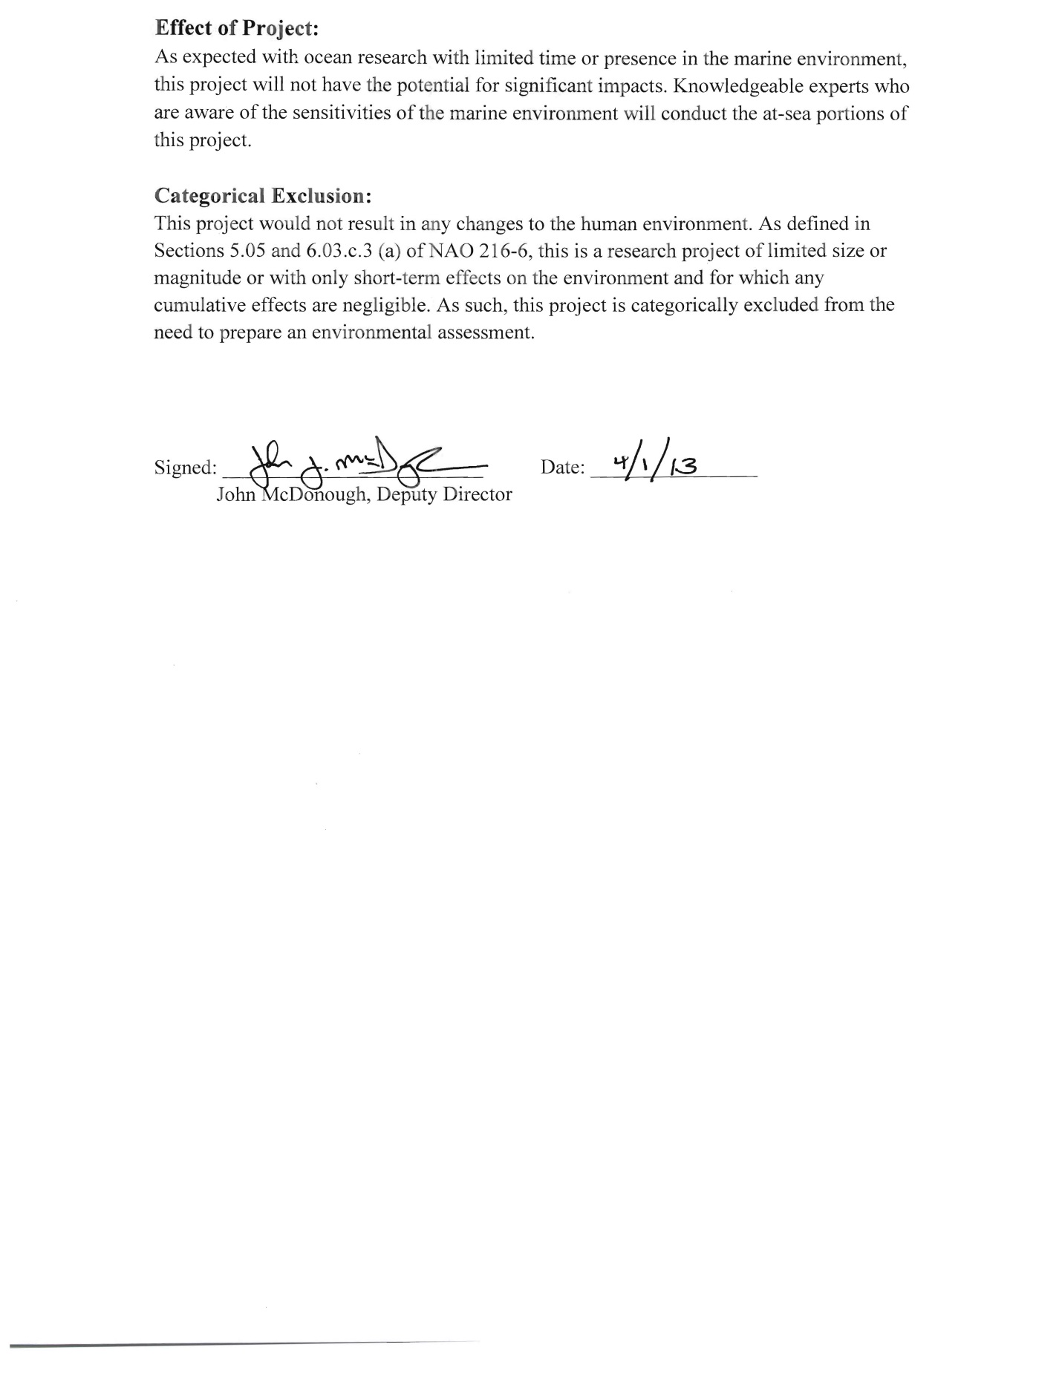

Appendix C: Recommended EK 60 calibration plan
Recommended EK 60 calibration procedures are outlined in “Simrad EK 60 Scientific Echo Sounder Reference Manual Release 2.2.0, January 2008.”
Location:
It is recommended to conduct calibration at a deep pier facility (with depth > 10 m). If no deep pier facility is available the calibration can be conducted at anchor / while drifting in a location where there is minimal impact by fish (to avoid acoustic interference) and current/sea conditions (to avoid excessive movement which makes the mechanics of the calibration difficult). A final location will be chosen based on the impeding weather conditions and discussions with the ship.
Procedure:
The general procedure to conduct EK 60 calibration is:
1. Secure the vessel in a suitable location (bow/stern anchored in still water that is free of biological scatterers) or drifting in water with minimal currents.
2. Suspend the target sphere and weight (depending on the rigging, it may make sense to do this prior to anchoring).
a) Take a long line with a weight attached to the middle, and drop it down from either the bow or stern.
b) Walk back (or forward) holding the two ends of the line on either side of the vessel, keeping the line/weight clear of the hull (and thrusters, etc.)
c) Attach one end of the line to a pole/reel on the port (or stbd) side of the vessel.
d) Pay out the monofilament on the port (or stbd) side reel, and pull on the opposite side until the monofilament is reached. Detach the line, and attach the two remaining reels (e.g., one reel on port, two on stbd).
e) Attach a piece of monofilament, the calibration sphere, and a weight (weight needs to be at least one pulse length below the calibration sphere) to the point where the monofilament from all three reels are attached.
f) Soap the calibration sphere using ordinary liquid hand soap to avoid bubble development on the surface of the sphere.
g) Lower the calibration sphere over the side until all three lines are equal (ideally, this will place the sphere underneath the EK60 transducer). Ship's drawing will be consulted to precisely position the reels.
h) Adjust the lines in order to do the calibration. Will require someone on each reel, with radios, to make this work well.
i) After the calibration is finished, pay out the line on port side until the stbd lines are vertical. Then reel in on one of the stbd poles while continuing to pay out on port (to avoid tangles with ship).
j) Recover sphere/weight, untie lines and reel in all monofilament. The above methodology is the recommended approach for giving us the best control.
Time estimates:
It could take a few hours to precisely place the sphere under the EK 60. Up to 12 hours on-site may be required to conduct calibration. If additional time is available, it is recommended to collect data from both the EM 302 and the Knudsen while conducting EK 60 calibration in which case it might take up to 24 hours to complete the calibration.
Gear requirement
Kongbserg, Inc will provide with the calibration gear including outriggers, calibration sphere etc. The ship will be required to provide lines and personnel for lowering the gear into water.
Risks:
1. Gear entanglement: The ship’s motion during the calibration procedure should be minimal to avoid any gear entanglement. If gear entanglement is suspected, the calibration procedure will be halted and ship’s divers will inspect the ship hull for any entanglement.

Appendix E. NASA Maritime Aerosols Network Survey of Opportunity

Survey or Project Name
Maritime Aerosol Network
Points of Contact (POC)
Lead POC or Principle Investigator (PI & Affiliation) Supporting Team Members ashore
POC: Dr. Alexander Smirnov Supporting Team Members aboard (if required)
Activities Description(s) (Include goals, objectives and tasks)
The Maritime Aerosol Network (MAN) component of AERONET provides ship-borne aerosol
optical depth measurements from the Microtops II sun photometers. These data provide an
alternative to observations from islands as well as establish validation points for satellite and
aerosol transport models. Since 2004, these instruments have been deployed periodically on ships of
opportunity and research vessels to monitor aerosol properties over the World Oceans

Appendix F: USBL Calibration Instructions