Document Purpose
This document is an addendum to the overarching Okeanos Explorer FY13 Data Management Plan (EX_FY13_DMP.pdf) and is specific to the EX-13-01 mission entitled “Ship Shakedown and Patch Test Exploration, NE Canyons and Seamounts” For more detailed information on the data management effort for the Okeanos Explorer in FY13, please refer to that document.

General Description of the Data to be Managed
EX1301 operations are expected to begin on March 18 from Davisville, RI and return April 5, 2013 to Davisville, RI. Multibeam and single beam mapping operations will be conducted 24 hours a day during the cruise. Sub bottom profile mapping will be conducted each day between 1000 and 1800. XBT casts will be conducted at an interval defined by prevailing oceanographic conditions, but not to exceed 6 hours. Data management procedures are fully documented in the data management plan for the Okeanos Explorer for the FY13 field season (EX_FY13_DMP.pdf)
- Name of Dataset
  - : “EX1301: Ship Shakedown and Patch Test Exploration, NE Canyons and Seamounts”
- Mission Specific Keywords:
  - Place Specific:
    - Davisville
    - Rhode Island
    - Cape Hatteras
    - Western North Atlantic Ocean
    - US-Canadian territorial boundary
    - Veatch Canyon
    - Northeast Seamounts
    - Accomac Canyon
    - Baltimore Canyon
    - Washington Canyon
    - Bear Seamount
    - Mytilus Seamount
    - Buell Seamount
    - Physalia Seamount
    - Retriever Seamount
    - Picket Seamount
    - Balanus Seamount
    - Kiwi Seamount
    - Kelvin Seamount
    - Asterius Seamount
    - Panulirus Seamount
    - Dogbody Canyon
    - Welker Canyon
    - Sharpshooter Canyon
    - Clipper Canyon
    - Heel Tapper Canyon
    - Powell Canyon
    - Munson Canyon
    - Nygren Canyon

  - Theme Specific:
    - Multibeam
    - Multibeam sonar
    - Multi-beam sonar
    - Sub-bottom profile
    - Mapping survey
    - Multibeam backscatter
    - Water column backscatter
    - Singlebeam sonar
    - Singe beam sonar
    - Single-beam sonar
    - New England Seamounts
    - Continental shelf mapping
    - Extended continental shelf
    - ECS
    - Henry Bigelow
    - Henry B. Bigelow
    - Ferdinand Hassler
    - Ferdinand R. Hassler
    - Nancy Foster
    - Ronald H. Brown
    - Ron Brown
    - EX1201
    - EX1204
    - EX1106
    - EX1205L2
    - ACUMEN
    - Atlantic Canyons Undersea Mapping Expedition
    - Mid-Atlantic Canyons
    - Mid-Atlantic Regional Council on the Ocean
    - MARCO
- Summary description: EX1301 will be primarily focused on the annual ship and system shakedown and multibeam patch test operations. Following these operations, the EX will complete the comprehensive mapping of the Northeast canyons and the adjacent continental shelf carried out by the cruises involved in the Atlantic Canyons Undersea Mapping Expeditions (ACUMEN) 2012 project.

- Temporal Bounds:
  - March 18 – April 5, 2013
- Spatial Bounds:
  - Northern: 41.2
  - Southern: 38.4
  - Western: -71.4
  - Eastern: -63.5
- Data Type Collections for Preservation/Stewardship:
  - Multibeam Bathymetry – continuous collection during the duration of the expedition.
  - Bottom Backscatter – continuous collection during the entire duration of the expedition
  - Water Column Backscatter – continuous collection during the entire duration of the expedition
  - Scientific Computing System (SCS) output – continuous collection of navigational, meteorological, integrated oceanographic sensor data
  - XBT – casts will be conducted at an interval defined by prevailing oceanographic conditions, but not to exceed 6 hours. Casts will collect water temperature at depth for sound velocity calculations to maintain multibeam data quality
  - Knudsen CHIRP 3260 –sub-bottom profiler data collected between 1000 and 1800 each day
  - EK60 – single beam sonar for water column features during the entire duration of the expedition
- Data Product/Product Collections for Preservation/Stewardship:
  - Gridded bathymetry (.txt)
  - Gridded bathymetric image (.tif)
  - Fledermaus gridded bathymetry imagery (.sd)
  - Fledermaus gridded backscatter imagery (.sd)
  - Google Earth gridded bathymetry (.kml)
  - ArcView gridded bathymetry (.asc)
  - SCS data output in NetCDF
  - Final Mapping Summary document
  - Final Cruise Summary document
- Volume of Data Expected
  - The volume of data expected from this cruise is approximately 120 GB.
- Personally Identifiable Information (PII) concerns
  - No PII will be included in these data.

Points of Contact
- Overall Point of Contact (POC) for the data:
  - Data Acquisition: EX Mapping Team: oar.oer.exmappingteam@noaa.gov
  - Data Management: Susan Gottfried (oer.info.mgmt@noaa.gov)
- Responsible for Data Quality:
  - Seafloor mapping and water column data:
EX Mapping Team: oar.oer.exmappingteam@noaa.gov
  - SCS data: Office of Marine and Aviation Operations (OMAO): Lt. Laura Gallant, Okeanos Explorer Operations Officer (Ops.Explorer@noaa.gov)
- Responsible for data documentation and metadata activities:
  - National Coastal Data Development Center (NCDDC); Susan Gottfried, OER Data Management Coordinator (oer.info.mgmt@noaa.gov)
- Responsible for the data storage and data disaster recovery activities:
  - NOAA National Data Centers; National Oceanographic Data Center (NODC), National Geophysical Data Center (NGDC), NOAA Central Library (NCL)
- Responsible for ensuring adherence to this data management plan, including resources are made available to implement the DMP:
  - Data Acquisition: Meme Lobecker, Expedition Co-Coordinator, Mapping Team Lead
  - Data Acquisition: Mashkoor Malik, Expedition Co-Coordinator, Mapping Team Lead
  - Data Acquisition: Lt. Laura Gallant, OMAO, Okeanos Explorer Operations Officer
  - Data Management: Susan Gottfried, OER Data Management Coordinator

Data Stewardship
- What quality control procedures will be employed?
  - Quality control procedures for the data from the Kongsberg EM302 is handled at UNH CCOM/JHC. Raw (level-0) bathymetry files are cleaned/edited into new data files (level-1) and converted to a variety of products (level-2).
  - Data from sensors monitored through the SCS are archived in their native format and are not quality controlled.
  - Data from XBT firings are archived in their native format and are not quality controlled.
- What is the overall lifecycle of the data from collection or acquisition to making it available to customer?
  - All ship data from this mission is expected to be archived and accessible within 60-90 days post-mission.
  - METOC data from the SCS are converted in a post-mission model into archive-ready compressed NetCDF3 format and stored within the NCDDC THREDDS open-access server.
  - CTD data from casts are processed in a post-mission model and converted into archive-ready compressed NetCDF3 format and stored within the NCDDC THREDDS open-access server.

Data Documentation
- An ISO format metadata record to document the mission will be generated during pre-cruise planning and published in an OER catalog for public discovery and access. Documentation templates will be provided for post-mission products with references back to the overall mission metadata documents. Data collections and products will be documented with ISO or FGDC CSDGM metadata and published at the appropriate NOAA Data Center.
- ISO 19115-2 Geographic Information with Extensions for Imagery and Gridded Data will be the metadata standard employed.

Data Sharing
- All data recorded, observed, generated or otherwise produced on the Okeanos Explorer are considered non-proprietary and will be made available to the public as soon as possible after a period of due diligence in performing quality assurance and data documentation procedures.

Initial Data Storage and Protection
- Data are recorded and stored on NOAA shipboard systems compliant with NOAA IT procedures. Data are moved from ship to shore using a variety of standard, documented data custody transfer procedures. Data are transferred to NOAA data centers using digital and physical data transfer models depending upon data volume.

Long-Term Archiving and Preservation
- Data from this mission will be preserved and stewarded through the NOAA National Data Centers. Refer to the Okeanos Explorer FY13 Data Management Plan (EX_FY13_DMP.pdf) for detailed descriptions of the processes, procedures, and partners involved in this collaborative process. Appendix A has an excerpt from EX_FY13_DMP.pdf) that illustrates the data and product pipelines that will be employed for this mission.

Data Management Objectives
The DMT’s specific objectives for this mission are:
- Transfer and integrate streamed video capture stations to the Okeanos Explorer
- Develop scripts/protocols to capture the video feeds using Video LAN Client (VLC) and rewrap/section the output video
- Write SOP for on-ship video stream capture
- Adapt cruise variable php script (Rsync) to include section of code where survey techs can manipulate priority levels
- Update dashboard software and test
- Document SOP for automated backup system (Rsync) and the data dashboard
- Train the new survey tech on operation of the automated backup system (Rsync) and data dashboard
The DMT’s common objectives for this mission are:
- Ensure the near real-time update of the Okeanos Atlas with
  - Ship track and hourly observations received via email.
  - Daily logs pulled from URI through RSS feeds and links to related images on oceanexplorer.noaa.gov website.
  - Daily cumulative bathymetric image overlays received via URI SRS.
- Execute multibeam and oceanographic data pipelines according to the FY13 DMP (EX_FY13_DMP.pdf).
- Develop ISO metadata for collection-level and dataset-level records collected from the ship (multibeam, singlebeam sonar, sub-bottom profiler, XBT, CTD, EX METOC,)

Expedition Principals for Data Management
Webb Pinner, OER Telepresence, EX Data and Information Lead, Webb.Pinner@noaa.gov
Sharon Mesick, NCDDC, Federal Program Manager, Data Management IPT Chair, Sharon.Mesick@noaa.gov
Susan Gottfried, NCDDC, OER Data Management Coordinator, Susan.Gottfried@noaa.gov
Brendan Reser, NCDDC, OER Cruise Data Manager, Brendan.Reser@noaa.gov
Andy Navard, NCDDC, Okeanos Atlas Developer, Andrew.Navard@noaa.gov
Dan Price, NGDC, Geophysical Data Officer, Daniel.Price@noaa.gov
Tom Ryan, NODC, Oceanographic Data Officer, Thomas.Ryan@noaa.gov
Anna Fiolek, NCL, Multimedia Librarian, Anna.Fiolek@noaa.gov
Appendix A: Data and Product Pipelines (excerpt from EX_FY13_DMP.pdf)

Oceanographic/Meteorological/Navigational Data Archive Pipeline

Data from hull-mounted and off-board oceanographic and meteorological (METOC) sensors; integrated oceanographic sensors from the submersibles; and navigational instrumentation on both the vessel and its submersibles are monitored through the ship’s Scientific Computer System (SCS). Some of these data will be used in a near real-time mode to update the Okeanos Atlas. All of these data will be archived at the National Oceanographic Data Center (NODC) Marine Data Stewardship Division (MDSD) in Silver Spring, MD. A collection level metadata record describing the data inventory to be archived at the NODC/MDSD will be included with the data submission.

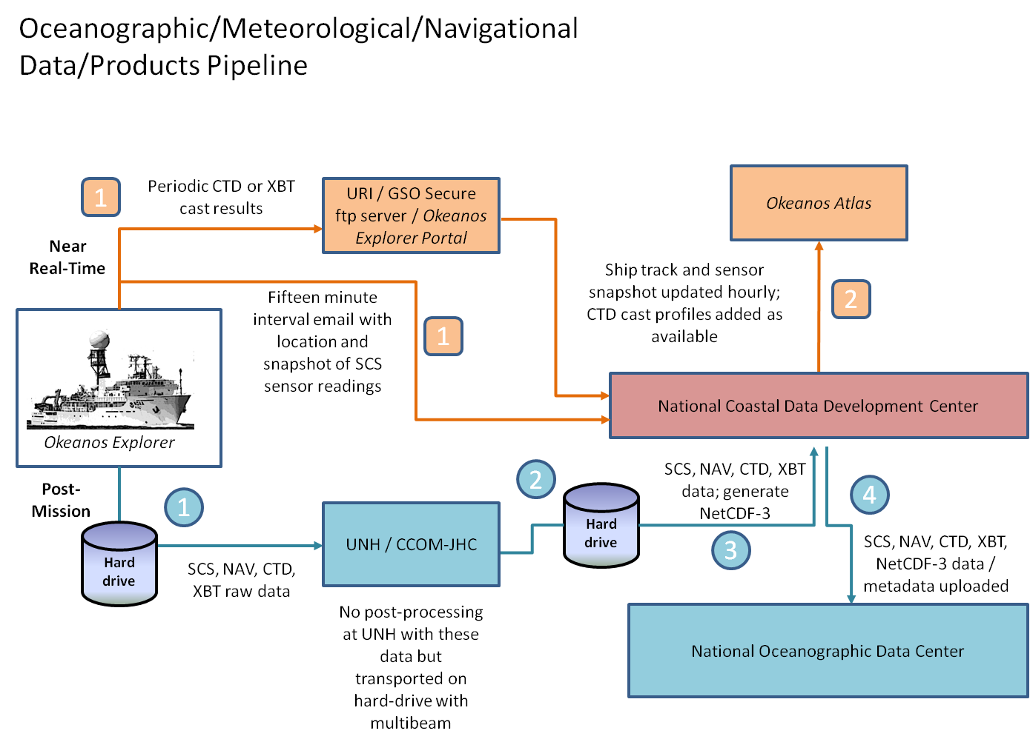

Fig 1: Oceanographic/Meteorological/Navigational Data Archive Pipeline

1

At periodic (currently twenty minutes) intervals, an email from the ship to NCDDC is delivered with the ship’s position and a snapshot of the SCS sensor suite.

As CTD or XBT casts are deployed, the results of the cast are included in the hourly synchronizations to the SRS.
2

The GIS team at NCDDC processes CTD cast data into thinned profiles for comparison to World Ocean Atlas historical profiles in the same region and month. The thinned profiles are geo-located on the Okeanos Atlas. Ship track and sensor snapshot readings are geo-located on the Okeanos Atlas.

 All SCS data, including navigation and CTD/XBT cast data are saved to a hard-drive. This hard-drive is the same that will hold the multibeam survey raw data and products generated on-board. This hard-drive will be either brought back or shipped to the University of New Hampshire Center for Coastal and Ocean Mapping (UNH CCOM) for post-processing, after which it will be shipped to NCDDC.

 The Data Management team will post-process the SCS, NAV, CTD, and XBT raw data files, adding ASCII headers to each file and generating NetCDF-3 formatted files for the entire cruise for both SCS/NAV data and CTD/XBT data. FGDC CSDGM metadata will be generated for the navigational data and for the METOC sensor data.

 The ASCII files, and the metadata will be uploaded to the National Oceanographic Data Center (NODC), where they will be accessioned and archived.

 The NetCDF3 files will be stored within an NCDDC hosted Thematic Real-time Environmental Distributed Data Services (THREDDS) server for user discoverability and access.

Data Class | Instrument | Data Type | Format | Metadata Granularity | Archive Center
OCN/MET | All SCS monitored sensors | Meteorological and Oceanographic data sensors | ASCII | 1 meta rec | NODC/MDSD
NAV | DGPS, CNAV | EX, ROV, and sled navigation | ASCII | 1 meta rec | NODC/MDSD
ALL | All | Archive Ready | NetCDF-3 | 1 meta rec | NODC/MDSD

Table 4: Oceanographic/Meteorological/Navigational Metadata Granularity and Target Archive

Multibeam Survey Data Archive Pipeline

The multibeam survey data collected by bottom-looking and complementary sensors, data from the calibration instruments, and the products generated after the data is returned to and post-processed at UNH will be archived at the NGDC. These data will be accompanied with a collection level metadata record for the NGDC as well as individual metadata records for each raw (level-0) file, each edited (level-1) file and each data product (level-2) and report (level-3) generated as a result. In addition, the submission to NGDC will include the following:
- raw (level-0) mapping survey and water column data files,
- CTD and/or XBT profile data used for calibration in multibeam survey,
- post-processed, quality assured, and edited (level-1) data files,
- specific data products (level-2) including cumulative GeoTIF images, gridded bathymetric files, KML files, Fledermaus output files, and an ArcGrid format, and
- comprehensive mapping survey data summary (level-3) report.

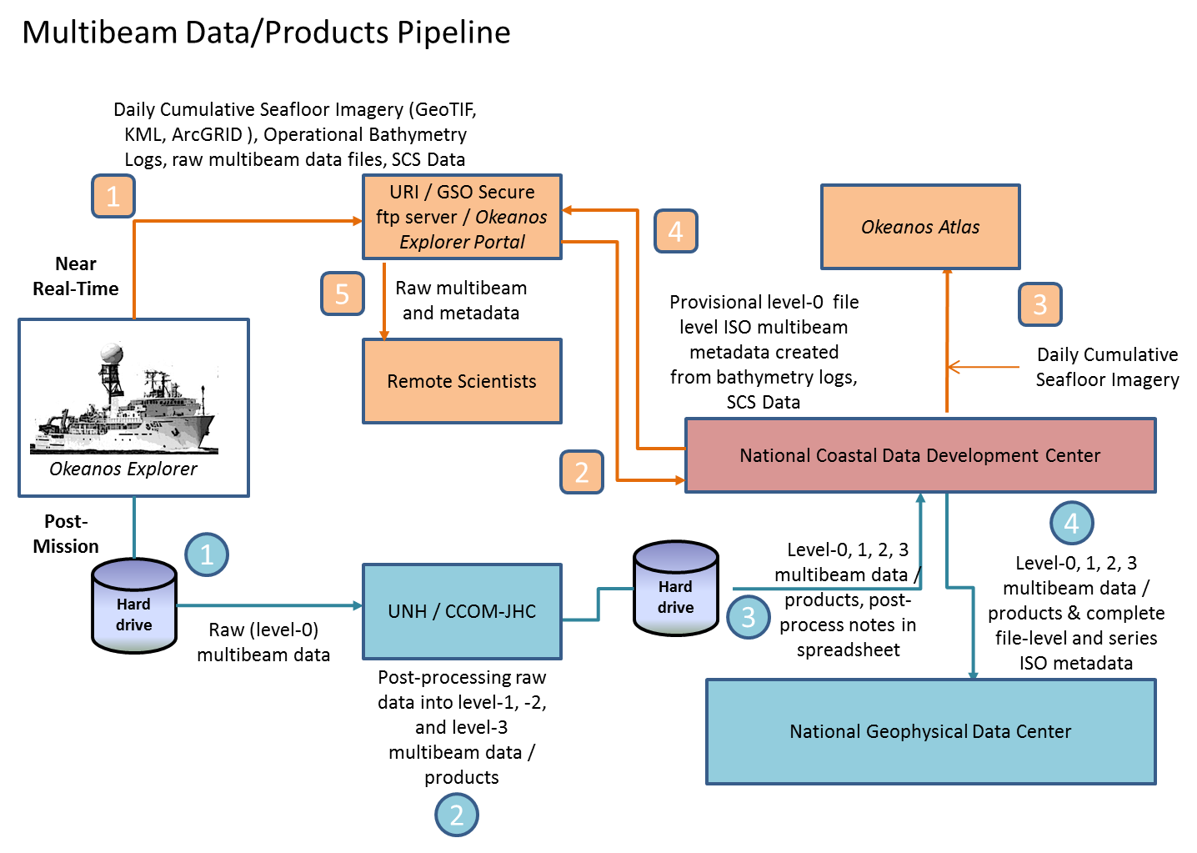

Figure 2: Multibeam Survey Data Archive Pipeline

Near Real-Time
1

The mapping survey team on the EX will include their operational processing spreadsheet in the folder that is targeted for synchronization to the SRS periodically throughout the day. As operational GeoTIFF images are created, these will also be saved to this folder.
2

The data management team at NCDDC pulls the GeoTIFF images, operational bathymetry processing spreadsheet and the SCS data streams for near real-time metadata generation and Okeanos Atlas update procedures.

3

Daily cumulative GeoTIFF images of the seafloor imagery are geo-located on the Okeanos Atlas by the GIS team at NCDDC.

4

Provisional metadata in an ISO format is generated for each raw (level-0) multibeam raw files using the SCS exported data, the operational processing spreadsheet and saved to the SRS.

5

Participating scientists wanting access to the raw multibeam in near real-time can pull the individual files with the metadata that provides operational and provisional processing steps and a disclaimer for non-QC status of the data.

Post-Mission
All bottom-looking sensor data and complementary data (water column and sound velocity) are saved to a hard-drive. This hard-drive will be either brought back or shipped to the University of New Hampshire Center for Coastal and Ocean Mapping (UNH CCOM) for post-processing.

A full complement of multibeam data from a 30-day EX cruise on which the Kongsberg EM302 multibeam system runs continuously will produce 200-300 Gigabytes of raw multibeam (37.5% of total volume) and water column data (62.5% of total volume). At UNH, the mapping team will post-process the multibeam data through the following steps:

- The raw (level-0) data will be saved to the CCOM file servers, where they will be quality checked and post-processed.
- The edited level-0 data is saved as level-1 data files in a non-proprietary format – ASCII xyz files (cleaned not gridded).
- The post-processing steps used to produce the level-1 data will be documented.
- Level-2 products will be generated from the level-1 data files.
- The post-processing steps used to produce the level-2 data products will be documented.
- The level-1 data, level-2 products, post-processing steps, and working data processing spreadsheets will be copied to the hard drive in a new folder. A processing spreadsheet for FY12 will contain the temporal and spatial limits of each file and any supplemental information documenting problems or issues that affected the quality of the data in that file.

The hard-drive will be shipped to the NCDDC within approximately 3 weeks from cruise end date.

At NCDDC, all multibeam related files will be post-processed through metadata generation procedures. Metadata will be generated for each individual survey track file (level-0 and -1), for accompanying CTD/XBT profile data sets, for composite xyz files, KMLs, GeoTIFs, png images, and Fledermaus output (level-2), and a set of data products and reports (level-3). The metadata will be added to the hard-drive and the hard-drive will be shipped to NGDC.

NOAA Ship Okeanos Explorer
Data Class | Instrument | Data Type | Format | Metadata Granularity | Archive Center
GEO | Kongsberg EM302 (30 kHz) | Multibeam Bathymetry, Bottom Backscatter, Water Column Backscatter (proprietary format read into MBSystem) | .all, .wcd (proprietary) | 1 meta rec per .all file in Multibeam Data folder and subfolders | NGDC
GEO | Simrad EK60 | Singlebeam (time,depth) | .txt, (ASCII), .raw (proprietary) | Included in the SCS feed | TBD
GEO | Knudsen CHIRP 3260 (3.5 kHz) | Sub-bottom profile | .sgy, .kea, .keb (proprietary) | 1 meta rec = Subbottom Profile Data folder | NGDC
OCN | SeaBird SBE-911plus | CTD Cast | .hex, .con (Proprietary); .cnv, .hdr, .bl, .jpg (processed) | 1 meta rec = CTD folder | NGDC
OCN | Sippican MK-21 eXpendable BathyThermograph (XBT) | XBT | .edf (ASCII), .rdf (proprietary) | 1 meta rec = XBT folder | NGDC
OCN | RESON | Sound Velocity (m/s) | TBD | 1 meta rec = RESON folder | NGDC
OCN | Calculated | Sound Velocity (m/s) | .asvp (ASCII) | 1 meta rec = Profile_Data/SVP or Profile_Data/ASVP | NGDC

Table 5: Multibeam Survey Metadata Granularity and Target Archive

