CTD Cast Name |  |   Cruise |  |  |  |  |  | CTD Number |  |  | Date
 |  | EX1205L1 |  |  |  |  |  | CTD002 |  |  | 7/13/2012
Expedition Coordinator/  Science Team Lead |  | Kelley Elliott/Cindy Van Dover |  |  |  |  |  |  | 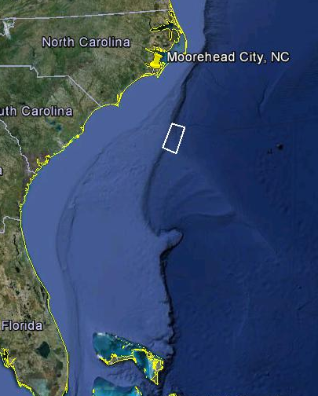
General Area Descriptor |  | Blake Ridge
Site Name |  | Blake Ridge Diapir
Type of CTD Operation |  | Vertical Cast Po-Go
 |  | Tow-Yo Combination
Target Position |  | 32° 28.900’N
 |  | 76° 12.078’W
Deployment  Time & Location |  | UTC Time | 01:07
 |  | Latitude | 32 |  | º | 28.900 |  |  |  |  |  |  | ‘ |  |  | N
 |  | Longitude | 76 |  | º | 12.079 |  |  |  |  |  |  | ‘ |  |  | W
Time & Location  At Depth |  | UTC Time | 02:48 |  | Target Depth/Range |  |  |  |  | 20mab
 |  | Latitude | 32 |  | º |  | 29.014 |  |  |  |  |  |  | ‘ |  |  | N
 |  | Longitude | 76 |  | º |  | 12.005 |  |  |  |  |  |  | ‘ |  |  | W
Recovery  Time & Location |  | UTC Time | 03:29 |  | Maximum Depth (m) |  |  |  |  | 2142
 |  | Latitude | 32 |  | º | 29.032 |  |  |  |  |  | ‘ |  |  | N
 |  | Longitude | 76 |  | º | 11.994 |  |  |  |  |  | ‘ |  |  | W
CTD Sensor  Data Acquired |  | CTD P 0906 T1 5023 T2 5026 C1 3455 C2 3456
 |  | ORP 07 Votage Channel 05
 |  | LSS 12790 Voltage Channel 02 LSS 12791 Voltage Channel OFF
 |  | Dissolved Oxygen Voltage Channel 04 Altimeter Voltage Channel 00
 |  | Other (specify) ____________ Voltage Channel __ ____________ Voltage Channel __
Water Samples Collected? |  | Yes No If Yes, Number of Bottles Tripped: _____________
Sample  Processing |  | Sample Type(s): ___ ________________________________
 |  | Processed on board Preserved Chemicals _______________________
 |  | None Room Temp Storage -80 Freezer -20 Freezer Refrigerator
Data Archival |  | Tethys FTP site
Equipment Malfunctions | Dissolved oxygen sensor not in line with other sensors – very jagged profile.
Special Notes | Extremely strong current - With 2400m wire out CTD was >500m from the ship with a 45° Wire angle during most of the cast.
Scientists Involved  (name / location / affiliation / email) |  | Chris German (WHOI), cgerman@whoi.edu  Cindy Van Dover (Duke), clv3@duke.edu  Laura Brothers (USGS), lbrothers@usgs.gov
Purpose of the CTD operation: Acquire data over the Cape Fear Diapir
Description of the Data/Results:
Overall Map of CTD Cast Area | Screen Grab of Data
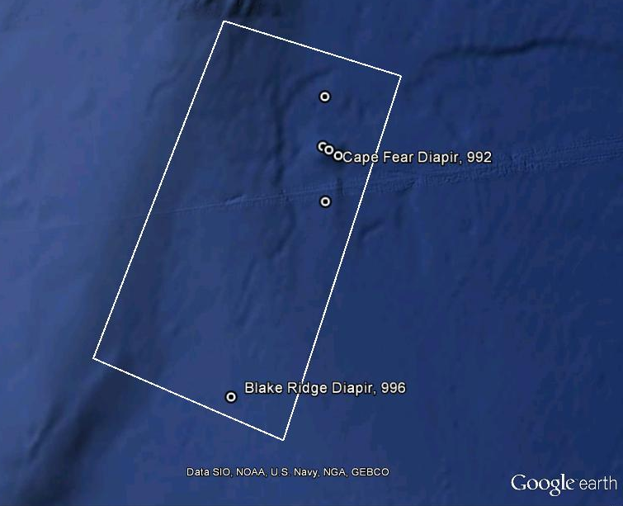 | 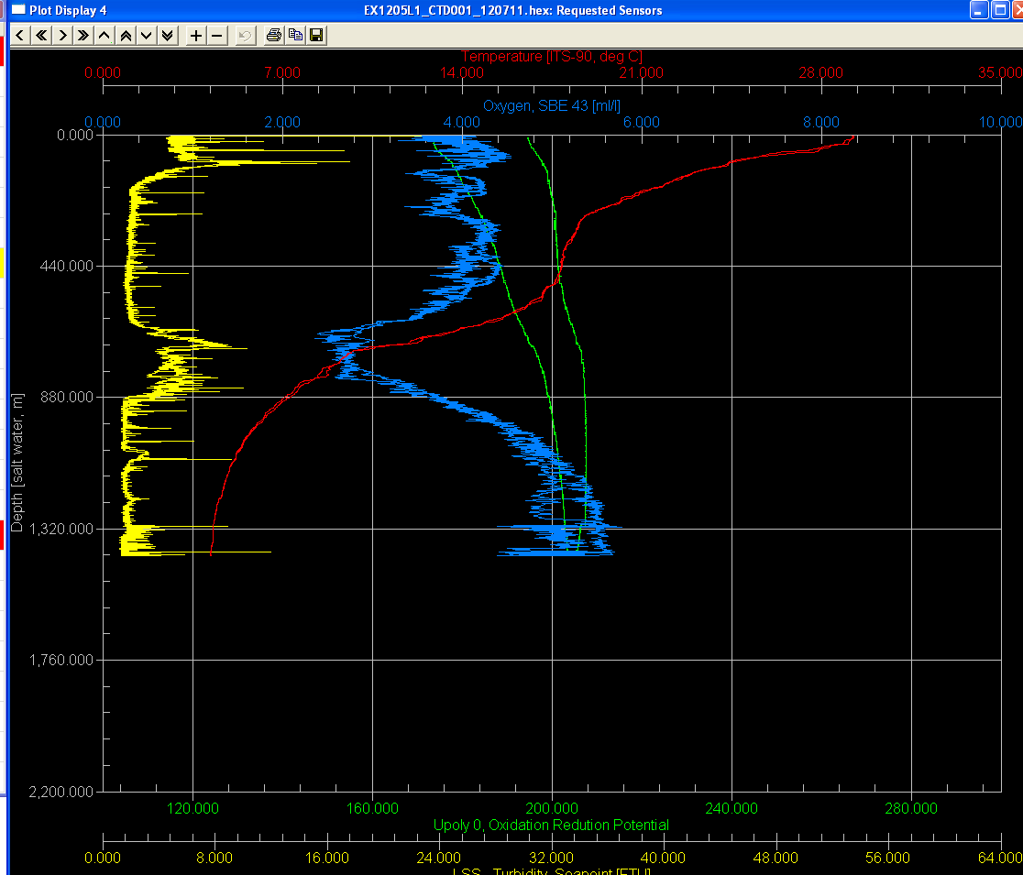
Overview of Cast site | SeaSave Data Acquisition Screen
Please direct inquiries to: | NOAA Office of Ocean Exploration & Research  1315 East-West Highway (SSMC3 10th Floor)  Silver Spring, MD 20910  (301) 734-1014

