**NOAA *Okeanos Explorer* Program**

**MAPPING DATA REPORT**

**CRUISE EX1203**

Exploration Mapping: Gulf of Mexico

May 5 – May 23, 2012

Galveston, TX to Norfolk, VA

Report Contributors:

Mashkoor Malik, Lillian Stuart, Adam Argento, Sean Denney, Ashton Flinders, Daniel Whitesell, Adrienne George, Charles Bendig and Erin Hunter

8 June, 2012

NOAA Office of Ocean Exploration and Research

1315 East-West Hwy, SSMC3, #10210

Silver Spring, MD 20910



# Introduction



**The *Okeanos Explorer* Program**

Commissioned in August 2008, the NOAA Ship *Okeanos Explorer* is the nation’s only federal vessel dedicated to ocean exploration. With 95% of the world’s oceans left unexplored, the ship’s combination of scientific and technological tools uniquely positions it to systematically explore new areas of our largely unknown ocean. These exploration cruises are explicitly designed to generate hypotheses and lead to further investigations by the wider scientific community.

Using a high-resolution multibeam sonar with water column capabilities, a deep water remotely operated vehicle, and telepresence technology, *Okeanos Explorer* provides NOAA the ability to foster scientific discoveries by identifying new targets in real time, diving on those targets shortly after initial detection, and then sending this information back to shore for immediate near-real-time collaboration with scientists and experts at Exploration Command Centers around the world. The subsequent transparent and rapid dissemination of information-rich products to the scientific community ensures that discoveries are immediately available to experts in relevant disciplines for research and analysis

Through the *Okeanos Explorer* Program, NOAA’s Office of Ocean Exploration and Research (OER) provides the nation with unparalleled capacity to discover and investigate new oceanic regions and phenomena, conduct the basic research required to document discoveries, and seamlessly disseminate data and information-rich products to a multitude of users. The program strives to develop technological solutions and innovative applications to critical problems in undersea exploration and to provide resources for developing, testing, and transitioning solutions to meet these needs.

***Okeanos Explorer* Management – a unique partnership within NOAA**

The *Okeanos Explorer* Program combines the capabilities of the NOAA Ship *Okeanos Explorer* with shore-based high speed networks and infrastructure for systematic telepresence-enabled exploration of the world ocean. The ship is operated, managed and maintained by NOAA’s Office of Marine and Aviation Operations, which includes commissioned officers of the NOAA Corps and civilian wage mariners. OER owns and is responsible for operating and managing the cutting-edge ocean exploration systems on the vessel (ROV, mapping and telepresence) and ashore including Exploration Command Centers and terrestrial high speed networks. The ship and shore-based infrastructure combine to be the only federal program dedicated to systematic telepresence-enabled exploration of the planet’s largely unknown ocean.

Table of Contents

1. Introduction 2

2. Report Purpose 4

3. Cruise Objectives 4

4. Participating Personnel 8

5. Summary of Major Findings 8

a. BOEM / UNH Focused site (In vicinity of Green Canyon and Assumption Hill) 8

b. Mississippi Canyon 13

c. Western Florida Escarpment focused mapping area 14

d. South Atlantic Bight focused mapping areas 15

6. Mapping Statistics 17

7. Mapping Sonar Setup 18

8. Data Acquisition and processing summary 18

9. Data Archival Procedures 20

10. Cruise Calendar 25

11. References 26

12. Appendices 27

Appendix A: Tables of data files collected 27

Appendix B: EM302 description and operational specs 40

Appendix C: Acronyms and abbreviations 43

Appendix D: May 24, 2012 Event attendees list 44

# Report Purpose

The purpose of this report is to briefly describe the mapping data collection and processing methods, and to report the major results of the cruise. For a detailed description of the *Okeanos Explorer* mapping capabilities, see Appendix B as well as the ship’s readiness report, which can be obtained by contacting the ships Operations Officer ([ops.explorer@noaa.gov](mailto:ops.explorer@noaa.gov)).

This report focuses on exploration expedition EX1203 during which areas of Gulf of Mexico, Florida Escarpment, and South Atlantic Bight were mapped.

# Cruise Objectives

The exploration area for this expedition was chosen based upon guidance from the OER / Ocean Exploration Advisory Working Group (OEAWG) workshop results (Atlantic Basin Workshop, 2011) that identified high priority target areas for exploration in the Gulf of Mexico (Fig. 1) and input received from participating scientists from the Bureau of Ocean Energy Management (BOEM, Bill Shedd), the United States Geological Survey (Laura Brothers), other NOAA line offices (National Ocean Service, Geo Olmi) and academic institutions including the University of New Hampshire (UNH, Larry Mayer and Tom Weber), Louisiana State University (LSU, Bob Carney), the University of North Carolina (UNC, Steve Ross and Michael Rhodes), Scott Harris (CoC) and Duke University (Cindy Vandover).

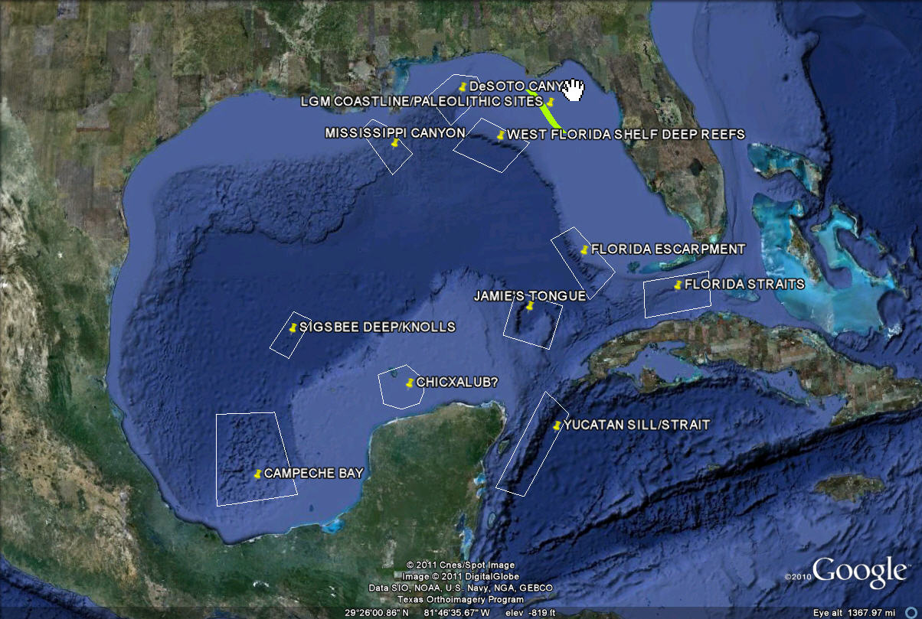

Figure 1: Priority exploration targets identified during Atlantic basin workshop held in May 2011. Image created in Google Earth.

Most of the sites in the southern part of the Gulf of Mexico (Fig. 1) were excluded from consideration for EX1203 as they are outside the US EEZ and the time frame for this cruise was considered too short to pursue any foreign clearances/ permits. Focusing on the Northern part of the Gulf, two exploration areas were chosen: the Mississippi Canyon and the Western Florida Shelf.

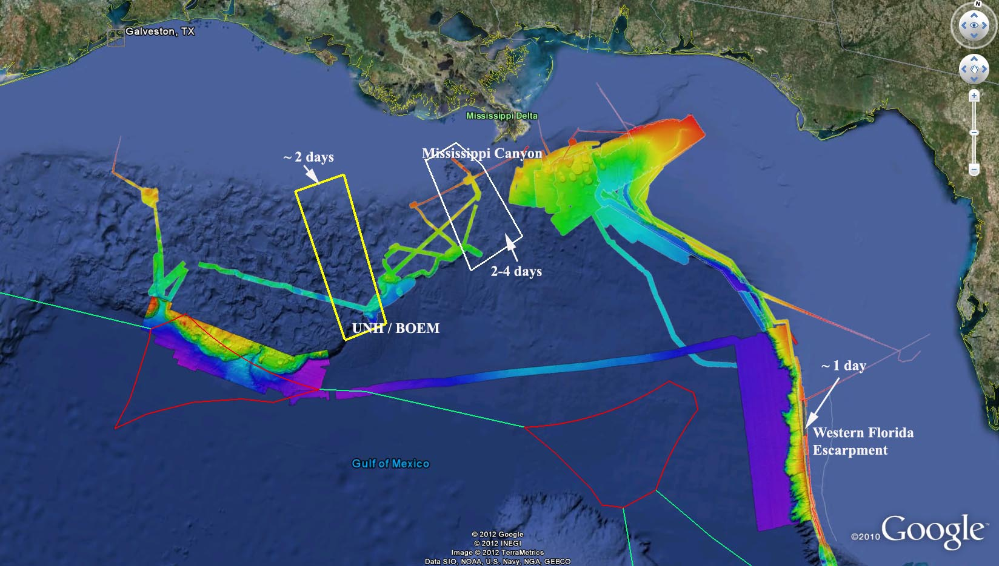

Figure 2a: Mapping priority areas for EX1203 along with expected time to be spent at each site in Gulf of Mexico. Shown is the previous mapping coverage in vicinity of work areas. Image created in Google Earth.

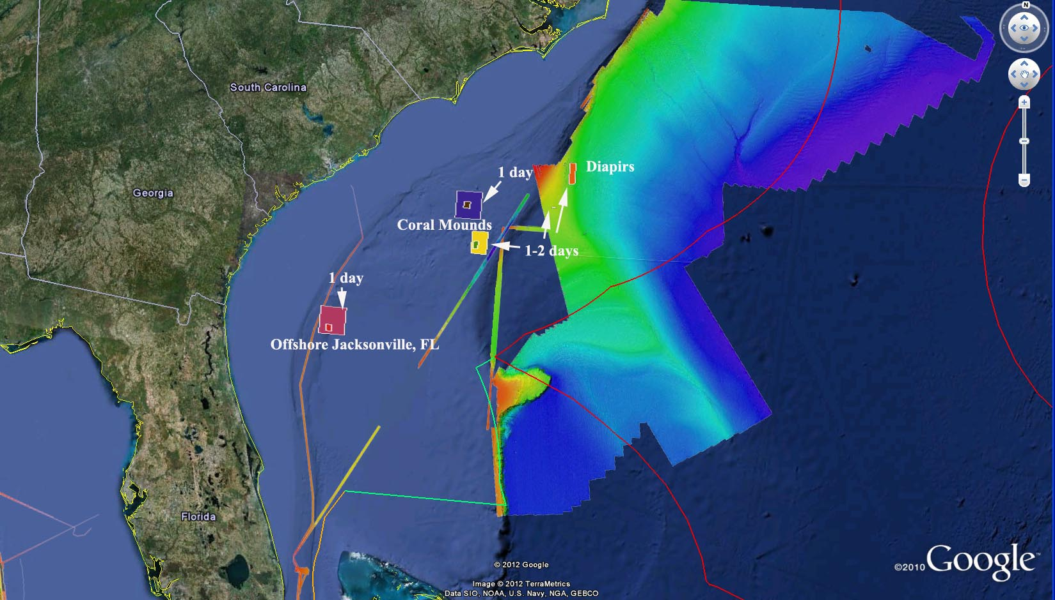

Figure 2b: Mapping priority areas for EX1203 along with expected time to be spent at each site in South Atlantic Bight. Shown is the previous mapping coverage in vicinity of work areas. Image created in Google Earth.

In summary the following were mission objectives for EX1203 (as per EX1203 project instructions, April 2, 2012):

*a. Safe Transit from Galveston, TX to Norfolk, VA*

The overall objective was data collection during a safe transit from Galveston, TX to Norfolk, VA. Continuous data collection (24 hours per day) occurred for the following data types: EM 302 multibeam bathymetry, bottom backscatter, and water column backscatter; EK 60 singlebeam water column; and Knudsen sub-bottom profiler data (collected daily from 0800-2000 local time).

*b. Focused mapping during the transit*

A relatively direct route from Galveston, TX to Norfolk, VA was approximately 1836 NM (3400 km), a time of approximately 9 days at transit speeds (~ 10-12 knots). The remaining approximately 10 days of the cruise were dedicated to focused mapping exploration operations. These operations included (please refer to Figure 2):

1. Completion of partial mapping in the BOEM/UNH box. Continue mapping coverage along the Florida Escarpment during transit adjacent to previous *Okeanos Explorer* coverage and completing Mapping Area along the Florida Escarpment (Figure 2a);
2. Water column and sub-bottom exploration mapping operations in the vicinity of the Blake Ridge Diapir in preparation for EX-12-05 Leg 1 (Figure 2b);
3. Mapping in focused previously unexplored areas offshore Jacksonville, FL over coral mounds (Figure 2b).

*c. Science objectives*

* 1. Continue to identify and explore the diversity of benthic habitats in the region (e.g. seeps, deep corals, canyons) by building on mapping coverage obtained during EX-11-05, EX-11-06, and EX-12-02 Legs 1, 2, and 3;
  2. Possibly locate and characterize submerged cultural resources (SCR), e.g. shipwrecks (data will be used to assess their eligibility for the National Register of Historic Places) within EX-1203 operating area;
  3. Utilize sub-bottom sonar to explore diapirs in the vicinity of Blake Ridge;
  4. Conduct preliminary water column mapping (24-48 hrs) of Blake Ridge diapir system to test the hypothesis that there may be seepage and chemosynthetic communities along the 1000-m isobaths at the boundary of the methane hydrate stability zone using mapping and photo groundtruthing of selected targets.

d. *Telepresence* (VSAT 5 mb/sec ship to shore; T1 shore to ship)

1. Test and refine ship-to-shore communications and operations procedures;

2. Test and refine operating procedures and products;

3. Engage a broad spectrum of the scientific community and public in telepresence-based exploration, including during the cruise planning process; and

4. Expand use of the ‘Doctors-on-Call’ model.

*e. Data Management*

* 1. Provide a foundation of publicly accessible data and information products to spur further exploration, research, and management activities, as detailed in the 2012 post-cruise product list;
  2. Provide daily, cumulative multibeam products to shore for operational decision making purposes, as detailed in the 2012 field products list;
  3. Test data pipeline for daily transfer of raw sonar data to shore;
  4. Test data pipeline of operationally required sub-bottom and EK 60 products to shore.

*f. Outreach / Media*

* 1. Port events in Norfolk, VA was conducted on 24 May 2012 that included ship’s tours by NOAA leadership including Acting Deputy Administrator Eric Schwaab. Complete attendeed list is attached as Appendix D. After the tours, a brief discussion was held accompanied by a light lunch at the pier (hosted by VA Coastal Zone management Program and VA Sea Grant) to discuss OER partnership activities to map NE canyons.
  2. Live interaction between the ship’s control room and Silver Spring ECC on 22 May to host (Mr. Glen Paul, Media Officer in Corporate Communications for CSIRO, Australia, OER POC Fred Gorrell), and on 21 May to host Bill Gibson, a D.C.-based reporter for the Ft. Lauderdale Sun-Sentinel and the Orlando Sentinel (OER POC Fred Gorrell) and on 16 May to host OER intern Daniela Vitarelli (OER POC Joanne Flanders).

# Participating Personnel

|  |  |  |
| --- | --- | --- |
| **NAME** | **ROLE** | **AFFILIATION** |
| CDR Robert Kamphaus | Commanding Officer | NOAA Corps |
| LT Megan Nadeau | Field Operations Officer | NOAA Corps |
| Mashkoor Malik | Expedition Coordinator / Mapping Team Lead | NOAA OER / ERT Inc. |
| Sean Denney | Mapping Watch Leader | NOAA OER / UCAR |
| Adam Argento | Mapping Watch Leader | NOAA PHB |
| Lillian Stuart | Mapping Watch Leader | NOAA OMAO |
| Daniel Whitesell | Mapping Watch Stander | NOAA OER / UCAR |
| Adrienne George | Mapping Watch Stander | NOAA OER / UCAR |
| Erin Hunter | Mapping Watch Stander | NOAA OER / UCAR |
| Charles Bendig | Mapping Watch Stander | NOAA OER / UCAR |
| Ashton Flinders | Mapping Watch Stander/ Leader | NOAA OER / UCAR |
|  |  |  |

# 

# Summary of Major Findings

The expedition was divided into focused mapping areas while in transit from Galveston, TX to Norfolk, VA. The transit track line was deliberately laid adjacent to existing multibeam coverage.

## a. BOEM / UNH Focused site (In vicinity of Green Canyon and Assumption Hill)

Assumption Hill / Green Canyon was the first focused site of the expedition where the EM302 and EK60 detected approximately 50 distinct water column targets which were presumed to be gas seeps rising from the seafloor. Dr. Carney (LSU) provided locations of the video observations of the seeps from 1980 to the present. Figure 3 shows a screen shot of QPS/Fledermaus processed data of the northern area within this focused mapping site showing the bathymetry and the water column curtain obtained from the EK 60 sonar. The presumed seeps are highlighted by blue arrows.

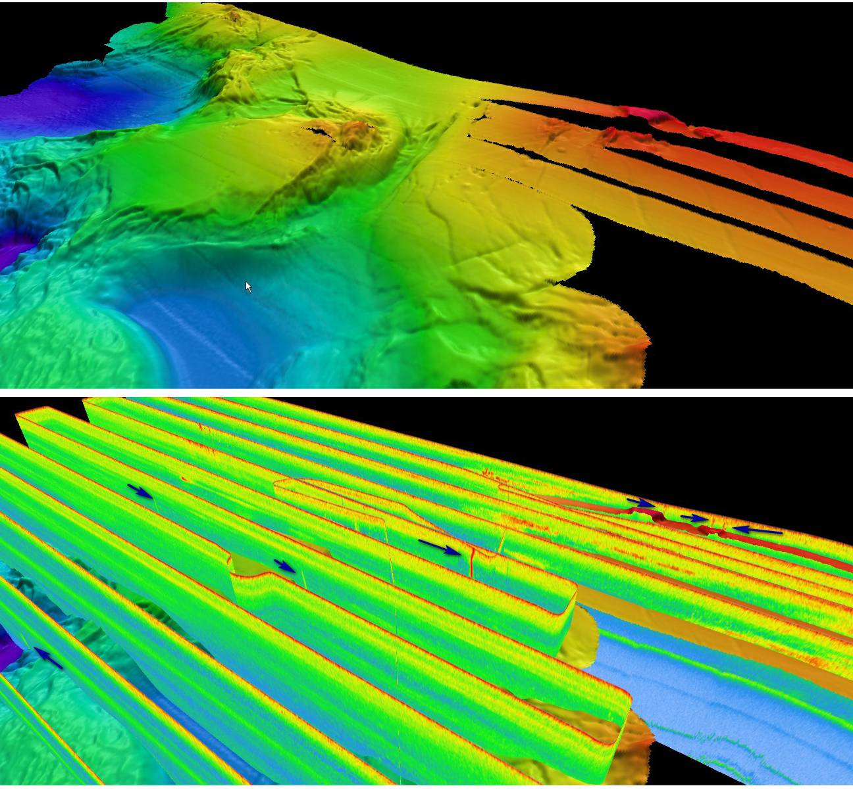

Figure 3: Top panel shows the bathymetry collected by EM 302. Lower panel shows the curtain of EK 60 single beam water column backscatter showing several presumed gaseous seeps (highlighted by blue arrows).

The following image (Figure 4) shows the location of the video observations of the seeps along with the seeps locations as detected by the EM302 and the EK60. The seep locations are overlaid on the bathymetric data that were collected during the current expedition.

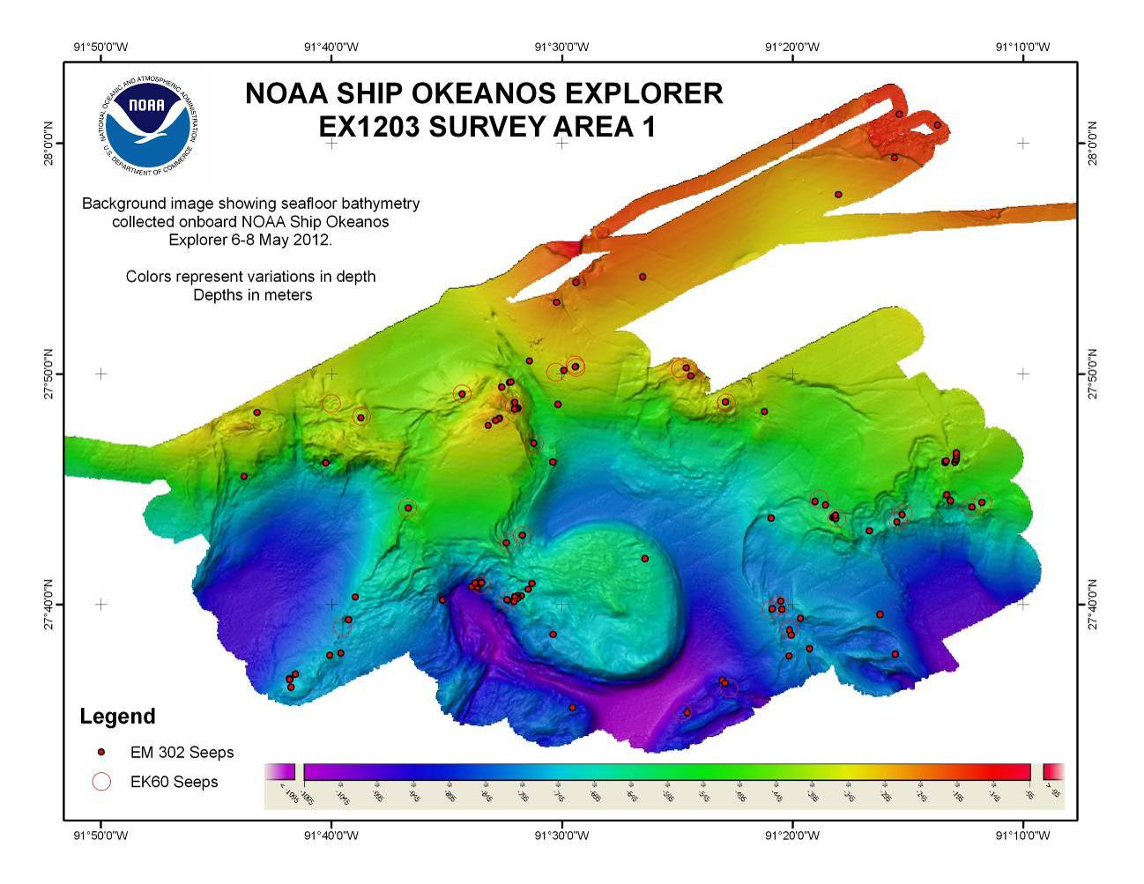

Figure 4: Compilation of presumed gaseous seeps detected by EM 302 and EK 60 water column backscatter data draped over the bathymetry collected by EM 302. The near circular feature in the middle of the Figure is Assumption Hill.

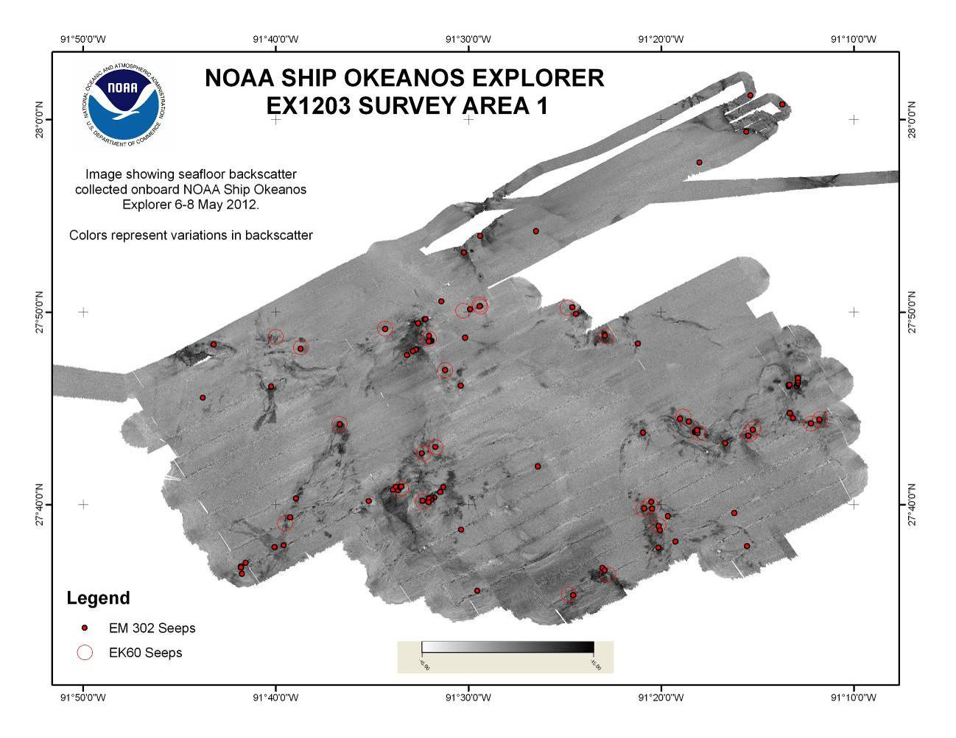

Figure 5: Compilation of presumed gaseous seeps detected by EM 302 and EK 60 water column backscatter data draped over the seafloor backscatter data collected by EM 302.

The locations of the seeps detected in this area are tabulated below:

*Table 1: Seep locations detected by EM 302.*

|  |  |  |  |  |  |
| --- | --- | --- | --- | --- | --- |
| **Longitude(W)** | **Latitude(N)** | **Depth** | **Longitude(W)** | **Latitude(N)** | **Depth** |
| -91.553 | 27.79611 | -76.1 | -91.258 | 27.72639 | -628.37 |
| -91.259 | 27.63055 | -822.61 | -91.278 | 27.71992 | -661.22 |
| -91.49 | 27.83852 | -281.99 | -91.504 | 27.88504 | -184.22 |
| -91.49 | 27.83849 | -308.07 | -91.228 | 28.01329 | -132.13 |
| -92.174 | 27.81228 | -308.96 | -91.26 | 27.98956 | -163.56 |
| -92.174 | 27.81138 | -302.54 | -91.572 | 27.81889 | -356.94 |
| -92.153 | 27.80588 | -246.09 | -91.076 | 27.95412 | -195.07 |
| -91.256 | 28.02112 | -130.41 | -91.076 | 27.95405 | -193.59 |
| -91.49 | 27.89958 | -180.3 | -91.064 | 27.95508 | -198.88 |
| -91.73 | 27.75915 | -516.93 | -91.52 | 27.7833 | -519.86 |
| -91.442 | 27.90349 | -202.81 | -91.611 | 27.73644 | -486 |
| -91.645 | 27.80155 | -368.22 | -91.649 | 27.67198 | -703.8 |
| -91.3 | 27.96291 | -267.84 | -91.382 | 27.81312 | -319.05 |
| -91.523 | 27.84253 | -370.67 | -91.31 | 27.73868 | -533.2 |
| -91.721 | 27.80529 | -337.12 | -91.317 | 27.74122 | -580.83 |
| -91.503 | 27.81134 | -465.32 | -91.349 | 27.72914 | -644.33 |
| -91.671 | 27.76906 | -562.5 | -91.492 | 27.59195 | -894.43 |
| -91.384 | 27.61177 | -889.81 | -91.348 | 27.66338 | -792.17 |
| -91.382 | 27.60975 | -903.83 | -91.341 | 27.66321 | -779.86 |
| -91.27 | 27.6595 | -825.73 | -91.342 | 27.66903 | -806.44 |
| -91.321 | 27.63451 | -795.76 | -91.204 | 27.7372 | -544.53 |
| -91.409 | 27.58827 | -945.83 | -91.196 | 27.74036 | -540.38 |
| -91.336 | 27.62947 | -807.76 | -91.335 | 27.64816 | -783.99 |
| -91.44 | 27.69987 | -617.66 | -91.334 | 27.64449 | -802.4 |
| -91.506 | 27.64479 | -792.15 | -91.328 | 27.65675 | -798.34 |
| -91.304 | 27.72961 | -526.15 | -91.41 | 27.83758 | -265.66 |
| -91.303 | 27.72949 | -555.15 | -91.407 | 27.83175 | -221.22 |
| -91.303 | 27.72966 | -557.43 | -91.507 | 27.76971 | -555.39 |
| -91.302 | 27.72878 | -560.86 | -91.696 | 27.61311 | -767.9 |
| -91.302 | 27.73114 | -511.37 | -91.697 | 27.61305 | -773.67 |
| -91.223 | 27.76914 | -450.87 | -91.696 | 27.60691 | -765.8 |
| -91.223 | 27.77028 | -420.52 | -91.697 | 27.61238 | -783.18 |
| -91.222 | 27.77038 | -429.12 | -91.693 | 27.61622 | -748.38 |
| -91.216 | 27.76944 | -374 | -91.668 | 27.62975 | -696.33 |
| -91.215 | 27.77117 | -433.77 | -91.66 | 27.63128 | -775.43 |
| -91.215 | 27.77214 | -440.44 | -91.586 | 27.6698 | -860.6 |
| -91.215 | 27.77406 | -421.49 | -91.565 | 27.67957 | -910.74 |
| -91.215 | 27.77616 | -435.75 | -91.561 | 27.67891 | -885.48 |
| -91.219 | 27.74156 | -540.39 | -91.563 | 27.68202 | -841.32 |
| -91.222 | 27.74594 | -524.09 | -91.559 | 27.68114 | -839.26 |
| -91.254 | 27.73152 | -630.43 | -91.559 | 27.68228 | -839.18 |
| -91.558 | 27.68219 | -835.3 | -91.534 | 27.81282 | -341.05 |
| -91.522 | 27.68165 | -663.48 | -91.532 | 27.80856 | -107.1 |
| -91.525 | 27.67742 | -698.24 | -91.533 | 27.8085 | -102.67 |
| -91.53 | 27.67271 | -694.45 | -91.533 | 27.80835 | -104.36 |
| -91.532 | 27.67291 | -717.59 | -91.534 | 27.80821 | -85.98 |
| -91.532 | 27.67116 | -715.59 | -91.534 | 27.80799 | -80.02 |
| -91.533 | 27.6706 | -707.93 | -91.534 | 27.80794 | -80.99 |
| -91.534 | 27.67216 | -721.37 | -91.545 | 27.80128 | -70.12 |
| -91.534 | 27.67186 | -725.23 | -91.545 | 27.80105 | -71.49 |
| -91.535 | 27.66873 | -733.02 | -91.546 | 27.80092 | -79.87 |
| -91.539 | 27.66965 | -783.35 | -91.548 | 27.79957 | -67.29 |
| -91.54 | 27.66987 | -800.56 | -91.499 | 27.83598 | -347.53 |
| -91.654 | 27.65567 | -772.95 | -91.353 | 27.80618 | -435.62 |
| -91.544 | 27.82379 | -305.32 | -91.529 | 27.71656 | -641.32 |
| -91.538 | 27.82711 | -365.38 | -91.54 | 27.71119 | -609.43 |
| -91.537 | 27.82729 | -365.34 |  |  |  |
|  |  |  |  |  |  |

*Table 2: Seep Locations detected by EK60*

|  |  |  |
| --- | --- | --- |
| **Longitude (W)** | **Latitude (N)** | **Depth** |
| -91.667 | 27.81214 | -343.33 |
| -91.645 | 27.80276 | -355.29 |
| -91.572 | 27.81901 | -331.37 |
| -91.491 | 27.83987 | -294.28 |
| -91.612 | 27.73659 | -474.92 |
| -91.52 | 27.78319 | -501.24 |
| -91.414 | 27.83726 | -251.22 |
| -91.381 | 27.81256 | -321.8 |
| -91.529 | 27.71663 | -625.65 |
| -91.539 | 27.71137 | -593.35 |
| -91.659 | 27.65041 | -744.08 |
| -91.559 | 27.68077 | -797.92 |
| -91.54 | 27.66957 | -765.62 |
| -91.314 | 27.74302 | -558.66 |
| -91.301 | 27.72877 | -558.66 |
| -91.254 | 27.73243 | -617.28 |
| -91.343 | 27.66615 | -813.47 |
| -91.349 | 27.6629 | -779.97 |
| -91.204 | 27.73689 | -520.38 |
| -91.196 | 27.74088 | -519.18 |
| -91.336 | 27.64887 | -789.54 |
| -91.413 | 27.58896 | -949.84 |
| -91.379 | 27.60601 | -947.45 |
| -91.257 | 27.7276 | -648.38 |
| -91.535 | 27.81039 | -301.46 |
| -91.49 | 27.83813 | -299.07 |
| -91.505 | 27.83468 | -334.96 |

Ship observed an unknown sheen on 7 May which was reported to NRC (Incident # 1010808)

http://www.nrc.uscg.mil/reports/rwservlet?standard_web+inc_seq=1010808

## b. Mississippi Canyon

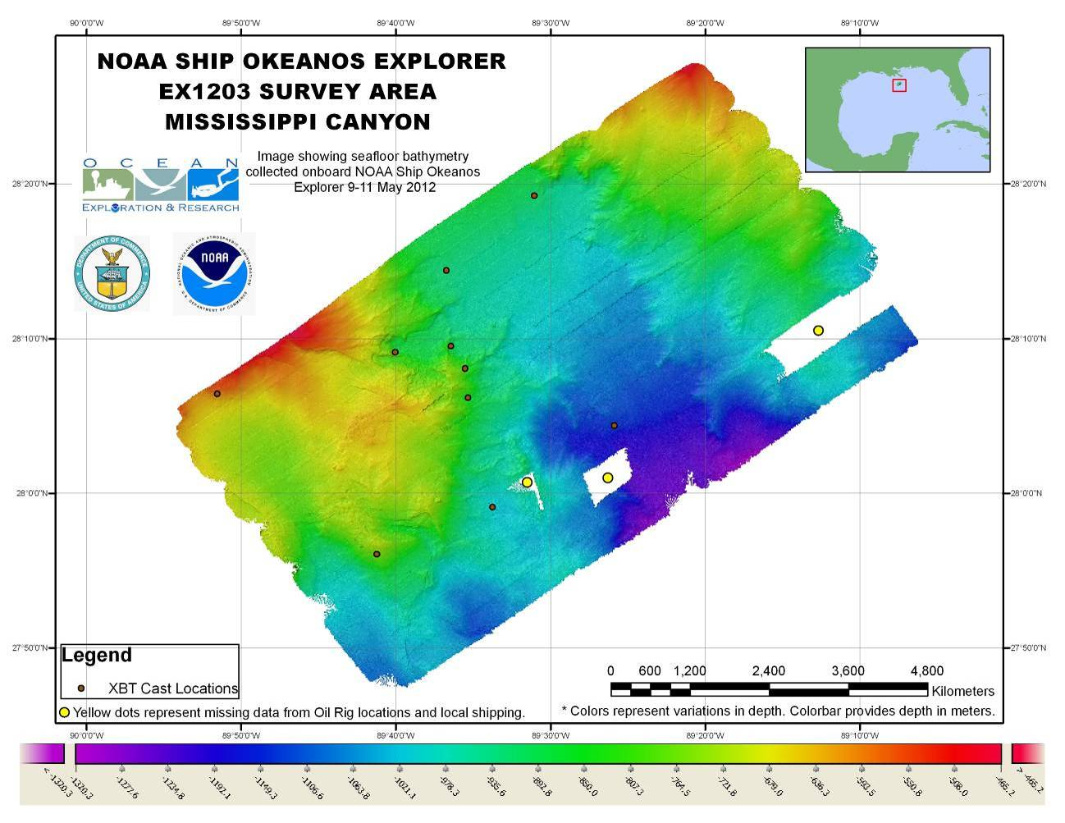

Figure 6: Bathymetry data acquired in the Mississippi canyon priority mapping box overlaid with the XBT cast locations and the oil rig locations which hindered collection of the data in vicinity of these oil rigs.

## c. Western Florida Escarpment focused mapping area

The mapping area was identified during 2011 by Steve Ross (UNC). Over the previous five cruises during 2011 and 2012, the transit mapping track line to and from the Gulf of Mexico from the East coast was intentionally planned to overlap the previous data. Over these five cruises, the whole of the area identified by the scientists has been mapped (Figure 7).

Several interesting features were observed in the vicinity of the priority area. A few of the examples are provided in Figures 8.

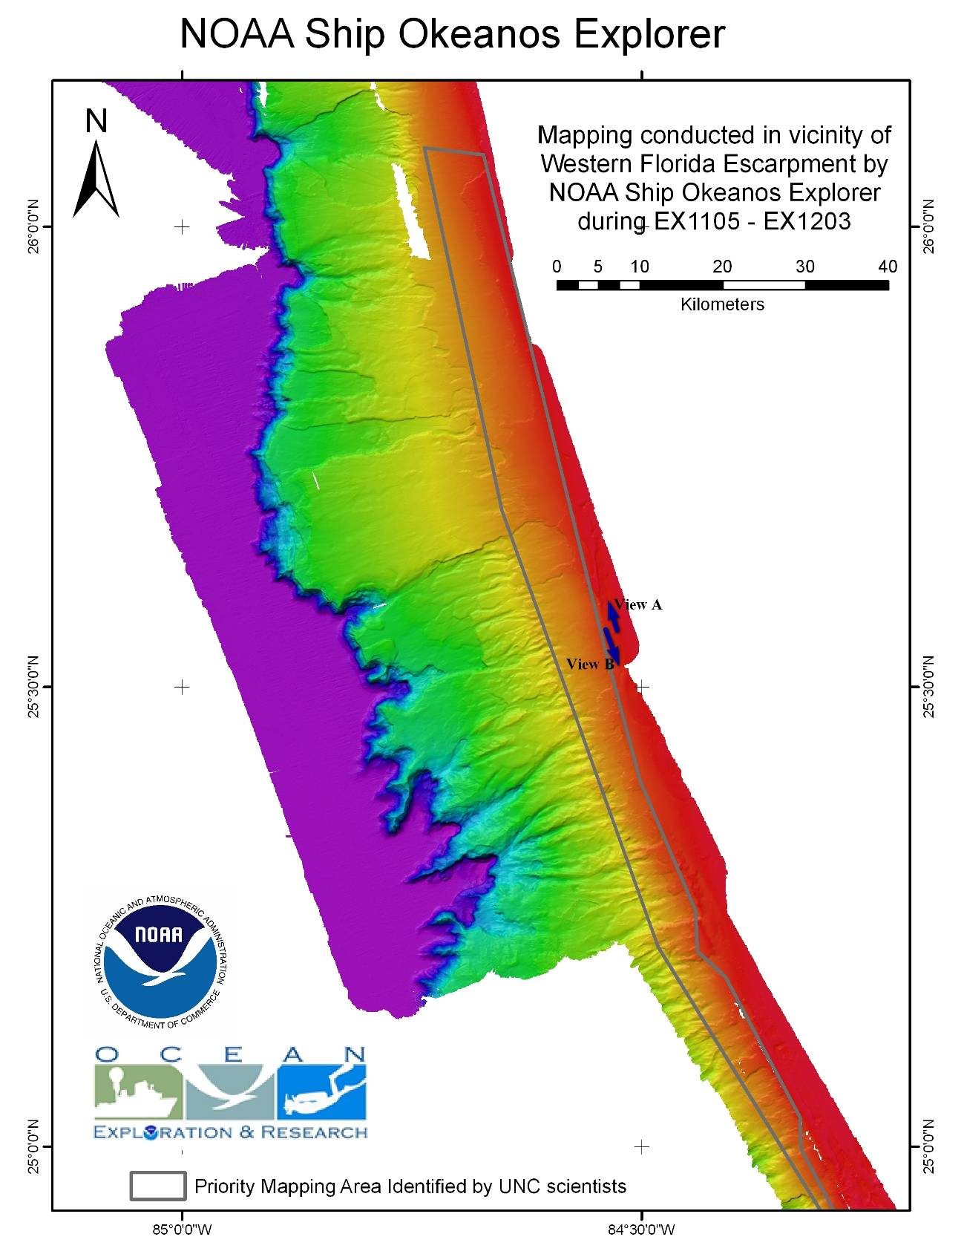

Figure 7: Western Florida Escarpment priority box. The bathymetric data shown is the compilation of all the bathymetric data that has been collected in this area during the ship’s expeditions in Gulf of Mexico since 2011. Zoomed in perspective views (A and B) are shown in Figure 8.

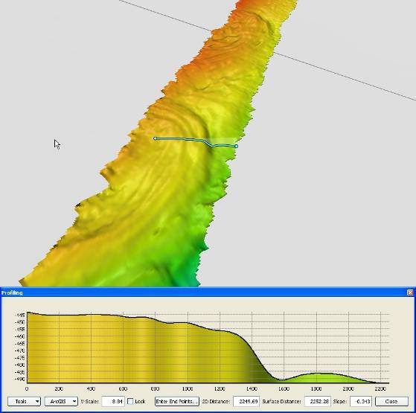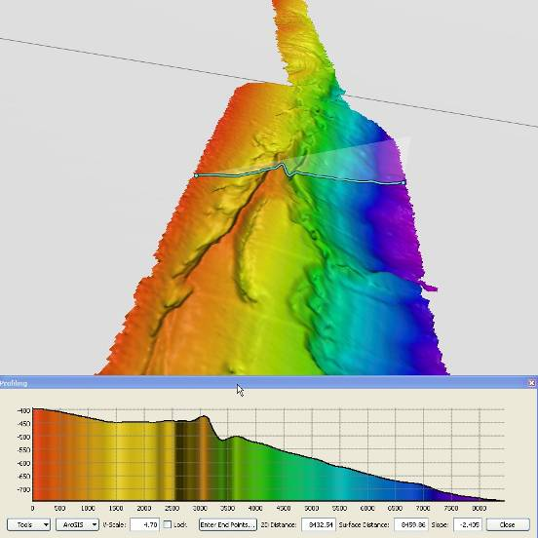

A B

Figure 8: Left (A) and right (B) panels represent virtual-view direction using QPS/Fledermaus. View directions are shown in Figure 7.

## d. South Atlantic Bight focused mapping areas

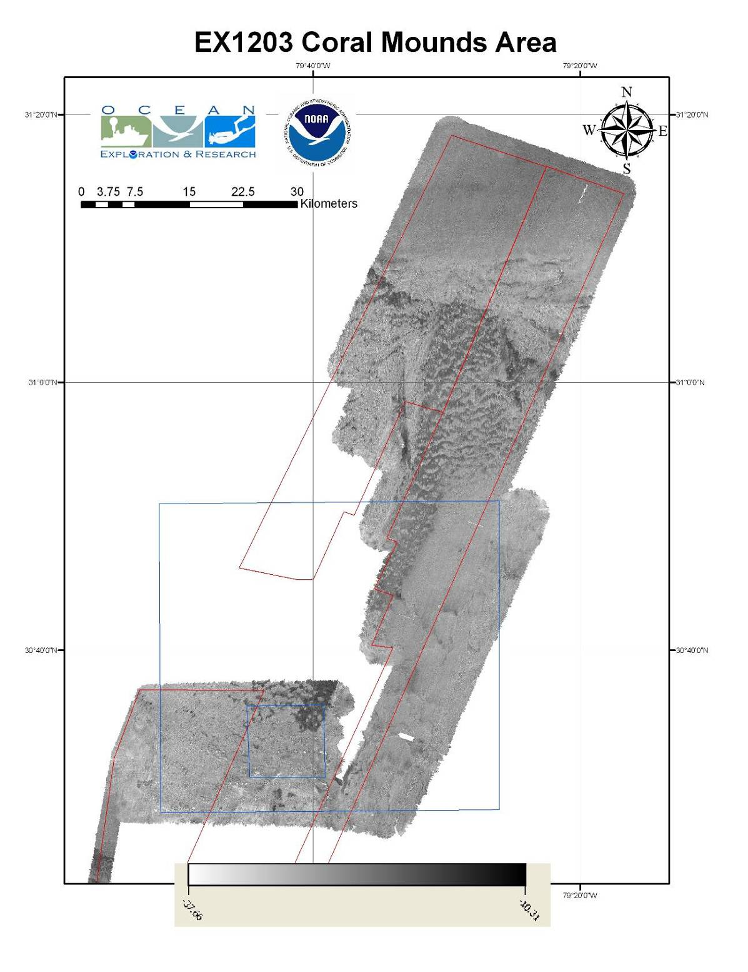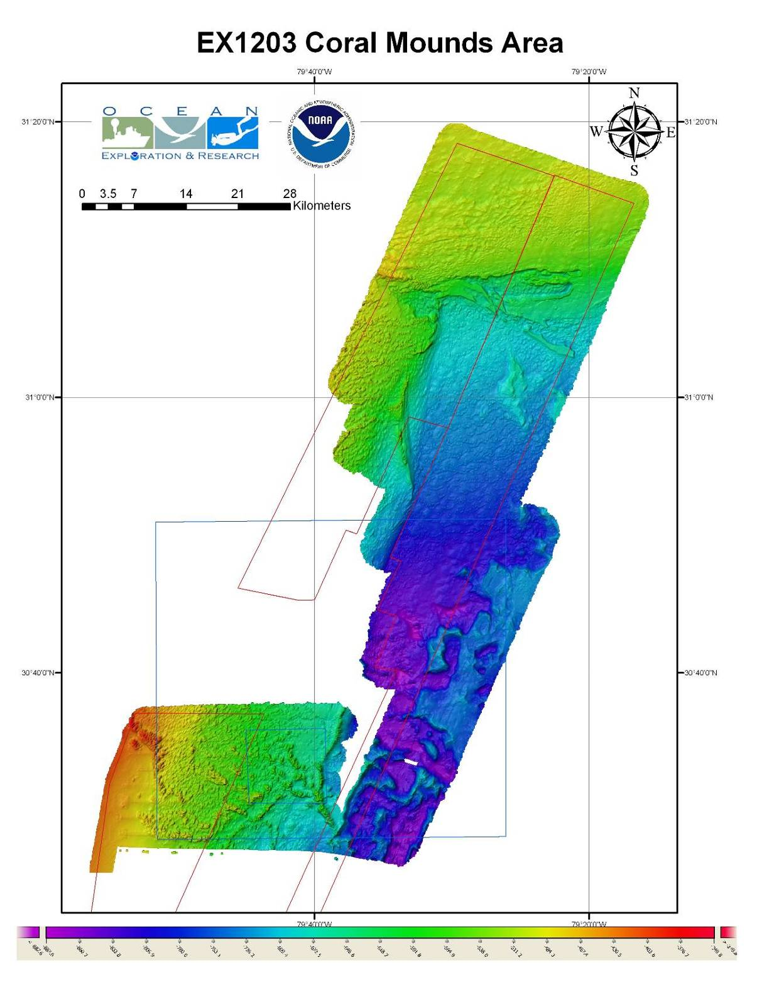

Figure 9: Left and right panel show the EM 302 seafloor bathymetry and backscatter respectively. Overlaid are the priority mapping boxes that were received from the scientists. Red boxes were received from Mike Rhode (UNC) and Blue boxes were received from Scott Harris (CoC)

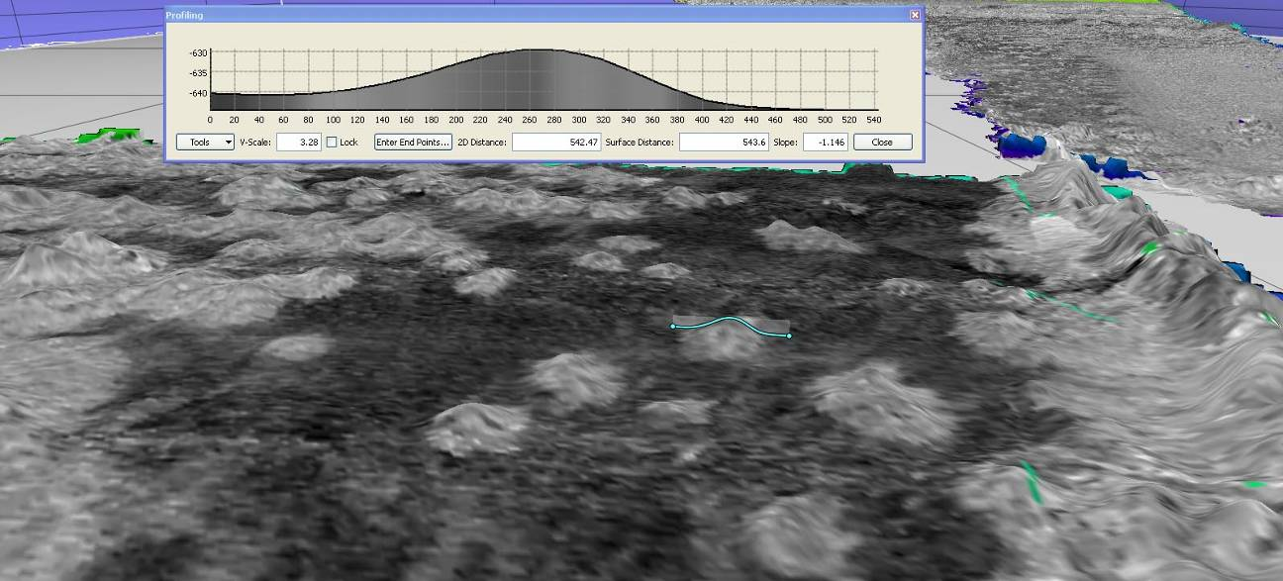

Figure 10: A zoomed in view of the seafloor backscatter data draped over the seafloor bathymetry. A profile is drawn across a topographic high presumed to be a coral mound. High backscatter shown in darker color.

These areas showed several topographic circular features which were ~ 200-500 m in diameter and varied in relief of ~ 10 – 20 m. A distinct anomalous character of these topographic high features was their low backscatter contrast from surrounding seafloor.

**e. Blake Ridge Diapirs focused mapping areas**

On 19 May the Tropical Storm Alberto intensified which forced the ship to take shelter in MayPort, FL. After leaving from MayPort, Fl on 21 May, the ship assessed the situation and a decision was made to not pursue the mapping of rest of Coral mounds and diapirs mapping areas. The image below summarizes the location of the storm with respect to the suggested mapping areas along with the ship’s location as of 21 May 2012 PM.

During transit from MayPort, FL to Norfolk, VA on 22 May several flares were observed which were reported to USCG. Upon request from USCG a search pattern was conducted for any possible rescue operations. Later USCG notified that the flares were part of a military exercise.

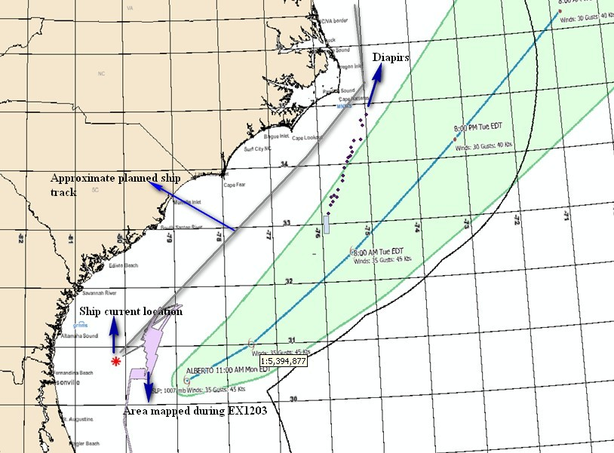

Figure 11: An image showing the projected track of Tropical Storm Alberto and the planned mapping areas (Diapirs). Tropical storm projected track from National Hurricane Center. Image created in ESRI ArcMap.

# Mapping Statistics

|  |  |
| --- | --- |
| Dates | 05/05/12-05/23/12 |
| Weather delays | 1 day |
| Total non-mapping days | 0 days |
| Total survey mapping days | 9 days |
| Total transit mapping days | 9 days |
| Line kilometers of survey | 6761.8 km |
| Square kilometers mapped | 17734.5 sq km |
| Number of bathymetric multibeam files | 315 |
| Data volume of raw multibeam data files | 37.1 GB |
| Number of water column multibeam files | 309 |
| Data volume of water column multibeam files | 75.3 GB |
| Number of XBT casts | 83 |
| Number of CTD casts | 1 |
| Beginning draft | 14’6’’ (fwd) 14’8’’ (aft) |
| Ending draft | 13’8’’ (fwd) 15’2’’ |
| Average ship speed for survey | 8.0 kts |
|  |  |

# Mapping Sonar Setup

The NOAA Ship *Okeanos Explorer* is equipped with a 30 kHz Kongsberg EM 302 multibeam sonar. Appendix B contains a detailed description of sonar system functionality and technical specifications. For this cruise no changes were made to the standard setup of the mapping sonars onboard.

# Data Acquisition and processing summary

Multibeam sonar (EM 302) data were acquired using Kongsberg Seafloor Information System (SIS ver. 3.6.4). SIS system accounts for all the static offsets and biases during real time acquisition. The motion data from the POS MV 320 (Ver. 4.0.2.0) was directly fed into SIS during data acquisition to account for ship motion (i.e. heave, roll, pitch). Yaw data was provided by the TSS gyro-compasses located on the bridge. Also the real time sound speed near the sonar head (dually measured by Reson Sound Speed sensor and a CTD sensor installed in proximity to the EM 302 receiver) was fed into SIS and the most updated acquired sound speed profile was used in real time to correct soundings for sound speed corrections during data acquisition. Unless there are problems observed in the data, there is no requirement to apply these corrections during post processing. The water column backscatter were collected all the time (except for few files listed in the multibeam data files list) which were recorded into separate to bottom bathymetry and backscatter data as *.wcd files.

CARIS HIPS/SIPS v. 6.3 was used to edit the bathymetric data from the EM 302 multibeam. Edited data was exported to ASCII text files and then imported to QPS Fledermaus Ver. 7.3.0c Build 968 for further processing, visualization, quality control, and product generation.

The QPS Fledermaus FMGT (Ver. 7.3.0c Build 968) software package was used for processing EM 302 bottom backscatter data. Processing watches were setup separately for water column backscatter processing. The observed location of seeps noted in the log book during data acquisition helped greatly in the process of detecting seeps during analysis of the water column backscatter in QPS. ‘Fan view’ and ‘Stacked view’ were used in the QPS water column tool to identify the possible seeps. The locations of the seeps detected in each line were then exported into a text file. Some of the characteristic examples of the seep shape and structure observed in the Green Canyon mapping area are provided below:

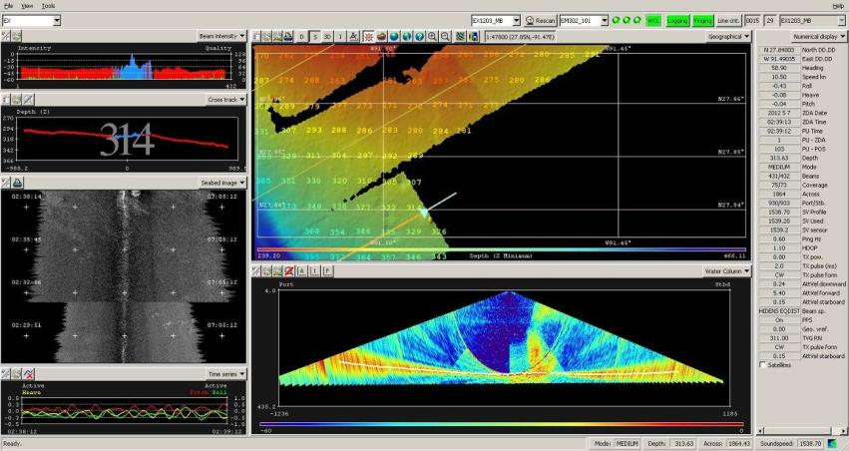

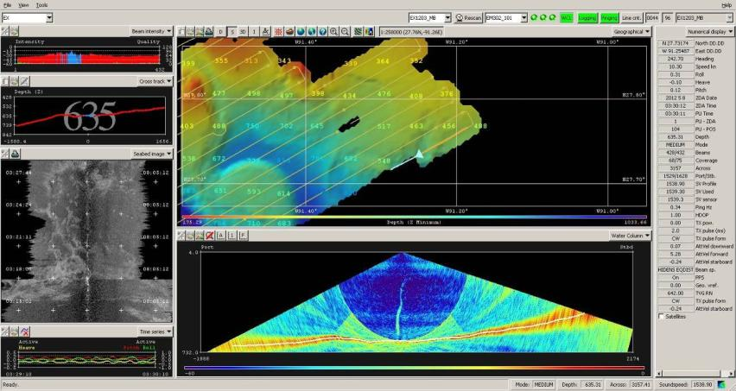

Figure 12: Screen grabs of SIS computer data acquisition showing two seeps observed in vicinity of Green Canyon.

EK 60 data were collected using Kongsberg GPT firm ware version 2.2.1 in the *.raw data file format.

The QPS Fledermaus MidWater software package (Ver. 7.3.0c Build 968) was used to process EM 302 water column backscatter and EK 60 data and view the resulting Fledermaus SD objects. The programs are the best method available to the mapping department for water column data processing.

The visualization of EK60 and EM302 data together showed a close agreement between all the seeps that were detected by EK60 were also picked up by EM 302. However, EM302 was able to pick up also the seeps which were off nadir. An example of visualization of water column data showing the bathymetry, EK 60 single beam water column backscatter curtain and volume object of EM 302 is below:

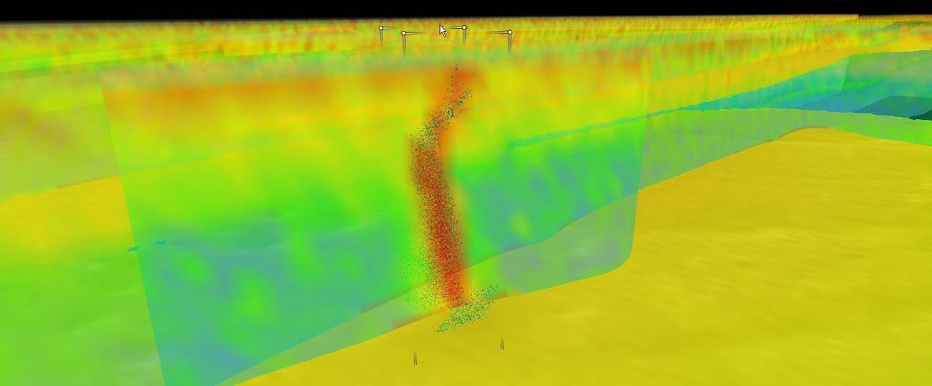

Figure 13: EK 60 water column curtain superimposed by the EM302 water column backscatter seep cloud (green points).

Sub-bottom profiler (SBP) data were collected using Knudsen Chirp 3260 v. 1.6.1. Data in SGY, and KEB file format were collected on most of the days between 0800-2000 local ship time using minimum power level to minimize SBP noise inside the ship’s living quarters. Available post processing software onboard, Sonar Wiz v. 4004.0034 was found to only work with SGY file format but was found not to take into account the scale changes resulting in images which were not corrected for the scale changes appropriately.

**EM 302 Trouble Shooting**

During inport before the current cruise the EM302 data acquisition computer (SIS) windows were updated to the latest version. This resulted in issues related to virtual memory on the SIS computer that resulted in SIS crashing several times in beginning of the cruise. The windows system was then back tracked to an earlier version which seems to resolve the SIS issues.

# Data Archival Procedures

All the data from the expedition has been submitted to NCDDC where the data are being prepared for onward submission to the archival centers. Following is the brief data pipeline excerpts from Data management plan, EX1203.

The multibeam survey data collected by bottom-looking and complementary sensors, data from the calibration instruments, and the products generated after the data are returned to and post-processed at shore will be archived at NGDC. These data will be accompanied with a collection level metadata record for NGDC as well as individual metadata records for each raw (level-0) file, each edited (level-1) file and each data product (level-2) and report (level-3) generated as a result. In addition, the submission to NGDC will include the following:

* raw (level-0) mapping survey and water column data files,
* CTD and/or XBT profile data used for calibration in multibeam survey,
* post-processed, quality assured, and edited (level-1) data files,
* specific data products (level-2) including cumulative GeoTIF images, gridded bathymetric files, KML files, Fledermaus output files, and an ArcGrid format, and
* comprehensive mapping survey data summary (level-3) report.

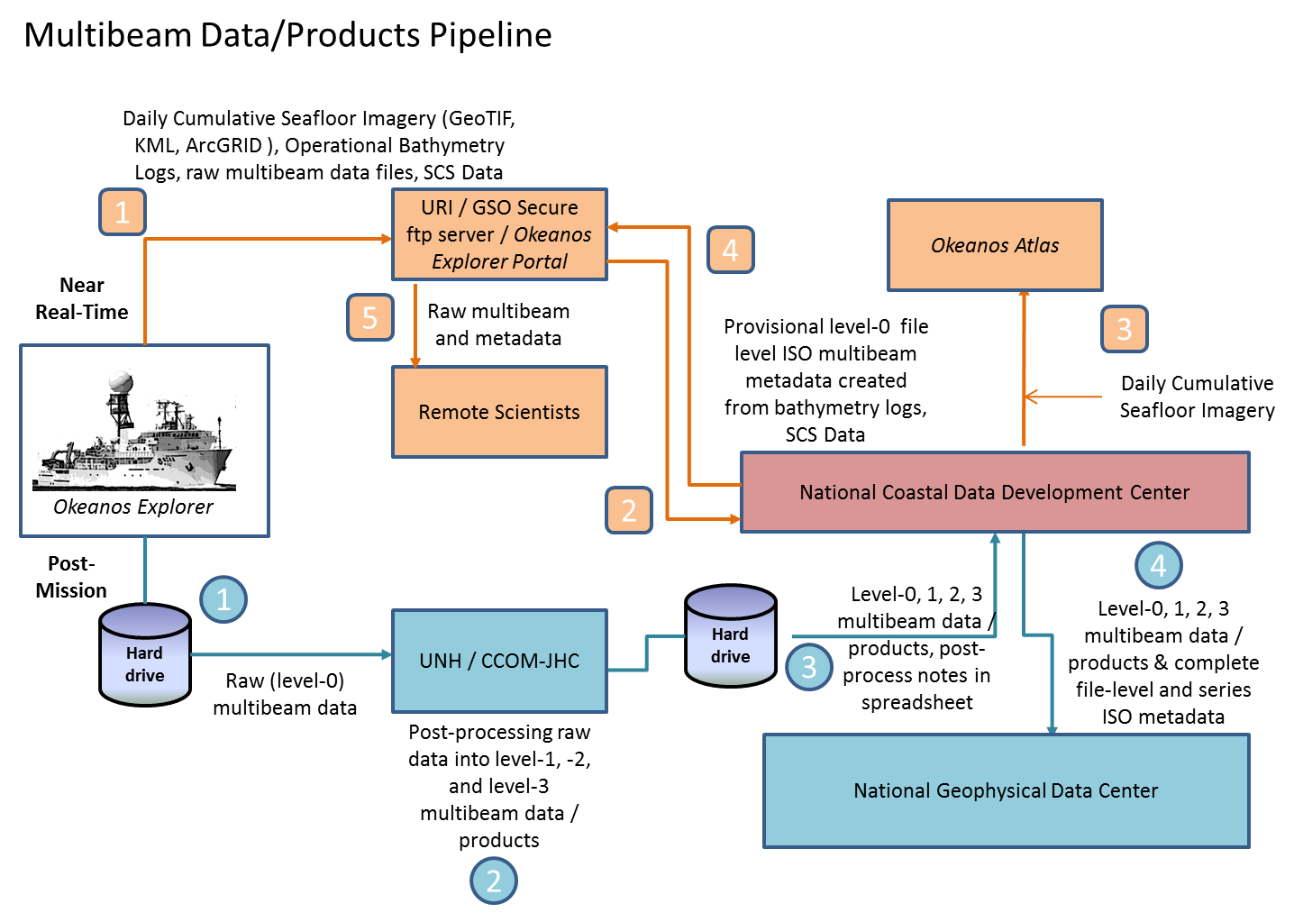

Figure 10: Multibeam Survey Data Archive Pipeline

**Near Real-Time**

1

The mapping survey team on the EX will include their operational processing spreadsheet in the folder that is targeted for synchronization to the SRS periodically throughout the day. As operational GeoTIFF images are created, these will also be saved to this folder.

2

The data management team at NCDDC pulls the GeoTIFF images, operational bathymetry processing spreadsheet and the SCS data streams for near real-time metadata generation and *Okeanos* Atlas update procedures.

3

Daily cumulative GeoTIFF images of the seafloor imagery are geo-located on the *Okeanos* Atlas by the GIS team at NCDDC.

4

Provisional metadata in an ISO format is generated for each raw (level-0) multibeam raw files using the SCS exported data, the operational processing spreadsheet and saved to the SRS.

5

Participating scientists wanting access to the raw multibeam in near real-time can pull the individual files with the metadata that provides operational and provisional processing steps and a disclaimer for non-QC status of the data.

**Post-Mission**

All bottom-looking sensor data and complementary data (water column and sound velocity) are saved to a hard-drive. This hard-drive will be either brought back or shipped to the University of New Hampshire Center for Coastal and Ocean Mapping (UNH CCOM) for post-processing.

A full complement of multibeam data from a 30-day EX cruise on which the Kongsberg EM302 multibeam system runs continuously will produce 200-300 Gigabytes of raw multibeam (37.5% of total volume) and water column data (62.5% of total volume). At UNH, the mapping team will post-process the multibeam data through the following steps:

* The raw (level-0) data will be saved to the IOCM/ CCOM file servers, where they will be quality checked and post-processed.
* The edited level-0 data is saved as level-1 data files in a non-proprietary format – ASCII xyz files (cleaned not gridded).
* The post-processing steps used to produce the level-1 data will be documented.
* Level-2 products will be generated from the level-1 data files.
* The post-processing steps used to produce the level-2 data products will be documented.
* The level-1 data, level-2 products, post-processing steps, and working data processing spreadsheets will be copied to the hard drive in a new folder. A processing spreadsheet for FY12 will contain the temporal and spatial limits of each file and any supplemental information documenting problems or issues that affected the quality of the data in that file.

The hard-drive will be shipped to the NCDDC within approximately 3 weeks from cruise end date.

At NCDDC, all multibeam related files will be post-processed through metadata generation procedures. Metadata will be generated for each individual survey track file (level-0 and -1), for accompanying CTD/XBT profile data sets, for composite xyz files, KMLs, GeoTIFs, png images, and Fledermaus output (level-2), and a set of data products and reports (level-3). The metadata will be added to the hard-drive and the hard-drive will be shipped to NGDC.

Following table provides details about multibeam survey metadata granularity and target archive dates:

|  |  |  |  |  |  |
| --- | --- | --- | --- | --- | --- |
| **Data Class** | **Instrument** | **Data Type** | **Format** | **Metadata Granularity** | **Archive Center** |
| **GEO** | Kongsberg EM302 (30 kHz) | Multibeam Bathymetry, Bottom Backscatter, Water Column Backscatter (proprietary format read into MBSystem) | .all, .wcd (proprietary) | 1 meta rec per .all file in Multibeam Data folder and subfolders | NGDC |
| **GEO** | Simrad EK60 | Singlebeam (time,depth) | .txt, (ASCII), .raw (proprietary) | Included in the SCS feed | TBD |
| **GEO** | Knudsen CHIRP 3260 (3.5 kHz) | Sub-bottom profile | .sgy, .kea, .keb (proprietary) | 1 meta rec = Subbottom Profile Data folder | NGDC |
| **OCN** | SeaBird SBE-911plus | CTD Cast | .hex, .con (Proprietary); .cnv, .hdr, .bl, .jpg (processed) | 1 meta rec = CTD folder | NGDC |
| **OCN** | Sippican MK-21 eXpendable BathyThermograph (XBT) | XBT | .edf (ASCII), .rdf (proprietary) | 1 meta rec = XBT folder | NGDC |
| **OCN** | RESON | Sound Velocity (m/s) | TBD | 1 meta rec = RESON folder | NGDC |
| **OCN** | Calculated | Sound Velocity (m/s) | .asvp (ASCII) | 1 meta rec = Profile_Data/SVP or Profile_Data/ASVP | NGDC |

# Cruise Calendar

|  |  |  |  |  |  |  |
| --- | --- | --- | --- | --- | --- | --- |
| Mon | Tue | Wed | Thu | Fri | Sat | Sun |
|  |  |  |  |  | 5 May  Depart Galveston. Conducted Fire and Emergency Drill / Abandon Ship Drill | 6 May  Arrive in Green canyon mapping area |
| 7 May  Continue operations in Green canyon survey area.  Oil Sheen observed - reported to NRC and USCG. | 8 May  Start transit towards Mississippi  Canyon (MC) mapping area | 9 May  Continue mapping in MC mapping area. Small boat operations to train deck personnel on FRB Davits | 10 May  Continue mapping in MC mapping area | 11 May  Continue mapping in MC mapping area.  Commence Transit to Western Florida Escarpment  (WFE). Conducted Fire and Emergency Drill / Abandon Ship Drill | 12 May  Continue transit to WFE mapping area adjacent to existing bathymetry | 13 May  Commence WFE mapping.  Commence. transit to Dry Tortugas diving site for ship’s divers proficiency dive. |
| 14 May  Weather too rough for small boat / diving operations. Dive cancelled. Commenced transit through Florida Strait. Diving operations near Key Largo conducted | 15 May  Commence transit to Coral Mounds (CM) mapping area 1 | 16 May  Commenced mapping in CM mapping area # 1 | 17 May  Continued mapping in CM mapping area #1.  Test CTD Cast. | 18 May  Commenced transit to CM mapping area # 2. Abandon Ship Drill, Fire & Emergency Drill and MOB Drill | 19 May  Tropical Storm ‘Alberto’ formed offshore Carolinas. Due to rough weather returned to CM mapping area # 1 | 20 May  ‘Alberto’ predicted to intensify – Pulled into MayPort, FL till ‘Alberto’ clears the area |
| 21 May  1000 Departed Mayport Naval Station, Mayport, FL | 22 May  Search pattern conducted at request of USCG after observing a flare later determined to be related to military exercises in the area.  Continue transit towards Norfolk, VA. | 23 May  Arrived Norfolk 1800 |  |  |  |  |

# References

Office of Ocean Exploration Draft Workshop Summary, NOAA Workshop on Systematic Telepresence-Enabled Exploration in the Atlantic Basin, May 10-11, 2011, Coastal Institute Building, University of Rhode Island, Narragansett, Rhode Island, , September 19, 201. Available online at: <ftp://dossier.ogp.noaa.gov/OER/Atlantic_Workshop_2011/Individual_Draft_Summary_Files/Atl_Basin_Workshop_2011_Summary_Draft%2020110919.docx>

Lobecker, E., Malik, M., Nadeau, M. and Skarke, A., Mapping Systems Readiness Report 2012, NOAA Ship *Okeanos Explorer*, March 2012.

Office of Ocean Exploration and Research, EX1203, Gulf of Mexico Exploration, Data Management Plan, April 2012.

Office of Ocean Exploration and Research, EX1203, Gulf of Mexico Exploration, Project instructions, April 2012.

# Appendices

## Appendix A: Tables of data files collected

**Table of Multibeam EM 302 files collected. File Name format:**

**Line Number _ Date_Time_CruiseID_MB.all**

Note: Issues with Java and repeated crashes of SIS caused issues with filenames and loss of water column data files.

|  |  |  |
| --- | --- | --- |
| Multibeam File | Water Column file | Comments |
| 0000_20120506_031921_EX.all | 0000_20120506_031921_EX.wcd | Galveston, TX to Green Canyon Mapping Grounds |
| 0001_20120506_051921_EX.all | 0001_20120506_051921_EX.wcd | Galveston, TX to Green Canyon Mapping Grounds |
| 0002_20120506_071921_EX.all | 0002_20120506_071921_EX.wcd | Galveston, TX to Green Canyon Mapping Grounds |
| 0003_20120506_073501_EX.all | 0003_20120506_073501_EX.wcd | Galveston, TX to Green Canyon Mapping Grounds |
| 0004_20120506_074034_EX.all | 0004_20120506_074034_EX.wcd | Galveston, TX to Green Canyon Mapping Grounds |
| 0005_20120506_074411_EX.all | 0005_20120506_074411_EX.wcd | Galveston, TX to Green Canyon Mapping Grounds |
| 0000_20120506_081712_EX1203_MB.all | 0000_20120506_081712_EX1203_MB.wcd | Galveston, TX to Green Canyon Mapping Grounds |
| 0001_20120506_085425_EX1203_MB.all | 0001_20120506_085425_EX1203_MB.wcd | Galveston, TX to Green Canyon Mapping Grounds |
| 0002_20120506_105426_EX1203_MB.all | 0002_20120506_105426_EX1203_MB.wcd | Green Canyon Mapping Grounds |
| 0003_20120506_125424_EX1203_MB.all | 0003_20120506_125424_EX1203_MB.wcd | Green Canyon Mapping Grounds |
| 0004_20120506_135322_EX1203_MB.all | 0004_20120506_135322_EX1203_MB.wcd | Green Canyon Mapping Grounds |
| 0005_20120506_140200_EX1203_MB.all | 0005_20120506_140200_EX1203_MB.wcd | Green Canyon Mapping Grounds |
| 0006_20120506_160201_EX1203_MB.all | N/A | Green Canyon Mapping Grounds |
| 0007_20120506_181405_EX1203_MB.all | N/A | Green Canyon Mapping Grounds |
| 0008_20120506_183039_EX1203_MB.all | 0008_20120506_183039_EX1203_MB.wcd | Green Canyon Mapping Grounds |
| 0009_20120506_203036_EX1203_MB.all | 0009_20120506_203036_EX1203_MB.wcd | Green Canyon Mapping Grounds |
| 0010_20120506_213733_EX1203_MB.all | 0010_20120506_213733_EX1203_MB.wcd | Green Canyon Mapping Grounds |
| 0011_20120506_214514_EX1203_MB.all | 0011_20120506_214514_EX1203_MB.wcd | Green Canyon Mapping Grounds |
| 0012_20120506_234514_EX1203_MB.all | 0012_20120506_234514_EX1203_MB.wcd | Green Canyon Mapping Grounds |
| 0013_20120507_000004_EX1203_MB.all | 0013_20120507_000004_EX1203_MB.wcd | Green Canyon Mapping Grounds |
| 0014_20120507_005913_EX1203_MB.all | 0014_20120507_005913_EX1203_MB.wcd | Green Canyon Mapping Grounds |
| 0015_20120507_010740_EX1203_MB.all | 0015_20120507_010740_EX1203_MB.wcd | Green Canyon Mapping Grounds |
| 0016_20120507_024945_EX1203_MB.all | 0016_20120507_024945_EX1203_MB.wcd | Green Canyon Mapping Grounds |
| 0017_20120507_025919_EX1203_MB.all | 0017_20120507_025919_EX1203_MB.wcd | Green Canyon Mapping Grounds |
| 0018_20120507_044748_EX1203_MB.all | 0018_20120507_044748_EX1203_MB.wcd | Green Canyon Mapping Grounds |
| 0019_20120507_045633_EX1203_MB.all | 0019_20120507_045633_EX1203_MB.wcd | Green Canyon Mapping Grounds |
| 0020_20120507_064955_EX1203_MB.all | 0020_20120507_064955_EX1203_MB.wcd | Green Canyon Mapping Grounds |
| 0021_20120507_070005_EX1203_MB.all | 0021_20120507_070005_EX1203_MB.wcd | Green Canyon Mapping Grounds |
| 0022_20120507_090005_EX1203_MB.all | 0022_20120507_090005_EX1203_MB.wcd | Green Canyon Mapping Grounds |
| 0023_20120507_090013_EX1203_MB.all | 0023_20120507_090013_EX1203_MB.wcd | Green Canyon Mapping Grounds |
| 0024_20120507_090934_EX1203_MB.all | 0024_20120507_090934_EX1203_MB.wcd | Green Canyon Mapping Grounds |
| 0025_20120507_110934_EX1203_MB.all | 0025_20120507_110934_EX1203_MB.wcd | Green Canyon Mapping Grounds |
| 0026_20120507_114855_EX1203_MB.all | 0026_20120507_114855_EX1203_MB.wcd | Green Canyon Mapping Grounds |
| 0027_20120507_115737_EX1203_MB.all | 0027_20120507_115737_EX1203_MB.wcd | Green Canyon Mapping Grounds |
| 0028_20120507_135737_EX1203_MB.all | 0028_20120507_135737_EX1203_MB.wcd | Green Canyon Mapping Grounds |
| 0029_20120507_144327_EX1203_MB.all | 0029_20120507_144327_EX1203_MB.wcd | Green Canyon Mapping Grounds |
| 0030_20120507_145404_EX1203_MB.all | 0030_20120507_145404_EX1203_MB.wcd | Green Canyon Mapping Grounds |
| 0031_20120507_165403_EX1203_MB.all | 0031_20120507_165403_EX1203_MB.wcd | Green Canyon Mapping Grounds |
| 0032_20120507_173942_EX1203_MB.all | 0032_20120507_173942_EX1203_MB.wcd | Green Canyon Mapping Grounds |
| 0033_20120507_183154_EX1203_MB.all | 0033_20120507_183154_EX1203_MB.wcd | Green Canyon Mapping Grounds |
| 0034_20120507_195645_EX1203_MB.all | 0034_20120507_195645_EX1203_MB.wcd | Green Canyon Mapping Grounds |
| 0035_20120507_200456_EX1203_MB.all | 0035_20120507_200456_EX1203_MB.wcd | Green Canyon Mapping Grounds |
| 0036_20120507_220455_EX1203_MB.all | 0036_20120507_220455_EX1203_MB.wcd | Green Canyon Mapping Grounds |
| 0037_20120507_221526_EX1203_MB.all | 0037_20120507_221526_EX1203_MB.wcd | Green Canyon Mapping Grounds |
| 0038_20120507_222350_EX1203_MB.all | 0038_20120507_222350_EX1203_MB.wcd | Green Canyon Mapping Grounds |
| 0039_20120508_000228_EX1203_MB.all | 0039_20120508_000228_EX1203_MB.wcd | Green Canyon Mapping Grounds |
| 0040_20120508_003423_EX1203_MB.all | 0040_20120508_003423_EX1203_MB.wcd | Green Canyon Mapping Grounds |
| 0041_20120508_004233_EX1203_MB.all | 0041_20120508_004233_EX1203_MB.wcd | Green Canyon Mapping Grounds |
| 0042_20120508_024230_EX1203_MB.all | 0042_20120508_024230_EX1203_MB.wcd | Green Canyon Mapping Grounds |
| 0043_20120508_025458_EX1203_MB.all | 0043_20120508_025458_EX1203_MB.wcd | Green Canyon Mapping Grounds |
| 0044_20120508_030513_EX1203_MB.all | 0044_20120508_030513_EX1203_MB.wcd | Green Canyon Mapping Grounds |
| 0045_20120508_050426_EX1203_MB.all | 0045_20120508_050426_EX1203_MB.wcd | Green Canyon Mapping Grounds |
| 0046_20120508_051617_EX1203_MB.all | 0046_20120508_051617_EX1203_MB.wcd | Green Canyon Mapping Grounds |
| 0047_20120508_070941_EX1203_MB.all | 0047_20120508_070941_EX1203_MB.wcd | Green Canyon Mapping Grounds |
| 0048_20120508_071805_EX1203_MB.all | 0048_20120508_071805_EX1203_MB.wcd | Green Canyon Mapping Grounds |
| 0049_20120508_085149_EX1203_MB.all | 0049_20120508_085149_EX1203_MB.wcd | Green Canyon Mapping Grounds |
| 0050_20120508_090059_EX1203_MB.all | 0050_20120508_090059_EX1203_MB.wcd | Green Canyon Mapping Grounds |
| 0051_20120508_090115_EX1203_MB.all | 0051_20120508_090115_EX1203_MB.wcd | Green Canyon Mapping Grounds |
| 0052_20120508_102742_EX1203_MB.all | 0052_20120508_102742_EX1203_MB.wcd | Green Canyon Mapping Grounds |
| 0053_20120508_103733_EX1203_MB.all | 0053_20120508_103733_EX1203_MB.wcd | Green Canyon Mapping Grounds |
| 0054_20120508_111410_EX1203_MB.all | 0054_20120508_111410_EX1203_MB.wcd | Green Canyon Mapping Grounds |
| 0055_20120508_112335_EX1203_MB.all | 0055_20120508_112335_EX1203_MB.wcd | Green Canyon Mapping Grounds |
| 0055_20120508_124327_EX1203_MB.all | 0055_20120508_124327_EX1203_MB.wcd | Green Canyon Mapping Grounds |
| 0056_20120508_131638_EX1203_MB.all | 0056_20120508_131638_EX1203_MB.wcd | Green Canyon Mapping Grounds |
| 0057_20120508_133050_EX1203_MB.all | 0057_20120508_133050_EX1203_MB.wcd | Green Canyon Mapping Grounds |
| 0058_20120508_142727_EX1203_MB.all | 0058_20120508_142727_EX1203_MB.wcd | Green Canyon Mapping Grounds |
| 0059_20120508_144335_EX1203_MB.all | 0059_20120508_144335_EX1203_MB.wcd | Green Canyon Mapping Grounds |
| 0060_20120508_145721_EX1203_MB.all | 0060_20120508_145721_EX1203_MB.wcd | Green Canyon Mapping Grounds |
| 0061_20120508_152626_EX1203_MB.all | 0061_20120508_152626_EX1203_MB.wcd | Green Canyon Mapping Grounds |
| 0062_20120508_172626_EX1203_MB.all | 0062_20120508_172626_EX1203_MB.wcd | Green Canyon Mapping Grounds |
| 0063_20120508_173302_EX1203_MB.all | 0063_20120508_173302_EX1203_MB.wcd | Green Canyon Mapping Grounds |
| 0064_20120508_174405_EX1203_MB.all | 0064_20120508_174405_EX1203_MB.wcd | Green Canyon Mapping Grounds |
| 0065_20120508_192651_EX1203_MB.all | 0065_20120508_192651_EX1203_MB.wcd | Green Canyon Mapping Grounds |
| 0066_20120508_193421_EX1203_MB.all | 0066_20120508_193421_EX1203_MB.wcd | Green Canyon Mapping Grounds |
| 0067_20120508_195228_EX1203_MB.all | 0067_20120508_195228_EX1203_MB.wcd | Green Canyon Mapping Grounds |
| 0068_20120508_212026_EX1203_MB.all | 0068_20120508_212026_EX1203_MB.wcd | Green Canyon Mapping Grounds |
| 0069_20120508_232026_EX1203_MB.all | 0069_20120508_232026_EX1203_MB.wcd | Green Canyon Mapping Grounds to Mississippi Canyon Mapping Grounds |
| 0070_20120509_000001_EX1203_MB.all | 0070_20120509_000001_EX1203_MB.wcd | Green Canyon Mapping Grounds to Mississippi Canyon Mapping Grounds |
| 0071_20120509_020001_EX1203_MB.all | 0071_20120509_020001_EX1203_MB.wcd | Green Canyon Mapping Grounds to Mississippi Canyon Mapping Grounds |
| 0072_20120509_040001_EX1203_MB.all | 0072_20120509_040001_EX1203_MB.wcd | Green Canyon Mapping Grounds to Mississippi Canyon Mapping Grounds |
| 0073_20120509_053603_EX1203_MB.all | 0073_20120509_053603_EX1203_MB.wcd | Mississippi Canyon Mapping Grounds |
| 0074_20120509_073603_EX1203_MB.all | 0074_20120509_073603_EX1203_MB.wcd | Mississippi Canyon Mapping Grounds |
| 0075_20120509_091327_EX1203_MB.all | 0075_20120509_091327_EX1203_MB.wcd | Mississippi Canyon Mapping Grounds |
| 0076_20120509_092048_EX1203_MB.all | 0076_20120509_092048_EX1203_MB.wcd | Mississippi Canyon Mapping Grounds |
| 0077_20120509_112048_EX1203_MB.all | 0077_20120509_112048_EX1203_MB.wcd | Mississippi Canyon Mapping Grounds |
| 0078_20120509_125945_EX1203_MB.all | 0078_20120509_125945_EX1203_MB.wcd | Mississippi Canyon Mapping Grounds |
| 0079_20120509_130817_EX1203_MB.all | 0079_20120509_130817_EX1203_MB.wcd | Mississippi Canyon Mapping Grounds |
| 0080_20120509_150819_EX1203_MB.all | 0080_20120509_150819_EX1203_MB.wcd | Mississippi Canyon Mapping Grounds |
| 0081_20120509_164237_EX1203_MB.all | 0081_20120509_164237_EX1203_MB.wcd | Mississippi Canyon Mapping Grounds |
| 0082_20120509_164844_EX1203_MB.all | 0082_20120509_164844_EX1203_MB.wcd | Mississippi Canyon Mapping Grounds |
| 0083_20120509_184844_EX1203_MB.all | 0083_20120509_184844_EX1203_MB.wcd | Mississippi Canyon Mapping Grounds |
| 0084_20120509_203147_EX1203_MB.all | 0084_20120509_203147_EX1203_MB.wcd | Mississippi Canyon Mapping Grounds |
| 0085_20120509_204441_EX1203_MB.all | 0085_20120509_204441_EX1203_MB.wcd | Mississippi Canyon Mapping Grounds |
| 0086_20120509_224444_EX1203_MB.all | 0086_20120509_224444_EX1203_MB.wcd | Mississippi Canyon Mapping Grounds |
| 0087_20120510_000201_EX1203_MB.all | 0087_20120510_000201_EX1203_MB.wcd | Mississippi Canyon Mapping Grounds |
| 0088_20120510_002150_EX1203_MB.all | 0088_20120510_002150_EX1203_MB.wcd | Mississippi Canyon Mapping Grounds |
| 0089_20120510_003400_EX1203_MB.all | 0089_20120510_003400_EX1203_MB.wcd | Mississippi Canyon Mapping Grounds |
| 0090_20120510_023359_EX1203_MB.all | 0090_20120510_023359_EX1203_MB.wcd | Mississippi Canyon Mapping Grounds |
| 0091_20120510_041119_EX1203_MB.all | 0091_20120510_041119_EX1203_MB.wcd | Mississippi Canyon Mapping Grounds |
| 0092_20120510_042803_EX1203_MB.all | 0092_20120510_042803_EX1203_MB.wcd | Mississippi Canyon Mapping Grounds |
| 0093_20120510_062803_EX1203_MB.all | 0093_20120510_062803_EX1203_MB.wcd | Mississippi Canyon Mapping Grounds |
| 0094_20120510_080945_EX1203_MB.all | 0094_20120510_080945_EX1203_MB.wcd | Mississippi Canyon Mapping Grounds |
| 0095_20120510_082150_EX1203_MB.all | 0095_20120510_082150_EX1203_MB.wcd | Mississippi Canyon Mapping Grounds |
| 0096_20120510_102153_EX1203_MB.all | N/A | Mississippi Canyon Mapping Grounds |
| 0097_20120510_115520_EX1203_MB.all | N/A | Mississippi Canyon Mapping Grounds |
| 0098_20120510_120905_EX1203_MB.all | 0098_20120510_120905_EX1203_MB.wcd | Mississippi Canyon Mapping Grounds |
| 0099_20120510_140903_EX1203_MB.all | 0099_20120510_140903_EX1203_MB.wcd | Mississippi Canyon Mapping Grounds |
| 0100_20120510_155730_EX1203_MB.all | 0100_20120510_155730_EX1203_MB.wcd | Mississippi Canyon Mapping Grounds |
| 0101_20120510_161055_EX1203_MB.all | 0101_20120510_161055_EX1203_MB.wcd | Mississippi Canyon Mapping Grounds |
| 0102_20120510_181056_EX1203_MB.all | 0102_20120510_181056_EX1203_MB.wcd | Mississippi Canyon Mapping Grounds |
| 0103_20120510_200917_EX1203_MB.all | 0103_20120510_200917_EX1203_MB.wcd | Mississippi Canyon Mapping Grounds |
| 0104_20120510_202234_EX1203_MB.all | 0104_20120510_202234_EX1203_MB.wcd | Mississippi Canyon Mapping Grounds |
| 0105_20120510_222234_EX1203_MB.all | 0105_20120510_222234_EX1203_MB.wcd | Mississippi Canyon Mapping Grounds |
| 0106_20120510_234813_EX1203_MB.all | 0106_20120510_234813_EX1203_MB.wcd | Mississippi Canyon Mapping Grounds |
| 0107_20120511_000004_EX1203_MB.all | 0107_20120511_000004_EX1203_MB.wcd | Mississippi Canyon Mapping Grounds |
| 0108_20120511_020004_EX1203_MB.all | 0108_20120511_020004_EX1203_MB.wcd | Mississippi Canyon Mapping Grounds |
| 0109_20120511_022253_EX1203_MB.all | 0109_20120511_022253_EX1203_MB.wcd | Mississippi Canyon Mapping Grounds |
| 0110_20120511_024641_EX1203_MB.all | 0110_20120511_024641_EX1203_MB.wcd | Mississippi Canyon Mapping Grounds |
| 0111_20120511_041055_EX1203_MB.all | 0111_20120511_041055_EX1203_MB.wcd | Mississippi Canyon Mapping Grounds |
| 0112_20120511_042330_EX1203_MB.all | 0112_20120511_042330_EX1203_MB.wcd | Mississippi Canyon Mapping Grounds |
| 0113_20120511_052938_EX1203_MB.all | 0113_20120511_052938_EX1203_MB.wcd | Mississippi Canyon Mapping Grounds |
| 0114_20120511_054209_EX1203_MB.all | 0114_20120511_054209_EX1203_MB.wcd | Mississippi Canyon Mapping Grounds |
| 0115_20120511_065123_EX1203_MB.all | 0115_20120511_065123_EX1203_MB.wcd | Mississippi Canyon Mapping Grounds |
| 0116_20120511_072544_EX1203_MB.all | 0116_20120511_072544_EX1203_MB.wcd | Mississippi Canyon Mapping Grounds |
| 0117_20120511_092211_EX1203_MB.all | 0117_20120511_092211_EX1203_MB.wcd | Mississippi Canyon Mapping Grounds |
| 0118_20120511_095017_EX1203_MB.all | 0118_20120511_095017_EX1203_MB.wcd | Mississippi Canyon Mapping Grounds |
| 0119_20120511_113116_EX1203_MB.all | 0119_20120511_113116_EX1203_MB.wcd | Mississippi Canyon Mapping Grounds |
| 0120_20120511_130450_EX1203_MB.all | 0120_20120511_130450_EX1203_MB.wcd | Mississippi Canyon Mapping Grounds to Florida Escarpment (Area B) |
| 0121_20120511_150456_EX1203_MB.all | 0121_20120511_150456_EX1203_MB.wcd | Mississippi Canyon Mapping Grounds to Florida Escarpment (Area B) |
| 0122_20120511_170450_EX1203_MB.all | 0122_20120511_170450_EX1203_MB.wcd | Mississippi Canyon Mapping Grounds to Florida Escarpment (Area B) |
| 0123_20120511_190451_EX1203_MB.all | 0123_20120511_190451_EX1203_MB.wcd | Mississippi Canyon Mapping Grounds to Florida Escarpment (Area B) |
| 0124_20120511_210449_EX1203_MB.all | 0124_20120511_210449_EX1203_MB.wcd | Mississippi Canyon Mapping Grounds to Florida Escarpment (Area B) |
| 0125_20120511_230458_EX1203_MB.all | 0125_20120511_230458_EX1203_MB.wcd | Mississippi Canyon Mapping Grounds to Florida Escarpment (Area B) |
| 0126_20120511_233107_EX1203_MB.all | 0126_20120511_233107_EX1203_MB.wcd | Mississippi Canyon Mapping Grounds to Florida Escarpment (Area B) |
| 0127_20120511_233548_EX1203_MB.all | 0127_20120511_233548_EX1203_MB.wcd | Mississippi Canyon Mapping Grounds to Florida Escarpment (Area B) |
| 0128_20120512_000005_EX1203_MB.all | 0128_20120512_000005_EX1203_MB.wcd | Mississippi Canyon Mapping Grounds to Florida Escarpment (Area B) |
| 0129_20120512_020005_EX1203_MB.all | 0129_20120512_020005_EX1203_MB.wcd | Mississippi Canyon Mapping Grounds to Florida Escarpment (Area B) |
| 0130_20120512_033526_EX1203_MB.all | 0130_20120512_033526_EX1203_MB.wcd | Mississippi Canyon Mapping Grounds to Florida Escarpment (Area B) |
| 0131_20120512_033838_EX1203_MB.all | 0131_20120512_033838_EX1203_MB.wcd | Mississippi Canyon Mapping Grounds to Florida Escarpment (Area B) |
| 0132_20120512_043032_EX1203_MB.all | 0132_20120512_043032_EX1203_MB.wcd | Mississippi Canyon Mapping Grounds to Florida Escarpment (Area B) |
| 0133_20120512_043508_EX1203_MB.all | 0133_20120512_043508_EX1203_MB.wcd | Mississippi Canyon Mapping Grounds to Florida Escarpment (Area B) |
| 0134_20120512_063500_EX1203_MB.all | 0134_20120512_063500_EX1203_MB.wcd | Mississippi Canyon Mapping Grounds to Florida Escarpment (Area B) |
| 0135_20120512_071053_EX1203_MB.all | 0135_20120512_071053_EX1203_MB.wcd | Mississippi Canyon Mapping Grounds to Florida Escarpment (Area B) |
| 0136_20120512_081434_EX1203_MB.all | 0136_20120512_081434_EX1203_MB.wcd | Mississippi Canyon Mapping Grounds to Florida Escarpment (Area B) |
| 0137_20120512_081828_EX1203_MB.all | 0137_20120512_081828_EX1203_MB.wcd | Mississippi Canyon Mapping Grounds to Florida Escarpment (Area B) |
| 0138_20120512_101829_EX1203_MB.all | 0138_20120512_101829_EX1203_MB.wcd | Mississippi Canyon Mapping Grounds to Florida Escarpment (Area B) |
| 0139_20120512_121830_EX1203_MB.all | 0139_20120512_121830_EX1203_MB.wcd | Mississippi Canyon Mapping Grounds to Florida Escarpment (Area B) |
| 0142_20120512_135923_EX1203_MB.all | 0142_20120512_135923_EX1203_MB.wcd | Mississippi Canyon Mapping Grounds to Florida Escarpment (Area B) |
| 0143_20120512_155919_EX1203_MB.all | 0143_20120512_155919_EX1203_MB.wcd | Mississippi Canyon Mapping Grounds to Florida Escarpment (Area B) |
| 0144_20120512_175918_EX1203_MB.all | 0144_20120512_175918_EX1203_MB.wcd | Mississippi Canyon Mapping Grounds to Florida Escarpment (Area B) |
| 0145_20120512_195917_EX1203_MB.all | 0145_20120512_195917_EX1203_MB.wcd | Mississippi Canyon Mapping Grounds to Florida Escarpment (Area B) |
| 0146_20120512_215918_EX1203_MB.all | 0146_20120512_215918_EX1203_MB.wcd | Florida Escarpment (Area B) |
| 0147_20120512_235501_EX1203_MB.all | 0147_20120512_235501_EX1203_MB.wcd | Florida Escarpment (Area B) |
| 0148_20120513_000001_EX1203_MB.all | 0148_20120513_000001_EX1203_MB.wcd | Florida Escarpment (Area B) |
| 0149_20120513_003807_EX1203_MB.all | 0149_20120513_003807_EX1203_MB.wcd | Florida Escarpment (Area B) |
| 0150_20120513_005027_EX1203_MB.all | 0150_20120513_005027_EX1203_MB.wcd | Florida Escarpment (Area B) |
| 0151_20120513_015621_EX1203_MB.all | 0151_20120513_015621_EX1203_MB.wcd | Florida Escarpment (Area B) |
| 0152_20120513_015930_EX1203_MB.all | 0152_20120513_015930_EX1203_MB.wcd | Florida Escarpment (Area B) |
| 0153_20120513_035932_EX1203_MB.all | 0153_20120513_035932_EX1203_MB.wcd | Florida Escarpment (Area B) |
| 0154_20120513_040124_EX1203_MB.all | 0154_20120513_040124_EX1203_MB.wcd | Florida Escarpment (Area B) |
| 0155_20120513_041057_EX1203_MB.all | 0155_20120513_041057_EX1203_MB.wcd | Florida Escarpment (Area B) |
| 0156_20120513_060812_EX1203_MB.all | 0156_20120513_060812_EX1203_MB.wcd | Florida Escarpment (Area B) |
| 0157_20120513_061923_EX1203_MB.all | 0157_20120513_061923_EX1203_MB.wcd | Florida Escarpment (Area B) |
| 0158_20120513_081924_EX1203_MB.all | 0158_20120513_081924_EX1203_MB.wcd | Florida Escarpment (Area B) |
| 0159_20120513_083302_EX1203_MB.all | 0159_20120513_083302_EX1203_MB.wcd | Florida Escarpment (Area B) to Coral Mounds Mapping Grounds |
| 0160_20120513_095535_EX1203_MB.all | 0160_20120513_095535_EX1203_MB.wcd | Florida Escarpment (Area B) to Coral Mounds Mapping Grounds |
| 0161_20120513_115534_EX1203_MB.all | 0161_20120513_115534_EX1203_MB.wcd | Florida Escarpment (Area B) to Coral Mounds Mapping Grounds |
| 0162_20120513_135534_EX1203_MB.all | 0162_20120513_135534_EX1203_MB.wcd | Florida Escarpment (Area B) to Coral Mounds Mapping Grounds |
| 0163_20120513_155533_EX1203_MB.all | 0163_20120513_155533_EX1203_MB.wcd | Florida Escarpment (Area B) to Coral Mounds Mapping Grounds |
| 0164_20120513_175400_EX1203_MB.all | 0164_20120513_175400_EX1203_MB.wcd | Florida Escarpment (Area B) to Coral Mounds Mapping Grounds |
| 0165_20120513_195402_EX1203_MB.all | 0165_20120513_195402_EX1203_MB.wcd | Florida Escarpment (Area B) to Coral Mounds Mapping Grounds |
| 0166_20120513_204654_EX1203_MB.all | 0166_20120513_204654_EX1203_MB.wcd | Florida Escarpment (Area B) to Coral Mounds Mapping Grounds |
| 0167_20120513_224653_EX1203_MB.all | 0167_20120513_224653_EX1203_MB.wcd | Florida Escarpment (Area B) to Coral Mounds Mapping Grounds |
| 0168_20120513_232415_EX1203_MB.all | 0168_20120513_232415_EX1203_MB.wcd | Florida Escarpment (Area B) to Coral Mounds Mapping Grounds |
| 0169_20120514_000003_EX1203_MB.all | 0169_20120514_000003_EX1203_MB.wcd | Florida Escarpment (Area B) to Coral Mounds Mapping Grounds |
| 0170_20120514_020002_EX1203_MB.all | 0170_20120514_020002_EX1203_MB.wcd | Florida Escarpment (Area B) to Coral Mounds Mapping Grounds |
| 0171_20120514_040002_EX1203_MB.all | 0171_20120514_040002_EX1203_MB.wcd | Florida Escarpment (Area B) to Coral Mounds Mapping Grounds |
| 0172_20120514_045819_EX1203_MB.all | 0172_20120514_045819_EX1203_MB.wcd | Florida Escarpment (Area B) to Coral Mounds Mapping Grounds |
| 0173_20120514_065817_EX1203_MB.all | 0173_20120514_065817_EX1203_MB.wcd | Florida Escarpment (Area B) to Coral Mounds Mapping Grounds |
| 0174_20120514_085818_EX1203_MB.all | 0174_20120514_085818_EX1203_MB.wcd | Florida Escarpment (Area B) to Coral Mounds Mapping Grounds |
| 0175_20120514_105818_EX1203_MB.all | 0175_20120514_105818_EX1203_MB.wcd | Florida Escarpment (Area B) to Coral Mounds Mapping Grounds |
| 0176_20120514_125818_EX1203_MB.all | 0176_20120514_125818_EX1203_MB.wcd | Florida Escarpment (Area B) to Coral Mounds Mapping Grounds |
| 0177_20120514_145819_EX1203_MB.all | 0177_20120514_145819_EX1203_MB.wcd | Florida Escarpment (Area B) to Coral Mounds Mapping Grounds |
| 0178_20120514_151749_EX1203_MB.all | 0178_20120514_151749_EX1203_MB.wcd | Florida Escarpment (Area B) to Coral Mounds Mapping Grounds |
| 0179_20120514_224136_EX1203_MB.all | 0179_20120514_224136_EX1203_MB.wcd | Florida Escarpment (Area B) to Coral Mounds Mapping Grounds |
| 0180_20120515_000001_EX1203_MB.all | 0180_20120515_000001_EX1203_MB.wcd | Florida Escarpment (Area B) to Coral Mounds Mapping Grounds |
| 0181_20120515_020002_EX1203_MB.all | 0181_20120515_020002_EX1203_MB.wcd | Florida Escarpment (Area B) to Coral Mounds Mapping Grounds |
| 0182_20120515_040001_EX1203_MB.all | 0182_20120515_040001_EX1203_MB.wcd | Florida Escarpment (Area B) to Coral Mounds Mapping Grounds |
| 0183_20120515_060002_EX1203_MB.all | 0183_20120515_060002_EX1203_MB.wcd | Florida Escarpment (Area B) to Coral Mounds Mapping Grounds |
| 0184_20120515_080000_EX1203_MB.all | 0184_20120515_080000_EX1203_MB.wcd | Florida Escarpment (Area B) to Coral Mounds Mapping Grounds |
| 0185_20120515_100000_EX1203_MB.all | 0185_20120515_100000_EX1203_MB.wcd | Florida Escarpment (Area B) to Coral Mounds Mapping Grounds |
| 0186_20120515_105430_EX1203_MB.all | 0186_20120515_105430_EX1203_MB.wcd | Florida Escarpment (Area B) to Coral Mounds Mapping Grounds |
| 0187_20120515_125429_EX1203_MB.all | 0187_20120515_125429_EX1203_MB.wcd | Florida Escarpment (Area B) to Coral Mounds Mapping Grounds |
| 0188_20120515_145430_EX1203_MB.all | 0188_20120515_145430_EX1203_MB.wcd | Florida Escarpment (Area B) to Coral Mounds Mapping Grounds |
| 0189_20120515_165429_EX1203_MB.all | 0189_20120515_165429_EX1203_MB.wcd | Florida Escarpment (Area B) to Coral Mounds Mapping Grounds |
| 0191_20120515_192450_EX1203_MB.all | 0191_20120515_192450_EX1203_MB.wcd | Florida Escarpment (Area B) to Coral Mounds Mapping Grounds |
| 0192_20120515_204342_EX1203_MB.all | 0192_20120515_204342_EX1203_MB.wcd | Florida Escarpment (Area B) to Coral Mounds Mapping Grounds |
| 0193_20120515_224344_EX1203_MB.all | 0193_20120515_224344_EX1203_MB.wcd | Florida Escarpment (Area B) to Coral Mounds Mapping Grounds |
| 0194_20120516_000045_EX1203_MB.all | 0194_20120516_000045_EX1203_MB.wcd | Florida Escarpment (Area B) to Coral Mounds Mapping Grounds |
| 0195_20120516_020044_EX1203_MB.all | 0195_20120516_020044_EX1203_MB.wcd | Coral Mounds Mapping Grounds |
| 0196_20120516_040045_EX1203_MB.all | 0196_20120516_040045_EX1203_MB.wcd | Coral Mounds Mapping Grounds |
| 0197_20120516_042756_EX1203_MB.all | 0197_20120516_042756_EX1203_MB.wcd | Coral Mounds Mapping Grounds |
| 0198_20120516_043326_EX1203_MB.all | 0198_20120516_043326_EX1203_MB.wcd | Coral Mounds Mapping Grounds |
| 0199_20120516_054535_EX1203_MB.all | 0199_20120516_054535_EX1203_MB.wcd | Coral Mounds Mapping Grounds |
| 0200_20120516_055935_EX1203_MB.all | 0200_20120516_055935_EX1203_MB.wcd | Coral Mounds Mapping Grounds |
| 0201_20120516_072144_EX1203_MB.all | 0201_20120516_072144_EX1203_MB.wcd | Coral Mounds Mapping Grounds |
| 0202_20120516_073524_EX1203_MB.all | 0202_20120516_073524_EX1203_MB.wcd | Coral Mounds Mapping Grounds |
| 0203_20120516_084411_EX1203_MB.all | 0203_20120516_084411_EX1203_MB.wcd | Coral Mounds Mapping Grounds |
| 0204_20120516_085835_EX1203_MB.all | 0204_20120516_085835_EX1203_MB.wcd | Coral Mounds Mapping Grounds |
| 0205_20120516_102210_EX1203_MB.all | 0205_20120516_102210_EX1203_MB.wcd | Coral Mounds Mapping Grounds |
| 0206_20120516_103601_EX1203_MB.all | 0206_20120516_103601_EX1203_MB.wcd | Coral Mounds Mapping Grounds |
| 0207_20120516_114320_EX1203_MB.all | 0207_20120516_114320_EX1203_MB.wcd | Coral Mounds Mapping Grounds |
| 0208_20120516_115334_EX1203_MB.all | 0208_20120516_115334_EX1203_MB.wcd | Coral Mounds Mapping Grounds |
| 0209_20120516_131312_EX1203_MB.all | 0209_20120516_131312_EX1203_MB.wcd | Coral Mounds Mapping Grounds |
| 0210_20120516_133000_EX1203_MB.all | 0210_20120516_133000_EX1203_MB.wcd | Coral Mounds Mapping Grounds |
| 0211_20120516_143942_EX1203_MB.all | 0211_20120516_143942_EX1203_MB.wcd | Coral Mounds Mapping Grounds |
| 0212_20120516_145058_EX1203_MB.all | 0212_20120516_145058_EX1203_MB.wcd | Coral Mounds Mapping Grounds |
| 0213_20120516_160816_EX1203_MB.all | 0213_20120516_160816_EX1203_MB.wcd | Coral Mounds Mapping Grounds |
| 0214_20120516_162143_EX1203_MB.all | 0214_20120516_162143_EX1203_MB.wcd | Coral Mounds Mapping Grounds |
| 0215_20120516_180557_EX1203_MB.all | 0215_20120516_180557_EX1203_MB.wcd | Coral Mounds Mapping Grounds |
| 0216_20120516_200558_EX1203_MB.all | 0216_20120516_200558_EX1203_MB.wcd | Coral Mounds Mapping Grounds |
| 0217_20120516_203555_EX1203_MB.all | 0217_20120516_203555_EX1203_MB.wcd | Coral Mounds Mapping Grounds |
| 0218_20120516_205019_EX1203_MB.all | 0218_20120516_205019_EX1203_MB.wcd | Coral Mounds Mapping Grounds |
| 0219_20120516_225020_EX1203_MB.all | 0219_20120516_225020_EX1203_MB.wcd | Coral Mounds Mapping Grounds |
| 0000_20120516_225320_EX1203_MB.all | 0000_20120516_225320_EX1203_MB.wcd | Coral Mounds Mapping Grounds |
| 0219_20120516_230323_EX1203_MB.all | 0219_20120516_230323_EX1203_MB.wcd | Coral Mounds Mapping Grounds |
| 0220_20120516_234530_EX1203_MB.all | 0220_20120516_234530_EX1203_MB.wcd | Coral Mounds Mapping Grounds |
| 0221_20120517_000003_EX1203_MB.all | 0221_20120517_000003_EX1203_MB.wcd | Coral Mounds Mapping Grounds |
| 0222_20120517_020003_EX1203_MB.all | 0222_20120517_020003_EX1203_MB.wcd | Coral Mounds Mapping Grounds |
| 0223_20120517_040001_EX1203_MB.all | 0223_20120517_040001_EX1203_MB.wcd | Coral Mounds Mapping Grounds |
| 0224_20120517_042716_EX1203_MB.all | 0224_20120517_042716_EX1203_MB.wcd | Coral Mounds Mapping Grounds |
| 0225_20120517_044630_EX1203_MB.all | 0225_20120517_044630_EX1203_MB.wcd | Coral Mounds Mapping Grounds |
| 0226_20120517_064632_EX1203_MB.all | 0226_20120517_064632_EX1203_MB.wcd | Coral Mounds Mapping Grounds |
| 0227_20120517_084632_EX1203_MB.all | 0227_20120517_084632_EX1203_MB.wcd | Coral Mounds Mapping Grounds |
| 0228_20120517_090334_EX1203_MB.all | 0228_20120517_090334_EX1203_MB.wcd | Coral Mounds Mapping Grounds |
| 0229_20120517_091233_EX1203_MB.all | 0229_20120517_091233_EX1203_MB.wcd | Coral Mounds Mapping Grounds |
| 0230_20120517_111234_EX1203_MB.all | 0230_20120517_111234_EX1203_MB.wcd | Coral Mounds Mapping Grounds |
| 0231_20120517_124823_EX1203_MB.all | 0231_20120517_124823_EX1203_MB.wcd | Coral Mounds Mapping Grounds |
| 0232_20120517_130352_EX1203_MB.all | 0232_20120517_130352_EX1203_MB.wcd | Coral Mounds Mapping Grounds |
| 0233_20120517_150353_EX1203_MB.all | 0233_20120517_150353_EX1203_MB.wcd | Coral Mounds Mapping Grounds |
| 0234_20120517_162748_EX1203_MB.all | 0234_20120517_162748_EX1203_MB.wcd | Coral Mounds Mapping Grounds |
| 0235_20120517_163655_EX1203_MB.all | 0235_20120517_163655_EX1203_MB.wcd | Coral Mounds Mapping Grounds |
| 0236_20120517_192555_EX1203_MB.all | 0236_20120517_192555_EX1203_MB.wcd | Coral Mounds Mapping Grounds |
| 0237_20120517_200945_EX1203_MB.all | 0237_20120517_200945_EX1203_MB.wcd | Coral Mounds Mapping Grounds |
| 0238_20120517_211927_EX1203_MB.all | 0238_20120517_211927_EX1203_MB.wcd | Coral Mounds Mapping Grounds |
| 0239_20120517_213100_EX1203_MB.all | 0239_20120517_213100_EX1203_MB.wcd | Coral Mounds Mapping Grounds |
| 0240_20120517_233059_EX1203_MB.all | 0240_20120517_233059_EX1203_MB.wcd | Coral Mounds Mapping Grounds |
| 0241_20120518_000003_EX1203_MB.all | 0241_20120518_000003_EX1203_MB.wcd | Coral Mounds Mapping Grounds |
| 0242_20120518_002142_EX1203_MB.all | 0242_20120518_002142_EX1203_MB.wcd | Coral Mounds Mapping Grounds |
| 0243_20120518_003331_EX1203_MB.all | 0243_20120518_003331_EX1203_MB.wcd | Coral Mounds Mapping Grounds |
| 0244_20120518_023332_EX1203_MB.all | 0244_20120518_023332_EX1203_MB.wcd | Coral Mounds Mapping Grounds |
| 0245_20120518_023423_EX1203_MB.all | 0245_20120518_023423_EX1203_MB.wcd | Coral Mounds Mapping Grounds |
| 0246_20120518_024200_EX1203_MB.all | 0246_20120518_024200_EX1203_MB.wcd | Coral Mounds Mapping Grounds |
| 0247_20120518_044202_EX1203_MB.all | 0247_20120518_044202_EX1203_MB.wcd | Coral Mounds Mapping Grounds |
| 0248_20120518_053942_EX1203_MB.all | 0248_20120518_053942_EX1203_MB.wcd | Coral Mounds Mapping Grounds |
| 0249_20120518_055128_EX1203_MB.all | 0249_20120518_055128_EX1203_MB.wcd | Coral Mounds Mapping Grounds |
| 0250_20120518_075128_EX1203_MB.all | 0250_20120518_075128_EX1203_MB.wcd | Coral Mounds Mapping Grounds |
| 0251_20120518_075928_EX1203_MB.all | 0251_20120518_075928_EX1203_MB.wcd | Coral Mounds Mapping Grounds |
| 0252_20120518_081111_EX1203_MB.all | 0252_20120518_081111_EX1203_MB.wcd | Coral Mounds Mapping Grounds |
| 0253_20120518_101110_EX1203_MB.all | 0253_20120518_101110_EX1203_MB.wcd | Coral Mounds Mapping Grounds |
| 0254_20120518_103953_EX1203_MB.all | 0254_20120518_103953_EX1203_MB.wcd | Coral Mounds Mapping Grounds |
| 0255_20120518_105101_EX1203_MB.all | 0255_20120518_105101_EX1203_MB.wcd | Coral Mounds Mapping Grounds |
| 0256_20120518_123941_EX1203_MB.all | 0256_20120518_123941_EX1203_MB.wcd | Coral Mounds Mapping Grounds |
| 0257_20120518_134113_EX1203_MB.all | 0257_20120518_134113_EX1203_MB.wcd | Coral Mounds Mapping Grounds |
| 0258_20120518_142808_EX1203_MB.all | 0258_20120518_142808_EX1203_MB.wcd | Coral Mounds Mapping Grounds |
| 0259_20120518_144916_EX1203_MB.all | 0259_20120518_144916_EX1203_MB.wcd | Coral Mounds Mapping Grounds |
| 0260_20120518_151833_EX1203_MB.all | 0260_20120518_151833_EX1203_MB.wcd | Coral Mounds Mapping Grounds |
| 0261_20120518_171832_EX1203_MB.all | 0261_20120518_171832_EX1203_MB.wcd | Coral Mounds Mapping Grounds to Blake Plateau (Aborted) |
| 0262_20120518_175646_EX1203_MB.all | 0262_20120518_175646_EX1203_MB.wcd | Coral Mounds Mapping Grounds to Blake Plateau (Aborted) |
| 0263_20120518_195647_EX1203_MB.all | 0263_20120518_195647_EX1203_MB.wcd | Coral Mounds Mapping Grounds to Blake Plateau (Aborted) |
| 0264_20120518_215645_EX1203_MB.all | 0264_20120518_215645_EX1203_MB.wcd | Coral Mounds Mapping Grounds to Blake Plateau (Aborted) |
| 0265_20120518_230014_EX1203_MB.all | 0265_20120518_230014_EX1203_MB.wcd | Coral Mounds Mapping Grounds to Blake Plateau (Aborted) |
| 0266_20120519_000010_EX1203_MB.all | 0266_20120519_000010_EX1203_MB.wcd | Coral Mounds Mapping Grounds |
| 0267_20120519_020009_EX1203_MB.all | 0267_20120519_020009_EX1203_MB.wcd | Coral Mounds Mapping Grounds |
| 0268_20120519_022737_EX1203_MB.all | 0268_20120519_022737_EX1203_MB.wcd | Coral Mounds Mapping Grounds |
| 0269_20120519_024116_EX1203_MB.all | 0269_20120519_024116_EX1203_MB.wcd | Coral Mounds Mapping Grounds |
| 0270_20120519_044116_EX1203_MB.all | 0270_20120519_044116_EX1203_MB.wcd | Coral Mounds Mapping Grounds |
| 0271_20120519_064115_EX1203_MB.all | 0271_20120519_064115_EX1203_MB.wcd | Coral Mounds Mapping Grounds |
| 0272_20120519_071919_EX1203_MB.all | 0272_20120519_071919_EX1203_MB.wcd | Coral Mounds Mapping Grounds |
| 0273_20120519_073530_EX1203_MB.all | 0273_20120519_073530_EX1203_MB.wcd | Coral Mounds Mapping Grounds |
| 0274_20120519_093532_EX1203_MB.all | 0274_20120519_093532_EX1203_MB.wcd | Coral Mounds Mapping Grounds |
| 0275_20120519_113530_EX1203_MB.all | 0275_20120519_113530_EX1203_MB.wcd | Coral Mounds Mapping Grounds |
| 0276_20120519_124419_EX1203_MB.all | 0276_20120519_124419_EX1203_MB.wcd | Coral Mounds Mapping Grounds |
| 0277_20120519_125629_EX1203_MB.all | 0277_20120519_125629_EX1203_MB.wcd | Coral Mounds Mapping Grounds |
| 0278_20120519_132143_EX1203_MB.all | 0278_20120519_132143_EX1203_MB.wcd | Coral Mounds Mapping Grounds |
| 0279_20120519_152143_EX1203_MB.all | 0279_20120519_152143_EX1203_MB.wcd | Coral Mounds Mapping Grounds |
| 0280_20120519_170642_EX1203_MB.all | 0280_20120519_170642_EX1203_MB.wcd | Coral Mounds Mapping Grounds to Blake Plateau (Aborted) |
| 0281_20120519_172619_EX1203_MB.all | 0281_20120519_172619_EX1203_MB.wcd | Coral Mounds Mapping Grounds to Blake Plateau (Aborted) |
| 0282_20120519_192557_EX1203_MB.all | 0282_20120519_192557_EX1203_MB.wcd | Coral Mounds Mapping Grounds to Blake Plateau (Aborted) |
| 0283_20120519_212557_EX1203_MB.all | 0283_20120519_212557_EX1203_MB.wcd | Tropical Storm Alberto: Transit to Naval Station Mayport, Jacksonville, FL |
| 0284_20120519_232557_EX1203_MB.all | 0284_20120519_232557_EX1203_MB.wcd | Tropical Storm Alberto: Transit to Naval Station Mayport, Jacksonville, FL |
| 0285_20120520_000004_EX1203_MB.all | 0285_20120520_000004_EX1203_MB.wcd | Tropical Storm Alberto: Transit to Naval Station Mayport, Jacsonville, FL |
| 0286_20120520_020004_EX1203_MB.all | 0286_20120520_020004_EX1203_MB.wcd | Tropical Storm Alberto: Transit to Naval Station Mayport, Jacksonville, FL |
| 0287_20120520_040003_EX1203_MB.all | 0287_20120520_040003_EX1203_MB.wcd | Tropical Storm Alberto: Transit to Naval Station Mayport, Jacksonville, FL |
| 0288_20120521_210313_EX1203_MB.all | 0288_20120521_210313_EX1203_MB.wcd | Naval Station Mayport, Jacksonville, FL to Norfolk, VA |
| 0289_20120521_222816_EX1203_MB.all | 0289_20120521_222816_EX1203_MB.wcd | Naval Station Mayport, Jacksonville, FL to Norfolk, VA |
| 0290_20120522_000032_EX1203_MB.all | 0290_20120522_000032_EX1203_MB.wcd | Naval Station Mayport, Jacksonville, FL to Norfolk, VA |
| 0291_20120522_020030_EX1203_MB.all | 0291_20120522_020030_EX1203_MB.wcd | Naval Station Mayport, Jacksonville, FL to Norfolk, VA |
| 0292_20120522_040030_EX1203_MB.all | 0292_20120522_040030_EX1203_MB.wcd | Naval Station Mayport, Jacksonville, FL to Norfolk, VA |
| 0293_20120522_060030_EX1203_MB.all | 0293_20120522_060030_EX1203_MB.wcd | Naval Station Mayport, Jacksonville, FL to Norfolk, VA |
| 0294_20120522_080031_EX1203_MB.all | 0294_20120522_080031_EX1203_MB.wcd | Naval Station Mayport, Jacksonville, FL to Norfolk, VA |
| 0295_20120522_100030_EX1203_MB.all | 0295_20120522_100030_EX1203_MB.wcd | Naval Station Mayport, Jacksonville, FL to Norfolk, VA |
| 0296_20120522_120030_EX1203_MB.all | 0296_20120522_120030_EX1203_MB.wcd | Naval Station Mayport, Jacksonville, FL to Norfolk, VA |
| 0297_20120522_140030_EX1203_MB.all | 0297_20120522_140030_EX1203_MB.wcd | Naval Station Mayport, Jacksonville, FL to Norfolk, VA |
| 0298_20120522_160030_EX1203_MB.all | 0298_20120522_160030_EX1203_MB.wcd | Naval Station Mayport, Jacksonville, FL to Norfolk, VA |
| 0299_20120522_180029_EX1203_MB.all | 0299_20120522_180029_EX1203_MB.wcd | Naval Station Mayport, Jacksonville, FL to Norfolk, VA |
| 0300_20120522_193442_EX1203_MB.all | 0300_20120522_193442_EX1203_MB.wcd | Naval Station Mayport, Jacksonville, FL to Norfolk, VA |
| 0301_20120522_213441_EX1203_MB.all | 0301_20120522_213441_EX1203_MB.wcd | Naval Station Mayport, Jacksonville, FL to Norfolk, VA |
| 0302_20120522_233441_EX1203_MB.all | 0302_20120522_233441_EX1203_MB.wcd | Naval Station Mayport, Jacksonville, FL to Norfolk, VA |
| 0303_20120523_000008_EX1203_MB.all | 0303_20120523_000008_EX1203_MB.wcd | Naval Station Mayport, Jacksonville, FL to Norfolk, VA |
| 0304_20120523_020011_EX1203_MB.all | 0304_20120523_020011_EX1203_MB.wcd | Naval Station Mayport, Jacksonville, FL to Norfolk, VA |
| 0305_20120523_032606_EX1203_MB.all | 0305_20120523_032606_EX1203_MB.wcd | Naval Station Mayport, Jacksonville, FL to Norfolk, VA |
| 0306_20120523_052601_EX1203_MB.all | 0306_20120523_052601_EX1203_MB.wcd | Naval Station Mayport, Jacksonville, FL to Norfolk, VA |
|  |  |  |

**EK 60 files Name format Cruise ID_EK60_Date_Time.raw**

|  |  |  |
| --- | --- | --- |
| EX1203-D20120506-T001331.raw | EX1203-D20120508-T222335.raw | EX1203-D20120508-T223321.raw |
| EX1203-D20120508-T224235.raw | EX1203-D20120508-T225126.raw | EX1203-D20120508-T172709.raw |
| EX1203-D20120508-T173601.raw | EX1203-D20120508-T174454.raw | EX1203-D20120508-T175358.raw |
| EX1203-D20120508-T180452.raw | EX1203-D20120508-T181425.raw | EX1203-D20120508-T182400.raw |
| EX1203-D20120508-T183317.raw | EX1203-D20120508-T184227.raw | EX1203-D20120508-T185154.raw |
| EX1203-D20120508-T190128.raw | EX1203-D20120508-T191035.raw | EX1203-D20120508-T191926.raw |
| EX1203-D20120508-T192831.raw | EX1203-D20120508-T193812.raw | EX1203-D20120508-T194816.raw |
| EX1203-D20120508-T195810.raw | EX1203-D20120508-T200840.raw | EX1203-D20120508-T201853.raw |
| EX1203-D20120508-T202923.raw | EX1203-D20120508-T203905.raw | EX1203-D20120508-T204917.raw |
| EX1203-D20120508-T212046.raw | EX1203-D20120508-T213004.raw | EX1203-D20120508-T213857.raw |
| EX1203-D20120508-T214752.raw | EX1203-D20120508-T215641.raw | EX1203-D20120508-T220527.raw |
| EX1203-D20120508-T221430.raw | EX1203-D20120508-T221430.raw | EX1203-D20120508-T230031.raw |
| EX1203-D20120509-T154901.raw | EX1203-D20120512-T231402.raw | EX1203-D20120514-T084132.raw |
| EX1203-D20120513-T150723.raw | EX1203-D20120515-T150635.raw | EX1203-D20120514-T222933.raw |
| EX1203-D20120515-T233411.raw | EX1203-D20120516-T162331.raw | EX1203-D20120517-T121827.raw |
| EX1203-D20120518-T004558.raw | EX1203-D20120518-T160531.raw | EX1203-D20120519-T065248.raw |
| EX1203-D20120519-T220007.raw | EX1203-D20120520-T060611.raw | EX1203-D20120520-T061227.raw |
| EX1203-D20120521-T165710.raw | EX1203-D20120521-T190153.raw | EX1203-D20120521-T210255.raw |
| EX1203-D20120521-T231259.raw | EX1203-D20120522-T071637.raw | EX1203-D20120522-T232102.raw |
| EX1203-D20120523-T112926.raw | EX1203-D20120523-T113107.raw | EX1203-D20120523-T113127.raw |
| EX1203-D20120523-T113337.raw | EX1203-D20120523-T113451.raw | EX1203-D20120523-T113501.raw |
| EX1203-D20120523-T134906.raw | EX1203-D20120523-T15460.raw |  |
|  |  |  |

**List of Knudsen SBP files (SGY Files)**

|  |  |  |  |
| --- | --- | --- | --- |
| **Name of SGY File** | **Date Collected** | **Name of SGY File** | **Date Collected** |
| EX1203_SBP_70870_3.5kHz_014.sgy | 05/06/2012 | EX1203_SBP_70870_3.5kHz_015.sgy | 05/06/2012 |
| EX1203_SBP_70870_3.5kHz_016.sgy | 05/06/2012 | EX1203_SBP_70870_3.5kHz_017.sgy | 05/06/2012 |
| EX1203_SBP_70870_3.5kHz_018.sgy | 05/06/2012 | EX1203_SBP_70870_3.5kHz_019.sgy | 05/06/2012 |
| EX1203_SBP_70870_3.5kHz_020.sgy | 05/06/2012 | EX1203_SBP_70870_3.5kHz_021.sgy | 05/06/2012 |
| EX1203_SBP_70870_3.5kHz_022.sgy | 05/06/2012 | EX1203_SBP_70870_3.5kHz_023.sgy | 05/06/2012 |
| EX1203_SBP_70870_3.5kHz_024.sgy | 05/06/2012 | EX1203_SBP_70870_3.5kHz_025.sgy | 05/06/2012 |
| EX1203_SBP_70870_3.5kHz_026.sgy | 05/06/2012 | EX1203_SBP_70870_3.5kHz_027.sgy | 05/06/2012 |
| EX1203_SBP_70870_3.5kHz_028.sgy | 05/06/2012 | EX1203_SBP_70870_3.5kHz_029.sgy | 05/06/2012 |
| EX1203_SBP_70870_3.5kHz_030.sgy | 05/06/2012 | EX1203_SBP_70870_3.5kHz_031.sgy | 05/06/2012 |
| EX1203_SBP_70870_3.5kHz_032.sgy | 05/06/2012 | EX1203_SBP_70870_3.5kHz_033.sgy | 05/06/2012 |
| EX1203_SBP_70870_3.5kHz_034.sgy | 05/06/2012 | EX1203_SBP_70870_3.5kHz_035.sgy | 05/06/2012 |
| EX1203_SBP_70870_3.5kHz_036.sgy | 05/06/2012 | EX1203_SBP_70870_3.5kHz_037.sgy | 05/06/2012 |
| EX1203_SBP_70870_3.5kHz_038.sgy | 05/06/2012 | EX1203_SBP_70870_3.5kHz_039.sgy | 05/06/2012 |
| EX1203_SBP_70870_3.5kHz_040.sgy | 05/06/2012 | EX1203_SBP_70870_3.5kHz_041.sgy | 05/06/2012 |
| EX1203_SBP_70870_3.5kHz_042.sgy | 05/06/2012 | EX1203_SBP_70870_3.5kHz_043.sgy | 05/06/2012 |
| EX1203_SBP_70870_3.5kHz_044.sgy | 05/06/2012 | EX1203_SBP_70870_3.5kHz_045.sgy | 05/06/2012 |
| EX1203_SBP_70870_3.5kHz_046.sgy | 05/06/2012 | EX1203_SBP_70870_3.5kHz_047.sgy | 05/06/2012 |
| EX1203_SBP_70870_3.5kHz_048.sgy | 05/06/2012 | EX1203_SBP_70870_3.5kHz_049.sgy | 05/06/2012 |
| EX1203_SBP_70870_3.5kHz_050.sgy | 05/06/2012 | EX1203_SBP_70870_3.5kHz_051.sgy | 05/06/2012 |
| EX1203_SBP_70870_3.5kHz_052.sgy | 05/06/2012 | EX1203_SBP_70870_3.5kHz_053.sgy | 05/06/2012 |
| EX1203_SBP_70870_3.5kHz_054.sgy | 05/07/2012 | EX1203_SBP_70870_3.5kHz_055.sgy | 05/07/2012 |
| EX1203_SBP_70870_3.5kHz_056.sgy | 05/07/2012 | EX1203_SBP_70870_3.5kHz_057.sgy | 05/07/2012 |
| EX1203_SBP_70870_3.5kHz_058.sgy | 05/07/2012 | EX1203_SBP_70870_3.5kHz_059.sgy | 05/07/2012 |
| EX1203_SBP_70870_3.5kHz_060.sgy | 05/07/2012 | EX1203_SBP_70870_3.5kHz_061.sgy | 05/07/2012 |
| EX1203_SBP_70870_3.5kHz_062.sgy | 05/07/2012 | EX1203_SBP_70870_3.5kHz_063.sgy | 05/07/2012 |
| EX1203_SBP_70870_3.5kHz_064.sgy | 05/07/2012 | EX1203_SBP_70870_3.5kHz_065.sgy | 05/07/2012 |
| EX1203_SBP_70870_3.5kHz_066.sgy | 05/07/2012 | EX1203_SBP_70870_3.5kHz_067.sgy | 05/07/2012 |
| EX1203_SBP_70870_3.5kHz_068.sgy | 05/07/2012 | EX1203_SBP_70870_3.5kHz_069.sgy | 05/08/2012 |
| EX1203_SBP_70870_3.5kHz_070.sgy | 05/08/2012 | EX1203_SBP_70870_3.5kHz_071.sgy | 05/08/2012 |
| EX1203_SBP_70870_3.5kHz_072.sgy | 05/08/2012 | EX1203_SBP_70870_3.5kHz_073.sgy | 05/08/2012 |
| EX1203_SBP_70870_3.5kHz_074.sgy | 05/08/2012 | EX1203_SBP_70870_3.5kHz_075.sgy | 05/08/2012 |
| EX1203_SBP_70870_3.5kHz_076.sgy | 05/08/2012 | EX1203_SBP_70870_3.5kHz_077.sgy | 05/08/2012 |
| EX1203_SBP_70870_3.5kHz_078.sgy | 05/08/2012 | EX1203_SBP_70870_3.5kHz_079.sgy | 05/08/2012 |
| EX1203_SBP_70870_3.5kHz_080.sgy | 05/08/2012 | EX1203_SBP_70870_3.5kHz_081.sgy | 05/08/2012 |
| EX1203_SBP_70870_3.5kHz_082.sgy | 05/08/2012 | EX1203_SBP_70870_3.5kHz_083.sgy | 05/08/2012 |
| EX1203_SBP_70870_3.5kHz_084.sgy | 05/08/2012 | EX1203_SBP_70870_3.5kHz_085.sgy | 05/08/2012 |
| EX1203_SBP_70870_3.5kHz_086.sgy | 05/08/2012 | EX1203_SBP_70870_3.5kHz_087.sgy | 05/08/2012 |
| EX1203_SBP_70870_3.5kHz_088.sgy | 05/08/2012 | EX1203_SBP_70870_3.5kHz_089.sgy | 05/08/2012 |
| EX1203_SBP_70870_3.5kHz_090.sgy | 05/08/2012 | EX1203_SBP_70870_3.5kHz_091.sgy | 05/08/2012 |
| EX1203_SBP_70870_3.5kHz_092.sgy | 05/08/2012 | EX1203_SBP_70870_3.5kHz_093.sgy | 05/09/2012 |
| EX1203_SBP_70870_3.5kHz_094.sgy | 05/09/2012 | EX1203_SBP_70870_3.5kHz_095.sgy | 05/09/2012 |
| EX1203_SBP_70870_3.5kHz_096.sgy | 05/09/2012 | EX1203_SBP_70870_3.5kHz_097.sgy | 05/09/2012 |
| EX1203_SBP_70870_3.5kHz_098.sgy | 05/09/2012 | EX1203_SBP_70870_3.5kHz_099.sgy | 05/09/2012 |
| EX1203_SBP_70870_3.5kHz_100.sgy | 05/09/2012 | EX1203_SBP_70870_3.5kHz_101.sgy | 05/09/2012 |
| EX1203_SBP_70870_3.5kHz_102.sgy | 05/09/2012 | EX1203_SBP_70870_3.5kHz_103.sgy | 05/09/2012 |
| EX1203_SBP_70870_3.5kHz_104.sgy | 05/09/2012 | EX1203_SBP_70870_3.5kHz_105.sgy | 05/09/2012 |
| EX1203_SBP_70870_3.5kHz_106.sgy | 05/09/2012 | EX1203_SBP_70870_3.5kHz_107.sgy | 05/10/2012 |
| EX1203_SBP_70870_3.5kHz_108.sgy | 05/10/2012 | EX1203_SBP_70870_3.5kHz_109.sgy | 05/10/2012 |
| EX1203_SBP_70870_3.5kHz_110.sgy | 05/10/2012 | EX1203_SBP_70870_3.5kHz_111.sgy | 05/10/2012 |
| EX1203_SBP_70870_3.5kHz_112.sgy | 05/10/2012 | EX1203_SBP_70870_3.5kHz_113.sgy | 05/10/2012 |
| EX1203_SBP_70870_3.5kHz_114.sgy | 05/10/2012 | EX1203_SBP_70870_3.5kHz_115.sgy | 05/10/2012 |
| EX1203_SBP_70870_3.5kHz_116.sgy | 05/10/2012 | EX1203_SBP_70870_3.5kHz_117.sgy | 05/10/2012 |
| EX1203_SBP_70870_3.5kHz_118.sgy | 05/10/2012 | EX1203_SBP_70870_3.5kHz_119.sgy | 05/10/2012 |
| EX1203_SBP_70870_3.5kHz_120.sgy | 05/10/2012 | EX1203_SBP_70870_3.5kHz_121.sgy | 05/10/2012 |
| EX1203_SBP_70870_3.5kHz_122.sgy | 05/10/2012 | EX1203_SBP_70870_3.5kHz_123.sgy | 05/11/2012 |
| EX1203_SBP_70870_3.5kHz_124.sgy | 05/11/2012 | EX1203_SBP_70870_3.5kHz_125.sgy | 05/11/2012 |
| EX1203_SBP_70870_3.5kHz_126.sgy | 05/11/2012 | EX1203_SBP_70870_3.5kHz_127.sgy | 05/11/2012 |
| EX1203_SBP_70870_3.5kHz_128.sgy | 05/11/2012 | EX1203_SBP_70870_3.5kHz_129.sgy | 05/11/2012 |
| EX1203_SBP_70870_3.5kHz_130.sgy | 05/11/2012 | EX1203_SBP_70870_3.5kHz_135.sgy | 05/11/2012 |
| EX1203_SBP_70870_3.5kHz_136.sgy | 05/12/2012 | EX1203_SBP_70870_3.5kHz_137.sgy | 05/12/2012 |
| EX1203_SBP_70870_3.5kHz_138.sgy | 05/12/2012 | EX1203_SBP_70870_3.5kHz_139.sgy | 05/12/2012 |
| EX1203_SBP_70870_3.5kHz_140.sgy | 05/12/2012 | EX1203_SBP_70870_3.5kHz_141.sgy | 05/12/2012 |
| EX1203_SBP_70870_3.5kHz_142.sgy | 05/12/2012 | EX1203_SBP_70870_3.5kHz_143.sgy | 05/12/2012 |
| EX1203_SBP_70870_3.5kHz_144.sgy | 05/12/2012 | EX1203_SBP_70870_3.5kHz_145.sgy | 05/12/2012 |
| EX1203_SBP_70870_3.5kHz_146.sgy | 05/12/2012 | EX1203_SBP_70870_3.5kHz_147.sgy | 05/12/2012 |
| EX1203_SBP_70870_3.5kHz_148.sgy | 05/12/2012 | EX1203_SBP_70870_3.5kHz_149.sgy | 05/12/2012 |
| EX1203_SBP_70870_3.5kHz_150.sgy | 05/12/2012 | EX1203_SBP_70870_3.5kHz_151.sgy | 05/12/2012 |
| EX1203_SBP_70870_3.5kHz_152.sgy | 05/12/2012 | EX1203_SBP_70870_3.5kHz_153.sgy | 05/12/2012 |
| EX1203_SBP_70870_3.5kHz_154.sgy | 05/12/2012 | EX1203_SBP_70870_3.5kHz_155.sgy | 05/12/2012 |
| EX1203_SBP_70870_3.5kHz_156.sgy | 05/12/2012 | EX1203_SBP_70870_3.5kHz_157.sgy | 05/12/2012 |
| EX1203_SBP_70870_3.5kHz_158.sgy | 05/12/2012 | EX1203_SBP_70870_3.5kHz_159.sgy | 05/12/2012 |
| EX1203_SBP_70870_3.5kHz_160.sgy | 05/12/2012 | EX1203_SBP_70870_3.5kHz_161.sgy | 05/12/2012 |
| EX1203_SBP_70870_3.5kHz_162.sgy | 05/13/2012 | EX1203_SBP_70870_3.5kHz_163.sgy | 05/13/2012 |
| EX1203_SBP_70870_3.5kHz_164.sgy | 05/13/2012 | EX1203_SBP_70870_3.5kHz_165.sgy | 05/13/2012 |
| EX1203_SBP_70870_3.5kHz_166.sgy | 05/13/2012 | EX1203_SBP_70870_3.5kHz_167.sgy | 05/13/2012 |
| EX1203_SBP_70870_3.5kHz_168.sgy | 05/13/2012 | EX1203_SBP_70870_3.5kHz_169.sgy | 05/13/2012 |
| EX1203_SBP_70870_3.5kHz_170.sgy | 05/13/2012 | EX1203_SBP_70870_3.5kHz_171.sgy | 05/13/2012 |
| EX1203_SBP_70870_3.5kHz_172.sgy | 05/13/2012 | EX1203_SBP_70870_3.5kHz_173.sgy | 05/13/2012 |
| EX1203_SBP_70870_3.5kHz_174.sgy | 05/13/2012 | EX1203_SBP_70870_3.5kHz_175.sgy | 05/13/2012 |
| EX1203_SBP_70870_3.5kHz_176.sgy | 05/13/2012 | EX1203_SBP_70870_3.5kHz_177.sgy | 05/13/2012 |
| EX1203_SBP_70870_3.5kHz_178.sgy | 05/13/2012 | EX1203_SBP_70870_3.5kHz_179.sgy | 05/13/2012 |
| EX1203_SBP_70870_3.5kHz_180.sgy | 05/13/2012 | EX1203_SBP_70870_3.5kHz_181.sgy | 05/13/2012 |
| EX1203_SBP_70870_3.5kHz_182.sgy | 05/13/2012 | EX1203_SBP_70870_3.5kHz_183.sgy | 05/13/2012 |
| EX1203_SBP_70870_3.5kHz_184.sgy | 05/13/2012 | EX1203_SBP_70870_3.5kHz_185.sgy | 05/13/2012 |
| EX1203_SBP_70870_3.5kHz_186.sgy | 05/13/2012 | EX1203_SBP_70870_3.5kHz_187.sgy | 05/13/2012 |
| EX1203_SBP_70870_3.5kHz_187.sgy | 05/14/2012 | EX1203_SBP_70870_3.5kHz_188.sgy | 05/14/2012 |
| EX1203_SBP_70870_3.5kHz_189.sgy | 05/14/2012 | EX1203_SBP_70870_3.5kHz_190.sgy | 05/14/2012 |
| EX1203_SBP_70870_3.5kHz_191.sgy | 05/14/2012 | EX1203_SBP_70870_3.5kHz_192.sgy | 05/14/2012 |
| EX1203_SBP_70870_3.5kHz_003.sgy | 05/15/2012 | EX1203_SBP_70870_3.5kHz_004.sgy | 05/15/2012 |
| EX1203_SBP_70870_3.5kHz_005.sgy | 05/15/2012 | EX1203_SBP_70870_3.5kHz_006.sgy | 05/15/2012 |
| EX1203_SBP_70870_3.5kHz_007.sgy | 05/15/2012 | EX1203_SBP_70870_3.5kHz_008.sgy | 05/15/2012 |
| EX1203_SBP_70870_3.5kHz_009.sgy | 05/15/2012 | EX1203_SBP_70870_3.5kHz_010.sgy | 05/15/2012 |
| EX1203_SBP_70870_3.5kHz_011.sgy | 05/15/2012 | EX1203_SBP_70870_3.5kHz_012.sgy | 05/15/2012 |
| EX1203_SBP_70870_3.5kHz_013.sgy | 05/15/2012 | EX1203_SBP_70870_3.5kHz.sgy | 05/15/2012 |
| 0007_2012_136_1547_70870_3.5kHz_015.sgy | 05/15/2012 | 0008_2012_136_1548_70870_3.5kHz_016.sgy | 05/15/2012 |
| 0008_2012_136_1620_70870_3.5kHz_017.sgy | 05/15/2012 | 0008_2012_136_1652_70870_3.5kHz_018.sgy | 05/15/2012 |
| 0008_2012_136_1725_70870_3.5kHz_019.sgy | 05/15/2012 | 0008_2012_136_1756_70870_3.5kHz_020.sgy | 05/15/2012 |
| 0008_2012_136_1828_70870_3.5kHz_021.sgy | 05/15/2012 | 0008_2012_136_1921_70870_3.5kHz_022.sgy | 05/15/2012 |
| 0008_2012_136_1955_70870_3.5kHz_023.sgy | 05/15/2012 | 0008_2012_136_2026_70870_3.5kHz_024.sgy | 05/15/2012 |
| 0008_2012_136_2058_70870_3.5kHz_025.sgy | 05/15/2012 | 0008_2012_136_2131_70870_3.5kHz_026.sgy | 05/15/2012 |
| 0008_2012_136_2204_70870_3.5kHz_027.sgy | 05/15/2012 | 0008_2012_136_2236_70870_3.5kHz_028.sgy | 05/15/2012 |
| 0008_2012_136_2307_70870_3.5kHz_029.sgy | 05/15/2012 | 0009_2012_137_1212_70870_3.5kHz_030.sgy | 05/16/2012 |
| 0009_2012_137_1249_70870_3.5kHz_031.sgy | 05/16/2012 | 0009_2012_137_1320_70870_3.5kHz_032.sgy | 05/16/2012 |
| 0009_2012_137_1351_70870_3.5kHz_033.sgy | 05/16/2012 | 0009_2012_137_1429_70870_3.5kHz_034.sgy | 05/16/2012 |
| 0009_2012_137_1510_70870_3.5kHz_035.sgy | 05/16/2012 | 0009_2012_137_1547_70870_3.5kHz_036.sgy | 05/16/2012 |
| 0009_2012_137_1618_70870_3.5kHz_037.sgy | 05/16/2012 | 0009_2012_137_1650_70870_3.5kHz_038.sgy | 05/16/2012 |
| 0009_2012_137_1728_70870_3.5kHz_039.sgy | 05/16/2012 | 0009_2012_137_1813_70870_3.5kHz_040.sgy | 05/16/2012 |
| 0009_2012_137_1901_70870_3.5kHz_041.sgy | 05/16/2012 | 0009_2012_137_1948_70870_3.5kHz_042.sgy | 05/16/2012 |
| 0009_2012_137_2034_70870_3.5kHz_043.sgy | 05/16/2012 | 0009_2012_137_2122_70870_3.5kHz_044.sgy | 05/16/2012 |
| 0009_2012_137_2211_70870_3.5kHz_045.sgy | 05/16/2012 | 0009_2012_137_2308_70870_3.5kHz_046.sgy | 05/16/2012 |
| 0009_2012_137_2357_70870_3.5kHz_047.sgy | 05/16/2012 | 0010_2012_138_1201_70870_3.5kHz_048.sgy | 05/17/2012 |
| 0010_2012_138_1237_70870_3.5kHz_049.sgy | 05/17/2012 | 0010_2012_138_1309_70870_3.5kHz_050.sgy | 05/17/2012 |
| 0010_2012_138_1342_70870_3.5kHz_051.sgy | 05/17/2012 | 0010_2012_138_1420_70870_3.5kHz_052.sgy | 05/17/2012 |
| 0010_2012_138_1504_70870_3.5kHz_053.sgy | 05/17/2012 | 0010_2012_138_1551_70870_3.5kHz_054.sgy | 05/17/2012 |
| 0010_2012_138_1639_70870_3.5kHz_055.sgy | 05/17/2012 | 0010_2012_138_1727_70870_3.5kHz_056.sgy | 05/17/2012 |
| 0010_2012_138_1812_70870_3.5kHz_057.sgy | 05/17/2012 | 0010_2012_138_1958_70870_3.5kHz_058.sgy | 05/17/2012 |
| 0010_2012_138_2038_70870_3.5kHz_059.sgy | 05/17/2012 | 0010_2012_138_2112_70870_3.5kHz_060.sgy | 05/17/2012 |
| 0010_2012_138_2144_70870_3.5kHz_061.sgy | 05/17/2012 | 0010_2012_138_2218_70870_3.5kHz_062.sgy | 05/17/2012 |
| 0010_2012_138_2255_70870_3.5kHz_063.sgy | 05/17/2012 | 0010_2012_138_2339_70870_3.5kHz_064.sgy | 05/18/2012 |
| 0011_2012_139_1216_70870_3.5kHz_065.sgy | 05/18/2012 | 0011_2012_139_1248_70870_3.5kHz_066.sgy | 05/18/2012 |
| 0011_2012_139_1321_70870_3.5kHz_067.sgy | 05/18/2012 | 0011_2012_139_1353_70870_3.5kHz_068.sgy | 05/18/2012 |
| 0011_2012_139_1428_70870_3.5kHz_069.sgy | 05/18/2012 | 0011_2012_139_1503_70870_3.5kHz_070.sgy | 05/18/2012 |
| 0011_2012_139_1536_70870_3.5kHz_071.sgy | 05/18/2012 | 0011_2012_139_1607_70870_3.5kHz_072.sgy | 05/18/2012 |
| 0011_2012_139_1634_70870_3.5kHz_073.sgy | 05/18/2012 | 0011_2012_139_1702_70870_3.5kHz_074.sgy | 05/18/2012 |
| 0011_2012_139_1730_70870_3.5kHz_075.sgy | 05/18/2012 | 0011_2012_139_1758_70870_3.5kHz_076.sgy | 05/18/2012 |
| 0011_2012_139_1827_70870_3.5kHz_077.sgy | 05/18/2012 | 0011_2012_139_1856_70870_3.5kHz_078.sgy | 05/18/2012 |
| 0011_2012_139_1928_70870_3.5kHz_079.sgy | 05/18/2012 | 0011_2012_139_1958_70870_3.5kHz_080.sgy | 05/18/2012 |
| 0011_2012_139_2028_70870_3.5kHz_081.sgy | 05/18/2012 | 0011_2012_139_2054_70870_3.5kHz_082.sgy | 05/18/2012 |
| 0011_2012_139_2123_70870_3.5kHz_083.sgy | 05/18/2012 | 0011_2012_139_2153_70870_3.5kHz_084.sgy | 05/18/2012 |
| 0011_2012_139_2219_70870_3.5kHz_085.sgy | 05/18/2012 | 0011_2012_139_2245_70870_3.5kHz_086.sgy | 05/18/2012 |
| 0011_2012_139_2311_70870_3.5kHz_087.sgy | 05/18/2012 | 0011_2012_139_2338_70870_3.5kHz_088.sgy | 05/19/2012 |
| 0011_2012_140_0006_70870_3.5kHz_089.sgy | 05/19/2012 | 0012_2012_140_1209_70870_3.5kHz_090.sgy | 05/19/2012 |
| 0012_2012_140_1304_70870_3.5kHz_091.sgy | 05/19/2012 | 0012_2012_140_1359_70870_3.5kHz_092.sgy | 05/19/2012 |
| 0012_2012_140_1455_70870_3.5kHz_093.sgy | 05/19/2012 |  |  |
|  |  |  |  |

**List of Knudsen SBP files (KEB Files)**

|  |  |
| --- | --- |
| **Name of KEB file** | **Date Collected** |
| EX1203_SBP_000.keb | 05/10/2012 |
| EX1203_SBP_001.keb | 05/10/2012 |
| EX1203_SBP_001.keb | 05/11/2012 |
| EX1203_SBP_002.keb | 05/11/2012 |
| EX1203_SBP_003.keb | 05/14/2012 |
| EX1203_SBP_004.keb | 05/15/2012 |
| EX1203_SBP_005.keb | 05/15/2012 |
| EX1203_SBP_006.keb | 05/15/2012 |
| EX1203_SBP.keb | 05/15/2012 |
| EX1203_SBP_007.keb | 05/15/2012 |
| 0007_2012_136_1547_007.keb | 05/15/2012 |
| 0008_2012_136_1548_007.keb | 05/15/2012 |
| 0009_2012_137_1212_008.keb | 05/16/2012 |
| 0010_2012_138_1201_009.keb | 05/18/2012 |
| 0011_2012_139_1216_010.keb | 05/19/2012 |
| 0012_2012_140_1209_011.keb | 05/19/2012 |
|  |  |
|  |  |
|  |  |
|  |  |
|  |  |

## Appendix B: EM302 description and operational specs

**EM 302 : Ideal for Ocean Exploration**

There are several features of the *Okeanos Explorer’s* 30 kHz multibeam that make it an excellent tool for ocean exploration. The following is a brief description of these features.

**Depth Range**

The system is designed to map the seafloor in water depths of 10 to 7000 meters. This leaves only the deepest parts of the deeper ocean trenches out of the EM 302’s reach. Moreover, operational experience on the *Okeanos Explorer* has shown consistent EM 302 bottom detection at depth ranges in excess of 8000m. The optimal depth for EM 302 has been found to be > 150 m.

**High Density Data**

In multibeam data, the denser the data, the finer resolution maps you can produce. The system can operate in dual swath, or multi-ping mode, which results in increased along track data density. This is achieved by detecting two swaths per ping cycle, resulting in up to 864 beams per ping.

The *Okeanos Explorer* mapping team typically operates the multibeam in high density equidistant ping mode, which results in up to 864 soundings on the seafloor per ping.

**Full Suite of Data Types Collected**

The system collects seafloor backscatter data, which provides information about the character of the seafloor in terms of bottom type.

The system also collects water column backscatter data, which has the ability to detect gaseous plumes in the water column. The full value of this feature is still being realized.

FM chirp mode is utilized in water depths greater than 1000 meters, and allows for the detection of the bottom further out from nadir than with previous 30 kHz systems.

**Multibeam Primer**

The area of the seafloor covered, or ensonified, by a single beam within a pulse of sound, or ping, is called the beam footprint. This beam footprint is defined in terms of the across track and along track values. Both of these values are dependent on water depth and the beam width at which the sound pulse is transmitted and received. The across track beam width value is also dependent on the receive angle, or “listening” angle, of the system, and the angle from nadir which it is received from. The receive angle for the receive transducer on the *Okeanos Explorer* EM302 is 1°, which is the smallest possible angle currently available for the EM302 system. The further out from nadir a sounding occurs, the larger the footprint will be. For example, as seen in Table 1 below, in 2000 meters of water, a beam footprint will have a radius of 18 meters at nadir but 25 meters by the time it hits the seafloor at an angle 140 degrees out from nadir.

|  |  |  |  |  |
| --- | --- | --- | --- | --- |
| **Calculated acrosstrack acoustic beam footprint for EM 302  (high density ping mode, 432 soundings/profile)** | | | | |
|
| **Water depth (m)** | **Angle from nadir** | | | |
| 50 | 1 deg RX center | 90 deg | 120 deg | 140 deg |
| 100 | 1 | 0.5 | 1 | 1 |
| 200 | 2 | 1 | 2 | 3 |
| 400 | 4 | 2 | 3 | 5 |
| 1000 | 7 | 4 | 6 | 10 |
| 2000 | 18 | 9 | 16 | 25 |
| 4000 | 35 | 19 | 32 | - |
| 6000 | 70 | 37 | - | - |
| 7000 | 105 | 56 | - | - |

Table 1. Calculated across track EM 302 beam footprint. Reference: Kongsberg Product description, Kongsberg document 302675 Rev B, Date 14/06/06, p. 17.

|  |  |  |  |
| --- | --- | --- | --- |
| **Calculated acrosstrack sounding density for EM 302 (high density ping mode, 432 soundings/profile)** | | | |
|
| **Water depth (m)** | **Swath Width** | | |
| 50 | 90 deg | 120 deg | 140 deg |
| 100 | 0.2 | 0.4 | 0.9 |
| 200 | 0.5 | 0.8 | 1.7 |
| 400 | 0.9 | 1.6 | 3.5 |
| 1000 | 1.9 | 3.2 | 6.9 |
| 2000 | 4.6 | 8.1 | 17.4 |
| 4000 | 9.3 | 16.2 | - |

Table 2. Calculated across track EM 302 sounding density. Reference: Kongsberg Product description, Kongsberg document 302675 Rev B, Date 14/06/06, p. 17.

Acrosstrack sounding density describes the spacing between individual soundings on the seafloor in the acrosstrack direction. The maximum swath of the EM 302 is 150 degrees. At this swath, the sounding density will be the least dense, since the beams will be spread out over a larger horizontal distance over the seafloor. As the swath angle (width) is decreased, the sounding density will increase, as the same number of beams are now spread out over a smaller horizontal distance over the seafloor.

|  |  |  |  |  |  |
| --- | --- | --- | --- | --- | --- |
| **Calculated ping rate and alongtrack resolution for EM 302** | | | | | |
| **140 deg swath, one profile per ping** | | | | | |
|  |  |  | **Alongtrack distance between profiles (m)** | | |
| **Water depth (m)** | **Swath Width (m)** | **Ping Rate (pings/second)** | **@4 kts** | **@8 kts** | **@12 kts** |
| 50 | 275 | 3.2 | 0.7 | 1.2 | 1.9 |
| 100 | 550 | 1.8 | 1.1 | 2.2 | 3.3 |
| 200 | 1100 | 1 | 2.1 | 4.2 | 6.3 |
| 400 | 2200 | 0.5 | 4.1 | 8.2 | 12.2 |
| 1000 | 5500 | 0.2 | 10 | 20 | 30 |
| 2000 | 8000 | 0.1 | 15.2 | 30.5 | 45.7 |
| 4000 | 8000 | 0.06 | 19.2 | 38.5 | 57.7 |
| 6000 | 8000 | 0.04 | 24.5 | 49 | 73.4 |

Table 3. Calculated ping rate and along track EM 302 sounding density, one profile per ping. Reference: Kongsberg Product description, Kongsberg document 302675 Rev B, Date 14/06/06, p. 15.

|  |  |  |  |  |  |
| --- | --- | --- | --- | --- | --- |
| **Calculated ping rate and alongtrack resolution for EM 302** | | | | | |
| **140 deg swath, two profiles per ping** | | | | | |
| **Water depth (m)** | **Swath Width (m)** | **Ping Rate** | **Alongtrack distance between profiles (m)** | | |
| **@4 kts** | **@8 kts** | **@12 kts** |
| 50 | 275 | 3.2 | 0.3 | 0.6 | 0.9 |
| 100 | 550 | 1.8 | 0.6 | 1.1 | 1.7 |
| 200 | 1100 | 1 | 1.1 | 2.1 | 3.2 |
| 400 | 2200 | 0.5 | 2 | 4.1 | 6.1 |
| 1000 | 5500 | 0.2 | 5 | 10 | 15 |
| 2000 | 8000 | 0.1 | 7.6 | 15.2 | 22.8 |

Table 4. Calculated ping rate and along track EM 302 sounding density, two profiles per ping. Reference: Kongsberg Product description, Kongsberg document 302675 Rev B, Date 14/06/06, p. 15.

Reference: Kongsberg Product Description: EM 302 multibeam echosounder.

## Appendix C: Acronyms and abbreviations

BOEM: Bureau of Ocean Energy Management

CCOM: Center for Coastal and Ocean Mapping (UNH)

CTD: Conductivity, Temperature, Depth

EEZ: Exclusive Economic Zone

ERT Inc: Earth Resources Technologies, Inc

GSO: Graduate School of Oceanography (URI)

JHC: Joint Hydrographic Center (UNH)

MBES: Multibeam Echo Sounder

NCDDC: National Coastal Data Development Center

NGDC: National Geophysical Data Center

NOAA: National Oceanic and Atmospheric Administration

OER: Office of Ocean Exploration and Research

OMAO: Office of Marine and Aviation Operations

SCS: Shipboard Computer System

SOP: Standard Operating Procedure

SST: Senior Survey Technician

ST: Survey Technician

UCAR: University Corporation for Atmospheric Research

UNH: University of New Hampshire

URI: University of Rhode Island

USGS: United States Geological Survey

XBT: Expendable Bathy Thermograph

CSIRO: The Commonwealth Scientific and Industrial Research Organisation

## Appendix D: May 24, 2012 Event attendees list

