Okeanos Explorer ROV Dive Summary
Site Name | Sigsbee |  |  |  | 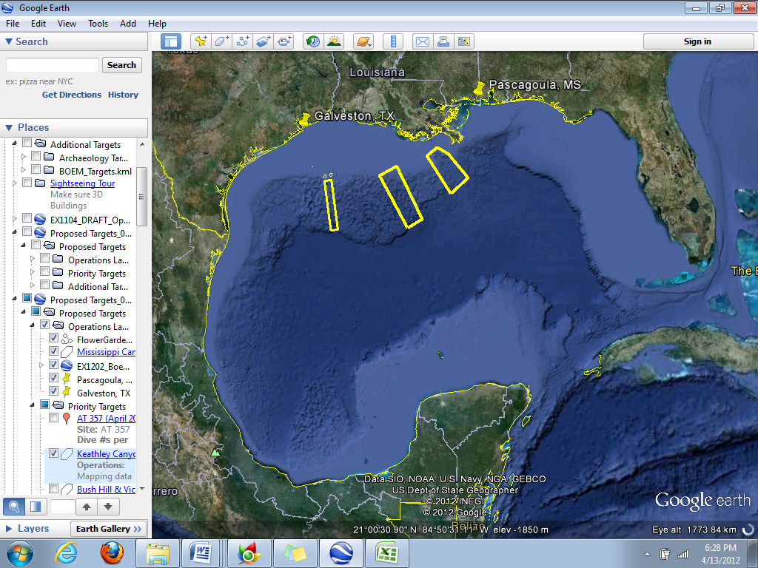
ROV Lead | Dave Lovalvo
General Area Descriptor | Northern Gulf of Mexico
ROV Dive Name | Cruise Season |  | Leg |  |  | Dive Number
 | EX1202 |  | 3 |  |  | DIVE10
Equipment Deployed | ROV: |  | Little Hercules
 | Camera Platform: |  | Seirios
ROV Measurements | CTD |  | Depth |  |  | Altitude
 | Scanning Sonar |  | USBL Position |  |  | Heading
 | Pitch |  | Roll |  |  | HD Camera
 | Low Res Cam 1 |  | Low Res Cam 2
Equipment Malfunctions | N/A
ROV Dive Summary  (From processed ROV data) | Dive Summary: EX1202L3_DIVE10  ^^^^^^^^^^^^^^^^^^^^^^^^^^^^^^^^^^^^^^^^^^^^^^^^^^^  In Water at: 2012-04-24T13:21:46.406000  27°, 08.168' N ; 090°, 28.946' W  Out Water at: 2012-04-24T23:05:39.947000  27°, 08.085' N ; 090°, 29.221' W  Off Bottom at: 2012-04-24T22:21:17.288000  27°, 07.733' N ; 090°, 29.243' W  On Bottom at: 2012-04-24T14:13:16.149000  27°, 08.358' N ; 090°, 28.906' W  Dive duration: 9:43:53  Bottom Time: 8:8:1  Max. depth: 1165.1 m
Special Notes
Scientists Involved  (please provide name / location / affiliation / email) | Jamie Austin (On-board science lead), EX, U. Texas, Austin, jamie@utig.ig.utexas.edu  Erin Becker, EX, Penn State, erinbeckr@gmail.com  Tom Weber (Flux work science lead), UNH, UNH CCOM, weber@ccom.unh.edu  Larry Mayer, UNH, UNH CCOM, larry@ccom.unh.edu  Kevin Jerram, UNH, UNH CCOM, kjerram@gmail.com  Bob Carney, LSU, LSU, rcarne1@lsu.edu  Mike Vecchione, SI, NOAA/SI  Bill Kiene, FGBNMS, FGBNMS, william.kiene@noaa.gov
Purpose of the Dive

Description of the Dive:
Overall Map of ROV Dive Area |  |  |  | Close-up Map of Main Dive Site
Representative Photos of the Dive
Please direct inquiries to: |  | NOAA Office of Ocean Exploration & Research  1315 East-West Highway (SSMC3 10th Floor)  Silver Spring, MD 20910  (301) 734-1014

