Okeanos Explorer ROV Dive Summary
Site Name | EW915/EW959 |  |  |  | 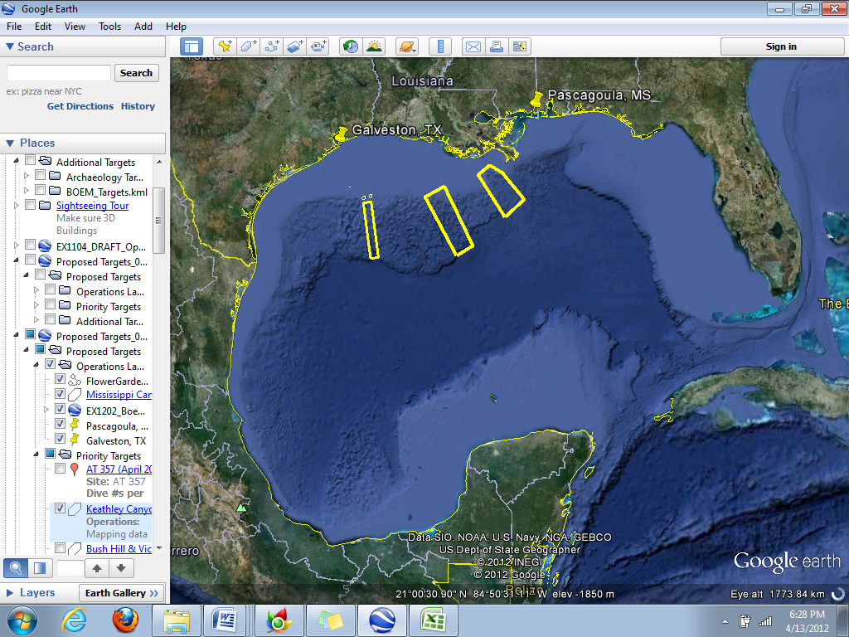
ROV Lead | Dave Lovalvo
General Area Descriptor | Northern Gulf of Mexico
ROV Dive Name | Cruise Season |  | Leg |  |  | Dive Number
 | EX1202 |  | 3 |  |  | DIVE08
Equipment Deployed | ROV: |  | Little Hercules
 | Camera Platform: |  | Seirios
ROV Measurements | CTD |  | Depth |  |  | Altitude
 | Scanning Sonar |  | USBL Position |  |  | Heading
 | Pitch |  | Roll |  |  | HD Camera
 | Low Res Cam 1 |  | Low Res Cam 2
Equipment Malfunctions | N/A
ROV Dive Summary  (From processed ROV data) | Dive Summary: EX1202L3_DIVE08  ^^^^^^^^^^^^^^^^^^^^^^^^^^^^^^^^^^^^^^^^^^^^^^^^^^^  In Water at: 2012-04-20T13:33:04.123000  28°, 02.420' N ; 090°, 20.136' W  Out Water at: 2012-04-20T21:35:50.816000  28°, 02.569' N ; 090°, 19.132' W  Off Bottom at: 2012-04-20T21:17:50.146000  28°, 02.481' N ; 090°, 19.287' W  On Bottom at: 2012-04-20T13:52:50.919000  28°, 02.459' N ; 090°, 20.037' W  Dive duration: 8:2:46  Bottom Time: 7:24:59  Max. depth: 349.0 m
Special Notes
Scientists Involved  (please provide name / location / affiliation / email) | Jamie Austin (On-board science lead), EX, U. Texas, Austin, jamie@utig.ig.utexas.edu  Erin Becker (on-board biologist), EX, Penn State, erinbeckr@gmail.com  Tom Weber (Flux work science lead), UNH, UNH CCOM, weber@ccom.unh.edu  Bob Carney, LSU, LSU, rcarne1@lsu.edu  Mike Vecchione, SI, NOAA/SI, vecchionem@si.edu  Bill Shedd, Stennis ECC, BOEM, William.Shedd@boem.gov  Kody Kramer, Stennis ECC, BOEM, Kody.Kramer@boem.gov  Santiago Herrera, WHOI, WHOI, sherrera@whoi.edu  Andrea Quattrini, Temple, tub79176@temple.edu  John Reed, HBOI, HBOI, Jreed12@hboi.fau.edu  Erik Cordes, Temple, ecordes@temple.edu
Purpose of the Dive
All waypoints were possible seeps. Traverse to four local topographic high points to look for seeps and hardgrounds.
Description of the Dive:
This area contained several interesting seep features and biological communities, including large brine pools, small seep volcano features emitting gas/oil and brine, and a brine river flanked by carbonate hardgrounds inhabited by corals, anemones and tubeworms.
Waypoints (WP1-WP5 on the map) for this dive were identified based on BOEM’s 3-D seismic data. Later, we determined that the waypoints were a bit off when overlain on the OE multibeam bathymetry, because the two data sets were generated using different geographic projections. Additional areas of interest were identified based on the multibeam data collected the night prior to the dive, which showed acoustic backscatter in the water column indicative of escaping gas plumes. An oil sheen was present on the sea surface around the ship prior to the ROV launch.
The dive began at WP1 at the base of a large dome feature. No signs of seepage were observed in this area. Next, we headed northeast to the cluster of targets identified from the multibeam backscatter data (called Seep1-Seep7 on map), using a side-to-side sweeping motion with the ROV along the way. About midway between WP1 and this cluster of acoustic targets, we came across a bed of dead clam shells and a few carbonate hardgrounds with live tubeworms and an Anthomastus octocoral. A couple of catsharks and smaller red fish were also present here. Bubble escape was observed, but it ceased within 10 seconds. A slow motion replay of the video showed that the bubbles began when one of the small red fish disturbed the sediment, which could indicate that this sediment is charged with gas that is occasionally released when disturbed. Virtual marker D08-1 was dropped here.
While exploring the acoustic seep targets, we came across a small patch of dead clam shells and possibly some live clams. There were a few small carbonate hardgrounds with dead bamboo coral skeletons that had been colonized by stoloniferan anemones. A bubble stream appeared here but stopped after a short while, perhaps again initiated by fish disturbance.
Moving toward WP2, we came across an area of extensive black staining and orange and white Beggiatoa (bacterial mat) and carbonate hardgrounds with tubeworms. Here, we found a steady stream of bubbles that we were able to image for 2-3 minutes. Virtual marker D08-2 was dropped here. Further toward WP2, we came across a brine seep with a few large brine pools and flow/drainage features; marker D08-3 was dropped here. Oil and gas bubbles were observed escaping from the seafloor, trailing brine(?) behind them as they rose. We also came across some very interesting small volcano-like mound features, one releasing gas bubbles and one releasing oil(?). There was orange and white staining on and around these features. This area was marked with D08-4. The area immediately around WP2 was relatively featureless. Between WP2 and WP3, we observed a large patch of yellow Beggiatoa, and close to WP3 found a brine river feature that flowed through a drainage channel/fracture in carbonate pavements. These carbonates were colonized by actinostolid anemones, Anthomastus octocorals, isolated tubeworms and bamboo corals. Intermittent bubbles were observed in this area; virtual target D08-5 was dropped here. Around WP3, there were a few hardgrounds with anemones, lollipop sponges, Anthomastus,and serpulid worms.
In moving between targets, we saw a number of large tilefish burrows (some of which had tilefish in them) and burrows inhabited by hakes. We also observed several flounder, a skate, a ray, a striped eel, sea stars, anemones, crabs (rochina), a hermit crab, many transparent swimming pelagic polychaetes, and empty urchin tests.

Overall Map of ROV Dive Area |  |  |  | Close-up Map of Main Dive Site
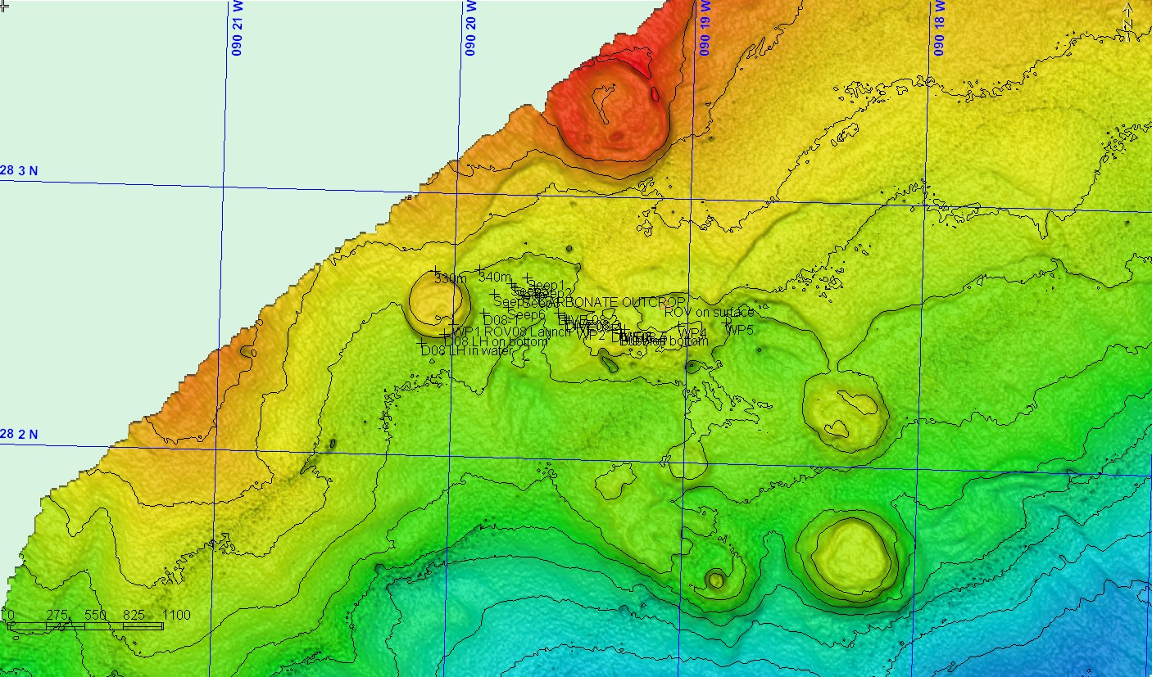 |  |  |  | 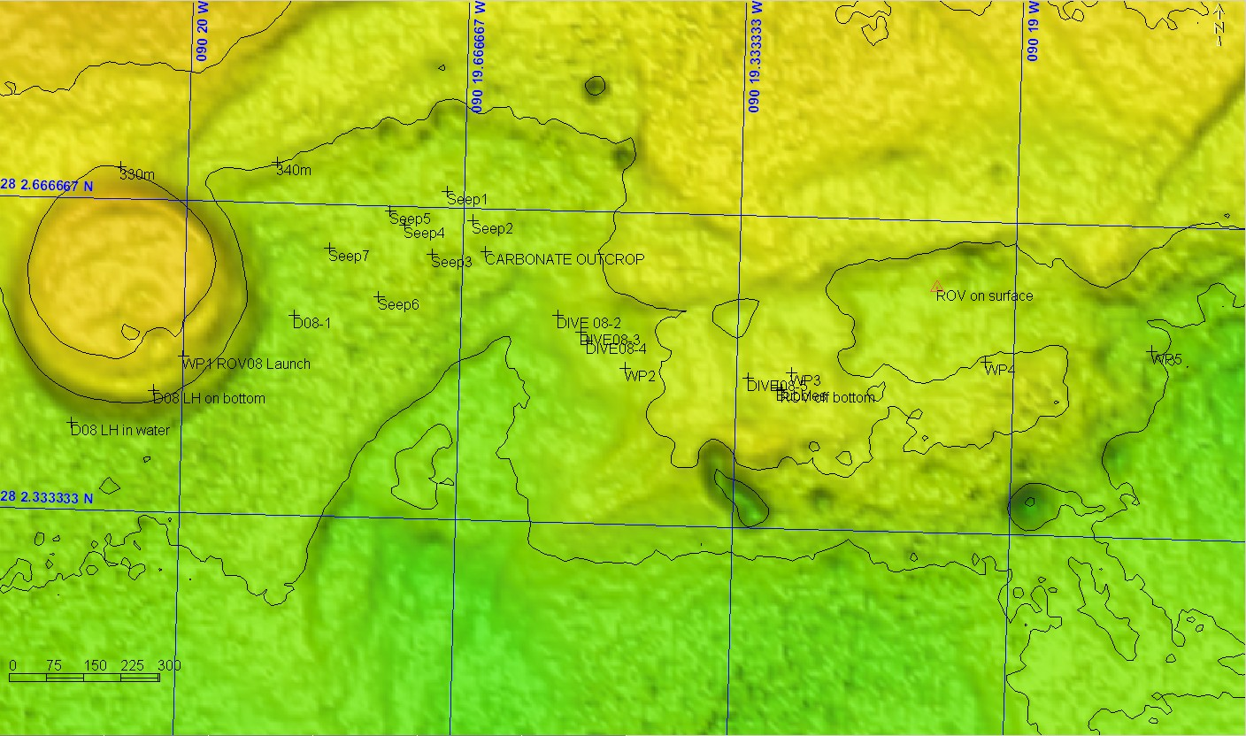
Representative Photos of the Dive
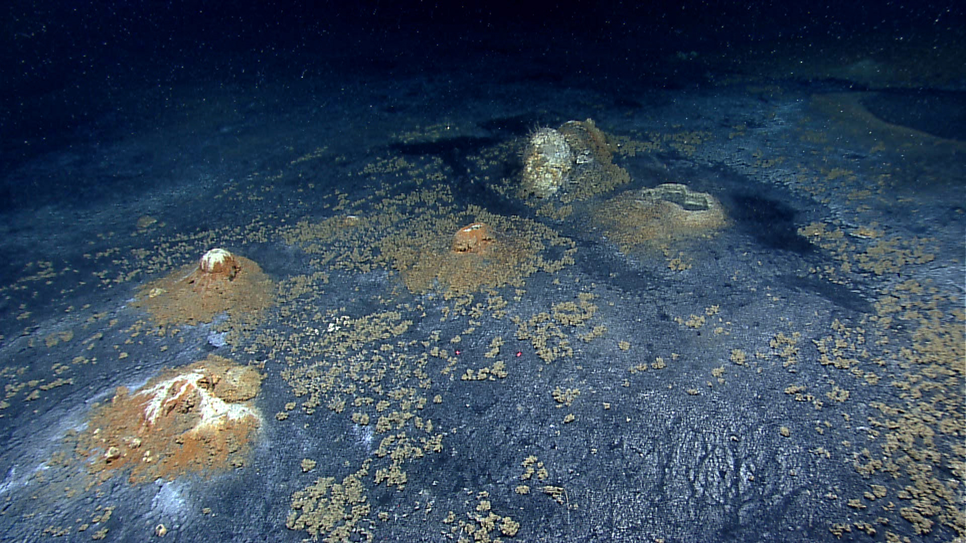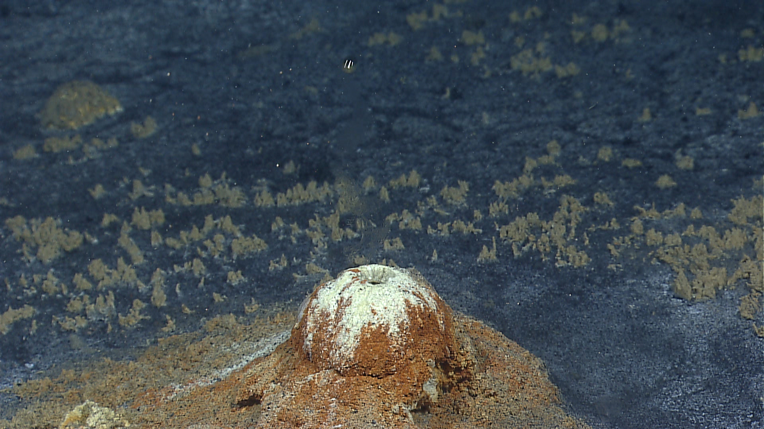 |  |  |  | 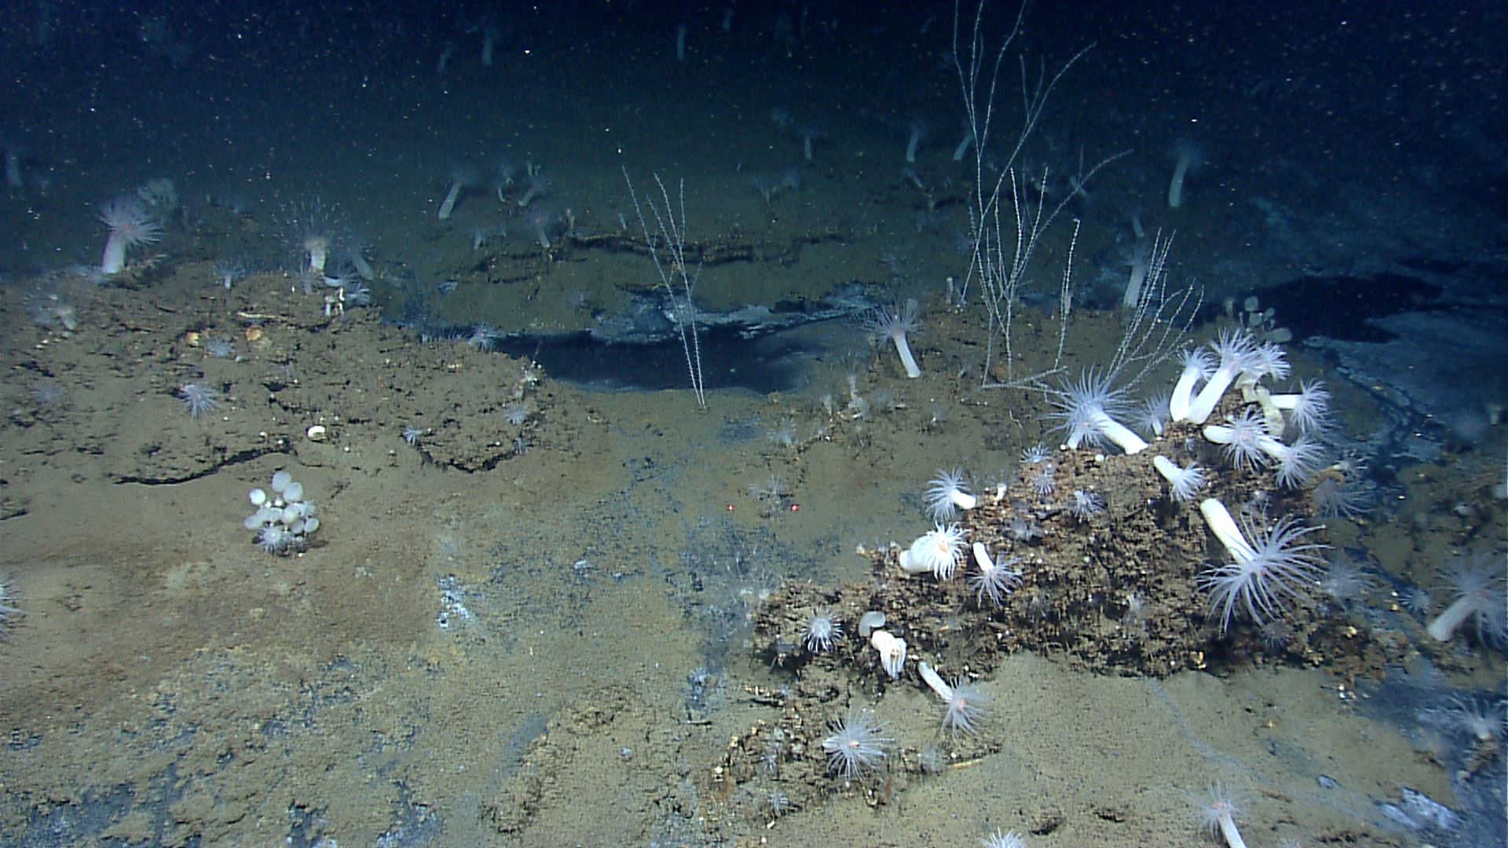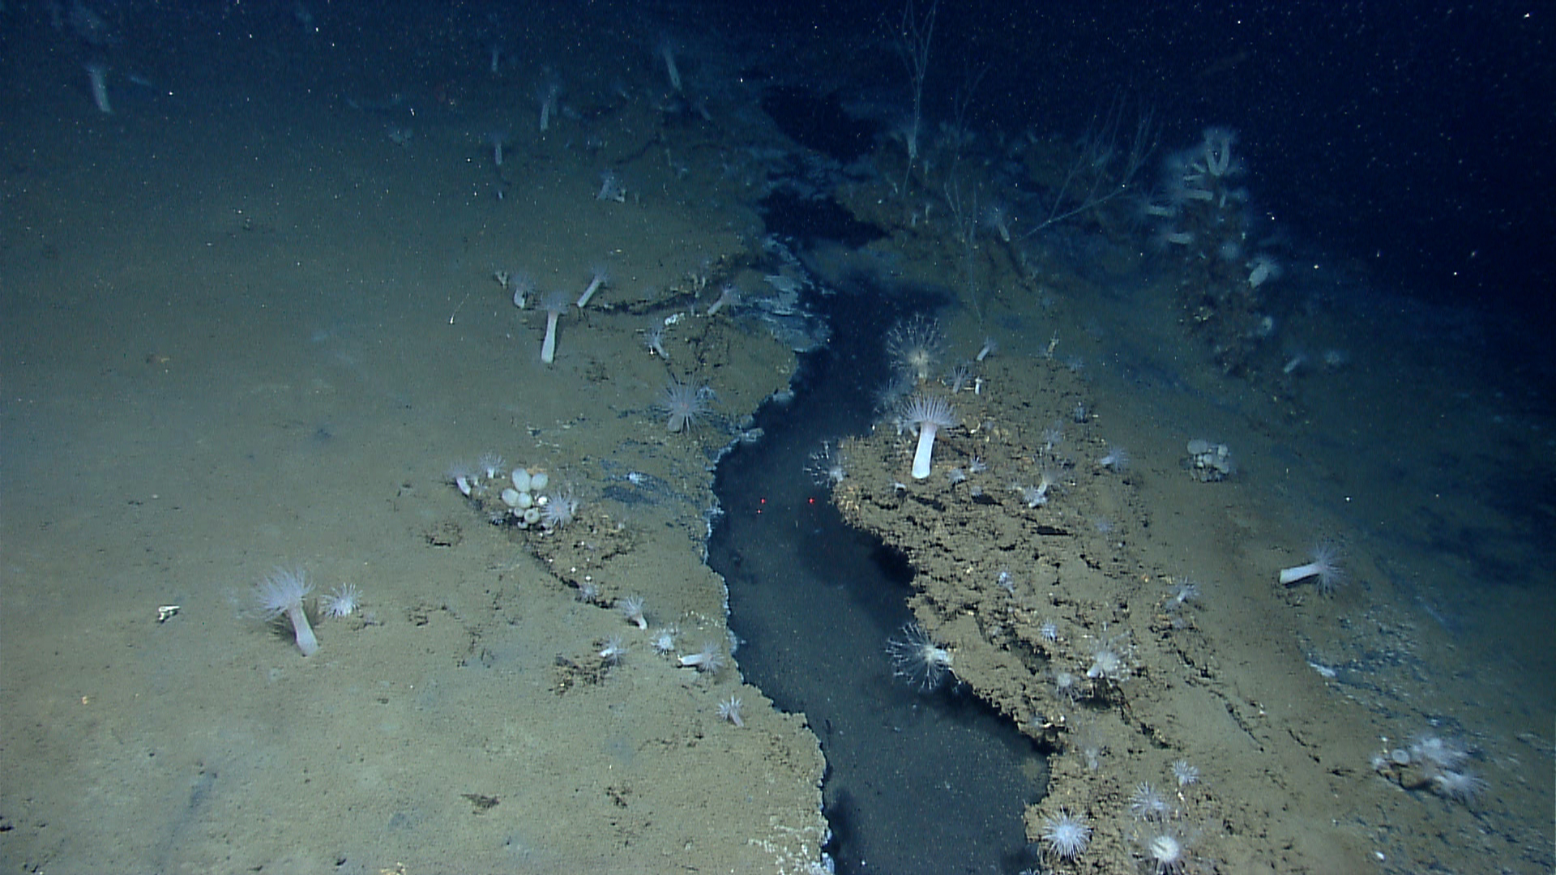
(Top) Small volcano-like features, one releasing oil(?) droplets and another releasing gas bubbles. (Bottom) a close-up of an oil/gas droplet rising from the volcano trailing brine (the transparent shimmering tail). |  |  |  | A brine river feature flowing through a fracture/drainage channel in carbonate pavements. The flanking carbonates are inhabited by anemones, sponges, vestimentiferan tubeworms and bamboo corals.
Please direct inquiries to: |  | NOAA Office of Ocean Exploration & Research  1315 East-West Highway (SSMC3 10th Floor)  Silver Spring, MD 20910  (301) 734-1014

