Okeanos Explorer ROV Dive Summary
Site Name | Pascagoula Salt Dome (Grid Experiment) |  |  |  | 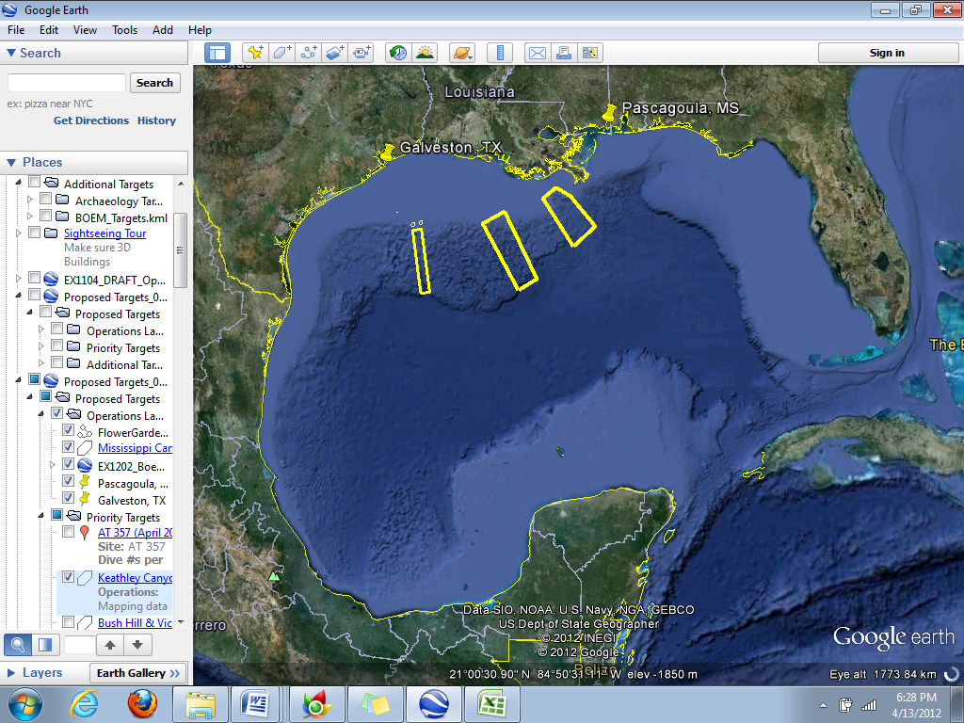
ROV Lead | Dave Lovalvo
General Area Descriptor | Northern Gulf of Mexico
ROV Dive Name | Cruise Season |  | Leg |  |  | Dive Number
 | EX1202 |  | 3 |  |  | DIVE05
Equipment Deployed | ROV: |  | Little Hercules
 | Camera Platform: |  | Seirios
ROV Measurements | CTD |  | Depth |  |  | Altitude
 | Scanning Sonar |  | USBL Position |  |  | Heading
 | Pitch |  | Roll |  |  | HD Camera
 | Low Res Cam 1 |  | Low Res Cam 2
Equipment Malfunctions | N/A
ROV Dive Summary  (From processed ROV data) | Dive Summary: EX1202L3_DIVE05  ^^^^^^^^^^^^^^^^^^^^^^^^^^^^^^^^^^^^^^^^^^^^^^^^^^^  In Water at: 2012-04-17T13:28:53.966000  28°, 58.702' N ; 088°, 01.842' W  Out Water at: 2012-04-17T17:27:13.189000  28°, 58.583' N ; 088°, 01.500' W  Off Bottom at: 2012-04-17T16:44:00.891000  28°, 58.697' N ; 088°, 01.814' W  On Bottom at: 2012-04-17T14:14:54.626000  28°, 58.687' N ; 088°, 01.824' W  Dive duration: 3:58:19  Bottom Time: 2:29:6  Max. depth: 1124.1 m
Special Notes | ROV setup in “methane grid” configuration.
Scientists Involved  (please provide name / location / affiliation / email) | Jamie Austin (On-board science lead), EX, U. Texas, Austin, jamie@utig.ig.utexas.edu  Erin Becker, EX, Penn State, erinbeckr@gmail.com  Tom Weber (Flux work science lead), UNH, UNH CCOM, weber@ccom.unh.edu  Larry Mayer, UNH, UNH CCOM, larry@ccom.unh.edu  Kevin Jerram, UNH, UNH CCOM, kjerram@gmail.com  Bob Carney, LSU, LSU, rcarne1@lsu.edu  Mike Vecchione, SI, NOAA/SI, VecchioneM@si.edu  Erik Cordes, Temple, Temple University, ecordes@temple.edu
Purpose of the Dive
The objective of this work is to characterize the bubble size distribution at two seep locations on the Pascagoula Dome in order to understand better our acoustic measurements of these same seeps and, ultimately, to understand the flux of free gas entering the water column at this (and similar) location(s).
Description of the Dive:
The vehicles were in the water about ~0820 CDT, to a depth of ~1120 m. The primary objective of this dive was to assess sizes and rates of bubble escape at the seep identified for gas capture during Dive 04, and at a neighboring area of disseminated bubble escape, for comparison purposes. To make that assessment, a grid was installed on the Little Herc ROV in place of the gas catching cylinder used for Dive 04.
After a short search, the continuous bubble stream (where the gas capture experiment occurred for Dive 04) was identified. Video was acquired for 2-3 min. of the bubble escape location at the seafloor, with lasers (10 cm. spacing) on. Little Herc was then positioned so that the stream was rising in front of the grid, and held stable in order to collect ~5 min. of bubble escape video with the video camera trained on the grid, again with lasers on. This procedure was done once.
Following this continuous bubble census, three different locations within the part of the vent field with disseminated bubble escape were identified, and the same procedure was carried out.
Prior to leaving the seafloor, a small survey of the vent field, covered with living and dead mussels and scattered tubeworms, clams, crabs and snails, was accomplished.
On the way to the surface, the continuous bubble trail was followed as long as possible, to a height of ~40 m above the seafloor with both Little Herc and Seirios cameras. Vehicles were back on deck prior to 1400 CDT, in advance of the arrival of advancing thunderstorms.
Overall Map of ROV Dive Area |  |  |  | Close-up Map of Main Dive Site
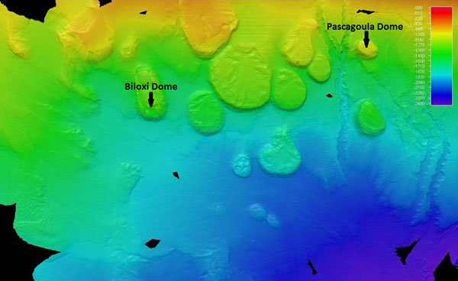 |  |  |  | 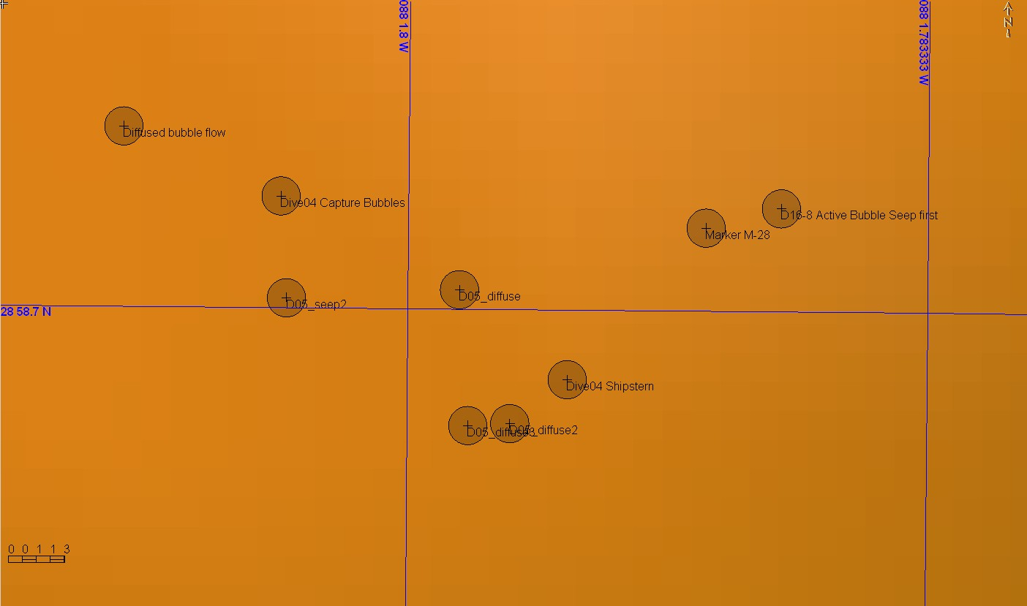
Representative Photos of the Dive
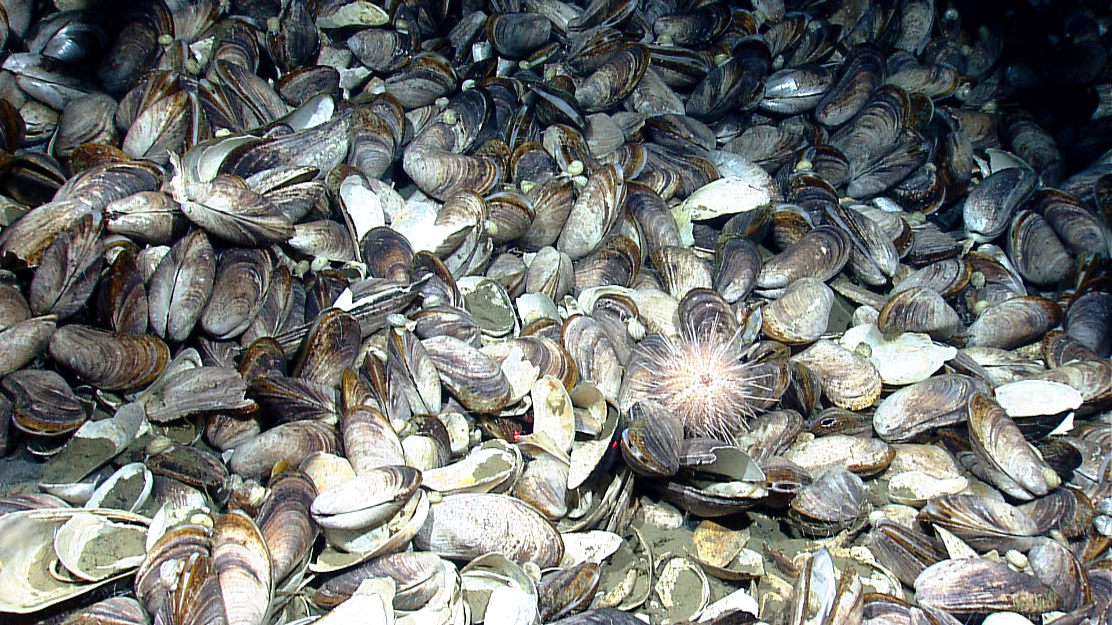 |  |  |  | 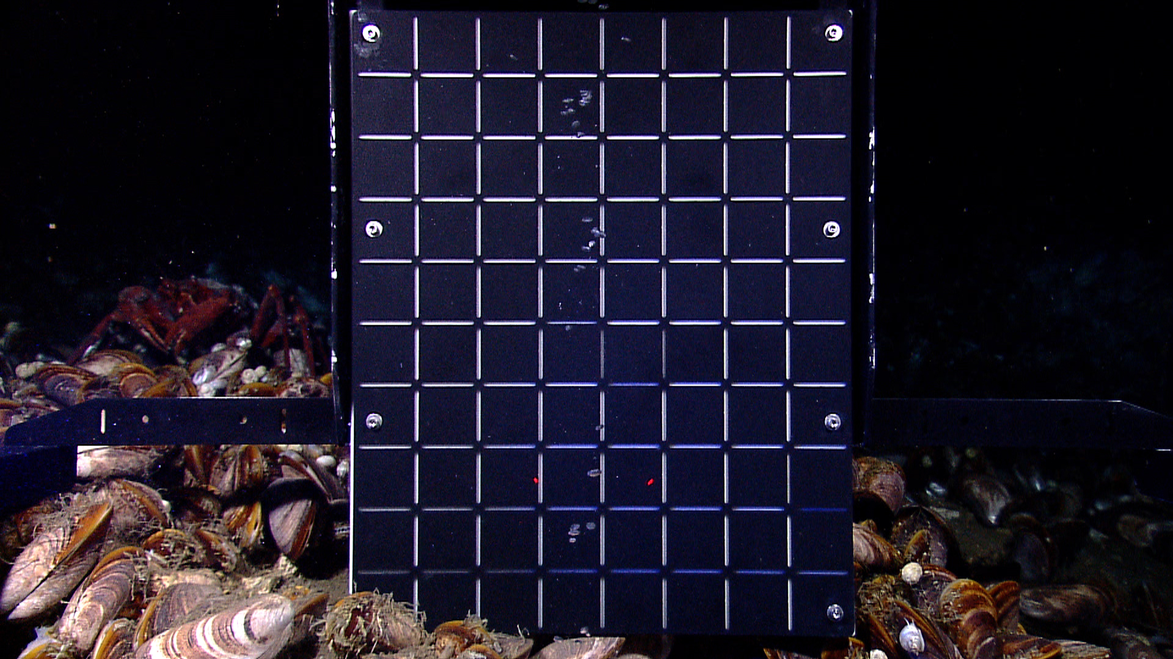
An extensive bed of live and dead mussels. The mussel species Bathymodiolus childressi and probably B. brooksi were present in this bed as well as numerous associated mobile fauna such as the small white gastropods and the regular urchin shown in this photo. |  |  |  | A calibrated grid was placed directly behind a continuous focused stream of bubble escape. The grid allows us to measure the size of bubbles as they escape the seafloor and rise into the water column.
Please direct inquiries to: |  | NOAA Office of Ocean Exploration & Research  1315 East-West Highway (SSMC3 10th Floor)  Silver Spring, MD 20910  (301) 734-1014

