Okeanos Explorer ROV Dive Summary
Site Name | Biloxi B (Methane Bucket Experiment) |  |  |  | 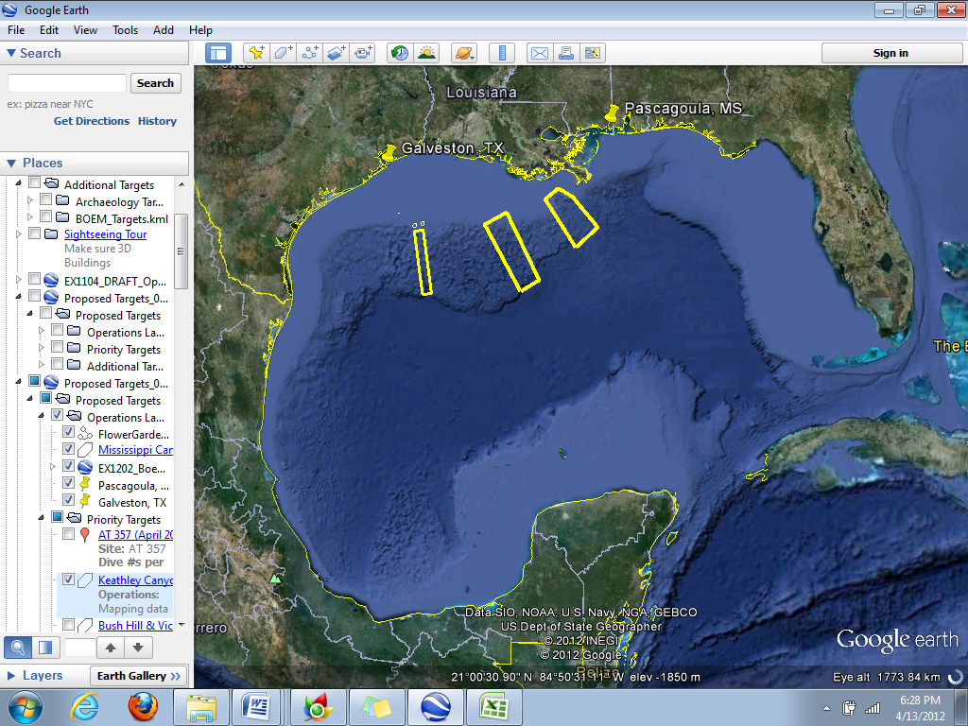
ROV Lead | Dave Lovalvo
General Area Descriptor | Northern Gulf of Mexico
ROV Dive Name | Cruise Season |  | Leg |  |  | Dive Number
 | EX1202 |  | 3 |  |  | DIVE03
Equipment Deployed | ROV: |  | Little Hercules
 | Camera Platform: |  | Seirios
ROV Measurements | CTD |  | Depth |  |  | Altitude
 | Scanning Sonar |  | USBL Position |  |  | Heading
 | Pitch |  | Roll |  |  | HD Camera
 | Low Res Cam 1 |  | Low Res Cam 2
Equipment Malfunctions | Methane bucket leaked bubbles during ascent.
ROV Dive Summary  (From processed ROV data) | Dive Summary: EX1202L3_DIVE03  ^^^^^^^^^^^^^^^^^^^^^^^^^^^^^^^^^^^^^^^^^^^^^^^^^^^  In Water at: 2012-04-14T13:21:55.053000  28°, 40.542' N ; 088°, 28.277' W  Out Water at: 2012-04-14T19:17:37.842000  28°, 40.493' N ; 088°, 27.973' W  Off Bottom at: 2012-04-14T16:58:26.516000  28°, 40.529' N ; 088°, 28.155' W  On Bottom at: 2012-04-14T14:17:24.065000  28°, 40.512' N ; 088°, 28.152' W  Dive duration: 5:55:42  Bottom Time: 2:41:2  Max. depth: 1363.6 m
Special Notes | ROV setup in “methane bucket” configuration.
Scientists Involved  (please provide name / location / affiliation / email) | Jamie Austin (On-board science lead), EX, U. Texas, Austin, jamie@utig.ig.utexas.edu  Erin Becker, EX, Penn State, erinbeckr@gmail.com  Tom Weber (Flux work science lead), UNH, UNH CCOM, weber@ccom.unh.edu  Larry Mayer, UNH, UNH CCOM, larry@ccom.unh.edu  Kevin Jerram, UNH, UNH CCOM, kjerram@gmail.com  Bob Carney, LSU, LSU, rcarne1@lsu.edu  Bill Kiene, FGBNMS, FGBNMS, william.kiene@noaa.gov
Purpose of the Dive
The objective of this dive was to make a direct estimate of flux from a seep site by collecting a known volume of gas over a known duration of time. During EX1202L3 Dive 01 reconnaissance at “Biloxi B”, twin seeps (designated seep 2) were located and imaged with the ROV. We returned to this location to try to capture flux over a known duration of time.
Description of the Dive:
After reaching the seafloor at 09:17 CDT, the twin seep site (seep 2) was found after a ~20 min. search. Gas was found to be seeping from several locations associated with the same small (~20 cm long) carbonate hardground formation where the seep was observed during EX1202-L3 Dive 01, possibly at faster rates. Bubble streams were observed seeping from at least three discrete locations on the seabed, all within a range of ~10 cm of one another. After completing visual observations of the seep for an interval long enough to use video to conduct post-cruise bubble counts from all streams, the top valve on the gas collection bucket was closed and the Little Herc ROV was maneuvered so that the flare at the base of the methane bucket was positioned over all three seep locations, capturing all gas escaping from seep 2. Gas capture commenced for 1 hr, 33 min. During this bucket filling operation, hydrate was observed forming on its inside upper portion of the bucket, to a length between the .2 and .3 volume bands. After the fill operation, Little Herc proceeded to ascend at a rate of ~10 m/minute.

During the ascent, bubbles were observed rising inside the bucket from the lower, opaque flare at its bottom, beginning early in the ascent and increasing in rate as the vehicle ascended; apparently, a substantial amount of hydrate had also formed at the level of the flare (unseen visually given existing camera placements on the ROV) during the fill operation. At a depth of ~900 m, bubbles were observed escaping from the (supposedly closed) upper lid on the bucket into the surrounding seawater. By the time the vehicle had passed 600 m water depth, bubbles were observed to be rapidly rising from the opaque flare at the bottom of the cylinder, into the cylinder, and also from around the edge of the upper into the surrounding water. Very little (if any) gas appeared to be escaping the flare directly into the surrounding water. After passing 400 m, loose pieces of hydrate were observed floating upward into the bucket, apparently having been dislodged from the opaque flare wall at the base of the bucket. The ROV stabilized for several minutes at 300 m, at which point the hydrate had completely dissociated and very little gas remained in the cylinder. The ROV and Seirios were then recovered on deck to complete Dive 03, at ~1430 CDT.

This was the first deployment of the gas collection bucket on Little Herc, with the goal being to focus on the methodology associated with navigating to a previously observed seep, positioning the ROV in a manner that allowed for complete capture of one (or in this case, several) bubble plumes associated with such a seep, holding position during a fill operation, and assessing the behavior of the hydrate/gas inside the cylinder during ascent. From those standpoints, Dive 03 was completely successful. At least one more dive at this location, using a modified top valve to prevent gas from escaping during ascent, is being planned.
Overall Map of ROV Dive Area |  |  |  | Close-up Map of Main Dive Site
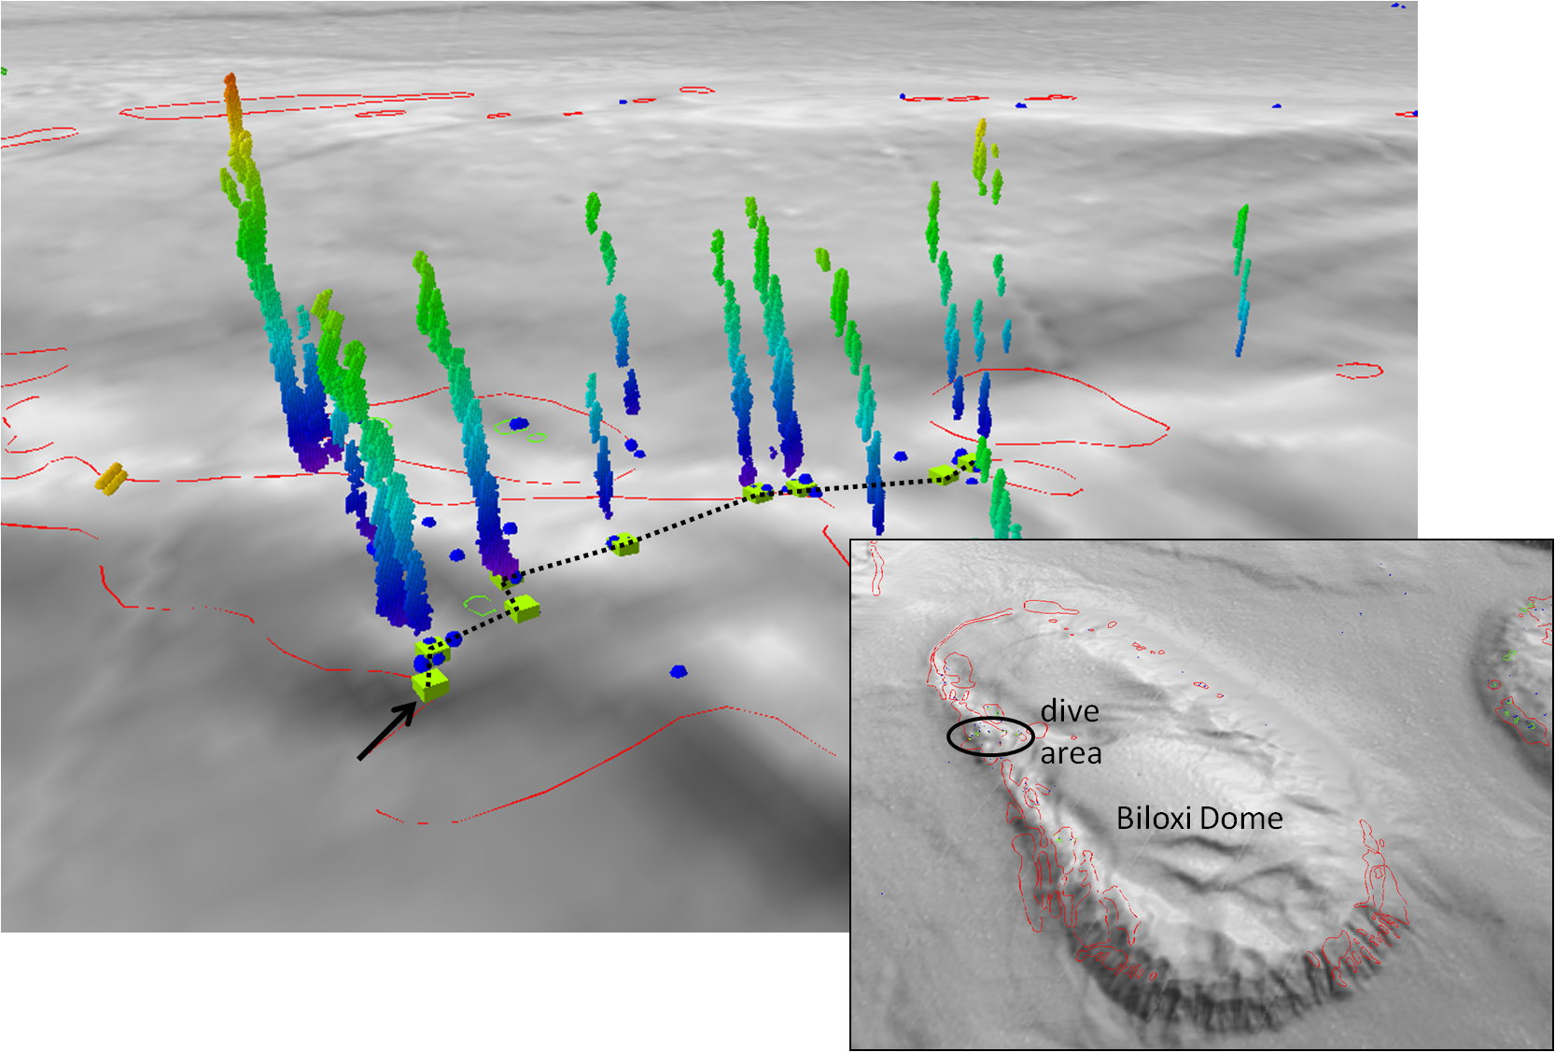
Bathymetric image showing the Biloxi salt dome and dive site “Biloxi B” |  |  |  | Fledermaus image showing sonar data of seeps, and projected dive track.
Representative Photos of the Dive
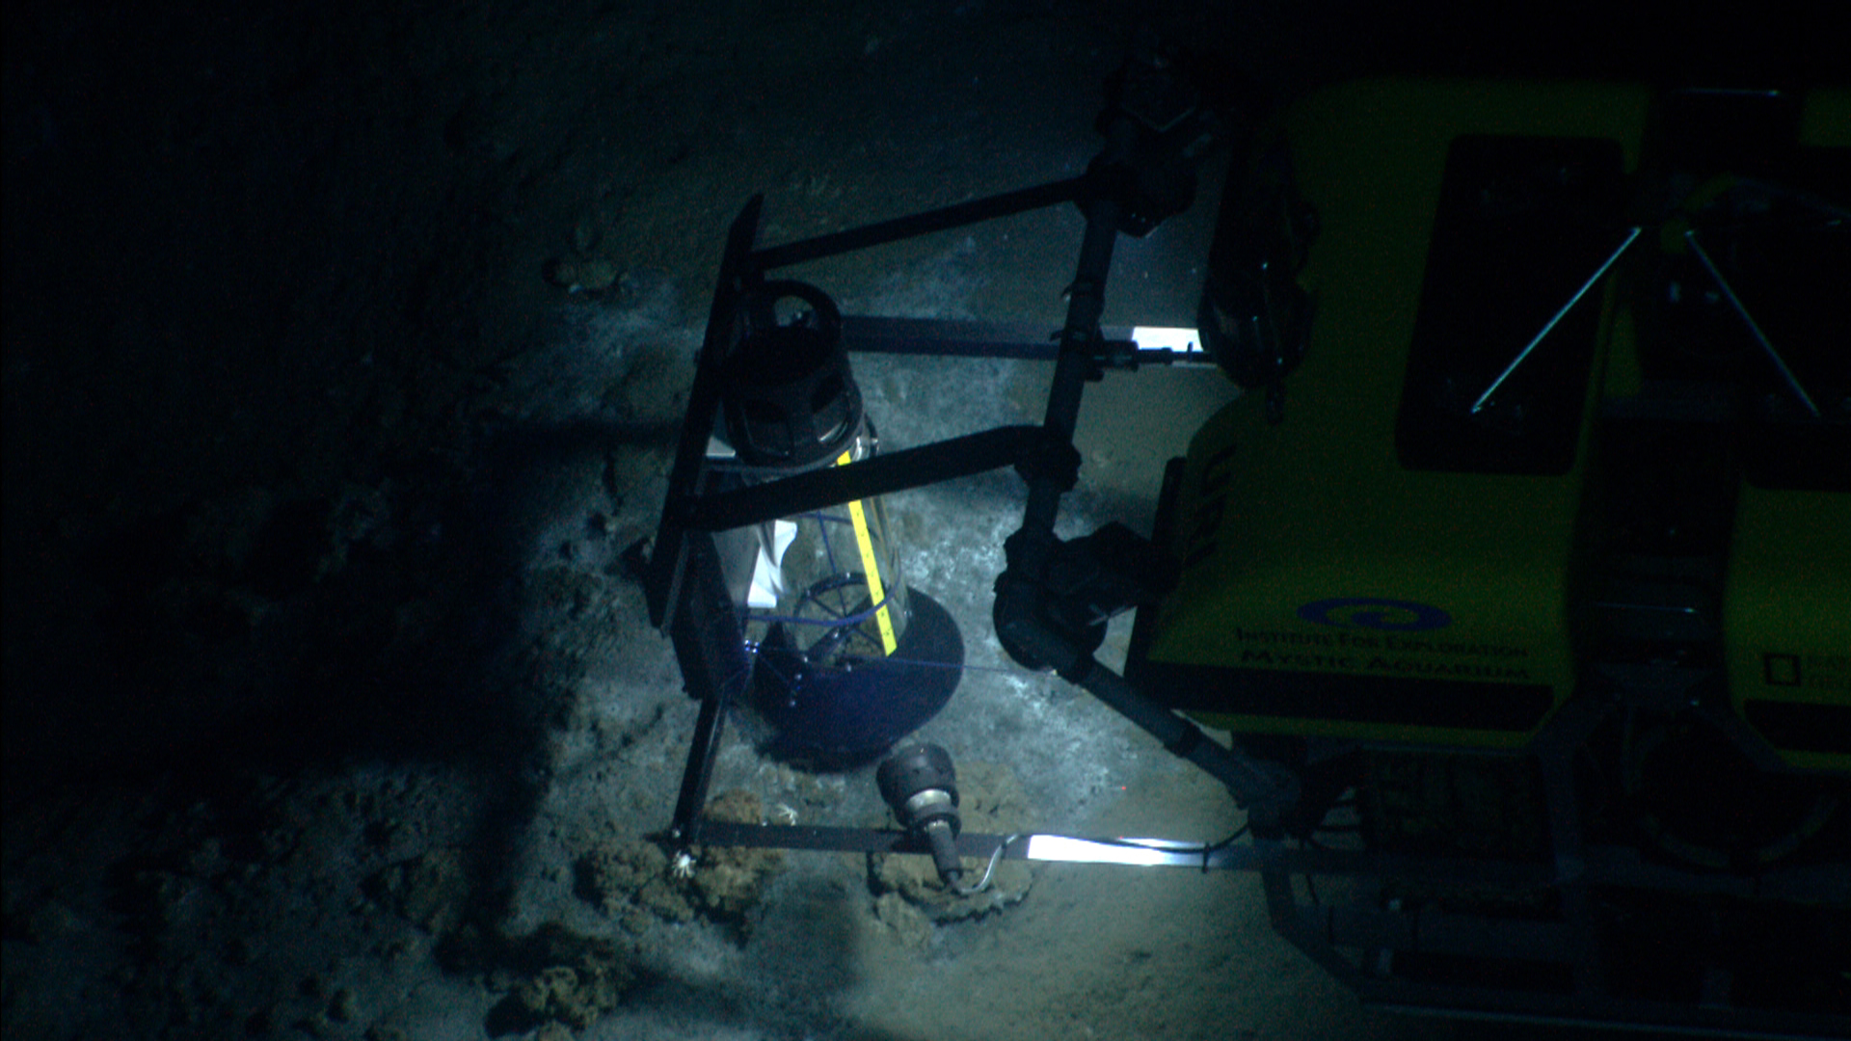 |  |  |  | 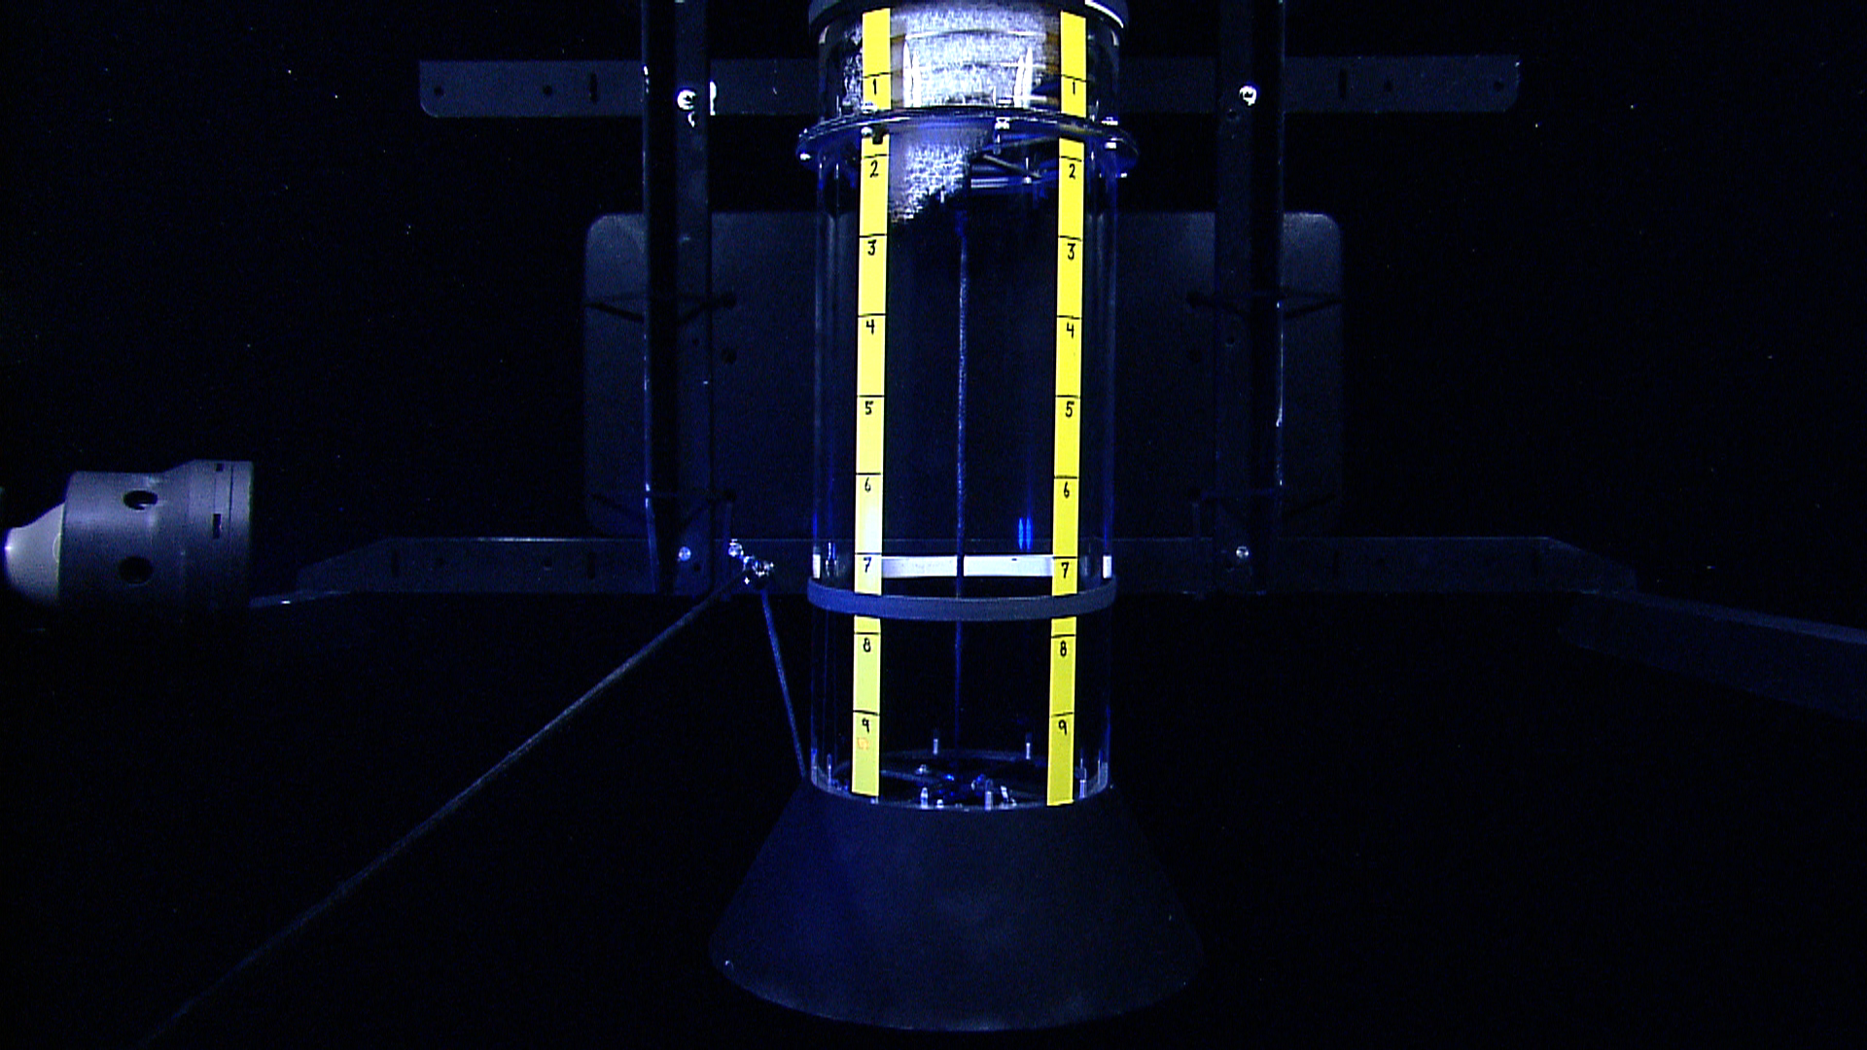
A profile view of Little Hercules taken from Seirios during methane bubble collection. The collection bucket is positioned over Seep 2. |  |  |  | Methane ice has formed in a cone at the top left of the cylinder. This photo was taken during ascent and the ice formation ad begun to expand downward and toward the right before later exolving in warmer, shallower water.
Please direct inquiries to: |  | NOAA Office of Ocean Exploration & Research  1315 East-West Highway (SSMC3 10th Floor)  Silver Spring, MD 20910  (301) 734-1014

