Okeanos Explorer ROV Dive Summary
Site Name | Biloxi B (Methane Bucket Experiment) |  |  |  | 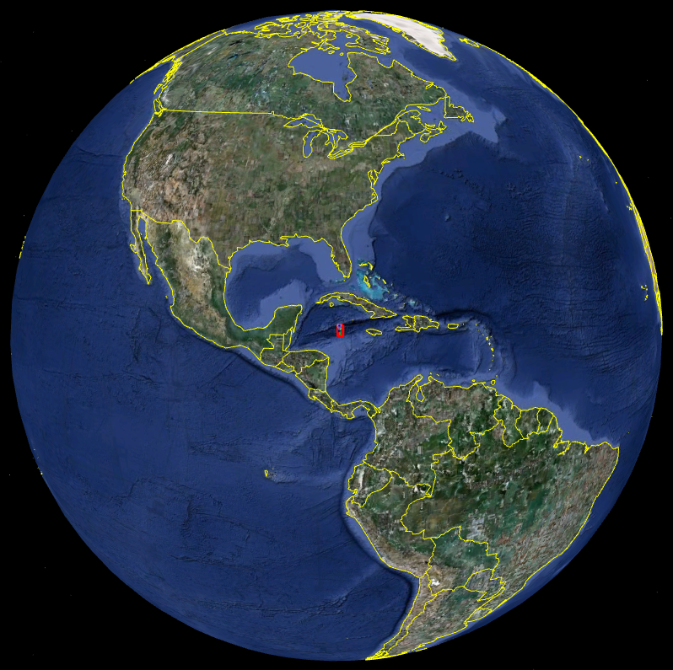
ROV Lead | Dave Lovalvo
General Area Descriptor
ROV Dive Name | Cruise Season |  | Leg |  |  | Dive Number
 | EX1202 |  | 3 |  |  | DIVE03
Equipment Deployed | ROV: |  | Little Hercules
 | Camera Platform: |  | Seirios
ROV Measurements | CTD |  | Depth |  |  | Altitude
 | Scanning Sonar |  | USBL Position |  |  | Heading
 | Pitch |  | Roll |  |  | HD Camera
 | Low Res Cam 1 |  | Low Res Cam 2
Equipment Malfunctions | Methane bucket leaked bubbles during ascent.
ROV Dive Summary  (From processed ROV data) | Dive Summary: EX1202L3_DIVE03  ^^^^^^^^^^^^^^^^^^^^^^^^^^^^^^^^^^^^^^^^^^^^^^^^^^^  In Water at: 2012-04-14T13:21:55.053000  28°, 40.542' N ; 088°, 28.277' W  Out Water at: 2012-04-14T19:17:37.842000  28°, 40.493' N ; 088°, 27.973' W  Off Bottom at: 2012-04-14T16:58:26.516000  28°, 40.529' N ; 088°, 28.155' W  On Bottom at: 2012-04-14T14:17:24.065000  28°, 40.512' N ; 088°, 28.152' W  Dive duration: 5:55:42  Bottom Time: 2:41:2  Max. depth: 1363.6 m
Special Notes | ROV setup in “methane bucket” configuration.
Scientists Involved
(please provide name / location / affiliation / email)
Purpose of the Dive
Description of the Dive:
Overall Map of ROV Dive Area |  |  |  | Close-up Map of Main Dive Site
Representative Photos of the Dive
xxx |  |  |  | xxx
Please direct inquiries to: |  | NOAA Office of Ocean Exploration & Research  1315 East-West Highway (SSMC3 10th Floor)  Silver Spring, MD 20910  (301) 734-1014

