Okeanos Explorer ROV Dive Summary
Site Name | Biloxi Dome A |  |  |  | 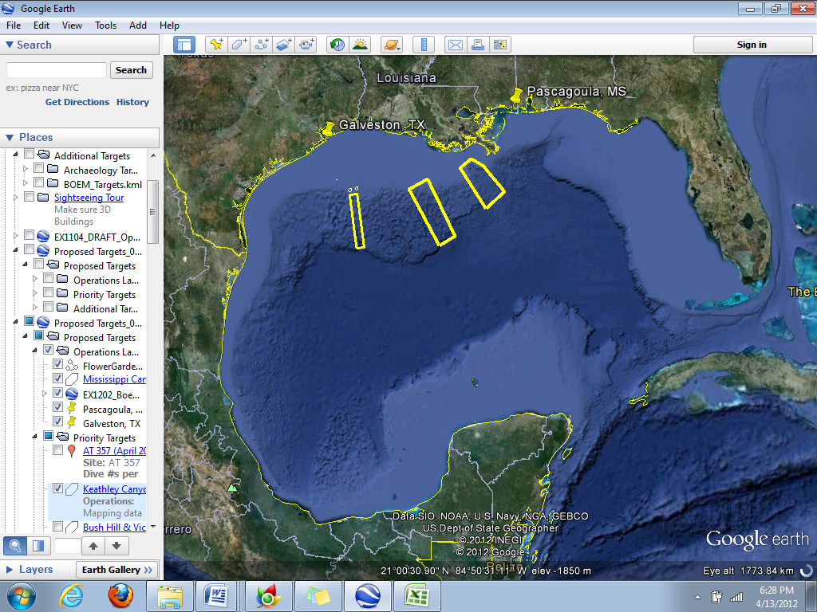
ROV Lead | Dave Lovalvo
General Area Descriptor | Northern Gulf of Mexico
ROV Dive Name | Cruise Season |  | Leg |  |  | Dive Number
 | EX1202 |  | 3 |  |  | DIVE02
Equipment Deployed | ROV: |  | Little Hercules
 | Camera Platform: |  | Seirios
ROV Measurements | CTD |  | Depth |  |  | Altitude
 | Scanning Sonar |  | USBL Position |  |  | Heading
 | Pitch |  | Roll |  |  | HD Camera
 | Low Res Cam 1 |  | Low Res Cam 2
Equipment Malfunctions | N/A
ROV Dive Summary  (From processed ROV data) | Dive Summary: EX1202L3_DIVE02  ^^^^^^^^^^^^^^^^^^^^^^^^^^^^^^^^^^^^^^^^^^^^^^^^^^^  In Water at: 2012-04-13T13:28:02.401000  28°, 38.849' N ; 088°, 27.525' W  Out Water at: 2012-04-13T21:33:51.249000  28°, 38.397' N ; 088°, 27.298' W  Off Bottom at: 2012-04-13T20:28:48.897000  28°, 38.765' N ; 088°, 27.501' W  On Bottom at: 2012-04-13T14:25:36.836000  28°, 38.821' N ; 088°, 27.532' W  Dive duration: 8:5:48  Bottom Time: 6:3:12  Max. depth: 1418.1 m
Special Notes | Click here to enter text.
Scientists Involved  (please provide name / location / affiliation / email) | Jamie Austin (On-board science lead), EX, U. Texas, Austin, jamie@utig.ig.utexas.edu  Erin Becker, EX, Penn State, erinbeckr@gmail.com  Tom Weber (Flux work science lead), UNH, UNH CCOM, weber@ccom.unh.edu  Larry Mayer, UNH, UNH CCOM, larry@ccom.unh.edu  Kevin Jerram, UNH, UNH CCOM, kjerram@gmail.com  Bob Carney, LSU, LSU, rcarne1@lsu.edu  John Reed, HBOI, HBOI, Jreed12@hboi.fau.edu  Mike Vecchione, SI, NOAA/SI, VecchioneM@si.edu  Tim Shank, EX, WHOI, tshank@whoi.edu  Bill Kiene, FGBNMS, FGBNMS, william.kiene@noaa.gov  Cat Munro, WHOI, WHOI, cmunro@whoi.edu  Santiago Herrerra, WHOI, WHOI, sherrera@whoi.edu
Purpose of the Dive
The objective of this dive was to characterize as many seeps as possible in terms of their relative flow rate, apparent flow rate, and the nature of the seep origin (one isolated spots or several closely located seepage points). This was a reconnaissance dive to ground-truth and characterize seeps imaged by the Okeanos EM302 and EK 60 sonar systems, and select locations for further analysis with the calibrated grid and methane bucket ROV configurations.
Description of the Dive:
For this dive, we set out 3 waypoints situated in a triangle covering a linear distance of ~146 m total (point 1 to 2 to 3). We spent the entire dive visually covering this entire area, by sweeping back and forth with Little Herc from point 1 to 2, 2 to 3, then back to 1. A fourth pass then covered the region missed within the center of the triangle. While moving between waypoints, Little Herc covered swaths of up to ~40 m and advancing ahead ~5-10 m with every swath. A plot of the dive track shows that the entire triangle was visually covered; concentrated survey efforts involved the areas around the three waypoints, where previous MBES passes had produced acoustic evidence for plumes in the water column.
In the vicinity of waypoint 2, we observed extensive black and white staining and exposed, bioeroded, highly porous carbonate hardgrounds, with some scattered vestimentiferan tubeworms, galatheid crabs (squat lobsters), and Chaceon crabs. Close to these communities, we observed bubbles leaving the seafloor at a rate of ~1 5 s. Upon closer inspection, it became apparent that these bubbles were emanating from at least two locations in the sediment over a ~50cm² area. We called the virtual target for this location Seep 3. Numerous swimming copepods were observed, and there were also small, bulbous, tubular structures protruding from the sediment that we later deduced to be thin methane hydrate tubes or bubbles perhaps covered by thin layers of hydrate. A few tubeworms (Lamellibrachia) occupied adjacent carbonate hardground outcrops. The terrain in this area was complex, defined by ridges and enclosed depressions, perhaps formed by collapse following dissolution of underlying methane hydrate deposits. Sediments along the sides of depression slopes appeared unstable, with pieces of grey and yellow methane hydrate outcropping or lying on the seafloor. A close examination of one of these revealed that it was colonized by the methane ice worm Hesiocaeca methanicola. However, no de-gassing was observed from individual hydrate fragments.
Continuing to look around waypoint 2, we found another location where bubbles were being released from under a small hydrate outcrop at a rate of ~1/20-25s. We called this location Seep 4. There was a readily identifiable piece of twisted cable, possibly fishing line, close by. We also observed what looked like solid methane hydrate bubbles under the lip of a hydrate outcrop, similar to those we saw on the sediment surface at Seep 3.
En route back toward waypoint 1 from waypoint 3, we but did not observe any further signs of seepage. The center of the surveyed triangular area was also free of seeps. Aside from the areas where we encountered seeps, the seafloor was relatively flat, with occasional areas characterized by many burrows and hummocky terrain. These areas were characterized by usual deep-sea fauna, including Chaceon and magid crabs, fish, shrimp, a few asteroid sea stars and a brittle star. There were also galatheid crabs; these tended to be associated with carbonate hardground outcrops. There was a notable lack of mussels and only a few isolated mussel shells.
Overall Map of ROV Dive Area |  |  |  | Close-up Map of Main Dive Site
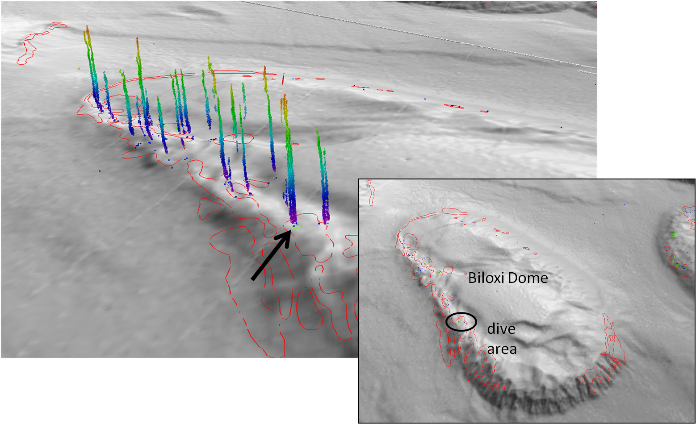
Bathymetric image showing the Biloxi salt dome and dive site “Biloxi A” |  |  |  | Fledermaus image showing sonar data of seeps, and projected dive track.
Representative Photos of the Dive
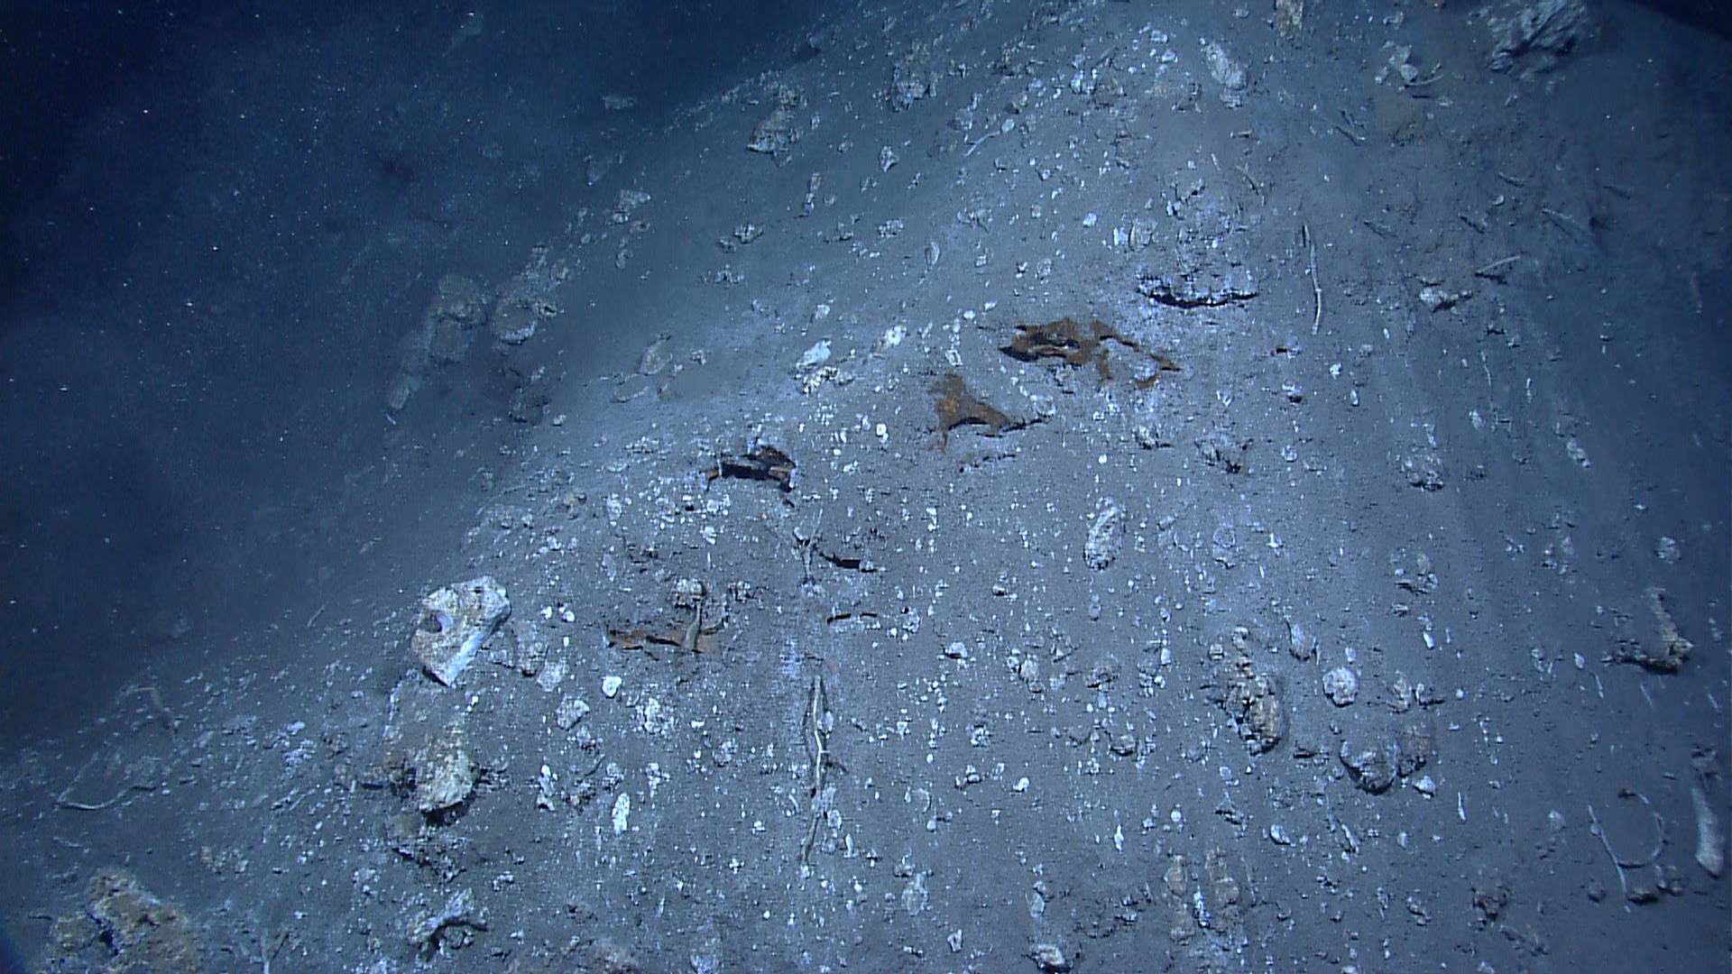 |  |  |  | 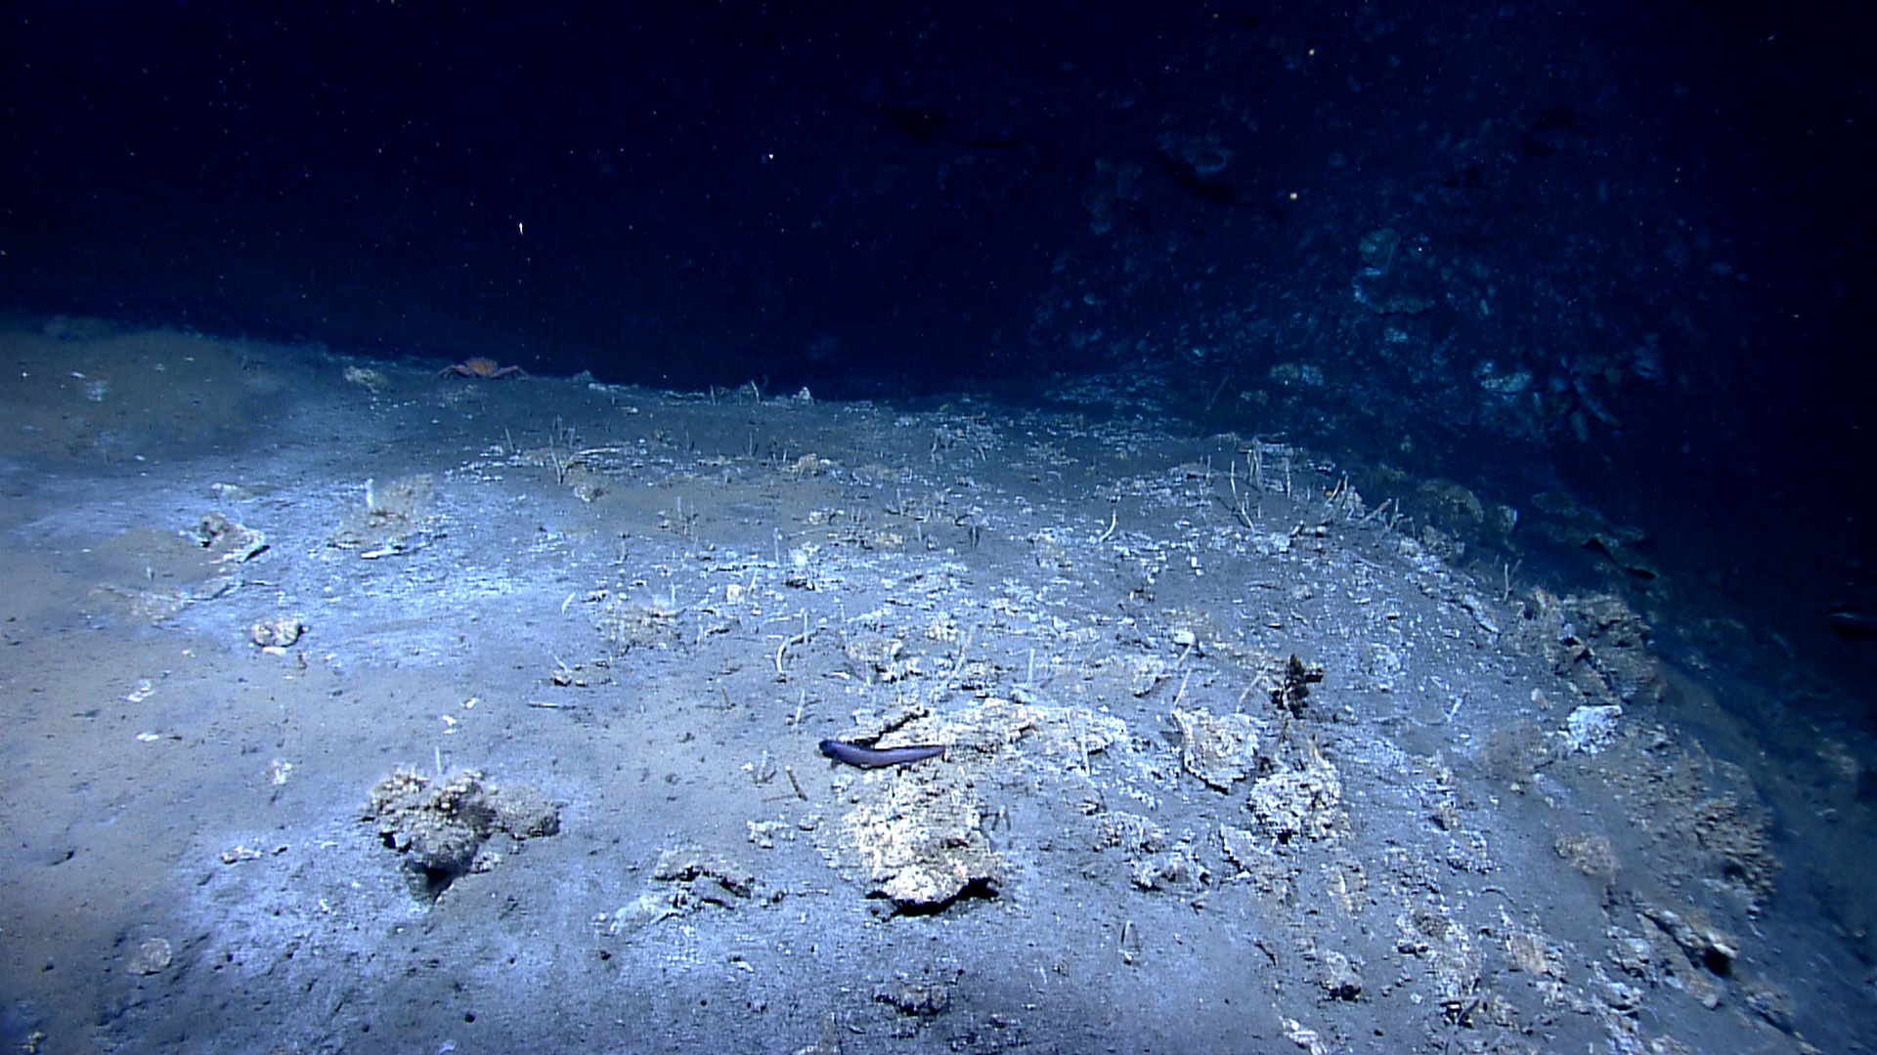
A slope of unstable-looking sediment near the WP2/Seep 4 area. Outcroppings of yellow methane hydrate are visible. |  |  |  | The complex topography around WP2 consisted of many ridges and enclosed depressions, perhaps formed by collapse following dissolution of underlying methane hydrate deposits.
Please direct inquiries to: |  | NOAA Office of Ocean Exploration & Research  1315 East-West Highway (SSMC3 10th Floor)  Silver Spring, MD 20910  (301) 734-1014

