Okeanos Explorer ROV Dive Summary
Site Name | Biloxi Salt Dome B |  |  |  | 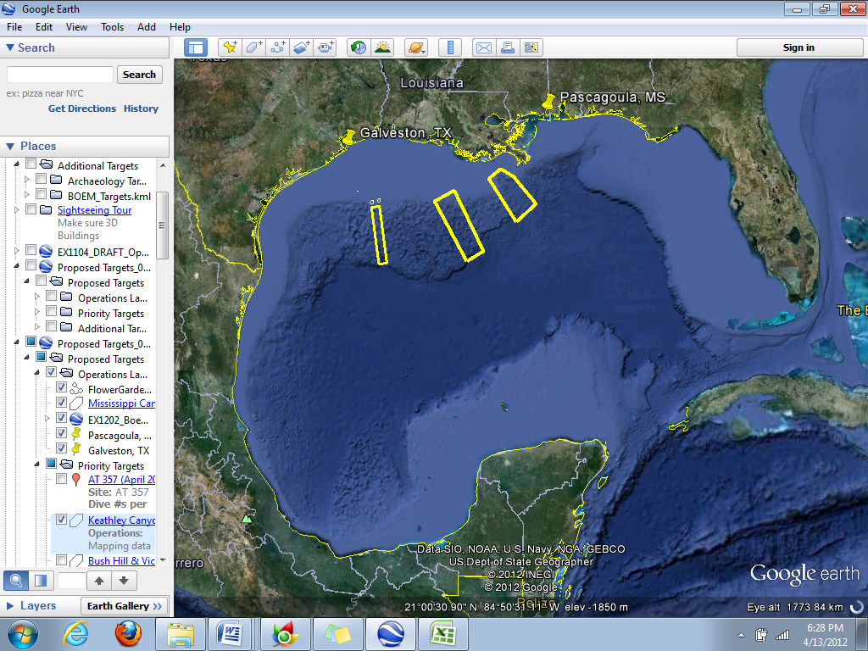
ROV Lead | Dave Lovalvo
General Area Descriptor | Northern Gulf of Mexico
ROV Dive Name | Cruise Season |  | Leg |  |  | Dive Number
 | EX1202 |  | 3 |  |  | DIVE01
Equipment Deployed | ROV: |  | Little Hercules
 | Camera Platform: |  | Seirios
ROV Measurements | CTD |  | Depth |  |  | Altitude
 | Scanning Sonar |  | USBL Position |  |  | Heading
 | Pitch |  | Roll |  |  | HD Camera
 | Low Res Cam 1 |  | Low Res Cam 2
Equipment Malfunctions | Seirios lost comms/and or power for 15min during ascent.
ROV Dive Summary  (From processed ROV data) | Dive Summary: EX1202L3_DIVE01  ^^^^^^^^^^^^^^^^^^^^^^^^^^^^^^^^^^^^^^^^^^^^^^^^^^^  In Water at: 2012-04-12T13:27:47.742000  28°, 40.454' N ; 088°, 28.900' W  Out Water at: 2012-04-12T23:14:56.947000  28°, 40.376' N ; 088°, 27.771' W  Off Bottom at: 2012-04-12T22:11:28.633000  28°, 40.520' N ; 088°, 28.162' W  On Bottom at: 2012-04-12T14:29:28.305000  28°, 40.441' N ; 088°, 28.895' W  Dive duration: 9:47:9  Bottom Time: 7:42:0  Max. depth: 1402.8 m
Special Notes | Click here to enter text.
Scientists Involved  (please provide name / location / affiliation / email) | Jamie Austin (On-board science lead), EX, U. Texas, Austin, jamie@utig.ig.utexas.edu  Erin Becker, EX, Penn State, erinbeckr@gmail.com  Tom Weber (Flux work science lead), UNH, UNH CCOM, weber@ccom.unh.edu  Kevin Jerram, UNH, UNH CCOM, kjerram@gmail.com  Bob Carney, LSU, LSU, rcarne1@lsu.edu  John Reed, HBOI, HBOI, Jreed12@hboi.fau.edu  Mike Vecchione, SI, NOAA/SI, VecchioneM@si.edu  Tim Shank, EX, WHOI, tshank@whoi.edu  Bill Kiene, FGBNMS, FGBNMS, william.kiene@noaa.gov  Cat Munro, WHOI, WHOI, cmunro@whoi.edu  Santiago Herrerra, WHOI, WHOI, sherrera@whoi.edu
Purpose of the Dive
The objective of this dive was to characterize as many seeps as possible in terms of their relative flow rate, apparent flow rate, and the nature of the seep origin (one isolated spots or several closely located seepage points). This dive was also used to select locations for further analysis with both the calibrated grid and methane bucket ROV configurations.

Description of the Dive:
This dive was conducted in a generally W to E direction through 9 waypoints across the SE flank of the exhumed crest of the Biloxi Salt Dome. Bottom topography ranged from smooth, with only small burrows, to a spectacular collapse feature several meters across (near WP 9), perhaps caused by the surfacing of halite followed by its dissolution and cave-in of caprock sediments, and/or by dissolution of clathrate in the caprock of the dome. Associated with this collapse was a cave ~ 1 m across lined with outcropping hydrate associated with a colony of ice worms. Another, smaller hydrate exposure with ice worms was found along the flank of a smaller (hydrate?) mound nearby. Carbonate hardgrounds were encountered intermittently throughout the dive. Most were associated with seep-endemic megafauna, including mussels, tubeworms and alvinocarid shrimp.
Description of the Dive
There were signs of seepage around all waypoints, but only two where we observed visible bubbles. Seep fauna were observed around waypoints 3 and 4, including the mussel Bathymodiolus brooksi and vestimentiferan tubeworms, as well as visible brine staining and bacterial mats. It became apparent that the waypoints derived from the acoustic data might be associated with enough error that the vehicles could be close to bubble plumes that had caused the acoustic scatter, but were simply not observing them in the limited visual fields of the Little Herc ROV and Seirios. As we moved from waypoint 4 to 5, we began to move the ROV back and forth in a “mow the lawn” fashion in order to cover more ground. Seep-endemic fauna were also present around waypoint 5, where we first observed gas bubbles rising from the seafloor very close to a patch of living mussels. These bubbles were intermittent; we concluded that there was not enough volume to conduct follow-on flux measurements at this location. Nonetheless, a virtual marker was dropped at the site, called “Seep 1”.
Between waypoints 5 and 6, we observed a large (~80cm) squid, and as we approached waypoint 6, we began to see bacterial mats (Beggiatoa) and live mussels. Again, we saw intermittent bubbles escaping from the seafloor. We also saw a clump of vestimentiferan tubeworms (Escarpia laminata). A video zoom showed the polychaete worm Protomystides sp. inhabiting the prostomium of one E. laminata individual. Both orange and white Beggiatoa were seen in these bacterial mats, and copepods and amphipods were swarming above these mats, a characteristic of all mats on this dive for which we obtained good close-up imagery. As we moved from waypoint 7 to 8, we came across a mussel bed about halfway between the waypoints. This was the largest mussel bed we observed on this dive and also contained a large size distribution, including some very large individuals of B. brooksi. There were also some small vestimentiferan tubeworms, along with numerous Alvinocaris muricola (shrimp). Between waypoints 8 and 9, we came across some interesting bottom topography, including a mound structure and a large cave-like feature associated with the suspected collapse mentioned above. Upon further inspection, we found that both of these features contained methane hydrate colonized by the methane ice worm Hesiocaeca methanicola. We also identified two distinct, but proximal, streams of methane bubbles. This became a potential location to do flux measurement work, which could be complicated because of bottom topography in the immediate vicinity of the seep. A virtual marker was dropped at the site, called “Seep 2”.
Some background (non-seep) fauna were ubiquitous throughout the dive, while others had a patchier distribution. Shrimp, Chaceon and magid crabs, and various fish (eel pout, rattail, cusk eel) were observed throughout the dive, while holothurians (probably Mesothuria lactea) were not observed until we approached waypoint 6, and then they occurred with some regularity for the remainder of the dive.
Overall Map of ROV Dive Area |  |  |  | Close-up Map of Main Dive Site
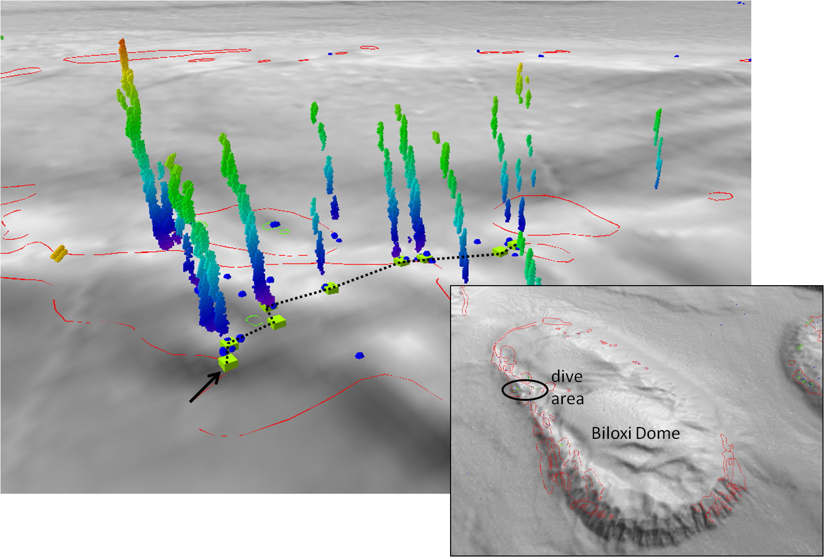
Bathymetric image showing the Biloxi salt dome and dive site “Biloxi B” |  |  |  | Fledermaus image showing sonar data of seeps, and projected dive track.
Representative Photos of the Dive
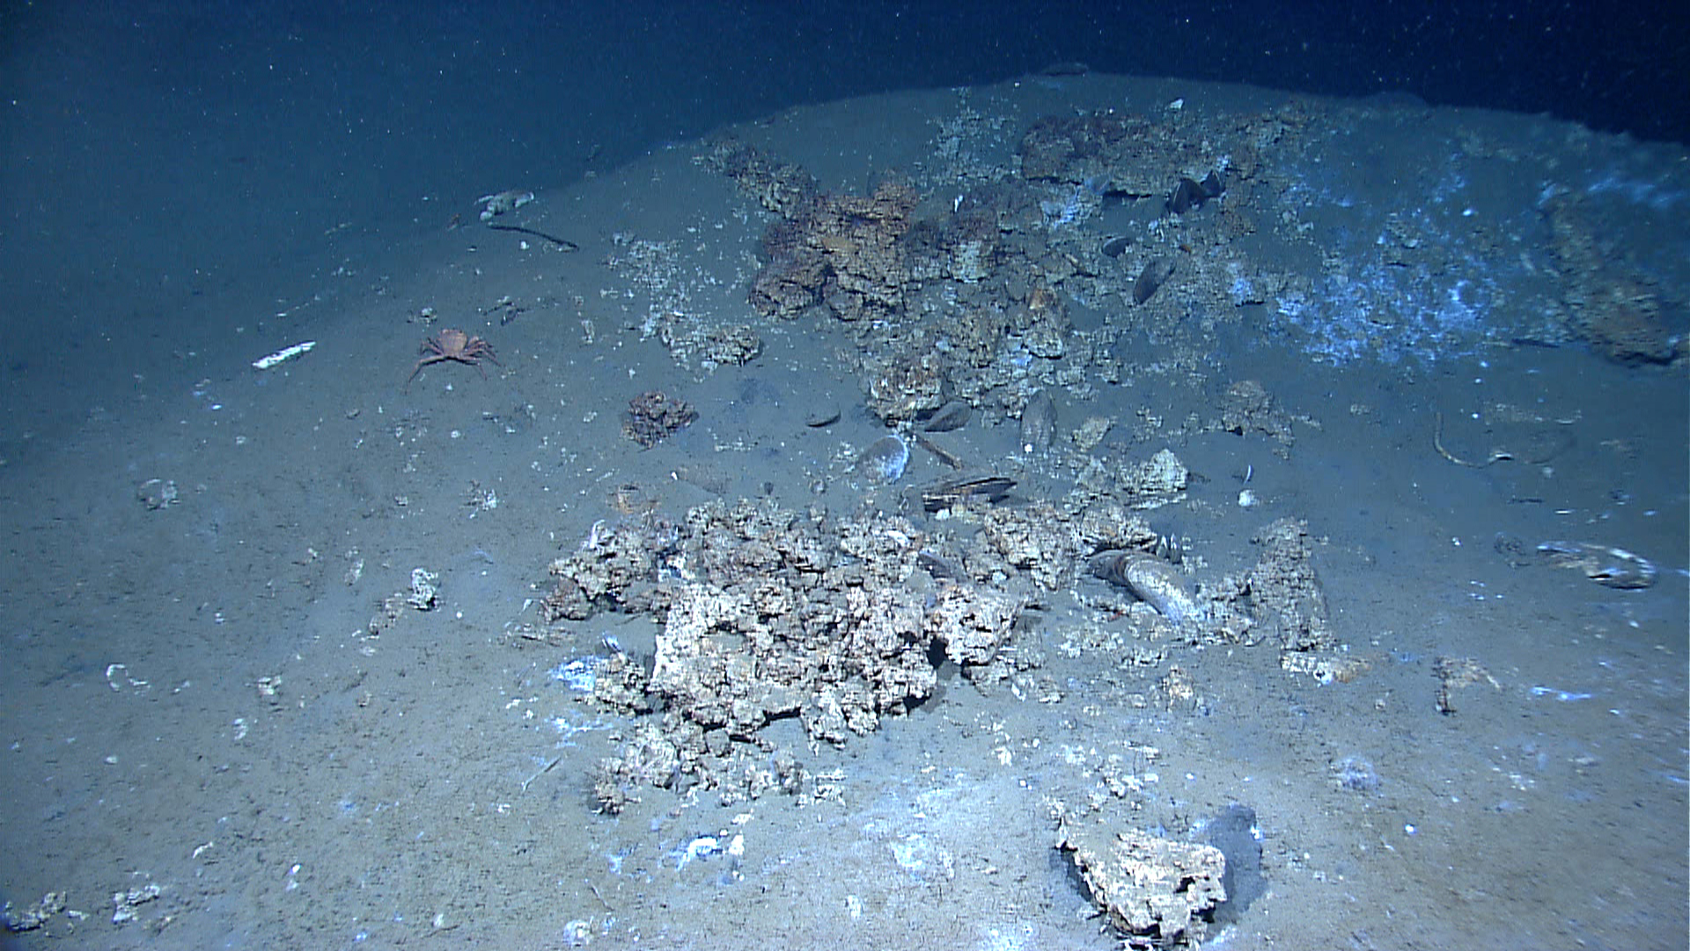 |  |  |  | 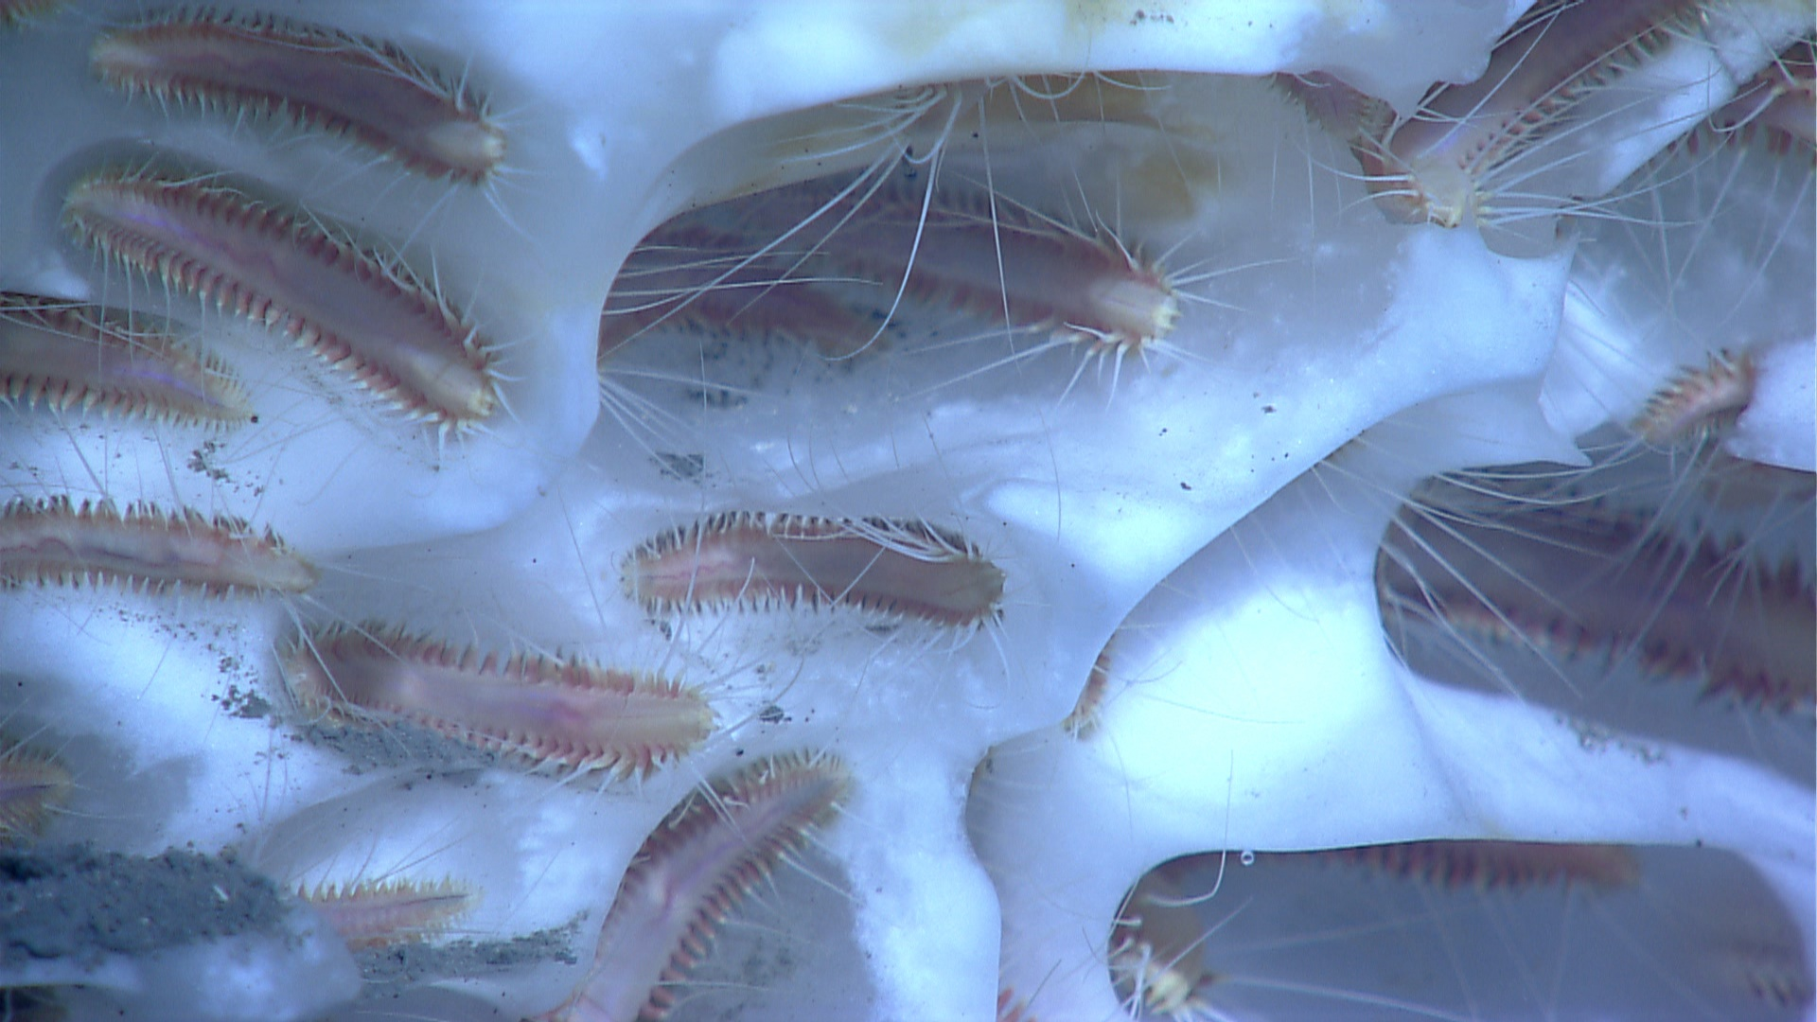
Scattered small carbonate, a few live mussels, and scattered vestimentiferan tubeworms atop a mound. This was a typical site on this dive. |  |  |  | An aggregation of methane ice worms (Hesiocaeca methanicola) inhabiting a white methane hydrate. Studies have suggested that these worms eat chemoautotrophic bacteria that are living off of chemicals in the hydrate and that the worms contribute to the dissolution of the hydrate by beating their parapodia (leg-like appendages) and moving water over the hydrate surface.
Please direct inquiries to: |  | NOAA Office of Ocean Exploration & Research  1315 East-West Highway (SSMC3 10th Floor)  Silver Spring, MD 20910  (301) 734-1014

