Okeanos Explorer ROV Dive Summary
Site Name | KeathlyCanyon |  |  |  | 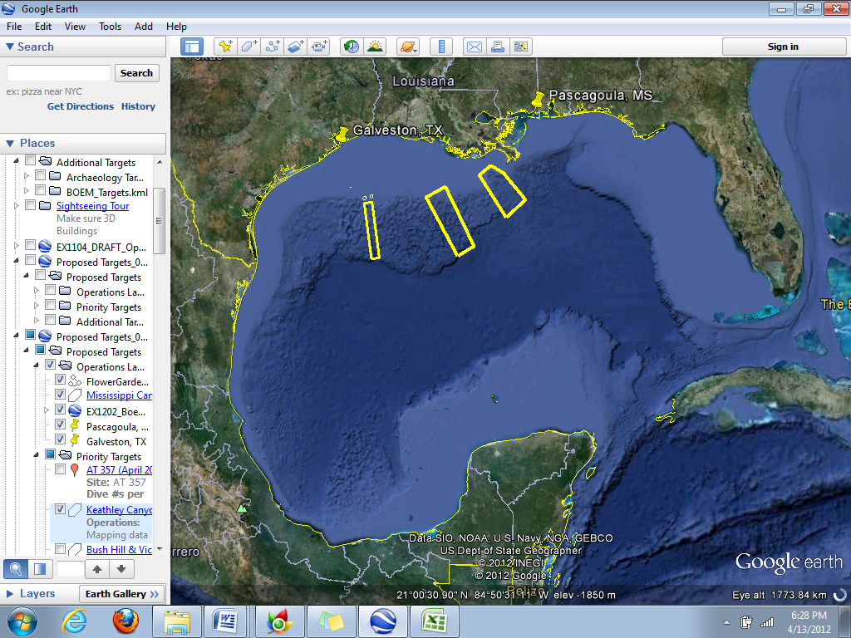
ROV Lead | Dave Lovalvo
General Area Descriptor | Northern Gulf of Mexico
ROV Dive Name | Cruise Season |  | Leg |  |  | Dive Number
 | EX1202 |  | 3 |  |  | DIVE13
Equipment Deployed | ROV: |  | Little Hercules
 | Camera Platform: |  | Seirios
ROV Measurements | CTD |  | Depth |  |  | Altitude
 | Scanning Sonar |  | USBL Position |  |  | Heading
 | Pitch |  | Roll |  |  | HD Camera
 | Low Res Cam 1 |  | Low Res Cam 2
Equipment Malfunctions | N/A
ROV Dive Summary  (From processed ROV data) | Dive Summary: EX1202L3_DIVE13  ^^^^^^^^^^^^^^^^^^^^^^^^^^^^^^^^^^^^^^^^^^^^^^^^^^^  In Water at: 2012-04-27T13:25:24.517000  26°, 18.484' N ; 093°, 25.777' W  Out Water at: 2012-04-27T21:26:30.294000  26°, 17.809' N ; 093°, 26.215' W  Off Bottom at: 2012-04-27T20:04:58.122000  26°, 18.267' N ; 093°, 26.366' W  On Bottom at: 2012-04-27T14:48:42.551000  26°, 18.276' N ; 093°, 25.700' W  Dive duration: 8:1:5  Bottom Time: 5:16:15  Max. depth: 2040.9 m
Special Notes
Scientists Involved  (please provide name / location / affiliation / email) | Jamie Austin (On-board science lead), EX, U. Texas, Austin, jamie@utig.ig.utexas.edu  Erin Becker, EX, Penn State, erinbeckr@gmail.com  Tom Weber (Flux work science lead), UNH, UNH CCOM, weber@ccom.unh.edu  Larry Mayer, UNH, UNH CCOM, larry@ccom.unh.edu  Kevin Jerram, UNH, UNH CCOM, kjerram@gmail.com  Bob Carney, LSU, LSU, rcarne1@lsu.edu  Mike Vecchione, SI, NOAA/SI  Bill Kiene, FGBNMS, FGBNMS, william.kiene@noaa.gov
Purpose of the Dive

Description of the Dive:
Overall Map of ROV Dive Area |  |  |  | Close-up Map of Main Dive Site
Representative Photos of the Dive
Please direct inquiries to: |  | NOAA Office of Ocean Exploration & Research  1315 East-West Highway (SSMC3 10th Floor)  Silver Spring, MD 20910  (301) 734-1014

