Okeanos Explorer ROV Dive Summary
Site Name | Biloxi Dome A |  |  |  | 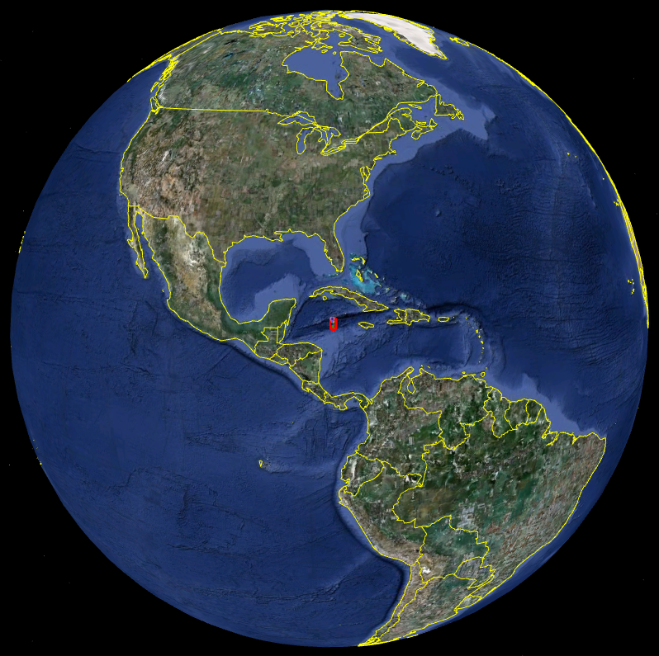
ROV Lead | Dave Lovalvo
General Area Descriptor
ROV Dive Name | Cruise Season |  | Leg |  |  | Dive Number
 | EX1202 |  | 3 |  |  | DIVE02
Equipment Deployed | ROV: |  | Little Hercules
 | Camera Platform: |  | Seirios
ROV Measurements | CTD |  | Depth |  |  | Altitude
 | Scanning Sonar |  | USBL Position |  |  | Heading
 | Pitch |  | Roll |  |  | HD Camera
 | Low Res Cam 1 |  | Low Res Cam 2
Equipment Malfunctions | N/A
ROV Dive Summary  (From processed ROV data) | Dive Summary: EX1202L3_DIVE02  ^^^^^^^^^^^^^^^^^^^^^^^^^^^^^^^^^^^^^^^^^^^^^^^^^^^  In Water at: 2012-04-13T13:28:02.401000  28°, 38.849' N ; 088°, 27.525' W  Out Water at: 2012-04-13T21:33:51.249000  28°, 38.397' N ; 088°, 27.298' W  Off Bottom at: 2012-04-13T20:28:48.897000  28°, 38.765' N ; 088°, 27.501' W  On Bottom at: 2012-04-13T14:25:36.836000  28°, 38.821' N ; 088°, 27.532' W  Dive duration: 8:5:48  Bottom Time: 6:3:12  Max. depth: 1418.1 m
Special Notes | Click here to enter text.
Scientists Involved
(please provide name / location / affiliation / email)
Purpose of the Dive
Description of the Dive:
Overall Map of ROV Dive Area |  |  |  | Close-up Map of Main Dive Site
Representative Photos of the Dive
xxx |  |  |  | xxx
Please direct inquiries to: |  | NOAA Office of Ocean Exploration & Research  1315 East-West Highway (SSMC3 10th Floor)  Silver Spring, MD 20910  (301) 734-1014

