Okeanos Explorer ROV Dive Summary
Site Name | KeathleyCanyon |  |  |  | 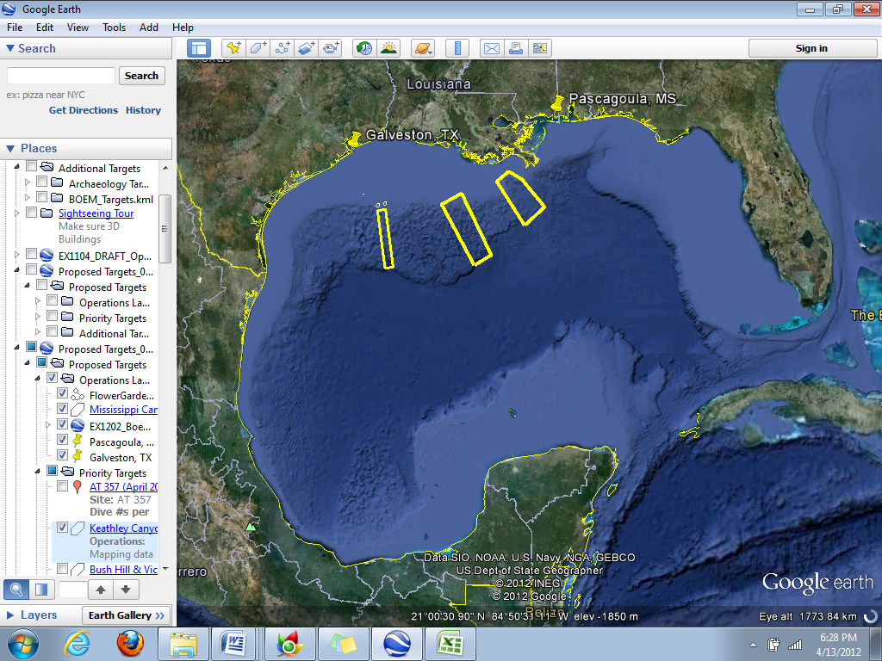
ROV Lead | Dave Lovalvo
General Area Descriptor | Northern Gulf of Mexico
ROV Dive Name | Cruise Season |  | Leg |  |  | Dive Number
 | EX1202 |  | 3 |  |  | DIVE13
Equipment Deployed | ROV: |  | Little Hercules
 | Camera Platform: |  | Seirios
ROV Measurements | CTD |  | Depth |  |  | Altitude
 | Scanning Sonar |  | USBL Position |  |  | Heading
 | Pitch |  | Roll |  |  | HD Camera
 | Low Res Cam 1 |  | Low Res Cam 2
Equipment Malfunctions | N/A
ROV Dive Summary  (From processed ROV data) | Dive Summary: EX1202L3_DIVE13  ^^^^^^^^^^^^^^^^^^^^^^^^^^^^^^^^^^^^^^^^^^^^^^^^^^^  In Water at: 2012-04-27T13:25:24.517000  26°, 18.484' N ; 093°, 25.777' W  Out Water at: 2012-04-27T21:26:30.294000  26°, 17.809' N ; 093°, 26.215' W  Off Bottom at: 2012-04-27T20:04:58.122000  26°, 18.267' N ; 093°, 26.366' W  On Bottom at: 2012-04-27T14:48:42.551000  26°, 18.276' N ; 093°, 25.700' W  Dive duration: 8:1:5  Bottom Time: 5:16:15  Max. depth: 2040.9 m
Special Notes
Scientists Involved  (please provide name / location / affiliation / email) | Jamie Austin (On-board science lead), EX, U. Texas, Austin, jamie@utig.ig.utexas.edu  Erin Becker, EX, Penn State, erinbeckr@gmail.com  Santiago Herrera, WHOI, sherrera@whoi.edu  Andrea Quattrini, Temple, andrea.quattrini@temple.edu  John Reed, HBOI, HBOI, Jreed12@hboi.fau.edu  Bill Kiene, FGBNMS, FGBNMS, william.kiene@noaa.gov
Purpose of the Dive
The dive on the western flank of Keathley Canyon will start at a depth of ~2040 m and climb upslope to WP2 at 1930m. We will then continue upward to WP3 on a ridge feature (1820 m). This dive will provide contrast to previous work conducted in other regions of the Gulf of Mexico and, to our knowledge, provide the first data on species living here.
Description of the Dive:
The vehicles were in the water at ~0825 CDT. The objective of this dive was to climb a portion of the lower western wall of the Keathley Canyon. First visual sighting by the ROV of a sedimented, burrowed seafloor occurred at ~0945 CDT, at a depth of ~2035 m. For the entire dive, a sedimented seafloor with no outcrops persisted. Only one small rocky hardground was encountered. In places, the seafloor was also furrowed, a testament to the presence of intermittent bottom currents in this area. Such currents were also encountered by the vehicles during the transit.
Despite the relatively featureless seafloor, there were a number of interesting animals, many having fascinating interactions with one another. We saw many sea pens (mostly isidid ocotocorals) and a few small basket-shaped isidid corals. The basket isidids each had one shrimp associate clinging to the branches and two had another tiny shrimp hovering about the polyps like a hummingbird. One sea pen was being predated by a large fat seastar that was slowly climbing the coral skeleton eating all living tissue along the way. We saw another one of these seastars under a chrysogorgid coral, probably preying about that coral as well. There were many holothurians of at least three different types and several fish, including tripod fish, ipnops (has photoreceptor on the top of its head instead of eyes), a giant snake eel, halosaurs, and rattails. There were at least three different kinds of sponges. Cylindrical hexactinellid sponges held a pairs of amphipods within a cage of spicules, a long stalked sponge had zoanthids on the stalk and tiny amphipods swimming about its cone-shaped top, and another round sponge sat atop an ophiuroid, which sat atop an anemone. There were many pterapod shells scattered about as there often are on the deep sea, but we came across one clump curiously cemented together in the shape of a sea cucumber. No animal was visible inside the shell of pterapod shells. There seemed to be quite a lot of sargassum on the seafloor, mostly resting in small indentions or large trenches. A Magnapinna squid with very long tentacles hung vertically in the water column until it swam away when approached by the ROV. There were many large furrows thought to be whale feeding traces.
The vehicles came off the seafloor at ~1505 CDT
Overall Map of ROV Dive Area |  |  |  | Close-up Map of Main Dive Site
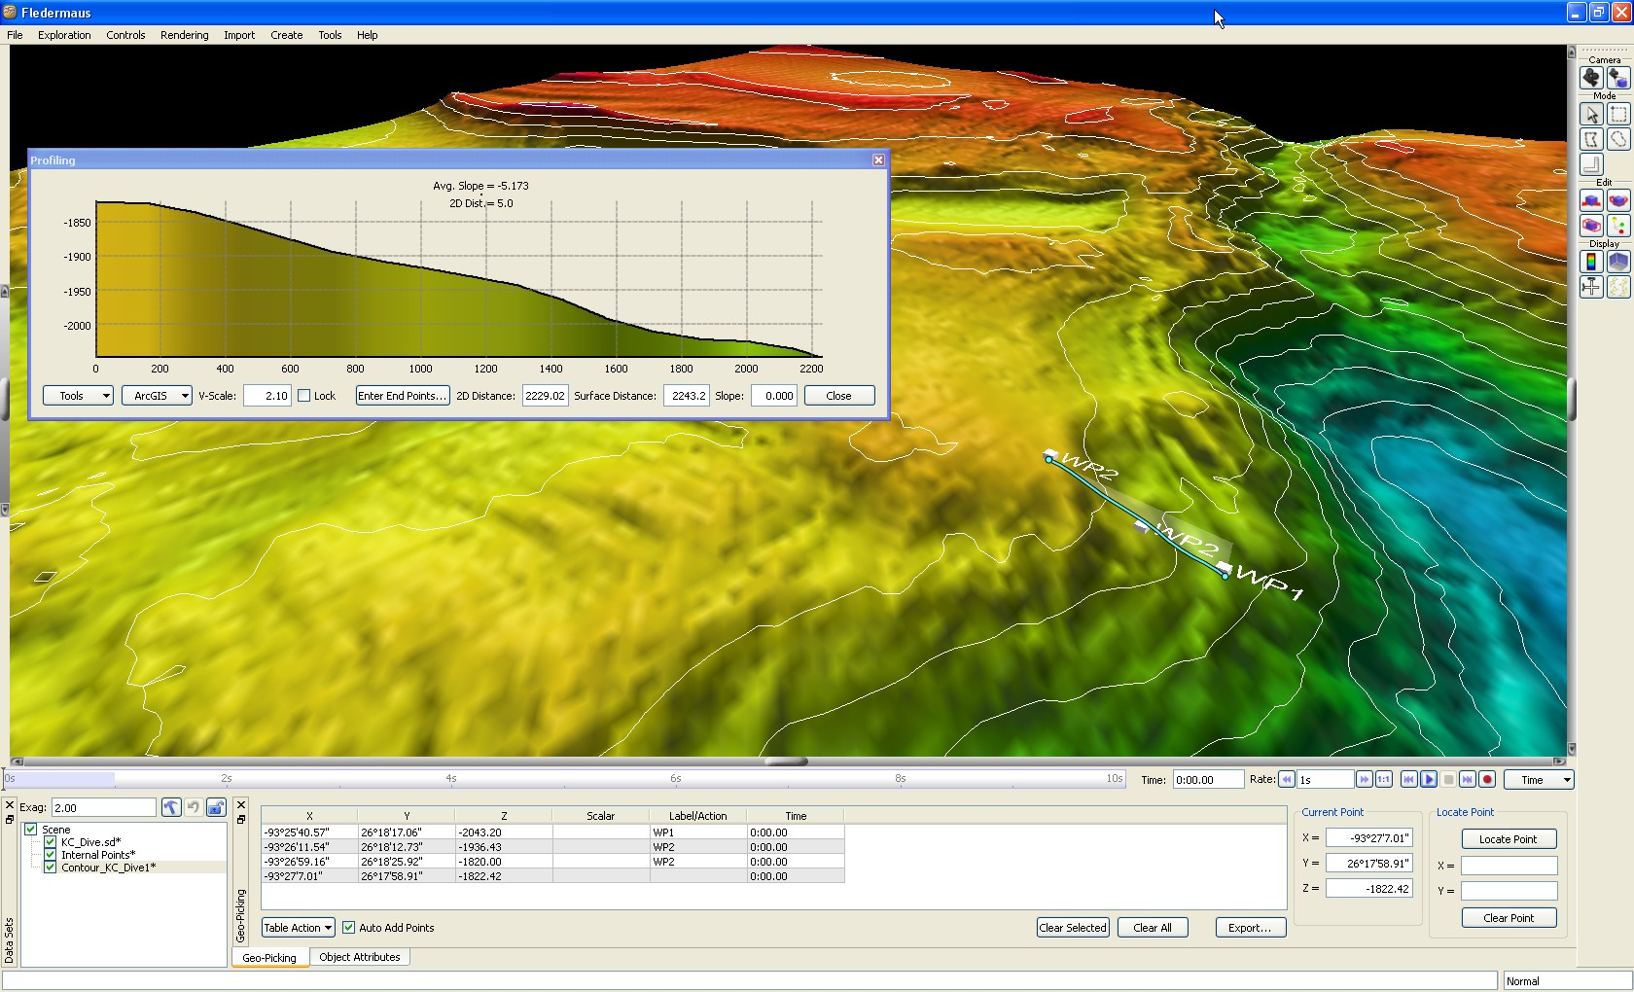 |  |  |  | 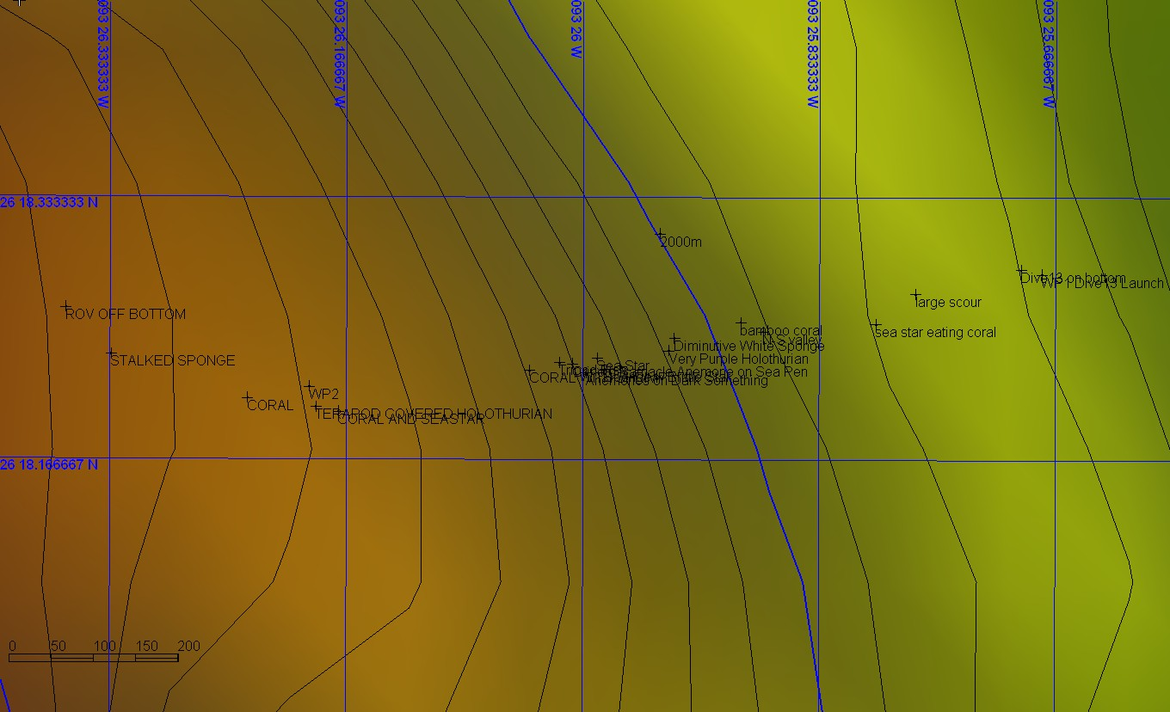
Representative Photos of the Dive
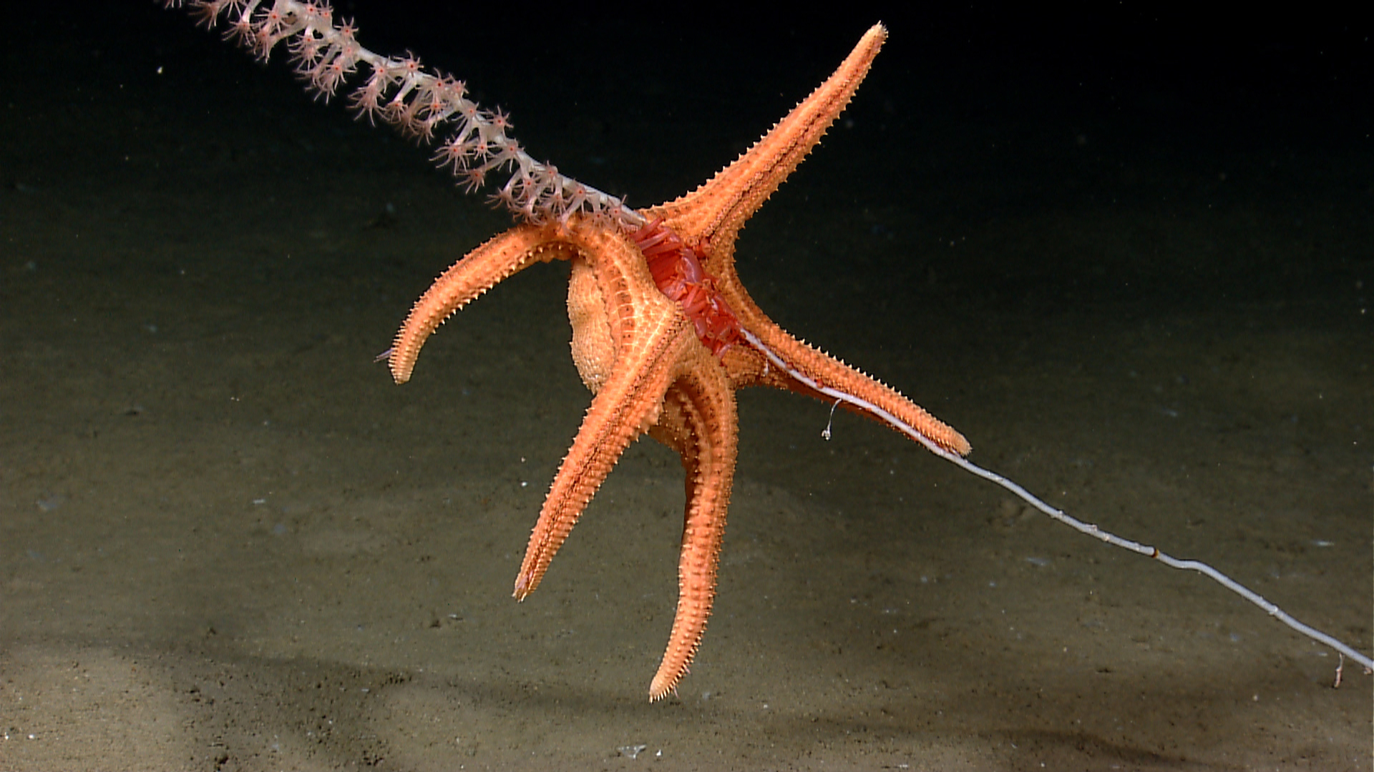 |  |  |  | 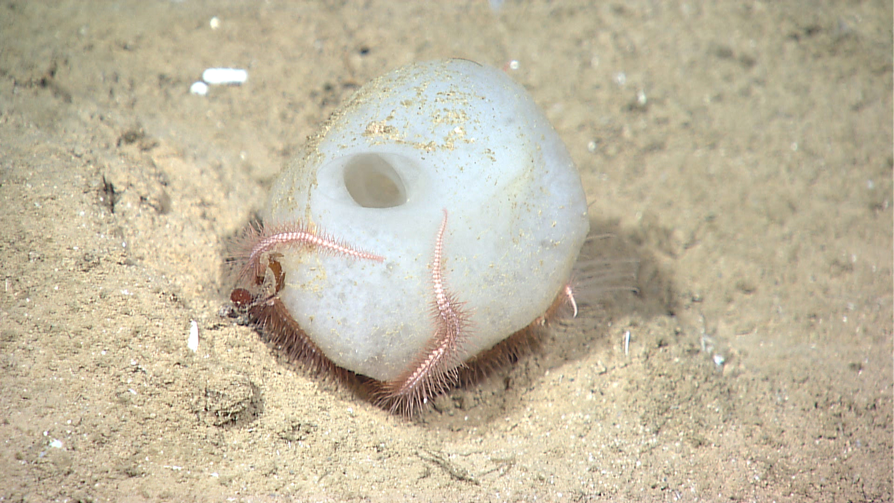
A predatory sea star eating a sea pen (isidid octocroal). |  |  |  | A sponge sitting atop a small anemone (anemone tentacles on the right behind the sponge). A brittle star wraps its arms around the sponge from underneath.
Please direct inquiries to: |  | NOAA Office of Ocean Exploration & Research  1315 East-West Highway (SSMC3 10th Floor)  Silver Spring, MD 20910  (301) 734-1014

