Okeanos Explorer ROV Dive Summary
Site Name | KC Wreck 15577 |  |  |  | 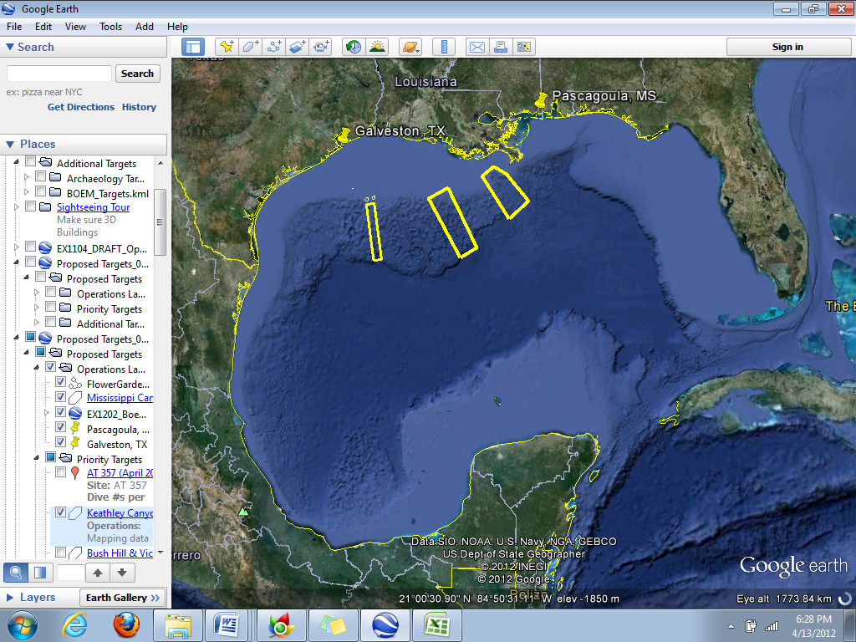
ROV Lead | Dave Lovalvo
General Area Descriptor | Northern Gulf of Mexico
ROV Dive Name | Cruise Season |  | Leg |  |  | Dive Number
 | EX1202 |  | 3 |  |  | DIVE12
Equipment Deployed | ROV: |  | Little Hercules
 | Camera Platform: |  | Seirios
ROV Measurements | CTD |  | Depth |  |  | Altitude
 | Scanning Sonar |  | USBL Position |  |  | Heading
 | Pitch |  | Roll |  |  | HD Camera
 | Low Res Cam 1 |  | Low Res Cam 2
Equipment Malfunctions | N/A
ROV Dive Summary  (From processed ROV data) | Dive Summary: EX1202L3_DIVE12  ^^^^^^^^^^^^^^^^^^^^^^^^^^^^^^^^^^^^^^^^^^^^^^^^^^^  In Water at: 2012-04-26T23:42:34.888000  Out Water at: 2012-04-27T04:13:27.548000  Off Bottom at: 2012-04-27T03:21:06.291000  On Bottom at: 2012-04-27T00:44:01.123000  Dive duration: 4:30:52  Bottom Time: 2:37:5  Max. depth: 1333.7 m
Special Notes
Scientists Involved  (please provide name / location / affiliation / email) | Jamie Austin (On-board science lead), EX, U. Texas, Austin, jamie@utig.ig.utexas.edu  Erin Becker, EX, Penn State, erinbeckr@gmail.com  Jack Irion (chief scientist), New Orleans, BOEM, jack.irion@boem.gov  Dan Warren, Houston, C&C Technologies, djw@cctechnol.com  Kim Faulk, Houston, GEMS, Kim.Faulk@f-e-t.com  Amanda Evans, Baton Rouge, LSU, evansa@teslaoffshore.com  James Delgado, NOAA Maritime Heritage Program, james.delgado@noaa.gov
Purpose of the Dive
Site 15577 was initially located as a sonar contact in October 2011 during an oil and gas industry survey. The target measures approximately 84 feet long, 26 feet wide, and stands 10 feet high. The collected data may show a largely intact wooden vessel with masts resting on the seafloor. It is unknown at this time whether Site 15577 represents a significant historical resource. An archaeological ROV dive over this site would assist in determining the preliminary potential for the site to be listed on the National Register of Historic Places.
Description of the Dive:
Site 15577 was found to be the remains of a large wooden-hulled sailing vessel sheathed in copper below the waterline as protection against marine boring organisms. Most of the wooden hull had deteriorated, leaving a copper shell retaining the form of the ship. Inside the remains of the hull was a dense concentration of artifacts relating to its use and function, and life aboard the vessel at the time of its demise. Some of the artifacts observed included two anchors resembling the Pering 1813 patent type; at least two cannon; muskets; the ship’s stove; numerous bottles, including liquor, wine, medicine, and food storage bottles; dinnerware including plates, platters and cups; a large number of storage jars; and navigational instruments such as an octant, a spyglass, a compass binnacle, and numerous sand clocks. Most of the artifacts are remarkable for their state of preservation, including several plates that appear to be English green shell-edged pearlware, which enjoyed its greatest popularity between 1802 and 1832. What appeared to be masts in the sidescan image are most likely shadows cast by concentrations of artifacts within the hull, although the area of the wreck away from the hull was not examined in detail due to time constraints. However, one of the mast trucks was found some 20 meters outboard of the hull. The shipwreck was determined to be of National Register significance. Further analysis of the video is expected to yield additional results and observations.
Biology was sparse on the wreck due to the copper sheathing, but there were several venus flytrap and other anemones on artifacts and on the apparent lead sheathing coating both bow and stern keel lines. The exposed portions of the keel were also covered in hydroids. There was a lone vestimentiferan tubeworm on sediment filling the inside of the wreck. It is possible that organic enrichment from decaying wood and/or unknown cargo created a reducing environment in the sediment, allowing the tubeworm to live there.
Overall Map of ROV Dive Area |  |  |  | Close-up Map of Main Dive Site
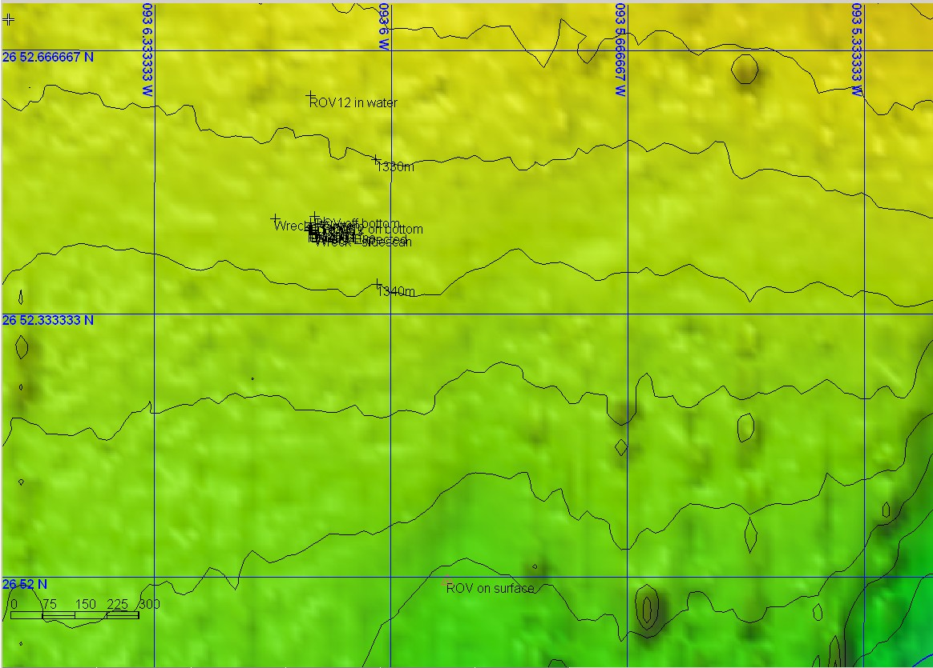 |  |  |  | 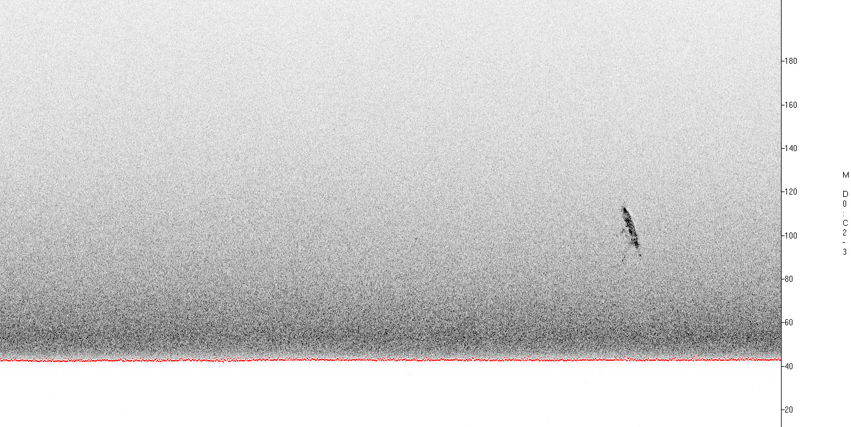
Representative Photos of the Dive
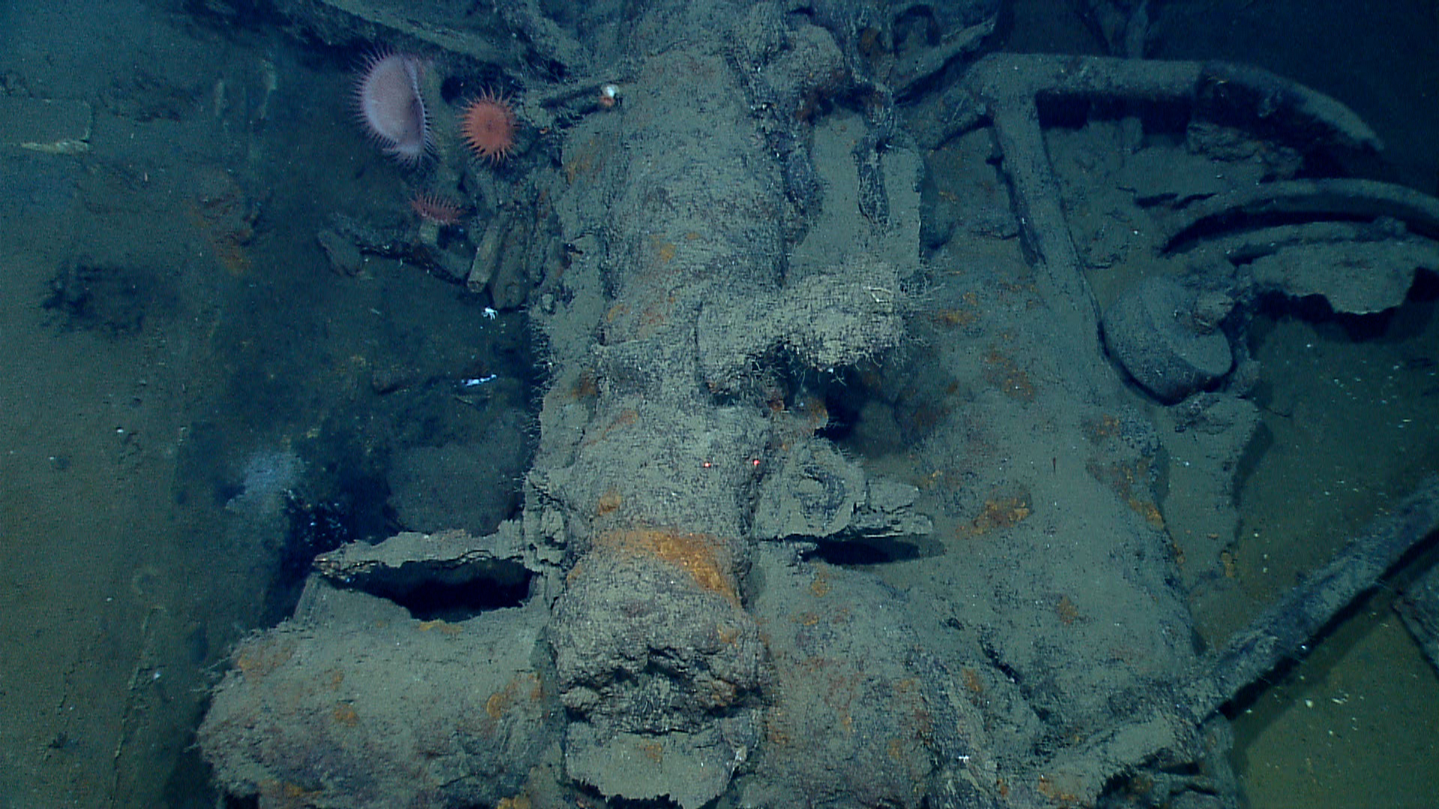 |  |  |  | 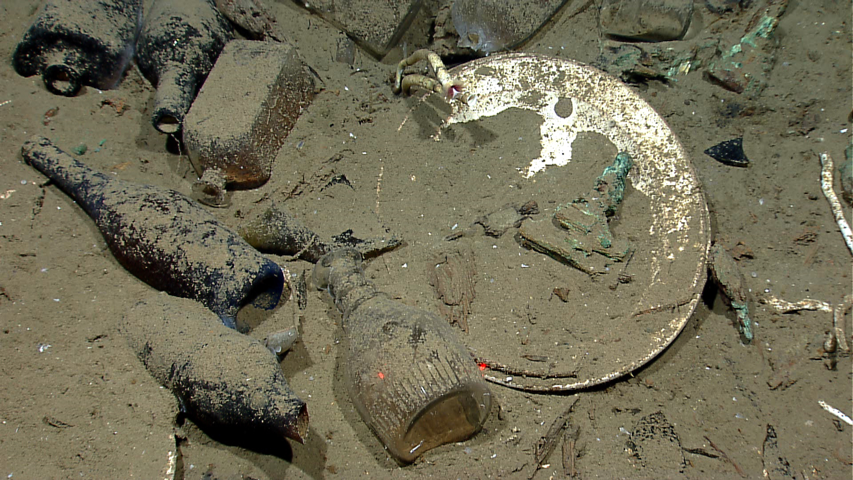
Much of the ship’s equipment remained inside the hull, including cannons, the ship’s stove, navigational instruments and anchors. A cannon, anchor and the wheel of a gun carriage are visible in the image above. |  |  |  | A variety of artifacts inside the ship's hull relates either to daily life on board or the ship’s cargo. These artifacts included ceramic plates, platters and bowls, along with glass liquor, wine, medicine and food storage bottles of many shapes and colors (some with the contents still sealed inside).
Please direct inquiries to: |  | NOAA Office of Ocean Exploration & Research  1315 East-West Highway (SSMC3 10th Floor)  Silver Spring, MD 20910  (301) 734-1014

