Okeanos Explorer ROV Dive Summary
Site Name | SWofSigsbee |  |  |  | 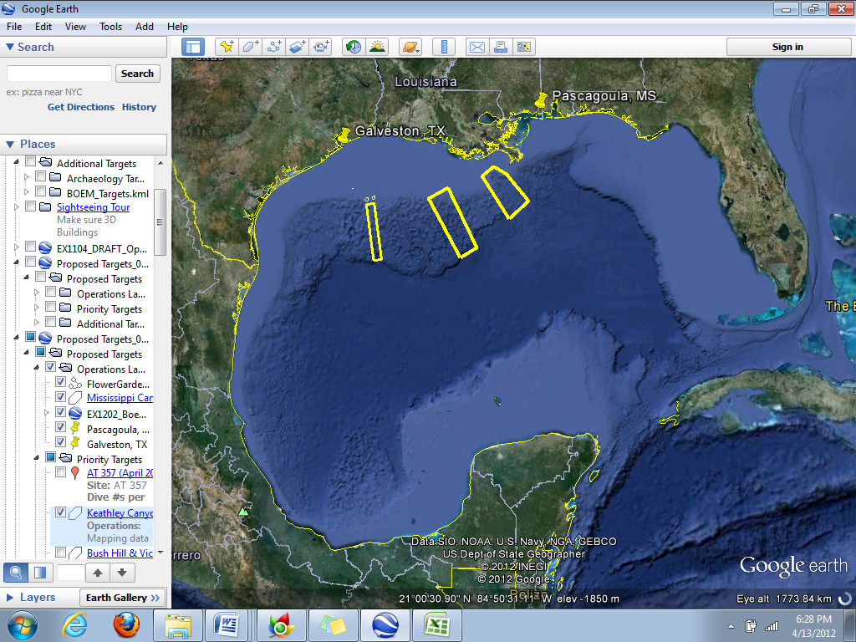
ROV Lead | Dave Lovalvo
General Area Descriptor | Northern Gulf of Mexico
ROV Dive Name | Cruise Season |  | Leg |  |  | Dive Number
 | EX1202 |  | 3 |  |  | DIVE11
Equipment Deployed | ROV: |  | Little Hercules
 | Camera Platform: |  | Seirios
ROV Measurements | CTD |  | Depth |  |  | Altitude
 | Scanning Sonar |  | USBL Position |  |  | Heading
 | Pitch |  | Roll |  |  | HD Camera
 | Low Res Cam 1 |  | Low Res Cam 2
Equipment Malfunctions | N/A
ROV Dive Summary  (From processed ROV data) | Dive Summary: EX1202L3_DIVE11  ^^^^^^^^^^^^^^^^^^^^^^^^^^^^^^^^^^^^^^^^^^^^^^^^^^^  In Water at: 2012-04-25T13:48:53.920000  26°, 43.115' N ; 090°, 35.482' W  Out Water at: 2012-04-25T23:00:18.670000  26°, 43.277' N ; 090°, 35.465' W  Off Bottom at: 2012-04-25T21:42:30.829000  26°, 43.685' N ; 090°, 35.738' W  On Bottom at: 2012-04-25T15:15:49.784000  26°, 43.224' N ; 090°, 35.502' W  Dive duration: 9:11:24  Bottom Time: 6:26:41  Max. depth: 2094.9 m
Special Notes
Scientists Involved  (please provide name / location / affiliation / email) | Jamie Austin (On-board science lead), EX, U. Texas, Austin, jamie@utig.ig.utexas.edu  Erin Becker, EX, Penn State, erinbeckr@gmail.com  Bill Kiene, FGBNMS, FGBNMS, william.kiene@noaa.gov  Santiago Herrera, WHOI, sherrera@whoi.edu  Catriona Muro, WHOI, cmunro@whoi.edu  Mary Wicksten, TAMU, wicksten@bio.tamu.edu  Andrea Quattrini, Temple, andrea.quattrini@temple.edu  Dan Warren, Houston, C&C Technologies, Inc., dan.warren@cctechnol.com  Bill Shedd, BOEM, William.Shedd@boem.gov
Purpose of the Dive
The dive on the deep Sigsbee Escarpment will start at a depth of ~2100 m and climb up the escarpment to WP2 at the top of the escarpment (~1800m). We will then continue upward to WP3 at the top of an adjacent ridge feature (~1750 m). Exploration of the Florida Escarpment during Leg 2 of this expedition revealed large communities of gorgonian corals on areas of pronounced slope. This dive will provide contrast to this previous work and, in addition to Dive 12, provide the first data on the coral species living in the Sigsbee Escarpment region.

Description of the Dive:
Geology and ops summary
The vehicles were in the water a little later than usual, as a result of a need to re-calibrate the DP system. The ROV was on the seafloor at a depth of ~2090 m at 1020 CDT. The slope near WP 1 was steep, resembling an avalanche slope of diverse rock fragments. No encrusting biology was observed. As the vehicles moved upslope, the geology became dominated by thinly layered mudstones (probably turbidites related to distal Mississippi Cone deposition; age unknown, but probably less than several million years). Slopes were steep to vertical, and currents across and downslope were occasionally strong.
Occasional bedding plane outcrops, which appeared as near-horizontal steps in the otherwise steep slope, furnished habitat for a variety of deep-water corals and their associates, on both bedding planes and fragments. Other parts of this steep, stepped slope were covered with a dusting (thickness indeterminate) of fine-grained hemipelagic sediments. On this sedimented part of the slope, biology was largely absent.
The slope above 1900 m became more gentle, although strong currents were still apparent. The seafloor was predominantly sedimented, with minor burrowing. Small fragments of mudstone accommodated isolated occurrences of corals, anemones, occasional encrusting sponges, and other organisms (see biology).
During a live event for the Aquarium of the Pacific in the midst of the dive, a stunning bright red swimming holothurian was observed in the mid-water for several minutes.
The vehicles left the seafloor at 1640 CDT, from a depth of ~1830 m. They were back on deck at ~1815 CDT.
Biology
At a depth of ~2060 m, we encountered the first significant biological community on a horizontal step on the slope where hard substrates were present. Several colonies of Paramuricid ocotocorals were encountered, and with them brittle star associates, presumably of the genus *Asteroschema*. Other noteworthy habitants of this community included whip, fan, and bushy bamboo corals (Keratoisidinae), and a few chrysogorgid corals cf. *Iridogorgia* and cf. *Chrysogorgia* with their respective crustacean associates (shrimp cf. *B. serratipalma*), small paragorgiid bubblegum corals, a couple of mushroom corals cf. *Anthomastus*, *Swiftia*, and hexactinellid glass sponges. Large comatulid crinoids and squat lobsters were the most abundant mobile benthic fauna.

A second large horizontal step area containing megafaunal communities was found at a depth of ~1965 m. Several scattered colonies of the same paramuricid + ophiuroid combination seen at deeper water depths were found, as well as several stoloniferan colonies of at least three different color morphs: yellow, white and purple (cf. *Clavularia*), and a few chrysogorgids.

Finally, at depths of 1890-1860 m, we found the last conspicuous area containing significant communities. Several scattered fragments of hardgrounds provided suitable habitat to many paramuricid + ophiuroid systems, as well as small bubblegum corals.
Overall Map of ROV Dive Area |  |  |  | Close-up Map of Main Dive Site
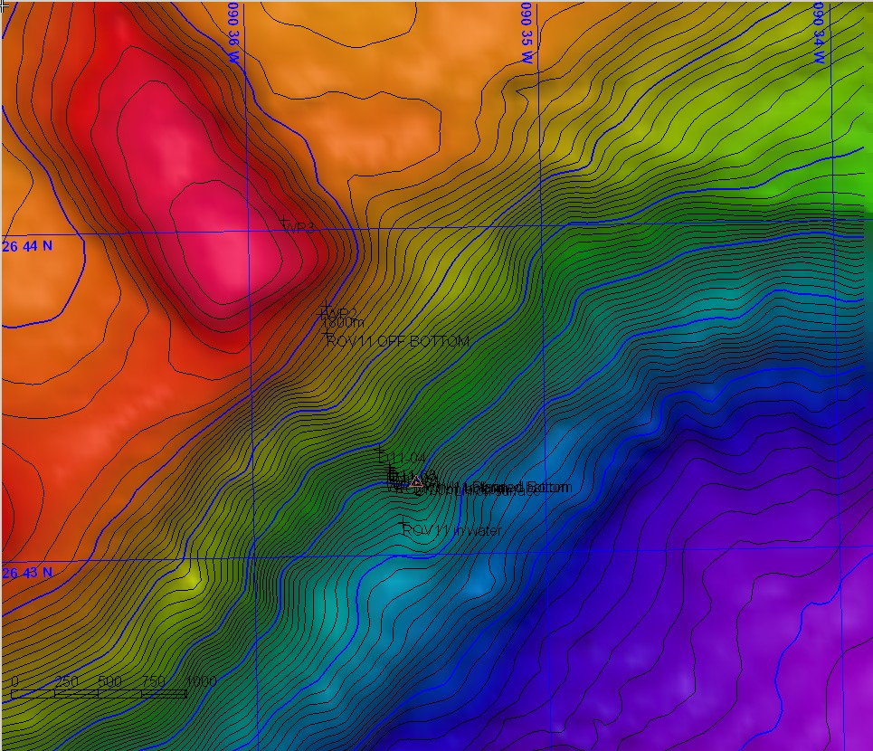 |  |  |  | 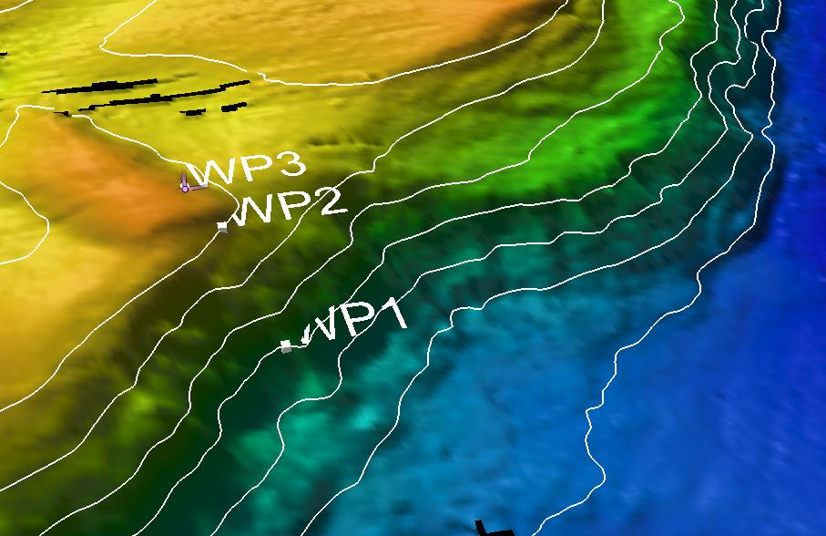
Representative Photos of the Dive
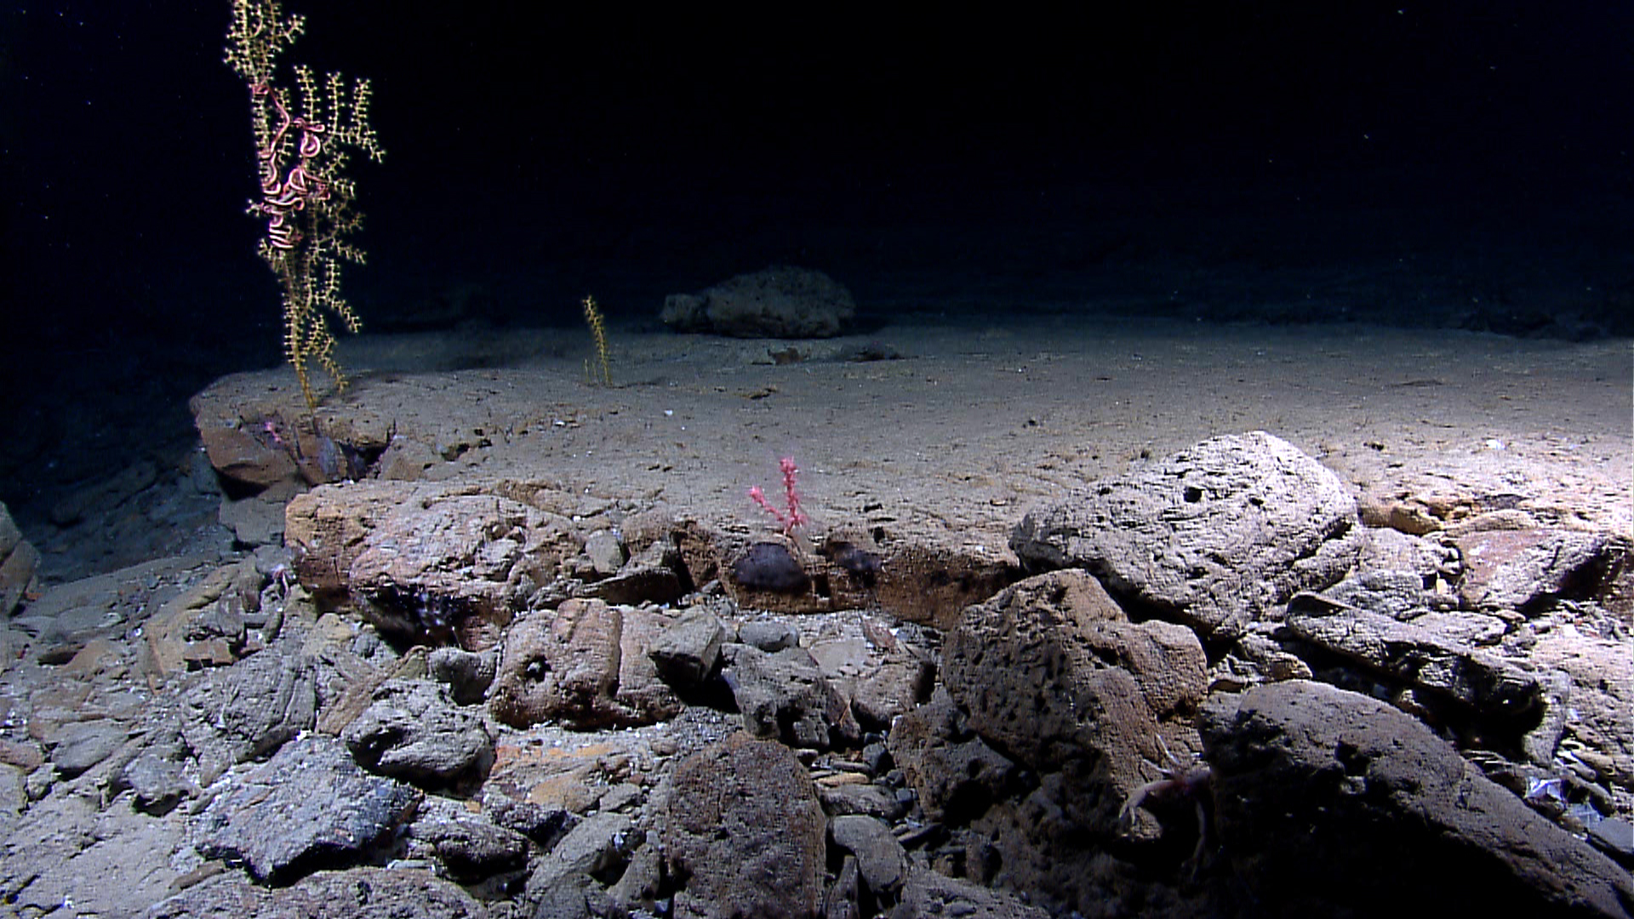 |  |  |  | 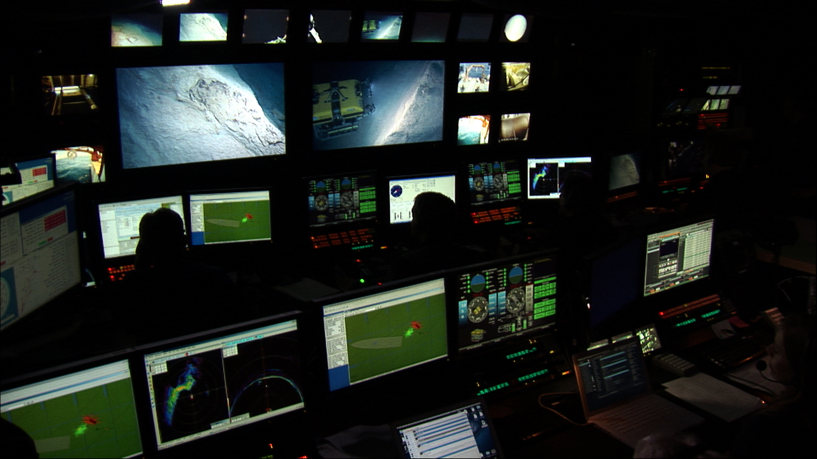
Soft corals colonized the flat step areas between steep cliff faces. |  |  |  | A photo of the control room during the Aquarium of the Pacific telepresence event. The right large monitor is the Seirios view of the Little Herc ROV viewing the edge of a steep cliff face.
Please direct inquiries to: |  | NOAA Office of Ocean Exploration & Research  1315 East-West Highway (SSMC3 10th Floor)  Silver Spring, MD 20910  (301) 734-1014

