Okeanos Explorer ROV Dive Summary
Site Name | GC 470 |  |  |  | 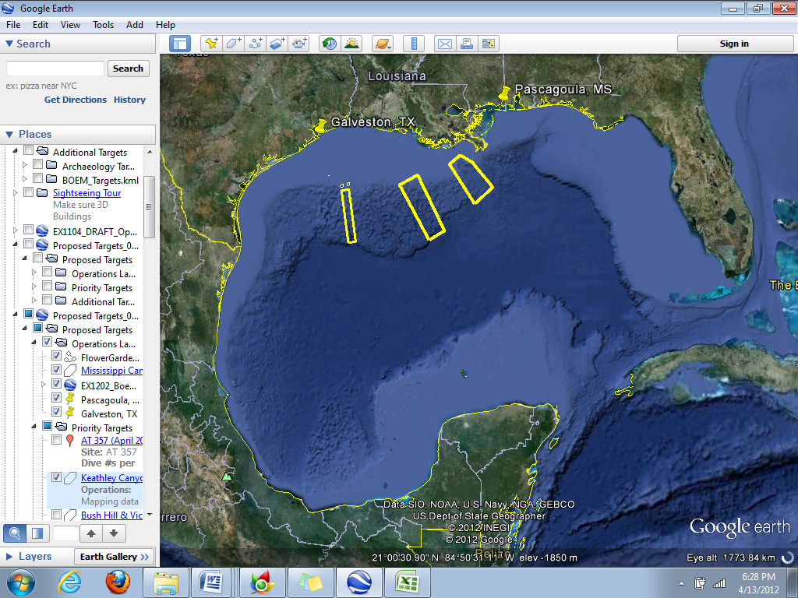
ROV Lead | Dave Lovalvo
General Area Descriptor | Northern Gulf of Mexico
ROV Dive Name | Cruise Season |  | Leg |  |  | Dive Number
 | EX1202 |  | 3 |  |  | DIVE09
Equipment Deployed | ROV: |  | Little Hercules
 | Camera Platform: |  | Seirios
ROV Measurements | CTD |  | Depth |  |  | Altitude
 | Scanning Sonar |  | USBL Position |  |  | Heading
 | Pitch |  | Roll |  |  | HD Camera
 | Low Res Cam 1 |  | Low Res Cam 2
Equipment Malfunctions | N/A
ROV Dive Summary
(From processed ROV data)
Special Notes
Scientists Involved  (please provide name / location / affiliation / email) | Jamie Austin (On-board science lead), EX, U. Texas, Austin, jamie@utig.ig.utexas.edu  Erin Becker, EX, Penn State, erinbeckr@gmail.com  Tom Weber (Flux work science lead), UNH, UNH CCOM, weber@ccom.unh.edu  Bill Shedd, Stennis ECC, BOEM, William.Shedd@boem.gov  Kody Kramer, Stennis ECC, BOEM, Kody.Kramer@boem.gov  Bob Carney, LSU, LSU, rcarne1@lsu.edu  Mike Vecchione, SI, NOAA/SI, VecchioneM@si.edu  Bill Kiene, FGBNMS, FGBNMS, william.kiene@noaa.gov
Purpose of the Dive
Dive 09 was concentrated around the top of a roughly circular topographic high, presumably the crest of a surfacing salt dome, in Green Canyon block 470. The overall goal was to ground-truth acoustic anomalies identified by BOEM personnel on seafloor syntheses derived from 3D seismic data. To prepare for this dive, Okeanos Explorer conducted EM302/EK 60 mapping over this site. A backscatter map was also prepared from these data.
Description of the Dive:
The vehicles were deployed to a water depth slightly in excess of 1000 m. Deployment was delayed by ~1 hr by passing thunderstorms. The dive track was defined by three preexisting waypoints (3-5) around the SE flank of the high, supplemented by a number of potential seeps along the northwestern flank of the high identified from the EM302/EK 60 data. The dive began at waypoint 3 and ended before arrival at waypoint 5. No active seeps were identified, but many small (relief generally a few cm or less, of varying width) drainage channels, presumably old brine flow features, were recognized throughout the dive. Towards the end of the dive, en route to WP5, an extinct brine pool was identified. Small amounts of brine were also encountered; many extinct brine channels from the subsurface were also identified (Virtual Marker D09-1). There was white staining that appeared to be a chemical precipitate when viewed through zoom. Weather forced a premature end to this dive. The vehicles came off the seafloor at 1500 hrs CDT.
We encountered no seep-related megafauna, nor any sessile cnidarians (anemones and corals) or sponges that typically inhabit hardgrounds (we saw no hardgrounds). However, there was an unusually large abundance of fish throughout the entire area. There was hardly a frame in the video that did not contain at least one fish, and the majority of fish were oriented with their heads facing into the current. The most abundant were rattails (at least two species), followed by halosaurs, then eel pouts. There was an occasional cutthroat eel and chimera (short-nosed and long-nosed kinds). We also saw an occasional magid or Chaceon crab and several crangonid and “royal red” shrimp. Around 1045 CDT, we came across as small brine pool with a live eelpout sitting in it. At the very end of the dive, near the brine pool on the way to WP5, there was a giant isopod burrowing in the sediment.
Overall Map of ROV Dive Area |  |  |  | Close-up Map of Main Dive Site
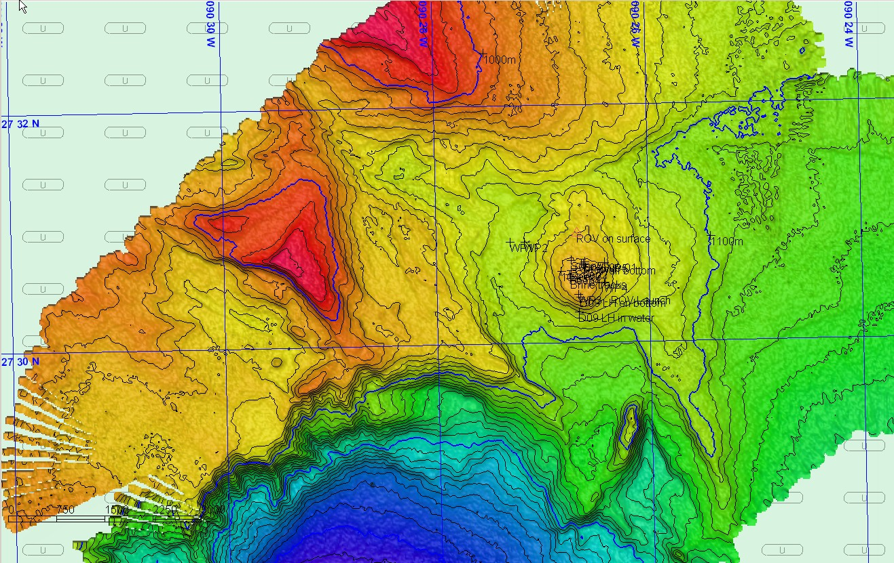 |  |  |  | 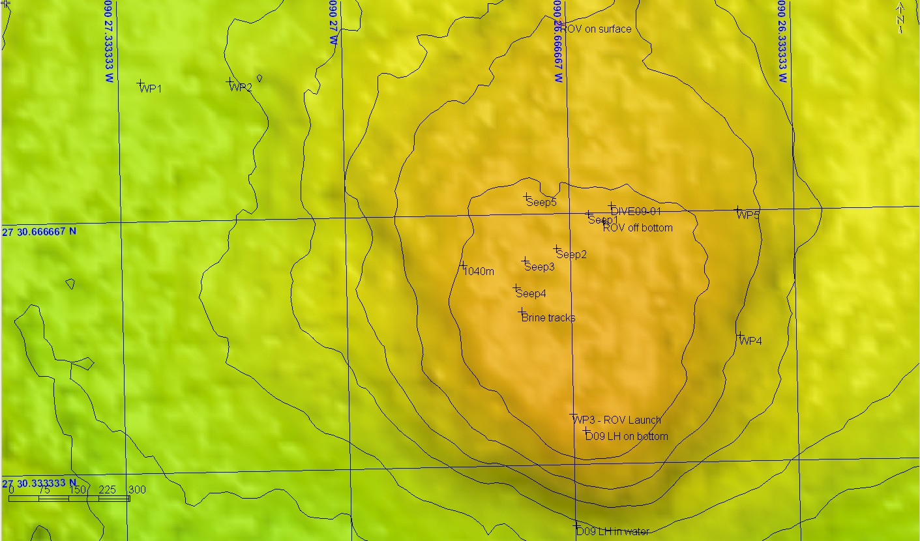
Representative Photos of the Dive
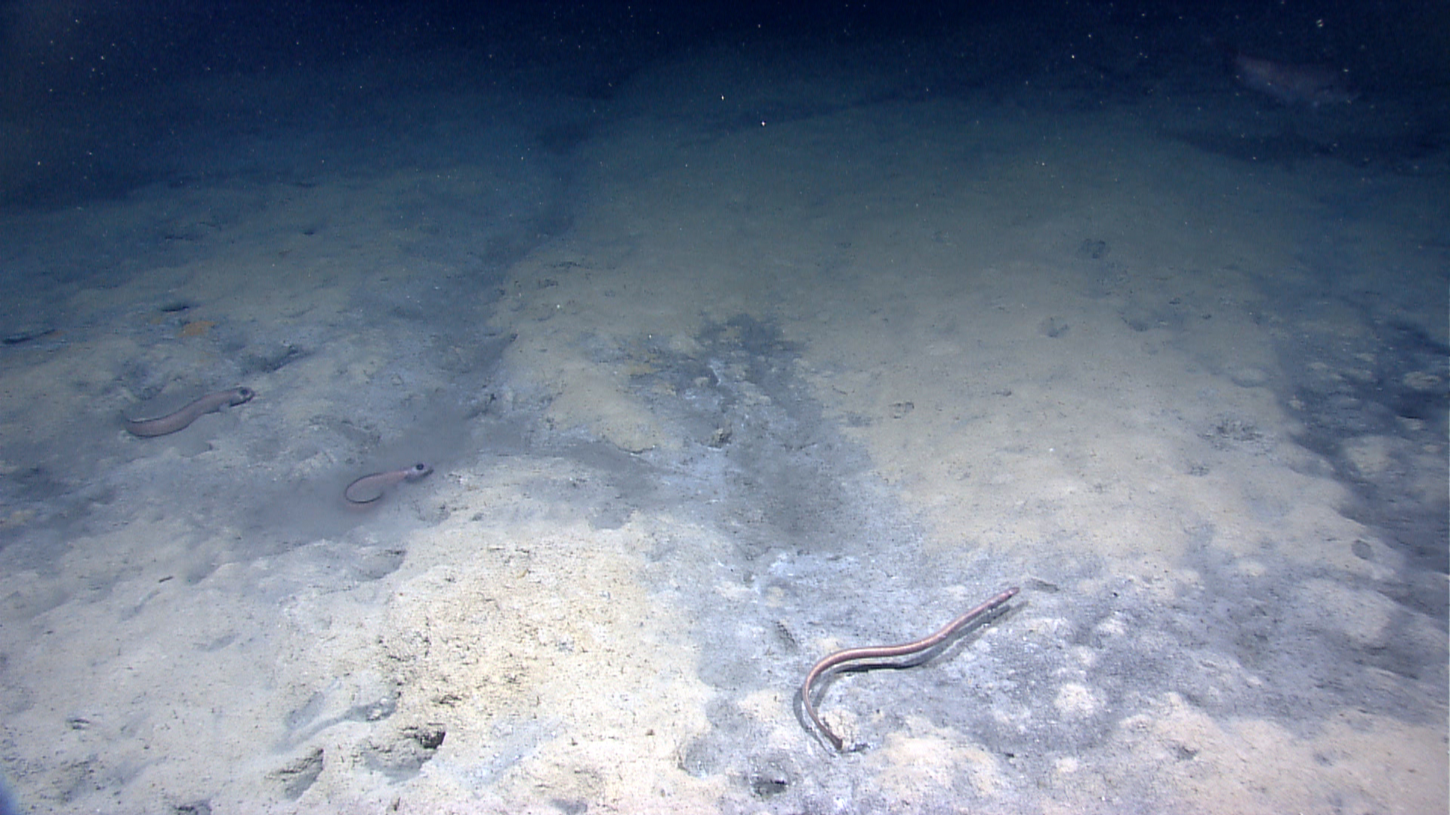 |  |  |  | 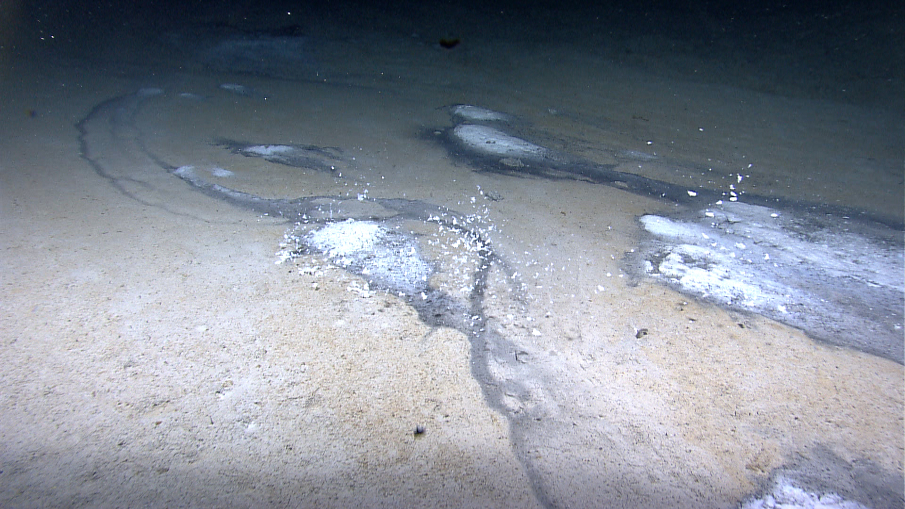
The first area where we encountered a small amount of active brine seepage. An eelpout bathes in a small pool of brine. |  |  |  | A shot of the final area we visited as the ROV leaves the seafloor. Some pieces of the white chemical precipitate break off and float into the water as the thrusters disturb the sediment. This area contained some active brine features, but no distinctive seep biology.
Please direct inquiries to: |  | NOAA Office of Ocean Exploration & Research  1315 East-West Highway (SSMC3 10th Floor)  Silver Spring, MD 20910  (301) 734-1014

