Okeanos Explorer ROV Dive Form
Site Name | DeSoto Canyon 493 (West Facing Scarp) |  |  |  |  |  |  | 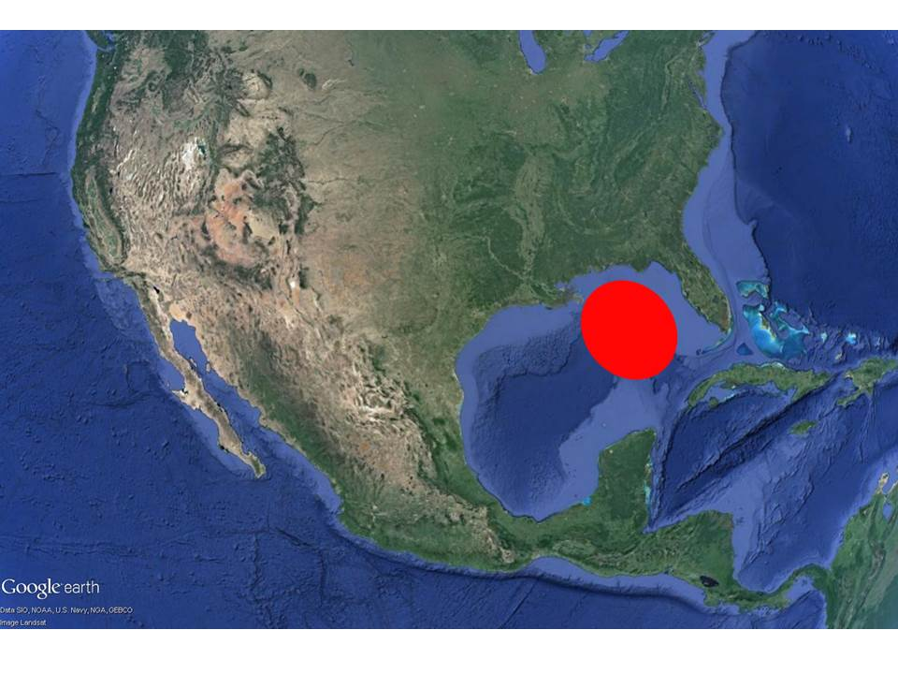
ROV Lead/Expedition Coordinator | Dave Lovalvo/Jeremy Potter
General Area Descriptor | ~275 nm northwest of Tampa, Florida
UTC Date & Time | Deployment |  | 3/26/2012 12:23 PM
UTC Date & Time | Recovery |  | 3/26/2012 20:29 PM
Bottom Time  [HH:MM] | 2:50:04 (max depth 2255.7 m)
Landing  Time & Location | UTC Time | 16:08 |  |  |  |  |  |  | Depth [m] |  | 2252
Landing  Time & Location | Latitude | 28 |  |  |  | º | 40.671 |  |  |  |  | ‘ |  | N
Landing  Time & Location | Longitude | 87 |  |  |  | º | 33.229 |  |  |  |  | ‘ |  | W
Off Bottom  Time & Location | UTC Time | 18:59 |  |  |  |  |  |  | Depth [m] |  | 2058
Off Bottom  Time & Location | Latitude | 28 |  |  |  | º | 40.740 |  |  |  |  |  | ‘ | N
Off Bottom  Time & Location | Longitude | 87 |  |  |  | º | 32.797 |  |  |  |  |  | ‘ | W
ROV Dive Name | Cruise Season |  |  |  | Leg |  |  |  |  | Dive Number
ROV Dive Name | EX1202 |  |  |  | LEG02 |  |  |  |  | ROV6
Equipment Deployed | ROV: |  |  |  | Little Hercules
Equipment Deployed | Camera Platfom: |  |  |  | Seirios Camera Platform
ROV Measurements | CTD |  |  |  | Depth |  |  |  |  | Altitude
ROV Measurements | Scanning Sonar |  |  |  | USBL Position |  |  |  |  | Heading
ROV Measurements | Pitch |  |  |  | Roll |  |  |  |  | HD Camera
ROV Measurements | Low Res Cam 1 |  |  |  | Low Res Cam 2
Equipment Malfunctions | None
Special Notes | Click here to enter text.
Scientists Involved  (please provide name / location / affiliation / email) | Tim Shank (on-board Science Lead), EX, WHOI, tshank@whoi.edu  Pen-Yuan Hsing, PSU, penyuan.hsing@psu.edu  Eleanor Bors, WHOI, WHOI, ekbors@gmail.com  Catriona Munro, WHOI, WHOI, cmunro@whoi.edu
Purpose of the Dive: The DeSoto Canyon escarpment region has not been well characterized. Past cruises discovered fauna here not found in other parts of the Gulf of Mexico, and some were similar to those found in the Atlantic. Today we will explore the west facing side of this escarpment to document its biology and geology, with waypoints at backscatter targets for soft sediment, and along the slope. The information gathered can be compared to the rest of the DeSoto Canyon escarpment and the rest of the Gulf of Mexico. This dive will also include mid water surveys for potential sperm whale prey items in the water column.
Description of the Dive:
During descent we conducted visual water column surveys at 100 meter increments between 600m and 1200m. This exploration was for mid-water prey items of sperm whales that are known to occupy this region (along the scarp) of the DeSoto Canyon. The ship transited backwards while the ROV drove forward at each depth interval at an approx speed of ~1knot. The ROV reached the seafloor at depth 2252m (28.67786ºN, 87.55382ºW), and started exploring heading towards the end waypoint, which is upslope at 2076m. During the whole dive, the ROV headed roughly east. The seafloor was consistently sediment, covered with pteropods, and few rocks.
During the transect upslope, the dominant fauna were crabs including many carapaces; hermit crabs; shrimp (possibly Crangonidae); sea urchins (such as Phormosomatidae, Areosoma); holothurians (such as Benthothuria or Bathyplotes); numerous straight, rod like shells that may be straight needle pteropods (Creseis acicula) or a type of scaphopod. Fish included tripod fish and rattails. We noticed an abundance of fecal material on the seafloor, presumably from holothurians or sea urchins.
At 13:34 EDT, we observed polychaetes on a rock, with Venus fly trap anemones and echiuran sightings nearby. At 13:52 EDT, we came upon several “rocks” that may be old clinkers (steam boiler residue) from steamships. Many had growth on them, such as anemones or polychaete tubes.
At 14:07 EDT the first bamboo coral of the dive was noted. At 14:24 EDT, an octocoral was observed with an orange overgrowth on its left side. At least two more octocorals were discovered before ROV recovery.
During the dive we also passed several sediment mounds, and several instances of a distinctive mark in the sediment. The mark was described as four to six lines arranged perpendicular to an unseen ellipse. The pattern suggests a buried cup coral calyx. Detailed analyses of framegrabs may help with identification.
No virtual targets were dropped during this dive. The previous one was DC007 from dive 5.
Overall Map of ROV Dive Area |  |  |  | Close-up Map of Main Dive Site
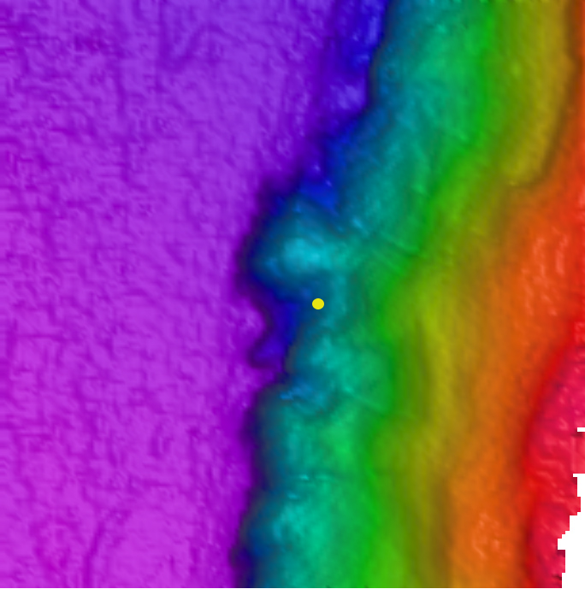 |  |  |  | 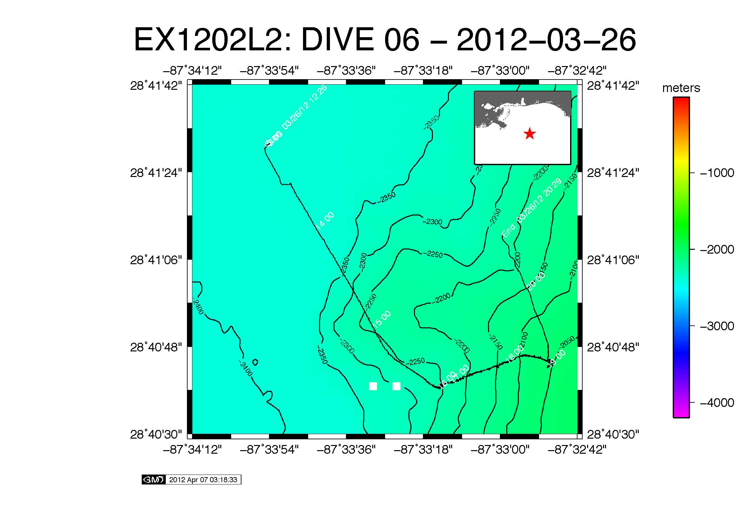
Representative Photos of the Dive
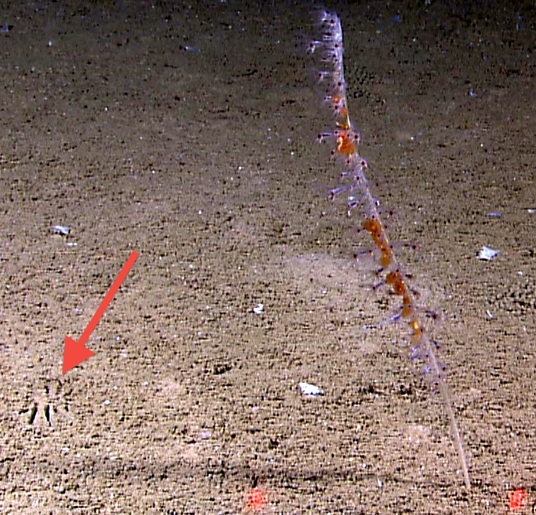 |  |  |  |  |  |  | 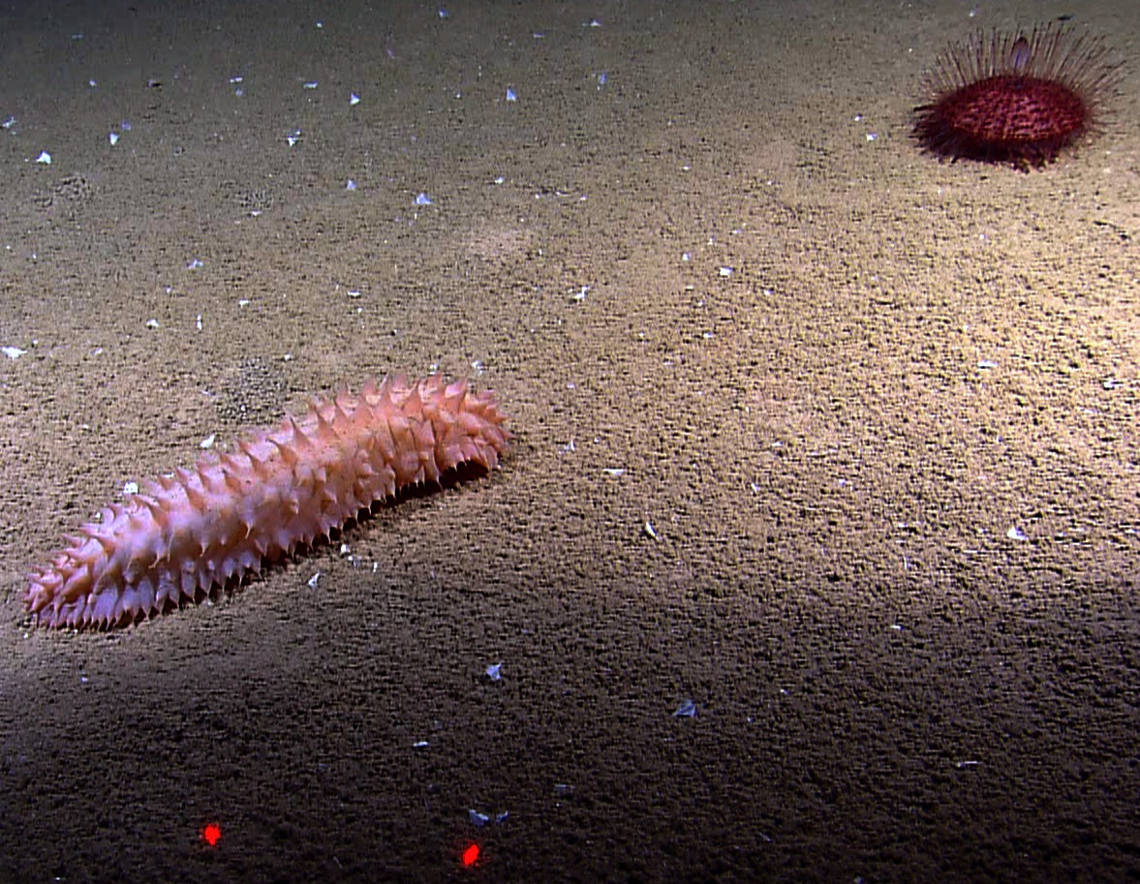
EX1202L2_IMG_20120326T182407Z_ROVHD_COR_TIGHT.jpg (cropped from original)  The unidentified mark in sediment (red arrow) encountered several times on this dive. It may be a partially buried cup coral. On the right is an octocoral. Red laser points are 10 cm apart. |  |  |  |  |  |  | EX1202L2_IMG_20120326T171404Z_ROVHD_HOL.jpg  Typical holothurian and sea urchin encountered. They were among the most numerous of all fauna during the dive. Red laser points are 10 cm apart.
Please direct inquiries to: |  | NOAA Office of Ocean Exploration & Research  1315 East-West Highway (SSMC3 10th Floor)  Silver Spring, MD 20910  (301) 734-1014

