Okeanos Explorer ROV Dive Form
Site Name | DeSoto Canyon (DC) #673 |  |  |  |  |  |  |  | 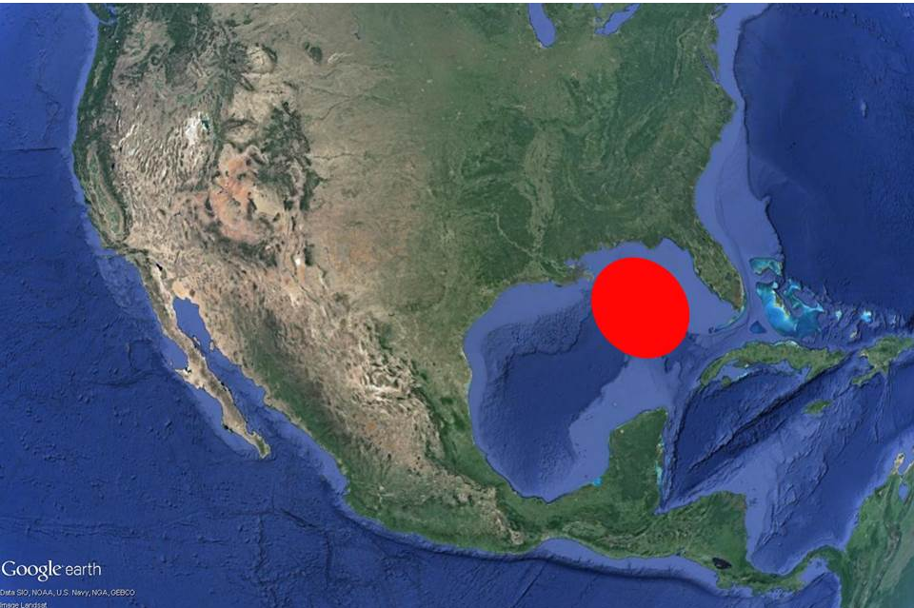
ROV Lead/Expedition Coordinator | Dave Lovalvo/Jeremy Potter
General Area Descriptor | ~260nm west of Tampa, Florida
UTC Date & Time | Deployment |  | 3/25/2012 12:24:29 PM
UTC Date & Time | Recovery |  | 3/25/2012 20:40:44 PM
Bottom Time  [HH:MM] | 5:03:06 (max depth 2148.0 m)
Landing  Time & Location | UTC Time | 14:00:21 |  |  |  |  |  |  |  | Depth [m] |  | 2145
Landing  Time & Location | Latitude | 28 |  |  | º | 17.916 |  |  |  |  |  |  | ‘ |  | N
Landing  Time & Location | Longitude | 87 |  |  | º | 17.321 |  |  |  |  |  |  | ‘ |  | W
Off Bottom  Time & Location | UTC Time | 18:58 |  |  |  |  |  |  |  | Depth [m] |  | 2020
Off Bottom  Time & Location | Latitude | 28 |  |  | º | 18.055 |  |  |  |  |  |  |  | ‘ | N
Off Bottom  Time & Location | Longitude | 87 |  |  | º | 17.183 |  |  |  |  |  |  |  | ‘ | W
ROV Dive Name | Cruise Season |  |  | Leg |  |  |  |  |  |  | Dive Number
ROV Dive Name | EX1202 |  |  | LEG02 |  |  |  |  |  |  | ROV5
Equipment Deployed | ROV: |  |  | Little Hercules
Equipment Deployed | Camera Platfom: |  |  | Seirios Camera Platform
ROV Measurements | CTD |  |  | Depth |  |  |  |  |  |  | Altitude
ROV Measurements | Scanning Sonar |  |  | USBL Position |  |  |  |  |  |  | Heading
ROV Measurements | Pitch |  |  | Roll |  |  |  |  |  |  | HD Camera
ROV Measurements | Low Res Cam 1 |  |  | Low Res Cam 2
Equipment Malfunctions | None
Special Notes | Click here to enter text.
Scientists Involved  (please provide name / location / affiliation / email) | Tim Shank (on-board Science Lead), EX, WHOI, tshank@whoi.edu  Pen-Yuan Hsing, PSU, penyuan.hsing@psu.edu  Santiago Herrera, WHOI, sherrera@mit.edu  Taylor Heyl, WHOI, theyl@whoi.edu  Eleanor Bors, WHOI, ekbors@gmail.com  Catriona Munro, WHOI, cmunro@whoi.edu  Bob Carney, LSU, rcarne1@lsu.edu  Erik Cordes, Temple, ecordes@temple.edu  Andrea Quattrini, Temple, andrea.quattrini@temple.edu  Peter Etnoyer, NOAA, Peter.Etnoyer@noaa.gov  Mike Vecchione, Smithsonian, VecchioneM@si.edu
Purpose of the Dive: To explore a position south of the DeSoto Canyon (DC) in the lease block #673. Seep and coral communities have been reported in the region, based on two previous dives. We will explore the lithology or physical character of the seafloor starting on what we think is an apparent breakout of sediment or a slump over the escarpment, and then as we proceed upslope encounter the escarpment proper. We will explore the potential differences in fauna associated with these different substrates
Description of the Dive:
On bottom at 28 17.925N 87 17.322W, depth 2145m, LH landed on soft sediment covered with pteropod shells before transiting at heading 035 toward the scarp. Synaphobranchid eels and holosaur fish were visible and we stopped to image a Halosaur at 1409, 2146m depth. At 1412 we encountered a coral not seen before, thought to be a pennatulid octocoral. Looking East/NE, bottom temp 4.28C on the northern end of slump, we then made a move toward the scarp over mottled sediments with fewer pteropod shells and some holothurians, including benthothuria, Peniagone/Scotoannas and pseudostichopus. At 1429, LH began moving moving NE over rippled sediment at a heading of 030, seeing hermit crabs, squat lobsters, some sargassum and a few small octocorals (one new sea pen at 1436). A dark/light sediment contact became apparent, 28 17.961 87 17.287W, thought to be a surface expression of a buried fault. As LH followed this contact, we encountered a tripod fish and pycnogonid, small cup corals and crab carapaces as we continued maneuvering over sediment with pteropod shells. At a small isolated rock with hermit crabs, anemones and worm tubes, 28.30004N -87.28774W, we found a paramuricid coral with an ophiuroid associate and stopped to image. While there, we also imaged a notacanthid fish and Bathylotes holothurian before traversing upslope over sediment. At 1536, 28.30026N, -87.28735W we encountered the first substantial rocky area of this dive with multiple corals and dropped a virtual target "DC005 rocky wall" as we stopped to survey and image this area. This area appeared to have a higher diversity of corals than previously seen, including Paramuricea, two different morphs of Irridogorgia with shrimp and amphipod associates and Chrysogorgia. At 1638, we placed a virtual target DC −06 along this coral wall. At 1657, while still surveying and imaging the wall, we found abundant bamboo and whip corals, bathypathes, shrimp, multiple other corals, sponges and crinoids. At 1713, we stopped to image a Lepidisis coral and crinoid before coming down 6 meters to image zoanthids covering bamboo with 3 chirostylid crabs. At 1748 we imaged a stoloniferan octocoral colonizing bare skeleton between zoanthid parasite and isidid and then observed Paragorgia growing out of a bamboo coral skeleton. We continued close up imaging of this coral wall until the end of the dive at 1852, 28.30080N -87.28637W.
Overall Map of ROV Dive Area |  |  |  |  |  |  |  | Close-up Map of Main Dive Site
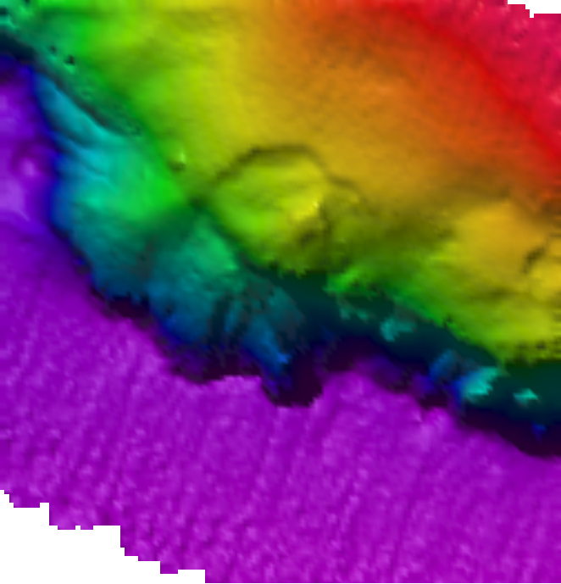
Representative Photos of the Dive
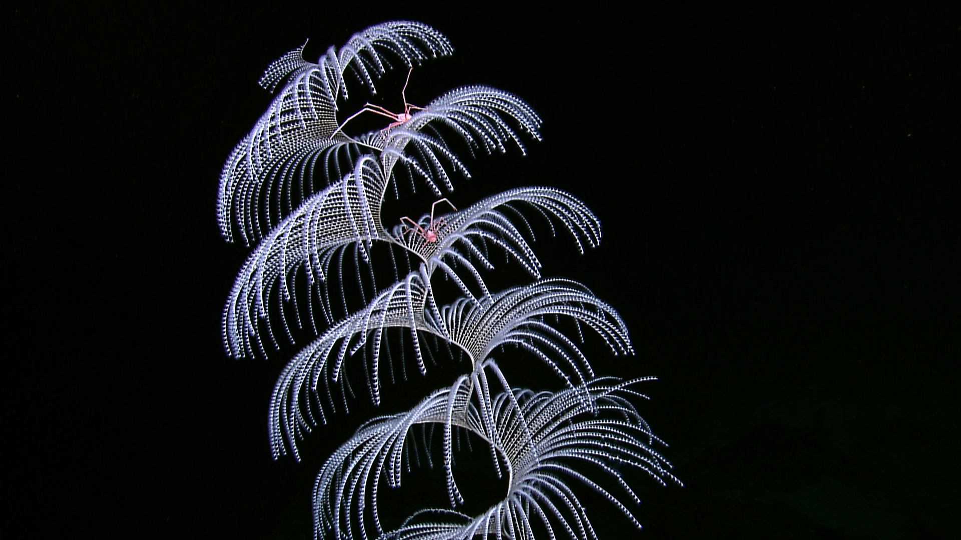 |  |  |  |  |  |  | 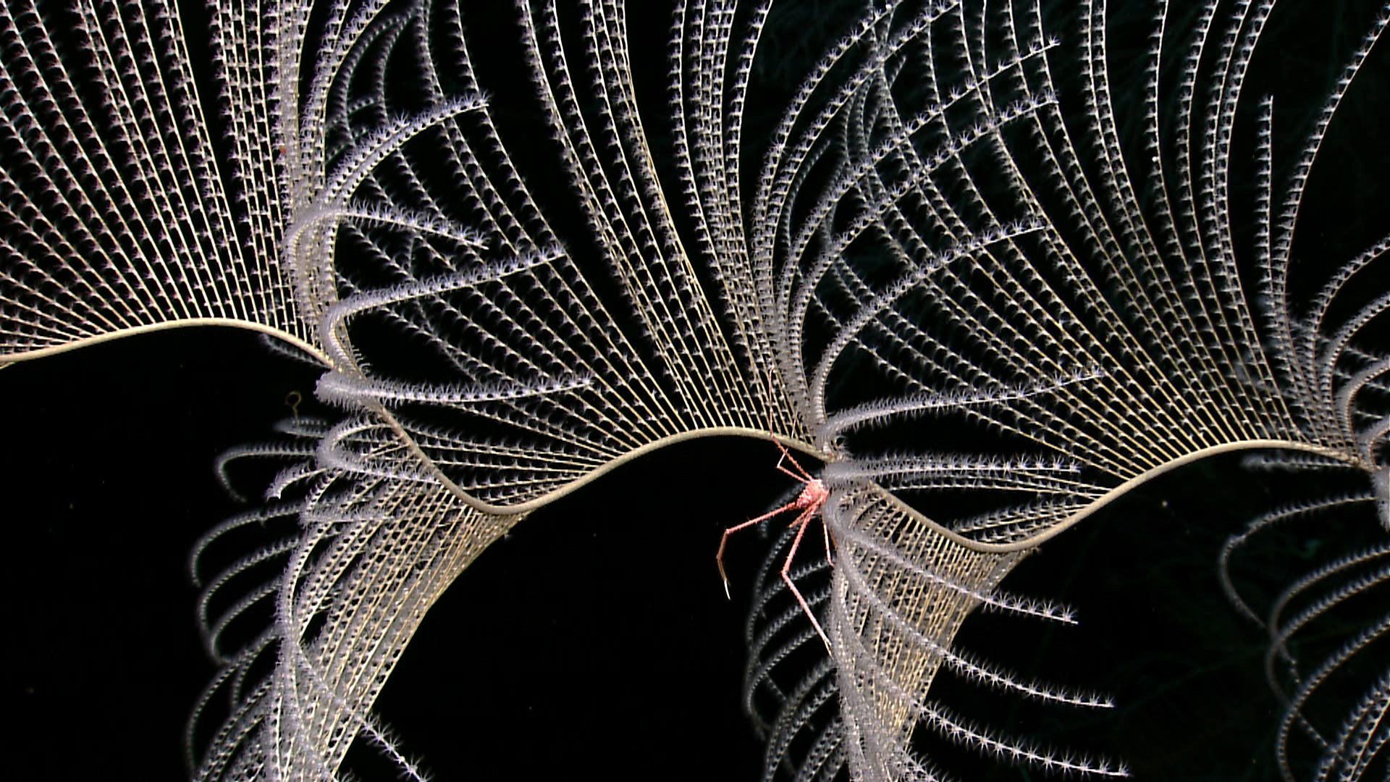
EX1202L2_IMG_20120325T165502Z_ROVHD_COR_SQA_00  On this dive we discovered two morphs of Iridogorgia coral. This one, with its spiral pattern was host to several squat lobsters. |  |  |  |  |  |  | EX1202L2_IMG_20120325T175320Z_ROVHD_COR_SQA_00  Close up of squat lobster living in association with Iridogorgia.
Please direct inquiries to: |  | NOAA Office of Ocean Exploration & Research  1315 East-West Highway (SSMC3 10th Floor)  Silver Spring, MD 20910  (301) 734-1014

