Okeanos Explorer ROV Dive Form
Site Name | DeSoto Canyon 493 |  |  |  |  |  | 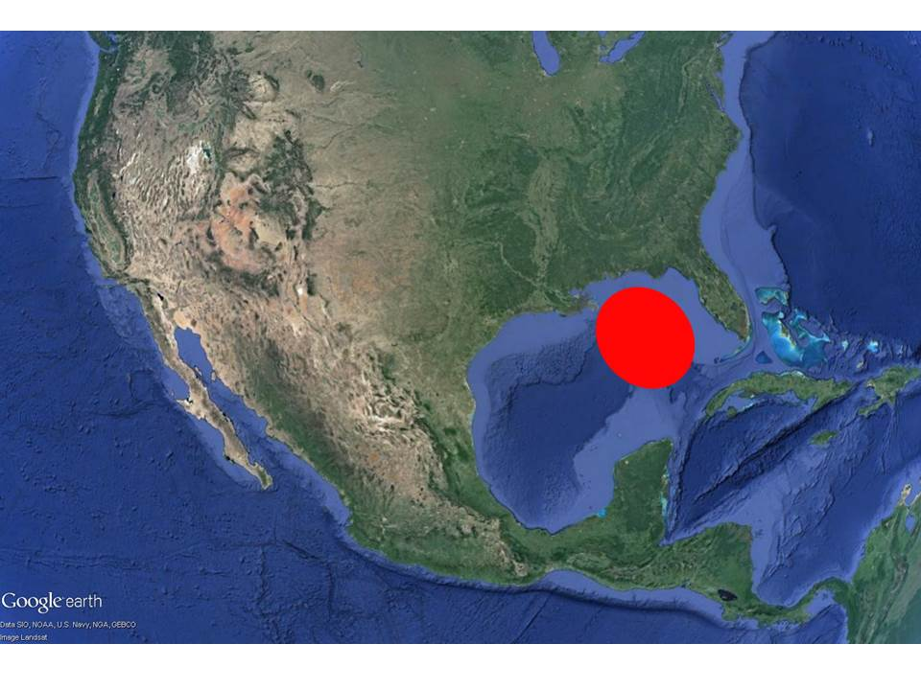
ROV Lead/ Expedition Coordinator | Dave Lovalvo/Jeremy Potter
General Area Descriptor | ~270nm west of Tampa, Florida
UTC Date & Time | Deployment |  | 3/24/2012 12:25:45 PM
UTC Date & Time | Recovery |  | 3/24/2012 20:29:48 PM
Bottom Time  [HH:MM] | 4:28:33 (max depth 2471.7 m)
Landing  Time & Location | UTC Time | 14:17:56 |  |  |  |  |  | Depth [m] |  | 2427
Landing  Time & Location | Latitude | 28 |  |  | º | 30.095N |  |  |  |  | ‘ |  | N
Landing  Time & Location | Longitude | 87 |  |  | º | 29.125 |  |  |  |  | ‘ |  | W
Off Bottom  Time & Location | UTC Time | 18:46:29 |  |  |  |  |  | Depth [m] |  | 2279
Off Bottom  Time & Location | Latitude | 28 |  |  | º | 30.330 |  |  |  |  |  | ‘ | N
Off Bottom  Time & Location | Longitude | 87 |  |  | º | 28.990 |  |  |  |  |  | ‘ | W
ROV Dive Name | Cruise Season |  |  | Leg |  |  |  |  | Dive Number
ROV Dive Name | EX1202 |  |  | LEG02 |  |  |  |  | ROV1
Equipment Deployed | ROV: |  |  | Little Hercules
Equipment Deployed | Camera Platfom: |  |  | Seirios Camera Platform
ROV Measurements | CTD |  |  | Depth |  |  |  |  | Altitude
ROV Measurements | Scanning Sonar |  |  | USBL Position |  |  |  |  | Heading
ROV Measurements | Pitch |  |  | Roll |  |  |  |  | HD Camera
ROV Measurements | Low Res Cam 1 |  |  | Low Res Cam 2
Equipment Malfunctions | None
Special Notes | Click here to enter text.
Scientists Involved  (please provide name / location / affiliation / email) | Tim Shank (on-board Science Lead), EX, WHOI, tshank@whoi.edu  Pen-Yuan Hsing, PSU, penyuan.hsing@psu.edu  Eleanor Bors, WHOI, WHOI, ekbors@gmail.com  Catriona Munro, WHOI, WHOI, cmunro@whoi.edu
Purpose of the Dive: The DeSoto Canyon escarpment region has not been well characterized. Past cruises discovered fauna here not found in other parts of the Gulf of Mexico, some were similar to those found in the Atlantic. This dive explored a possible seep site at the bottom of the escarpment, and moved towards possible hard substrate along the slope, identified from backscatter data.
Description of the Dive:
The ROV reached the seafloor about 200 m from the bottom edge of the escarpment. On our way to the edge, we explored the first sonar target, a rocky outcrop, at 14:38 UTC, coordinates 28.50129ºN, 87.48517ºW. On it we observed shrimps, a holothurian, sponges, sepulid polychaetes, crinoids, a pycnogonid, and corals (cup and bamboo). We placed a virtual target here called DC001.
As we continued towards the escarpment, a benthothuria holothurian was observed taking off from the sediment, ejecting fecal material. More anemones, polychaetes, sponges, and other holothurians were also noted.
At about 15:12 UTC we noted a dead coral on a rock, and continued to the NE, looking for the bottom of the escarpment. There were other rocks along the way, with attached anemones, octocorals, squat lobsters, and polychaetes (virtual target DC002 at 28.50264ºN, 87.48489ºW). These rocks all had a dark complexion.
We encountered the first possible seep location at 15:30 UTC (28.50250ºN, 87.48530ºW), with multiple tubeworm (Lamellibrachia) bushes (virtual target DC003). These tubeworms had some hydroid growth on their tubes, and the ones near the base could be Escarpia. Associated animals near this bush included anemones, Alvinocaris shrimp, hydroids, and octocorals growing on the tubes. There are boulders and scattered rocks nearby with rusty/dark texture.
At 16:00 UTC we discovered more tubeworm bushes (28.50277ºN, 87.48500ºW) near rocky base of the DeSoto Canyon escarpment. There were possible tubeworms, mussels, and clams here. We didn't see distinctive tubeworm bushes, but they were scattered and sticking out from under the rocks here.
Afterwards we followed the bottom edge of the escarpment in the NW direction, noting a possible pock mark at 16:42 UTC (28.50291ºN, 87.48505ºW). Some of the holothurians here (Pseudostichopus) had petropods on their back.
At 16:50 UTC (28.50291ºN, 87.48542ºW) we started heading up the escarpment in NE direction. Initially we observed more holothurians, and a pen-like tripod fish.
At about 17:10 UTC we moved over an area filled with large, dark boulders with sediment, but the biology was less dense here. As we approached a plateau - the intermediate waypoint for the dive - we passed by an almost vertical rock slope, then the seafloor became all sediment with few rocks. We reached the plateau at about 17:40 UTC (28.50360ºN, 87.48487ºW), still lots of sediment.
After we passed the plateau, which is an area less steep, we continued NE along a steeper slope. Lots of scattered rocks, heavily sedimented. All along the escarpment we observed dense, white pteropod sheels along the bottom. Other biology include multiple sightings of holothurians of the pseudostichopus or benthosthuria varieties. Some small corals were noted when we neared the plateau, growing on the rocks. Most were cup corals.
The rocks on this dive all had the dark and rusty red colour, presumably due to manganese or iron oxide staining on limestone.
Before the dive ended at 18:30 UTC, we explored an almost vertical, rocky wall (28.50528ºN, 87.48323ºW). It was still heavily sedimented with limited fauna on it. We reached the top of the wall at about 18:28 UTC (28.50563ºN, 87.4830ºW), virtual target "DC004 Top of the wall". There were several corals here, mostly Irridigorgia.
Overall Map of ROV Dive Area |  |  |  |  |  | Close-up Map of Main Dive Site
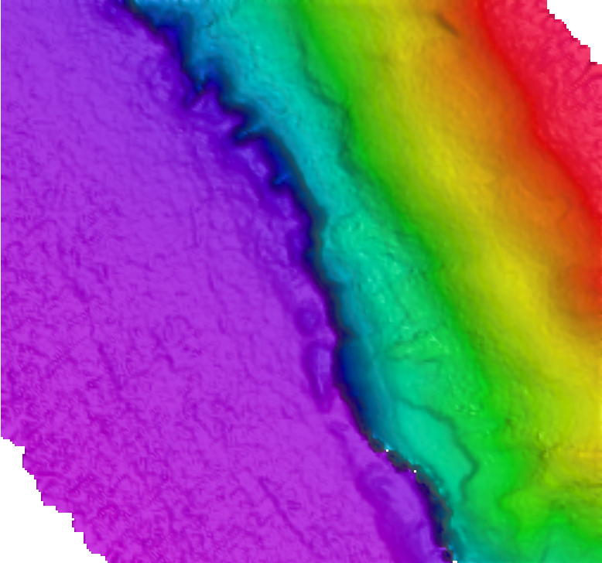
Representative Photos of the Dive
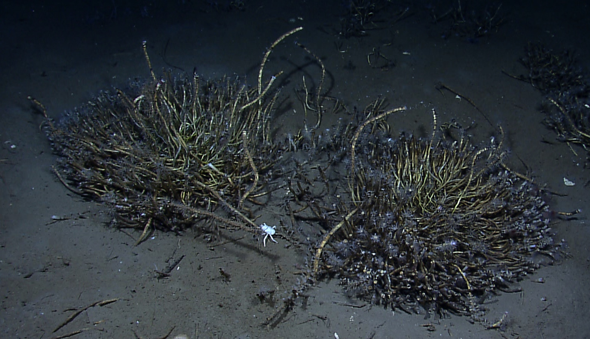 |  |  |  |  |  | 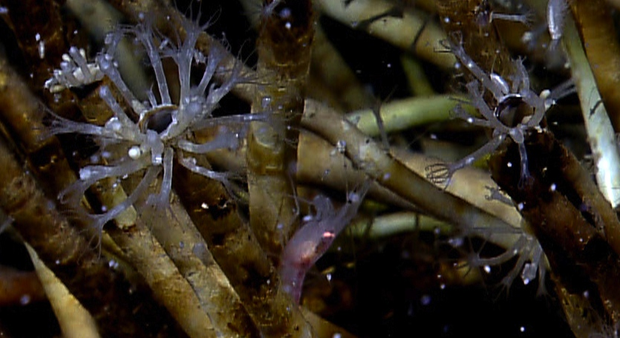
EX1202L2_IMG_20120324T152850Z_ROVHD_COP_TUB_SQA.jpg  Typical tubeworm bush (Lamellibrachia and Escarpia) in seep area near bottom of escarpment. |  |  |  |  |  | EX1202L2_IMG_20120324T154822Z_ROVHD_COP_TUB_SQA_SHI.jpg  Associate fauna on tubeworms include shrimp and octocorals that grow near the tube openings.
Please direct inquiries to: |  | NOAA Office of Ocean Exploration & Research  1315 East-West Highway (SSMC3 10th Floor)  Silver Spring, MD 20910  (301) 734-1014

