Okeanos Explorer ROV Dive Form
Site Name | West Florida Escarpment Canyon |  |  |  |  |  |  |  | 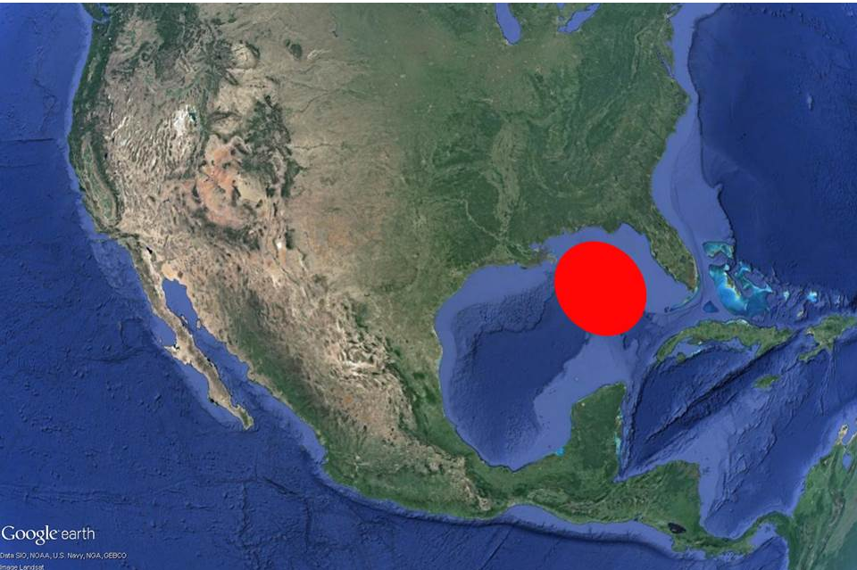
ROV Lead/Expedition Coordinator | Dave Lovalvo/Jeremy Potter
General Area Descriptor | ~190nm west of Tampa, Florida
UTC Date & Time | Deployment |  | 3/23/2012 12:34PM
UTC Date & Time | Recovery |  | 3/23/2012 21:59PM
Bottom Time  [HH:MM] | 6:14:0 (max depth 2140.7 m)
Landing  Time & Location | UTC Time | 14:21:44 |  |  |  |  |  |  |  | Depth [m] |  | 2140
Landing  Time & Location | Latitude | 27 |  |  |  | º | 54.844N |  |  |  |  |  | ‘ |  | N
Landing  Time & Location | Longitude | 86 |  |  |  | º | 2.082W |  |  |  |  |  | ‘ |  | w
Off Bottom  Time & Location | UTC Time | 20:35:45 |  |  |  |  |  |  |  | Depth [m] |  | 1671
Off Bottom  Time & Location | Latitude | 27 |  |  |  | º | 54.980 |  |  |  |  |  |  | ‘ | N
Off Bottom  Time & Location | Longitude | 86 |  |  |  | º | 2.138 |  |  |  |  |  |  | ‘ | w
ROV Dive Name | Cruise Season |  |  |  | Leg |  |  |  |  |  | Dive Number
ROV Dive Name | EX1202 |  |  |  | LEG02 |  |  |  |  |  | ROV3
Equipment Deployed | ROV: |  |  |  | Little Hercules
Equipment Deployed | Camera Platfom: |  |  |  | Seirios Camera Platform
ROV Measurements | CTD |  |  |  | Depth |  |  |  |  |  | Altitude
ROV Measurements | Scanning Sonar |  |  |  | USBL Position |  |  |  |  |  | Heading
ROV Measurements | Pitch |  |  |  | Roll |  |  |  |  |  | HD Camera
ROV Measurements | Low Res Cam 1 |  |  |  | Low Res Cam 2
Equipment Malfunctions | None
Special Notes | Click here to enter text.
Scientists Involved  (please provide name / location / affiliation / email) | Tim Shank (on-board Science Lead), EX, WHOI, tshank@whoi.edu  Pen-Yuan Hsing, PSU, penyuan.hsing@psu.edu  Santiago Herrera, WHOI, sherrera@mit.edu  Taylor Heyl, WHOI, theyl@whoi.edu  Eleanor Bors, WHOI, ekbors@gmail.com  Catriona Munro, WHOI, cmunro@whoi.edu  Bob Carney, LSU, rcarne1@lsu.edu  Erik Cordes, Temple, ecordes@temple.edu  Andrea Quattrini, Temple, andrea.quattrini@temple.edu  Peter Etnoyer, NOAA, Peter.Etnoyer@noaa.gov  Mike Vecchione, Smithsonian, VecchioneM@si.edu
Purpose of the Dive:
To explore an area on a West Florida Escarpment Canyon at 27° 54.84N 86° 02.05W at a depth of 2100m, beginning at the base of the escarpment wall on the inward side of the canyon basin on sedimented slope near 2100m depth. The plan is to explore this sedimented region, the base of the escarpment and then progress up the face of the scarp to the top at about 1700m.
Description of the Dive:
Dive 3 of this program began at 1423, 27 54.839N 86 2.068W at an area on the West Florida Escarpment Cayon. Once on bottom, LH faced a sedimented 45 degree slope covered with pteropod shells, at a depth of 2140m and prepared for a move upslope. Holothurians, nematocarcinid shrimp and exposed rocky carbonates with worm tubes were common on soft sediment as we moved upslope. Given this precarious terrain, LH was not able to set down quickly for imaging and most imaging was done on the fly. At 1507, we placed a virtual target on WFL-16 Pseudostichopus holothurian at 27 54.852N 86 02.083W, depth 2127. At 1512, LH continued moving upslope, over heavily sedimented carbonate rock with no attached or mobile fauna visible, depth 2118m. Exposed carbonate rock and pteropod shells seen on sediment, few worm tubes and more Pseudostichopus holothurians. 1536, seeing more hard substrate as we move upslope but not much attached fauna at 7.91446N, -86.03486W, depth 2104m. At 1605, LH transiting upslope in a "zig zag fashion" to the tether length to see more seafloor, terrain has steepened. 1612, imaged a cup coral and dropped virtual target WFL-17 - Octocoral on scarp, depth 2048m. Encountered chrysogorgiid coral with reddish polychaete associate and several other corals on the wall, including a paramuricea as we moved upslope. At 1630, 27.91481, -86.03485 LH stopped to image diversity of corals on this wall, including an iridogorgia, bamboo coral and paramuricea as well as small burrow openings and pteropod shells on sediment at the base of the rock. 1655, imaging paramuricea coral with ophiuroid associate. Two species of hexactinellida sponge, shrimp, and several more corals were observed as LH moved closer to the rock wall. 1727 we imaged red/pinkish octocoral, Anthomastus at 27.91534, -86.03502, depth 1951m and a purple spherical sponge at 1744 before moving to image a second sponge, possibly Euritidea, that appeared to be dead.
At approximately 200m from the top of this steep rocky, and heavily sedimented slope, we encountered several sponges, corals, including iridogorgia, and holothurians and dropped a virtual target before deciding to move as quickly (and safely) as possible upslope to the rim. Crinoids were visible and multiple sponges as we crossed 1800m on an almost vertical and less sedimented rock face. At 1833, 27.91582, -86.03544 we dropped a virtual target ("Coral on underside of overhang") for this site with multiple large corals, including Isidid and Stichopathes depth 1680m. A distinctive band of high coral and crinoid density was observed just below the top rim of the canyon and the goal for the remainder of this dive was to image/document this band. Predatory asteroids were observed on several bamboo corals and LH was repositioned to image them. We then imaged white gorgonian corals and madrepora with a zig zag pattern at 1904, 27.91620, -86.03560, depth 1671m before moving slightly upslope to image a yellow madrepora with close up imaging on polyps at 1920. We imaged a primnoid coral at 1928 and shortly after, a Bathypathes at 27.91621, -86.03557. At 1948 LH moved in to image pinkish COR Irridogorgia with gravid shrimp and crinoid associates before dropping virtual target "WFL018 Area of most coral videos". Shortly before the end of this dive at 2004, 27.91619, -86.03568, LH imaged a Paramuricea, primnoid, small white ophiuroid, and Anthomastus, growing on what may be a dead coral base with hydroid associates at depth 1671m.
Overall Map of ROV Dive Area |  |  |  | Close-up Map of Main Dive Site
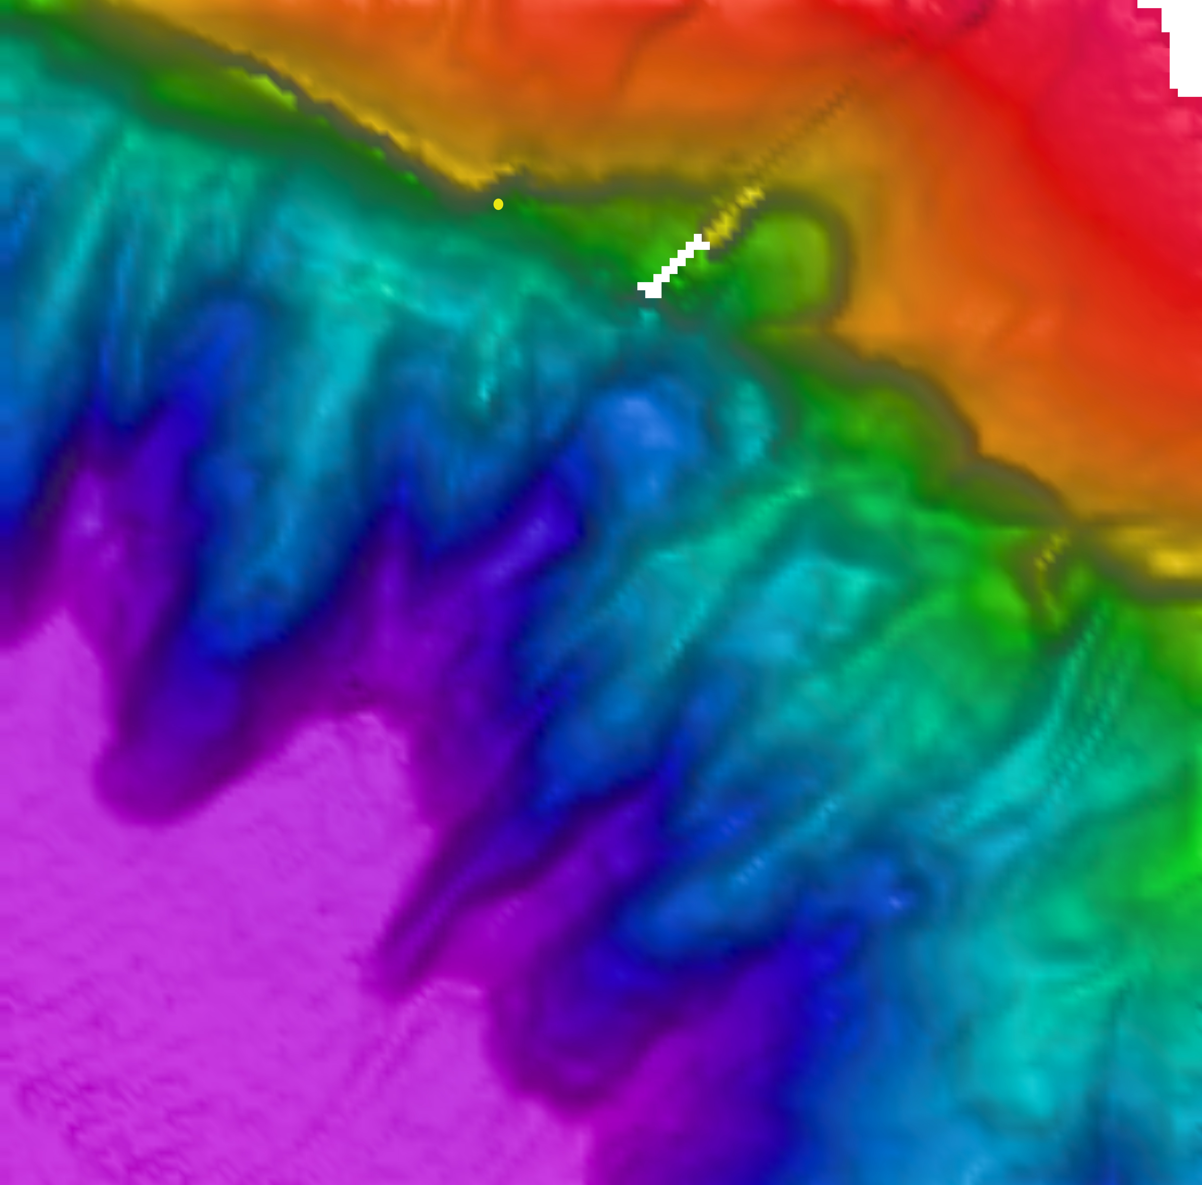 |  |  |  | 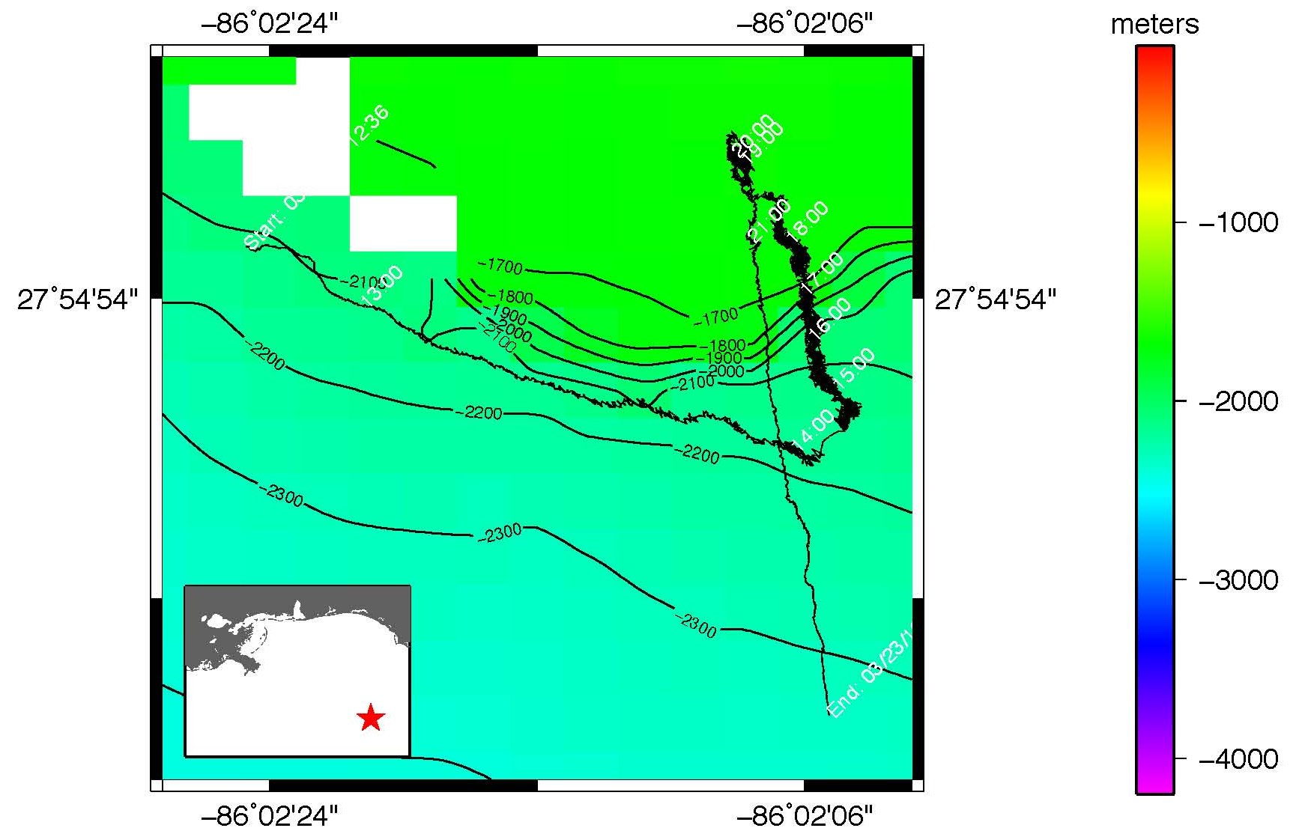
Representative Photos of the Dive
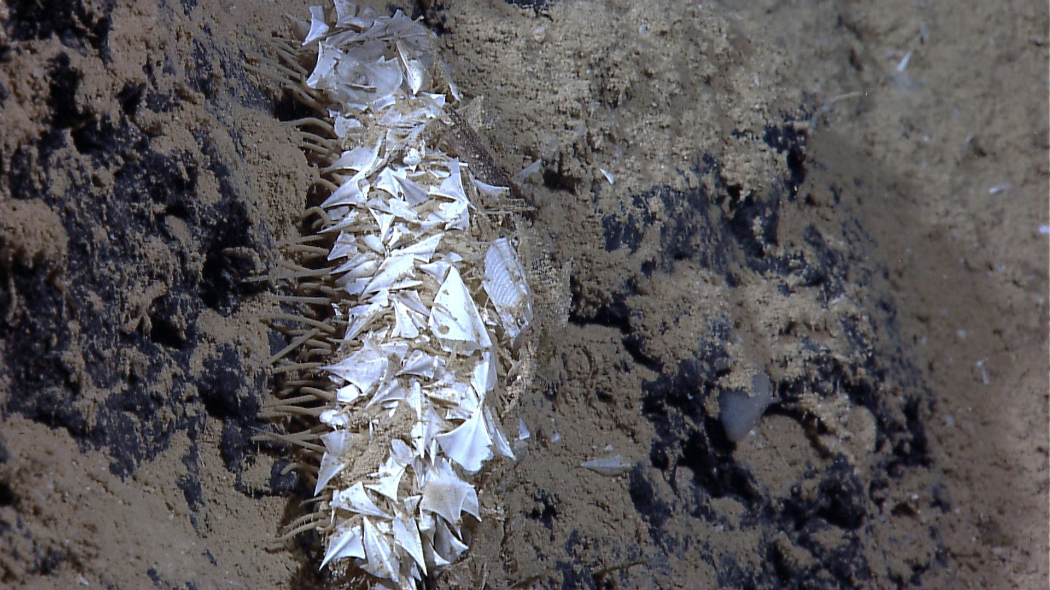 |  |  |  |  |  |  |  | 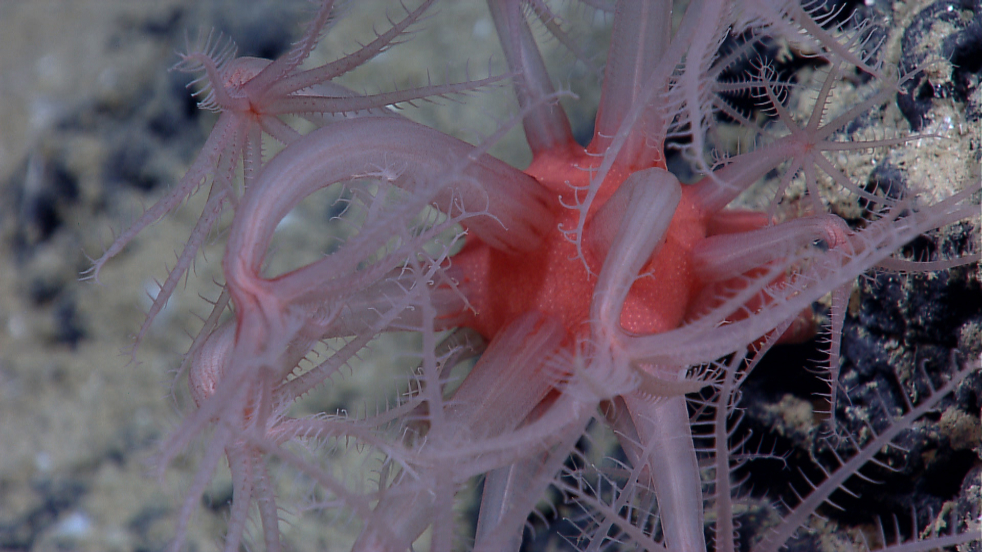
EX1202L2_IMG_20120323T142812Z_ROVHD_HOL_3  A close-up of a benthic holothurian on heavily sedimented carbonate rock. |  |  |  |  |  |  |  | EX1202L2_IMG_20120323T172913Z_ROVHD_COR_AUDIO  Red/pinkish octocoral Anthomastus imaged at a depth of 1951meters on a carbonate wall.
Please direct inquiries to: |  | NOAA Office of Ocean Exploration & Research  1315 East-West Highway (SSMC3 10th Floor)  Silver Spring, MD 20910  (301) 734-1014

