Okeanos Explorer ROV Dive Form
Site Name | Salt Dome Seep Target |  |  |  |  |  |  |  | 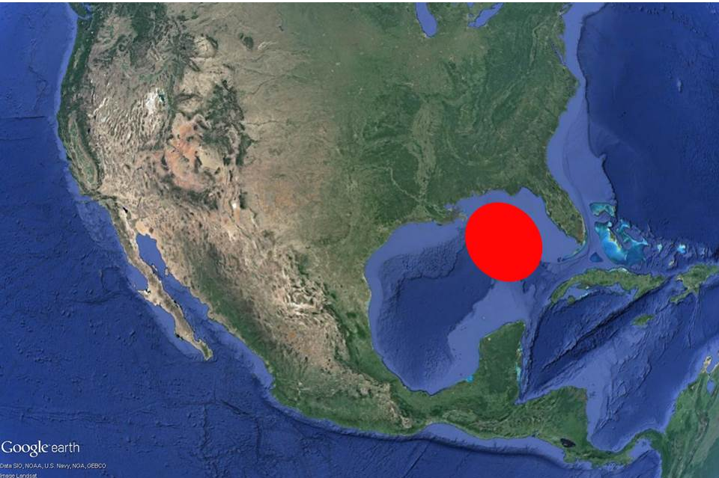
ROV Lead/Expedition Coordinator | Dave Lovalvo/Jeremy Potter
General Area Descriptor | ~300nm northwest of Tampa, Florida
UTC Date & Time | Deployment |  | 4/06/2012 12:31 PM
UTC Date & Time | Recovery |  | 4/06/2012 21:51 PM
Bottom Time  [HH:MM] | 6:12:12 (max depth 1182.2 m)
Landing  Time & Location | UTC Time | 14:47 |  |  |  |  |  |  |  | Depth [m] |  | 1182
Landing  Time & Location | Latitude | 28 |  |  |  | º | 58.59 |  |  |  |  |  | ‘ |  | N
Landing  Time & Location | Longitude | 88 |  |  |  | º | 01.91 |  |  |  |  |  | ‘ |  | w
Off Bottom  Time & Location | UTC Time | 21:00 |  |  |  |  |  |  |  | Depth [m] |  | 1055.6
Off Bottom  Time & Location | Latitude | 28 |  |  |  | º | 58.679 |  |  |  |  |  |  | ‘ | N
Off Bottom  Time & Location | Longitude | 88 |  |  |  | º | 01.87 |  |  |  |  |  |  | ‘ | w
ROV Dive Name | Cruise Season |  |  |  | Leg |  |  |  |  |  | Dive Number
ROV Dive Name | EX1202 |  |  |  | LEG02 |  |  |  |  |  | ROV16
Equipment Deployed | ROV: |  |  |  | Little Hercules
Equipment Deployed | Camera Platfom: |  |  |  | Seirios Camera Platform
ROV Measurements | CTD |  |  |  | Depth |  |  |  |  |  | Altitude
ROV Measurements | Scanning Sonar |  |  |  | USBL Position |  |  |  |  |  | Heading
ROV Measurements | Pitch |  |  |  | Roll |  |  |  |  |  | HD Camera
ROV Measurements | Low Res Cam 1 |  |  |  | Low Res Cam 2
Equipment Malfunctions | None
Special Notes | Click here to enter text.
Scientists Involved  (please provide name / location / affiliation / email) | Tim Shank (on-board Science Lead), EX, WHOI, tshank@whoi.edu  Pen-Yuan Hsing, PSU, penyuan.hsing@psu.edu  Santiago Herrera, WHOI, sherrera@mit.edu  Taylor Heyl, WHOI, theyl@whoi.edu  Eleanor Bors, WHOI, ekbors@gmail.com  Catriona Munro, WHOI, cmunro@whoi.edu  Bob Carney, LSU, rcarne1@lsu.edu  Erik Cordes, Temple, ecordes@temple.edu  Andrea Quattrini, Temple, andrea.quattrini@temple.edu  Peter Etnoyer, NOAA, Peter.Etnoyer@noaa.gov  Mike Vecchione, Smithsonian, VecchioneM@si.edu
Purpose of the Dive:
The goal of this exploratory dive is to groundtruth bubble stream observations in EX multibeam by locating the seafloor source location of these bubbles, and ultimately seep environments. In addition, the acoustic backscatter of this area contains high reflectivity, and as such may also provide hard ground habitats for exploration. We will also explore the mid-water column during descent, running for 10 minute intervals at 600, 700, 800, 900, and 1000 meters. Our bottom target depth is 1100 meters. Once on bottom, we will move upslope searching for seafloor sources of methane bubbles. We will begin with an on bottom position downslope 150m south of the target area.
Description of the Dive:
EX1202 L2-Dive 16 focused on locating the seafloor source location of methane bubbles and ultimately seep environments. Bubble streams were observed by EX multibeam showed bubble streams and acoustic backscatter in this area contained high reflectivity indicative of hard bottom habitats. During descent, we explored the mid-water column, running for 10 minute intervals at 600, 700, 800, 900, and 1000 meters. Once on bottom (at depth of 1182 meters and 150m South and downslope of the target area at 28º58.59"N 88º01.91W), LH proceeded upslope at 6m altitude over sediment, bivalve shell and rock rubble searching for sources of methane bubbles. Small burrows, few fish and shrimp were also observed. We then headed upslope over pitted sediment to the North (28.97656 N, -88.03174 W, depth 1175m), seeing fewer clam shells but more bivalve shell fragments, burrows in the sediment, shrimp in the water column, rattail and synaphobranchid eel fish. At 1502, 28.97671, -88.03187, depth 1170m we encountered first signs of white staining on sediment with copepods present within stain area, as well as an increase in clam shells/shell fragments and few mussels. The white staining patches increased and it became clear we were approaching an active seep area. We dropped virtual target D16-1 over white staining close to seep/briny area (28.97670, -88.03159, depth 1168m). At 1508, 28.97678, -88.03171, we encountered a large crab and two chaceon crabs mating as we moved upslope (heading 362) over pitted sediment and clam shells at a depth of 1162m. At 1511, 28.97697, -88.03171 we discovered what appeared to be a pogonophoran worm with translucent tube and hydrozoans growing on the tube. LH stopped to image this worm and once finished with this imaging, we headed North (depth 1159m) traversing over sediment covered with extensive clam shells, mostly disarticulated. We began to notice two different types of shell, some elongated and some rounded as we came upslope at a depth of 1153m. Here we continued to see small white staining spots and several small heavily-pitted boulders. At 1521, we were almost to the top of the Pascagoula dome, seeing first rocks and shells abundant in the sediment. A few squat lobsters, white urchins, and tubeworm colony were observed next to heavily pitted rock. Serpulid worms present on the rock. As we moved further towards target (continuing East at a heading of 083, 28.97750, -88.03152 and depth 1149m), LH moved over extensive fields of clam shells and mussels, some small tubes present in the sediment and shrimp and fish in the water column. At 1530, more translucent tubeworms were observed, apparently pointing downslope. At 1536, 28.97768, -88.03170, we encountered another pair of mating chaceon crabs and dropped a virtual target D16-3 on possible rocks on the sonar. Appear to have higher abundance of rattail fish in this area. After moving over an area of sediment with fewer shells that were partially buried in sediment (depth of 1140m), shell abundance increased again at 28.97789, -88.03153. We approached rocks and noticed a benthic angler fish at the top of a rock. Just beyond these rocks at 28.97789, -88.03153, depth 1140m, we noticed live patches of tubeworms on the sediment and dropped virtual target D16-4 on an active seep site. At 1546, depth 1135m, we encountered more tube worms on the seafloor with live mussel patches. At 1547, started moving toward seep target across sediment with shell fragments, burrows, red shrimp, more clam shells and white staining. At 1548 we approached a larger area of white and dark staining but with no copepods visible within this staining area. LH continued to move over sediment with bivalve fragments and small isolated boulders. At 1554, 28.97847, -88.03141 and depth 1122m, we arrived at our possible seep target. At 1557, 28.97857, -88.03125, we observed a Paramuricea coral with extended polyps and dropped a virtual target D16-5.
At 1630, LH began moving toward second seep target area, passing rock outcrops with white urchins, few shrimp and a pair of chaceon crabs mating. 1633, encountered largest area of staining seen on this dive at 1118m and shortly after, noticed live clams in the sediment and began to move upslope through this large seep area with extensive bivalve shells, mostly clams but few mussels interspersed. Once we reached the western extent of this seep field, LH turned South through extensive clam shell beds (no live clams) with small patches of live mussels. At 1645, 28.97860, -88.03024, imaged mussels with gastropods congregating along a fault or fissure. Also observed chitons and limpets within these mussel communities. At 1657, 28.97849, -88.02976, depth 1119m we observed methane bubbles coming from seafloor within this large seep area dominated by clam and mussel shells and dropped virtual target D16-8. Methane hydrate was imaged on one mussel shell and a polychaete living among mussels but no shrimp or galatheid crabs were visible at this seep site. Deployed static physical marker M28. At 1722, ROV moved up in water column to measure width of bubbles, which spread out rapidly at 10m altitude. Amphipods were observed within the methane bubbles. Imaged mussel colony close-up before moving East along a ridge to locate the boundary of this seep site and then come back into the field, looking for methane bubbles and other features.
At 1816, 28.97787, -88.02975, dropped target D16-9 at live mussel lake on the northern edge, depth 1126m. ROV traversed to seep target 3, still seeing extensive clam shells until dropping target D16–10 over the edge of SE extent of the field and mound area and concluding ROV survey. LH headed to the NE, depth 1129m,, moving over increasing density of dead and articulated bivalves, with few live bivalves. At 1841, we observed brine staining as we moved back into the seep field. We returned to the central part of the field and imaged mussel communities with methane bubbles at 28.97832, -88.02979, depth 1120m. At 1936 we encountered a line of bubbles (bubble curtain) along brine stained area coming through dead/older bivalve shells. LH then headed west toward mussel seam area (D16-7) to image what appeared to be two mussel species and tubeworms with scale worms on tubes, white anemones, urchins, some galatheid crabs, and white anemones. At 2048 and the end of this dive, we encountered a sipunculid worm before LH was recovered at 28.97820, -88.03141, depth 1127m.
Overall Map of ROV Dive Area |  |  |  | Close-up Map of Main Dive Site
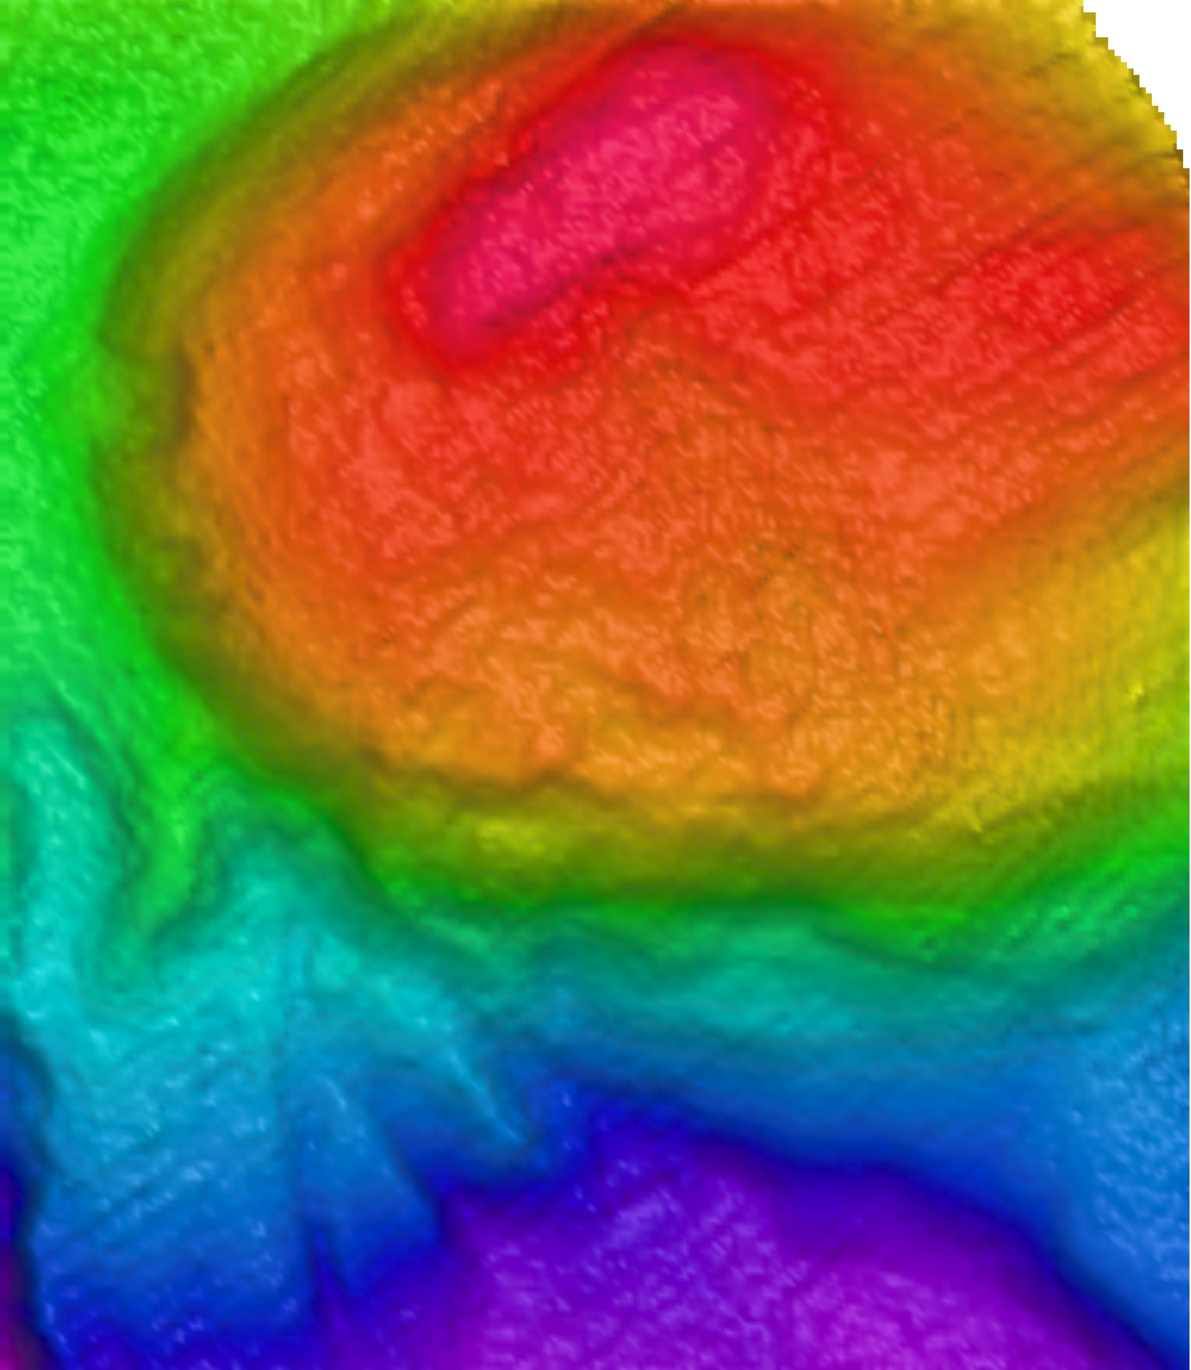 |  |  |  | 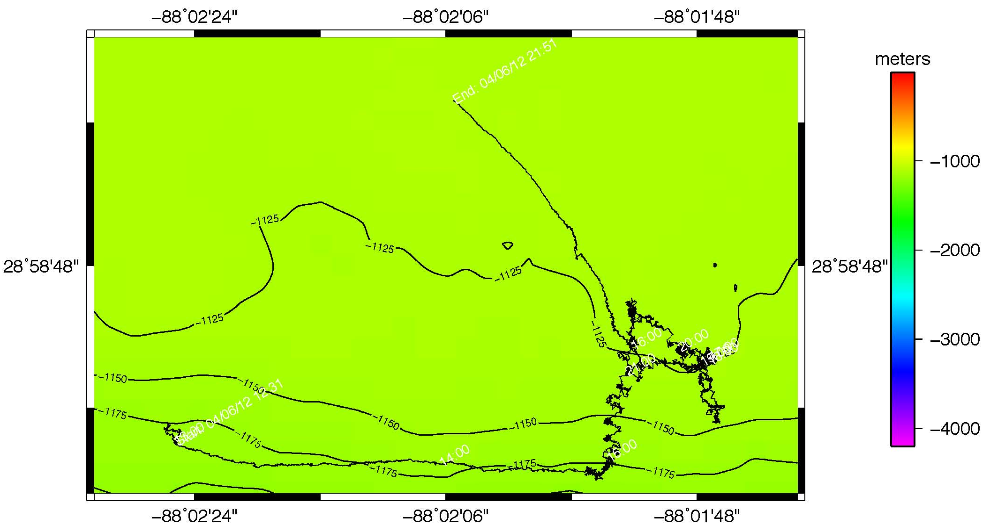
Representative Photos of the Dive
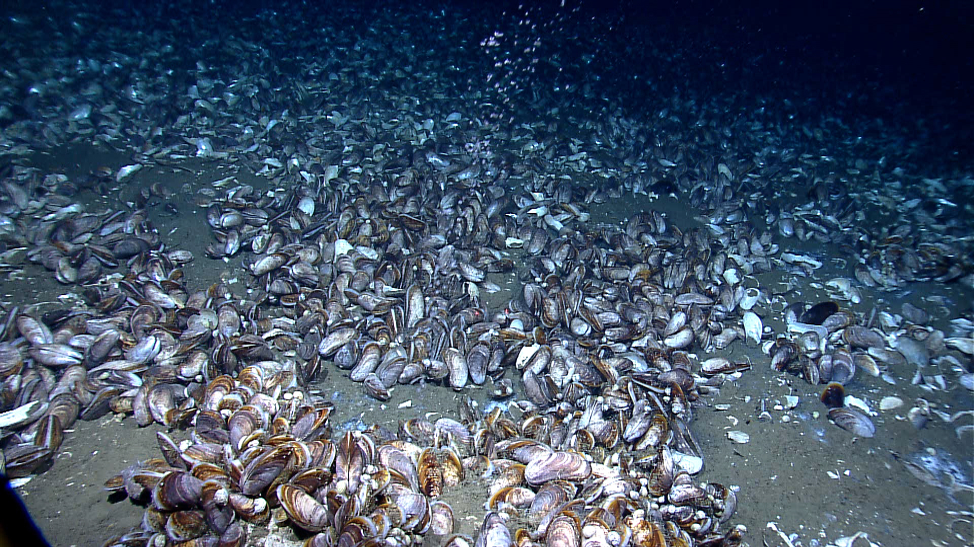 |  |  |  |  |  |  |  | 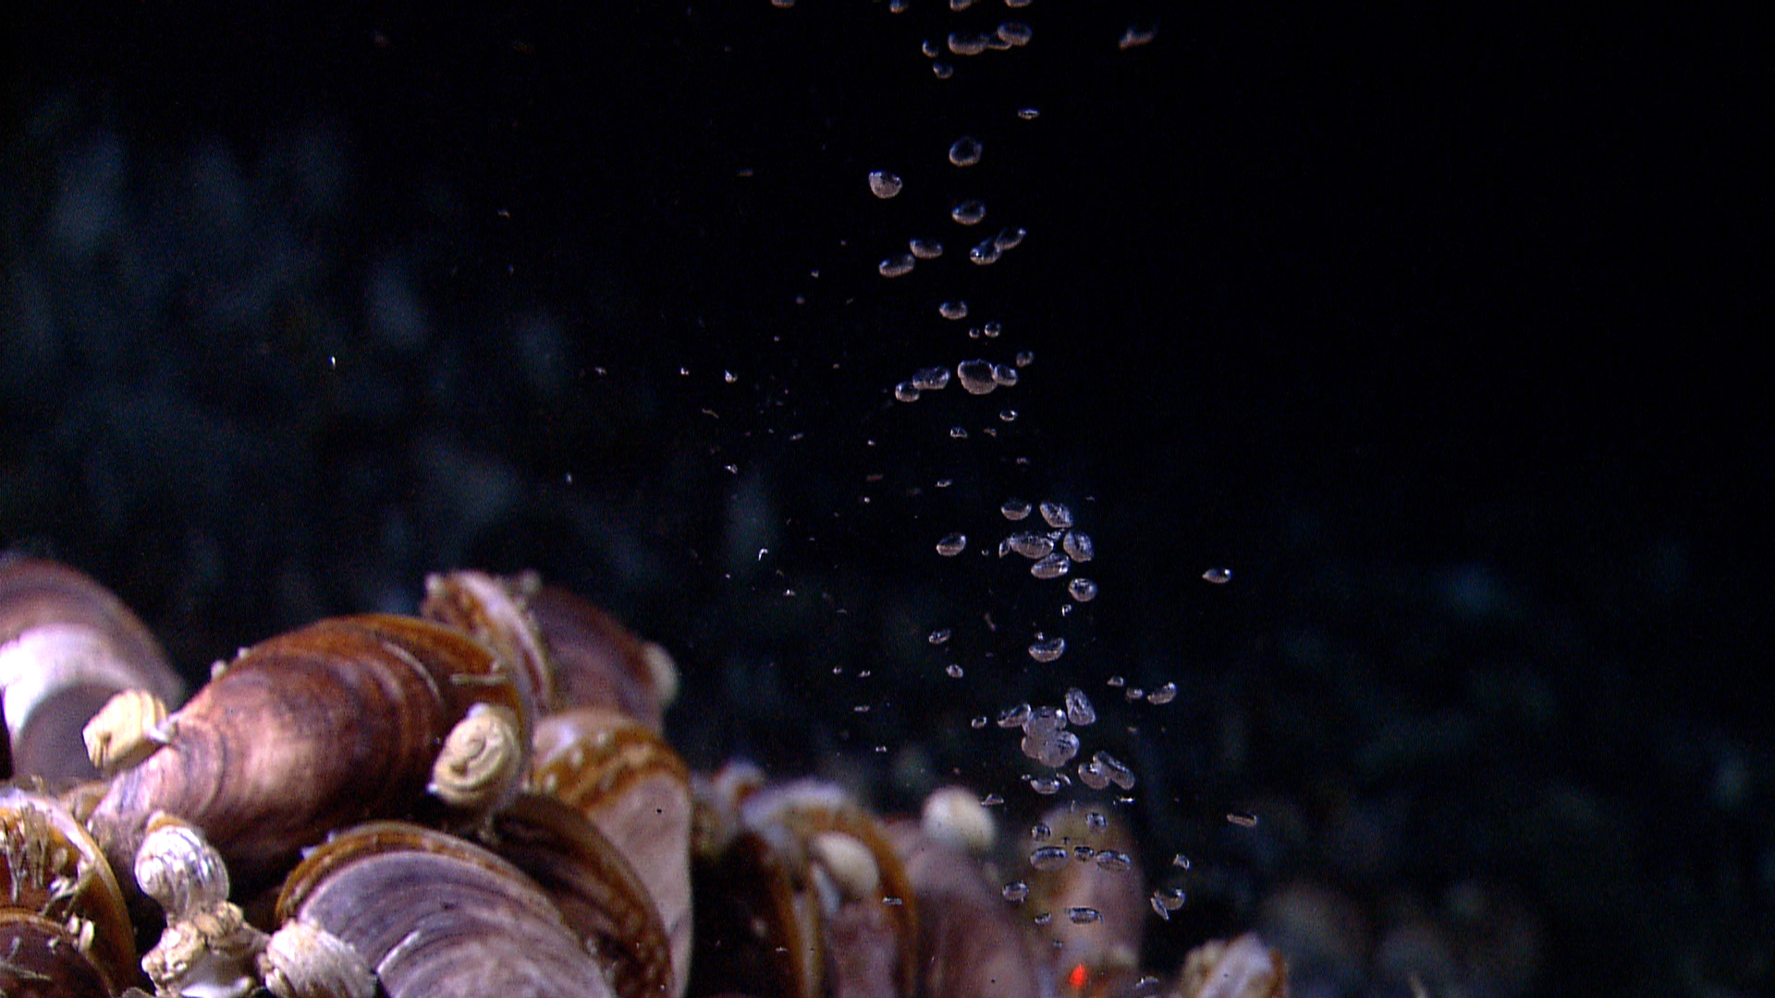
EX1202L2_IMG_20120406T173022Z_ROVHD_CAMERA_WORK_D16_00  On this dive we encountered a large seep area dominated by extensive fields of clam and mussel shells. In the central part of the field, methane bubbled up through older bivalve shells. |  |  |  |  |  |  |  | EX1202L2_IMG_20120406T173747Z_ROVHD_CAMERA_WORK_D16_00  Close up of methane bubbles coming from the seafloor within mussel communities at a depth of 1119 meters.
Please direct inquiries to: |  | NOAA Office of Ocean Exploration & Research  1315 East-West Highway (SSMC3 10th Floor)  Silver Spring, MD 20910  (301) 734-1014

