Okeanos Explorer ROV Dive Form
Site Name | Mississippi Canyon 036 |  |  |  |  |  |  |  | 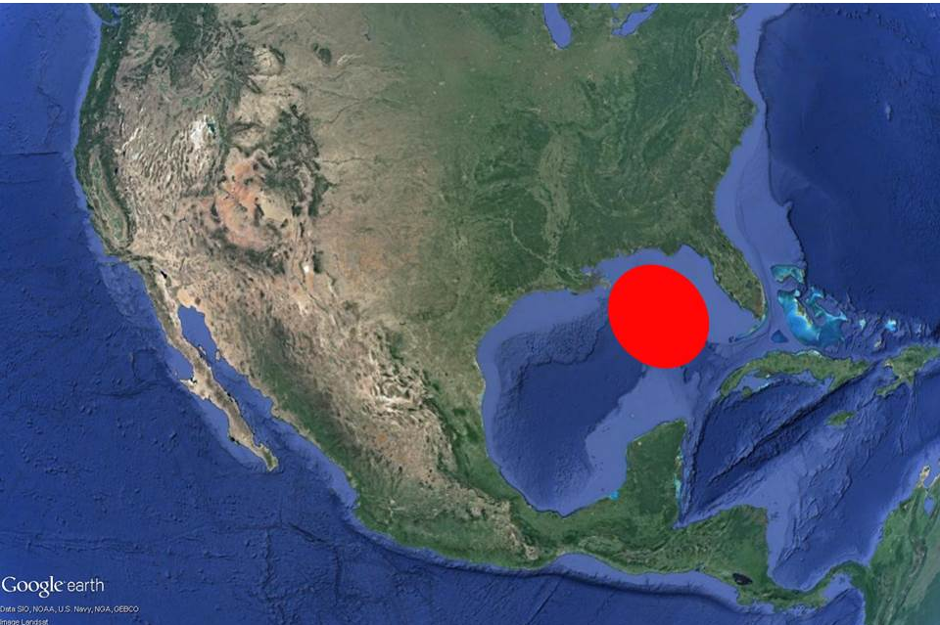
ROV Lead/Expedition Coordinator | Dave Lovalvo/Jeremy Potter
General Area Descriptor | ~310nm northwest of Tampa, Florida (vicinity of Deepwater Horizon)
UTC Date & Time | Deployment |  | 4/5/2012 14:27 PM
UTC Date & Time | Recovery |  | 3/20/2012 23:18 PM
Bottom Time  [HH:MM] | 7:19:50 (max depth 1104.7 m)
Landing  Time & Location | UTC Time | 15:14 |  |  |  |  |  |  |  | Depth [m] |  | 1092
Landing  Time & Location | Latitude | 28 |  |  |  |  | º | 56.138 |  |  |  |  | ‘ |  | N
Landing  Time & Location | Longitude | 88 |  |  |  |  | º | 12.135 |  |  |  |  | ‘ |  | W
Off Bottom  Time & Location | UTC Time | 22:32 |  |  |  |  |  |  |  | Depth [m] |  | 1087
Off Bottom  Time & Location | Latitude | 28 |  |  |  | º |  | 56.167 |  |  |  |  |  | ‘ | N
Off Bottom  Time & Location | Longitude | 88 |  |  |  | º |  | 12.007 |  |  |  |  |  | ‘ | W
ROV Dive Name | Cruise Season |  |  |  | Leg |  |  |  |  |  | Dive Number
ROV Dive Name | EX1202 |  |  |  | LEG02 |  |  |  |  |  | ROV14
Equipment Deployed | ROV: |  |  |  | Little Hercules
Equipment Deployed | Camera Platfom: |  |  |  | Seirios Camera Platform
ROV Measurements | CTD |  |  |  | Depth |  |  |  |  |  | Altitude
ROV Measurements | Scanning Sonar |  |  |  | USBL Position |  |  |  |  |  | Heading
ROV Measurements | Pitch |  |  |  | Roll |  |  |  |  |  | HD Camera
ROV Measurements | Low Res Cam 1 |  |  |  | Low Res Cam 2
Equipment Malfunctions | None
Special Notes | Click here to enter text.
Scientists Involved  (please provide name / location / affiliation / email) | Tim Shank (on-board Science Lead), EX, WHOI, tshank@whoi.edu  Pen-Yuan Hsing, PSU, penyuan.hsing@psu.edu  Eleanor Bors, WHOI, WHOI, ekbors@gmail.com  Catriona Munro, WHOI, WHOI, cmunro@whoi.edu
Purpose of the Dive: Today's dive will explore possible hardgrounds, identified by a previous survey by the AUV Sentry, in the MC036 region in the Mississippi Canyon. In addition, we will briefly revisit two sites in this area with corals previously documented as part of the effort to determine extent and intensity of the Deepwater Horizon oil spill.
Description of the Dive:
The ROV reached bottom (approximately 1088m, 28.93552ºN, -88.20224ºW) at 11:14 EDT at about 35m northeast of the first dive target. This is an area with scattered small carbonate rocks and shell fragments. The shells could be vesycomid and/or lucinid. We also imaged a polychaete, shrimps, and a possible tubeworm tube. Afterwards we started the transit southwest towards dive target 1.
At 11:42 EDT we imaged a pair of golden crabs on top of some rocks (virtual target: “D15-1 pair of crabs”), and continued to the dive target. On the way at 11:57 EDT, we noted a purple looking coral (virtual target: “D15-2 purple coral”, position - 28º56.125”N 88º12.145”W), the first coral imaged for this dive.
We reached the first dive target at 12:00 EDT, and confirmed our location with the sighting of physical marker M11. We imaged five paramuricea corals here and one Chrysogorgia. For each coral imaged today, it started with a full frame view where the coral filled the entire image, followed by closeups of all associate fauna on the coral. They may include polychaetes, ophiuroids, amphipods, shrimps, or squat lobsters. When imaging associates, we focused on obtaining clear views of features that enable us to identify them down to the lowest taxonomic level possible. In addition, the presence of hydroids on branches were noted for some corals. For each coral, we also noted the ROV heading and other pertinent information that allow future revisits to image them from the same perspective. When deemed useful for providing spatial context information, we also made overview video clips of groups of corals. We imaged at least 20 individual coral colonies this way.
Dive target 2, distinguished by crumbly rocks, was reached at 13:43 EDT (28º56.13"N 88º12.21"W, depth 1096.6m), we dropped a virtual target here called D15-3. We imaged a Chrysogorgia coral right next to a Venus fly trap anemone here, and labelled it as DC15-3-1. On the opposite end of these rocks, four meter are two large paramuricea with purple stems, and we named them D15-3-2, and D15-3-3. Around them are shrimps, squat lobsters, and a large majid crab. We extensively imaged these corals and their associates. Some associates included ophiuroids, shrimps (B. serratapalma), squat lobsters, and zoanthids. Another virtual target (D15-4, 28.93511ºN, 88.20354ºW) at was dropped on the other side of the rocks, near a paramuricea coral.
At 15:00 EDT we started the transit to dive target 3. During this transverse over sediment, we observed patches of white and dark staining, and bivalve shell fragments, suggesting possible seep activity. The target was reached at about 15:10 EDT (virtual target D15-5, 28.93466ºN, 88.20336ºW), and we imaged two Chrysogorgias here.
The next transit was to dive target 4, 130m to the northeast. During this time we discovered fishing line in the sediment (15:29 EDT), and imaged two Chrysogorgid corals (virtual target D15-6 at 28.93497ºN, 88.20303ºW). As we approached dive target 4, there was a noticeable increase in shell fragment density, stained sediment, and scattered carbonate rocks. We discovered live mussels on the side of a small mound, along with live gastropods and clam. All had apparent chiton on their shells. Dive target 4 is apparently an active seep area, and we explored this area until 16:04 EDT.
On the way to dive target 5, we continued to see some bivalve shell fragments, fish, shrimp, and light sediment staining. The target was reached at 16:26 EDT, confirmed by sighting of physical marker M18 (28.93549ºN, 88.20128ºW). This area is characterized by a boulder about 2 m wide, and 0.5 m tall. On it were numerous paramuricea corals, but they were somewhat different from what we've seen in that they had purple stems. Typical associates on these corals included barnacles, anemones, ophiuroids, and slight amounts of hydroids on some. We extensively imaged at least five corals here, and moved to dive target 6 at 17:42 EDT.
The move to target 6 was similar to earlier transits, with light sediment staining, fish, urchins, some bivalve shells, hermit crabs, and occasional scattered rocks. We reached the target at about 18:04 EDT (28.93595ºN, 88.20021ºW). We searched for sonar targets in the area, and during the process imaged burrows and possible gastropod trails in the sediment. There were more scattered rocks here, some with red staining suggesting they are burrow casts. There was also a crab, possibly of the family Kiwidae. Finally, we deployed a physical marker PS2 at 18:28 EDT (28.93594ºN, 88.20024ºW), before the scheduled recovery time of 18:30 EDT.
The water temperature was consistent through the dive at about 4.3ºC.
Overall Map of ROV Dive Area |  |  |  | Close-up Map of Main Dive Site
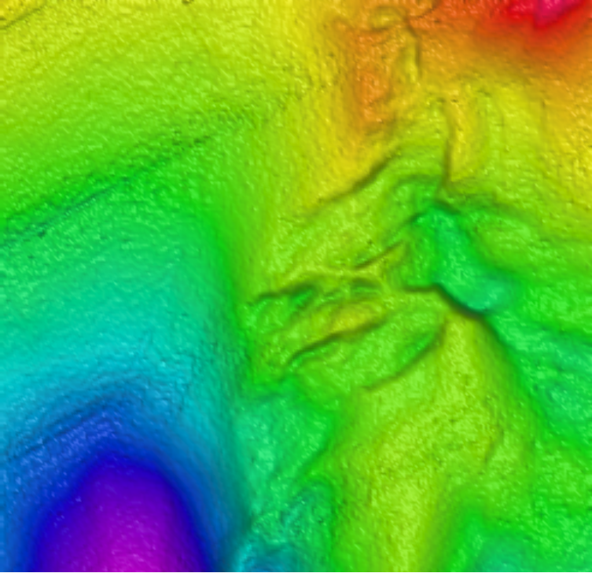 |  |  |  | 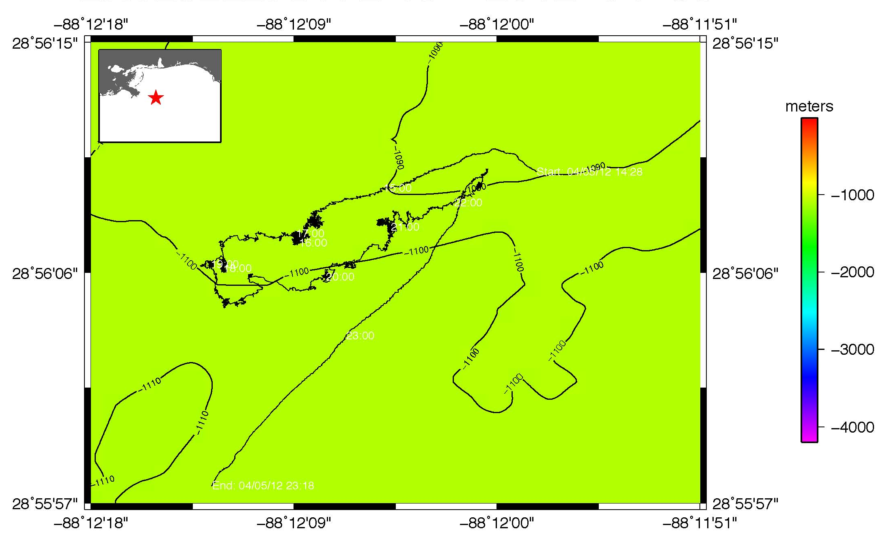
Representative Photos of the Dive
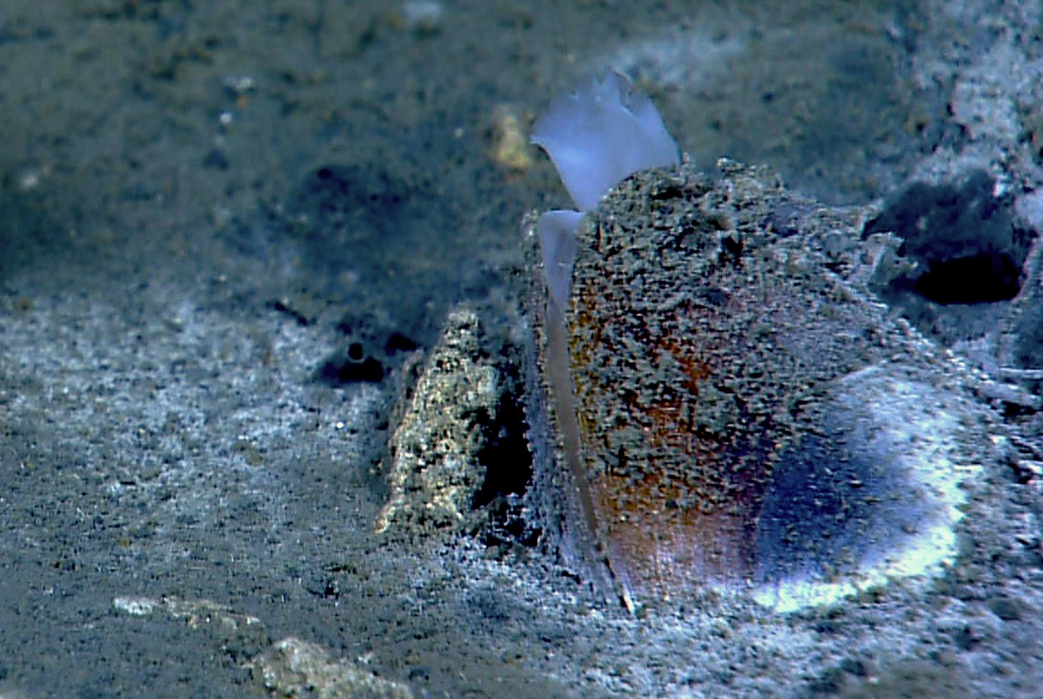 |  |  |  |  |  |  |  | 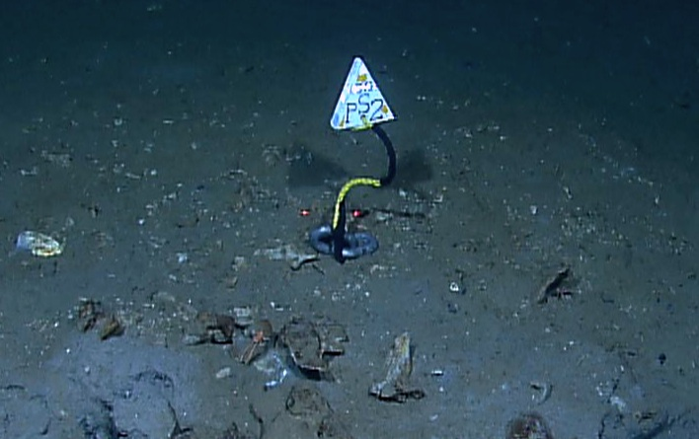
EX1202L2_IMG_20120405T195213Z_ROVHD_COP.jpg (cropped from original)  A live mussel with its siphon outside at the seep site discovered today. |  |  |  |  |  |  |  | EX1202L2_IMG_20120405T222940Z_ROVHD_PS2_MARKER_DROP_00.jpg (cropped from original) Marker PS2 was deployed by the Little Hercules ROV near the end of the dive.
Please direct inquiries to: |  | NOAA Office of Ocean Exploration & Research  1315 East-West Highway (SSMC3 10th Floor)  Silver Spring, MD 20910  (301) 734-1014

