Okeanos Explorer ROV Dive Form
Site Name | Mississippi Canyon 255 |  |  |  |  |  | 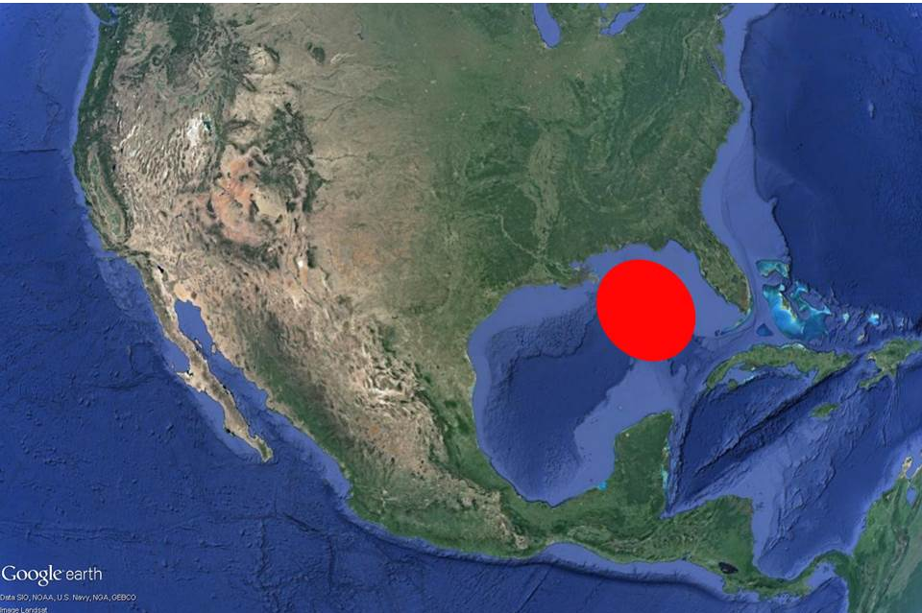
ROV Lead/Expedition Coordinator | Dave Lovalvo/Jeremy Potter
General Area Descriptor | ~310nm northwest of Tampa, Florida (vicinity of Deepwater Horizon)
UTC Date & Time | Deployment |  | 4/4/2012 13:25 PM
UTC Date & Time | Recovery |  | 4/4/2012 20:34 PM
Bottom Time  [HH:MM] | 4:57:55 (max depth 1613.5 m)
Landing  Time & Location | UTC Time | 14:35 |  |  |  |  |  | Depth [m] |  | 1614
Landing  Time & Location | Latitude | 28 |  |  | º | 43.426 |  |  |  |  | ‘ |  | N
Landing  Time & Location | Longitude | 88 |  |  | º | 14.918 |  |  |  |  | ‘ |  | W
Off Bottom  Time & Location | UTC Time | 19:31 |  |  |  |  |  | Depth [m] |  | 1359
Off Bottom  Time & Location | Latitude | 28 |  |  | º | 44.047 |  |  |  |  |  | ‘ | N
Off Bottom  Time & Location | Longitude | 88 |  |  | º | 15.134 |  |  |  |  |  | ‘ | W
ROV Dive Name | Cruise Season |  |  | Leg |  |  |  |  | Dive Number
ROV Dive Name | EX1202 |  |  | LEG02 |  |  |  |  | ROV14
Equipment Deployed | ROV: |  |  | Little Hercules
Equipment Deployed | Camera Platfom: |  |  | Seirios Camera Platform
ROV Measurements | CTD |  |  | Depth |  |  |  |  | Altitude
ROV Measurements | Scanning Sonar |  |  | USBL Position |  |  |  |  | Heading
ROV Measurements | Pitch |  |  | Roll |  |  |  |  | HD Camera
ROV Measurements | Low Res Cam 1 |  |  | Low Res Cam 2
Equipment Malfunctions | None
Special Notes | Click here to enter text.
Scientists Involved  (please provide name / location / affiliation / email) | Tim Shank (on-board Science Lead), EX, WHOI, tshank@whoi.edu  Pen-Yuan Hsing, PSU, penyuan.hsing@psu.edu  Eleanor Bors, WHOI, WHOI, ekbors@gmail.com  Catriona Munro, WHOI, WHOI, cmunro@whoi.edu
Purpose of the Dive: Today's dive will explore two regions of strong 3D seismic signal from past surveys. One is on the bottom, the other on the top edge of a salt dome in the MC 255 lease block. The moderate to strong signals suggest possible hard grounds that could host coral colonies. We will start from the bottom of the salt dome and explore up its slope, documenting the biology and geology here.
Description of the Dive:
The ROV reached bottom (approximately 1610m, 28.72394°N, 88.24849°W) at 10:35 EDT at waypoint 1, the first dive target. This is an area showing high reflectivity during 3D seismic scans, indicating possible hard bottom and potential coral substrate. However, exploring the area until about 11:00 EDT we did not encounter any hard substrate, and observed only holothurians, shrimps, fish (halosaur, rattails, eels), sea urchins, and numerous bio mounds. Therefore, we decided to head uphill to the second waypoint at the top of the faulted escarpment, depth about 1400m.
To reduce transit time to the top waypoint, we increased speed to 0.3 knots at 11:41 EDT, still noting biology alon g the way. When traversing uphill, we continued to observe bio mounds, fish (such as rattail), ophiuroids, sea urchins, red shrimp (eryonidae) in the water column, crabs (possible chaceon), and occasional squat lobsters sargassum. Also, we did not notice any holothurians during this up slope transect. The sediment here has a low density of white pteropod shells, and we noticed several furrows at least 40m long, perpendicular to the direction of the slope, running in the east west direction.
The first coral we observed during the dive was at 12:48 EDT (28.73128ºN, 88.24597ºW, 1434m), while we were moving up the scarp. We also observed a gravid crab at 12:52 EDT, followed by another of the same coral 12:54 EDT (28.73159ºN, 88.24567ºW, 1430m). A third coral of its kind was seen at 13:08 EDT (28.73280ºN, 88.24522ºW, 1403m). These three corals appeared as just one vertical branch growing out of the seafloor, several more were noted through the remainder of this dive. Another kind of octocoral, with branching, was seen at 13:25 EDT (28.73341ºN, 88.24427ºW, depth 1389m), and it had two associates on its branches, which could be small crabs. At 14:54 EDT (28.73382ºN, 88.24854ºW, depth 1376m), we encountered three holes, each roughly 10cm across, on the seafloor. This time, we did not see any organisms inside the holes, though one of them seemed to have caved in at its entrance.
We reached waypoint 2 (28.73344ºN, 88.24469ºW, depth 1388m) at about 13:17 EDT, but did not detect sonar targets suggesting hard grounds in any direction for almost 100m. Therefore, at 13:45 EDT we decided to head west 250m , towards a steeper slope on the bathymetry map, along the southern edge of the top of the escarpment. During this transect, we observed a number of seastars (such as at 14:20 EDT, 28.73363ºN, 88.24542ºW, depth 1385.8m). One round sponge was seen at 14:31 EDT (28.73375ºN, 88.24650ºW, 1379.8m).
The ROV left bottom at the scheduled time of 15:30 EDT (28.73390ºN, 88.25188ºW, depth 1359.2m), without encountering significant sonar targets or hard grounds. By this time it has traveled more than 770m due west from waypoint 2.
The water temperature was consistent through the dive at about 4.3ºC.
Overall Map of ROV Dive Area |  |  |  |  |  | Close-up Map of Main Dive Site
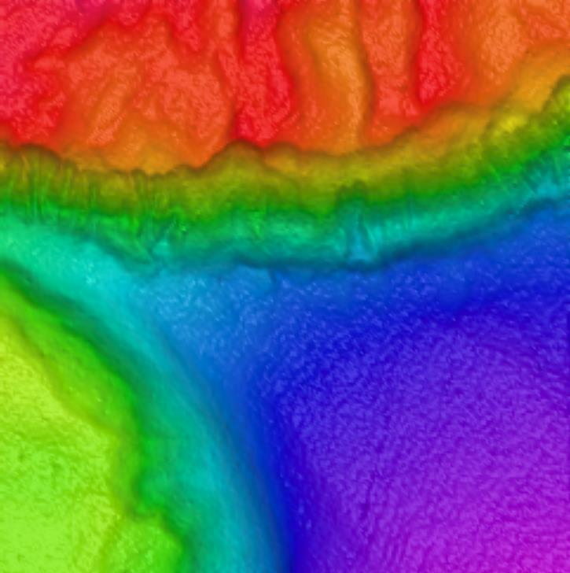
Representative Photos of the Dive
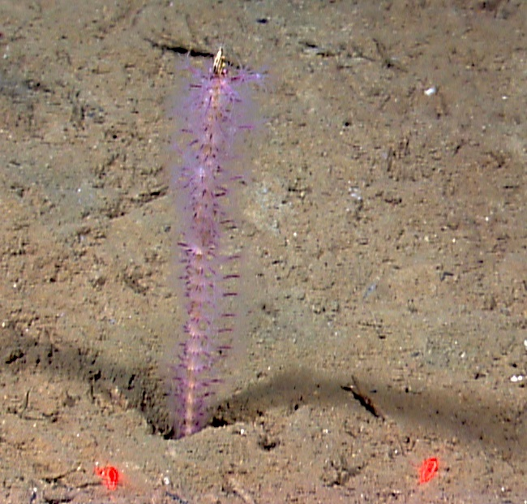 |  |  |  |  |  | 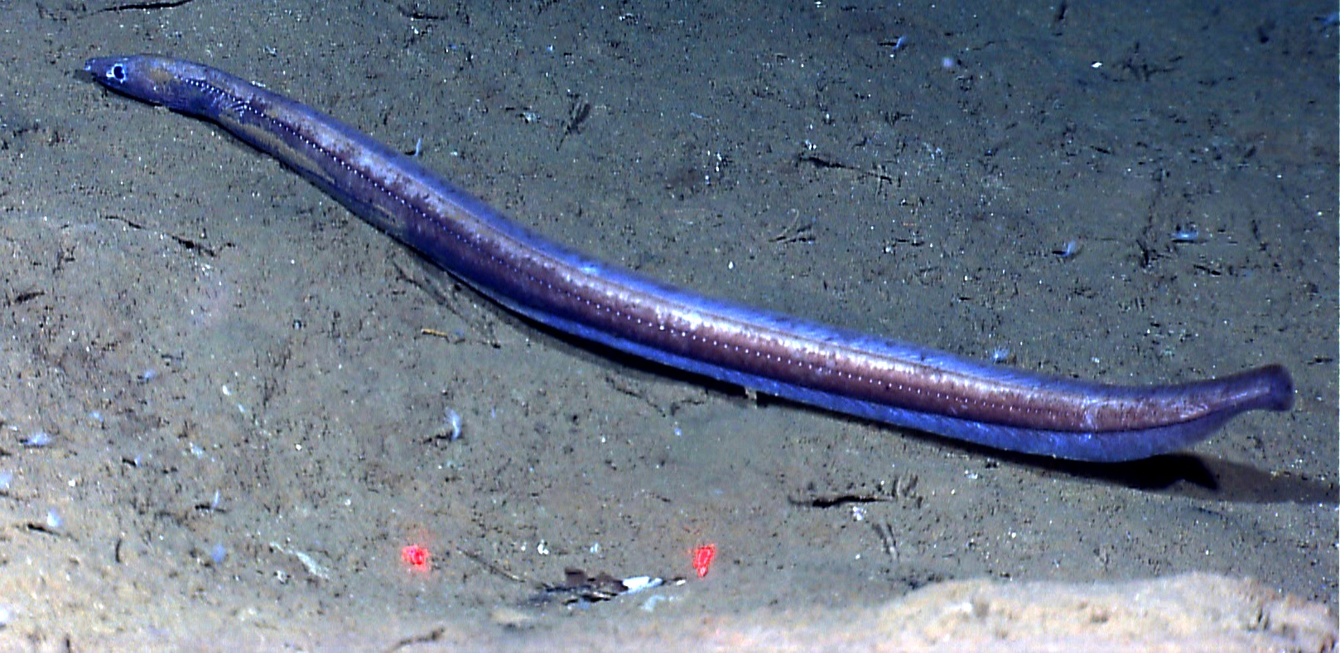
EX1202L2_IMG_20120403T165336Z_ROVHD_FSH_COR.jpg (cropped from original)  One of the octocorals discovered during this dive. The red laser dots are 10 cm apart. |  |  |  |  |  | EX1202L2_IMG_20120403T150205Z_ROVHD_EEL.jpg (cropped from original)  We encountered numerous eels like the one pictured.
Please direct inquiries to: |  | NOAA Office of Ocean Exploration & Research  1315 East-West Highway (SSMC3 10th Floor)  Silver Spring, MD 20910  (301) 734-1014

