Okeanos Explorer ROV Dive Form
Site Name | Mississippi Canyon 388 |  |  |  |  |  |  |  | 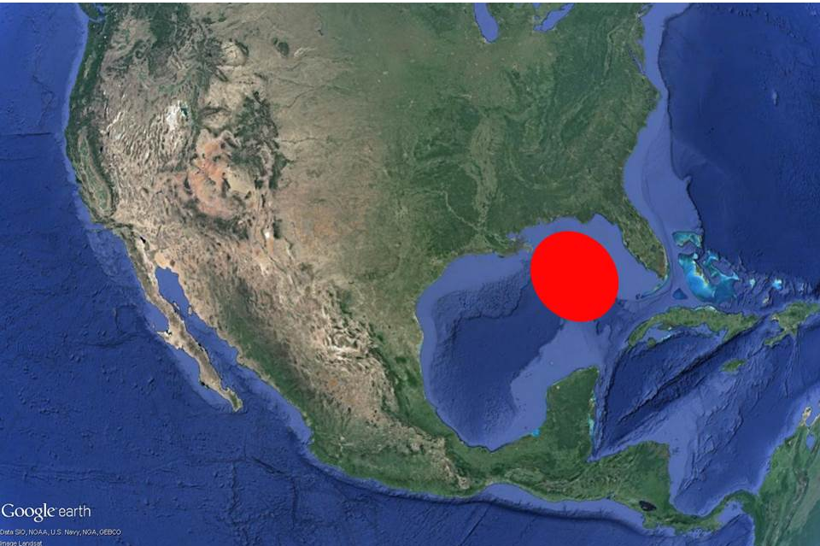
ROV Lead/Expedition Coordinator | Dave Lovalvo/Jeremy Potter
General Area Descriptor | ~300nm northwest of Tampa, Florida (vicinity of Deepwater Horizon)
UTC Date & Time | Deployment |  | 4/02/2012 12:29 PM
UTC Date & Time | Recovery |  | 4/02/2012 20:31 PM
Bottom Time  [HH:MM] | 5:20:56 (max depth 1899.2 m)
Landing  Time & Location | UTC Time | 13:51 |  |  |  |  |  |  |  | Depth [m] |  | 1849
Landing  Time & Location | Latitude | 28 |  |  | º | 38.023 |  |  |  |  |  |  | ‘ |  | N
Landing  Time & Location | Longitude | 88 |  |  | º | 10.186 |  |  |  |  |  |  | ‘ |  | w
Off Bottom  Time & Location | UTC Time | 19:28 |  |  |  |  |  |  |  | Depth [m] |  | 1895
Off Bottom  Time & Location | Latitude | 28 |  |  | º | 37.761 |  |  |  |  |  |  |  | ‘ | N
Off Bottom  Time & Location | Longitude | 88 |  |  | º | 10.431 |  |  |  |  |  |  |  | ‘ | w
ROV Dive Name | Cruise Season |  |  | Leg |  |  |  |  |  |  | Dive Number
ROV Dive Name | EX1202 |  |  | LEG02 |  |  |  |  |  |  | ROV13
Equipment Deployed | ROV: |  |  | Little Hercules
Equipment Deployed | Camera Platfom: |  |  | Seirios Camera Platform
ROV Measurements | CTD |  |  | Depth |  |  |  |  |  |  | Altitude
ROV Measurements | Scanning Sonar |  |  | USBL Position |  |  |  |  |  |  | Heading
ROV Measurements | Pitch |  |  | Roll |  |  |  |  |  |  | HD Camera
ROV Measurements | Low Res Cam 1 |  |  | Low Res Cam 2
Equipment Malfunctions | None
Special Notes | Click here to enter text.
Scientists Involved  (please provide name / location / affiliation / email) | Tim Shank (on-board Science Lead), EX, WHOI, tshank@whoi.edu  Pen-Yuan Hsing, PSU, penyuan.hsing@psu.edu  Santiago Herrera, WHOI, sherrera@mit.edu  Taylor Heyl, WHOI, theyl@whoi.edu  Eleanor Bors, WHOI, ekbors@gmail.com  Catriona Munro, WHOI, cmunro@whoi.edu  Bob Carney, LSU, rcarne1@lsu.edu  Erik Cordes, Temple, ecordes@temple.edu  Andrea Quattrini, Temple, andrea.quattrini@temple.edu  Peter Etnoyer, NOAA, Peter.Etnoyer@noaa.gov  Mike Vecchione, Smithsonian, VecchioneM@si.edu
Purpose of the Dive: To launch the vehicles on a study location in Mississippi Canyon lease block 388. This site was discovered during a towed camera and AUV Sentry surveys, and then visited with Alvin in December 2011. It has both seep communities and coral communities distributed over a fairly large area. Multibeam data and 3D seismic data for the area suggests that coral will be much more widespread at this site. The purpose of revisiting this location is to explore and characterize these coral ecosystems, and explore for additional seep and coral communities.
Description of the Dive:
At 1351, LH approached bottom, 28.63370, -88.16979, depth 1849m, on brown/gray mottled sediment with holothurians and seep tubeworms, setting up at marker 9 after passing MM2. Starting at 1424, 28.63368, -88.16961, depth 1424m, we started close up imaging of each coral in the vicinity of Marker 9. For each coral, imaging started with a full frame view where the coral filled the entire image, followed by closeups of all associate fauna on the coral. They may include ophiuroids, amphipods, shrimps, or squat lobsters. When imaging associates, we focused on obtaining clear views of features that enable us to identify them down to the lowest possible taxonomic level. In addition, the presence and absence of hydroids on branches were noted for all corals. For each coral, we also noted the ROV heading and other pertinent information that would allow future visits to image them from the same perspective. When deemed useful for providing spatial context information, we also made overview video clips of groups of corals.
At 1513, we encountered a new coral with what appeared to be curves branching at the top (and named it 9-9), adjacent to live seep tubeworms and clam shells present on soft sediment at the base of the corals. At 1628, we imaged an overview of marker 5 corals and observed white sediment stain with gray and brown dusting and burrow contrasts before preparing for a move to the SW along the ridge on margin of the dome. Black staining was present all the way down slope in this area and we encountered mussels and tubeworms within the staining. The remainder of the dive was spent exploring the area 70m away from Marker 8 site downslope to the west where holothurians, mottled sediment with pteropod shells, burrows, hole rings, fecal traces and sargassum were common. From 1808 to 1809, we imaged an ophiuroid swimming and then parachuting to the seafloor before all internet from the OKEX was temporarily disconnected and this signaled the end of the dive.
Overall Map of ROV Dive Area |  |  |  |  |  |  |  | Close-up Map of Main Dive Site
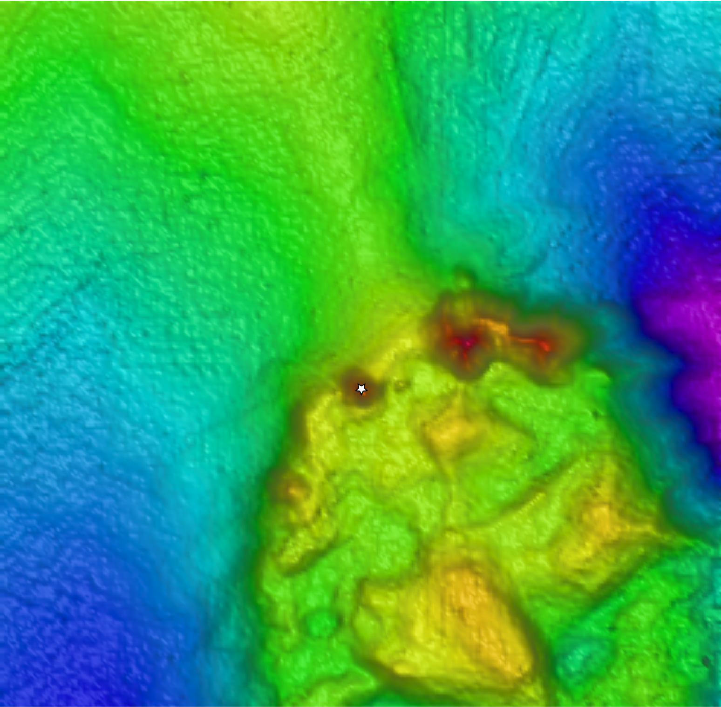
Representative Photos of the Dive
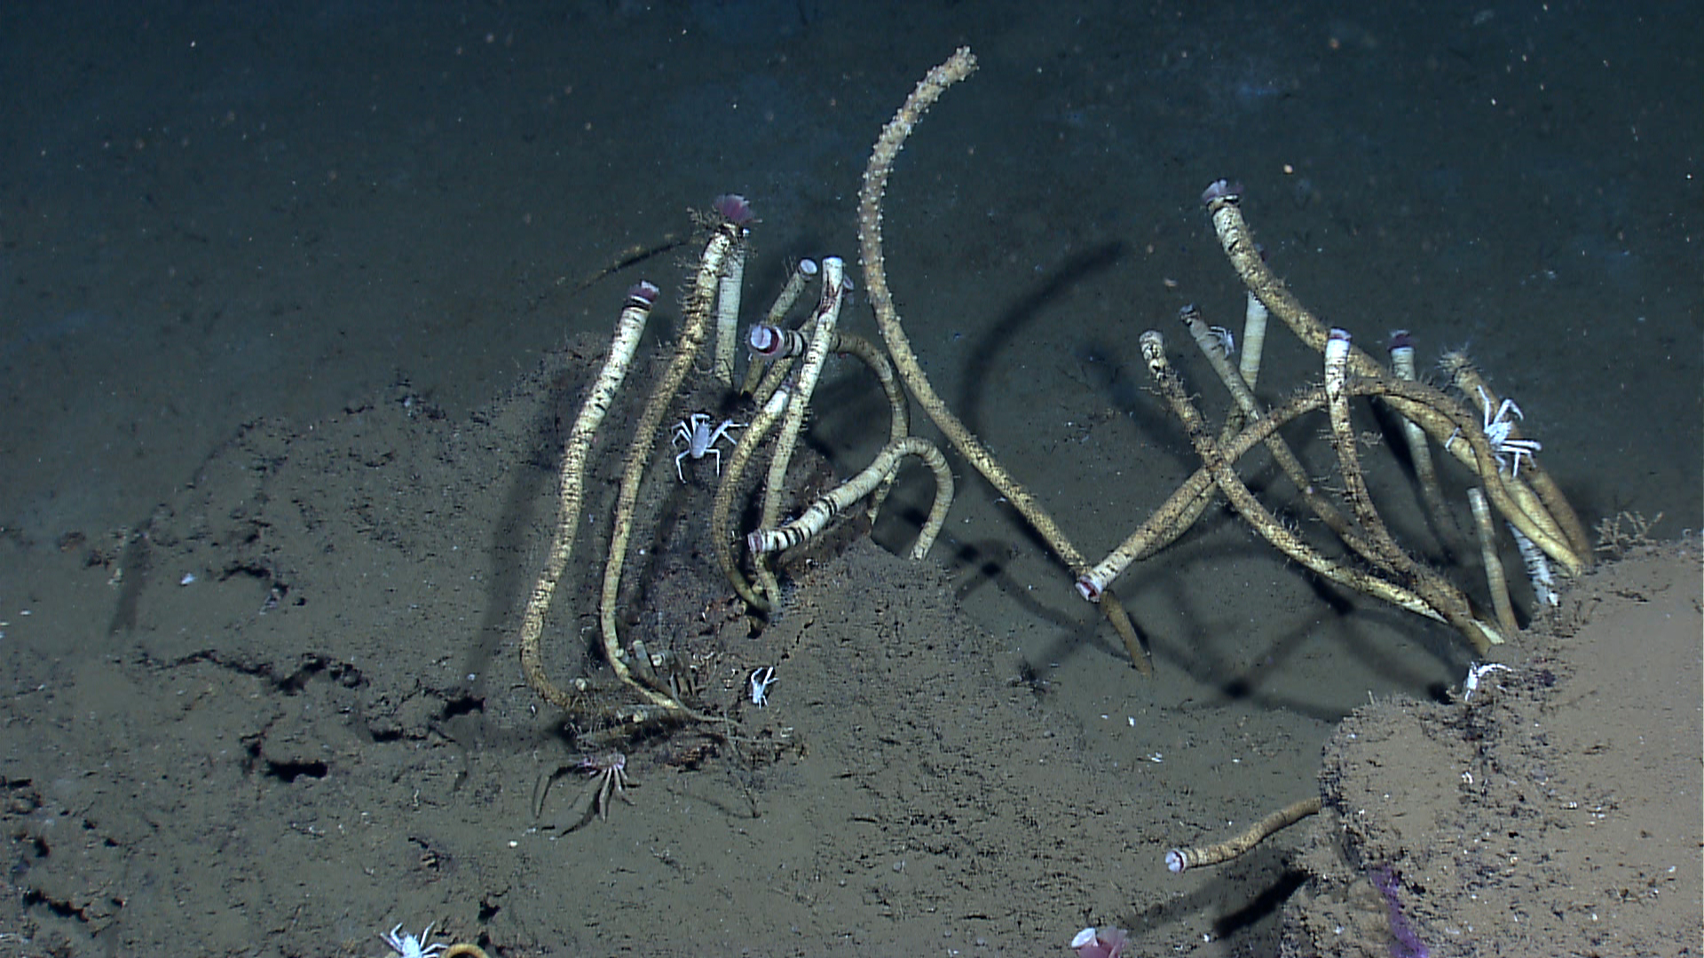 |  |  |  |  |  |  | 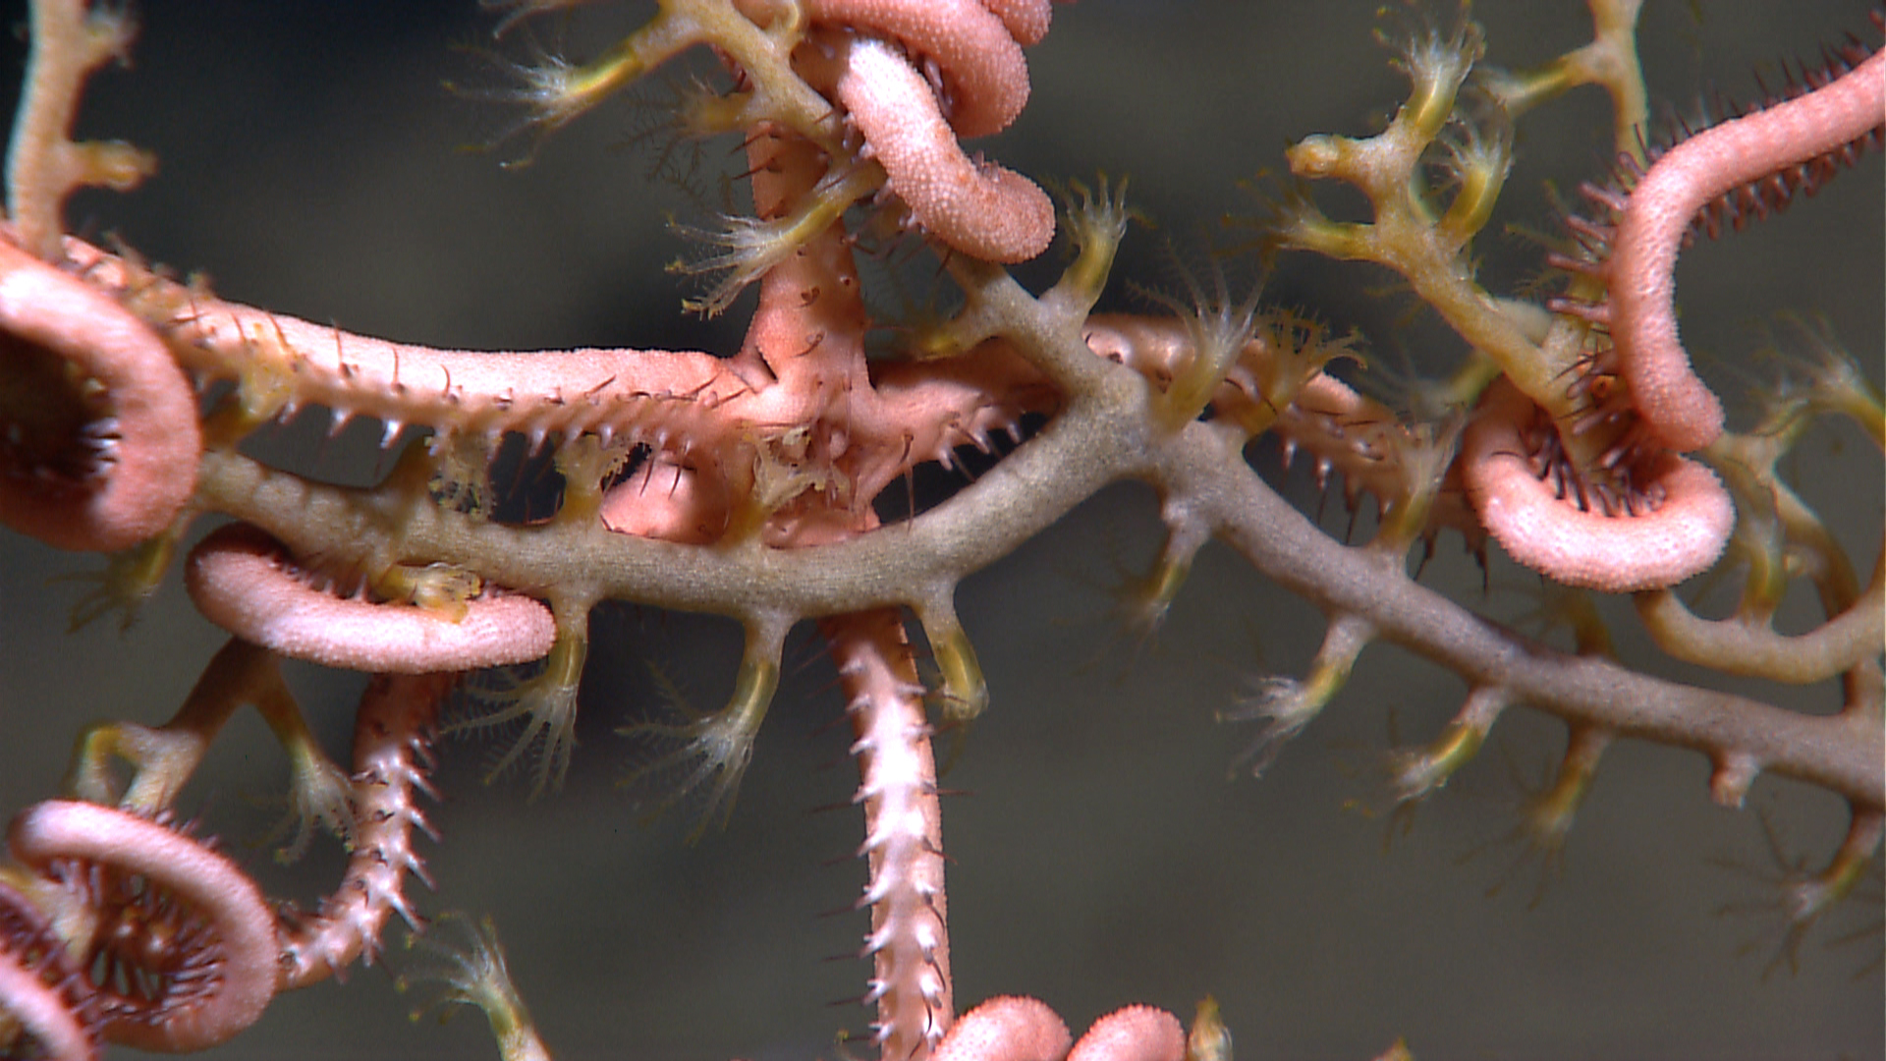
EX1202L2_IMG_20120402T140649Z_ROVHD_SQA_TUB_CORO  Live seep tubeworms found on soft sediment at the base of Marker 9 corals at Mississippi Canyon lease block 388. |  |  |  |  |  |  | EX1202L2_IMG_20120402T142442Z_ROVHD_M9_3_COR_OPH  Close up image of an ophiuroid associate found on a paramuricea coral (M9-3) with polyps extended.
Please direct inquiries to: |  | NOAA Office of Ocean Exploration & Research  1315 East-West Highway (SSMC3 10th Floor)  Silver Spring, MD 20910  (301) 734-1014

