Okeanos Explorer ROV Dive Form
Site Name | Mississippi Canyon MC294/338 |  |  |  |  |  | 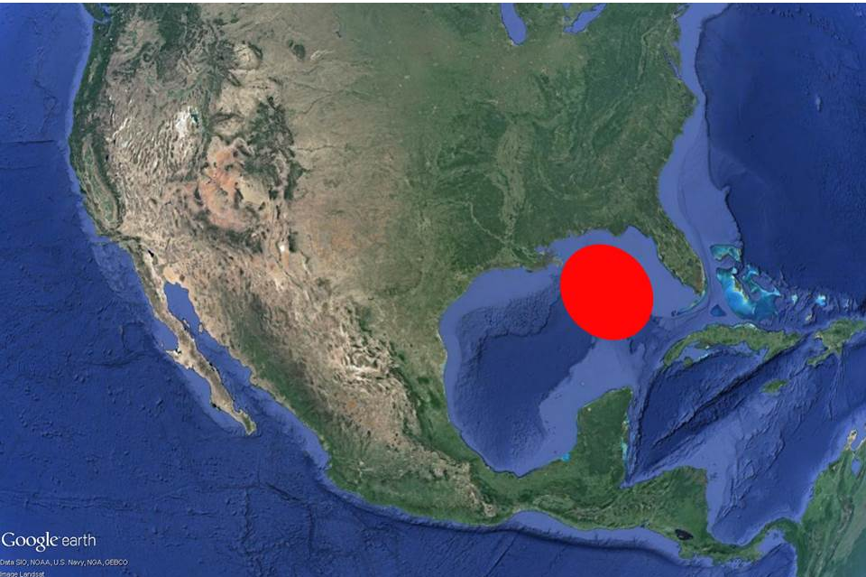
ROV Lead/Expedition Coordinator | Dave Lovalvo/Jeremy Potter
General Area Descriptor | ~325nm northwest of Tampa, Florida (vicinity of Deepwater Horizon)
UTC Date & Time | Deployment |  | 3/31/2012 12:49 PM
UTC Date & Time | Recovery |  | 3/31/2012 01:10 PM
Bottom Time  [HH:MM] | 7:14:52 (max depth 1374.7 m)
Landing  Time & Location | UTC Time | 13:48 |  |  |  |  |  | Depth [m] |  | 475 m
Landing  Time & Location | Latitude | 28 |  |  | º | 40.322 |  |  |  |  | ‘ |  | N
Landing  Time & Location | Longitude | 88 |  |  | º | 28.631 |  |  |  |  | ‘ |  | W
Off Bottom  Time & Location | UTC Time | 20:16 |  |  |  |  |  | Depth [m] |  | 382
Off Bottom  Time & Location | Latitude | 28 |  |  | º | 40.340 |  |  |  |  |  | ‘ | N
Off Bottom  Time & Location | Longitude | 88 |  |  | º | 28.595 |  |  |  |  |  | ‘ | W
ROV Dive Name | Cruise Season |  |  | Leg |  |  |  |  | Dive Number
ROV Dive Name | EX1202 |  |  | LEG02 |  |  |  |  | ROV11
Equipment Deployed | ROV: |  |  | Little Hercules
Equipment Deployed | Camera Platfom: |  |  | Seirios Camera Platform
ROV Measurements | CTD |  |  | Depth |  |  |  |  | Altitude
ROV Measurements | Scanning Sonar |  |  | USBL Position |  |  |  |  | Heading
ROV Measurements | Pitch |  |  | Roll |  |  |  |  | HD Camera
ROV Measurements | Low Res Cam 1 |  |  | Low Res Cam 2
Equipment Malfunctions | None
Special Notes | Click here to enter text.
Scientists Involved  (please provide name / location / affiliation / email) | Tim Shank (on-board Science Lead), EX, WHOI, tshank@whoi.edu  Pen-Yuan Hsing, PSU, penyuan.hsing@psu.edu  Eleanor Bors, WHOI, WHOI, ekbors@gmail.com  Catriona Munro, WHOI, WHOI, cmunro@whoi.edu
Purpose of the Dive: The timing of today's dive is critical to a substantial effort by NOAA and other parties to track changes over time at a site in lease block MC294. We will explore and image corals growing on hard substrate for changes since previous visits in 2010 and 2011. Today's exploration in the time domain will be a wonderful complement to the work that we have be doing on this cruise.
Description of the Dive:
The ROV reached bottom at 09:48 EDT (28º40.322”N, 88º28.628”W) 50 m west of the dive target as planned, and we proceeded east to explore the coral communities here. On the way, we noted some stained sediment and small tubeworm tubes, fish (longnose chimera) and shrimp.
We reached the dive target at 10:10 EDT (28.67232ºN, 88.47658ºW, depth 1371.5 m), and did a transect across the two carbonate slabs hosting about 50 corals. Site location was confirmed with sightings of two physical markers, AA and 44, deployed here in November 2010.
Starting from 10:30 EDT, we started close up imaging of each coral on the two carbonate slabs. For each coral, imaging started with a full frame view where the coral filled the entire image, followed by closeups of all associate fauna on the coral. They may include ophiuroids, amphipods, shrimps, or squat lobsters. When imaging associates, we focused on obtaining clear views of features that enable us to identify them down to the lowest possible taxonomic level. In addition, the presence of hydroids on branches were noted for some corals. For each coral, we also noted the ROV heading and other pertinent information that allow future revisits to image them from the same perspective. When deemed useful for providing spatial context information, we also made overview video clips of groups of corals. We imaged at least 50 individual coral colonies.
The last coral, named E-1, was imaged at 16:37 EDT. Afterwards we continued to explore the area and discovered a new paramuricea coral on a rock, just behind E-1. Also, (16:57 EDT, 28.67229ºN, 88.47655ºW, 1370.7m) we observed an ophiuroid in the process of moving from one coral (B-1) to another (B-6), this is a phenomenon that, to the best of our knowledge, has never been observed in the deep-sea before.
The water temperature was consistent through the dive at about 9.3ºC. Virtual targets were deployed for the physical markers and imaged corals.
Overall Map of ROV Dive Area |  |  |  |  |  | Close-up Map of Main Dive Site
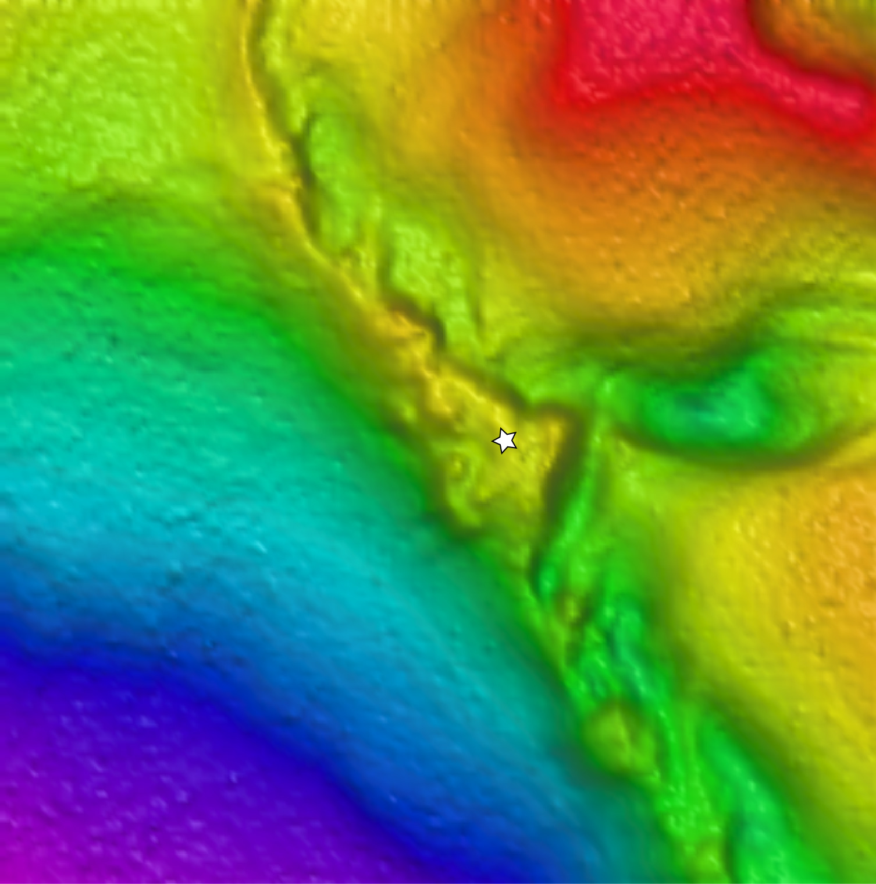
Representative Photos of the Dive
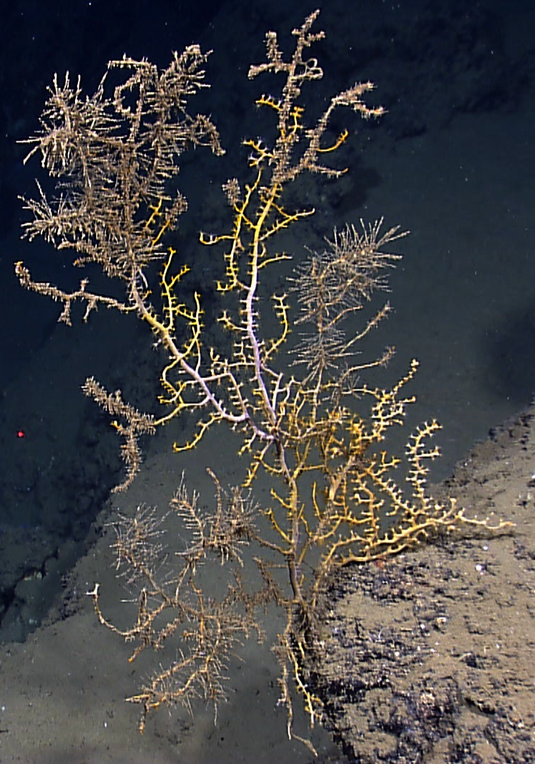 |  |  |  |  |  | 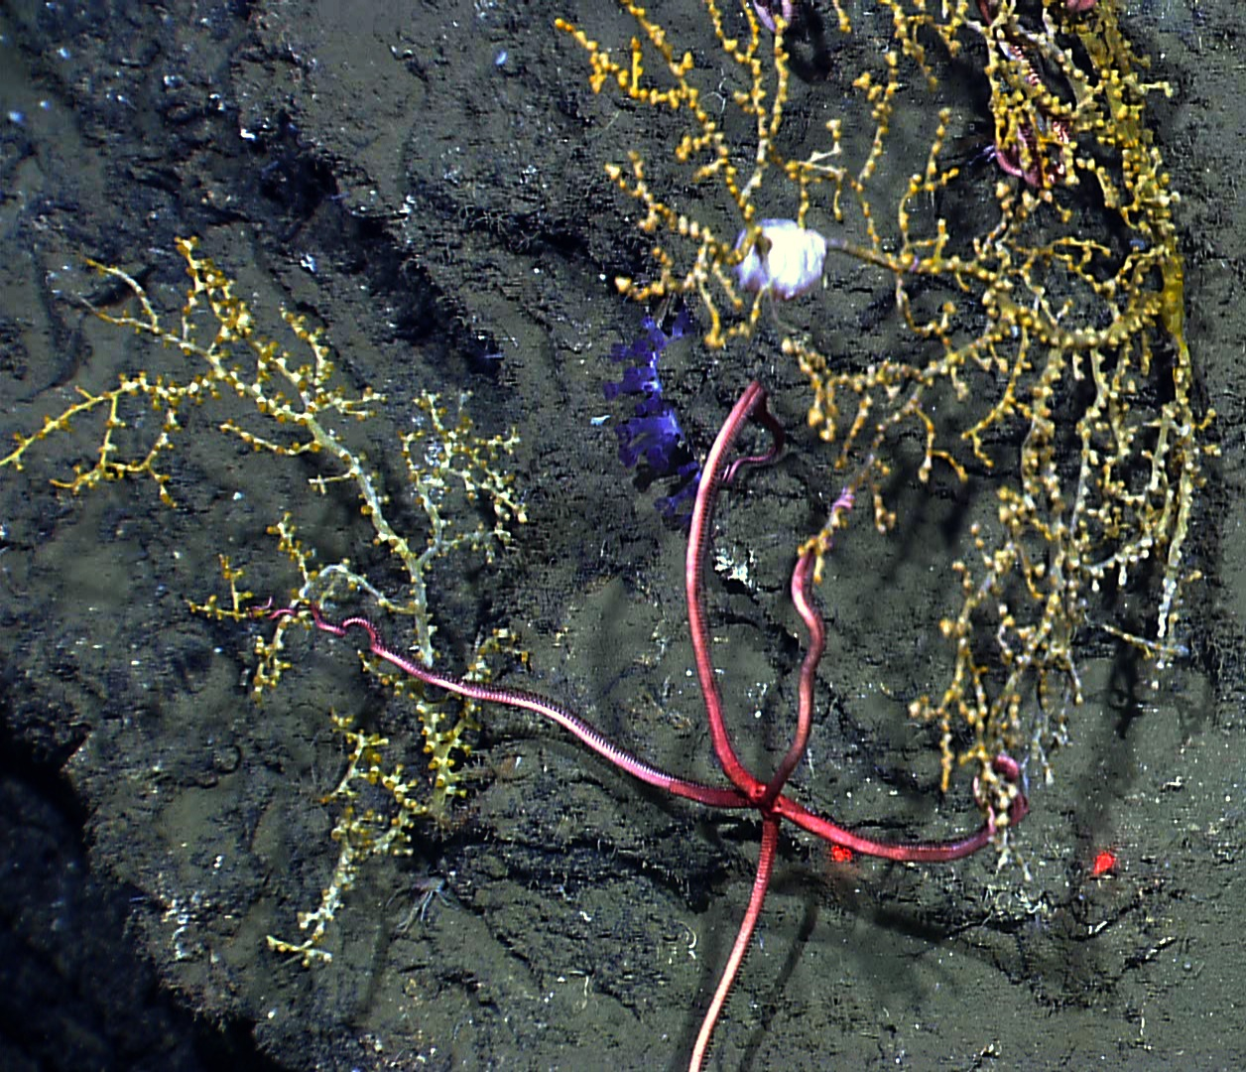
EX1202L2_IMG_20120331T192345Z_ROVHD_MC294_A10_A14_00.jpg (cropped from original)  One of the Paramuricea corals (A-10) imaged during this dive. Most of the more than 50 corals we imaged occurred on one of two carbonate slabs, covering an area roughly 10x10m. |  |  |  |  |  | EX1202L2_IMG_20120331T205642Z_ROVHD_MC294_B_OVERVIEW_00.jpg  Ophiuroid moving from one coral to another. This behaviour has not been observed in the deep-sea before.
Please direct inquiries to: |  | NOAA Office of Ocean Exploration & Research  1315 East-West Highway (SSMC3 10th Floor)  Silver Spring, MD 20910  (301) 734-1014

