Okeanos Explorer ROV Dive Summary
Site Name | MC 297 |  |  |  | 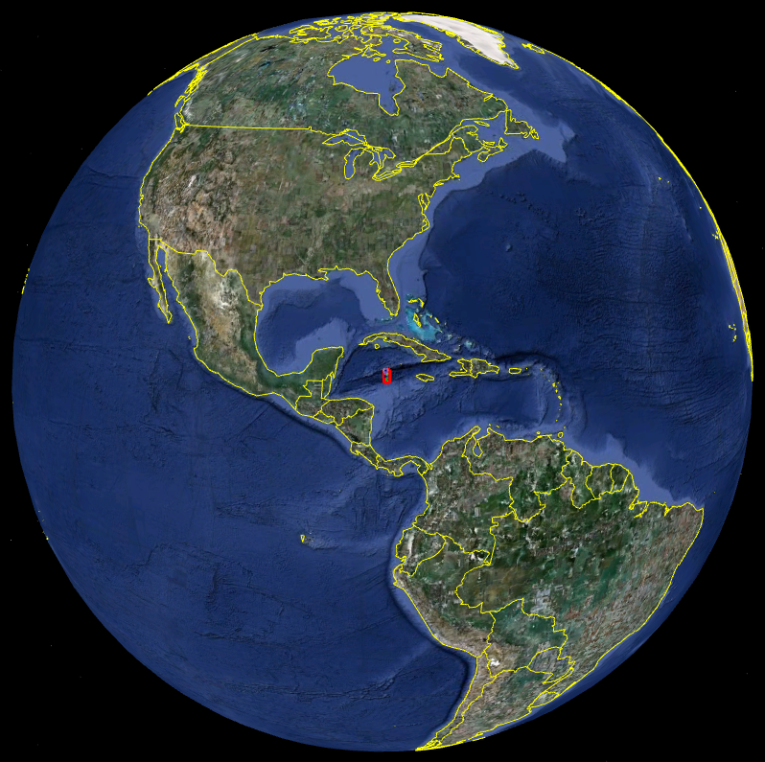
ROV Lead | Dave Lovalvo
General Area Descriptor
ROV Dive Name | Cruise Season |  | Leg |  |  | Dive Number
 | EX1202 |  | 2 |  |  | DIVE12
Equipment Deployed | ROV: |  | Little Hercules
 | Camera Platform: |  | Seirios
ROV Measurements | CTD |  | Depth |  |  | Altitude
 | Scanning Sonar |  | USBL Position |  |  | Heading
 | Pitch |  | Roll |  |  | HD Camera
 | Low Res Cam 1 |  | Low Res Cam 2
Equipment Malfunctions | none
ROV Dive Summary  (From processed ROV data) | Dive Summary: EX1202L2_DIVE12  ^^^^^^^^^^^^^^^^^^^^^^^^^^^^^^^^^^^^^^^^^^^^^^^^^^^  In Water at: 2012-04-01T12:23:37.555000  28°, 41.117' N ; 088°, 20.951' W  Out Water at: 2012-04-01T20:30:36.472000  28°, 40.701' N ; 088°, 20.603' W  Off Bottom at: 2012-04-01T19:28:06.846000  28°, 40.963' N ; 088°, 20.726' W  On Bottom at: 2012-04-01T13:33:48.437000  28°, 40.947' N ; 088°, 20.716' W  Dive duration: 8:6:58  Bottom Time: 5:54:18  Max. depth: 1585.5 m
Special Notes | Click here to enter text.
Scientists Involved
(please provide name / location / affiliation / email)
Purpose of the Dive
Description of the Dive:
Overall Map of ROV Dive Area |  |  |  | Close-up Map of Main Dive Site
Representative Photos of the Dive
xxx |  |  |  | xxx
Please direct inquiries to: |  | NOAA Office of Ocean Exploration & Research  1315 East-West Highway (SSMC3 10th Floor)  Silver Spring, MD 20910  (301) 734-1014

