Okeanos Explorer ROV Dive Summary
Site Name | Wreck Site 15598 DC485 |  |  |  | 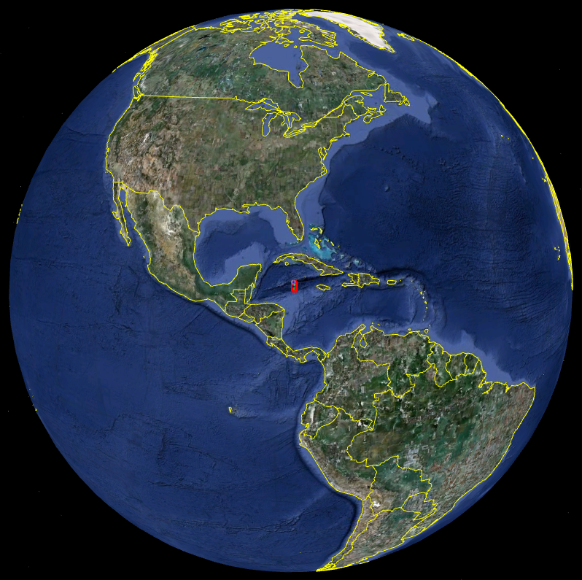
ROV Lead | Dave Lovalvo
General Area Descriptor
ROV Dive Name | Cruise Season |  | Leg |  |  | Dive Number
 | EX1202 |  | 2 |  |  | DIVE07
Equipment Deployed | ROV: |  | Little Hercules
 | Camera Platform: |  | Seirios
ROV Measurements | CTD |  | Depth |  |  | Altitude
 | Scanning Sonar |  | USBL Position |  |  | Heading
 | Pitch |  | Roll |  |  | HD Camera
 | Low Res Cam 1 |  | Low Res Cam 2
Equipment Malfunctions | none
ROV Dive Summary  (From processed ROV data) | Dive Summary: EX1202L2_DIVE07  ^^^^^^^^^^^^^^^^^^^^^^^^^^^^^^^^^^^^^^^^^^^^^^^^^^^  In Water at: 2012-03-27T12:39:11.579000  28°, 13.095' N ; 087°, 31.450' W  Out Water at: 2012-03-27T20:34:18.005000  28°, 13.322' N ; 087°, 30.606' W  Off Bottom at: 2012-03-27T18:37:29.401000  28°, 13.303' N ; 087°, 31.256' W  On Bottom at: 2012-03-27T14:34:51.934000  28°, 13.210' N ; 087°, 31.342' W  Dive duration: 7:55:6  Bottom Time: 4:2:37  Max. depth: 2550.2 m
Special Notes | Click here to enter text.
Scientists Involved
(please provide name / location / affiliation / email)
Purpose of the Dive
Description of the Dive:
Overall Map of ROV Dive Area |  |  |  | Close-up Map of Main Dive Site
Representative Photos of the Dive
xxx |  |  |  | xxx
Please direct inquiries to: |  | NOAA Office of Ocean Exploration & Research  1315 East-West Highway (SSMC3 10th Floor)  Silver Spring, MD 20910  (301) 734-1014

