Okeanos Explorer ROV Dive Summary
Site Name | WFE1 |  |  |  | 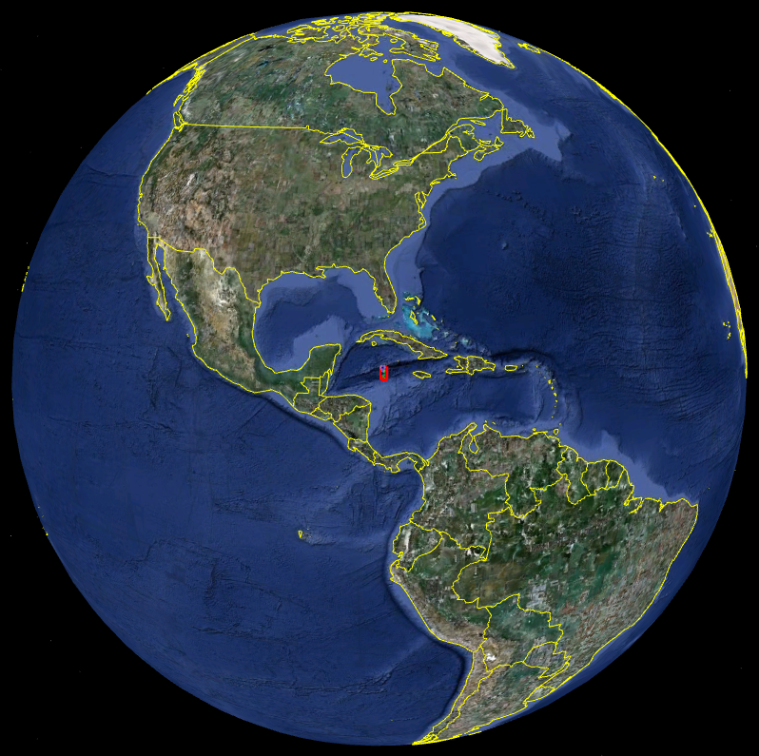
ROV Lead | Dave Lovalvo
General Area Descriptor | 200km W of Tampa, FL
ROV Dive Name | Cruise Season |  | Leg |  |  | Dive Number
 | EX1202 |  | 2 |  |  | DIVE03
Equipment Deployed | ROV: |  | Little Hercules
 | Camera Platfom: |  | Seirios
ROV Measurements | CTD |  | Depth |  |  | Altitude
 | Scanning Sonar |  | USBL Position |  |  | Heading
 | Pitch |  | Roll |  |  | HD Camera
 | Low Res Cam 1 |  | Low Res Cam 2
Equipment Malfunctions | none
ROV Dive Summary  (From processed ROV data) | Dive Summary: EX1202L2_DIVE03  ^^^^^^^^^^^^^^^^^^^^^^^^^^^^^^^^^^^^^^^^^^^^^^^^^^^  In Water at: 2012-03-23T12:34:26.895000  27°, 54.938' N ; 086°, 02.423' W  Out Water at: 2012-03-23T21:59:22.696000  27°, 54.678' N ; 086°, 02.085' W  Off Bottom at: 2012-03-23T20:35:45.054000  27°, 54.980' N ; 086°, 02.138' W  On Bottom at: 2012-03-23T14:21:44.602000  27°, 54.844' N ; 086°, 02.082' W  Dive duration: 9:24:55  Bottom Time: 6:14:0  Max. depth: 2140.7 m
Special Notes | Click here to enter text.
Scientists Involved
(please provide name / location / affiliation / email)
Purpose of the Dive
Description of the Dive:
Overall Map of ROV Dive Area |  |  |  | Close-up Map of Main Dive Site
Representative Photos of the Dive
xxx |  |  |  | xxx
Please direct inquiries to: |  | NOAA Office of Ocean Exploration & Research  1315 East-West Highway (SSMC3 10th Floor)  Silver Spring, MD 20910  (301) 734-1014

