NOAA OFFICE OF OCEAN EXPLORATION AND RESEARCH
Draft Project Instructions

Date Submitted: February 15, 2012
Platform: NOAA Ship Okeanos Explorer
Cruise Number: EX-12-02 Leg I
Project Title: Gulf of Mexico Exploration
Cruise Dates: February 27- March 14, 2012

Prepared by: Mashkoor Malik
Physical Scientist / Hydrographer
Office of Ocean Exploration & Research

Approved by: ________________________ Dated: __________________
Craig W. Russell, NOAA
Program Manager
Office of Ocean Exploration & Research

Approved by: ________________________ Dated: __________________
CAPT David Score, NOAA
Commanding Officer
Marine Operations Center – Atlantic

- OVERVIEW
- Cruise Period
This document contains project instructions for the EX 1202 Leg I of NOAA ship Okeanos Explorer (EX) that focused on exploration of North Eastern region of Gulf of Mexico using the ships’ Kongsberg EM302 multibeam sonar, EK 60 and Knudsen sub-bottom profiler. EX1202 Leg I operations are expected to commence on February 27, 2012 at Charleston, SC and conclude on March 14, 2012 at Tampa, FL. The planed transit line from Charleston, SC to the working grounds is ~ 1000 nautical miles and is expected to take ~ 5 days at an average speed of 8.5 knots (Figure 1). Multibeam mapping operations will be conducted 24 hours a day during the transit, including regular XBT casts.
- Operating Area
The operating area is the North Eastern region in Gulf of Mexico. The proposed transit from Charleston, SC to the working grounds lies entirely within the 200nm exclusive economic zone (EEZ) maritime boundary of the United States of America (Figure 1).
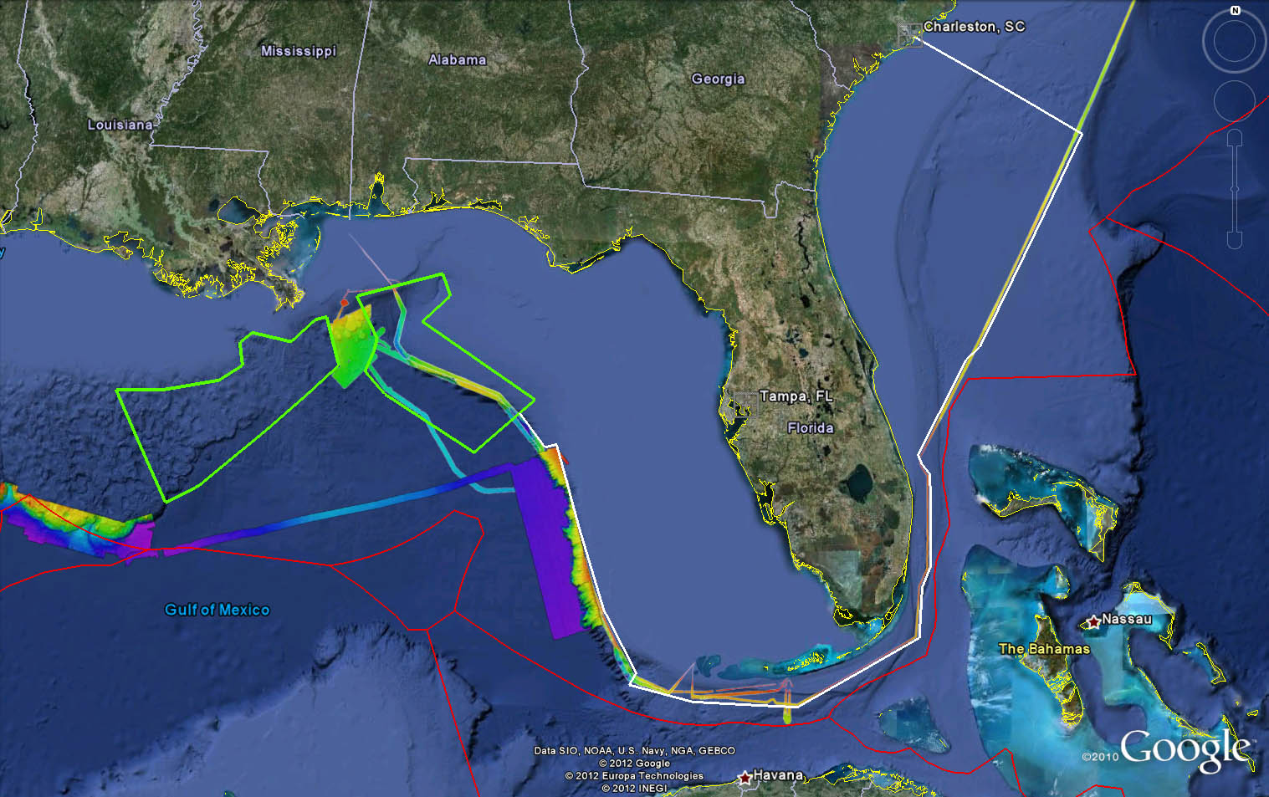

Figure 1: Operating area NE region of Gulf of Mexico (green polygons) with proposed cruise track between Charleston,SC and the working grounds. The actual cruise track is subject to change due to weather and survey conditions. Earlier multibeam coverage during EX1105 (2011) and OER/CCOM survey (2007) is also shown. National 200nm EEZ boundaries are shown in red. Image created with Google Earth.

Generalized Cruise track for transit between Charleston To Working Grounds
Longitude | Latitude
-79.8851 | 32.76777
-77.2727 | 31.46816
-79.0096 | 28.68914
-79.2156 | 28.53535
-79.9511 | 27.31547
-79.8978 | 27.20178
-79.7746 | 27.05678
-79.773 | 25.86588
-79.8919 | 25.60441
-79.9312 | 24.94556
-81.6683 | 24.05936
-83.1509 | 24.12512
-84.0483 | 24.33145
-83.9557 | 24.48949
-84.4356 | 25.29945
-84.805 | 26.3135
-85.1749 | 27.39795
-85.3395 | 27.3554
-85.7252 | 27.78502

Table 1: General waypoints for EX transit from Charleston, SC to the EX1202 Leg I working grounds. The actual cruise track may vary due to prevailing conditions and the discretion of the commanding officer.

EX 1202 Leg I – Mapping areas considerations (In development with science team):

EX1202 Leg I is scheduled to be followed by EX1202 Leg II and III (03/19-04/07 and 04/11-04/29) focused on ROV work in the Gulf (39 days at sea). During these ROV legs, it is expected that limited mapping operations will also be carried out during night time. If ROV dive locations are planned carefully, these nightly mapping operations can be streamlined to provide additional coverage which can be as much as close to coverage obtained in ~ 20 days of 24 hrs mapping. While considering mapping areas for EX1202 Leg I therefore, the areas where we do not anticipate a lot of ROV dives should be given preference.

The guidance for the choice of mapping areas comes from OER/OEAWG Atlantic Basin workshop (May 2011) that identified high priority target areas for exploration (Figure 2) and input received from participating scientists from BOEM and UNH.
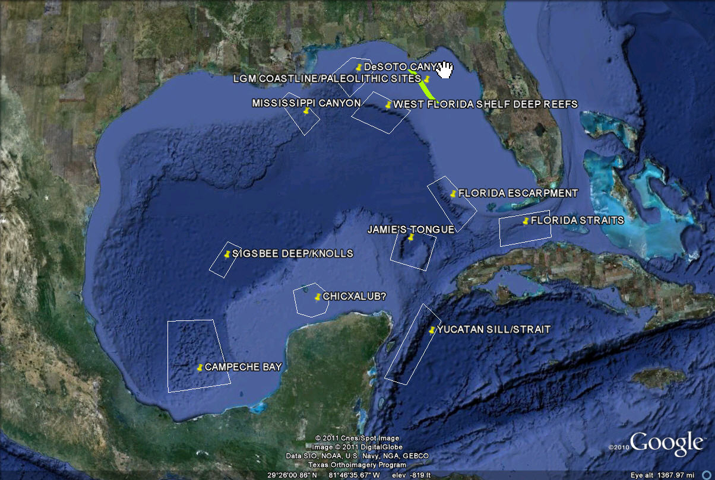

Figure 2: Priority exploration targets identified during Atlantic basin workshop held in May 2011.

Most of the sites in the southern part of the Gulf of Mexico (Figure 2) were excluded from consideration for EX1202 as they are outside US EEZ and the time frame for this cruise was considered too short to pursue any foreign clearances / permits. Focusing on Northern part of the Gulf, Figure 2 provides the overview of the priority mapping sites.

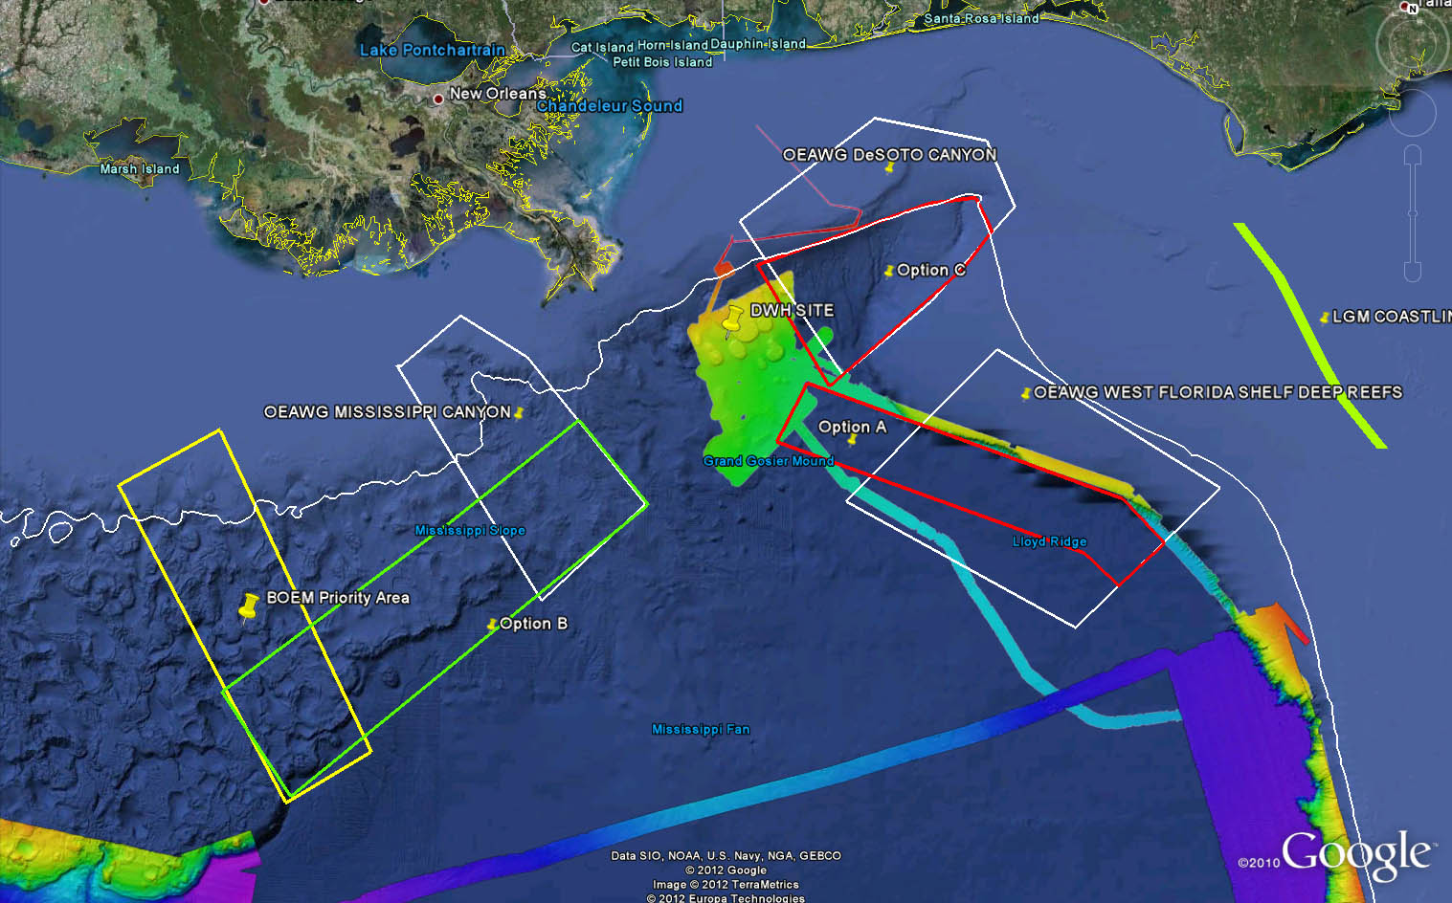

Figure 3: Mapping priority areas being considered for EX1202 leg 1. White polygons: OEAWG Atlantic basin workshop exploration recommendations, Red and Green polygon: Focus mapping site options for EX1202 Leg 1, Yellow polygon: BOEM priority area, white line: 500 m contour line. Multibeam coverage from EX1105 (2011) and ECS cruise (2007) is provided. Multibeam coverage from BOEM multibeam cruises is being processed (not shown here).

Considering the optimal swath coverage for EM 302 in areas deeper than 500 m, the focus mapping sites have been limited to water depths deeper than 500 m. No or limited mapping data are available in region of option A. This area also has the potential to be mapped during several transits anticipated during 2012. It is expected that between three legs of EX1202, 4 additional lines can be run in the option A area, providing data in this area with limited cost. It is proposed that two survey lines are run in this area so the full coverage of option A can be obtained by end of EX1202. Running of two lines in this area are expected to take ~ 1 day.

Option C and Option B are the areas where multibeam data exists (BOEM data available at NGDC). The quality of the available data has not been examined as yet. However, it is clear that water column mapping that EM 302 is capable of providing may provide additional insights into the seep distribution and density in these areas.

Option C area also falls with OEAWG recommended area around DeSoto Canyon where gaseous seeps are expected to be present. Full coverage in the northern and eastern part of Option C area may require substantial effort due to shallow depths and it is expected that to cover the area with 2 x water depth swath coverage (optimal swath coverage found during EX1105) may require approximately 6-8 days.

Option B area is expected to be revisited during EX1202 Leg II and III due to a lot of interest in conducting ROV dives in this area. If substantial ROV dives are focused on this site during legs II and III, an optimal scenario will be build coverage in this area during night time operations during EX1202 Leg II and III.

As these different options are under investigation, two broad exploration areas are proposed with in which specific targets will be identified close to the start of the cruise. The overall exploration areas are shown in Figure 4.

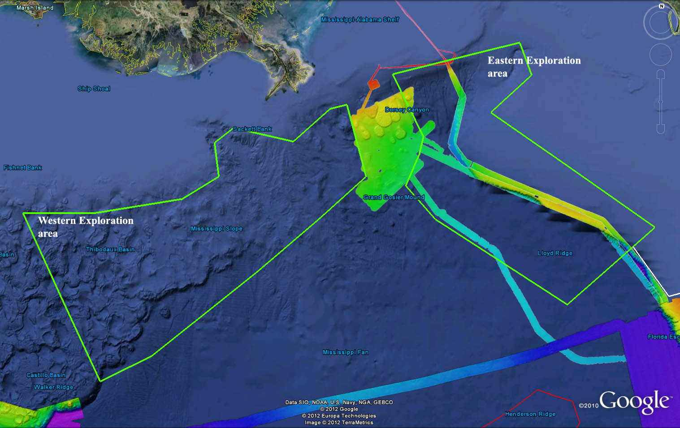

Figure 4: Two exploration areas are being considered for EX1202 Leg I operations. Eastern exploration area covers the two regions (DeSoto Canyon and Western Florida Shelf) and Western Exploration area covers Mississipi Canyon and the BOEM priority areas. Specific targets with in these exploration areas are bring refined and will be communicated to the ship before the start of EX1202 Leg I.

BOEM reported that after Hurrican Katrina, one of the platforms was reported missing from position 28 56 17 N, 88 58 17 W (MC20) after a land slide occurred in this area. BOEM has requested to investigate the area in vicinity to provide high resolution bathymetry and water column mapping with the aim of identifying the location of the platform on the seafloor. This is expected to be a half a day operations collecting few short lines in vicinity of this potion (TBD)

Coordinates of these broad exploration areas are listed in the following table.

Eastern Exploration area coordinates |  | Western Exploration area coordinates
Longitude | Latitude | Longitude | Latitude
-88.1974 | 29.18473 | -88.6334 | 28.89626
-87.8598 | 28.65632 | -88.797 | 28.85129
-87.8912 | 28.5023 | -89.1392 | 28.548
-88.0088 | 28.22295 | -89.7375 | 28.63346
-87.7007 | 27.94604 | -89.9161 | 28.49326
-86.3576 | 27.25536 | -89.8497 | 28.20186
-85.5064 | 27.95821 | -90.1952 | 27.98542
-87.2029 | 28.89819 | -91.0618 | 27.8034
-86.8076 | 29.24439 | -91.7745 | 27.75309
-86.94 | 29.52457 | -90.8772 | 26.33836
-88.1974 | 29.18473 | -90.3881 | 26.5987
 |  | -89.41 | 27.39999
 |  | -88.8385 | 27.89194
 |  | -88.4025 | 28.28273
 |  | -88.6334 | 28.89626

- Summary of Objectives
The following are mission objectives for EX1202 Leg I (presented in no particular order):
- Run mapping systems (MBES)
- Conduct 24-hr mapping operations during transit, with possible further development of exploration targets and collect bottom and water column data.

- Conduct training of new SST personnel in all data collection and processing procedures (continuous throughout cruise).

- Collect data from ancillary sonar systems as permitted by staffing / operational paradigm
- EK60 single beam
- Knudsen sub-bottom profiler
- Test updated triggering and syncing for multi-sonar operation

- CTD operations
- One – three CTD full ocean casts are anticipated to collect oceanographic data to compare XBT and surface sound speed performance. Collection of additional water samples are being considered pending appropriate staff is available.

- ROV / telepresence system

A. No ROV / Telepresence operations are anticipated at this time (pending confirmation from ROV / Telepresence leads)

- XBT operations
A.XBT casts will be collected at regular interval of 4 hours
- Participating Institutions
National Oceanic and Atmospheric Administration (NOAA) - Office of Ocean Exploration and Research (OER) - 1315 East-West Hwy, Silver Spring, MD 20910 USA

University of New Hampshire (UNH) - Center for Coastal and Ocean Mapping (CCOM) - Jere A. Chase Ocean Engineering Lab, 24 Colovos Road, Durham, NH 03824 USA

BOEM,

- Personnel (Science Party)
A full mapping complement is necessary for this cruise. Required mission personnel include a mapping lead/expedition coordinator as well as two qualified watchstanders for each of the three eight hour watches. The mapping lead is responsible for facilitating overall mapping operations, including participating in operational meetings, providing guidance for mapping/survey troubleshooting, and communicating status of mapping sensors to personnel on shore.

Name | Affiliation | Position | M/F | Status
Mashkoor Malik | OER (ERT Inc) | Mapping Lead | M | US Citizen
John Doroba | NOAA Ship Rainier | Watch Lead | M | US Citizen
Elaine Stuart | OER (UCAR) | Watch Lead | F | US Citizen
Allison Stone | OER (UCAR) | Watch Stander | F | US Citizen
Anistia Abramova | UNH/ OER (UCAR) | Watch stander | F | Non-US Citizen (Awaiting approval)
Denise Gordan | OER (NCDDC) | Watch stander | F | US Citizen
Sean Denny | UNH/ OER (UCAR) | Watch stander | M | US Citizen

Table 2: Full list of the science party and their affiliation

- Administrative

Key Points of Contact:

Ship Operations

Marine Operations Center, Atlantic (MOA)  439 West York Street  Norfolk, VA 23510-1145  Telephone: (757) 441-6776  Fax: (757) 441-6495 | Marine Operations Center, Pacific (MOP)  2002 SE Marine Science Drive  Newport, OR 97365-5229  Telephone: (541) 867-8700  Fax: (541) 867-8854
Chief, Operations Division, Atlantic (MOA)  LCDR Jennifer Pralgo  Telephone: (757) 441-6716  E-mail: ChiefOps.MOA@noaa.gov | Chief, Operations Division, Pacific (MOP)  CDR Michael Hopkins  Telephone: (541) 867-8703  Email: ChiefOps.MOP@noaa.gov

Mission Operations

Jeremy Potter, Expedition Manager (on shore)  NOAA Office of Ocean Exploration  Phone : (301) -  E-mail : Jeremy.Potter@noaa.gov  Mashkoor Malik, Mapping Lead (Onboard)  NOAA Office of Ocean Exploration  and Research (ERT, Inc.)  Phone: (301) 734-1015/ (603)377-6319E-mail: Mashkoor.Malik@noaa.gov | CDR Robert Kamphaus, NOAA  Commanding Officer  NOAA Ship Okeanos Explorer  Phone: (401) 378-8284  Email: CO.Explorer@noaa.gov  LT Megan Nadeau, NOAA  Operations Officer  NOAA Ship Okeanos Explorer  Phone: (401) 874-6150 (o)/ (207) 240-0957 (c)  E-mail: Ops.Explorer@noaa.gov

Other Mission Contacts
Craig Russell, EX Program Manager  NOAA Ocean Exploration & Research  Phone: 206-526-4803 / 206-518-1068  E-mail: Craig.Russell@noaa.gov | LT Nicola VerPlanck,  NOAA Ocean Exploration & Research  Phone: 206-526-4801  E-mail: Nicola.Verplanck@noaa.gov
Catalina Martinez, Regional Manager  NOAA Office of Ocean Exploration & Research  Phone: (401) 874-6250 (o) / (401) 330-9662 (c)  Email: Catalina.Martinez@noaa.gov | Webb Pinner, Telepresence Lead  NOAA Office of Ocean Exploration & Research  Phone: (401) 874-6250 (o) / (401) 330-9662 (c)  Email: Webb.Pinner@noaa.gov

Shipments

Send an email to the Okeanos Explorer Operations Officer at OPS.Explorer@noaa.gov indicating the size and number of items being shipped. All items should arrive in Davisville, RI prior to COB Tuesday, February 7, 2012.

Vessel shipping address:

ATTN: LT Megan Nadeau
NOAA Ship Okeanos Explorer
2578 Davisville Road
North Kingston, RI 02852
- Diplomatic Clearances
NOT APPLICABLE TO THIS CRUISE
- Licenses and Permits
See appendix C for categorical exclusion documentation

- OPERATIONS
- Cruise Plan Itinerary (All times and dates are subject to prevailing conditions and the discretion of the commanding officer)
Sunday, February 26
- Mission personnel report to ship, particularly air travelers

Monday, February 27
0900 Science party briefing (Expedition Coordinator and Ops Officer Dry Lab)
TBD Ship departs Charleston, SC

Details about salient operations are as below

Date | Operations | Remarks
2/26/12 | Mission party arrives on the ship
2/27/12-3/3/12 | Ship transits from Charleston, SC to working grounds | ~ 5 days transit
3/4/12-3/5/12 | Commence and run multibeam mapping lines in option A (Figure 3)
3/5/12-3/12/12 | Run multibeam survey in option B and / or option C
3/12/12 | TBD – Investigate MC 20 target as requested by BOEM
3/12/12 | Commence transit to Tampa, FL paralleling the mapping completed with in option A | 1-2 days of transit time to Tampa, FL
3/14/12 | Arrive Tampa, FL

- Telepresence Events
No Telepresence events anticipated during this leg
- In-Port Events
No port events in Tampa, FL anticipated at this time
- Staging and Destaging
NOT APPLICABLE TO THIS CRUISE
- Sonar Operations
Mapping Operations
Round the clock EM 302 and EK 60 data acquisition is being planned for this cruise. Mapping team will ensure that all the standard protocols as laid out in the commanding officer and mapping lead directives will be followed for efficient and safe mapping operations round the clock.
Knudsen sub-bottom profiler has been synchronized with EM 302 but round the clock operations are not anticipated due to excessive noise with in the living quarters. As a compromise, it is anticipated that Knudsen sub-bottom profiler will be operated during day times to minimize impact of excessive noise on the crew. The final decision to operate and collect sub-bottom profiler data will be at the discretion of commanding officer.

- Dive Plan
NOT APPLICABLE TO THIS CRUISE
- Applicable Restrictions
NOT APPLICABLE TO THIS CRUISE

- EQUIPMENT
- Equipment and capabilities provided by the ship
- Kongsberg Simard EM302 Multibeam Echosounder (MBES)
- Kongsberg Simrad EA600 Deepwater Echosounder
- Knudsen Chirp 3260 Sub-bottom profiler (SBP)
- LHM Sippican XBT (various probes)
- Seabird SBE 911Plus CTD
- Seabird SBE 32 Carousel and 24 2.5 L Niskin Bottles
- CNAV GPS
- POS/MV
- Seabird SBE-45 (Micro TSG)
- Kongsberg Dynamic Positioning-1 System
- NetApps mapping storage system
- CARIS HIPS Software
- IVS Fledermaus Software
- SIS Software
- Hypack Software
- Scientific Computing System (SCS)
- ECDIS
- Met/Wx Sensor Package
- Cruise Information Management System (CIMS)
- Equipment and capabilities provided by the scientists
- CCOM calibrated hydrophone with pre-amp and data logger (POC: Tom Webber / Andy McCloud).

- HAZARDOUS MATERIALS
- Policy and Compliance
The Expedition Coordinator is responsible for complying with MOCDOC 15, Fleet Environmental Compliance #07, Hazardous Material and Hazardous Waste Management Requirements for Visiting Scientists, released July 2002. Documentation regarding those requirements will be provided by the Chief of Operations, Marine Operations Center, upon request.
By Federal regulations and NOAA Marine and Aviation Operations policy, the ship may not sail without a complete inventory of all hazardous materials by name and the anticipated quantity brought aboard, MSDS and appropriate neutralizing agents, buffers, and/or absorbents in amounts adequate to address spills of a size equal to the amount of chemical brought aboard. The amount of hazardous material arriving and leaving the vessel shall be accounted for by the Expedition Coordinator.
- Radioactive Isotopes
NOT APPLICABLE TO THIS CRUISE
- Inventory
NOT APPLICABLE TO THIS CRUISE

- ADDITIONAL PROJECTS
- Supplementary Projects
NOT APPLICABLE TO THIS CRUISE
- NOAA Fleet Ancillary Projects
NOT APPLICABLE TO THIS CRUISE

- DISPOSITION OF DATA AND REPORTS
- Data Responsibilities
All data acquired on Okeanos Explorer will be provided to the public archives without proprietary rights. All data management activities shall be executed in accordance with NAO 212-15, Management of Environmental and Geospatial Data and Information [http://www.corporateservices.noaa.gov/ames/NAOs/Chap_212/naos_212_15.html].

Ship Responsibilities
The Commanding Officer is responsible for all data collected for missions until those data have been transferred to mission party designees. Data transfers will be documented on NOAA Form 61-29. Reporting and sending copies of project data to NESDIS (ROSCOP form) is the responsibility of OER.

NOAA OER Responsibilities
The Expedition Coordinator will work with the Okeanos Explorer Operations Officer to ensure data pipeline protocols are followed for final archive of all data acquired on the EX without proprietary rights.

Deliverables
  - At sea
      - Daily plans of the Day (POD)
      - Daily situation reports (SITREPS)
      - Daily summary bathymetry data files
  - Post cruise
      - Refined SOPs for all pertinent operational activities
      - Assessments of all activities
  - Science
- Multibeam and XBT raw and processed data (see appendix B for the formal cruise data management plan)
- Mapping data report
- 2012 System Readiness Report

Archive
- The Program and ship will work together to ensure documentation and
stewardship of acquired data sets in accordance with NAO 212-15. The Cruise Information Management System is the primary tool used to accomplish this activity.
- Pre and Post Cruise Meeting
Pre-Cruise Meeting
Prior to departure, the Operation’s Officer will conduct a meeting of the scientific party to inform them of cruise objectives and vessel protocols, e.g., meals, watches, etiquette, etc.
Post-Cruise Meeting
Upon completion of the cruise, a meeting will be held by the Operation’s Officer and attended by the ship’s Survey Technicians, the Expedition Coordinator and members of the scientific party to review the cruise. Concerns regarding safety, efficiency, and suggestions for improvements for future cruises should be discussed.
Shipboard Meetings
Daily Operations Briefing meetings will be held at 1530 in the forward lounge to review the current day, and define operations, associated requirements and staffing needs for the following day. A Plan of the Day (POD) will be posted each evening for the next day in specified locations throughout the ship. A safety brief and overview of POD will occur on the Bridge each morning at 0800. Daily Situation Reports (SITREPS) will be posted as well and shared daily through e-mail and/or the EX PLONE site ( http://tethys.gso.uri.edu/OkeanosExplorerPortal ).
- Ship Operation Evaluation Report
Within seven days of the completion of the cruise, a Ship Operation Evaluation form is to be completed by the Expedition Coordinator and lead scientist. The preferred method of transmittal of this form is via email to OMAO.Customer.Satisfation@noaa.gov. If email is not an option, a hard copy may be forwarded to:
Director, NOAA Marine and Aviation Operations
NOAA Office of Marine and Aviation Operations
8403 Colesville Road, Suite 500
Silver Spring, MD 20910

- MISCELLANEOUS
- Meals and Berthing
Meals and berthing are required for up to 19 scientists. Meals will be served 3 times daily beginning one hour before scheduled departure, extending throughout the cruise, and ending two hours after the termination of the cruise. Since the watch schedule is split between day and night, the night watch may often miss daytime meals and will require adequate food and beverages (for example a variety of sandwich items, cheeses, fruit, milk, juices) during what are not typically meal hours. Special dietary requirements for scientific participants will be made available to the ship’s command at least twenty-one days prior to the survey (e.g., Expedition Coordinator is allergic to fin fish). Berthing requirements, including number and gender of the scientific party, will be provided to the ship by the Expedition Coordinator. The Expedition Coordinator and Operations Officer will work together on a detailed berthing plan to accommodate the gender mix of the scientific party taking into consideration the current make-up of the ship’s complement. The Expedition Coordinator is responsible for ensuring the scientific berthing spaces are left in the condition in which they were received; for stripping bedding and linen return; and for the return of any room keys which were issued. The Expedition Coordinator is also responsible for the cleanliness of the laboratory spaces and the storage areas utilized by the scientific party, both during the cruise and at its conclusion prior to departing the ship.
All NOAA scientists will have proper travel orders when assigned to any NOAA ship. The Expedition Coordinator will ensure that all non NOAA or non Federal scientists aboard also have proper orders. It is the responsibility of the Expedition Coordinator to ensure that the entire scientific party has a mechanism in place to provide lodging and food and to be reimbursed for these costs in the event that the ship becomes uninhabitable and/or the galley is closed during any part of the scheduled project.
All persons boarding NOAA vessels give implied consent to comply with all safety and security policies and regulations which are administered by the Commanding Officer. All spaces and equipment on the vessel are subject to inspection or search at any time. All personnel must comply with OMAO's Drug and Alcohol Policy dated May 7, 1999 which forbids the possession and/or use of illegal drugs and alcohol aboard NOAA Vessels.
- Medical Forms and Emergency Contacts
The NOAA Health Services Questionnaire (NHSQ, Revised: 08/08) must be completed in advance by each participating scientist. The NHSQ can be obtained from the Expedition Coordinator or the NOAA website at NOAA HEALTH SERVICES QUESTIONNAIRE found at http://www.omao.noaa.gov/medical/NHSQ_Final_wi_Instructions_fill.pdf. The completed form should be sent to the Regional Director of Health Services at Marine Operations Center. The participant can mail, fax, or scan the form into an email using the contact information below. The NHSQ should reach the Health Services Office no later than 4 weeks prior to the cruise to allow time for the participant to obtain and submit additional information that health services might require before clearance to sail can be granted. Please contact MOC Health Services with any questions regarding eligibility or completion of the NHSQ. Be sure to include proof of tuberculosis (TB) testing, sign and date the form, and indicate the ship or ships the participant will be sailing on. Clearances are valid for 2 years for personnel under age 50 and 1 year for age 50 and over. All PPD’s expire after one year from the date of administration. The participant will receive an email notice when medically cleared to sail if a legible email address is provided on the NHSQ.
Contact information:
Regional Director of Health Services
Marine Operations Center – Atlantic
439 W. York Street
Norfolk, VA 23510
Telephone 757.441.6320
Fax 757.441.3760
E-mail: MOA.Health.Services@noaa.gov
Please make sure the medical.explorer@noaa.gov email address is cc’d on all medical correspondence.
Prior to departure, the Expedition Coordinator must provide a listing of emergency contacts to the Operations Officer for all members of the scientific party, with the following information: name, address, relationship to member, and telephone number.
Emergency contact form is included as Appendix A.
- Shipboard Safety
Wearing open-toed footwear or shoes that do not completely enclose the foot (such as sandals or clogs) outside of private berthing areas is not permitted. Steel-toed shoes are required to participate in any work dealing with suspended loads, including CTD deployments and recovery. The ship does not provide steel-toed boots. Hard hats are also required when working with suspended loads. Work vests are required when working near open railings and during small boat launch and recovery operations. Hard hats and work vests will be provided by the ship when required.
Operational Risk Management: For every operation to be conducted aboard the ship (NOAA-wide initiative), risk management procedures will be followed. For each operation, risks will be identified and assessed for probability and severity. Risk mitigation strategies / measures will be investigated and implemented where possible. After mitigation, the residual risk will have to be assessed to make Go-No Go decisions for the operations. Particularly with new operations, risk assessment will be ongoing and updated as necessary. This does not only apply to over-the-side operations, but to everyday tasks aboard the vessel that pose risk to personnel and property.
- CTD, ROV (and other pertinent) ORM documents will be followed by all personnel working on board the EX.
- All personnel on board are in the position of calling a halt to operations/activities in the event of a safety concern.
- Communications
A daily situation report (SITREP) on operations prepared by the Expedition Coordinator will be relayed to the program office. Sometimes it is necessary for the Expedition Coordinator to communicate with another vessel, aircraft, or shore facility. Through various modes of communication, the ship is able to maintain contact with the Marine Operations Center on an as needed basis. These methods will be made available to the Expedition Coordinator upon request, in order to conduct official business. The ship’s primary means of communication with the Marine Operations Center is via e-mail and the Very Small Aperture Terminal (VSAT) link. Standard VSAT bandwidth at 128kbs is shared by all vessels staff and the science team at no charge. Increased bandwidth in 30 day increments is available on the VSAT systems at increased cost to the scientific party. If increased bandwidth is being considered, program accounting is required it must be arranged at least 30 days in advance.
Specific information on how to contact the NOAA Ship Okeanos Explorer and all other fleet vessels can be found at: http://www.moc.noaa.gov/phone.htm

Important Telephone and Facsimile Numbers and E-mail Addresses

Ocean Exploration and Research (OER):
OER Program Administration:
Phone: (301) 734-1010
Fax: (301) 713-4252
E-mail: Firstname.Lastname@noaa.gov

University of New Hampshire, Center for Coastal and Ocean Mapping
Phone: (603) 862-3438
Fax: (603) 862-0839

NOAA Ship Okeanos Explorer - Telephone methods listed in order of increasing expense:

EX Cellular: (401) 378-7947
EX Iridium: (808) 659-9179
OER Mission Iridium (dry lab): (808) 851-3827

EX INMARSAT B
Line 1: 011-872-764-852-328
Line 2: 011-872-764-852-329

Voice Over IP (VoIP) Phone:
301-713-7772 (expect a delay once picked up by directory)

E-Mail: Ops.Explorer@noaa.gov - (mention the person’s name in SUBJECT field)

expeditioncoordinator.explorer@noaa.gov - For dissemination of all hands emails by Expedition Coordinator while on board. See ET for password.
- IT Security
Any computer that will be hooked into the ship's network must comply with the NMAO Fleet IT Security Policy prior to establishing a direct connection to the NOAA WAN. Requirements include, but are not limited to:
- Installation of the latest virus definition (.DAT) file on all systems and performance of a virus scan on each system.
- Installation of the latest critical operating system security patches.
- No external public Internet Service Provider (ISP) connections.
Completion of these requirements prior to boarding the ship is required.
Non-NOAA personnel using the ship's computers or connecting their own computers to the ship's network must complete NOAA’s IT Security Awareness Course within 3 days of embarking.

- Foreign National Guests Access to OMAO Facilities and Platforms
Anastia Abromava-Canadian National
FNG documentation was submitted for approval 12/19/2011

All foreign national access to the vessel shall be in accordance with NAO 207-12 and RADM De Bow’s March 16, 2006 memo.
The following are basic requirements. Full compliance with NAO 207-12 is required.
Responsibilities of the Expedition Coordinator:
- Provide the Commanding Officer with the e-mail generated by the FRNS granting approval for the foreign national guest’s visit. This e-mail will identify the guest’s DSN and will serve as evidence that the requirements of NAO 207-12 have been complied with.
- Escorts – The Expedition Coordinator is responsible to provide escorts to comply with NAO 207-12 Section 5.10, or as required by the vessel’s DOC/OSY Regional Security Officer. Ensure all non-foreign national members of the scientific party receive the briefing on Espionage Indicators (NAO 207-12) at least annually or as required by the servicing Regional Security Officer.
- Export Control - The NEFSC currently neither possesses nor utilizes technologies that are subject to Export Administration Regulations (EAR).
The Commanding Officer and the Expedition Coordinator will work together to implement any access controls necessary to ensure no unlicensed export occurs of any controlled technology onboard regardless of ownership.
Responsibilities of the Commanding Officer:
- Ensure only those foreign nationals with DOC/OSY clearance are granted access.
- Deny access to OMAO platforms and facilities by foreign nationals from countries controlled for anti-terrorism (AT) reasons and individuals from Cuba or Iran without written NMAO approval and compliance with export and sanction regulations.
- Ensure foreign national access is permitted only if unlicensed deemed export is not likely to occur.
- Ensure receipt from the Expedition Coordinator or the DSN of the FRNS e-mail granting approval for the foreign national guest’s visit.
- Ensure Foreign Port Officials, e.g., Pilots, immigration officials, receive escorted access in accordance with maritime custom to facilitate the vessel’s visit to foreign ports.
- Export Control - 8 weeks in advance of the cruise, provide the Expedition Coordinator with a current inventory of OMAO controlled technology onboard the vessel and a copy of the vessel Technology Access Control Plan (TACP). Also notify the Expedition Coordinator of any OMAO-sponsored foreign nationals that will be onboard while program equipment is aboard so that the Expedition Coordinator can take steps to prevent unlicensed export of Program controlled technology. The Commanding Officer and the Expedition Coordinator will work together to implement any access controls necessary to ensure no unlicensed export occurs of any controlled technology onboard regardless of ownership.
- Ensure all OMAO personnel onboard receive the briefing on Espionage Indicators (NAO 207-12) at least annually or as required by the servicing Regional Security Officer.
Responsibilities of the Foreign National Sponsor:
- Export Control - The foreign national’s sponsor is responsible for obtaining any required export licenses and complying with any conditions of those licenses prior to the foreign national being provided access to the controlled technology onboard regardless of the technology’s ownership.
- The DSN of the foreign national shall assign an on-board Program individual, who will be responsible for the foreign national while on board. The identified individual must be a U.S. citizen, NOAA (or DOC) employee. According to DOC/OSY, this requirement cannot be altered.
- Ensure completion and submission of the Certification of Conditions and Responsibilities for a Foreign National Guest as required by NAO 207-12 Section 5.03.h.
Appendix A

EMERGENCY DATA SHEET
NOAA OKEANOS EXPLORER

PRINT CLEARLY

NAME: __________________________________________________________
(Last, First, Middle)

Mailing Address ____________________________________________________

_____________________________________________________

_____________________________________________________
(Other than the ship address)

Phone (Home) _________________________________________________________

(Cell) ___________________________________________________________

Date of Birth ___________________________________________________________

Emergency Contact: _____________________________________________________
(Name and Relationship)

Address: ______________________________________________________________

______________________________________________________________

_______________________________________________________________

Phone (Home) ____________________________________________________

(Work) ____________________________________________________

(Cell) _____________________________________________________

Email: ________________________________________________________________

Signature __________________________________ Date _______________________
Appendix B

EX 1201 Data Management Plan

In production POC: Susan Gottfried

Appendix C

EX 1202 Leg I Categorical Exclusion

MEMORANDUM FOR: The Record

FROM: John McDonough
Deputy Director NOAA Office of Ocean Exploration and Research (OER)

SUBJECT: Categorical Exclusion for NOAA Ship Okeanos Explorer cruise EX1202 Leg I

NAO 216-6, Environmental Review Procedures, requires all proposed projects to be reviewed with respect to environmental consequences on the human environment. This memorandum addresses the NOAA Ship Okeanos Explorer’s scientific sensors possible affect on the human environment.

Description of Project
This project is part of the NOAA Office of Ocean Exploration and Research’s “Science Program” and entails multi-disciplinary ocean mapping and exploration activities designed to increase knowledge of the marine environment. This project is entitled “EX1202 Leg I Gulf of Mexico exploration” and will be lead by Mashkoor Malik, a physical scientist for the Okeanos Explorer program within OER. The ship will depart Charleston, SC on February 27, 2012, and arrive in Tampa, Florida on March 14, 2012, and conduct sonar mapping operations at all times during the transit. Focused mapping and sonar testing operations will occur at offshore areas in North Eastern Gulf of Mexico. Acoustic instruments that will be operational during the project are a 30 kHz multibeam echosounder (Kongsburg EM 302), an 18 kHz singlebeam echosounder (Kongsberg EK 60), and a 3.5 kHz sub-bottom profiler (Knudsen Chirp 3260). Additionally, expendable bathythermographs (XBTs) will be deployed regular intervals in association with multibeam data collection.

Effect of Projects
As expected for ocean research with limited duration or presence in the marine environment, this project will not have the potential for significant impacts. Knowledgeable experts who are aware of the sensitivities of the marine environment will conduct the at-sea portions of this project.

Categorical Exclusion
This project would not result in any changes to the human environment. As defined in Sections 5.05 and 6.03.c.3 (a) of NAO 216-6, this is a research project of limited size or magnitude or with only short-term effects on the environment and for which any cumulative effects are negligible. As such, this project is categorically excluded from the need to prepare an environmental assessment.

Signed:_________________________ Date:________________
John McDonough, Deputy Director

