NOAA Okeanos Explorer Program

MAPPING DATA REPORT

CRUISE EX1202 Leg 1

Exploration Mapping: Gulf of Mexico

Feb 27 – March 14, 2012
Charleston, SC to Tampa, FL

Report Contributors:
Mashkoor Malik, Elaine Stuart, John Doroba, Lillian Stuart, Denise Gordon, Anastasia Abramova, Allison Stone and Sean Denney

30 March, 2012

NOAA Office of Ocean Exploration and Research
1315 East-West Hwy, SSMC3, #10210
Silver Spring, MD 20910




Introduction




The Okeanos Explorer Program

Commissioned in August 2008, the NOAA Ship Okeanos Explorer is the nation’s only federal vessel dedicated to ocean exploration. With 95% of the world’s oceans left unexplored, the ship’s combination of scientific and technological tools uniquely positions it to systematically explore new areas of our largely unknown ocean. These exploration cruises are explicitly designed to generate hypotheses and lead to further investigations by the wider scientific community.

Using a high-resolution multibeam sonar with water column capabilities, a deep water remotely operated vehicle, and telepresence technology, Okeanos Explorer provides NOAA the ability to foster scientific discoveries by identifying new targets in real time, diving on those targets shortly after initial detection, and then sending this information back to shore for immediate near-real-time collaboration with scientists and experts at Exploration Command Centers around the world. The subsequent transparent and rapid dissemination of information-rich products to the scientific community ensures that discoveries are immediately available to experts in relevant disciplines for research and analysis

Through the Okeanos Explorer Program, NOAA’s Office of Ocean Exploration and Research (OER) provides the nation with unparalleled capacity to discover and investigate new oceanic regions and phenomena, conduct the basic research required to document discoveries, and seamlessly disseminate data and information-rich products to a multitude of users. The program strives to develop technological solutions and innovative applications to critical problems in undersea exploration and to provide resources for developing, testing, and transitioning solutions to meet these needs.

Okeanos Explorer Management – a unique partnership within NOAA

The Okeanos Explorer Program combines the capabilities of the NOAA Ship Okeanos Explorer with shore-based high speed networks and infrastructure for systematic telepresence-enabled exploration of the world ocean. The ship is operated, managed and maintained by NOAA’s Office of Marine and Aviation Operations, which includes commissioned officers of the NOAA Corps and civilian wage mariners. OER owns and is responsible for operating and managing the cutting-edge ocean exploration systems on the vessel (ROV, mapping and telepresence) and ashore including Exploration Command Centers and terrestrial high speed networks. The ship and shore-based infrastructure combine to be the only federal program dedicated to systematic telepresence-enabled exploration of the planet’s largely unknown ocean.
Table of Contents
1. Introduction 2
2. Report Purpose 4
3. Cruise Objectives 4
4. Participating Personnel 9
5. Summary of Major Findings 9
6. Mapping Statistics 13
7. Mapping Sonar Setup 13
8. Data Acquisition and processing summary 13
9. Data Archival Procedures 15
10. Cruise Calendar 19
11. References 20
12. Appendices 21
Appendix A: Tables of data files collected 21
Appendix B: EM302 description and operational specs 29
Appendix C: Acronyms and abbreviations 32

Report Purpose

The purpose of this report is to briefly describe the mapping data collection and processing methods, and to report the major results of the cruise. For a detailed description of the Okeanos Explorer mapping capabilities, see appendix B and the ship’s readiness report, which can be obtained by contacting the ships operations officer (ops.explorer@noaa.gov).

This report focuses on exploration of North Eastern region of Gulf of Mexico.

Cruise Objectives

The exploration area for this expedition was chosen based on guidance from OER / Ocean Exploration Advisory Working Group (OEAWG) workshop results (Atlantic Basin Workshop, 2011) that identified high priority target areas for exploration in Gulf of Mexico (Figure 1) and input received from participating scientists from Bureau of Ocean Energy Management (BOEM) and University of New Hampshire (UNH).

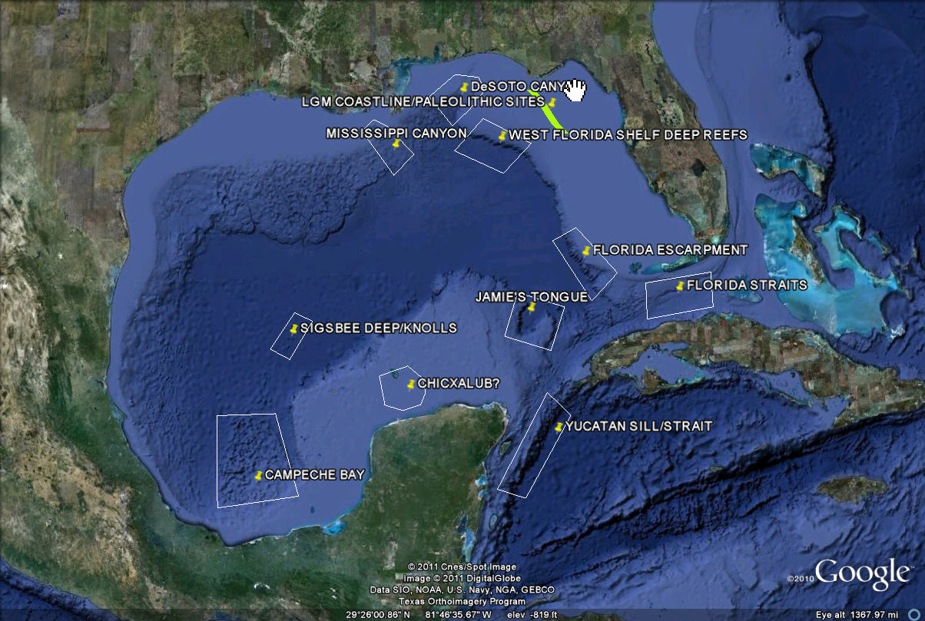

Figure 1: Priority exploration targets identified during Atlantic basin workshop held in May 2011. Image created in Google Earth.

Most of the sites in the southern part of the Gulf of Mexico (Figure 1) were excluded from consideration for EX1202 Leg I as they are outside US EEZ and the time frame for this cruise was considered too short to pursue any foreign clearances / permits. Focusing on Northern part of the Gulf, two exploration areas were chosen (Green polygon in Figure 2): West Florida Escarpment and DeSoto Canyon.

With in Exploration area identified, two mapping priorities areas have been identified (shown as red polygons, Figure 2). The compilation of existing data from National Geophysical Data Center (NGDC) showed that the western Florida escarpment remains largely unexplored. The multibeam coverage obtained in this area during EX1105 and EX1106 during 2011 was extended adding lines in the Florida Escarpment priority area.

The DeSoto Canyon has been an exploration priority during last few decades. Previous work in this area has included studies of animal abundance (for example OER Operation Deep Scope, 2004) by NOAA Office of Ocean Exploration and Research, mapping effort to map canyon heads to study the geomorphology and benthic reef habitats that occur in this area (Gardner et al., 2001) by USGS, and multibeam mapping by BOEM in 1990s of deeper portions of the DeSoto Canyon. The northern shallower part of the DeSoto Canyon remains unmapped and was the prime focus of mapping efforts during this cruise (Figure 3).

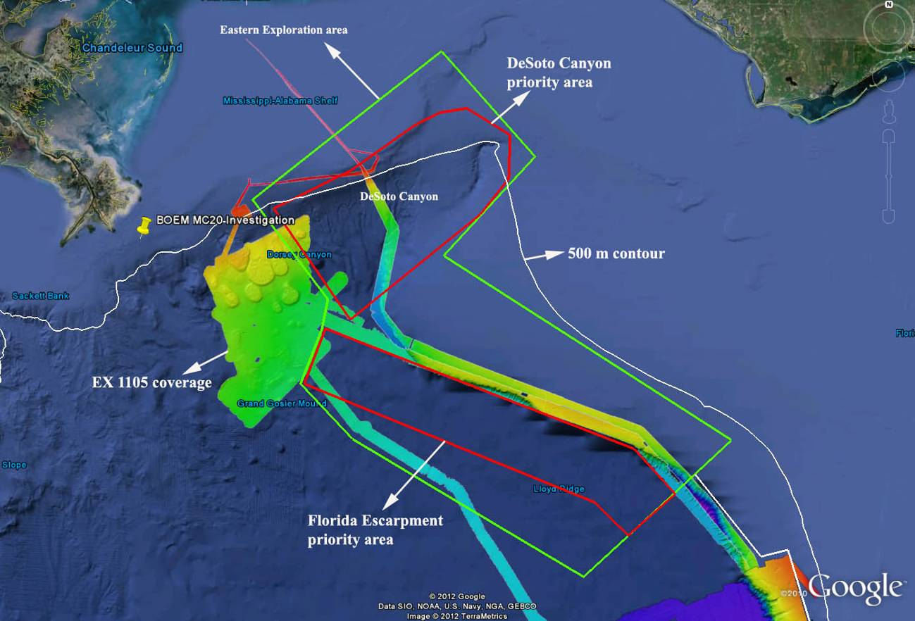

Figure 2: Mapping priority for EX1202 leg I. Red polygons: Focus mapping priorities for EX1202 Leg I, Green polygon: Exploration area, white line: 500 m contour line. Image created in Google Earth.

Coordinates of the broad exploration areas (Figure 1) are listed in the following table.

Exploration area coordinates
Longitude | Latitude | Longitude | Latitude
-88.3145 | 29.15689 | -85.5064 | 27.95821
-87.8598 | 28.65632 | -87.1912 | 28.88899
-87.8912 | 28.5023 | -86.6647 | 29.40115
-88.0088 | 28.22295 | -87.2225 | 29.93578
-87.7007 | 27.94604 | -88.3145 | 29.15689
-86.3576 | 27.25536

Table 2: Coordinates of EX1202 Leg I exploration area.
A compilation of existing multibeam data in vicinity of DeSoto Canyon identified areas in depths of ~ 200 – 1000 m that have not been mapped earlier (see Deep Unmapped and Shallow areas in Figure 4). Based on swath coverage and expected depths, it was decided to focus on the areas deeper than 400 m.

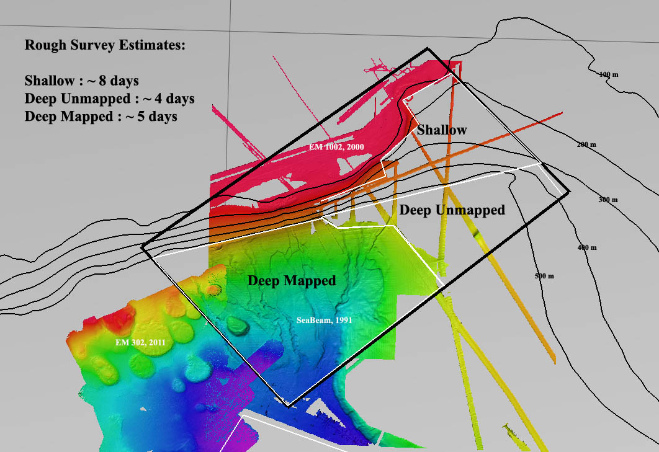

Figure 3: Mapping data compiled in vicinity of DeSoto Canyon. Earlier mapping efforts in this area show EM 302 (2011), Seabeam (1991) and EM 1002 (2000) data collected by NOAA OER, BOEM and USGS respectively. Only EM 302 data collected in 2011 was collected with concurrent water column mapping.

Earlier multibeam work in this area did not collect water column data. The water column data by multibeam sonar can aid in the detection of gaseous seeps which are important benthic habitat in Gulf of Mexico. The deep area (Deep Mapped), although is already mapped, was therefore partially mapped for the purposes of detecting new gaseous seeps.
In summary the following were mission objectives for EX1202 Leg I (as per EX1202L1 project instructions, 21 February 2012):
1. Collect deep water multibeam sonar data (MBES)

Conduct 24-hr mapping operations during transit, with possible further development of exploration targets and collect bottom and water column data

The ship conducted 24 hr mapping operations during transit. Weather conditions prohibited collection of good quality data while heading directly into the seas.

2. Conduct training of new ST personnel in all data collection and processing procedures. Provide training to the interns (continuous throughout cruise).

The anticipated new hire of survey technicians did not materialize before the cruise.

Three mapping interns during this expedition were new to the EM 302 multibeam operations. Familiarization with the mapping system, data acquisition and processing was conducted at the beginning of the cruise. These personnel were then paired with experienced mapping watch standers who trained these personnel one to one in conducting and processing XBTs, data acquisition and processing.

3. Collect data from ancillary sonar systems as permitted by staffing / operational paradigm
including EK60 single beam and Knudsen sub-bottom profiler.

EK 60 single beam data were collected throughout the cruise. Knudsen sub-bottom profiler data were collected from 0800-2000 each day of the cruise at minimum power level and pulse length settings to minimize noise inside the living spaces. EK 60 and Knudsen were able to collect data simultaneously with EM 302 with no interference observed between the three sonars.

This cruise was the first cruise onboard where Knudsen was operated for extended period of time. The data quality suffered adversely from the operators being not familiar with the system (loosing bottom extensively, loss of data due to wrong settings, unable to process the data fully due to inadequate data processing training). Based on lessons learnt during this leg, modifications to the operating procedures (SOPs) will be made.

Also the limitation of operating the system at minimum power level setting to minimize the noise created by Knudsen in the living quarters hampered the full possible penetration of the seafloor.

4. CTD operations

One – three CTD full ocean casts are anticipated to collect oceanographic data to compare XBT and surface sound speed performance. Collection of additional water samples are being considered pending appropriate staff is available.

One CTD cast was completed during the cruise to depth of ~ 1000 m for cross checking the sound speed estimates with the XBT sound speed profile. Minimal differences (~ 2 m/s) were observed. No water samples were collected.

Following image shows the comparison between the CTD and XBT data.

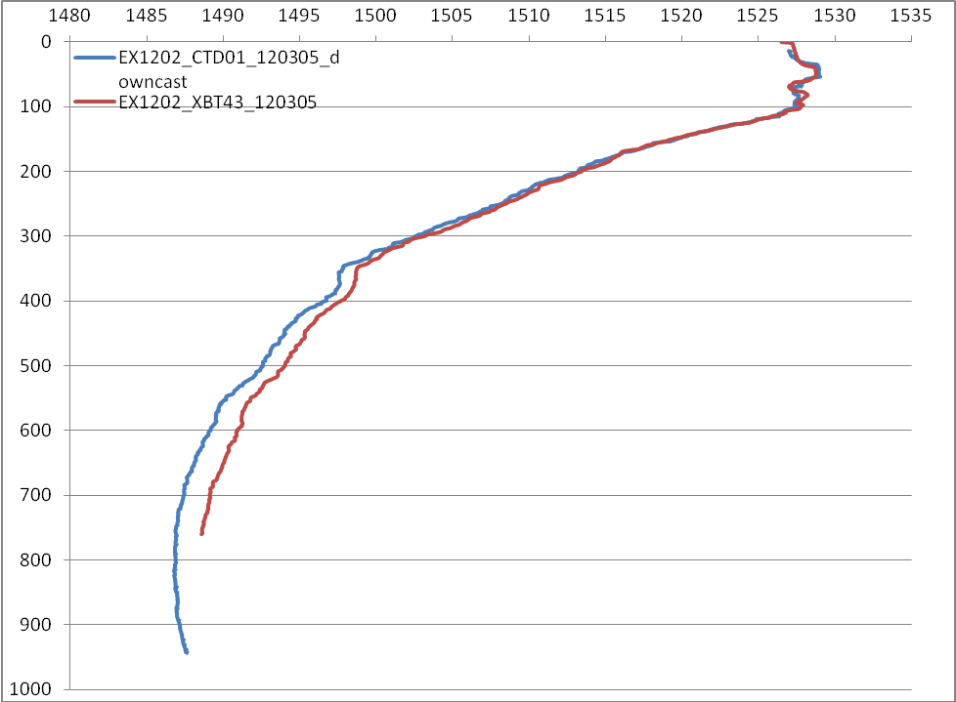

Figure 4: Comparison between sound speed profile inferred from CTD and XBT casts collected on 5 March 2012.

5. XBT operations
A.XBT casts will be collected at regular interval of 4 hours

Regular XBT casts were collected at intervals of 2-4 hours. In shallower waters the interval for XBT cast had to be reduced to 2 hours to deal with the rapidly fluctuating oceanographic conditions.

6. EM 302 soft start up – Hydrophone noise test

EM 302 is equipped with a soft start up feature (Mammal protection feature) that allows the transmitted power level to be increased slowly after the system is turned on. This feature is expected to provide a warning to the possible mammals in the vicinity of the ship. A hydrophone was used to test the functionality of this feature.

Participating Personnel

NAME | ROLE | AFFILIATION
CDR Robert Kamphaus | Commanding Officer | NOAA Corps
LT Megan Nadeau | Field Operations Officer | NOAA Corps
Mashkoor Malik | Expedition Coordinator | NOAA OER / ERT Inc.
Mashkoor Malik | Mapping Team Lead | NOAA OER / ERT Inc.
John Doroba | Mapping watch leader | NOAA OMAO
Lillian Stuart | Mapping watch leader | NOAA OMAO
Elaine Stuart | Mapping watch leader | NOAA OER / UCAR
Allison Stone | Mapping watch stander | NOAA OER / UCAR
Anastasia Abramova | Mapping watch stander | NOAA OER / UCAR
Sean Denney | Mapping watch stander | NOAA OER / UCAR
Denise Gordon | Data manager | NOAA NCDDC

Summary of Major Findings

During the six (6) days transit from Charleston, SC to DeSoto canyon, the ship mapped various geographic features within the continental shelf off the Carolinas and Florida including ledges and a known but unidentified wreck (Figure 1) and areas in vicinity of the Florida escarpment.

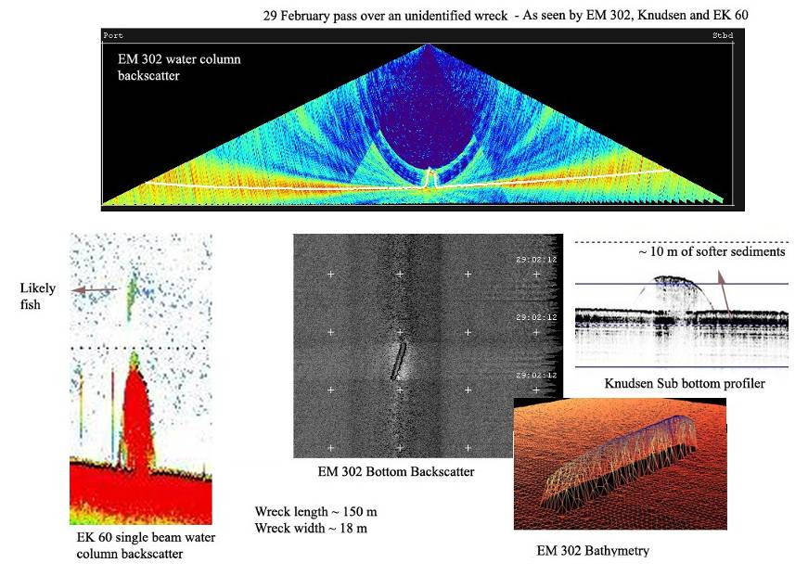

Figure 4: A known but un-identified wreck investigated by the Okeanos Explorer during her transit from Charleston, SC to Northern Gulf of Mexico. The wreck was imaged by EM 302 MBES, EK 60 and Knudsen SBP resulting in various distinct data sets as provided in the image.

The ship arrived in vicinity of DeSoto canyon, primary exploration area of this expedition, on 4 March and commenced mapping of the canyon using a Kongsberg EM 302 multibeam echo sounder (EM302 MBES), Kongsberg EK 60 single beam fisheries echo sounder (EK60) and Knudsen sub bottom profiler (SBP).

The DeSoto Canyon lies approximately 100 km south-southwest of Pensacola, Florida. DeSoto Canyon’s gradual gradients and unusual S-shape makes it distinct to its counterparts in the east coast encountered earlier by the ship (EX1201, Ship Shake Down and Patch Test). The canyon cuts through the continental shelf in the northern part of the gulf that results in an upwelling of deep nutrient-rich water, resulting in relatively high primary productivity in this area. The origin and distinct shape of the canyon has been debated to be a result due to presence of salt domes, erosion and deposition due to bottom currents, and subsurface structure possibly a salt ridge (Harbison, 1968) The bottom depths range from 800-1000 m.
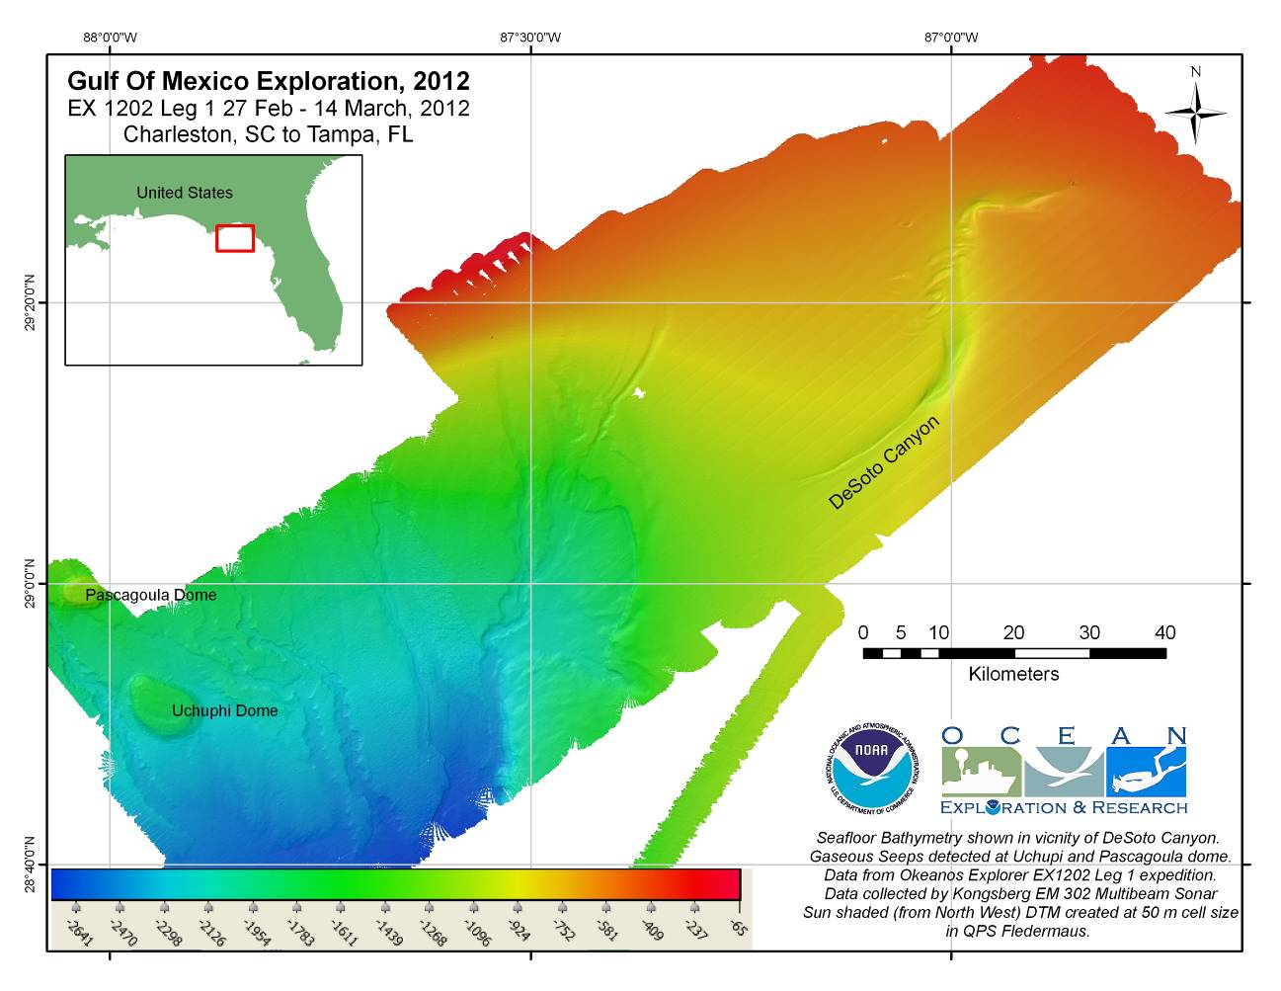

Figure 5: Bathymetric map of DeoSoto Canyon generated at 50 m grid cell size resolution based on preliminary data processing onboard during the expedition.

DeSoto canyon has been a subject of several earlier research and exploration activities including study of surface current (Wang et al, 2003), bottom currents (Hamilton et al, 2001), mapping the canyon heads with multibeam sonar (Gardner et al, 2003), underwater video and imagery exploration (OER expedition Operation Deep Scope, 2004), and, Seismic reflection surveys (Harbison, 1968). In spite of some previous efforts, there was no multibeam data currently available publicly over the northern part of the canyon prior to this expedition. Additionally, the EM 302 MBES and EK 60 water column data were collected round the clock that can be used to detect anomalies such as assemblages of biomass in water or gaseous seeps.

The ship completed her mapping of the DeSoto canyon on 12 March, 2012 and started her transit towards Tampa, FL with adding coverage along the Florida escarpment to data previously collected by the Okeanos Explorer in the area (Figure 6).

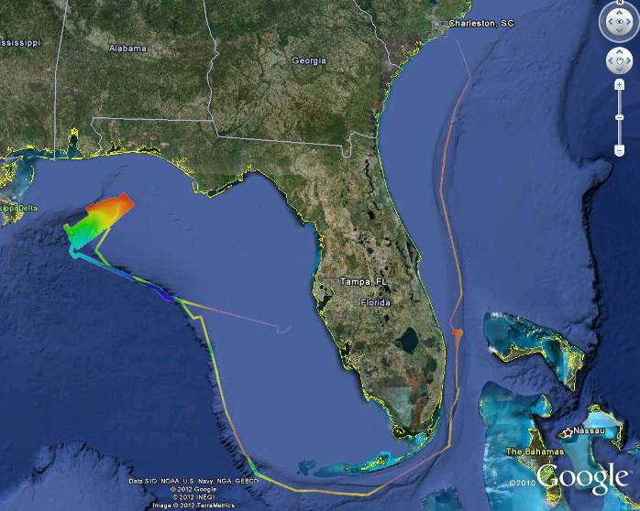
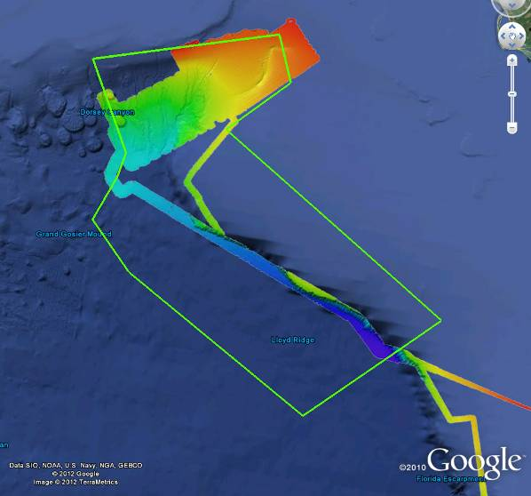

Figure 6: (Left) Overview of the mapping data collected from Charleston, SC to Tampa, FL. (Right) The overview of the data collected during this cruise in the Eastern Exploration area (refer to figure 3).

A major focus of the expedition was the identification of gaseous seeps in vicinity of DeSoto canyon. At the time of writing of this report, only two sites of gas seep like features were observed over the Pascagoula and Uchupi dome in the south western area of the survey (Figure 7). These two sites showed at least 3-4 individual seep like features.

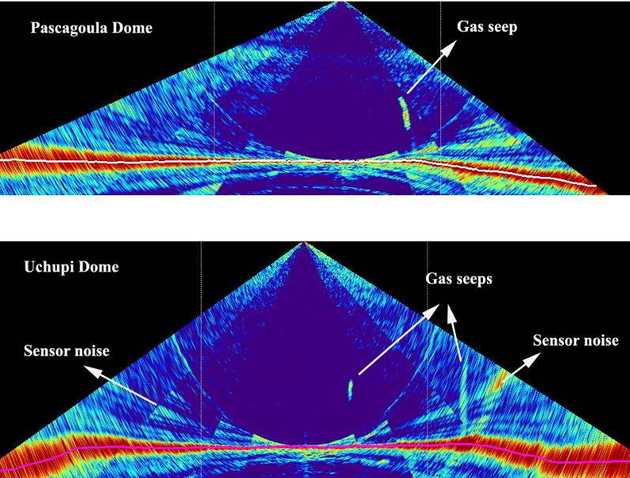

Figure 7: Images showing possible gas seeps as observed in the EM 302 water column data over Pascagoula and Uchupi dome.

Hydrophone test

A calibrated hydrophone was lowered to the side of the ship adjacent to the location of the multibeam sonar (EM302) transmitter. The ship was then turned on with soft start with -20 dB below the maximum power level with a ramp up time of 3 minutes.

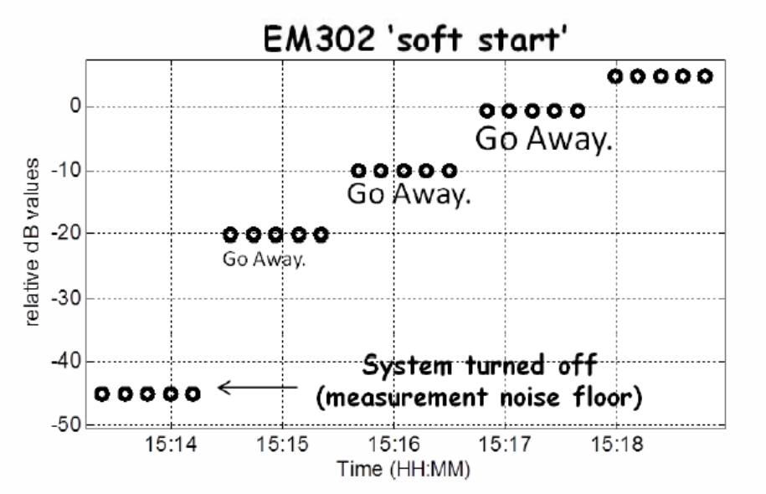

Figure 8: EM 302 soft start up results based on data collected on 5 March 2012. Image courtesy Dr. Tom Weber (CCOM, UNH).

The results of this experiment showed that the transmitted power level was ~ -18 dB lower than maximum power level at the time of starting the multibeam sonar which periodically was increased to the maximum power level during the 3 minutes ramp up time.

This feature is recommended by the manufacturer (Kongsberg Inc) to be used while working in an area where marine mammals can be present to provide a warning to the animals. However, to confirm the actual levels of transmitted power, the hydrophone test provide useful data.

Mapping Statistics

Dates | 02/27/2012-3/14/2012
Weather delays | 0 days
Total non-mapping days | 0 days
Total survey mapping days | 17 days
Total transit mapping days | 7 days
Line kilometers of survey | 5705 km
Square kilometers mapped | 14,914.60 sq km
Number of bathymetric multibeam files | 280
Data volume of raw multibeam data files | 40.6 GB
Number of water column multibeam files | 277
Data volume of water column multibeam files | 75.9 GB
Number of XBT casts | 98
Number of CTD casts | 1
Beginning draft | 15’6’’ (fwd) 14’5’’ (aft)
Ending draft | 14’6’’ (fwd) 14’7’’
Average ship speed for survey | 8.0 kts

Mapping Sonar Setup

The NOAA Ship Okeanos Explorer is equipped with a 30 kHz Kongsberg EM 302 multibeam sonar. Appendix B contains a detailed description of sonar system functionality and technical specifications. For this cruise no changes were made to the standard setup of the mapping sonars onboard.

Data Acquisition and processing summary

Multibeam sonar (EM 302) data were acquired using Kongsberg Seafloor Information System (SIS ver. 3.6.4). SIS system accounts for all the static offsets and biases during real time acquisition. The motion data from the POS MV 320 (Ver. 4.0.2.0) was directly fed into SIS during data acquisition to account for ship motion (i.e. heave, roll, pitch). Yaw data was provided by the TSS gyro-compasses located on the bridge. Also the real time sound speed near the sonar head (dually measured by Reson Sound Speed sensor and a CTD sensor installed in proximity to the EM 302 receiver) was fed into SIS and the most updated acquired sound speed profile was used in real time to correct soundings for sound speed corrections during data acquisition. Unless there are problems observed in the data, there is no requirement to apply these corrections during post processing. The water column backscatter were collected all the time which were recorded into separate to bottom bathymetry and backscatter data as *.wcd files.

CARIS HIPS/SIPS v. 6.3 was used to edit the bathymetric data from the EM 302 multibeam. Edited data was exported to ASCII text files and then imported to QPS Fledermaus Ver. 7.3.0c Build 968 for further processing, visualization, quality control, and product generation.

The QPS Fledermaus FMGT (Ver. 7.3.0c Build 968) software package was used for processing EM 302 bottom backscatter data.

EK 60 data were collected using Kongsberg GPT firm ware version 2.2.1 in the *.raw data file format.

The QPS Fledermaus MidWater software package (Ver. 7.3.0c Build 968) was used to process EM 302 water column backscatter and EK 60 data and view the resulting Fledermaus SD objects. The programs are the best method available to the mapping department for water column data processing.

Sub-bottom profiler (SBP) data were collected using Knudsen Chirp 3260 v. 1.6.1. This was the first expedition where SBP was operated for a relatively longer period of time. Experimentation with different raw data file formats was conducted. Data in SGY, and KEB file format were collected on most of the days between 0800-2000 local ship time using minimum power level to minimize SBP noise inside the ship’s living quarters. Available post processing software onboard, Sonar Wiz v. 4004.0034 was found to only work with SGY file format but was found not to take into account the scale changes resulting in images which were not corrected for the scale changes appropriately (Figure 9).
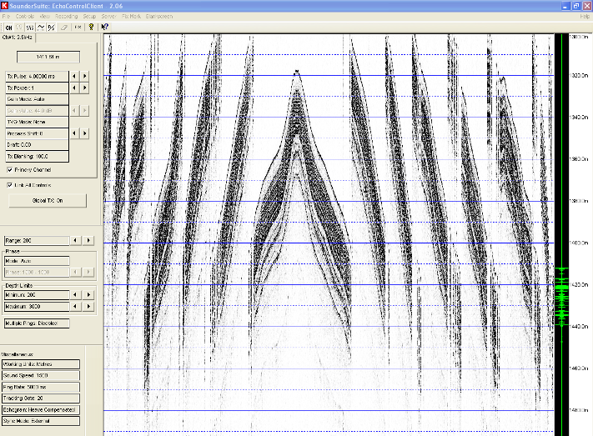

Figure 9: A screen grab of Knudsen SBP data acquisition screen.
Figure 9 shows SBP data while passing over a shallow areas. SGY file format requires very small scales (typically < 100 m) to operate and therefore rapidly varying seafloor depths changes dictate various changes in the scales which can supposedly be corrected for during post processing. Further work into investigating appropriate software for processing SGY files is recommended.

Data Archival Procedures

All the data from the expedition has been submitted to NCDDC where the data are being prepared for onward submission to the archival centers. Following is the brief data pipeline excerpts from Data management plan, EX1202 leg1.

The multibeam survey data collected by bottom-looking and complementary sensors, data from the calibration instruments, and the products generated after the data are returned to and post-processed at shore will be archived at the NGDC. These data will be accompanied with a collection level metadata record for the NGDC as well as individual metadata records for each raw (level-0) file, each edited (level-1) file and each data product (level-2) and report (level-3) generated as a result. In addition, the submission to NGDC will include the following:
- raw (level-0) mapping survey and water column data files,
- CTD and/or XBT profile data used for calibration in multibeam survey,
- post-processed, quality assured, and edited (level-1) data files,
- specific data products (level-2) including cumulative GeoTIF images, gridded bathymetric files, KML files, Fledermaus output files, and an ArcGrid format, and
- comprehensive mapping survey data summary (level-3) report.

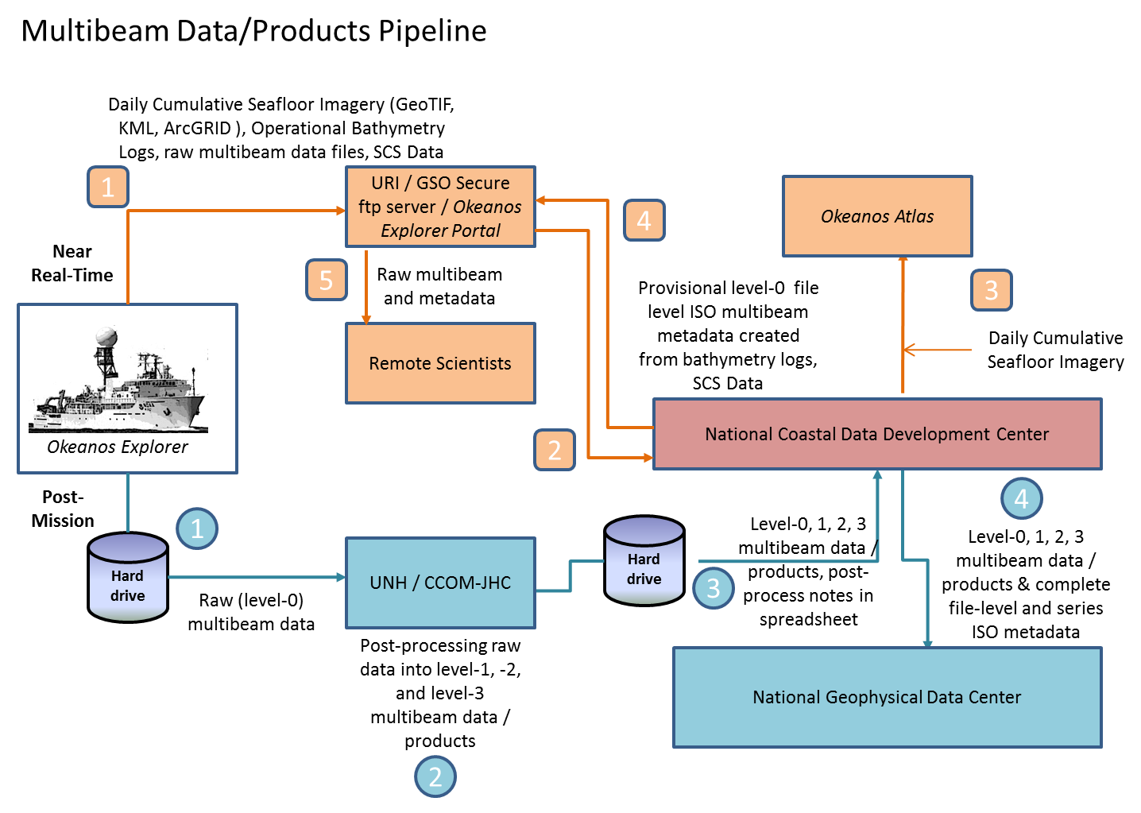

Figure 10: Multibeam Survey Data Archive Pipeline

Near Real-Time
1

The mapping survey team on the EX will include their operational processing spreadsheet in the folder that is targeted for synchronization to the SRS periodically throughout the day. As operational GeoTIFF images are created, these will also be saved to this folder.
2

The data management team at NCDDC pulls the GeoTIFF images, operational bathymetry processing spreadsheet and the SCS data streams for near real-time metadata generation and Okeanos Atlas update procedures.

3

Daily cumulative GeoTIFF images of the seafloor imagery are geo-located on the Okeanos Atlas by the GIS team at NCDDC.

4

Provisional metadata in an ISO format is generated for each raw (level-0) multibeam raw files using the SCS exported data, the operational processing spreadsheet and saved to the SRS.

5

Participating scientists wanting access to the raw multibeam in near real-time can pull the individual files with the metadata that provides operational and provisional processing steps and a disclaimer for non-QC status of the data.

Post-Mission
 All bottom-looking sensor data and complementary data (water column and sound velocity) are saved to a hard-drive. This hard-drive will be either brought back or shipped to the University of New Hampshire Center for Coastal and Ocean Mapping (UNH CCOM) for post-processing.

 A full complement of multibeam data from a 30-day EX cruise on which the Kongsberg EM302 multibeam system runs continuously will produce 200-300 Gigabytes of raw multibeam (37.5% of total volume) and water column data (62.5% of total volume). At UNH, the mapping team will post-process the multibeam data through the following steps:

- The raw (level-0) data will be saved to the IOCM/ CCOM file servers, where they will be quality checked and post-processed.
- The edited level-0 data is saved as level-1 data files in a non-proprietary format – ASCII xyz files (cleaned not gridded).
- The post-processing steps used to produce the level-1 data will be documented.
- Level-2 products will be generated from the level-1 data files.
- The post-processing steps used to produce the level-2 data products will be documented.
- The level-1 data, level-2 products, post-processing steps, and working data processing spreadsheets will be copied to the hard drive in a new folder. A processing spreadsheet for FY12 will contain the temporal and spatial limits of each file and any supplemental information documenting problems or issues that affected the quality of the data in that file.

 The hard-drive will be shipped to the NCDDC within approximately 3 weeks from cruise end date.

 At NCDDC, all multibeam related files will be post-processed through metadata generation procedures. Metadata will be generated for each individual survey track file (level-0 and -1), for accompanying CTD/XBT profile data sets, for composite xyz files, KMLs, GeoTIFs, png images, and Fledermaus output (level-2), and a set of data products and reports (level-3). The metadata will be added to the hard-drive and the hard-drive will be shipped to NGDC.

Following table provides details about multibeam survey metadata granularity and target archive dates:

Data Class | Instrument | Data Type | Format | Metadata Granularity | Archive Center
GEO | Kongsberg EM302 (30 kHz) | Multibeam Bathymetry, Bottom Backscatter, Water Column Backscatter (proprietary format read into MBSystem) | .all, .wcd (proprietary) | 1 meta rec per .all file in Multibeam Data folder and subfolders | NGDC
GEO | Simrad EK60 | Singlebeam (time,depth) | .txt, (ASCII), .raw (proprietary) | Included in the SCS feed | TBD
GEO | Knudsen CHIRP 3260 (3.5 kHz) | Sub-bottom profile | .sgy, .kea, .keb (proprietary) | 1 meta rec = Subbottom Profile Data folder | NGDC
OCN | SeaBird SBE-911plus | CTD Cast | .hex, .con (Proprietary); .cnv, .hdr, .bl, .jpg (processed) | 1 meta rec = CTD folder | NGDC
OCN | Sippican MK-21 eXpendable BathyThermograph (XBT) | XBT | .edf (ASCII), .rdf (proprietary) | 1 meta rec = XBT folder | NGDC
OCN | RESON | Sound Velocity (m/s) | TBD | 1 meta rec = RESON folder | NGDC
OCN | Calculated | Sound Velocity (m/s) | .asvp (ASCII) | 1 meta rec = Profile_Data/SVP or Profile_Data/ASVP | NGDC

Cruise Calendar

Mon | Tue | Wed | Thu | Fri | Sat | Sun
27 Feb  Departed Charleston, SC 1300 EST | 28 Feb  Continue transit to working grounds | 29 Feb  Continue transit to working grounds. Rendered assistance to USCG in search of person in water | 1 March  Continue transit to working grounds. | 2 March  Continue transit to working grounds | 3 March  Arrive working grounds 1600. Weather picked up | 4 March  Adverse weather. Continuing heading towards DeSoto area
5 March  Arrive DeSoto canyon working grounds.  Weather conditions improve. Conduct CTD/XBT comparison. Hydrophone test to analyze soft start up. | 6 March  Continue mapping DeSoto Canyon | 7 March  Continue mapping DeSoto canyon. Due to weather started running NW-SE lines in southern portion of the survey area. | 8 March  Continue mapping DeSoto Canyon | 9 March  Continue mapping DeSoto Canyon | 10 March  Continue mapping DeSoto Canyon | 11 March  Continue mapping DeSoto Canyon
12 March  Continue mapping DeSoto Canyon. Broke off survey to transit to Tampa, FL | 13 March  In transit to Tampa, FL | 14 March  Arrived Tampa, FL 1100 EST

References

Office of Ocean Exploration Draft Workshop Summary, NOAA Workshop on Systematic Telepresence-Enabled Exploration in the Atlantic Basin, May 10-11, 2011, Coastal Institute Building, University of Rhode Island, Narragansett, Rhode Island, , September 19, 201. Available online at: ftp://dossier.ogp.noaa.gov/OER/Atlantic_Workshop_2011/Individual_Draft_Summary_Files/Atl_Basin_Workshop_2011_Summary_Draft%2020110919.docx
Gardner, J.V, J. E. Hughes Clarke, L. A. Mayer, and P. Dartnell, 2003: Bathymetry and Acoustic Backscatter of the Mid and Outer Continental Shelf, Head of De Soto Canyon, Northeastern Gulf of Mexico, U.S. Geological Survey Open-File Report 03–7. http://geopubs.wr.usgs.gov/open-file/of03-007/
Wang, D.-P., L.-Y. Oey, T. Ezer, and P. Hamilton, 2003: Near-surface currents in DeSoto Canyon (1997–99): Comparison of current meters, satellite observation, and model simulation. J. Phys. Oceanogr., 33, 313–326.
Hamilton, P., and A. Lugo-Fernandez, 2001: Observations of high speed deep currents
in the northern Gulf of Mexico. Geophys. Res. Lett., 28, 2867-2870.

Operation Deep Scope: 2004, http://oceanexplorer.noaa.gov/explorations/04deepscope/background/geology/geology.html

Harbison, R.N, 1968: Geology of DeSoto Canyon, Journal of Geophysical Research, Vol. 73, No. 16, August 15, 1968.

Lobecker, E., Malik, M., Nadeau, M. and Skarke, A., Mapping Systems Readiness Report 2012, NOAA Ship Okeanos Explorer, March 2012.

Office of Ocean Exploration and Research, EX1202 Leg 1, Gulf of Mexico Exploration, Data Management Plan, March 2012.

Office of Ocean Exploration and Research, EX1202 Leg 1, Gulf of Mexico Exploration, Project instructions, February 2012.

Appendices

Appendix A: Tables of data files collected

Table of Multibeam EM 302 files collected. File Name format:
Line Number _ Date_Time_CruiseID_MB.all

0000_20120227_211024_EX1202L1_MB.all | 0039_20120302_002749_EX1202L1_MB.all | 0077_20120305_010405_EX1202L1_MB.all
0001_20120227_231024_EX1202L1_MB.all | 0040_20120302_022749_EX1202L1_MB.all | 0078_20120305_030406_EX1202L1_MB.all
0002_20120228_011024_EX1202L1_MB.all | 0041_20120302_042748_EX1202L1_MB.all | 0079_20120305_050405_EX1202L1_MB.all
0003_20120228_023626_EX1202L1_MB.all | 0042_20120302_062749_EX1202L1_MB.all | 0080_20120305_050814_EX1202L1_MB.all
0004_20120228_043626_EX1202L1_MB.all | 0043_20120302_082748_EX1202L1_MB.all | 0081_20120305_051906_EX1202L1_MB.all
0005_20120228_061412_EX1202L1_MB.all | 0044_20120302_102750_EX1202L1_MB.all | 0082_20120305_071905_EX1202L1_MB.all
0006_20120228_081412_EX1202L1_MB.all | 0045_20120302_12749_EX1202L1_MB.all | 0083_20120305_085125_EX1202L1_MB.all
0007_20120228_101412_EX1202L1_MB.all | 0046_20120302_142748_EX1202L1_MB.all | 0084_20120305_090630_EX1202L1_MB.all
0008_20120228_121413_EX1202L1_MB.all | 0047_20120302_162750_EX1202L1_MB.all | 0085_20120305_110630_EX1202L1_MB.all
0009_20120228_135835_EX1202L1_MB.all | 0048_20120302_182748_EX1202L1_MB.all | 0086_20120305_121058_EX1202L1_MB.all
0010_20120228_155834_EX1202L1_MB.all | 0048_20120302_200617_EX1202L1_MB.all | 0087_20120305_131209_EX1202L1_MB.all
0011_20120228_175834_EX1202L1_MB.all | 0049_20120302_203521_EX1202L1_MB.all | 0088_20120305_152150_EX1202L1_MB.all
0012_20120228_195834_EX1202L1_MB.all | 0050_20120302_223524_EX1202L1_MB.all | 0089_20120305_152555_EX1202L1_MB.all
0013_20120228_215834_EX1202L1_MB.all | 0051_20120303_003519_EX1202L1_MB.all | 0090_20120305_161723_EX1202L1_MB.all
0014_20120228_235833_EX1202L1_MB.all | 0052_20120303_023520_EX1202L1_MB.all | 0091_20120305_162329_EX1202L1_MB.all
0015_20120229_015834_EX1202L1_MB.all | 0053_20120303_043519_EX1202L1_MB.all | 0092_20120305_182327_EX1202L1_MB.all
0016_20120229_035835_EX1202L1_MB.all | 0054_20120303_063520_EX1202L1_MB.all | 0093_20120305_195644_EX1202L1_MB.all
0017_20120229_055834_EX1202L1_MB.all | 0055_20120303_083519_EX1202L1_MB.all | 0094_20120305_200739_EX1202L1_MB.all
0018_20120229_075833_EX1202L1_MB.all | 0056_20120303_103519_EX1202L1_MB.all | 0095_20120305_220739_EX1202L1_MB.all
0019_20120229_095834_EX1202L1_MB.all | 0057_20120303_123521_EX1202L1_MB.all | 0096_20120306_000115_EX1202L1_MB.all
0020_20120229_115833_EX1202L1_MB.all | 0058_20120303_143520_EX1202L1_MB.all | 0097_20120306_001232_EX1202L1_MB.all
0021_20120229_135832_EX1202L1_MB.all | 0059_20120303_163518_EX1202L1_MB.all | 0098_20120306_021232_EX1202L1_MB.all
0022_20120229_155833_EX1202L1_MB.all | 0060_20120303_183520_EX1202L1_MB.all | 0099_20120306_034006_EX1202L1_MB.all
0023_20120229_175833_EX1202L1_MB.all | 0061_20120303_203523_EX1202L1_MB.all | 0100_20120306_035022_EX1202L1_MB.all
0024_20120229_195834_EX1202L1_MB.all | 0062_20120303_223520_EX1202L1_MB.all | 0101_20120306_055024_EX1202L1_MB.all
0025_20120229_205435_EX1202L1_MB.all | 0063_20120304_003520_EX1202L1_MB.all | 0102_20120306_073704_EX1202L1_MB.all
0026_20120229_225435_EX1202L1_MB.all | 0064_20120304_023521_EX1202L1_MB.all | 0103_20120306_074727_EX1202L1_MB.all
0027_20120301_005435_EX1202L1_MB.all | 0065_20120304_043521_EX1202L1_MB.all | 0104_20120306_094726_EX1202L1_MB.all
0028_20120301_022749_EX1202L1_MB.all | 0066_20120304_063520_EX1202L1_MB.all | 0105_20120306_113848_EX1202L1_MB.all
0029_20120301_042750_EX1202L1_MB.all | 0067_20120304_083519_EX1202L1_MB.all | 0106_20120306_114916_EX1202L1_MB.all
0030_20120301_062750_EX1202L1_MB.all | 0068_20120304_103520_EX1202L1_MB.all | 0107_20120306_134916_EX1202L1_MB.all
0031_20120301_082750_EX1202L1_MB.all | 0069_20120304_123520_EX1202L1_MB.all | 0108_20120306_153745_EX1202L1_MB.all
0032_20120301_102750_EX1202L1_MB.all | 0070_20120304_143517_EX1202L1_MB.all | 0109_20120306_154938_EX1202L1_MB.all
0033_20120301_122750_EX1202L1_MB.all | 0071_20120304_163520_EX1202L1_MB.all | 0110_20120306_174937_EX1202L1_MB.all
0034_20120301_142749_EX1202L1_MB.all | 0072_20120304_183519_EX1202L1_MB.all | 0111_20120306_183921_EX1202L1_MB.all
0035_20120301_162749_EX1202L1_MB.all | 0073_20120304_202803_EX1202L1_MB.all | 0112_20120306_201642_EX1202L1_MB.all
0036_20120301_182751_EX1202L1_MB.all | 0074_20120304_210605_EX1202L1_MB.all | 0113_20120306_221642_EX1202L1_MB.all
0037_20120301_202750_EX1202L1_MB.all | 0075_20120304_230606_EX1202L1_MB.all | 0114_20120306_222145_EX1202L1_MB.all
0038_20120301_222748_EX1202L1_MB.all | 0076_20120305_004859_EX1202L1_MB.all | 0115_20120306_223329_EX1202L1_MB.all
0116_20120307_003330_EX1202L1_MB.all | 0157_20120308_143926_EX1202L1_MB.all | 0198_20120309_204835_EX1202L1_MB.all
0117_20120307_023331_EX1202L1_MB.all | 0158_20120308_144503_EX1202L1_MB.all | 0199_20120309_205757_EX1202L1_MB.all
0118_20120307_025136_EX1202L1_MB.all | 0159_20120308_164504_EX1202L1_MB.all | 0200_20120309_213801_EX1202L1_MB.all
0119_20120307_030335_EX1202L1_MB.all | 0160_20120308_172429_EX1202L1_MB.all | 0201_20120309_214635_EX1202L1_MB.all
0120_20120307_050335_EX1202L1_MB.all | 0161_20120308_173502_EX1202L1_MB.all | 0202_20120309_221409_EX1202L1_MB.all
0121_20120307_070335_EX1202L1_MB.all | 0162_20120308_193503_EX1202L1_MB.all | 0203_20120309_222626_EX1202L1_MB.all
0122_20120307_071101_EX1202L1_MB.all | 0163_20120308_202226_EX1202L1_MB.all | 0204_20120309_225128_EX1202L1_MB.all
0123_20120307_072131_EX1202L1_MB.all | 0164_20120308_203218_EX1202L1_MB.all | 0205_20120309_230054_EX1202L1_MB.all
0124_20120307_092131_EX1202L1_MB.all | 0165_20120308_223215_EX1202L1_MB.all | 0206_20120309_234952_EX1202L1_MB.all
0125_20120307_112133_EX1202L1_MB.all | 0166_20120308_224825_EX1202L1_MB.all | 0207_20120309_235348_EX1202L1_MB.all
0126_20120307_112701_EX1202L1_MB.all | 0167_20120308_225918_EX1202L1_MB.all | 0208_20120309_235731_EX1202L1_MB.all
0127_20120307_113716_EX1202L1_MB.all | 0168_20120309_005918_EX1202L1_MB.all | 0209_20120310_000230_EX1202L1_MB.all
0128_20120307_133713_EX1202L1_MB.all | 0169_20120309_011611_EX1202L1_MB.all | 0210_20120310_020229_EX1202L1_MB.all
0129_20120307_153714_EX1202L1_MB.all | 0170_20120309_011614_EX1202L1_MB.all | 0211_20120310_025845_EX1202L1_MB.all
0130_20120307_164744_EX1202L1_MB.all | 0171_20120309_012528_EX1202L1_MB.all | 0212_20120310_030010_EX1202L1_MB.all
0131_20120307_171032_EX1202L1_MB.all | 0172_20120309_031916_EX1202L1_MB.all | 0213_20120310_043409_EX1202L1_MB.all
0132_20120307_173109_EX1202L1_MB.all | 0173_20120309_032902_EX1202L1_MB.all | 0214_20120310_045432_EX1202L1_MB.all
0133_20120307_193110_EX1202L1_MB.all | 0174_20120309_051958_EX1202L1_MB.all | 0215_20120310_065432_EX1202L1_MB.all
0134_20120307_213109_EX1202L1_MB.all | 0175_20120309_052931_EX1202L1_MB.all | 0216_20120310_073845_EX1202L1_MB.all
0135_20120307_214724_EX1202L1_MB.all | 0176_20120309_064312_EX1202L1_MB.all | 0217_20120310_075424_EX1202L1_MB.all
0136_20120307_215008_EX1202L1_MB.all | 0177_20120309_065401_EX1202L1_MB.all | 0218_20120310_095425_EX1202L1_MB.all
0137_20120307_232243_EX1202L1_MB.all | 0178_20120309_081307_EX1202L1_MB.all | 0219_20120310_103934_EX1202L1_MB.all
0138_20120307_233319_EX1202L1_MB.all | 0179_20120309_082415_EX1202L1_MB.all | 0220_20120310_105806_EX1202L1_MB.all
0139_20120308_012057_EX1202L1_Mb.all | 0180_20120309_090409_EX1202L1_MB.all | 0221_20120310_125807_EX1202L1_MB.all
0140_20120308_013119_EX1202L1_MB.all | 0181_20120309_091133_EX1202L1_MB.all | 0222_20120310_135642_EX1202L1_MB.all
0141_20120308_030019_EX1202L1_MB.all | 0182_20120309_094448_EX1202L1_MB.all | 0223_20120310_141535_EX1202L1_MB.all
0142_20120308_031412_EX1202L1_MB.all | 0183_20120309_100256_EX1202L1_MB.all | 0224_20120310_161535_EX1202L1_MB.all
0143_20120308_044027_EX1202L1_MB.all | 0184_20120309_120257_EX1202L1_MB.all | 0225_20120310_184426_EX1202L1_MB.all
0144_20120308_045450_EX1202L1_MB.all | 0185_20120309_124350_EX1202L1_MB.all | 0226_20120310_190717_EX1202L1_MB.all
0145_20120308_060623_EX1202L1_MB.all | 0186_20120309_144351_EX1202L1_MB.all | 0227_20120310_190717_EX1202L1_MB.all
0146_20120308_060623_EX1202L1_MB.all | 0187_20120309_150037_EX1202L1_MB.all | 0228_20120310_213321_EX1202L1_MB.all
0147_20120308_060623_EX1202L1_MB.all | 0188_20120309_160825_EX1202L1_MB.all | 0229_20120310_215024_EX1202L1_MB.all
0148_20120308_060623_EX1202L1_MB.all | 0189_20120309_161729_EX1202L1_MB.all | 0230_20120310_235454_EX1202L1_MB.all
0149_20120308_085822_EX1202L1_MB.all | 0190_20120309_170902_EX1202L1_MB.all | 0231_20120311_001414_EX1202L1_MB.all
0150_20120308_090827_EX1202L1_MB.all | 0191_20120309_172701_EX1202L1_MB.all | 0232_20120311_022755_EX1202L1_MB.all
0151_20120308_102501_EX1202L1_MB.all | 0192_20120309_181351_EX1202L1_MB.all | 0233_20120311_024630_EX1202L1_MB.all
0152_20120308_103808_EX1202L1_MB.all | 0193_20120309_190221_EX1202L1_MB.all | 0234_20120311_045838_EX1202L1_MB.all
0153_20120308_113642_EX1202L1_MB.all | 0194_20120309_192226_EX1202L1_MB.all | 0235_20120311_052053_EX1202L1_MB.all
0154_20120308_115052_EX1202L1_MB.all | 0195_20120309_193413_EX1202L1_MB.all | 0236_20120311_073417_EX1202L1_MB.all
0155_20120308_125232_EX1202L1_MB.all | 0196_20120309_195902_EX1202L1_MB.all | 0237_20120311_075126_EX1202L1_MB.all
0156_20120308_125507_EX1202L1_MB.all | 0197_20120309_200704_EX1202L1_MB.all | 0238_20120311_101549_EX1202L1_MB.all
0239_20120311_103603_EX1202L1_MB.all | 0254_20120312_091152_EX1202L1_MB.all | 0269_20120313_081500_EX1202L1_MB.all
0240_20120311_124627_EX1202L1_MB.all | 0255_20120312_092809_EX1202L1_MB.all | 0270_20120313_111500_EX1202L1_MB.all
0241_20120311_125908_EX1202L1_MB.all | 0256_20120312_122417_EX1202L1_MB.all | 0271_20120313_141503_EX1202L1_MB.all
0242_20120311_154614_EX1202L1_MB.all | 0257_20120312_124407_EX1202L1_MB.all | 0272_20120313_171502_EX1202L1_MB.all
0243_20120311_155630_EX1202L1_MB.all | 0258_20120312_154405_EX1202L1_MB.all | 0273_20120313_201459_EX1202L1_MB.all
0244_20120311_181813_EX1202L1_MB.all | 0259_20120312_163858_EX1202L1_MB.all | 0274_20120313_231459_EX1202L1_MB.all
0245_20120311_183817_EX1202L1_MB.all | 0260_20120312_165805_EX1202L1_MB.all | 0275_20120313_013932_EX1202L1_MB.all
0246_20120311_213136_EX1202L1_MB.all | 0261_20120312_182639_EX1202L1_MB.all | 0276_20120313_033119_EX1202L1_MB.all
0247_20120311_215116_EX1202L1_MB.all | 0262_20120312_185913_EX1202L1_MB.all | 0277_20120313_035954_EX1202L1_MB.all
0248_20120312_000834_EX1202L1_MB.all | 0263_20120312_201844_EX1202L1_MB.all | 0278_20120313_052340_EX1202L1_MB.all
0249_20120312_002751_EX1202L1_MB.all | 0264_20120312_203721_EX1202L1_MB.all | 0279_20120313_062256_EX1202L1_MB.all
0250_20120312_032200_EX1202L1_MB.all | 0265_20120312_223127_EX1202L1_MB.all
0251_20120312_034152_EX1202L1_MB.all | 0266_20120313_011011_EX1202L1_MB.all
0252_20120312_055337_EX1202L1_MB.all | 0267_20120313_021501_EX1202L1_MB.all
0253_20120312_061205_EX1202L1_MB.all | 0268_20120313_051506_EX1202L1_MB.all

EK 60 files Name format Cruise ID_EK60_Date_Time.raw
Note: The EK 60 files were mistakenly named as EX1201. The names of the files will be corrected to EX1202L1 before submission to NGDC.
EX1201_EK60_-D20120228-T062502.raw | EX1201_EK60_-D20120301-T095539.raw | EX1201_EK60_-D20120303-T185254.raw
EX1201_EK60_-D20120228-T082812.raw | EX1201_EK60_-D20120301-T115932.raw | EX1201_EK60_-D20120303-T210441.raw
EX1201_EK60_-D20120228-T104340.raw | EX1201_EK60_-D20120301-T144538.raw | EX1201_EK60_-D20120303-T223846.raw
EX1201_EK60_-D20120228-T145949.raw | EX1201_EK60_-D20120301-T170151.raw | EX1201_EK60_-D20120304-T061505.raw
EX1201_EK60_-D20120228-T171046.raw | EX1201_EK60_-D20120301-T194915.raw | EX1201_EK60_-D20120304-T143000.raw
EX1201_EK60_-D20120228-T191708.raw | EX1201_EK60_-D20120301-T221854.raw | EX1201_EK60_-D20120304-T220427.raw
EX1201_EK60_-D20120228-T211907.raw | EX1201_EK60_-D20120302-T002143.raw | EX1201_EK60_-D20120305-T045321.raw
EX1201_EK60_-D20120228-T232817.raw | EX1201_EK60_-D20120302-T022609.raw | EX1201_EK60_-D20120305-T114841.raw
EX1201_EK60_-D20120229-T013629.raw | EX1201_EK60_-D20120302-T042638.raw | EX1201_EK60_-D20120305-T155954.raw
EX1201_EK60_-D20120229-T033801.raw | EX1201_EK60_-D20120302-T063134.raw | EX1201_EK60_-D20120305-T231710.raw
EX1201_EK60_-D20120229-T053945.raw | EX1201_EK60_-D20120302-T090533.raw | EX1201_EK60_-D20120306-T061801.raw
EX1201_EK60_-D20120229-T074731.raw | EX1201_EK60_-D20120302-T120926.raw | EX1201_EK60_-D20120306-T131816.raw
EX1201_EK60_-D20120229-T100218.raw | EX1201_EK60_-D20120302-T150037.raw | EX1201_EK60_-D20120306-T204841.raw
EX1201_EK60_-D20120229-T121850.raw | EX1201_EK60_-D20120302-T174106.raw | EX1201_EK60_-D20120307-T035317.raw
EX1201_EK60_-D20120229-T142519.raw | EX1201_EK60_-D20120302-T204052.raw | EX1201_EK60_-D20120307-T104213.raw
EX1201_EK60_-D20120229-T162810.raw | EX1201_EK60_-D20120302-T231504.raw | EX1201_EK60_-D20120309-T221423.raw
EX1201_EK60_-D20120229-T184057.raw | EX1201_EK60_-D20120303-T014410.raw | EX1201_EK60_-D20120310-T054110.raw
EX1201_EK60_-D20120229-T204719.raw | EX1201_EK60_-D20120303-T034415.raw | EX1201_EK60_-D20120310-T142836.raw
EX1201_EK60_-D20120229-T225301.raw | EX1201_EK60_-D20120303-T061027.raw | EX1201_EK60_-D20120310-T185523.raw
EX1201_EK60_-D20120301-T010224.raw | EX1201_EK60_-D20120303-T085323.raw | EX1201_EK60_-D20120311-T020703.raw
EX1201_EK60_-D20120301-T030814.raw | EX1201_EK60_-D20120303-T110240.raw | EX1201_EK60_-D20120311-T090620.raw
EX1201_EK60_-D20120301-T053053.raw | EX1201_EK60_-D20120303-T131539.raw | EX1201_EK60_-D20120311-T160508.raw
EX1201_EK60_-D20120301-T075939.raw | EX1201_EK60_-D20120303-T161738.raw | EX1201_EK60_-D20120311-T231057.raw
EX1201_EK60_-D20120312-T060224.raw | EX1201_EK60_-D20120313-T034148.raw | EX1201_EK60_-D20120313-T190642.raw
EX1201_EK60_-D20120312-T131302.raw | EX1201_EK60_-D20120313-T113032.raw | EX1201_EK60_-D20120314-T012611.raw
EX1201_EK60_-D20120312-T202111.raw

List of Knudsen SBP files (SGY Files)

Name of SGY File | Date Collected | Name of SGY File | Date Collected
EX1202L1_70870_3.5kHz_000.sgy | 2/28/2012 | EX1202L1_70870_3.5kHz_035.sgy | 2/29/2012
EX1202L1_70870_3.5kHz_001.sgy | 2/28/2012 | EX1202L1_70870_3.5kHz_036.sgy | 2/29/2012
EX1202L1_70870_3.5kHz_002.sgy | 2/28/2012 | EX1202L1_70870_3.5kHz_037.sgy | 2/29/2012
EX1202L1_70870_3.5kHz_003.sgy | 2/28/2012 | EX1202L1_70870_3.5kHz_038.sgy | 2/29/2012
EX1202L1_70870_3.5kHz_004.sgy | 2/28/2012 | EX1202L1_70870_3.5kHz_039.sgy | 2/29/2012
EX1202L1_70870_3.5kHz_005.sgy | 2/28/2012 | EX1202L1_70870_3.5kHz_040.sgy | 2/29/2012
EX1202L1_70870_3.5kHz_006.sgy | 2/28/2012 | EX1202L1_70870_3.5kHz_041.sgy | 2/29/2012
EX1202L1_70870_3.5kHz_007.sgy | 2/28/2012 | EX1202L1_70870_3.5kHz_042.sgy | 2/29/2012
EX1202L1_70870_3.5kHz_008.sgy | 2/28/2012 | EX1202L1_70870_3.5kHz_043.sgy | 2/29/2012
EX1202L1_70870_3.5kHz_009.sgy | 2/28/2012 | EX1202L1_70870_3.5kHz_044.sgy | 2/29/2012
EX1202L1_70870_3.5kHz_010.sgy | 2/28/2012 | EX1202L1_70870_3.5kHz_045.sgy | 2/29/2012
EX1202L1_70870_3.5kHz_011.sgy | 2/28/2012 | EX1202L1_70870_3.5kHz_046.sgy | 2/29/2012
EX1202L1_70870_3.5kHz_012.sgy | 2/28/2012 | EX1202L1_70870_3.5kHz_047.sgy | 2/29/2012
EX1202L1_70870_3.5kHz_013.sgy | 2/28/2012 | EX1202L1_70870_3.5kHz_048.sgy | 2/29/2012
EX1202L1_70870_3.5kHz_014.sgy | 2/28/2012 | EX1202L1_70870_3.5kHz_049.sgy | 2/29/2012
EX1202L1_70870_3.5kHz_015.sgy | 2/28/2012 | EX1202L1_70870_3.5kHz_050.sgy | 2/29/2012
EX1202L1_70870_3.5kHz_016.sgy | 2/28/2012 | EX1202L1_70870_3.5kHz_051.sgy | 2/29/2012
EX1202L1_70870_3.5kHz_017.sgy | 2/28/2012 | EX1202L1_70870_3.5kHz_052.sgy | 2/29/2012
EX1202L1_70870_3.5kHz_018.sgy | 2/28/2012 | EX1202L1_70870_3.5kHz_053.sgy | 2/29/2012
EX1202L1_70870_3.5kHz_019.sgy | 2/28/2012 | EX1202L1_70870_3.5kHz_054.sgy | 2/29/2012
EX1202L1_70870_3.5kHz_020.sgy | 2/28/2012 | EX1202L1_70870_3.5kHz_055.sgy | 2/29/2012
EX1202L1_70870_3.5kHz_021.sgy | 2/28/2012 | EX1202L1_70870_3.5kHz_056.sgy | 2/29/2012
EX1202L1_70870_3.5kHz_022.sgy | 2/28/2012 | EX1202L1_70870_3.5kHz_057.sgy | 2/29/2012
EX1202L1_70870_3.5kHz_023.sgy | 2/28/2012 | EX1202L1_70870_3.5kHz_058.sgy | 2/29/2012
EX1202L1_70870_3.5kHz_024.sgy | 2/28/2012 | EX1202L1_70870_3.5kHz_059.sgy | 2/29/2012
EX1202L1_70870_3.5kHz_025.sgy | 2/29/2012 | EX1202L1_70870_3.5kHz_060.sgy | 2/29/2012
EX1202L1_70870_3.5kHz_026.sgy | 2/29/2012 | EX1202L1_70870_3.5kHz_061.sgy | 2/29/2012
EX1202L1_70870_3.5kHz_027.sgy | 2/29/2012 | EX1202L1_70870_3.5kHz_062.sgy | 2/29/2012
EX1202L1_70870_3.5kHz_028.sgy | 2/29/2012 | EX1202L1_70870_3.5kHz_063.sgy | 2/29/2012
EX1202L1_70870_3.5kHz_029.sgy | 2/29/2012 | EX1202L1_70870_3.5kHz_064.sgy | 2/29/2012
EX1202L1_70870_3.5kHz_030.sgy | 2/29/2012 | EX1202L1_70870_3.5kHz_065.sgy | 2/29/2012
EX1202L1_70870_3.5kHz_031.sgy | 2/29/2012 | EX1202L1_70870_3.5kHz_066.sgy | 2/29/2012
EX1202L1_70870_3.5kHz_032.sgy | 2/29/2012 | EX1202L1_70870_3.5kHz_067.sgy | 2/29/2012
EX1202L1_70870_3.5kHz_033.sgy | 2/29/2012 | EX1202L1_70870_3.5kHz_068.sgy | 2/29/2012
EX1202L1_70870_3.5kHz_034.sgy | 2/29/2012 | EX1202L1_70870_3.5kHz_069.sgy | 2/29/2012
EX1202L1_70870_3.5kHz_070.sgy | 2/29/2012 | EX1202L1_70870_3.5kHz_110.sgy | 3/5/2012
EX1202L1_70870_3.5kHz_071_022912.sgy | 3/1/2012 | EX1202L1_70870_3.5kHz_111.sgy | 3/5/2012
EX1202L1_70870_3.5kHz_071_030112.sgy | 3/1/2012 | EX1202L1_70870_3.5kHz_112.sgy | 3/6/2012
EX1202L1_70870_3.5kHz_072.sgy | 3/1/2012 | EX1202L1_70870_3.5kHz_113.sgy | 3/6/2012
EX1202L1_70870_3.5kHz_073.sgy | 3/1/2012 | EX1202L1_70870_3.5kHz_114.sgy | 3/6/2012
EX1202L1_70870_3.5kHz_074.sgy | 3/1/2012 | EX1202L1_70870_3.5kHz_115.sgy | 3/6/2012
EX1202L1_70870_3.5kHz_075.sgy | 3/1/2012 | EX1202L1_70870_3.5kHz_116.sgy | 3/6/2012
EX1202L1_70870_3.5kHz_076.sgy | 3/1/2012 | EX1202L1_70870_3.5kHz_117.sgy | 3/6/2012
EX1202L1_70870_3.5kHz_077.sgy | 3/1/2012 | EX1202L1_70870_3.5kHz_118.sgy | 3/6/2012
EX1202L1_70870_3.5kHz_078.sgy | 3/1/2012 | EX1202L1_70870_3.5kHz_119.sgy | 3/6/2012
EX1202L1_70870_3.5kHz_079.sgy | 3/1/2012 | 0011_2012_066_1410_70870_3.5kHz_120.sgy | 3/6/2012
EX1202L1_70870_3.5kHz_080.sgy | 3/1/2012 | 0011_2012_066_1500_70870_3.5kHz_121.sgy | 3/6/2012
EX1202L1_70870_3.5kHz_081.sgy | 3/1/2012 | 0011_2012_066_1525_70870_3.5kHz_122.sgy | 3/6/2012
EX1202L1_70870_3.5kHz_082.sgy | 3/1/2012 | 0011_2012_066_1532_70870_3.5kHz_123.sgy | 3/6/2012
EX1202L1_70870_3.5kHz_083.sgy | 3/1/2012 | 0011_2012_066_1614_70870_3.5kHz_124.sgy | 3/6/2012
EX1202L1_70870_3.5kHz_084.sgy | 3/1/2012 | 0011_2012_066_1614_70870_3.5kHz_125.sgy | 3/6/2012
EX1202L1_70870_3.5kHz_085.sgy | 3/1/2012 | 0011_2012_066_1620_70870_3.5kHz_126.sgy | 3/6/2012
EX1202L1_70870_3.5kHz_086.sgy | 3/1/2012 | 0011_2012_066_1620_70870_3.5kHz_127.sgy | 3/6/2012
EX1202L1_70870_3.5kHz_087.sgy | 3/3/2012 | 0011_2012_066_1624_70870_3.5kHz_128.sgy | 3/6/2012
EX1202L1_70870_3.5kHz_088.sgy | 3/3/2012 | 0011_2012_066_1624_70870_3.5kHz_129.sgy | 3/6/2012
EX1202L1_70870_3.5kHz_089.sgy | 3/3/2012 | 0011_2012_066_1637_70870_3.5kHz_130.sgy | 3/6/2012
EX1202L1_70870_3.5kHz_090.sgy | 3/3/2012 | 0011_2012_066_1638_70870_3.5kHz_131.sgy | 3/6/2012
EX1202L1_70870_3.5kHz_091.sgy | 3/3/2012 | 0011_2012_066_1645_70870_3.5kHz_132.sgy | 3/6/2012
EX1202L1_70870_3.5kHz_092.sgy | 3/3/2012 | 0011_2012_066_1645_70870_3.5kHz_133.sgy | 3/6/2012
EX1202L1_70870_3.5kHz_093.sgy | 3/3/2012 | 0011_2012_066_1647_70870_3.5kHz_134.sgy | 3/6/2012
EX1202L1_70870_3.5kHz_094.sgy | 3/3/2012 | 0011_2012_066_1647_70870_3.5kHz_135.sgy | 3/6/2012
EX1202L1_70870_3.5kHz_095.sgy | 3/3/2012 | 0011_2012_066_1654_70870_3.5kHz_136.sgy | 3/6/2012
EX1202L1_70870_3.5kHz_096.sgy | 3/3/2012 | 0011_2012_066_1654_70870_3.5kHz_137.sgy | 3/6/2012
EX1202L1_70870_3.5kHz_097.sgy | 3/4/2012 | 0011_2012_066_1707_70870_3.5kHz_138.sgy | 3/6/2012
EX1202L1_70870_3.5kHz_098.sgy | 3/4/2012 | 0011_2012_066_1707_70870_3.5kHz_139.sgy | 3/6/2012
EX1202L1_70870_3.5kHz_099.sgy | 3/4/2012 | 0011_2012_066_1709_70870_3.5kHz_140.sgy | 3/6/2012
EX1202L1_70870_3.5kHz_100.sgy | 3/4/2012 | 0011_2012_066_1709_70870_3.5kHz_141.sgy | 3/6/2012
EX1202L1_70870_3.5kHz_101.sgy | 3/4/2012 | 0011_2012_066_1710_70870_3.5kHz_142.sgy | 3/6/2012
EX1202L1_70870_3.5kHz_102.sgy | 3/4/2012 | 0011_2012_066_1711_70870_3.5kHz_143.sgy | 3/6/2012
EX1202L1_70870_3.5kHz_103.sgy | 3/4/2012 | 0011_2012_066_1721_70870_3.5kHz_144.sgy | 3/6/2012
EX1202L1_70870_3.5kHz_104.sgy | 3/5/2012 | 0011_2012_066_1722_70870_3.5kHz_145.sgy | 3/6/2012
EX1202L1_70870_3.5kHz_105.sgy | 3/5/2012 | 0011_2012_066_1726_70870_3.5kHz_146.sgy | 3/6/2012
EX1202L1_70870_3.5kHz_106.sgy | 3/5/2012 | 0011_2012_066_1726_70870_3.5kHz_147.sgy | 3/6/2012
EX1202L1_70870_3.5kHz_107.sgy | 3/5/2012 | 0011_2012_066_1726_70870_3.5kHz_148.sgy | 3/6/2012
EX1202L1_70870_3.5kHz_108.sgy | 3/5/2012 | 0011_2012_066_1727_70870_3.5kHz_149.sgy | 3/6/2012
EX1202L1_70870_3.5kHz_109.sgy | 3/5/2012 | 0011_2012_066_1736_70870_3.5kHz_150.sgy | 3/6/2012
0011_2012_066_1736_70870_3.5kHz_151.sgy | 3/6/2012 | 0012_2012_067_1340_70870_3.5kHz_192.sgy | 3/7/2012
0011_2012_066_1743_70870_3.5kHz_152.sgy | 3/6/2012 | 0012_2012_067_1340_70870_3.5kHz_193.sgy | 3/7/2012
0011_2012_066_1743_70870_3.5kHz_153.sgy | 3/6/2012 | 0012_2012_067_1346_70870_3.5kHz_194.sgy | 3/7/2012
0011_2012_066_1748_70870_3.5kHz_154.sgy | 3/6/2012 | 0012_2012_067_1346_70870_3.5kHz_195.sgy | 3/7/2012
0011_2012_066_1748_70870_3.5kHz_155.sgy | 3/6/2012 | 0012_2012_067_1355_70870_3.5kHz_196.sgy | 3/7/2012
0011_2012_066_1751_70870_3.5kHz_156.sgy | 3/6/2012 | 0012_2012_067_1355_70870_3.5kHz_197.sgy | 3/7/2012
0011_2012_066_1751_70870_3.5kHz_157.sgy | 3/6/2012 | 0012_2012_067_1412_70870_3.5kHz_198.sgy | 3/7/2012
0011_2012_066_1803_70870_3.5kHz_158.sgy | 3/6/2012 | 0012_2012_067_1413_70870_3.5kHz_199.sgy | 3/7/2012
0011_2012_066_1804_70870_3.5kHz_159.sgy | 3/6/2012 | 0012_2012_067_1420_70870_3.5kHz_200.sgy | 3/7/2012
0011_2012_066_2025_70870_3.5kHz_160.sgy | 3/6/2012 | 0012_2012_067_1421_70870_3.5kHz_201.sgy | 3/7/2012
0011_2012_066_2026_70870_3.5kHz_161.sgy | 3/6/2012 | 0012_2012_067_1427_70870_3.5kHz_202.sgy | 3/7/2012
0011_2012_066_2026_70870_3.5kHz_162.sgy | 3/6/2012 | 0012_2012_067_1427_70870_3.5kHz_203.sgy | 3/7/2012
0011_2012_066_2026_70870_3.5kHz_163.sgy | 3/6/2012 | 0012_2012_067_1438_70870_3.5kHz_204.sgy | 3/7/2012
0011_2012_066_2028_70870_3.5kHz_164.sgy | 3/6/2012 | 0012_2012_067_1438_70870_3.5kHz_205.sgy | 3/7/2012
0011_2012_066_2028_70870_3.5kHz_165.sgy | 3/6/2012 | 0012_2012_067_1451_70870_3.5kHz_206.sgy | 3/7/2012
0011_2012_066_2033_70870_3.5kHz_166.sgy | 3/6/2012 | 0012_2012_067_1451_70870_3.5kHz_207.sgy | 3/7/2012
0011_2012_066_2033_70870_3.5kHz_167.sgy | 3/6/2012 | 0012_2012_067_1457_70870_3.5kHz_208.sgy | 3/7/2012
0011_2012_066_2040_70870_3.5kHz_168.sgy | 3/6/2012 | 0012_2012_067_1458_70870_3.5kHz_209.sgy | 3/7/2012
0011_2012_066_2154_70870_3.5kHz_169.sgy | 3/6/2012 | 0012_2012_067_1517_70870_3.5kHz_210.sgy | 3/7/2012
0011_2012_066_2237_70870_3.5kHz_170.sgy | 3/6/2012 | 0012_2012_067_1517_70870_3.5kHz_211.sgy | 3/7/2012
0011_2012_067_0038_70870_3.5kHz_171.sgy | 3/6/2012 | 0012_2012_067_1546_70870_3.5kHz_212.sgy | 3/7/2012
0011_2012_067_0038_70870_3.5kHz_172.sgy | 3/6/2012 | 0012_2012_067_1546_70870_3.5kHz_213.sgy | 3/7/2012
0011_2012_067_0042_70870_3.5kHz_173.sgy | 3/6/2012 | 0012_2012_067_1550_70870_3.5kHz_214.sgy | 3/7/2012
0011_2012_067_0042_70870_3.5kHz_174.sgy | 3/6/2012 | 0012_2012_067_1550_70870_3.5kHz_215.sgy | 3/7/2012
0011_2012_067_0042_70870_3.5kHz_175.sgy | 3/6/2012 | 0012_2012_067_1551_70870_3.5kHz_216.sgy | 3/7/2012
0011_2012_067_0042_70870_3.5kHz_176.sgy | 3/6/2012 | 0012_2012_067_1551_70870_3.5kHz_217.sgy | 3/7/2012
0011_2012_067_0059_70870_3.5kHz_177.sgy | 3/6/2012 | 0012_2012_067_1624_70870_3.5kHz_218.sgy | 3/7/2012
0011_2012_067_0059_70870_3.5kHz_178.sgy | 3/6/2012 | 0012_2012_067_1624_70870_3.5kHz_219.sgy | 3/7/2012
0012_2012_067_1313_70870_3.5kHz_179.sgy | 3/7/2012 | 0012_2012_067_1626_70870_3.5kHz_220.sgy | 3/7/2012
0012_2012_067_1314_70870_3.5kHz_180.sgy | 3/7/2012 | 0012_2012_067_1626_70870_3.5kHz_221.sgy | 3/7/2012
0012_2012_067_1314_70870_3.5kHz_181.sgy | 3/7/2012 | 0012_2012_067_1652_70870_3.5kHz_222.sgy | 3/7/2012
0012_2012_067_1321_70870_3.5kHz_182.sgy | 3/7/2012 | 0012_2012_067_1652_70870_3.5kHz_223.sgy | 3/7/2012
0012_2012_067_1321_70870_3.5kHz_183.sgy | 3/7/2012 | 0012_2012_067_1702_70870_3.5kHz_224.sgy | 3/7/2012
0012_2012_067_1322_70870_3.5kHz_184.sgy | 3/7/2012 | 0012_2012_067_1702_70870_3.5kHz_225.sgy | 3/7/2012
0012_2012_067_1322_70870_3.5kHz_185.sgy | 3/7/2012 | 0012_2012_067_1721_70870_3.5kHz_226.sgy | 3/7/2012
0012_2012_067_1331_70870_3.5kHz_186.sgy | 3/7/2012 | 0012_2012_067_1721_70870_3.5kHz_227.sgy | 3/7/2012
0012_2012_067_1331_70870_3.5kHz_187.sgy | 3/7/2012 | 0012_2012_067_1722_70870_3.5kHz_228.sgy | 3/7/2012
0012_2012_067_1340_70870_3.5kHz_188.sgy | 3/7/2012 | 0012_2012_067_1722_70870_3.5kHz_229.sgy | 3/7/2012
0012_2012_067_1340_70870_3.5kHz_189.sgy | 3/7/2012 | 0012_2012_067_1722_70870_3.5kHz_230.sgy | 3/7/2012
0012_2012_067_1340_70870_3.5kHz_190.sgy | 3/7/2012 | 0012_2012_067_1722_70870_3.5kHz_231.sgy | 3/7/2012
0012_2012_067_1340_70870_3.5kHz_191.sgy | 3/7/2012 | 0012_2012_067_1724_70870_3.5kHz_232.sgy | 3/7/2012
0012_2012_067_1724_70870_3.5kHz_233.sgy | 3/7/2012 | 0016_2012_070_1611_70870_3.5kHz_247.sgy | 3/10/2012
0012_2012_067_1724_70870_3.5kHz_234.sgy | 3/7/2012 | 0016_2012_070_1611_70870_3.5kHz_248.sgy | 3/10/2012
0012_2012_067_1724_70870_3.5kHz_235.sgy | 3/7/2012 | 0017_2012_070_2043_70870_3.5kHz_249.sgy | 3/10/2012
0012_2012_067_1755_70870_3.5kHz_236.sgy | 3/7/2012 | 0017_2012_070_2226_70870_3.5kHz_250.sgy | 3/10/2012
0012_2012_067_1755_70870_3.5kHz_237.sgy | 3/7/2012 | 0017_2012_071_0057_70870_3.5kHz_251.sgy | 3/10/2012
0012_2012_067_1833_70870_3.5kHz_238.sgy | 3/7/2012 | 0018_2012_071_1228_70870_3.5kHz_252.sgy | 3/11/2012
0012_2012_067_1833_70870_3.5kHz_239.sgy | 3/7/2012 | 0018_2012_071_1330_70870_3.5kHz_253.sgy | 3/11/2012
0012_2012_067_1835_70870_3.5kHz_240.sgy | 3/7/2012 | 0018_2012_071_1503_70870_3.5kHz_254.sgy | 3/11/2012
0012_2012_067_1835_70870_3.5kHz_241.sgy | 3/7/2012 | 0018_2012_071_1536_70870_3.5kHz_255.sgy | 3/11/2012
0012_2012_067_1847_70870_3.5kHz_242.sgy | 3/7/2012 | 0020_2012_072_1255_70870_3.5kHz_256.sgy | 3/12/2012
0012_2012_067_1847_70870_3.5kHz_243.sgy | 3/7/2012 | 0021_2012_072_1300_70870_3.5kHz_257.sgy | 3/12/2012
0012_2012_067_1850_70870_3.5kHz_244.sgy | 3/7/2012 | 0021_2012_072_1300_70870_3.5kHz_258.sgy | 3/12/2012
0016_2012_070_1343_70870_3.5kHz_246.sgy | 3/10/2012

List of Knudsen SBP files (KEB Files)

Name of KEB file | Date Collected
EX1202L1_000.keb | 2/29/2012
EX1202L1_001.keb | 2/29/2012
EX1202L1_003.keb | 3/1/2012
EX1202L1_004.keb | 3/3/2012
EX1202L1_005.keb | 3/4/2012
EX1202L1_006.keb | 3/4/2012
EX1202L1_007.keb | 3/5/2012
0011_2012_066_1410_000.keb | 3/6/2012
0012_2012_067_1313_001.keb | 3/7/2012
0013_2012_067_1858_000.keb | 3/7/2012
0014_2012_068_1315_001.keb | 3/8/2012
0015_2012_069_1326_002.keb | 3/9/2012
0015_2012_069_2349_003.keb | 3/10/2012
0016_2012_070_1343_000.keb | 3/10/2012
0017_2012_070_2043_000.keb | 3/10/2012
0018_2012_071_1228_001.keb | 3/11/2012
0019_2012_072_1239_002.keb | 3/12/2012
0020_2012_072_1255_000.keb | 3/12/2012
0021_2012_072_1300_000.keb | 3/12/2012
0022_2012_073_0115_000.keb | 3/12/2012
0023_2012_073_1230_001.keb | 3/13/2012

Appendix B: EM302 description and operational specs

EM 302 : Ideal for Ocean Exploration
There are several features of the Okeanos Explorer’s 30 kHz multibeam that make it an excellent tool for ocean exploration. The following is a brief description of these features.

Depth Range
The system is designed to map the seafloor in water depths of 10 to 7000 meters. This leaves only the deepest parts of the deeper ocean trenches out of the EM 302’s reach. Moreover, operational experience on the Okeanos Explorer has shown consistent EM 302 bottom detection at depth ranges in excess of 8000m. The optimal depth for EM 302 has been found to be > 150 m.

High Density Data
In multibeam data, the denser the data, the finer resolution maps you can produce. The system can operate in dual swath, or multiping mode, which results in increased along track data density. This is achieved by detecting two swaths per ping cycle, resulting in up to 864 beams per ping.

The Okeanos Explorer mapping team typically operates the multibeam in high density equidistant ping mode, which results in up to 864 soundings on the seafloor per ping.

Full Suite of Data Types Collected
The system collects seafloor backscatter data, which provides information about the character of the seafloor in terms of bottom type.

The system also collects water column backscatter data, which has the ability to detect gaseous plumes in the water column. The full value of this feature is still being realized.

FM chirp mode is utilized in water depths greater than 1000 meters, and allows for the detection of the bottom further out from nadir than with previous 30 kHz systems.

Multibeam Primer
The area of the seafloor covered, or ensonified, by a single beam within a pulse of sound, or ping, is called the beam footprint. This beam footprint is defined in terms of the across track and along track values. Both of these values are dependent on water depth and the beam width at which the sound pulse is transmitted and received. The across track beam width value is also dependent on the receive angle, or “listening” angle, of the system, and the angle from nadir which it is received from. The receive angle for the receive transducer on the Okeanos Explorer EM302 is 1°, which is the smallest possible angle currently available for the EM302 system. The further out from nadir a sounding occurs, the larger the footprint will be. For example, as seen in Table 1 below, in 2000 meters of water, a beam footprint will have a radius of 18 meters at nadir but 25 meters by the time it hits the seafloor at an angle 140 degrees out from nadir.

Calculated acrosstrack acoustic beam footprint for EM 302
(high density ping mode, 432 soundings/profile)
Water depth (m) | Angle from nadir
50 | 1 deg RX center | 90 deg | 120 deg | 140 deg
100 | 1 | 0.5 | 1 | 1
200 | 2 | 1 | 2 | 3
400 | 4 | 2 | 3 | 5
1000 | 7 | 4 | 6 | 10
2000 | 18 | 9 | 16 | 25
4000 | 35 | 19 | 32 | -
6000 | 70 | 37 | - | -
7000 | 105 | 56 | - | -

Table 1. Calculated across track EM 302 beam footprint. Reference: Kongsberg Product description, Kongsberg document 302675 Rev B, Date 14/06/06, p. 17.

Calculated acrosstrack sounding density for EM 302
(high density ping mode, 432 soundings/profile)
Water depth (m) | Swath Width
50 | 90 deg | 120 deg | 140 deg
100 | 0.2 | 0.4 | 0.9
200 | 0.5 | 0.8 | 1.7
400 | 0.9 | 1.6 | 3.5
1000 | 1.9 | 3.2 | 6.9
2000 | 4.6 | 8.1 | 17.4
4000 | 9.3 | 16.2 | -

Table 2. Calculated across track EM 302 sounding density. Reference: Kongsberg Product description, Kongsberg document 302675 Rev B, Date 14/06/06, p. 17.
Acrosstrack sounding density describes the spacing between individual soundings on the seafloor in the acrosstrack direction. The maximum swath of the EM 302 is 150 degrees. At this swath, the sounding density will be the least dense, since the beams will be spread out over a larger horizontal distance over the seafloor. As the swath angle (width) is decreased, the sounding density will increase, as the same number of beams are now spread out over a smaller horizontal distance over the seafloor.

Calculated ping rate and alongtrack resolution for EM 302
140 deg swath, one profile per ping
 |  |  | Alongtrack distance between profiles (m)
Water depth (m) | Swath Width (m) | Ping Rate (pings/second) | @4 kts | @8 kts | @12 kts
50 | 275 | 3.2 | 0.7 | 1.2 | 1.9
100 | 550 | 1.8 | 1.1 | 2.2 | 3.3
200 | 1100 | 1 | 2.1 | 4.2 | 6.3
400 | 2200 | 0.5 | 4.1 | 8.2 | 12.2
1000 | 5500 | 0.2 | 10 | 20 | 30
2000 | 8000 | 0.1 | 15.2 | 30.5 | 45.7
4000 | 8000 | 0.06 | 19.2 | 38.5 | 57.7
6000 | 8000 | 0.04 | 24.5 | 49 | 73.4
Table 3. Calculated ping rate and along track EM 302 sounding density, one profile per ping. Reference: Kongsberg Product description, Kongsberg document 302675 Rev B, Date 14/06/06, p. 15.
Calculated ping rate and alongtrack resolution for EM 302
140 deg swath, two profiles per ping
Water depth (m) | Swath Width (m) | Ping Rate | Alongtrack distance between profiles (m)
Water depth (m) | Swath Width (m) | Ping Rate | @4 kts | @8 kts | @12 kts
50 | 275 | 3.2 | 0.3 | 0.6 | 0.9
100 | 550 | 1.8 | 0.6 | 1.1 | 1.7
200 | 1100 | 1 | 1.1 | 2.1 | 3.2
400 | 2200 | 0.5 | 2 | 4.1 | 6.1
1000 | 5500 | 0.2 | 5 | 10 | 15
2000 | 8000 | 0.1 | 7.6 | 15.2 | 22.8

Table 4. Calculated ping rate and along track EM 302 sounding density, two profiles per ping. Reference: Kongsberg Product description, Kongsberg document 302675 Rev B, Date 14/06/06, p. 15.
Reference: Kongsberg Product Description: EM 302 multibeam echosounder.

Appendix C: Acronyms and abbreviations

BOEM: Bureau of Ocean Energy Management
CCOM: Center for Coastal and Ocean Mapping (UNH)
CTD: Conductivity, Temperature, Depth
EEZ: Exclusive Economic Zone
ERT Inc: Earth Resources Technologies, Inc
GSO: Graduate School of Oceanography (URI)
JHC: Joint Hydrographic Center (UNH)
MBES: Multibeam Echo Sounder
NCDDC: National Coastal Data Development Center
NGDC: National Geophysical Data Center
NOAA: National Oceanic and Atmospheric Administration
OER: Office of Ocean Exploration and Research
OMAO: Office of Marine and Aviation Operations
SCS: Shipboard Computer System
SOP: Standard Operating Procedure
SST: Senior Survey Technician
ST: Survey Technician
UCAR: University Corporation for Atmospheric Research
UNH: University of New Hampshire
URI: University of Rhode Island
USGS: United States Geological Survey
XBT: Expendable Bathy Thermograph

