**NOAA *Okeanos Explorer* Program**

**MAPPING REPORT**

**CRUISE EX1105**

Water Column Exploration, 2011

August 22, 2011 to September 10, 2011

Key West, FL – Pascagoula, MS

Report Contributors:

Dr. Thomas Weber, Dr. Jonathan Beaudoin, Colleen Peters, Lillian Stuart, Glen Rice, LTjg,

Gustav Karl Kagesten, Kevin Jerram, Maddie Schroth-Miller and Mashkoor Malik

20 September, 2011

NOAA Office of Ocean Exploration and Research

1315 East-West Hwy, SSMC3, #10210

Silver Spring, MD 20910



1. **Introduction**



**The *Okeanos Explorer* Program**

Commissioned in August 2008, NOAA Ship *Okeanos Explorer* (EX) is the nation’s only federal vessel dedicated to ocean exploration. With 95% of the world’s oceans left unexplored, the ship’s unique combination of scientific and technological tools position it to systematically explore new areas of our largely unknown oceans. These explorations will generate scientific questions leading to further scientific inquiries.

Using a high-definition multibeam sonar with water column capabilities, a deep water remotely operated vehicle, and telepresence, *Okeanos Explorer* provides NOAA the ability to foster scientific developments by identifying new targets in real time, diving on those targets shortly after initial detection, then sending this information back to shore for immediate real-time collaboration with scientists and experts based at Exploration Command Centers around the world. The subsequent transparent and rapid dissemination of information-rich products to the scientific community ensures that discoveries are immediately available to experts in relevant disciplines for better understanding.

Through the *Okeanos Explorer* Program, NOAA’s Office of Ocean Exploration and Research provides the nation with important capabilities to discover and investigate new ocean areas and phenomena, conduct the basic research required to document discoveries, and to seamlessly disseminate data and information-rich products to a multitude of users. The program strives to develop technological solutions and innovative applications to critical problems in undersea exploration and provide resources for developing, testing, and transitioning solutions to meet these needs.

***Okeanos Explorer* Management – a unique partnership within NOAA**

NOAA Ship *Okeanos Explorer* is operated, managed and maintained by NOAA’s Office of Marine and Aviation Operations, which includes commissioned officers of the NOAA Corps and civilian wage mariners. NOAA’s Office of Ocean Exploration and Research is responsible for operating the cutting-edge ocean exploration systems on the vessel. It is the only federal ship dedicated to systematic exploration of the planet’s largely unknown ocean.

Table of Contents

1. Purpose 4

2. Participating personnel 4

3. Background of EX 1105 Expedition 4

4. Mapping sonar data acquisition and processing setup 6

5a. Data Results 8

5b. Table of Cruise Statistics 9

6. Cruise Calendar 9

7. Daily cruise log 11

8. Tables of data files collected 11

Table 8a: XBT data 11

Table 8b: Multibeam files 12

Table 8c: CTD files 12

Table 8d: CTD vertical casts 13

# 1. Purpose

The purpose of this report is to briefly describe the data acquisition and processing of EM 302 multibeam system, EK 60 single beam echo sounder and Knudsen sub-bottom profiler during EX1105 (August 22 – September 10, 2011). For details about setup of the various mapping equipment / sensors please refer to ‘NOAA Ship *Okeanos Explorer* Mapping Readiness Report 2011’ which can be obtained from the ship.

Crew of the EX is greatly appreciated for their efforts in helping make the cruise a success.

The expedition was conducted jointly by NOAA’s Office of Ocean Exploration and Research (OER); the University of New Hampshire’s Center for Coastal and Ocean Mapping; the Bureau of Ocean Energy Management, Regulation and Enforcement (BOEMRE); and NOAA’s Southeast Fisheries Science Center.

# 2. Participating personnel

|  |  |
| --- | --- |
| Robert Kamphaus, CDR | Commanding Officer |
| Mashkoor Malik | Expedition coordinator |
| Megan Nadeau, LT | Field Operations Officer |
| Dr. Thomas Weber  Jonathan Beaudoin  Bill Shedd  Colleen Peters  Lillian Stuart  Glen Rice, LTjg  Gustav Karl Kagesten  Kevin Jerram  Maddie Schroth-Miller | Lead scientist  Lead scientist  BOEMRE representative  Senior Survey Technician  Senior Survey Technician  Mapping watch stander  Mapping watch stander  Mapping watch stander  Mapping watch stander |
|  |  |

# 3. Background of EX 1105 Expedition

In 2010 BP oil spill originating after Deep Water Horizon (DWH) incident resulted in the biggest oil spill in the history of Gulf of Mexico. Following the oil spill, several federal agencies, academic institutions, and other environmental groups focused their efforts (and still continue to do so) on understanding the extent and impact of the oil spill.

Single beam sonars have been used extensively to map gas seeps but do not provide as much coverage as typically collected by multibeam systems. Since multibeam sonars obtain information from a wide fan-shape of beams, they map wider areas more quickly and efficiently than single beam sonars. This cruise is part of an ongoing effort to better understand the deep water seep detection capability of the EX multibeam sonar. The EX is equipped with a unique multibeam sonar that is capable of providing high resolution water column backscatter. It has been indicated earlier (Gardner and Malik, 2009) that EM 302 is capable of detecting gaseous plumes but this cruise (EX1105) is the first comprehensive test of the EM 302 to detect gaseous plumes. To compare the results of the multibeam sonar, the EX was outfitted with a single beam fisheries sonar (EK 60 at 18 kHz) specifically for this expedition in May 2010.

The expedition was conducted in northern Gulf of Mexico. The northern Gulf of Mexico is an ideal site to achieve the testing objectives because of the large number of known naturally-occurring seeps. Underwater gaseous seeps are fed by the natural underground accumulations of oil and natural gas. Once released from the seafloor, the gas bubbles often rise through the water column, creating oil slicks on the sea surface. Scientists have been using satellite imagery of these surface slicks to identify many areas in the Gulf of Mexico where they believe oil is likely seeping from the ocean floor [Reference]. However, matching a surface slick to a location on the seafloor is often quite difficult due to currents and weather conditions.

**Expedition Objectives:**

Expedition objectives as highlighted in [Project instructions] are provided below. All the objectives were met during the cruise. Please see below a brief discussion of cruise objectives and corresponding activities during the expedition.

**1. Integration of EK 60:**

Kongsebrg EK 60 single beam echo sounder was installed onboard the EX in May 2011*.* The harbor acceptance trials were completed in June 2010. During the initial phase of the cruise, calibration of the system was attempted as well as noise measurements at different speeds using a small solid sphere. The synchronization between EM 302 and EK 60 were also completed during the expedition. Detailed SOPs for EK 60 calibration were developed. The procedures used along with the results are provided as Appendix A.

**2. Test EM 302 / EK 60 and Knudsen SBP capability to detect gaseous seeps / water column targets:**

Previous work in GoMex [[1] and references therein] has shown presence of several deep water gaseous seeps. One of the primary expedition objectives was to use EM 302 to collect water column and seafloor backscatter over these gaseous seeps locations. The data from the ships’ (*Okeanos Explorer* and *Pisces*) EK 60 sonars were then used as comparison data sets. The seafloor backscatter data collected by theEXwere also analyzed to infer if gaseous seeps present any signal in the seafloor backscatter data.

The capability of water column backscatter data to detect targets of different sizes depends on the frequency used. This cruise presented an interesting scenario where a broad spectrum of frequencies were used. The EX’s 3.5 kHz Knudsen sub-bottom profiler, 18 kHz EK 60 and 30 kHz EM 302 were all used to collect data over the gas seeps. In addition, the *Pisces* EK 60 (at 38 kHz) was also utitlized to collect control data sets over the known seep locations. The data results provided in this report describe details about these tests.

Recommended settings for EM 302 for optimizing the water column data are provided as Appendix ?

**3. Seafloor backscatter comparison**

NOAA Ship *Pisces* is outfitted with a fisheries multibeam sonar ME 70 (~ 70-120 kHz) that is capable of providing calibrated seafloor backscatter data. Both ships ran a small survey in shallow waters (ME 70 depth range < 200m) to collect comparison data sets.

Seafloor backscatter comparison ……..

**4. Upgrade of EM 302 TRU / SIS software**

Kongbserg engineers sailed for the first two days with the ship and upgraded the EM 302 TRU / SIS software from ? to ?. A survey line going over different depths were run before and after the upgrade. The results of the comparison showed that there is no degradation in the data quality before and after the software upgrade. The cruise report from Kongsberg is attached as Appendix B.

# 4. Mapping sonar data acquisition and processing setup

The EX is equipped with a 30 kHz Kongsberg EM 302 multibeam sonar, a 3.5 kHz Knudsen SBP 3260 sub-bottom profiler, and an 18 kHz Kongsberg EK 60 single-beam sonar. During this cruise EM 302 seafloor bathymetry and backscatter data along with water column backscatter data were collected. Additionally, EK 60 and EM 302 water column data were continuously logged. Knudsen sub-bottom profiler data were collected at selected locations for testing purposes.

The ship used the onboard Applanix POS/MV (ver. 4) to record and correct multibeam data for any ship’s motion before being logged by SIS software. The C-NAV GPS satellite service system provided DGPS correctors to the POS/MV with positional accuracy expected to be better than 2.0m.

All the corrections (motion, sound speed profile, sound speed at sonar head, draft, sensor offsets) were applied during real time data acquisition in Kongsberg data acquisition software Seafloor Information System (SIS) ver. 3.8.3. Sippican XBT casts (Deep Blue, max depth 760 m) were taken every 6 hours and more frequently if needed. XBT cast data were converted to SIS-compliant format using the NOAA in-house tool for XBT processing: Velocipy. The World Ocean Atlas was also utilized to generate sound speed profiles as well as extend XBT casts in lieu of Velocipy. The sound speed profiles used for each line are identified in Table #. Please consult Appendix A for details about parameters and settings used for EM 302 data acquisition.

Onboard processing of bathymetric data was performed using CARIS HIPS ver. 6.1. The data was cleaned using the CARIS ‘Swath Editor’ and ‘Subset Editor’ tools. A nominal grid cell size of 50 m was chosen for the bathymetric grids. Onboard processing of seabed and water column backscatter data was conducted using IVS Fledermaus ver. 7.3 FMGT and FM Midwater respectively. Additional water column backscatter data processing was completed by using UNB SwathEd tools as well as efforts to develop tools in Matlab (More details needed here).

**Simrad EK60 data processing**

A Simrad EK60 split-beam echosounder was used to collect water column data for the duration of EX1105. This system operates much like an 18-kHz single beam echosounder with a -3 dB beam width of 11°, but features four receiving quadrants which allow positioning of targets within the beam. The EK60 was calibrated twice during the data collection period, allowing comparison of Kongsberg EM302 multibeam echosounder water column data near nadir to a calibrated standard.

EK60 data were processed with IVS Fledermaus FMMidwater and a MATLAB split-beam processing routine. IVS Fledermaus FMMidwater was used to identify seep and plume features, create water column visualizations compatible with other IVS Fledermaus programs, and provide working estimates of seep locations using vessel positioning data. A processing example is presented in Figure NUMBER.

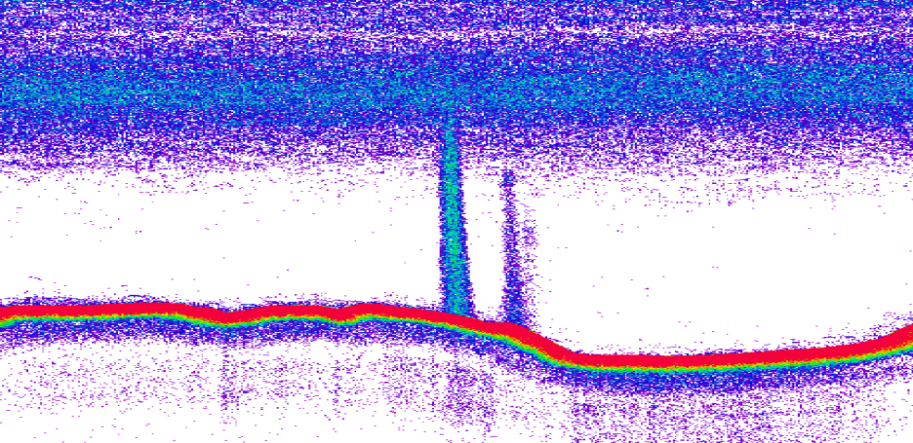

Figure NUMBER - IVS Fledermaus Midwater visualization of neighboring methane seep plumes.

MATLAB split-beam processing routines were used to take advantage of phase angle data within the EK60 raw data files for improved characterization of seep location and plume shape. In this routine, a volumetric scattering strength threshold was applied to examine only “strong” targets, such as methane bubbles. Electronic phase angles for received signals from water column targets within the 11° beam were converted to mechanical angles within the transducer reference frame. These mechanical angles were coupled with target ranges and vessel positioning and motion data to enable target position estimates in the geographic reference frame which may be more precise than using IVS Fledermaus FMMidwater alone. Subsets of targets were analyzed for the base of each plume to yield mean latitude and longitude near the seafloor. An example of MATLAB processing results for the plume feature on the left in Figure NUMBER is presented in Figure NUMBER+1.

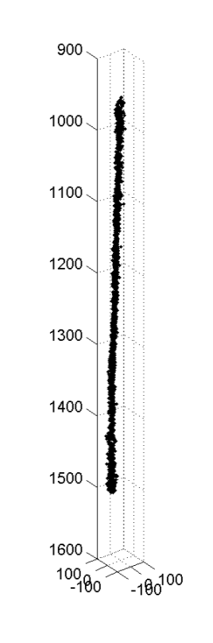

Figure NUMBER+1 - MATLAB split-beam processing example.

Seafloor backscatter processing was completed in IVS FMGT – (More details needed here)

Daily mapping products were made available to the shore through the FTP server that included bathymetry grids (in ASCII Latitude, Longitude and Depth), Fledermaus ver. 7 SD object, Geotiff image of gridded Bathymetric data, Google Earth KMZ of bathymetric data and Bathymetric grid in ArcView.

**Patch test results**

A separate patch test after the TRU/SIS upgrade was considered but not conducted in interest of time. Also the patch test was considered not essential after data comparison in SIS where lines running in different orientations and speed lined up very well.

Angular offsets (based on patch test conducted in May 2011) are tabulated as below. For complete processing unit setup (PU Setup) utilized for the cruise, please refer to Appendix A.

|  |  |  |  |
| --- | --- | --- | --- |
|  | Roll | Pitch | Heading |
| Tx Transducer | 0.0 | 0.0 | 359.98 |
| Rx Transducer | 0.0 | 0.0 | 0.03 |
| Attitude | 0 | -0.80 | 0.0 |

Table 2: Angular offsets for Transmit (TX) and Receive (RX) transducer as determined during a patch test conducted in May 2011.

**Data acquisition plan**

*Pre-EM302 Upgrade*

The EX was using SIS v. 3.8.3. Newer versions of the software had been available earlier in the field season, but not installed until Kongsberg representatives could be present. The EX ran several lines before doing the upgrade to both the SIS software and TRU so that comparisons could be made.

*Post-EM302 Upgrade*

After the upgrade was complete, the same lines were run covering depth range of ~ 200 – 1300 m. Comparisons showed no appreciable degradation of data quality. The difference between pre and post up grade resulted in mean and mean of 9 cm and 24 cm respectively. Additional assessment of effects of the upgrade will be conducted in future while working in different depths and bottom types. For details about the changes in the upgraded SIS 3.8.3 and EM 302 1.1.1 software please refer to respective release notes [4,5].

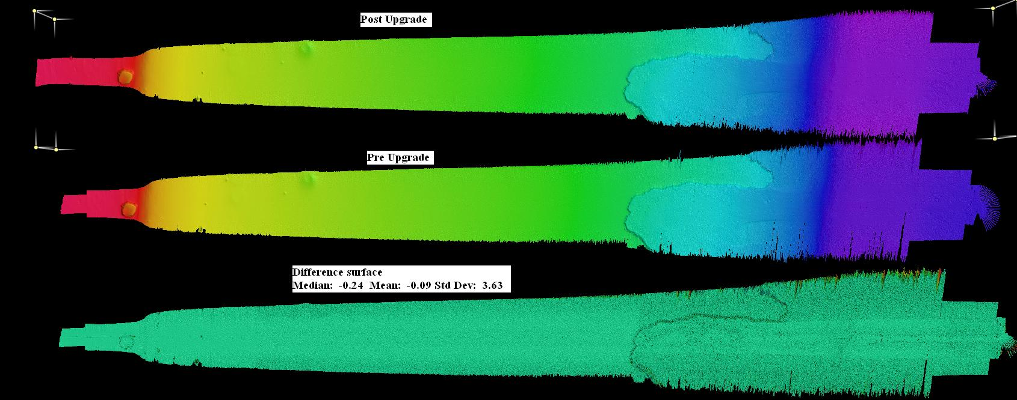

*EK60 Calibration*

EK60 calibration was conducted on August 22, 2011. There were no suitable anchorages outside of Key West, so the calibration was performed while the ship was drifting. The mapping team set up the downriggers and poles and put the sphere in the water. While conducting the calibration, one of the three lines on the sphere parted, so the calibration was not completed. Please see EX_SOP_EK60 Calibration for more details on conducting the calibration.

*Transit to Primary working grounds*

Once the Kongsberg representatives were ferried ashore, the EX headed towards the Gulf of Mexico. Shortly after, one crew member needed to be returned to port, so the EX headed back towards the nearest port, Key West, to drop him off. Once the crew member was ashore, the EX headed off again to the Gulf of Mexico, and mapped along the shelf break known as the Florida Escarpment. During this transit, the UNH team trained with the EX team on operating systems, collecting data on all of the sonars, and fine tuning of the settings for optimal acquisition.

*Running lines over Biloxi dome*

*EK60 Calibration #2*

On August 29, the EK60 calibration was conducted again. This time, the calibration was completed and successful.

*Start running the main survey lines*

*Oil slick report –*

*Coming back to lines over Biloxi dome (JB lines)*

*Running lines over Macando well*

Multiple lines were run over the Macando well in various directions. The EM302 bathymetry, backscatter and water column backscatter were all able to detect the wreckage of the DWH as well as some naturally occurring seeps in the vicinity.

*Florida escarpment mapping*

With Tropical Storm/Hurricane Lee approaching the EX working grounds, the weather was degraded so that it had become difficult to collect useful data. By late afternoon on September 1, the EX departed the primary working area to find a calmer area to survey. The EX headed to the Florida Escarpment where oil sheens had been previously observed.

*Return to working grounds*

On September 5, the EX was able to start working back towards the primary working grounds in an effort to finish collecting data for the water column backscatter testing over known natural seep areas.

**5a. Data Results**

Overall the ship mapped approximately 17477 sq km in depth range of ~ 30 m to 3400 m. The following image showed the overall results of the cruise:

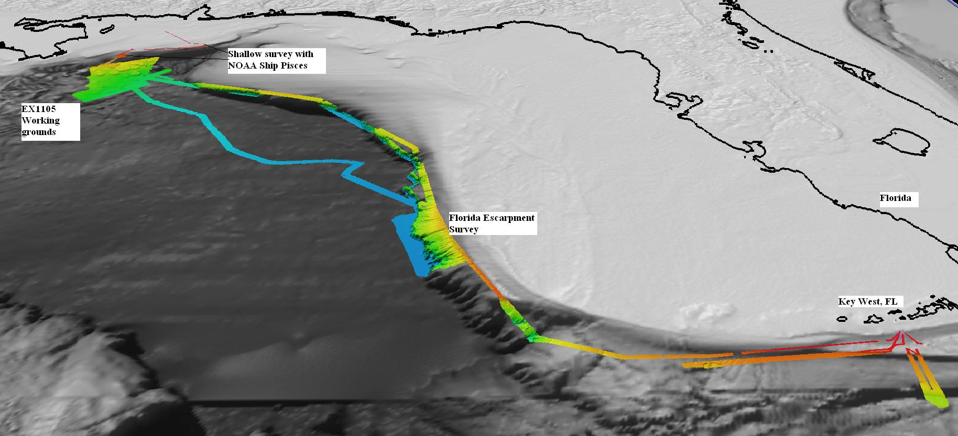

Figure : Perspective view showing the multibeam mapping collected during EX1105.

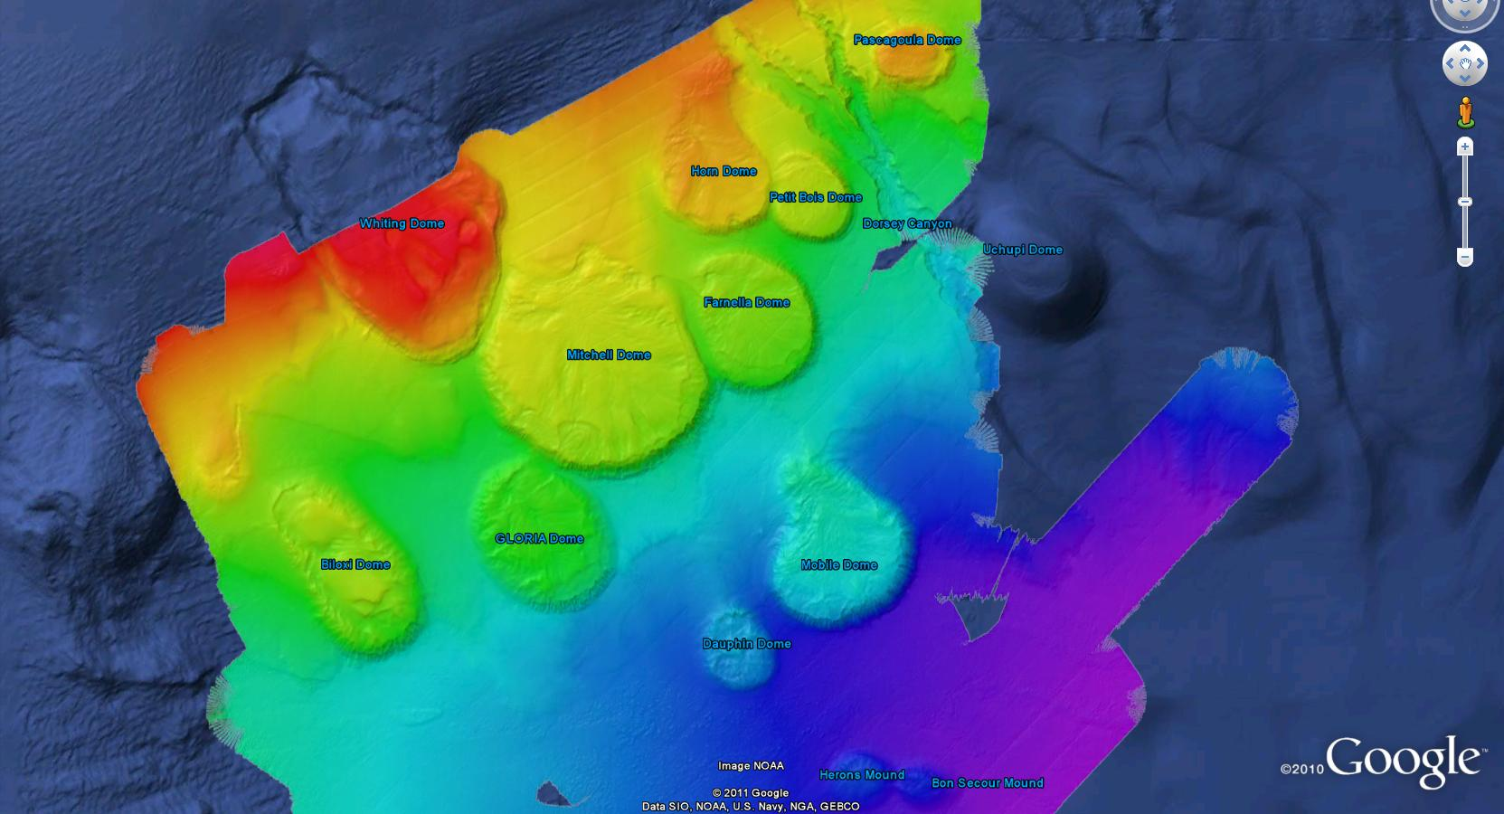

Figure : Zoomed in view of the EX1105 working grounds showing the multibeam bathymetry over the salt domes.

Efficacy of EM 302 to detect gas seeps

The EM 302 water column data analysis showed that the multibeam is capable of detecting gas seeps. The availability of EK 60 data helped in reaching to this conclusion where all the seeps that were detected by EK 60 were successfully detected by EM 302 also.

The multibeam ability of gas seep detected however decreased significantly in the outer beams.

(more details here)

# 5b. Table of Cruise Statistics

|  |  |
| --- | --- |
| Dates | 8/22/2011 – 9/10/2011 |
| Weather delays | 4 |
| Line kilometers surveyed | 6852 |
| Total area mapped | 17477 sq km |
| Number of CTD casts | 4 |
| Number of XBT casts | 70 |
| Beginning draft | Fwd: 14'6"  Aft: 14' 9" |
| End draft | Fwd:  14'3"  Aft: 14'7" |
|  |  |

# 6. Cruise Calendar

|  |  |  |  |  |  |  |
| --- | --- | --- | --- | --- | --- | --- |
| **August 2011** | | | | | | |
| **Mon** | **Tue** | **Wed** | **Thu** | **Fri** | **Sat** | **Sun** |
| 22  The ship departed Key West, FL  Conducted EK 60 calibration | 23  EM 302 upgrade completed.  Transfer Kongberg personnel by small boat to Key West, FL. | 24  Return to Key West to drop off injured personnel via small boat. | 25  In transit to working grounds in vicinity of DWH site | 26  Arrived at DWH site at 0852 EST. Observed a minute of silence in respect of victims who lost their lives. Started testing different settings over Biloxi dome | 27  Continued working over Biloxi dome running lines at different settings and offsets to optimize settings and line spacing for the seep detections | 28  Started running the survey to systematically map the area. |
| 29  CTD cast conducted. EK 60 calibration conducted followed by Knudsen operations over a feature of interest detected by EM 302 | 30  RV with *Pisces* run the same line an hour apart over the known seep sites.  A small overflying plan reported an oil slick.  The ship transited to investigate the oil slick | 31  Running lines in vicinity of the Macando well |  |  |  |  |
| **September 2011** | | | | | | |
|  |  |  | 1  Running lines in vicinity of Macando well. Weather picked up to 8-10 feet. | 2  In transit to Florida escarpment. Started running lines in the Florida escarpment area. | 3  Continue to run lines in Florida escarpment | 4  Continue to run lines in Florida escarpment |
| 5  Started heading towards primary working grounds | 6  Continue heading towards/arrive at primary working grounds | 7  CTD casts conducted on Dauphine dome | 8  Continue running survey lines | 9  Continue running survey lines | 10  Arrived Pascagoula, MS |  |

# 7. Tables of data files collected

Table 7a: XBT/CTD data collected during the cruise for the Multibeam Sound Speed computation

|  |  |  |  |  |  |  |  |
| --- | --- | --- | --- | --- | --- | --- | --- |
| **EX1105 Sound Speed profiles LOG** | | | | | | | |
| **DATE (GMT)** | **TIME (GMT)** | | | **XBT/CTD FILE NAME** | | **LAT/LONG (WGS84)** | **NOTES** |
| 8/23/2011 | | 00:07:03 | EX1105_XBT01_110823 | | 24 10.5166N | 81 44.5542W |  | |
| 8/23/2011 | | 23:30:25 | EX1105_XBT02_110823 | | 24 13.34399N | 82 41.87891W |  | |
| 8/24/2011 | | 04:16:50 | EX1105_XBT03_110824 | | 24 12.27222N | 82 41.68262W |  | |
| 8/24/2011 | | 10:25:51 | EX1105_XBT04_110824 | | 24 23.60498N | 81 50.71875W |  | |
| 8/24/2011 | | 22:48:53 | EX1105_XBT05_110824 | | 24 15.0061N | 83 14.53223W |  | |
| 8/25/2011 | | 04:17:25 | EX1105_XBT06_110825 | | 24 39.0791N | 84 7.88672W |  | |
| 8/25/2011 | | 10:32:56 | EX1105_XBT07_110825 | | 25 36.26392N | 84 39.75586W |  | |
| 8/25/2011 | | 17:49:42 | EX1105_XBT08_110825 | | 26 56.55737N | 85 1.50293W | Bad Cast | |
| 8/25/2011 | | 18:00:14 | EX1105_XBT09_110825 | | 26 57.98999N | 85 2.92383W |  | |
| 8/25/2011 | | 23:52:34 | EX1105_XBT10_110825 | | 27 47.54248N | 85 52.09863W |  | |
| 8/26/2011 | | 05:27:02 | EX1105_XBT11_110826 | | 28 14.22511N | 86 54.23535W |  | |
| 8/26/2011 | | 10:52:32 | EX1105_XBT12_110826 | | 28 36.21533N | 87 59.96582W |  | |
| 8/26/2011 | | 18:25:49 | EX1105_XBT13_110826 | | 28 47.55591N | 88 33.90981W |  | |
| 8/26/2011 | | 22:47:02 | EX1105_XBT14_110826 | | 28 39.2146N | 88 27.63867W |  | |
| 8/27/2011 | | 04:36:08 | EX1105_XBT15_110827 | | 28 42.80249N | 88 29.13379W |  | |
| 8/27/2011 | | 10:48:10 | EX1105_XBT16_110827 | | 28 38.49634N | 88 27.23242W |  | |
| 8/27/2011 | | 18:13:00 | EX1105_XBT17_110827 | | 28 39.42847N | 88 27.79102W |  | |
| 8/27/2011 | | 23:32:13 | EX1105_XBT18_110827 | | 28 40.47046N | 88 28.07617W |  | |
| 8/28/2011 | | 06:06:25 | EX1105_XBT19_110828 | | 28 6.99658N | 88 11.61914W |  | |
| 8/28/2011 | | 10:45:16 | EX1105_XBT20_110828 | | 28 11.69531N | 88 7.863280W |  | |
| 8/28/2011 | | 16:33:02 | EX1105_XBT21_110828 | | 28 20.08618N | 88 1.416990W |  | |
| 8/28/2011 | | 23:07:00 | EX1105_XBT22_110828 | | 28 26.67749N | 87 59.40527W |  | |
| 8/29/2011 | | 04:42:27 | EX1105_XBT23_110829 | | 28 23.02734N | 88 5.496100W |  | |
| 8/29/2011 | | 10:50:57 | EX1105_XBT24_110829 | | 28 9.13159N | 88 25.77246W |  | |
| 8/29/2011 | | 12:42:20 | EX1105_CTD02_110829 | | 28 15.3700 N | 088 12.7800 W |  | |
| 8/29/2011 | | 23:41:50 | EX1105_XBT25_110829 | | 28 37.22778N | 87 55.70508W |  | |
| 8/30/2011 | | 05:10:34 | EX1105_XBT26_110830 | | 28 18.29102N | 88 16.40039W |  | |
| 8/30/2011 | | 10:48:31 | EX1105_XBT27_110830 | | 28 35.51709N | 88 1.734380W |  | |
| 8/30/2011 | | 16:36:56 | EX1105_XBT28_110830 | | 28 50.15210N | 88 25.31641W |  | |
| 8/30/2011 | | 22:45:37 | EX1105_XBT29_110830 | | 28 56.27832N | 88 10.72461W |  | |
| 8/31/2011 | | 4:27:50 | EX1105_XBT30_110831 | | 28 43.76929N | 88 26.44336W |  | |
| 8/31/2011 | | 10:50:22 | EX1105_XBT31_110831 | | 28 46.87549N | 88 23.91113W |  | |
| 8/31/2011 | | 16:40:33 | EX1105_XBT32_110831 | | 28 47.75146N | 88 21.46582W |  | |
| 8/31/2011 | | 17:03:01 | EX1105_XSV33_110831 | | 28 44.02173N | 88 21.41016W |  | |
| 8/31/2011 | | 23:48:30 | EX1105_XBT34_110831 | | 28 47.22290N | 88 19.00680W |  | |
| 9/1/2011 | | 05:10:27 | EX1105_XBT35_110901 | | 28 33.39722 N | 88 9.928710W |  | |
| 9/1/2011 | | 14:42:30 | EX1105_XBT36_110901 | | 28 39.56665N | 88 2.298830W |  | |
| 9/2/2011 | | 04:26:33 | EX1105_XBT37_110902 | | 28 14.54175N | 86 58.99902W |  | |
| 9/2/2011 | | 10:44:55 | EX1105_XBT38_110902 | | 27 55.83936N | 86 2.003910W |  | |
| 9/2/2011 | | 23:35:54 | EX1105_XBT39_110902 | | 26 28.62012N | 84 59.26562W |  | |
| 9/2/2011 | | 23:35:54 | EX1105_XBT40_110902 | | 26 28.62012N | 84 59.26562W |  | |
| 9/3/2011 | | 02:34:39 | EX1105_XSV41_110903 | | 26 4.94116N | 84 55.65137W |  | |
| 9/3/2011 | | 05:14:54 | EX1105_XBT42_110903 | | 25 47.28076N | 85 1.371090W |  | |
| 9/3/2011 | | 10:57:12 | EX1105_XBT43_110903 | | 25 15.44604N | 84 47.26953W |  | |
| 9/3/2011 | | 07:37:00 | EX1105_CTD03_110903 | | 25 11.66367N | 84 41.67480W |  | |
| 9/3/2011 | | 23:33:10 | EX1105_XBT44_110903 | | 25 11.66367N | 84 41.67480W |  | |
| 9/4/2011 | | 10:48:14 | EX1105_XBT45_110904 | | 25 14.34302N | 84 36.78418W |  | |
| 9/4/2011 | | 10:48:14 | EX1105_XBT46_110904 | | 25 14.34302N | 84 36.78418W |  | |
| 9/4/2011 | | 16:41:15 | EX1105_XBT47_110904 | | 25 53.41357N | 84 49.11621W |  | |
| 9/4/2011 | | 22:45:45 | EX1105_XBT48_110904 | | 25 24.79224N | 84 36.83984W |  | |
| 9/5/2011 | | 05:32:05 | EX1105_XBT49_110905 | | 25 36.04102N | 84 39.66895W | bad cast, wire broke | |
| 9/5/2011 | | 05:35:13 | EX1105_XBT50_110905 | | 25 35.58301N | 84 39.50586W |  | |
| 9/5/2011 | | 10:52:05 | EX1105_XBT51_110906 | | 25 38.10742N | 84 39.16406W |  | |
| 9/5/2011 | | 16:37:21 | EX1105_XBT52_110905 | | 26 17.80347N | 85 12.63477W |  | |
| 9/6/2011 | | 23:39:36 | EX1105_XBT53_110905 | | 26 47.44873N | 85 35.87660W |  | |
| 9/6/2011 | | 06:06:44 | EX1105_XBT54_110906 | | 26 48.18335N | 86 16.69336W |  | |
| 9/6/2011 | | 10:50:01 | EX1105_XBT55_110906 | | 27 13.97876N | 86 46.24505W |  | |
| 9/6/2011 | | 16:41:09 | EX1105_XBT56_110906 | | 27 54.27197N | 87 28.41699W |  | |
| 9/6/2011 | | 11:09:19 | EX1105_XBT57_110906 | | 28 33.36182N | 88 04.47754W |  | |
| 9/7/2011 | | 5:00:19 | EX1105_XBT58_110907 | | 28 33.40234N | 88 9.488280W |  | |
| 9/7/2011 | | 10:36:35 | EX1105_XBT59_110907 | | 28 44.82104N | 88 02.00977W |  | |
| 9/8/2011 | | 5:05:26 | EX1105_XBT60_110908 | | 28 46.03390N | 88 05.06640W |  | |
| 9/8/2011 | | 10:33:57 | EX1105_XBT61_110908 | | 28 36.91064N | 88 21.03223W |  | |
| 9/8/2011 | | 16:34:46 | EX1105_XBT61_110908 | | 28 45.67163N | 88 16.20898W |  | |
| 9/8/2011 | | 23:02:45 | EX1105_XBT63_110908 | | 28 54.46265N | 88 08.42090W |  | |
| 9/9/2011 | | 5:04:32 | EX1105_XBT64_110909 | | 29 00.42829N | 88 03.67871W |  | |
| 9/9/2011 | | 10:50:30 | EX1105_XBT65_110909 | | 29 01.16211N | 88 07.44629W |  | |
| 9/9/2011 | | 16:35:25 | EX1105_XBT66_110909 | | 28 42.60962N | 88 30.47754W |  | |
| 9/9/2011 | | 19:07:42 | EX1105_XBT67_110909 | | 29 3.48169N | 88 23.43945W | T6 XBT | |
| 9/10/2011 | | 22:42:48 | EX1105_XBT68_110910 | | 29 7.05200N | 88 23.53516W |  | |

Table 7b: Multibeam filescollected during the cruise:

|  |  |  |  |
| --- | --- | --- | --- |
| **Date (GMT)** | **MB Line Filename** | **Location** | **Remarks** |
| 8/23/2011 | 0000_20110823_003743_EX1105_MB.all | Key West, FL | PreUpgrade |
| 8/23/2011 | 0001_20110823_011516_EX1105_MB.all | Key West, FL | PreUpgrade |
| 8/23/2011 | 0000_20110823_062314_EX1105_MB.all | Key West, FL | Post Upgrade |
| 8/23/2011 | 0001_20110823_064004_EX1105_MB.all | Key West, FL | Post Upgrade |
| 8/23/2011 | 0002_20110823_093647_EX1105_MB.all | Key West, FL | Post Upgrade |
| 8/23/2011 | 0003_20110823_153422_EX1105_MB.all | Key West, FL | Post Upgrade |
| 8/23/2011 | 0000_20110823_175500_EX1105_MB.all | Transit | EX1105_Survey |
| 8/23/2011 | 0001_20110823_182821_EX1105_MB.all | Transit to Working Ground (WG) | EX1105_Survey |
| 8/23/2011 | 0002_20110823_185807_EX1105_MB.all | Transit to WG | EX1105_Survey |
| 8/24/2011 | 0003_20110824_005807_EX1105_MB.all | Transit to WG | EX1105_Survey |
| 8/24/2011 | 0004_20110824_015105_EX1105_MB.all | Transit to WG | EX1105_Survey |
| 8/24/2011 | 0005_20110824_075106_EX1105_MB.all | Transit to WG | EX1105_Survey |
| 8/24/2011 | 0006_20110824_154752_EX1105_MB.all | Transit to WG | EX1105_Survey |
| 8/24/2011 | 0007_20110824_164128_EX1105_MB.all | Transit to WG | EX1105_Survey |
| 8/24/2011 | 0000_20110824_205708_EX1105_MB.all | Transit to WG | EX1105_Survey1 |
| 8/24/2011 | 0002_20110824_225936_EX1105_MB.all | Transit to WG | EX1105_Survey1 |
| 8/24/2011 | 0003_20110824_235421_EX1105_MB.all | Transit to WG | EX1105_Survey1 |
| 8/25/2011 | 0004_20110825_055420_EX1105_MB.all | Transit to WG | EX1105_Survey1 |
| 8/25/2011 | 0005_20110825_115419_EX1105_MB.all | Transit to WG | EX1105_Survey1 |
| 8/25/2011 | 0006_20110825_135501_EX1105_MB.all | Transit to WG | EX1105_Survey1 |
| 8/25/2011 | 0007_20110825_172156_EX1105_MB.all | Transit to WG | EX1105_Survey1 |
| 8/25/2011 | 0000_20110825_213114_EX1105_MB.all | Transit to WG | EX1105_Survey2 |
| 8/25/2011 | 0000_20110825_235407_EX1105_MB.all | Transit to WG | EX1105_Survey3 |
| 8/26/2011 | 0001_20110826_003851_EX1105_MB.all | Transit to WG |  |
| 8/26/2011 | 0002_20110826_010051_EX1105_MB.all | Transit to WG |  |
| 8/26/2011 | 0003_20110826_013131_EX1105_MB.all | Transit to WG |  |
| 8/26/2011 | 0004_20110826_020053_EX1105_MB.all | Transit to WG |  |
| 8/26/2011 | 0005_20110826_030052_EX1105_MB.all | Transit to WG |  |
| 8/26/2011 | 0006_20110826_040053_EX1105_MB.all | Transit to WG |  |
| 8/26/2011 | 0007_20110826_043844_EX1105_MB.all | Transit to WG |  |
| 8/26/2011 | 0008_20110826_050038_EX1105_MB.all | Transit to WG |  |
| 8/26/2011 | 0009_20110826_060041_EX1105_MB.all | Transit to WG |  |
| 8/26/2011 | 0010_20110826_070041_EX1105_MB.all | Transit to WG |  |
| 8/26/2011 | 0011_20110826_080039_EX1105_MB.all | Transit to WG |  |
| 8/26/2011 | 0012_20110826_090040_EX1105_MB.all | Transit to WG |  |
| 8/26/2011 | 0013_20110826_100041_EX1105_MB.all | WG |  |
| 8/26/2011 | 0014_20110826_110044_EX1105_MB.all | WG |  |
| 8/26/2011 | 0015_20110826_120041_EX1105_MB.all | WG |  |
| 8/26/2011 | 0016_20110826_125439_EX1105_MB.all | WG |  |
| 8/26/2011 | 0017_20110826_131534_EX1105_MB.all | WG |  |
| 8/26/2011 | 0018_20110826_140222_EX1105_MB.all | WG |  |
| 8/26/2011 | 0019_20110826_144810_EX1105_MB.all | WG |  |
| 8/26/2011 | 0020_20110826_145604_EX1105_MB.all | WG |  |
| 8/26/2011 | 0021_20110826_155126_EX1105_MB.all | WG |  |
| 8/26/2011 | 0022_20110826_160206_EX1105_MB.all | WG |  |
| 8/26/2011 | 0023_20110826_170207_EX1105_MB.all | WG |  |
| 8/26/2011 | 0024_20110826_170323_EX1105_MB.all | WG |  |
| 8/26/2011 | 0025_20110826_180326_EX1105_MB.all | WG |  |
| 8/26/2011 | 0026_20110826_181934_EX1105_MB.all | WG |  |
| 8/26/2011 | 0027_20110826_182904_EX1105_MB.all | WG |  |
| 8/26/2011 | 0028_20110826_190544_EX1105_MB.all | WG |  |
| 8/26/2011 | 0029_20110826_195532_EX1105_MB.all | WG |  |
| 8/26/2011 | 0030_20110826_200657_EX1105_MB.all | WG |  |
| 8/26/2011 | 0031_20110826_210052_EX1105_MB.all | WG |  |
| 8/26/2011 | 0032_20110826_212229_EX1105_MB.all | WG |  |
| 8/26/2011 | 0033_20110826_213054_EX1105_MB.all | WG |  |
| 8/26/2011 | 0034_20110826_220618_EX1105_MB.all | WG |  |
| 8/26/2011 | 0035_20110826_222649_EX1105_MB.all | WG |  |
| 8/26/2011 | 0036_20110826_223755_EX1105_MB.all | WG |  |
| 8/26/2011 | 0037_20110826_230259_EX1105_MB.all | WG |  |
| 8/26/2011 | 0038_20110826_232043_EX1105_MB.all | WG |  |
| 8/26/2011 | 0039_20110826_232504_EX1105_MB.all | WG |  |
| 8/26/2011 | 0040_20110826_234556_EX1105_MB.all | WG |  |
| 8/26/2011 | 0041_20110826_235801_EX1105_MB.all | WG |  |
| 8/27/2011 | 0054_20110827_050134_EX1105_MB.all | WG |  |
| 8/27/2011 | 0055_20110827_051454_EX1105_MB.all | WG |  |
| 8/27/2011 | 0056_20110827_052105_EX1105_MB.all | WG |  |
| 8/27/2011 | 0057_20110827_060851_EX1105_MB.all | WG |  |
| 8/27/2011 | 0058_20110827_061722_EX1105_MB.all | WG |  |
| 8/27/2011 | 0059_20110827_071134_EX1105_MB.all | WG |  |
| 8/27/2011 | 0060_20110827_075356_EX1105_MB.all | WG |  |
| 8/27/2011 | 0061_20110827_080201_EX1105_MB.all | WG |  |
| 8/27/2011 | 0062_20110827_083907_EX1105_MB.all | WG |  |
| 8/27/2011 | 0063_20110827_084829_EX1105_MB.all | WG |  |
| 8/27/2011 | 0064_20110827_093802_EX1105_MB.all | WG |  |
| 8/27/2011 | 0065_20110827_094722_EX1105_MB.all | WG |  |
| 8/27/2011 | 0066_20110827_103855_EX1105_MB.all | WG |  |
| 8/27/2011 | 0067_20110827_110023_EX1105_MB.all | WG |  |
| 8/27/2011 | 0068_20110827_113025_EX1105_MB.all | WG |  |
| 8/27/2011 | 0069_20110827_113858_EX1105_MB.all | WG |  |
| 8/27/2011 | 0070_20110827_120005_EX1105_MB.all | WG |  |
| 8/27/2011 | 0071_20110827_122356_EX1105_MB.all | WG |  |
| 8/27/2011 | 0072_20110827_122915_EX1105_MB.all | WG |  |
| 8/27/2011 | 0073_20110827_130014_EX1105_MB.all | WG |  |
| 8/27/2011 | 0074_20110827_133205_EX1105_MB.all | WG |  |
| 8/27/2011 | 0075_20110827_140141_EX1105_MB.all | WG |  |
| 8/27/2011 | 0076_20110827_150120_EX1105_MB.all | WG |  |
| 8/27/2011 | 0077_20110827_160120_EX1105_MB.all | WG |  |
| 8/27/2011 | 0078_20110827_202800_EX1105_MB.all | WG |  |
| 8/27/2011 | 0079_20110827_211022_EX1105_MB.all | WG |  |
| 8/27/2011 | 0080_20110827_212020_EX1105_MB.all | WG |  |
| 8/27/2011 | 0081_20110827_221938_EX1105_MB.all | WG |  |
| 8/27/2011 | 0082_20110827_222149_EX1105_MB.all | WG |  |
| 8/27/2011 | 0083_20110827_230434_EX1105_MB.all | WG |  |
| 8/27/2011 | 0084_20110827_231058_EX1105_MB.all | WG |  |
| 8/27/2011 | 0085_20110827_235705_EX1105_MB.all | WG |  |
| 8/28/2011 | 0086_20110828_000558_EX1105_MB.all | WG |  |
| 8/28/2011 | 0087_20110828_005500_EX1105_MB.all | WG |  |
| 8/28/2011 | 0088_20110828_015458_EX1105_MB.all | WG |  |
| 8/28/2011 | 0089_20110828_020950_EX1105_MB.all | WG |  |
| 8/28/2011 | 0090_20110828_030001_EX1105_MB.all | WG |  |
| 8/28/2011 | 0091_20110828_040004_EX1105_MB.all | WG |  |
| 8/28/2011 | 0092_20110828_050002_EX1105_MB.all | WG |  |
| 8/28/2011 | 0093_20110828_051641_EX1105_MB.all | WG |  |
| 8/28/2011 | 0094_20110828_060003_EX1105_MB.all | WG |  |
| 8/28/2011 | 0095_20110828_070001_EX1105_MB.all | WG |  |
| 8/28/2011 | 0096_20110828_080005_EX1105_MB.all | WG |  |
| 8/28/2011 | 0097_20110828_083824_EX1105_MB.all | WG |  |
| 8/28/2011 | 0098_20110828_084609_EX1105_MB.all | WG |  |
| 8/28/2011 | 0099_20110828_090005_EX1105_MB.all | WG |  |
| 8/28/2011 | 0100_20110828_100004_EX1105_MB.all | WG |  |
| 8/28/2011 | 0101_20110828_110002_EX1105_MB.all | WG |  |
| 8/28/2011 | 0102_20110828_120002_EX1105_MB.all | WG |  |
| 8/28/2011 | 0103_20110828_121045_EX1105_MB.all | WG |  |
| 8/28/2011 | 0104_20110828_121728_EX1105_MB.all | WG |  |
| 8/28/2011 | 0105_20110828_131231_EX1105_MB.all | WG |  |
| 8/28/2011 | 0106_20110828_140002_EX1105_MB.all | WG |  |
| 8/28/2011 | 0107_20110828_150003_EX1105_MB.all | WG |  |
| 8/28/2011 | 0108_20110828_150009_EX1105_MB.all | WG |  |
| 8/28/2011 | 0109_20110828_152358_EX1105_MB.all | WG |  |
| 8/28/2011 | 0110_20110828_153618_EX1105_MB.all | WG |  |
| 8/28/2011 | 0111_20110828_160103_EX1105_MB.all | WG |  |
| 8/28/2011 | 0112_20110828_170103_EX1105_MB.all | WG |  |
| 8/28/2011 | 0113_20110828_180047_EX1105_MB.all | WG |  |
| 8/28/2011 | 0114_20110828_190043_EX1105_MB.all | WG |  |
| 8/28/2011 | 0115_20110828_190100_EX1105_MB.all | WG |  |
| 8/28/2011 | 0116_20110828_191929_EX1105_MB.all | WG |  |
| 8/28/2011 | 0117_20110828_200320_EX1105_MB.all | WG |  |
| 8/28/2011 | 0118_20110828_210323_EX1105_MB.all | WG |  |
| 8/28/2011 | 0119_20110828_220000_EX1105_MB.all | WG |  |
| 8/28/2011 | 0120_20110828_223226_EX1105_MB.all | WG |  |
| 8/28/2011 | 0121_20110828_224928_EX1105_MB.all | WG |  |
| 8/28/2011 | 0122_20110828_234930_EX1105_MB.all | WG |  |
| 8/29/2011 | 0123_20110829_000001_EX1105_MB.all | WG |  |
| 8/29/2011 | 0124_20110829_010005_EX1105_MB.all | WG |  |
| 8/29/2011 | 0125_20110829_020003_EX1105_MB.all | WG |  |
| 8/29/2011 | 0126_20110829_021145_EX1105_MB.all | WG |  |
| 8/29/2011 | 0127_20110829_022901_EX1105_MB.all | WG |  |
| 8/29/2011 | 0128_20110829_032901_EX1105_MB.all | WG |  |
| 8/29/2011 | 0129_20110829_042900_EX1105_MB.all | WG |  |
| 8/29/2011 | 0130_20110829_052902_EX1105_MB.all | WG |  |
| 8/29/2011 | 0131_20110829_061952_EX1105_MB.all | WG |  |
| 8/29/2011 | 0132_20110829_063334_EX1105_MB.all | WG |  |
| 8/29/2011 | 0133_20110829_073332_EX1105_MB.all | WG |  |
| 8/29/2011 | 0134_20110829_083333_EX1105_MB.all | WG |  |
| 8/29/2011 | 0135_20110829_093335_EX1105_MB.all | WG |  |
| 8/29/2011 | 0136_20110829_103141_EX1105_MB.all | WG |  |
| 8/29/2011 | 0137_20110829_104354_EX1105_MB.all | WG |  |
| 8/29/2011 | 0138_20110829_110031_EX1105_MB.all | WG |  |
| 8/29/2011 | 0139_20110829_120031_EX1105_MB.all | WG |  |
| 8/29/2011 | 0140_20110829_201944_EX1105_MB.all | WG |  |
| 8/29/2011 | 0141_20110829_210239_EX1105_MB.all | WG |  |
| 8/29/2011 | 0142_20110829_220237_EX1105_MB.all | WG |  |
| 8/29/2011 | 0143_20110829_230238_EX1105_MB.all | WG |  |
| 8/29/2011 | 0144_20110829_230858_EX1105_MB.all | WG |  |
| 8/30/2011 | 0145_20110830_000859_EX1105_MB.all | WG |  |
| 8/30/2011 | 0146_20110830_000956_EX1105_MB.all | WG |  |
| 8/30/2011 | 0147_20110830_005416_EX1105_MB.all | WG |  |
| 8/30/2011 | 0148_20110830_010821_EX1105_MB.all | WG |  |
| 8/30/2011 | 0149_20110830_020822_EX1105_MB.all | WG |  |
| 8/30/2011 | 0150_20110830_030817_EX1105_MB.all | WG |  |
| 8/30/2011 | 0151_20110830_032600_EX1105_MB.all | WG |  |
| 8/30/2011 | 0152_20110830_042559_EX1105_MB.all | WG |  |
| 8/30/2011 | 0153_20110830_052600_EX1105_MB.all | WG |  |
| 8/30/2011 | 0154_20110830_062558_EX1105_MB.all | WG |  |
| 8/30/2011 | 0155_20110830_064330_EX1105_MB.all | WG |  |
| 8/30/2011 | 0156_20110830_065135_EX1105_MB.all | WG |  |
| 8/30/2011 | 0157_20110830_070119_EX1105_MB.all | WG |  |
| 8/30/2011 | 0158_20110830_080050_EX1105_MB.all | WG |  |
| 8/30/2011 | 0159_20110830_090050_EX1105_MB.all | WG |  |
| 8/30/2011 | 0160_20110830_100047_EX1105_MB.all | WG |  |
| 8/30/2011 | 0161_20110830_105219_EX1105_MB.all | WG |  |
| 8/30/2011 | 0162_20110830_110148_EX1105_MB.all | WG |  |
| 8/30/2011 | 0163_20110830_120151_EX1105_MB.all | WG |  |
| 8/30/2011 | 0164_20110830_130153_EX1105_MB.all | WG | Repeat line with Pisces |
| 8/30/2011 | 0165_20110830_140148_EX1105_MB.all | WG | Repeat line with Pisces |
| 8/30/2011 | 0166_20110830_150148_EX1105_MB.all | WG | Repeat line with Pisces |
| 8/30/2011 | 0168_20110830_153927_EX1105_MB.all | WG | Repeat line with Pisces |
| 8/30/2011 | 0169_20110830_160106_EX1105_MB.all | WG | Repeat line with Pisces |
| 8/30/2011 | 0170_20110830_164219_EX1105_MB.all | WG | Repeat line with Pisces |
| 8/30/2011 | 0171_20110830_174223_EX1105_MB.all | WG | Repeat line with Pisces |
| 8/30/2011 | 0172_20110830_184219_EX1105_MB.all | WG | Repeat line with Pisces |
| 8/30/2011 | 0173_20110830_185117_EX1105_MB.all | WG | Repeat line with Pisces |
| 8/30/2011 | 0174_20110830_195119_EX1105_MB.all | WG |  |
| 8/30/2011 | 0175_20110830_205119_EX1105_MB.all | WG |  |
| 8/30/2011 | 0176_20110830_210420_EX1105_MB.all | WG |  |
| 8/30/2011 | 0177_20110830_213831_EX1105_MB.all | WG |  |
| 8/30/2011 | 0178_20110830_215736_EX1105_MB.all | WG |  |
| 8/30/2011 | 0179_20110830_220517_EX1105_MB.all | WG |  |
| 8/30/2011 | 0180_20110830_220912_EX1105_MB.all | WG |  |
| 8/30/2011 | 0181_20110830_222656_EX1105_MB.all | WG |  |
| 8/30/2011 | 0182_20110830_223647_EX1105_MB.all | WG |  |
| 8/30/2011 | 0183_20110830_224009_EX1105_MB.all | WG |  |
| 8/30/2011 | 0184_20110830_231828_EX1105_MB.all | WG |  |
| 8/30/2011 | 0185_20110830_233955_EX1105_MB.all | WG |  |
| 8/31/2011 | 0186_20110831_002630_EX1105_MB.all | WG |  |
| 8/31/2011 | 0187_20110831_012631_EX1105_MB.all | WG |  |
| 8/31/2011 | 0188_20110831_013352_EX1105_MB.all | WG |  |
| 8/31/2011 | 0189_20110831_020118_EX1105_MB.all | WG |  |
| 8/31/2011 | 0190_20110831_020718_EX1105_MB.all | WG |  |
| 8/31/2011 | 0191_20110831_021952_EX1105_MB.all | WG |  |
| 8/31/2011 | 0192_20110831_025336_EX1105_MB.all | WG |  |
| 8/31/2011 | 0193_20110831_030540_EX1105_MB.all | WG |  |
| 8/31/2011 | 0194_20110831_033448_EX1105_MB.all | WG |  |
| 8/31/2011 | 0195_20110831_034347_EX1105_MB.all | WG |  |
| 8/31/2011 | 0197_20110831_041702_EX1105_MB.all | WG |  |
| 8/31/2011 | 0198_20110831_042550_EX1105_MB.all | WG |  |
| 8/31/2011 | 0199_20110831_045809_EX1105_MB.all | WG |  |
| 8/31/2011 | 0200_20110831_053722_EX1105_MB.all | WG |  |
| 8/31/2011 | 0201_20110831_061416_EX1105_MB.all | WG |  |
| 8/31/2011 | 0202_20110831_061923_EX1105_MB.all | WG |  |
| 8/31/2011 | 0203_20110831_070651_EX1105_MB.all | WG |  |
| 8/31/2011 | 0204_20110831_071238_EX1105_MB.all | WG |  |
| 8/31/2011 | 0205_20110831_080033_EX1105_MB.all | WG |  |
| 8/31/2011 | 0206_20110831_080708_EX1105_MB.all | WG |  |
| 8/31/2011 | 0207_20110831_090003_EX1105_MB.all | WG |  |
| 8/31/2011 | 0208_20110831_090713_EX1105_MB.all | WG |  |
| 8/31/2011 | 0209_20110831_091539_EX1105_MB.all | WG |  |
| 8/31/2011 | 0210_20110831_101540_EX1105_MB.all | WG |  |
| 8/31/2011 | 0211_20110831_101903_EX1105_MB.all | WG |  |
| 8/31/2011 | 0212_20110831_102736_EX1105_MB.all | WG |  |
| 8/31/2011 | 0213_20110831_110004_EX1105_MB.all | WG |  |
| 8/31/2011 | 0214_20110831_113734_EX1105_MB.all | WG |  |
| 8/31/2011 | 0215_20110831_114647_EX1105_MB.all | WG |  |
| 8/31/2011 | 0216_20110831_124647_EX1105_MB.all | WG |  |
| 8/31/2011 | 0217_20110831_125743_EX1105_MB.all | WG |  |
| 8/31/2011 | 0218_20110831_131802_EX1105_MB.all | WG |  |
| 8/31/2011 | 0219_20110831_140122_EX1105_MB.all | WG |  |
| 8/31/2011 | 0220_20110831_144209_EX1105_MB.all | WG |  |
| 8/31/2011 | 0221_20110831_145024_EX1105_MB.all | WG |  |
| 8/31/2011 | 0222_20110831_155027_EX1105_MB.all | WG |  |
| 8/31/2011 | 0223_20110831_161458_EX1105_MB.all | WG |  |
| 8/31/2011 | 0224_20110831_162215_EX1105_MB.all | WG |  |
| 8/31/2011 | 0225_20110831_172216_EX1105_MB.all | WG |  |
| 8/31/2011 | 0226_20110831_174629_EX1105_MB.all | WG |  |
| 8/31/2011 | 0227_20110831_175403_EX1105_MB.all | WG |  |
| 8/31/2011 | 0228_20110831_185404_EX1105_MB.all | WG |  |
| 8/31/2011 | 0229_20110831_191611_EX1105_MB.all | WG |  |
| 8/31/2011 | 0230_20110831_201612_EX1105_MB.all | WG |  |
| 8/31/2011 | 0231_20110831_210131_EX1105_MB.all | WG |  |
| 8/31/2011 | 0232_20110831_214501_EX1105_MB.all | WG |  |
| 8/31/2011 | 0233_20110831_224502_EX1105_MB.all | WG |  |
| 8/31/2011 | 0234_20110831_230044_EX1105_MB.all | WG |  |
| 8/31/2011 | 0235_20110831_231922_EX1105_MB.all | WG |  |
| 8/31/2011 | 0236_20110831_232628_EX1105_MB.all | WG |  |
| 8/31/2011 | 0237_20110831_233410_EX1105_MB.all | WG |  |
| 9/01/2011 | 0238_20110901_003411_EX1105_MB.all | WG |  |
| 9/01/2011 | 0239_20110901_005338_EX1105_MB.all | WG |  |
| 9/01/2011 | 0240_20110901_010104_EX1105_MB.all | WG |  |
| 9/01/2011 | 0241_20110901_015031_EX1105_MB.all | WG |  |
| 9/01/2011 | 0242_20110901_020749_EX1105_MB.all | WG |  |
| 9/01/2011 | 0243_20110901_022334_EX1105_MB.all | WG |  |
| 9/01/2011 | 0244_20110901_022908_EX1105_MB.all | WG |  |
| 9/01/2011 | 0245_20110901_023615_EX1105_MB.all | WG |  |
| 9/01/2011 | 0246_20110901_030002_EX1105_MB.all | WG |  |
| 9/01/2011 | 0247_20110901_040005_EX1105_MB.all | WG |  |
| 9/01/2011 | 0248_20110901_042722_EX1105_MB.all | WG |  |
| 9/01/2011 | 0249_20110901_042955_EX1105_MB.all | WG |  |
| 9/01/2011 | 0250_20110901_045005_EX1105_MB.all | WG |  |
| 9/01/2011 | 0251_20110901_054310_EX1105_MB.all | WG |  |
| 9/01/2011 | 0252_20110901_060517_EX1105_MB.all | WG |  |
| 9/01/2011 | 0253_20110901_061514_EX1105_MB.all | WG |  |
| 9/01/2011 | 0254_20110901_064412_EX1105_MB.all | WG |  |
| 9/01/2011 | 0255_20110901_072623_EX1105_MB.all | WG |  |
| 9/01/2011 | 0256_20110901_082625_EX1105_MB.all | WG |  |
| 9/01/2011 | 0257_20110901_092632_EX1105_MB.all | WG |  |
| 9/01/2011 | 0258_20110901_094506_EX1105_MB.all | WG |  |
| 9/01/2011 | 0259_20110901_100252_EX1105_MB.all | WG |  |
| 9/01/2011 | 0260_20110901_104529_EX1105_MB.all | WG |  |
| 9/01/2011 | 0261_20110901_114531_EX1105_MB.all | WG |  |
| 9/01/2011 | 0262_20110901_124527_EX1105_MB.all | WG |  |
| 9/01/2011 | 0263_20110901_134528_EX1105_MB.all | WG |  |
| 9/01/2011 | 0264_20110901_143441_EX1105_MB.all | WG |  |
| 9/01/2011 | 0265_20110901_153440_EX1105_MB.all | WG |  |
| 9/01/2011 | 0266_20110901_163438_EX1105_MB.all | WG |  |
| 9/01/2011 | 0267_20110901_165955_EX1105_MB.all | WG |  |
| 9/01/2011 | 0268_20110901_175956_EX1105_MB.all | WG |  |
| 9/01/2011 | 0269_20110901_185955_EX1105_MB.all | WG |  |
| 9/01/2011 | 0270_20110901_195954_EX1105_MB.all | WG |  |
| 9/01/2011 | 0271_20110901_200016_EX1105_MB.all | WG |  |
| 9/01/2011 | 0272_20110901_210017_EX1105_MB.all | WG |  |
| 9/01/2011 | 0273_20110901_220016_EX1105_MB.all | WG |  |
| 9/01/2011 | 0274_20110901_230017_EX1105_MB.all | Transit to Florida Escarpment (FE) |  |
| 9/02/2011 | 0275_20110902_000017_EX1105_MB.all | Transit to FE |  |
| 9/02/2011 | 0276_20110902_010019_EX1105_MB.all | Transit to FE |  |
| 9/02/2011 | 0277_20110902_014535_EX1105_MB.all | Transit to FE |  |
| 9/02/2011 | 0278_20110902_020001_EX1105_MB.all | Transit to FE |  |
| 9/02/2011 | 0279_20110902_030001_EX1105_MB.all | Transit to FE |  |
| 9/02/2011 | 0280_20110902_040001_EX1105_MB.all | Transit to FE |  |
| 9/02/2011 | 0281_20110902_050003_EX1105_MB.all | Transit to FE |  |
| 9/02/2011 | 0282_20110902_060004_EX1105_MB.all | Transit to FE |  |
| 9/02/2011 | 0283_20110902_070002_EX1105_MB.all | Transit to FE |  |
| 9/02/2011 | 0284_20110902_080003_EX1105_MB.all | Transit to FE |  |
| 9/02/2011 | 0285_20110902_090002_EX1105_MB.all | Transit to FE |  |
| 9/02/2011 | 0286_20110902_100001_EX1105_MB.all | Transit to FE |  |
| 9/02/2011 | 0287_20110902_110003_EX1105_MB.all | Transit to FE |  |
| 9/02/2011 | 0288_20110902_120007_EX1105_MB.all | Transit to FE |  |
| 9/02/2011 | 0289_20110902_130002_EX1105_MB.all | Transit to FE |  |
| 9/02/2011 | 0290_20110902_140001_EX1105_MB.all | Transit to FE |  |
| 9/02/2011 | 0291_20110902_150001_EX1105_MB.all | Transit to FE |  |
| 9/02/2011 | 0292_20110902_160004_EX1105_MB.all | Transit to FE |  |
| 9/02/2011 | 0293_20110902_165959_EX1105_MB.all | Transit to FE |  |
| 9/02/2011 | 0294_20110902_180001_EX1105_MB.all | Transit to FE |  |
| 9/02/2011 | 0295_20110902_190002_EX1105_MB.all | Transit to FE |  |
| 9/02/2011 | 0296_20110902_200000_EX1105_MB.all | Transit to FE |  |
| 9/02/2011 | 0297_20110902_210000_EX1105_MB.all | Transit to FE |  |
| 9/02/2011 | 0298_20110902_212102_EX1105_MB.all | Transit to FE |  |
| 9/02/2011 | 0299_20110902_212453_EX1105_MB.all | Transit to FE |  |
| 9/02/2011 | 0300_20110902_220000_EX1105_MB.all | Transit to FE |  |
| 9/02/2011 | 0301_20110902_221606_EX1105_MB.all | Transit to FE |  |
| 9/02/2011 | 0302_20110902_231242_EX1105_MB.all | Transit to FE |  |
| 9/02/2011 | 0303_20110902_231728_EX1105_MB.all | Transit to FE |  |
| 9/03/2011 | 0304_20110903_001153_EX1105_MB.all | Transit to FE |  |
| 9/03/2011 | 0305_20110903_005901_EX1105_MB.all | Transit to FE |  |
| 9/03/2011 | 0306_20110903_015901_EX1105_MB.all | Transit to FE |  |
| 9/03/2011 | 0307_20110903_025313_EX1105_MB.all | Transit to FE |  |
| 9/03/2011 | 0308_20110903_031829_EX1105_MB.all | FE |  |
| 9/03/2011 | 0309_20110903_032505_EX1105_MB.all | FE |  |
| 9/03/2011 | 0310_20110903_034250_EX1105_MB.all | FE |  |
| 9/03/2011 | 0311_20110903_043432_EX1105_MB.all | FE |  |
| 9/03/2011 | 0312_20110903_050001_EX1105_MB.all | FE |  |
| 9/03/2011 | 0313_20110903_060003_EX1105_MB.all | FE |  |
| 9/03/2011 | 0314_20110903_070001_EX1105_MB.all | FE |  |
| 9/03/2011 | 0315_20110903_080003_EX1105_MB.all | FE |  |
| 9/03/2011 | 0316_20110903_090004_EX1105_MB.all | FE |  |
| 9/03/2011 | 0317_20110903_100006_EX1105_MB.all | FE |  |
| 9/03/2011 | 0318_20110903_100344_EX1105_MB.all | FE |  |
| 9/03/2011 | 0319_20110903_101823_EX1105_MB.all | FE |  |
| 9/03/2011 | 0320_20110903_102326_EX1105_MB.all | FE |  |
| 9/03/2011 | 0321_20110903_110409_EX1105_MB.all | FE |  |
| 9/03/2011 | 0322_20110903_120404_EX1105_MB.all | FE |  |
| 9/03/2011 | 0323_20110903_130409_EX1105_MB.all | FE |  |
| 9/03/2011 | 0324_20110903_140408_EX1105_MB.all | FE |  |
| 9/03/2011 | 0325_20110903_150403_EX1105_MB.all | FE |  |
| 9/03/2011 | 0326_20110903_155146_EX1105_MB.all | FE |  |
| 9/03/2011 | 0327_20110903_183951_EX1105_MB.all | FE |  |
| 9/03/2011 | 0328_20110903_193949_EX1105_MB.all | FE |  |
| 9/03/2011 | 0329_20110903_203950_EX1105_MB.all | FE |  |
| 9/03/2011 | 0330_20110903_213950_EX1105_MB.all | FE |  |
| 9/03/2011 | 0331_20110903_220535_EX1105_MB.all | FE |  |
| 9/03/2011 | 0332_20110903_230417_EX1105_MB.all | FE |  |
| 9/03/2011 | 0333_20110903_232616_EX1105_MB.all | FE |  |
| 9/03/2011 | 0334_20110903_234150_EX1105_MB.all | FE |  |
| 9/04/2011 | 0335_20110904_000358_EX1105_MB.all | FE |  |
| 9/04/2011 | 0336_20110904_010353_EX1105_MB.all | FE |  |
| 9/04/2011 | 0337_20110904_020351_EX1105_MB.all | FE |  |
| 9/04/2011 | 0338_20110904_030357_EX1105_MB.all | FE |  |
| 9/04/2011 | 0339_20110904_040354_EX1105_MB.all | FE |  |
| 9/04/2011 | 0340_20110904_050355_EX1105_MB.all | FE |  |
| 9/04/2011 | 0341_20110904_052924_EX1105_MB.all | FE |  |
| 9/04/2011 | 0342_20110904_054645_EX1105_MB.all | FE |  |
| 9/04/2011 | 0343_20110904_060008_EX1105_MB.all | FE |  |
| 9/04/2011 | 0344_20110904_070004_EX1105_MB.all | FE |  |
| 9/04/2011 | 0345_20110904_080004_EX1105_MB.all | FE |  |
| 9/04/2011 | 0346_20110904_090003_EX1105_MB.all | FE |  |
| 9/04/2011 | 0347_20110904_100001_EX1105_MB.all | FE |  |
| 9/04/2011 | 0348_20110904_102627_EX1105_MB.all | FE |  |
| 9/04/2011 | 0349_20110904_104230_EX1105_MB.all | FE |  |
| 9/04/2011 | 0350_20110904_110003_EX1105_MB.all | FE |  |
| 9/04/2011 | 0351_20110904_120004_EX1105_MB.all | FE |  |
| 9/04/2011 | 0352_20110904_130001_EX1105_MB.all | FE |  |
| 9/04/2011 | 0353_20110904_140001_EX1105_MB.all | FE |  |
| 9/04/2011 | 0354_20110904_150003_EX1105_MB.all | FE |  |
| 9/04/2011 | 0355_20110904_160007_EX1105_MB.all | FE |  |
| 9/04/2011 | 0356_20110904_161618_EX1105_MB.all | FE |  |
| 9/04/2011 | 0357_20110904_171612_EX1105_MB.all | FE |  |
| 9/04/2011 | 0358_20110904_181613_EX1105_MB.all | FE |  |
| 9/04/2011 | 0359_20110904_191613_EX1105_MB.all | FE |  |
| 9/04/2011 | 0360_20110904_201610_EX1105_MB.all | FE |  |
| 9/04/2011 | 0361_20110904_210708_EX1105_MB.all | FE |  |
| 9/04/2011 | 0362_20110904_212032_EX1105_MB.all | FE |  |
| 9/04/2011 | 0363_20110904_220843_EX1105_MB.all | FE |  |
| 9/04/2011 | 0364_20110904_230839_EX1105_MB.all | FE |  |
| 9/05/2011 | 0365_20110905_000840_EX1105_MB.all | FE |  |
| 9/05/2011 | 0366_20110905_010231_EX1105_MB.all | FE |  |
| 9/05/2011 | 0367_20110905_020230_EX1105_MB.all | FE |  |
| 9/05/2011 | 0368_20110905_025708_EX1105_MB.all | FE |  |
| 9/05/2011 | 0369_20110905_030810_EX1105_MB.all | FE |  |
| 9/05/2011 | 0370_20110905_040809_EX1105_MB.all | FE |  |
| 9/05/2011 | 0371_20110905_050004_EX1105_MB.all | FE |  |
| 9/05/2011 | 0372_20110905_060002_EX1105_MB.all | FE |  |
| 9/05/2011 | 0373_20110905_070004_EX1105_MB.all | FE |  |
| 9/05/2011 | 0374_20110905_075138_EX1105_MB.all | FE |  |
| 9/05/2011 | 0375_20110905_080455_EX1105_MB.all | FE |  |
| 9/05/2011 | 0376_20110905_090243_EX1105_MB.all | FE |  |
| 9/05/2011 | 0377_20110905_100021_EX1105_MB.all | FE |  |
| 9/05/2011 | 0378_20110905_110018_EX1105_MB.all | FE |  |
| 9/05/2011 | 0379_20110905_120021_EX1105_MB.all | FE |  |
| 9/05/2011 | 0380_20110905_130020_EX1105_MB.all | FE |  |
| 9/05/2011 | 0381_20110905_131443_EX1105_MB.all | Transit to WG |  |
| 9/05/2011 | 0382_20110905_140147_EX1105_MB.all | Transit to WG |  |
| 9/05/2011 | 0383_20110905_150147_EX1105_MB.all | Transit to WG |  |
| 9/05/2011 | 0384_20110905_160149_EX1105_MB.all | Transit to WG |  |
| 9/05/2011 | 0385_20110905_170148_EX1105_MB.all | Transit to WG |  |
| 9/05/2011 | 0386_20110905_180147_EX1105_MB.all | Transit to WG |  |
| 9/05/2011 | 0387_20110905_190147_EX1105_MB.all | Transit to WG |  |
| 9/05/2011 | 0388_20110905_193307_EX1105_MB.all | Transit to WG |  |
| 9/05/2011 | 0389_20110905_203306_EX1105_MB.all | Transit to WG |  |
| 9/05/2011 | 0390_20110905_213307_EX1105_MB.all | Transit to WG |  |
| 9/05/2011 | 0391_20110905_221341_EX1105_MB.all | Transit to WG |  |
| 9/05/2011 | 0392_20110905_221647_EX1105_MB.all | Transit to WG |  |
| 9/05/2011 | 0393_20110905_231648_EX1105_MB.all | Transit to WG |  |
| 9/06/2011 | 0394_20110906_001646_EX1105_MB.all | Transit to WG |  |
| 9/06/2011 | 0395_20110906_011647_EX1105_MB.all | Transit to WG |  |
| 9/06/2011 | 0396_20110906_021646_EX1105_MB.all | Transit to WG |  |
| 9/06/2011 | 0397_20110906_031648_EX1105_MB.all | Transit to WG |  |
| 9/06/2011 | 0398_20110906_041650_EX1105_MB.all | Transit to WG |  |
| 9/06/2011 | 0399_20110906_051651_EX1105_MB.all | Transit to WG |  |
| 9/06/2011 | 0401_20110906_061651_EX1105_MB.all | Transit to WG |  |
| 9/06/2011 | 0402_20110906_071652_EX1105_MB.all | Transit to WG |  |
| 9/06/2011 | 0403_20110906_081651_EX1105_MB.all | Transit to WG |  |
| 9/06/2011 | 0404_20110906_091648_EX1105_MB.all | Transit to WG |  |
| 9/06/2011 | 0405_20110906_101650_EX1105_MB.all | Transit to WG |  |
| 9/06/2011 | 0406_20110906_110213_EX1105_MB.all | Transit to WG |  |
| 9/06/2011 | 0407_20110906_120212_EX1105_MB.all | Transit to WG |  |
| 9/06/2011 | 0408_20110906_130214_EX1105_MB.all | Transit to WG |  |
| 9/06/2011 | 0409_20110906_140213_EX1105_MB.all | Transit to WG |  |
| 9/06/2011 | 0410_20110906_150209_EX1105_MB.all | Transit to WG |  |
| 9/06/2011 | 0411_20110906_160212_EX1105_MB.all | Transit to WG |  |
| 9/06/2011 | 0412_20110906_170212_EX1105_MB.all | Transit to WG |  |
| 9/06/2011 | 0413_20110906_180210_EX1105_MB.all | Transit to WG |  |
| 9/06/2011 | 0414_20110906_184006_EX1105_MB.all | Transit to WG |  |
| 9/06/2011 | 0415_20110906_194006_EX1105_MB.all | Transit to WG |  |
| 9/06/2011 | 0416_20110906_204005_EX1105_MB.all | WG |  |
| 9/06/2011 | 0417_20110906_214006_EX1105_MB.all | WG |  |
| 9/06/2011 | 0418_20110906_220013_EX1105_MB.all | WG |  |
| 9/06/2011 | 0419_20110906_223858_EX1105_MB.all | WG |  |
| 9/06/2011 | 0420_20110906_224406_EX1105_MB.all | WG |  |
| 9/06/2011 | 0421_20110906_233751_EX1105_MB.all | WG |  |
| 9/06/2011 | 0422_20110906_234033_EX1105_MB.all | WG |  |
| 9/06/2011 | 0423_20110906_235423_EX1105_MB.all | WG |  |
| 9/07/2011 | 0424_20110907_005423_EX1105_MB.all | WG |  |
| 9/07/2011 | 0425_20110907_010608_EX1105_MB.all | WG |  |
| 9/07/2011 | 0426_20110907_020604_EX1105_MB.all | WG |  |
| 9/07/2011 | 0427_20110907_023438_EX1105_MB.all | WG |  |
| 9/07/2011 | 0428_20110907_025117_EX1105_MB.all | WG |  |
| 9/07/2011 | 0429_20110907_035117_EX1105_MB.all | WG |  |
| 9/07/2011 | 0430_20110907_045120_EX1105_MB.all | WG |  |
| 9/07/2011 | 0431_20110907_053214_EX1105_MB.all | WG |  |
| 9/07/2011 | 0432_20110907_063210_EX1105_MB.all | WG |  |
| 9/07/2011 | 0433_20110907_063757_EX1105_MB.all | WG |  |
| 9/07/2011 | 0434_20110907_065807_EX1105_MB.all | WG |  |
| 9/07/2011 | 0435_20110907_075807_EX1105_MB.all | WG |  |
| 9/07/2011 | 0436_20110907_083700_EX1105_MB.all | WG |  |
| 9/07/2011 | 0437_20110907_085057_EX1105_MB.all | WG |  |
| 9/07/2011 | 0438_20110907_095052_EX1105_MB.all | WG |  |
| 9/07/2011 | 0439_20110907_104855_EX1105_MB.all | WG |  |
| 9/07/2011 | 0440_20110907_105503_EX1105_MB.all | WG |  |
| 9/07/2011 | 0441_20110907_112346_EX1105_MB.all | WG |  |
| 9/07/2011 | 0442_20110907_122348_EX1105_MB.all | WG |  |
| 9/07/2011 | 0443_20110907_123430_EX1105_MB.all | WG |  |
| 9/07/2011 | 0444_20110907_124917_EX1105_MB.all | WG |  |
| 9/07/2011 | 0445_20110907_125810_EX1105_MB.all | WG |  |
| 9/07/2011 | 0446_20110907_130633_EX1105_MB.all | WG |  |
| 9/07/2011 | 0447_20110907_134046_EX1105_MB.all | WG |  |
| 9/07/2011 | 0448_20110907_144050_EX1105_MB.all | WG |  |
| 9/07/2011 | 0449_20110907_154046_EX1105_MB.all | WG |  |
| 9/07/2011 | 0450_20110907_154846_EX1105_MB.all | WG |  |
| 9/07/2011 | 0451_20110907_155404_EX1105_MB.all | WG |  |
| 9/07/2011 | 0452_20110907_165402_EX1105_MB.all | WG |  |
| 9/07/2011 | 0453_20110907_175406_EX1105_MB.all | WG |  |
| 9/07/2011 | 0454_20110907_180858_EX1105_MB.all | WG |  |
| 9/07/2011 | 0456_20110907_183118_EX1105_MB.all | WG |  |
| 9/07/2011 | 0457_20110907_193117_EX1105_MB.all | WG |  |
| 9/07/2011 | 0458_20110907_203117_EX1105_MB.all | WG |  |
| 9/07/2011 | 0459_20110907_210616_EX1105_MB.all | WG |  |
| 9/07/2011 | 0460_20110907_211933_EX1105_MB.all | WG |  |
| 9/07/2011 | 0461_20110907_221931_EX1105_MB.all | WG |  |
| 9/07/2011 | 0462_20110907_230124_EX1105_MB.all | WG |  |
| 9/08/2011 | 0463_20110908_000119_EX1105_MB.all | WG |  |
| 9/08/2011 | 0464_20110908_002054_EX1105_MB.all | WG |  |
| 9/08/2011 | 0465_20110908_005007_EX1105_MB.all | WG |  |
| 9/08/2011 | 0466_20110908_012855_EX1105_MB.all | WG |  |
| 9/08/2011 | 0467_20110908_013205_EX1105_MB.all | WG |  |
| 9/08/2011 | 0468_20110908_013855_EX1105_MB.all | WG |  |
| 9/08/2011 | 0469_20110908_014124_EX1105_MB.all | WG |  |
| 9/08/2011 | 0470_20110908_014130_EX1105_MB.all | WG |  |
| 9/08/2011 | 0471_20110908_020453_EX1105_MB.all | WG |  |
| 9/08/2011 | 0472_20110908_020947_EX1105_MB.all | WG |  |
| 9/08/2011 | 0473_20110908_022003_EX1105_MB.all | WG |  |
| 9/08/2011 | 0474_20110908_032001_EX1105_MB.all | WG |  |
| 9/08/2011 | 0475_20110908_040259_EX1105_MB.all | WG |  |
| 9/08/2011 | 0476_20110908_050300_EX1105_MB.all | WG |  |
| 9/08/2011 | 0477_20110908_055447_EX1105_MB.all | WG |  |
| 9/08/2011 | 0478_20110908_062347_EX1105_MB.all | WG |  |
| 9/08/2011 | 0479_20110908_070036_EX1105_MB.all | WG |  |
| 9/08/2011 | 0480_20110908_080036_EX1105_MB.all | WG |  |
| 9/08/2011 | 0481_20110908_090039_EX1105_MB.all | WG |  |
| 9/08/2011 | 0482_20110908_092923_EX1105_MB.all | WG |  |
| 9/08/2011 | 0483_20110908_094345_EX1105_MB.all | WG |  |
| 9/08/2011 | 0484_20110908_100235_EX1105_MB.all | WG |  |
| 9/08/2011 | 0485_20110908_110001_EX1105_MB.all | WG |  |
| 9/08/2011 | 0486_20110908_120002_EX1105_MB.all | WG |  |
| 9/08/2011 | 0487_20110908_130001_EX1105_MB.all | WG |  |
| 9/08/2011 | 0488_20110908_132741_EX1105_MB.all | WG |  |
| 9/08/2011 | 0489_20110908_134712_EX1105_MB.all | WG |  |
| 9/08/2011 | 0490_20110908_144710_EX1105_MB.all | WG |  |
| 9/08/2011 | 0491_20110908_154712_EX1105_MB.all | WG |  |
| 9/08/2011 | 0492_20110908_160633_EX1105_MB.all | WG |  |
| 9/08/2011 | 0493_20110908_162233_EX1105_MB.all | WG |  |
| 9/08/2011 | 0494_20110908_165133_EX1105_MB.all | WG |  |
| 9/08/2011 | 0495_20110908_172727_EX1105_MB.all | WG |  |
| 9/08/2011 | 0496_20110908_181250_EX1105_MB.all | WG |  |
| 9/08/2011 | 0497_20110908_182247_EX1105_MB.all | WG |  |
| 9/08/2011 | 0498_20110908_192245_EX1105_MB.all | WG |  |
| 9/08/2011 | 0499_20110908_193259_EX1105_MB.all | WG |  |
| 9/08/2011 | 0500_20110908_200111_EX1105_MB.all | WG |  |
| 9/08/2011 | 0501_20110908_201233_EX1105_MB.all | WG |  |
| 9/08/2011 | 0502_20110908_210155_EX1105_MB.all | WG |  |
| 9/08/2011 | 0503_20110908_214221_EX1105_MB.all | WG |  |
| 9/08/2011 | 0504_20110908_215707_EX1105_MB.all | WG |  |
| 9/08/2011 | 0505_20110908_225709_EX1105_MB.all | WG |  |
| 9/08/2011 | 0506_20110908_234822_EX1105_MB.all | WG |  |
| 9/09/2011 | 0507_20110909_000317_EX1105_MB.all | WG |  |
| 9/09/2011 | 0508_20110909_000822_EX1105_MB.all | WG |  |
| 9/09/2011 | 0509_20110909_010819_EX1105_MB.all | WG |  |
| 9/09/2011 | 0510_20110909_020819_EX1105_MB.all | WG |  |
| 9/09/2011 | 0511_20110909_021049_EX1105_MB.all | WG |  |
| 9/09/2011 | 0512_20110909_022300_EX1105_MB.all | WG |  |
| 9/09/2011 | 0513_20110909_032301_EX1105_MB.all | WG |  |
| 9/09/2011 | 0514_20110909_040004_EX1105_MB.all | WG |  |
| 9/09/2011 | 0515_20110909_043229_EX1105_MB.all | WG |  |
| 9/09/2011 | 0516_20110909_044141_EX1105_MB.all | WG |  |
| 9/09/2011 | 0517_20110909_050001_EX1105_MB.all | WG |  |
| 9/09/2011 | 0518_20110909_060002_EX1105_MB.all | WG |  |
| 9/09/2011 | 0519_20110909_070002_EX1105_MB.all | WG |  |
| 9/09/2011 | 0520_20110909_071130_EX1105_MB.all | WG |  |
| 9/09/2011 | 0521_20110909_072100_EX1105_MB.all | WG |  |
| 9/09/2011 | 0522_20110909_080004_EX1105_MB.all | WG |  |
| 9/09/2011 | 0523_20110909_090001_EX1105_MB.all | WG |  |
| 9/09/2011 | 0524_20110909_095237_EX1105_MB.all | WG |  |
| 9/09/2011 | 0525_20110909_100248_EX1105_MB.all | WG |  |
| 9/09/2011 | 0526_20110909_110249_EX1105_MB.all | WG |  |
| 9/09/2011 | 0527_20110909_120246_EX1105_MB.all | WG |  |
| 9/09/2011 | 0528_20110909_125520_EX1105_MB.all | WG |  |
| 9/09/2011 | 0529_20110909_132158_EX1105_MB.all | WG |  |
| 9/09/2011 | 0530_20110909_132544_EX1105_MB.all | WG |  |
| 9/09/2011 | 0531_20110909_134853_EX1105_MB.all | WG |  |
| 9/09/2011 | 0532_20110909_141313_EX1105_MB.all | WG |  |
| 9/09/2011 | 0533_20110909_142534_EX1105_MB.all | WG |  |
| 9/09/2011 | 0534_20110909_145646_EX1105_MB.all | WG |  |
| 9/09/2011 | 0535_20110909_145818_EX1105_MB.all | WG |  |
| 9/09/2011 | 0536_20110909_152512_EX1105_MB.all | WG |  |
| 9/09/2011 | 0537_20110909_153142_EX1105_MB.all | WG |  |
| 9/09/2011 | 0538_20110909_163142_EX1105_MB.all | Transit to shallow survey |  |
| 9/09/2011 | 0539_20110909_173141_EX1105_MB.all | Transit to shallow survey 1 |  |
| 9/09/2011 | 0540_20110909_174425_EX1105_MB.all | Transit to shallow survey 1 |  |
| 9/09/2011 | 0541_20110909_180202_EX1105_MB.all | Transit to shallow survey 1 |  |
| 9/09/2011 | 0542_20110909_190203_EX1105_MB.all | Shallow survey 1 |  |
| 9/09/2011 | 0543_20110909_190522_EX1105_MB.all | Shallow survey 1 |  |
| 9/09/2011 | 0544_20110909_192917_EX1105_MB.all | Shallow survey 1 |  |
| 9/09/2011 | 0545_20110909_193700_EX1105_MB.all | Shallow survey 1 |  |
| 9/09/2011 | 0546_20110909_200053_EX1105_MB.all | Shallow survey 1 |  |
| 9/09/2011 | 0547_20110909_200829_EX1105_MB.all | Shallow survey 1 |  |
| 9/09/2011 | 0548_20110909_202858_EX1105_MB.all | Shallow survey 1 |  |
| 9/09/2011 | 0549_20110909_203650_EX1105_MB.all | Shallow survey 1 |  |
| 9/09/2011 | 0550_20110909_210017_EX1105_MB.all | Shallow survey 1 |  |
| 9/09/2011 | 0551_20110909_210806_EX1105_MB.all | Shallow survey 1 |  |
| 9/09/2011 | 0552_20110909_212851_EX1105_MB.all | Shallow survey 1 |  |
| 9/09/2011 | 0553_20110909_215711_EX1105_MB.all | Shallow survey 1 |  |
| 9/09/2011 | 0554_20110909_220459_EX1105_MB.all | Shallow survey 1 |  |
| 9/09/2011 | 0555_20110909_222621_EX1105_MB.all | Shallow survey 1 |  |
| 9/09/2011 | 0556_20110909_223508_EX1105_MB.all | Shallow survey 1 |  |
| 9/09/2011 | 0557_20110909_225530_EX1105_MB.all | Transit to shallow survey 2 |  |
| 9/09/2011 | 0558_20110909_235529_EX1105_MB.all | Transit to shallow survey 2 |  |
| 9/10/2011 | 0559_20110910_000159_EX1105_MB.all | Shallow survey 2 |  |
| 9/10/2011 | 0560_20110910_001207_EX1105_MB.all | Shallow survey 2 |  |
| 9/10/2011 | 0561_20110910_001509_EX1105_MB.all | Shallow survey 2 |  |
| 9/10/2011 | 0562_20110910_002622_EX1105_MB.all | Transit to Pascagoula |  |
| 9/10/2011 | 0563_20110910_012622_EX1105_MB.all | Transit to Pascagoula |  |
| 9/10/2011 | 0564_20110910_022622_EX1105_MB.all | Transit to Pascagoula |  |
| 9/10/2011 | 0565_20110910_032623_EX1105_MB.all | Transit to Pascagoula |  |
| 9/10/2011 | 0566_20110910_040652_EX1105_MB.all | Transit to Pascagoula |  |
| 9/10/2011 | 0567_20110910_043635_EX1105_MB.all | Transit to Pascagoula |  |
| 9/10/2011 | 0568_20110910_044346_EX1105_MB.all | Transit to Pascagoula |  |
| 9/10/2011 | 0569_20110910_054346_EX1105_MB.all | Transit to Pascagoula |  |
| 9/10/2011 | 0570_20110910_064346_EX1105_MB.all | Transit to Pascagoula |  |
| 9/10/2011 | 0571_20110910_074346_EX1105_MB.all | Transit to Pascagoula |  |
| 9/10/2011 | 0572_20110910_084346_EX1105_MB.all | Transit to Pascagoula |  |
| 9/10/2011 | 0573_20110910_094346_EX1105_MB.all | Transit to Pascagoula |  |
|  |  |  |  |

Table 7c: Single beam EK 60 files collected during the cruise:

|  |  |  |  |
| --- | --- | --- | --- |
| **Date (GMT)** | **EK 60 Line Filename** | **Location** | **Remarks** |
| 8/22/2011 | EX1105_EK60_-D20110822-T212703.raw |  |  |
| 8/22/2011 | EX1105_EK60_-D20110822-T214156.raw |  |  |
| 8/22/2011 | EX1105_EK60_-D20110822-T214525.raw |  |  |
| 8/22/2011 | EX1105_EK60_-D20110822-T214803.raw |  |  |
| 8/22/2011 | EX1105_EK60_-D20110822-T221346.raw |  |  |
| 8/22/2011 | EX1105_EK60_-D20110822-T223254.raw |  |  |
| 8/22/2011 | EX1105_EK60_-D20110822-T225444.raw |  |  |
| 8/22/2011 | EX1105_EK60_-D20110823-T001157.raw |  |  |
| 8/22/2011 | EX1105_EK60_-D20110823-T031639.raw |  |  |
| 8/22/2011 | EX1105_EK60_-D20110823-T032202.raw |  |  |
| 8/23/2011 | EX1105_EK60_-D20110823-T032213.raw |  |  |
| 8/23/2011 | EX1105_EK60_-D20110823-T065653.raw |  |  |
| 8/23/2011 | EX1105_EK60_-D20110823-T093741.raw |  |  |
| 8/23/2011 | EX1105_EK60_-D20110823-T093953.raw |  |  |
| 8/24/2011 | EX1105_EK60_-D20110823-T205654.raw |  |  |
| 8/24/2011 | EX1105_EK60_-D20110824-T051035.raw |  |  |
| 8/24/2011 | EX1105_EK60_-D20110824-T155306.raw |  |  |
| 8/25/2011 | EX1105_EK60_-D20110825-T002416.raw |  |  |
| 8/25/2011 | EX1105_EK60_-D20110825-T094844.raw |  |  |
| 8/25/2011 | EX1105_EK60_-D20110825-T152338.raw |  |  |
| 8/25/2011 | EX1105_EK60_-D20110825-T191336.raw |  |  |
| 8/25/2011 | EX1105_EK60_-D20110825-T193455.raw |  |  |
| 8/25/2011 | EX1105_EK60_-D20110825-T194352.raw |  |  |
| 8/25/2011 | EX1105_EK60_-D20110826-T012623.raw |  |  |
| 8/25/2011 | EX1105_EK60_-D20110826-T025436.raw |  |  |
| 8/26/2011 | EX1105_EK60_-D20110826-T030135.raw |  |  |
| 8/26/2011 | EX1105_EK60_-D20110826-T072447.raw |  |  |
| 8/26/2011 | EX1105_EK60_-D20110826-T101219.raw |  |  |
| 8/26/2011 | EX1105_EK60_-D20110826-T144005.raw |  |  |
| 8/26/2011 | EX1105_EK60_-D20110826-T185703.raw |  |  |
| 8/26/2011 | EX1105_EK60_-D20110826-T230847.raw |  |  |
| 8/27/2011 | EX1105_EK60_-D20110827-T031053.raw |  |  |
| 8/27/2011 | EX1105_EK60_-D20110827-T070018.raw |  |  |
| 8/27/2011 | EX1105_EK60_-D20110827-T121112.raw |  |  |
| 8/27/2011 | EX1105_EK60_-D20110827-T165812.raw |  |  |
| 8/27/2011 | EX1105_EK60_-D20110827-T203116.raw |  |  |
| 8/27/2011 | EX1105_EK60_-D20110827-T203201.raw |  |  |
| 8/28/2011 | EX1105_EK60_-D20110828-T014452.raw |  |  |
| 8/28/2011 | EX1105_EK60_-D20110828-T061319.raw |  |  |
| 8/28/2011 | EX1105_EK60_-D20110828-T105302.raw |  |  |
| 8/28/2011 | EX1105_EK60_-D20110828-T152743.raw |  |  |
| 8/28/2011 | EX1105_EK60_-D20110828-T200405.raw |  |  |
| 8/29/2011 | EX1105_EK60_-D20110829-T003847.raw |  |  |
| 8/29/2011 | EX1105_EK60_-D20110829-T050610.raw |  |  |
| 8/29/2011 | EX1105_EK60_-D20110829-T094235.raw |  |  |
| 8/29/2011 | EX1105_EK60_-D20110829-T141033.raw |  |  |
| 8/29/2011 | EX1105_EK60_-D20110829-T175714.raw |  |  |
| 8/29/2011 | EX1105_EK60_-D20110829-T183309.raw |  |  |
| 8/29/2011 | EX1105_EK60_-D20110829-T185458.raw |  |  |
| 8/29/2011 | EX1105_EK60_-D20110829-T230127.raw |  |  |
| 8/30/2011 | EX1105_EK60_-D20110830-T033357.raw |  |  |
| 8/30/2011 | EX1105_EK60_-D20110830-T075856.raw |  |  |
| 8/30/2011 | EX1105_EK60_-D20110830-T110717.raw |  |  |
| 8/30/2011 | EX1105_EK60_-D20110830-T110854.raw |  |  |
| 8/30/2011 | EX1105_EK60_-D20110830-T135240.raw |  |  |
| 8/30/2011 | EX1105_EK60_-D20110830-T170611.raw |  |  |
| 8/30/2011 | EX1105_EK60_-D20110830-T195030.raw |  |  |
| 8/30/2011 | EX1105_EK60_-D20110830-T230051.raw |  |  |
| 8/31/2011 | EX1105_EK60_-D20110831-T015744.raw |  |  |
| 8/31/2011 | EX1105_EK60_-D20110831-T044452.raw |  |  |
| 8/31/2011 | EX1105_EK60_-D20110831-T074859.raw |  |  |
| 8/31/2011 | EX1105_EK60_-D20110831-T105112.raw |  |  |
| 8/31/2011 | EX1105_EK60_-D20110831-T134623.raw |  |  |
| 8/31/2011 | EX1105_EK60_-D20110831-T162851.raw |  |  |
| 8/31/2011 | EX1105_EK60_-D20110831-T192119.raw |  |  |
| 8/31/2011 | EX1105_EK60_-D20110831-T221806.raw |  |  |
| 9/1/2011 | EX1105_EK60_-D20110901-T011351.raw |  |  |
| 9/1/2011 | EX1105_EK60_-D20110901-T040908.raw |  |  |
| 9/1/2011 | EX1105_EK60_-D20110901-T065740.raw |  |  |
| 9/1/2011 | EX1105_EK60_-D20110901-T093733.raw |  |  |
| 9/1/2011 | EX1105_EK60_-D20110901-T124349.raw |  |  |
| 9/1/2011 | EX1105_EK60_-D20110901-T153802.raw |  |  |
| 9/1/2011 | EX1105_EK60_-D20110901-T183923.raw |  |  |
| 9/1/2011 | EX1105_EK60_-D20110901-T212820.raw |  |  |
| 9/1/2011 | EX1105_EK60_-D20110902-T002415.raw |  |  |
| 9/2/2011 | EX1105_EK60_-D20110902-T030941.raw |  |  |
| 9/2/2011 | EX1105_EK60_-D20110902-T060730.raw |  |  |
| 9/2/2011 | EX1105_EK60_-D20110902-T092838.raw |  |  |
| 9/2/2011 | EX1105_EK60_-D20110902-T122033.raw |  |  |
| 9/2/2011 | EX1105_EK60_-D20110902-T151034.raw |  |  |
| 9/2/2011 | EX1105_EK60_-D20110902-T180631.raw |  |  |
| 9/2/2011 | EX1105_EK60_-D20110902-T205124.raw |  |  |
| 9/2/2011 | EX1105_EK60_-D20110902-T233331.raw |  |  |
| 9/2/2011 | EX1105_EK60_-D20110903-T021521.raw |  |  |
| 9/3/2011 | EX1105_EK60_-D20110903-T035224.raw |  |  |
| 9/3/2011 | EX1105_EK60_-D20110903-T071222.raw |  |  |
| 9/3/2011 | EX1105_EK60_-D20110903-T101804.raw |  |  |
| 9/3/2011 | EX1105_EK60_-D20110903-T125909.raw |  |  |
| 9/3/2011 | EX1105_EK60_-D20110903-T153315.raw |  |  |
| 9/3/2011 | EX1105_EK60_-D20110903-T183551.raw |  |  |
| 9/3/2011 | EX1105_EK60_-D20110903-T211021.raw |  |  |
| 9/3/2011 | EX1105_EK60_-D20110904-T000335.raw |  |  |
| 9/4/2011 | EX1105_EK60_-D20110904-T025827.raw |  |  |
| 9/4/2011 | EX1105_EK60_-D20110904-T054837.raw |  |  |
| 9/4/2011 | EX1105_EK60_-D20110904-T084722.raw |  |  |
| 9/4/2011 | EX1105_EK60_-D20110904-T115935.raw |  |  |
| 9/4/2011 | EX1105_EK60_-D20110904-T150027.raw |  |  |
| 9/4/2011 | EX1105_EK60_-D20110904-T180127.raw |  |  |
| 9/4/2011 | EX1105_EK60_-D20110904-T210246.raw |  |  |
| 9/4/2011 | EX1105_EK60_-D20110904-T235108.raw |  |  |
| 9/5/2011 | EX1105_EK60_-D20110905-T025208.raw |  |  |
| 9/5/2011 | EX1105_EK60_-D20110905-T060942.raw |  |  |
| 9/5/2011 | EX1105_EK60_-D20110905-T092903.raw |  |  |
| 9/5/2011 | EX1105_EK60_-D20110905-T124246.raw |  |  |
| 9/5/2011 | EX1105_EK60_-D20110905-T155242.raw |  |  |
| 9/5/2011 | EX1105_EK60_-D20110905-T191357.raw |  |  |
| 9/5/2011 | EX1105_EK60_-D20110905-T222900.raw |  |  |
| 9/6/2011 | EX1105_EK60_-D20110906-T012838.raw |  |  |
| 9/6/2011 | EX1105_EK60_-D20110906-T041628.raw |  |  |
| 9/6/2011 | EX1105_EK60_-D20110906-T065415.raw |  |  |
| 9/6/2011 | EX1105_EK60_-D20110906-T093046.raw |  |  |
| 9/6/2011 | EX1105_EK60_-D20110906-T120530.raw |  |  |
| 9/6/2011 | EX1105_EK60_-D20110906-T144232.raw |  |  |
| 9/6/2011 | EX1105_EK60_-D20110906-T172256.raw |  |  |
| 9/6/2011 | EX1105_EK60_-D20110906-T202350.raw |  |  |
| 9/6/2011 | EX1105_EK60_-D20110906-T232556.raw |  |  |
| 9/7/2011 | EX1105_EK60_-D20110907-T021742.raw |  |  |
| 9/7/2011 | EX1105_EK60_-D20110907-T050823.raw |  |  |
| 9/7/2011 | EX1105_EK60_-D20110907-T080154.raw |  |  |
| 9/7/2011 | EX1105_EK60_-D20110907-T100209.raw |  |  |
| 9/7/2011 | EX1105_EK60_-D20110907-T124721.raw |  |  |
| 9/7/2011 | EX1105_EK60_-D20110907-T154025.raw |  |  |
| 9/7/2011 | EX1105_EK60_-D20110907-T181004.raw |  |  |
| 9/7/2011 | EX1105_EK60_-D20110907-T185349.raw |  |  |
| 9/7/2011 | EX1105_EK60_-D20110907-T214129.raw |  |  |
| 9/7/2011 | EX1105_EK60_-D20110908-T002610.raw |  |  |
| 9/8/2011 | EX1105_EK60_-D20110908-T030727.raw |  |  |
| 9/8/2011 | EX1105_EK60_-D20110908-T055140.raw |  |  |
| 9/8/2011 | EX1105_EK60_-D20110908-T083223.raw |  |  |
| 9/8/2011 | EX1105_EK60_-D20110908-T111152.raw |  |  |
| 9/8/2011 | EX1105_EK60_-D20110908-T135809.raw |  |  |
| 9/8/2011 | EX1105_EK60_-D20110908-T165820.raw |  |  |
| 9/8/2011 | EX1105_EK60_-D20110908-T201130.raw |  |  |
| 9/8/2011 | EX1105_EK60_-D20110908-T232909.raw |  |  |
| 9/9/2011 | EX1105_EK60_-D20110909-T024029.raw |  |  |
| 9/9/2011 | EX1105_EK60_-D20110909-T055457.raw |  |  |
| 9/9/2011 | EX1105_EK60_-D20110909-T085556.raw |  |  |
| 9/9/2011 | EX1105_EK60_-D20110909-T120429.raw |  |  |
| 9/9/2011 | EX1105_EK60_-D20110909-T150415.raw |  |  |
| 9/9/2011 | EX1105_EK60_-D20110909-T175620.raw |  |  |
| 9/9/2011 | EX1105_EK60_-D20110909-T204607.raw |  |  |
| 9/9/2011 | EX1105_EK60_-D20110909-T232556.raw |  |  |
| 9/10/2011 | EX1105_EK60_-D20110910-T021239.raw |  |  |
| 9/10/2011 | EX1105_EK60_-D20110910-T045926.raw |  |  |
| 9/10/2011 | EX1105_EK60_-D20110910-T073535.raw |  |  |

Table 7d: Knudsen subbottom profiler files (SGY format) collected during the cruise:

|  |  |  |  |
| --- | --- | --- | --- |
| **Date (GMT)** | **Knudsen SEGY files** | **Location** | **Remarks** |
| 08/23/2011 | 0001_2011_235_1410_70870_3.5kHz_000.sgy |  |  |
| 08/23/2011 | 0001_2011_235_1412_70870_5.0kHz_001.sgy |  |  |
| 08/23/2011 | 0001_2011_235_1412_70870_5.0kHz_002.sgy |  |  |
| 08/23/2011 | 0002_2011_235_1437_70870_5.0kHz_003.sgy |  |  |
| 08/23/2011 | 0002_2011_235_1439_70870_11.0kHz_004.sgy |  |  |
| 08/23/2011 | 0002_2011_235_1440_70870_11.0kHz_005.sgy |  |  |
| 08/23/2011 | 0003_2011_235_1532_70870_11.0kHz_006.sgy |  |  |
| 08/23/2011 | 0003_2011_235_1542_70870_5.0kHz_007.sgy |  |  |
| 08/23/2011 | 0003_2011_235_1543_70870_5.0kHz_008.sgy |  |  |
| 08/25/2011 | 0001_2011_237_1631_70870_5.0kHz_000.sgy |  |  |
| 08/25/2011 | 0001_2011_237_1634_70870_5.0kHz_001.sgy |  |  |
| 08/25/2011 | 0001_2011_237_1634_70870_5.0kHz_002.sgy |  |  |
| 08/25/2011 | 0001_2011_237_1637_70870_5.0kHz_003.sgy |  |  |
| 08/25/2011 | 0001_2011_237_1638_70870_5.0kHz_004.sgy |  |  |
| 08/25/2011 | 0001_2011_237_1647_70870_5.0kHz_005.sgy |  |  |
| 08/25/2011 | 0001_2011_237_1649_70870_5.0kHz_006.sgy |  |  |
| 08/25/2011 | 0001_2011_237_1701_70870_5.0kHz_007.sgy |  |  |
| 08/25/2011 | 0001_2011_237_1704_70870_5.0kHz_008.sgy |  |  |
| 08/25/2011 | 0002_2011_237_1723_70870_5.0kHz_009.sgy |  |  |
| 08/25/2011 | 0002_2011_237_1725_70870_5.0kHz_010.sgy |  |  |
| 08/25/2011 | 0002_2011_237_1726_70870_5.0kHz_011.sgy |  |  |
| 08/25/2011 | 0002_2011_237_1727_70870_5.0kHz_012.sgy |  |  |
| 08/25/2011 | 0002_2011_237_1822_70870_6.0kHz_013.sgy |  |  |
| 08/25/2011 | 0002_2011_237_1824_70870_7.0kHz_014.sgy |  |  |
| 08/25/2011 | 0002_2011_237_1827_70870_5.0kHz_015.sgy |  |  |
| 08/27/2011 | 0003_2011_239_1609_70870_5.0kHz_016.sgy |  |  |
| 08/27/2011 | 0004_2011_239_1647_70870_5.0kHz_017.sgy |  |  |
| 08/27/2011 | 0004_2011_239_1657_70870_5.0kHz_018.sgy |  |  |
| 08/27/2011 | 0004_2011_239_1731_70870_5.0kHz_019.sgy |  |  |
| 08/27/2011 | 0005_2011_239_1735_70870_5.0kHz_020.sgy |  |  |
| 08/27/2011 | 0005_2011_239_1843_70870_5.0kHz_021.sgy |  |  |
| 08/27/2011 | 0006_2011_239_1907_70870_5.0kHz_002.sgy |  |  |
| 08/27/2011 | 0007_2011_239_1929_70870_5.0kHz_003.sgy |  |  |
| 08/29/2011 | 0007_2011_241_1933_70870_5.0kHz_004.sgy |  |  |
| 08/29/2011 | 0007_2011_241_1933_70870_5.0kHz_005.sgy |  |  |
| 08/29/2011 | 0008_2011_241_1941_70870_5.0kHz_006.sgy |  |  |
| 08/29/2011 | 0009_2011_241_2005_70870_5.0kHz_007.sgy |  |  |
| 08/29/2011 | 0010_2011_241_2018_70870_5.0kHz_008.sgy |  |  |
| 08/29/2011 | 0011_2011_241_2035_70870_5.0kHz_009.sgy |  |  |

Table 7e: Knudsen subbottom profiler files (KEB/KEAB format) collected during the cruise:

|  |  |  |  |
| --- | --- | --- | --- |
| **Date (GMT)** | **Knudsen KEB files** | **Knudsen KEA files** | **Remarks** |
| 08/23/2011 | 0001_2011_235_1410_000.keb | 0001_2011_235_1410_000.kea |  |
| 08/23/2011 | 0002_2011_235_1437_000.keb | 0002_2011_235_1437_000.kea |  |
| 08/23/2011 | 0003_2011_235_1532_001.keb | 0003_2011_235_1532_001.kea |  |
| 08/25/2011 | 0001_2011_237_1631_000.keb | 0001_2011_237_1631_000.kea |  |
| 08/25/2011 | 0002_2011_237_1723_001.keb | 0002_2011_237_1723_001.kea |  |
| 08/27/2011 | 0003_2011_239_1609_000.keb | 0003_2011_239_1609_000.kea |  |
| 08/27/2011 | 0004_2011_239_1647_001.keb | 0004_2011_239_1647_001.kea |  |
| 08/27/2011 | 0005_2011_239_1735_002.keb | 0005_2011_239_1735_002.kea |  |
| 08/27/2011 | 0006_2011_239_1907_000.keb | 0006_2011_239_1907_000.kea |  |
| 08/27/2011 | 0007_2011_239_1929_001.keb | 0007_2011_239_1929_001.kea |  |
| 08/29/2011 | 0008_2011_241_1941_002.keb | 0008_2011_241_1941_002.kea |  |
| 08/29/2011 | 0009_2011_241_2005_003.keb | 0009_2011_241_2005_003.kea |  |
| 08/29/2011 | 0010_2011_241_2018_004.keb | 0010_2011_241_2018_004.kea |  |
| 08/29/2011 | 0011_2011_241_2035_005.keb | 0011_2011_241_2035_005.kea |  |

## Table 7f: CTD vertical casts and water samples collected during the cruise:

|  |  |  |  |  |
| --- | --- | --- | --- | --- |
| **CTD station** | **Date** | **Position** | **Sensors** | **Water Samples Collected (Depth/m)** |
|  |  |  |  |  |

**8. References:**

1. Project Instructions, EX 11-05, NOAA Ship *Okeanos Explorer*, July 2011.

Appendices

# Appendix A: Optimizing EM302 Settings for Water Column Imaging

Jonathan Beaudoin

Center for Coastal and Ocean Mapping/Joint Hydrographic Center

University of New Hampshire

Sept. 7, 2011

NOAA Ship Okeanos Explorer

## TVG offset

The water column data has its own unique time-varying gain (TVG) function applied that is independent of the TVG applied for bottom detection and seabed imagery data. The nominal range of the water column data, as stored on disk, is -64 dB to 63 dB. Signals below or above this range are clipped. It is possible to avoid clipping the weak scatters that we are seeking to image by modifying the TVG parameters for the water column data. This is done by starting a telnet session to the TRU cabinet from the SIS machine:

1. Click the Windows button on the taskbar and choose “Run”.
2. Type “telnet 157.237.14.60”, this will open a DOS command window with a telnet session actively connected to the TRU.
3. Type the following: x_log_offset=30 This will update the TVG to use an additional 30 dB gain (the default is 0 dB). The TRU should report back the typed command the value being used for the TVG offset
4. Type “exit”.

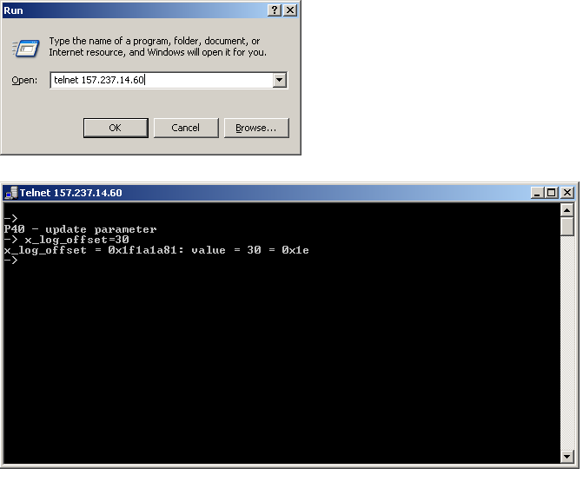

The above procedure must be repeated whenever the power is cycled on the TRU. If this procedure is not completed, then data whose level falls below -64dB will be lost.

## Runtime Parameters

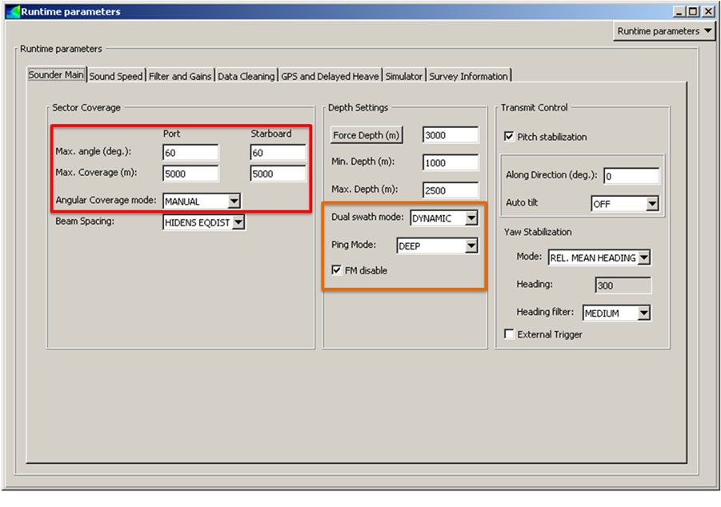

*Sector Coverage*

Setting the Angular Coverage Mode to “Automatic” will displace, grow or shrink the receiver beam fan to optimize the bottom detection quality across the swath. Though this is desirable from a bathymetric mapping point of view, it can be make further water column signal processing difficult as one can no longer assume that a given receive beam is at a fixed angle with respect to the vertical or within the same transmitter sector. For water column data acquisition, it is helpful to set the angular coverage mode to “Manual” with “Max. angle” values appropriate to the water depth. It is noteworthy that when the system runs in “Automatic” angular coverage mode that it will shrink the receiver coverage sector when faced with weak bottom returns at the outer edges of the swath. If water column mapping is the primary focus of the mission, then it may instead be desirable to allow for increased angular coverage despite the fact that the system cannot track the seabed at these angles. For example, in automatic mode you may find that the system selects +/-55° based on seabed return signal quality, however, water column imaging may still be possible over a much wider sector, e.g. +/-65°. Increasing the angular coverage must be balanced against a decrease in along-track density that comes with the reduced ping rate associated with large angular coverage.

*Depth Settings*

Dual swath sounding allows for increased along-track data density and/or faster survey speeds by essentially firing a second ping shortly after the first. The swaths are adjusted in the fore-aft direction such that one ensonifies an area slightly aft of the vessel and the other ensonifies an area slightly forward. The FIXED mode will set the fore and aft swaths at a fixed angle whereas the DYNAMIC mode will adjust the angular spacing to ensure a fixed along track sampling density to account for changes in vessel speed and water depth. The DYNAMIC mode is likely the better of the two as it attempts to maintain a constant along-track sampling density on the seafloor, however, it should be noted that this is not necessarily the case for water column targets, especially those in the upper part of the water column.

With the Ping Mode set to automatic, the system will choose an appropriate mode of operation depending on the water depth and return signal quality. In our experience, water column imaging artifacts can vary slightly or even dramatically between the various modes and some experimentation should be done to find a mode of operation that produces data of sufficient quality for the purpose of the mission. For our particular mission (mapping natural gas seeps), we desired a long pulse length to increase our chances of detecting weak scatterers in the water column so we chose to run in DEEP mode regardless of the water depth. Other water column mapping missions may have other priorities though and the table of mode characteristics should be consulted since the pulse length, number of transmit sectors and their operating frequencies all vary with Ping Mode. Furthermore, test data should be acquired using FM mode enabled and disabled (for the modes of operation that support both pulse waveforms) to determine if water column imagery quality varies with waveform type. Given the variety of data quality from one mode to the next, it is important to set aside time early in the cruise to assess the different Ping Modes and determine which is best suited for the mission at hand.

*Transmit Control*

Pitch and yaw stabilization is desirable as these both lessen the uncertainty in positioning with water column imagery that is not corrected for motion of the vessel. Currently, there is no commercially available software to fully geo-register water column imagery and it is thus advantageous to have the data compensated for motion in real-time such that the ensonified volume closely approximates a plane orthogonal to the vessel track.

## Real-Time Visualization

Real-time visualization parameters can be optimized to increase the utility of the water column data display for quality control such that watch standers can monitor data quality for problems such as ship noise, interference from other sounders or weather related signal degradation. Suggested settings are a fixed depth and across track scale with integer tickmarks such that the operator can quickly ascertain the vessel relative coordinates of any water column targets. When attempting to find water column targets, it is paticularly inconvenient if the reference frame in the image changes from swath to swath. Fixing the image scale may be of particular importance for operations where the water column display imagery is used to help coordinate other operations such as CTD or ROV.

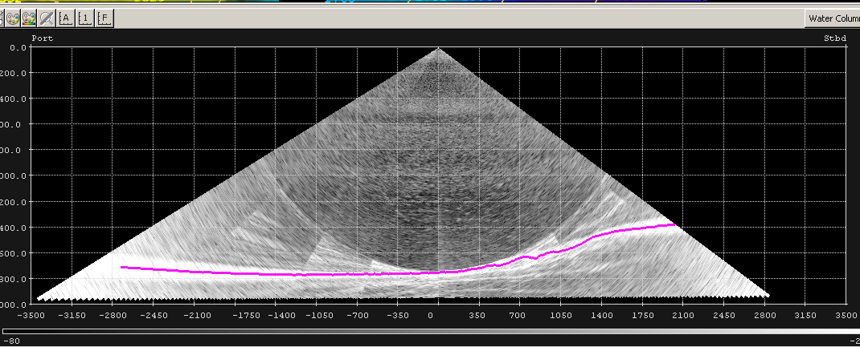

Fixing the image scale can be done through the “Show/Hide” interface which is accessed via the top left button in the water column imagery display. The “Depth Start Range Mode” and “Depth Stop Range Mode” should be set to fixed with reasonable scale values entered (e.g. image should stretch vertically from X meters to Y meters). The same is done for the “Across Start Range Mode” and “Across Stop Range Mode”. The number of grid lines are then set for both the X and Y Axes. This particular procedure is non-intuitive and some experimentation will be required to get a particular combination of Start/Stop range and number of grid lines to give reasonable (and usable) scales on the image. A more intuitive procedure would be to set the grid interval, however, this is not currently possible in SIS.

The color scaling for the image should be set to “Fixed” as well to maintain consistent imagery coloring from ping to ping that is visually easier to maintain watch over. The Data Range should be adjusted to avoid visually clipping the weaker targets, such as plumes, from the display (-80dB in the case below). Bringing the upper end of the scale down below or near the level of the bottom returns allows for an increase in contrast for water column scatterers at the expense of visually clipping the seabed returns. Note that these settings affect the display only and do not affect the data.

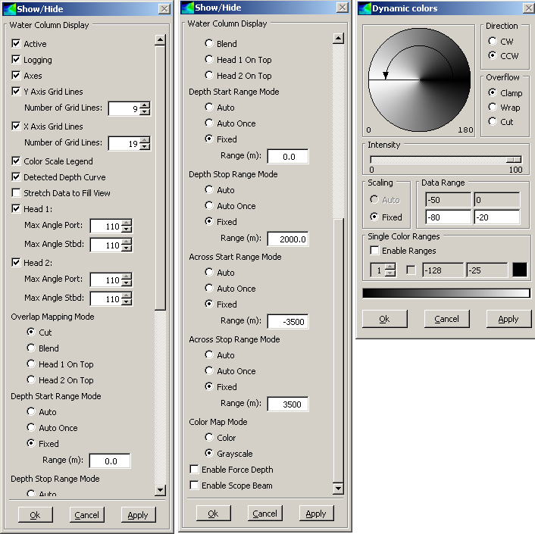

Once the settings are optimized, it is suggested that the current frame layout and settings are saved as a new set of settings for water column mapping operations.

## System Tuning

As mentioned earlier, there may be a particular set of system settings that provide optimal data quality for the task at hand. It is suggested that the following parameters be considered:

1. Ping Mode: dictates pulse lengths, transmit sector geometry and angular coverage (deeper modes may restrict the angular coverage even when used in water depths where the system is not attenuation limited at the outer edges of the swath)
2. Pulse wave form: CW and/or FM, some modes allow for both waveforms with the “FM disable” setting in the runtime parameters tab forcing the use of CW.
3. Dual swath versus single swath: water column artifacts, interference and noise levels may vary with the two modes of operation. Single swath may afford cleaner imagery however dual swath allows for increased along-track resolution at the expense of potential degradation of imagery quality due to imperfect normalization between the swath pairs (e.g. strobing effect).
4. Transmitter beamwidth. Though not mentioned in the configuration documentation above, it is possible to modify the beamwidth of the transmitter array. Depending on the nature of the mission, it may be desirable to increase the beamwidth to improve probability of detection. Though dual swath technology can virtually guarantee 100% along-track coverage on the seafloor, the same cannot be said of targets in the water column, especially if the system is actively optimizing transmitter steering to maintain coverage on the seafloor.

Though we can optimize the water column imagery display for real-time Q/A, this display is of limited use, particularly for system tuning, for several reasons:

1. The only mechanism to compare data quality is through screen grabs. This does not permit quantitative analysis of the data itself, only of the real-time display imagery.
2. Only one swath of the dual swath is displayed. Noise levels, artifacts and interference patterns cannot be assessed in the second swath.
3. The low ping rate in deep water can make this a particularly tedious and subjective exercise.

For these reasons, it is critical to assess data quality using post-processing software tools such as FM Midwater or SonarScope.

**Appendix B: Kongsberg trip Report, submitted by: Tony Dahlheim**



**NOAA Vessel: Okeanos Explorer**

**EM302 update / EK60 18kHz calibration - Training**

August 21st 2011 – August 23rd 2011

Coast Guard Station, Key West, Florida

**Kongsberg Personnel on Vessel:**

* Tony Dahlheim
* Jeff Condiotty

August 21st 2011

Met with Mashkoor Malik and other NOAA personnel aboard the vessel Okeanus Explorer. We discussed the EM302 update and the calibration proceedure of the EK60 18 kHz.

The decission was made that I perform a backup on the EM302 TRU and SIS while transisting to the EK60 calibration area. Once there we will log a line using the Exsisting EM302 SIS software version 3.6.4. Then we will update the EM302 TRU and SIS to current version 3.8.3 and log the same line. Comparrisions will be done by NOAA personnel to validate the data.

Once at the EK60 Calibration area the downriggers will be installed on vessel and the sphere attached and dropped overboard to begin the calibration of the EK60 18 Khz.

August 22nd 2011

Started back up of EM302 TRU and SIS during transist. First created an image of the HWS in which SIS runs on. Next I pulled the PU parameters and stored them on local drive under C:/em302/em302_bkup. I also took screen grabs of Installation settings, external sensors, and Set Parameters within SIS. Finally I exported the appropreate TRU files from the TRU and saved them to this directory.

The decission was made to start the EK60 18kHz calibration after back up was done. Installed outriggers to the appropreate locations on vessel decks and attached the 18kHz calibration sphere. Once the sphere was in the water, riggers were adjusted for line length and sphere was observed in the EK60 software window. Calibration was started and after some time about 50% of the calibration was performed before line broke off swivel on Straboard side. The decission was made by NOAA that they had enough information on how to perform the calibration, that they would perform one at later date before there testing at a specified location in the gulf.

August 23rd 2011

During the evening EM302 logged a two and half hour line at varring depths with the old version of software. After the line was run I performed the update to the TRU and the HWS which runs SIS. SIS was updated to reflect current version 3.8.3, PU parameters were imported and external sensors as well as Set Parameters were adjusted for Okeanus Explorer settings. The RX boards and TX boards firmware on the TRU were updated to current versions and all is operational.

Run time settings were adjusted in SIS to be the same settings as how the pervious line was run with the older version of software. After line was run NOAA validated the data and found that the system is running within specifications and there are no significant difference between these two data sets. The EM302 is running at full performance at this time.

**Summary:**

EM302 updated to 3.8.3 and fully operational. EK60 18kHz training provided to ship personnel and calibration will be performed by ship personnel again at later date.

**Concerns:**

* Found that stave 126 on receive array has a low db signal. Possible issue could be growth on receive array. Vessel should monitor this to see if it worst over time. Data being collected is still good.
* Recommend upgrading HWS in the future. As technology increases year by year the PC hardware platforms should be updated to accept new software that needs more processing power to run at peek performance.

1. Mineral Management Service, Gulf of Mexico OCS Region, Gulf of Mexico OCS Oil and Gas Lease Sales: 2007-2012, Draft Environmental Impact Statement, Volume I, MMS 2006-062, New Orleans, 2006.