anCTD Cast Name |  |   Cruise |  |  |  |  |  | CTD Number |  |  | Date
 |  | EX1104 |  |  |  |  |  | CTD05 |  |  | 8/9/11
Expedition Coordinator/  Science Team Lead |  | Kelley Elliott/Chris German |  |  |  |  |  |  | 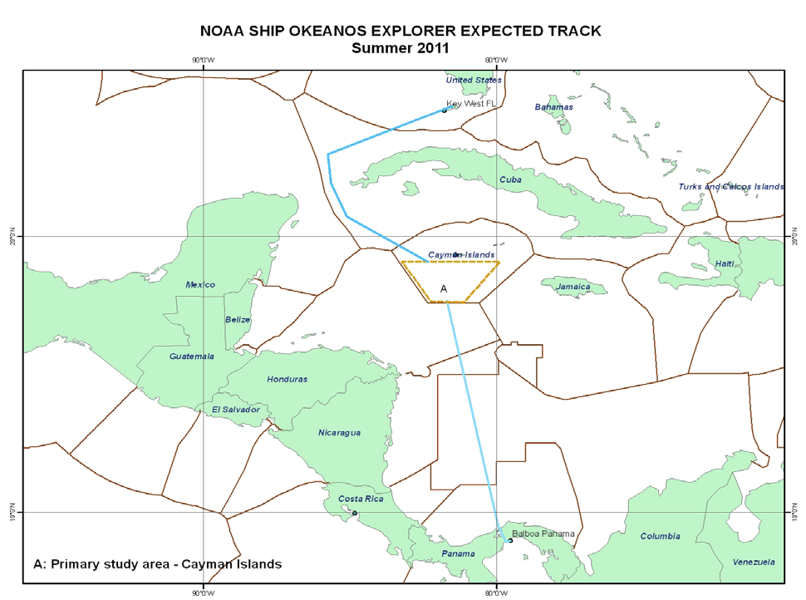
General Area Descriptor |  | Cayman Islands
Site Name |  | Da Bumps
Type of CTD Operation |  | Vertical Cast Po-Go
 |  | Tow-Yo Combination
Target Position |  | 18° 23.30’N |  | 18° 23.81’N
 |  | 081° 49.36’W |  | 081° 49.35’W
Deployment  Time & Location |  | UTC Time | 00:10
 |  | Latitude | 18 |  | º | 23.31 |  |  |  |  |  |  | ‘ |  |  | N
 |  | Longitude | 81 |  | º | 49.35 |  |  |  |  |  |  | ‘ |  |  | W
Time & Location  At Depth |  | UTC Time | 00:50 |  | Target Depth/Range |  |  |  |  | 20 mab
 |  | Latitude | 18 |  | º |  | 23.294 |  |  |  |  |  |  | ‘ |  |  | N
 |  | Longitude | 81 |  | º |  | 49.360 |  |  |  |  |  |  | ‘ |  |  | W
Recovery  Time & Location |  | UTC Time | 04:21 |  | Maximum Depth (m)
 |  | Latitude | 18 |  | º | 22.661 |  |  |  |  |  | ‘ |  |  | N
 |  | Longitude | 81 |  | º | 48.881 |  |  |  |  |  | ‘ |  |  | W
CTD Sensor  Data Acquired |  | CTD P 0905 T1 5001 T2 5017 C1 3449 C2 3451
 |  | ORP 08 Votage Channel 05
 |  | LSS 12790 Voltage Channel 02 LSS 12791 Voltage Channel 06
 |  | Dissolved Oxygen Voltage Channel __ Altimeter Voltage Channel 00
 |  | Other (specify) ____________ Voltage Channel __ ____________ Voltage Channel __
Water Samples Collected? |  | Yes No If Yes, Number of Bottles Tripped: ____20_________
Sample  Processing |  | Sample Type(s): ___Methane, TOC, Cell counts________________________________
 |  | Processed on board Preserved Chemicals __Formalin__________________
 |  | None Room Temp Storage -80 Freezer -20 Freezer Refrigerator
Data Archival |  | Tethys FTP site
Equipment Malfunctions | None.
Special Notes | None.
Scientists Involved  (name / location / affiliation / email) |  | cgerman@whoi.edu & cmcintyre@whoi.edu (WHOI)  Sarah.A.Bennett@jpl.nasa.gov (NASA-JPL), J. Kinsey (WHOI)
Purpose of the CTD operation: Prospecting for hydrothermal plumes near summit of Mt Dent.
Description of the Data/Results:
No in situ ORP or LSS anomalies observed.
Shipboard methane showed above backgroung concentrations at all three stations of PoGo. (Strongest at center).
Overall Map of CTD Cast Area | Screen Grab of Data
 | 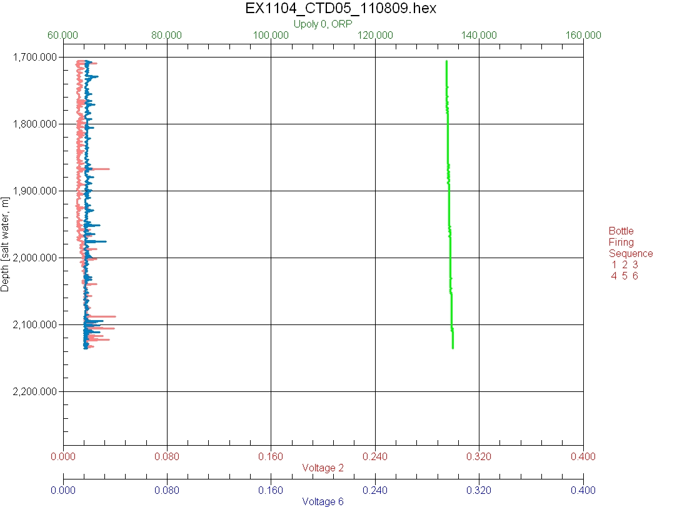
Overview of Cast site | SeaSave Data Acquisition Screen
Please direct inquiries to: | NOAA Office of Ocean Exploration & Research  1315 East-West Highway (SSMC3 10th Floor)  Silver Spring, MD 20910  (301) 734-1014

