CTD Cast Name |  |   Cruise |  |  |  |  |  | CTD Number |  |  | Date
 |  | EX1104 |  |  |  |  |  | CTD02 |  |  | 8/5/11
Expedition Coordinator/  Science Team Lead |  | Kelley Elliott/Chris German |  |  |  |  |  |  | 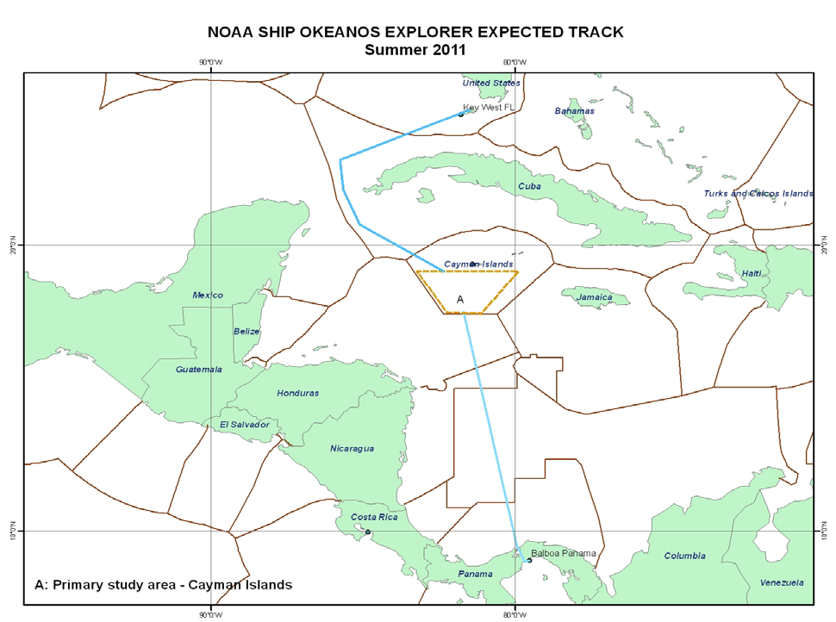
General Area Descriptor |  | Cayman Islands
Site Name |  | Von Damm
Type of CTD Operation |  | Vertical Cast Po-Go
 |  | Tow-Yo Combination
Target Position |  | 18° 22.592’N |  | 18° 22.591’N
 |  | 081° 47.884’W |  | 081° 47.892’W
Deployment  Time & Location |  | UTC Time | 00:40
 |  | Latitude | 18 |  | º | 22.591 |  |  |  |  |  |  | ‘ |  |  | N
 |  | Longitude | 81 |  | º | 47.892 |  |  |  |  |  |  | ‘ |  |  | W
Time & Location  At Depth |  | UTC Time | 01:23:27 |  | Target Depth/Range |  |  |  |  | 20 mab
 |  | Latitude | 18 |  | º |  | 22.591 |  |  |  |  |  |  | ‘ |  |  | N
 |  | Longitude | 81 |  | º |  | 47.892 |  |  |  |  |  |  | ‘ |  |  | W
Recovery  Time & Location |  | UTC Time | 04:22 |  | Maximum Depth (m) |  |  |  |  | 2291 m
 |  | Latitude | 18 |  | º | 22.328 |  |  |  |  |  | ‘ |  |  | N
 |  | Longitude | 81 |  | º | 48.388 |  |  |  |  |  | ‘ |  |  | W
CTD Sensor  Data Acquired |  | CTD P 0905 T1 5001 T2 5017 C1 3449 C2 3451
 |  | ORP 08 Votage Channel 05
 |  | LSS 12790 Voltage Channel 02 LSS 12791 Voltage Channel 06
 |  | Dissolved Oxygen Voltage Channel __ Altimeter Voltage Channel 00
 |  | Other (specify) ____________ Voltage Channel __ ____________ Voltage Channel __
Water Samples Collected? |  | Yes No If Yes, Number of Bottles Tripped: ____20_________
Sample  Processing |  | Sample Type(s): ___Methane, TOC, Microbiology________________________________
 |  | Processed on board Preserved Chemicals __Formalin__________________
 |  | None Room Temp Storage -80 Freezer -20 Freezer Refrigerator
Data Archival |  | Tethys FTP site
Equipment Malfunctions | Bottle 11 did not close—o-ring popped off bottom of bottle
Special Notes
Scientists Involved  (name / location / affiliation / email) |  | cgerman@whoi.edu & cmcintyre@whoi.edu (WHOI)  Sarah.A.Bennett@jpl.nasa.gov (NASA-JPL), J. Kinsey (WHOI), J. Huber (MBL)
Purpose of the CTD operation: dispersing plume tracking at Von Damm vent site
Description of the Data/Results:
Strong ORP signals at near bottom depths and plume height (2000m).
LSS and POTEMP at plume height only.
LSS, POTEMP and CH₄ traced to 1km from source by tow yo.

Overall Map of CTD Cast Area | Screen Grab of Data
 | 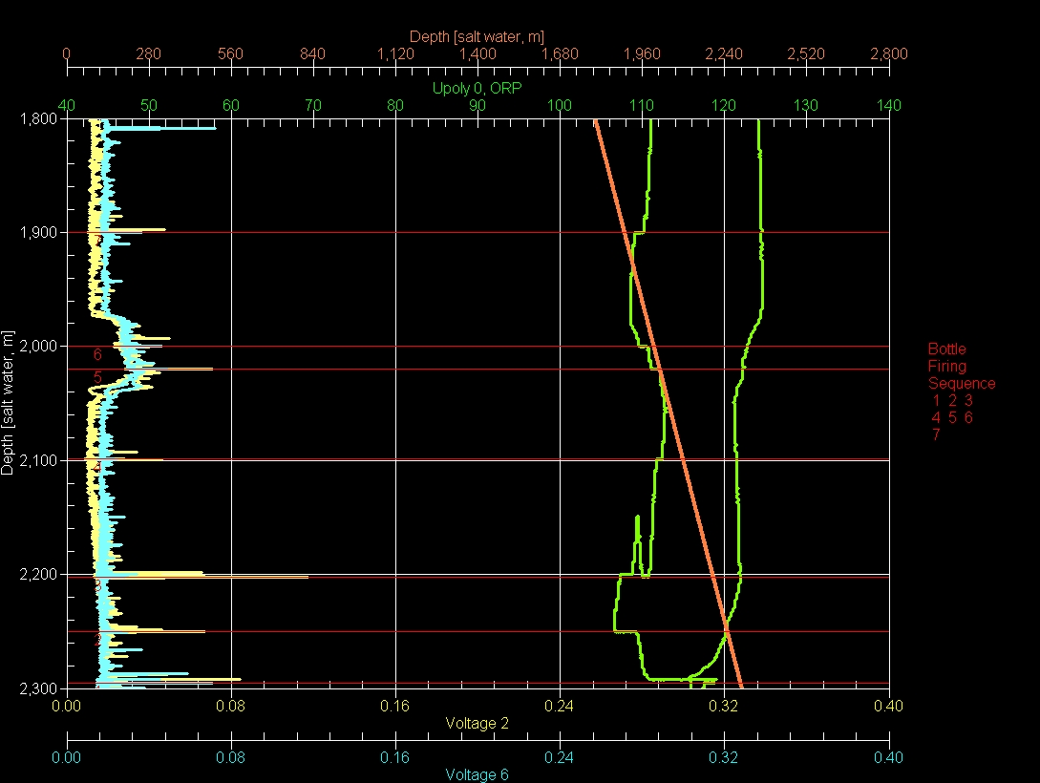
Overview of Cast site | SeaSave Data Acquisition Screen
Please direct inquiries to: | NOAA Office of Ocean Exploration & Research  1315 East-West Highway (SSMC3 10th Floor)  Silver Spring, MD 20910  (301) 734-1014

